Understanding the Transitions Between Web Interfaces Designed to Stimulate Specific Emotions
Michela Donati  ISTI - CNR  Pisa, Italy | Giulio Mori  ISTI - CNR  Pisa, Italy | Fabio Paternò  ISTI-CNR  Pisa, Italy

ABSTRACT
The main goal of this work is to understand how to obtain effective transitions when changing the Web user interfaces from one that stimulates negative affective states to one eliciting more positive emotions. The objective is to improve User eXperience (UX) and usability during the interaction. The transitions applied during the user interface adaptation seek to avoid undesired user disorientation, which can be a consequence of the change. A user study with 40 participants tested three types of transition solutions on a Web application: immediate (changes are applied abruptly all together), overview (changes are first previewed through a small window) and gradual (changes are progressively displayed directly on the interface). The overview and gradual transitions have been designed in such a way as to consider the design criteria used to stimulate specific emotions through the initial and final Web user interfaces. We report and discuss the results of the user test, which, amongst other findings, confirmed that users prefer the overview and gradual transitions.

Author Keywords
Web user interface adaptation; Affective Web; Transition styles.

INTRODUCTION
Emotions are increasingly recognized as an important aspect to consider in human-computer interaction (Hassenzahl, 2005; Karlsson, 2007; Kim et al., 2003). UX (User eXperience, 2010) is defined as the emotions and attitudes of a person regarding the use of a particular product, system or service (User Experience), and several authors agree on the importance of the affective state during interaction. For example, Kuniavsky (Kuniavsky, 2014) defines the UX as “the totality of end-users’ perceptions as they interact with a product or service. These perceptions include effectiveness (how good is the result?), efficiency (how fast or cheap is it?), emotional satisfaction (how good does the user feel?), and the quality of the relationship with the entity that created the product or service (what expectations does it create for subsequent interactions?)”. Desmer and Hekkert (Desmet Pieter, Hekkert, 2007) consider the UX as “the entire set of affects that is elicited by the interaction between a user and a product, including the degree to which all our senses are gratified (aesthetic experience), the meanings we attach to the product (experience of meaning) and the feelings and emotions that are elicited (emotional experience)”. So the emotions are generally recognised as a significant factor influencing the interaction with many types of systems.
Emotions are complex as they depend on individual preferences, attitudes, moods, dispositions, and interpersonal stances; “there is no single standard gold-method for their measurement” (Scherer, 2005). In particular, the affective effects of the Web design features are still a blurred and largely unknown world. Little work has been done to consider the role of emotion in Web applications, even if they are widely considered. In particular, there are many concrete indications to produce usable interfaces, for example Nielsen (Nielsen, 2000; Nielsen and Loranger, 2006; Nielsen, 2010; Nielsen, 1993), but there is a lack of Web design criteria indicating how to stimulate users’ affective states.
This work aims to enhance our understanding of how to exploit the affective effects of Web design characteristics in order to help designers to better apply them and improve the user experience. In particular, in this work we focus on how to design transitions when changing the Web design from stimulating negative emotions towards positive ones. We investigated the possible strategies of transitions that switch from one design to another, and we designed the implementations of such strategies taking into account the affective impact of the design. Then, we carried out a user study to identify the users’ preferences of the designed and implemented strategy types to collect the real opinions and perceptions of a number (40) of users.
The issue of using transitions as a support for interface or application changes has been discussed in the literature given its importance in increasingly dynamic interactive applications. Stasko (Stasko, 1993) indicated the benefits of the animated transitions for Graphical User Interfaces (GUIs): “a smooth interactive animation is particularly important because it can shift a user’s task from cognitive to perceptual activity, freeing cognitive processing capacity for application tasks”. Several authors have discussed the benefits of the animated transitions proposing them for many kinds of utilizations, such as spatial visual applications to make the possible interactions smoother and simple to understand (Huhtala et al., 2010; Bederson and Boltman, 1999), enhance the decision making (Gonzalez, 1996), improve visual perception of changes for data and statistics represented through graphics (Heer and Robertson, 2007), or boost navigation between revisions of textual documents (Chevalier, 2010).
However, in general, a dynamic change of a user interface design must be analysed carefully in order to avoid that the transition effects on the user could be disorienting and traumatic. For this reason, we investigated three types of Web design transitions in order to understand the emotional and usability effects, not only before and after the Web design transformation, but also during the transition itself. To summarise, the contributions of this work are:
- To identify possible strategies for supporting transitions from Web design stimulating negative emotions to positive ones;
- To design and implement such strategies in such a way to take into account the target affective state to stimulate;
- To report on the feedback gathered in a user study involving the application of such transition types in an example application.
After the related work section, the paper provides the necessary background with a short description of previous relevant studies for identifying relevant emotions in Web interaction and how to stimulate them through Web design criteria. The contributions cited in the background section represent the starting point for the research presented herein. Then, we describe the specific contribution of this work in terms of the three considered transition solutions, report on the user test conducted with 40 participants, including the results of the associated questionnaire, as well as an analysis of task performance, and discuss what emerged from the data gathered. Lastly, we draw some conclusions and provide indications for future work.

RELATED WORK
In this work we have considered contributions on two types of issues: emotions and transitions supporting user interface adaptations. There are many methods and tools to classify emotions in the literature, such as Geneva (Bànziger, 2005), Feeltrace (Cowie, 2000), the universal Ekman’s six emotions classification (Ekman and Friesen, 1971), or scales and questionnaires measuring negative or positive or hedonic dimensions of the moods (Watson and Clark, 1988; Voss et al., 2003; Diefenbach and Hassenzahl, 2001), but none of them has been specifically focused on Web interactions.
Some contributions (Hartmann, 2007; Kim, 2003) have compared different versions of pages or Web sites to investigate the impact of their attractiveness, or analyse the effects of the aesthetics by inspecting their influence on the user’s preference (Zheng et al., 2009), while some works (Lindgaard, 2006; Tuch, 2012) investigate the user’s first impression of a Web site appeal before noticing any details, but little attention has been dedicated to identifying the emotional effects of concrete Web design criteria.
Some work has analysed the hedonic elements (such as colours, images, shapes and photos) in some existing Web sites in order to investigate the user’s emotional impression (Cyr, 2014). Another study (Kim et al., 2003) has identified 13 emotional dimensions based on some adjectives provided by the users, and some limited relevant design factors (such as shape, texture and colour for the background, title, menu and main images) only for the Web home pages, but the authors did not investigate which design factors stimulate which feelings. Overall, we can note a lack of studies concerning the affective design criteria specific to the Web.
Regarding user interface adaptation, some authors (Dessart et al., 2012) indicate the advantages of smooth animated transitions to reduce the cognitive load when having to do with different views that require switching between different levels of abstraction (e.g. conceptual diagram, internal programming code or the final user interface). The same authors (Dessart et al., 2011) present the benefits of an animated transition scenario consisting of a sequence of adaptation operations (e.g., set/change a property of a widget, replace it by another or resize it), and the evolution of the user interface before and after the adaptation. Even if both contributions show the importance of the appropriate animated transitions to reduce the cognitive load, and the second work takes into consideration cognitive psychology and usability guidelines for animations, neither work focuses on the stimulated affective impact. Changing the user interface in order to modify the users’ affective state has effects on perception of continuity of interaction, which in turns influences UX.
Previous work (Baudisch et al., 2006) introduces phosphor transitions as a technique applied to an object to show the outcome of the change instantly, with the advantage that users who have already understood the transition can continue interacting without delay, while those who are inexperienced or may have been distracted can take time to view the effects at their own pace. Even if this idea is interesting, such work does not take into consideration the emotional effect at all.
Animations have the capacity to reduce the inevitable end user disruption and cognitive perturbation induced by adapting a graphical user interface, even if they still suffer from some time lag (Dessart et al., 2011; Baudisch et al., 2006).
Depending on the context and the application, even if animated transitions can improve user awareness, they also may introduce some complications consequent to the adaptation techniques adopted. For example, a three-dimensional map for navigating between directories can improve user learning of spatial relationships. However, users who try to return by memory alone can misjudge the spatial location of the target directory and may make several navigational errors (Bladh et al., 2005). Animations usually can be difficult to follow especially when many objects move at the same time, but this can be remedied under different conditions of temporal distortion (Dragicevic et al., 2011).
Considering the benefits and the possible implications of adaptation techniques analysed in literature, we chose to propose three different types of transitions (static, animated and through a preview window) to analyse the potential advantages and drawbacks of each solution. We wanted to understand how to design effective transitions when switching between two different Web designs eliciting different affecting states, bearing well in mind the importance of smooth continuity of interaction, usability and the perceived affective impact.

BACKGROUND
Before describing the novel work, it is useful to provide some details on two previous studies, which form the background of this research. The first one (Mori et al., 2014) carried out a preliminary survey with 50 users who were asked to indicate the typical emotions involved during the Web interaction and the main characteristics of Web design associated to each proposed emotion by the participants. No predefined emotions were proposed by us. The set of 219 emotions perceived as negative and 219 emotions perceived as positive by the interviewed persons were filtered discarding synonyms, emotions with low number of preferences and emotions having similar Web design characteristics associated. After the filter, the final resulting set was composed of six emotions: hate, anxiety, boredom, fun, serenity and love. Hate and love indicate the sense of disliking/liking typical of Web social network environments; anxiety and serenity denote the feeling during critical actions such as for example inserting personal data, or paying with a credit card; while boredom and fun express the level of the user interest for the way the contents of the interface are presented. The goal was not to provide a further exhaustive emotion classification, but rather to investigate whether some clearly distinguishable Web design characteristics could elicit a specific macro emotional state on the user. In fact, the preliminary survey showed that similar emotions (indicated by the users) were associated with some common design aspects.
The analysis took into consideration many Web design characteristics such as the pages and content structure, the type of multimedia, or the navigation and interactive elements, and their dimensions and colours. The participants advised many suggestions, and on the base of these collected indications proposed by them for each emotion, six interfaces had been implemented (each one with the goal of eliciting one of the hypothesized specific affective state). A user test was carried out with fifty different users to evaluate the emotional impact of each interface. The results showed that in a Likert scale from 1 to 5 (where value 5 indicated high emotional effectiveness, value 3 represented neutrality, and value 1 indicated low effectiveness), the fifty participants considered the interfaces eliciting hate, anxiety, boredom and serenity effective in stimulating the target emotions, while they considered neutral the interfaces eliciting fun and love, which thus would require some more investigation.
In a second study (Mori et al., 2015) two variants of the six interfaces were implemented taking into account also the suggestions of the previous user test to check what design techniques (between all those proposed in the previous user test) could be more relevant to stimulate each one of the six emotional state. The results of the new user test with 40 different participants provided several indications about the most important characteristics of Web design able to stimulate each emotional state, as summarized in Table 1. In that study, users evaluated the most relevant interactive characteristics (Table 1) for emotions elicitation.
Hate | - confused layout  - difficult interaction and navigation
Anxiety | - elements or effects generating emotional stress  - dynamic transformation of the elements
Boredom | - too much information  - lack of distracting elements, such as image or videos or dynamic effects
Fun | Requires a suitable mix:  - unusual elements  - graphics  - dynamic effects or animation  - appealing colours
Serenity | - ordered layout  - minimization of user effort  - user reassurance
Love | Requires a mix of:  - appealing graphics/aesthetics  - reassuring elements  - good usability
Table 1. Web design characteristics to elicit affective states.
Then, we deemed important to investigate usable solutions for the transitions when switching between two Web designs aiming to stimulate specific emotions, within the same application.
In fact, depending on the affective target (Table 1), a transformation of Web design can modify many aspects of the interface such as the colours, types and dimension of the multimedia elements (even removing them), can change the applied effects of text and multimedia (i.e. blur, saturation, animations, etc.), remodel the interface structure arranging the contents from a too long page in some shorter ones (with consequent navigation restyle), or also reposition the elements in a more functional way.
Thus, this work has the objective to investigate the impact of possible solutions for Web design adaptation, by considering three general different approaches for managing the transition from a Web design to another. In this perspective user feedback is extremely important because the goal is not just a mere Web design transformation but generating an improvement of the affective state and user experience avoiding disorienting effects.

The design and implementation of the adaptation transition types
In order to carry out our study we designed and implemented the Emotional Music System (EMS) Web application, which supports access to music information. Various types of music are considered and users can search for specific singers or groups and for information regarding them, listen to their songs, and book their events. EMS supports the most relevant Web characteristics for each one of the six designs corresponding to the six emotions identified in previous studies.
In this study, selection of the initial and target emotions is determined manually by the user. In particular, a control panel window (Figure 1) allows users to select one initial emotion on the negative side (hate, anxiety and boredom), and then a positive one (between love, serenity and fun).
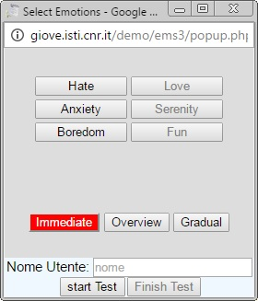
Figure 1. Control Panel window to select the transitions and emotions.
We chose to analyse transitions from an interface eliciting a negative emotion towards a positive one because such transitions would improve the users’ emotional state and their user experience, which is what usually applications aim to achieve. However, it is important to know the criteria for eliciting negative emotions in order to improve Web designers’ awareness, and thereby avoid the design of ineffective interfaces. In addition, such knowledge can also be useful in some particular applications such as Web games (recreating particular thrilling atmospheres), telemedicine (where it can be important to understand the reactions of patients in a positive or negative affective state), or in educational or psychological environments (e.g. improving children’s awareness of the difference between good and bad behaviours), etc.

The Three Transition Types
Three types of transitions have been considered to understand the most suitable approach when the user interface changes its design. One goal was to assess the perception of a smooth transition in comparison with an abrupt one as well. Thus, we considered three general solutions, one supporting immediate changes without any type of intermediate transformation, and two others providing support to understand the presentation of the design changes. The three transition types are independent of the characteristics of the six affective designs.
In particular, the transition types have the following characteristics:
- Immediate: All the Web design changes are instantaneous. The initial design eliciting a bad emotional state is instantly substituted by the new design eliciting a positive emotion (Figure 2). No animated effects are provided to indicate the design adjustments. The user, depending on the complexity of the page, can initially see only the part currently displayed on the screen. In case of larger content users have to scroll to access it.
Figure 2 shows an example of switching the design from anxiety to serenity stimulation with this technique. This means that features introduced for creating anxiety are replaced with others determined to stimulate serenity. The structure of the navigation has been reorganized in a simpler way by introducing tabs, which users perceive as effortless, and the animated effects utilized to generate emotional tension or stress (such as the countdown used to reload the form page) have been eliminated to favour a simple static look.
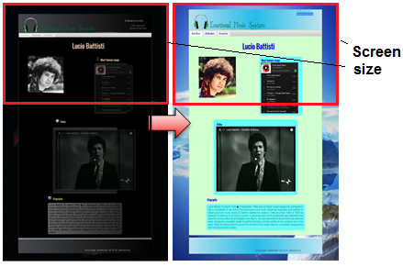
Figure 2. Example of Immediate transition.
- Overview: Design changes are represented by a small overview window (Figure 3), which illustrates the user interface with the support of icons associated with the various interface parts. This window displays animations to show how such parts will change and be repositioned in the target design.
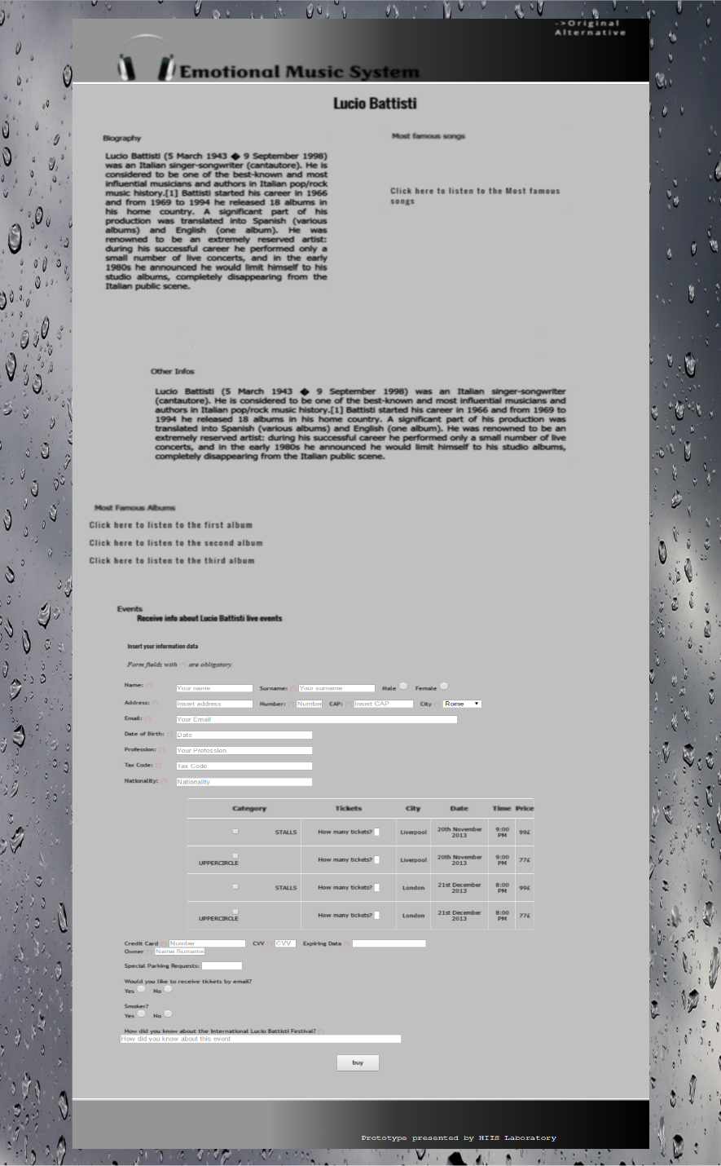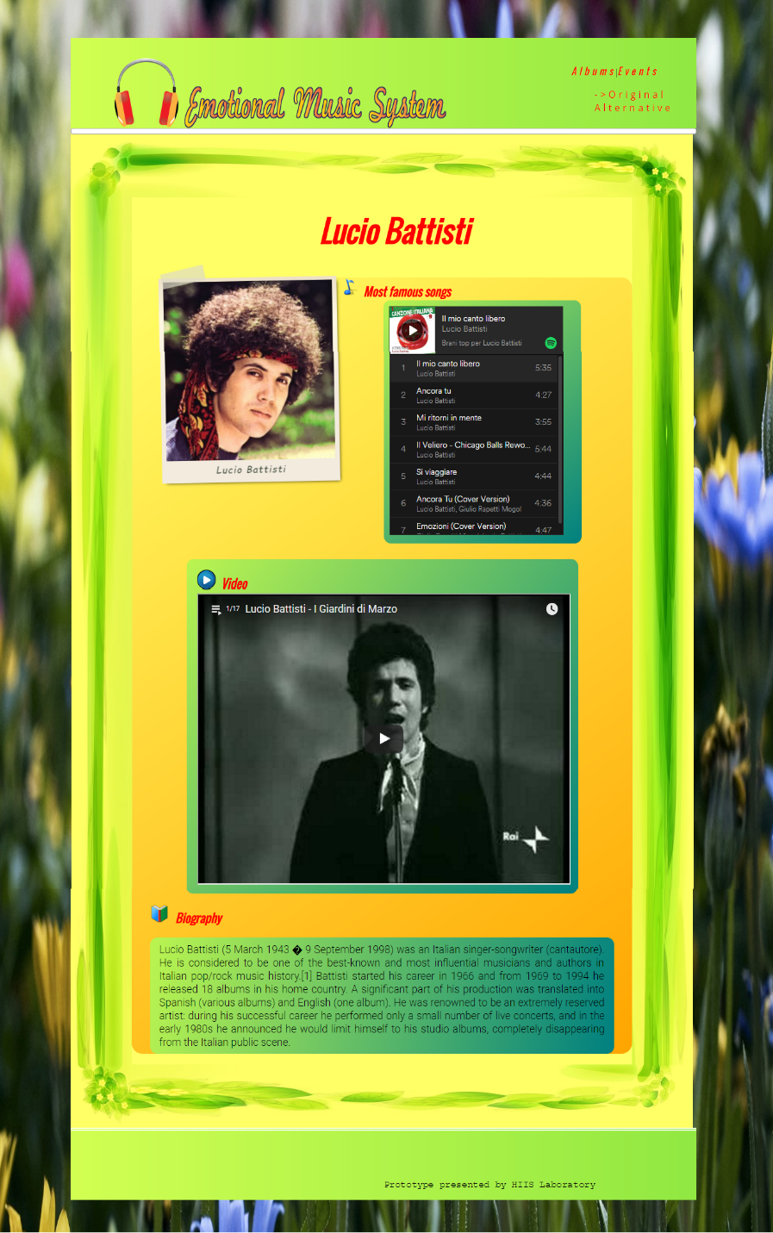
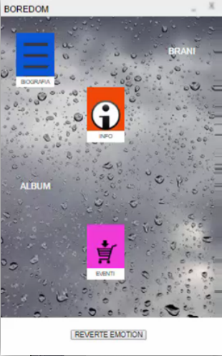
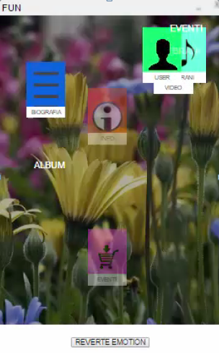
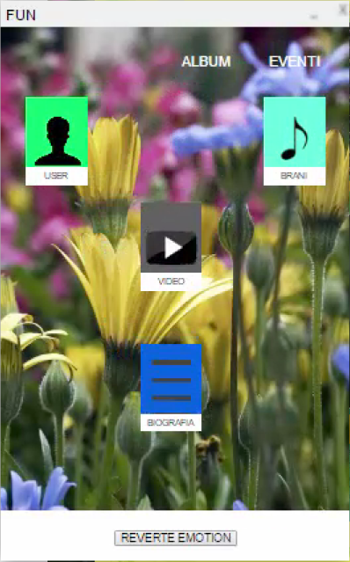
Figure 3. Example of Overview transition.
In this example, icons indicate where the text regarding the biography, the songs, the video or the photo of the artist, and the form to buy tickets for the events are situated. The overview window is also interactive through the clickable graphic icons associated with the different areas of the interface. In fact, the selection of one clickable icon allows users to navigate through the real interface, by scrolling the interface on the screen to the corresponding area. Figure 3 shows an example of the overview transition when switching from the boredom to the fun design, with the icon movements displayed in the overview window during the transition. Icons corresponding to photos and videos, which were not present in the boredom design are inserted in the new design with the goal of stimulating fun, while the excessive additional textual information (Info icon) typical of the boredom design is removed during the transformation.
Figure 4 shows the different graphic icons used to represent: the photo of the author or the band, the list of the most famous songs, one music video, three well-known albums in which each song is listenable, the biography, the form to buy tickets for some events related to the artist(s), and some additional textual information.
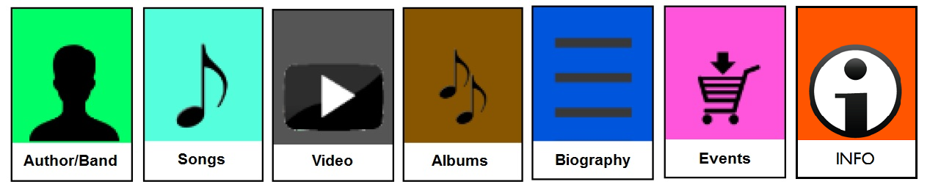
Figure 4. Icons of the overview window.
The new design is applied to the user interface after the animation preview has finished. The user can view the transition representation through the icons animations again by pressing the “Revert Emotion” button.
The overview is useful since often users cannot see all the user interface without scrolling because of the complexity and length of the page.
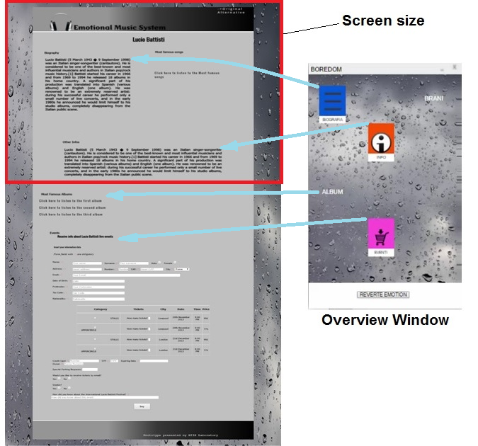
Figure 5. Boredom: correspondence of the Overview window icons with the interface. Overview window is enlarged.
Figure 5 and 6 show more in detail two examples of correspondence between the icons in the preview window and the parts in the application user interface for the boredom and fun designs.
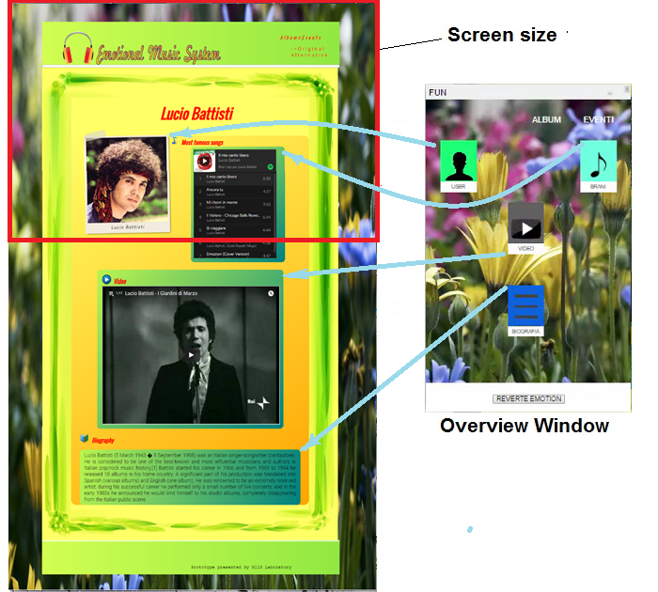
Figure 6. Fun: correspondence of the Overview window icons with the interface. Overview window is enlarged.
During the evolution of the transition moving from a page stimulating boredom to one associated with fun (Figure 3), contents of the single long page used in the boredom design (Figure 5) are distributed throughout some shorter pages in the fun design (Figure 6), requiring the introduction of a new structure for navigating between them. Absent media in boredom have been inserted in the fun design together with some simple animations and decorative graphic elements. Moreover, the annoyingly large amount of text information of the design boredom has been reduced.
- Gradual: In this type of transition the changes are progressively applied to the interface (Figure 7) supported by animated effects (fade out/in transformation and repositions of the elements, change of colours, etc.).
Due to the absence of an overview window, the user has to scroll the interface to be aware of the global changes. In this work we did not draw any conclusions about the discussed age-old question (McCarthy, 2013) of whether scrolling a Web interface is appropriate (Gilbertson, 2009; Schwartz and Yavilevich, 2006) or not (Nielsen, 2010; Sanchez and Wiley, 2009). Recently, the majority of the Web sites or social platforms have long pages, even in the smartphone or tablet versions. As a consequence, also our application supports scrolling, even if without excessively long pages, with a maximum of about three or four screens as the page length for a resolution of 1920x1080 pixels.
The Overview transition is the only one of the three solutions that allows the user to have a view of the entire interface and all its transformations through an additional window.
Figure 7 shows an intermediate stage of the gradual transformation of the interface when switching the design stimulation from hate to love. The confused layout is gradually rearranged improving the usability of the new design, together with the introduction of a mix of enriched graphics details (such as icons at the beginning of each section of the page, three-dimensional coloured edges of sections producing the three-dimensional effect, abstract textures being part of the interface background, etc.) and reassuring elements (for example, the credit card ﬁeld split into 4 groups, each 4 digits long, in order to facilitate reading and data input, etc.) to entice the user to interact pleasantly with the interface.
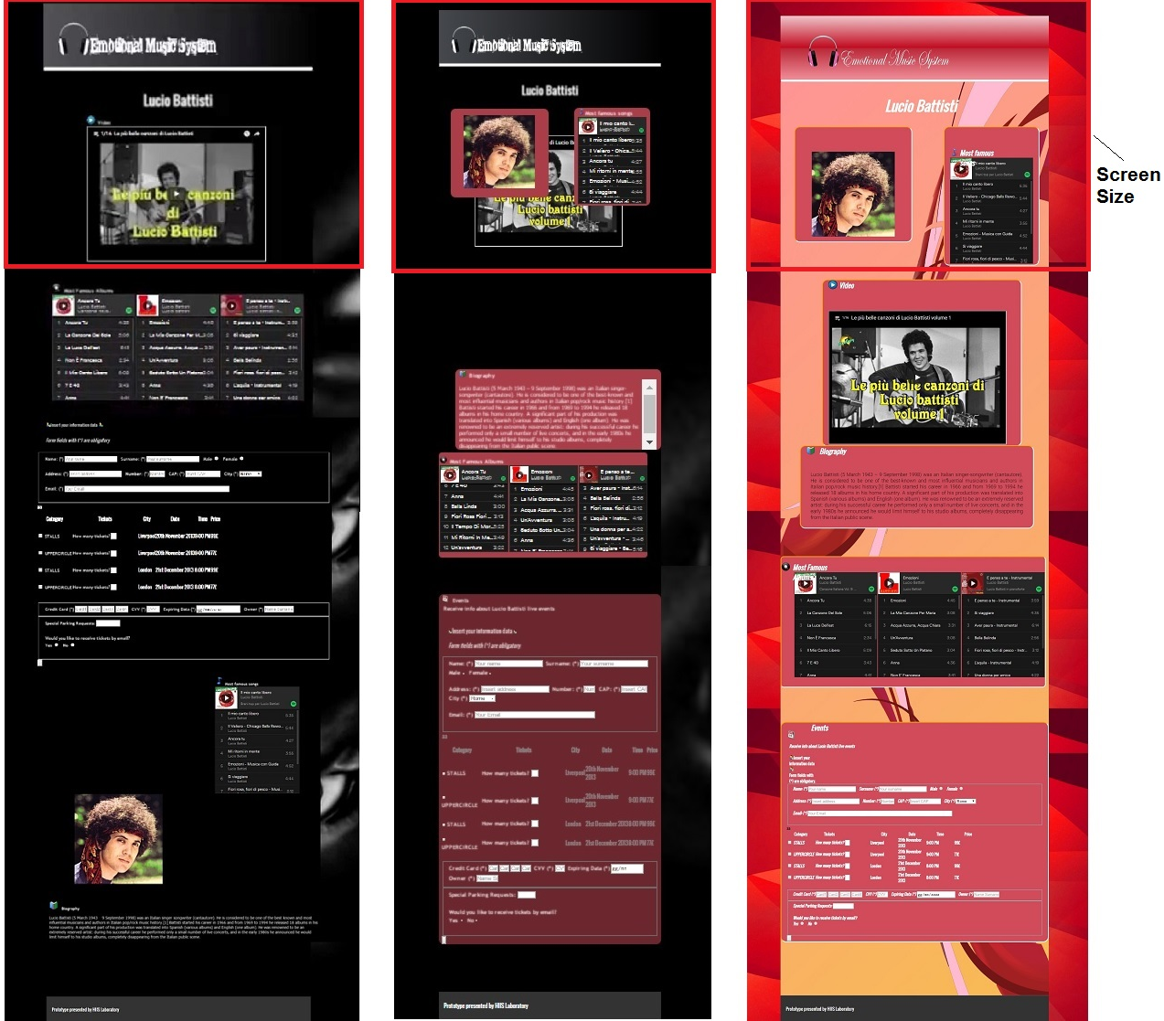
Figure 7. Example of Gradual transition.

USER INTERFACE TRANSFORMATIONS
In the EMS application it is possible to apply different design criteria to stimulate one of the six emotions. A transition replaces the initial Web design characteristics with another one aiming to generate the target emotional state. As we have explained in the previous section, the differences between the three considered transitions types (immediate, overview, gradual) lie in the way the substitution from the initial to the target Web designs is presented to the user.
Although the immediate transition is simple because it instantly replaces one design with another, the overview and gradual transitions require more explanation to clarify how they are obtained in the considered approach. As this work focuses on Web design and associated transitions, the six interfaces have the same contents and sections. The sections are arranged in the same positions for anxiety, fun, serenity and love designs, while hate and boredom designs are a bit different, as suggested by the subjects in previous user tests (Mori et al., 2015). The hate eliciting design has the sections arranged in a confused way. Design eliciting boredom has an additional section of text and no images or videos are present, because a lot of information and the absence of distracting multimedia elements have been considered relevant characteristics.
As a consequence, when the chosen initial emotion is anxiety and the target one is fun, serenity or love, no interface sections are moved. In such transitions, the only changes that come about involve other aspects such as the aesthetics of the interface and elements and/or the redefinition of the navigation connections (see following). Movements of the sections occur only for transitions in which one of the initial designs is hate or boredom, because of the different structure of their interfaces.
In particular, each one of the six affective interface designs has its specific characteristics:
- sections and elements of the interface for the hate design have been arranged confusedly with the addition of obstacles to the interaction, such as the appearance of some random advertisement pop-up windows, or some non-functioning elements, etc.
- dynamic effects, such as shrink distortion effects and jerky transformations of the elements are applied to the anxiety design, with the addition of emotional pressure and tension factors, such as a countdown deadline, a form that is not reassuring (with no logos for secure transitions) where sensitive personal data are inserted, or absence of feedback notifications after the data input and submission.
- No images or videos are present, and more textual information or more required data fields are added for the boredom design.
- In the fun design the sections are enriched with some graphical icons and decorations and unexpected dynamic effects of the elements (such as zoom or a little movement at mouse over). Effects should not be invasive during the interaction.
- The goal of the serenity design is to elicit minimal user stress during interaction and navigation, so a tab menu to facilitate navigation between the pages is included. Reassuring elements and notifications have been added together with a simple and ordered layout.
- The love design goal is to attract the user to frequently interact and use the interface. Fun and love designs are demanding because they require a mix of an appealing look, nice colours, stimulating graphical effects, and limited user effort.
The transformation of the interface design during a transition involves various aspects:
- The header and footer are replaced by those of the new design.
- The background and colours are converted to those relevant to the new design.
- Graphical effects such as blur or clear, black & white or colour, dark or bright, scale, skew or rotations effects, etc. are applied to the images and videos and text. The types of interactive (selection, input, etc.) or navigation (link, button, etc.) elements are changed, added or removed depending on the design.
- Blocks corresponding to the different sections of the interfaces (i.e. Author, Biography, Songs, Albums, Video, Events, etc.) are repositioned in the areas defined by the structure of the new design.
- User preferences in the previous studies suggested long interfaces for design eliciting hate, boredom and love, while short pages for design eliciting anxiety, fun and serenity. So, when the transition is from one design with a long interface to one designed with short ones, sections of the initial long main interface are split and distributed in three generated short pages (one for the author information together with images and video, one used to book an event of the author, and another supported by a Spotify plugin [https://developer.spotify.com/] to listen to some songs from three famous albums). This redistribution of the contents in three short pages calls for a redesign of the structure of the navigation connections between the new generated pages. Vice versa, when the transition is from a design composed of three short pages to a design with a single long one, sections are arranged in the target page (each section in the assigned position), and previous connections between the three short interfaces are no longer necessary.
These parts of the transformation are executed smoothly directly on the interface for the gradual transition, while they are executed on the overview window and then applied on the interface for the overview transition. Transformation on the overview window is executed in a simplified version, showing just only the movements of the sections and their new position, new colours and added links to other pages, while contents of the sections (Authors, Songs, Albums, Video, Events, etc.) are represented by graphical icons (Figure 4) without specifying any details about the aesthetical effects applied on them.

USER TEST
We conducted a user test to assess the user experience and usability of the three transition types and better understand how to design effective transitions. The user test was composed of three phases, during which users had to execute one task before and after each transition, and then they had to fill in a questionnaire.
We involved 40 participants (23 females and 17 males) of average age 36 (ranging from 26 to 66) and standard deviation 13.48. One user had a PhD, 5 users had a master degree, 12 users had a bachelor's degree, while 19 users had a high school diploma and 3 users had a middle school diploma. Users were used to surfing the Internet (37 were connected to the Web every day, 2 users navigated three times per week, and one user utilized the Web once every week/ten days). The sample included both experienced and inexperienced users in Web development (33 users had never implemented any Web interfaces, while the remaining 7 participants of the sample had experience at different levels). This study has been carried out in accordance with EU and national law on data protection, in particular, Directive 95/46/EC and the corresponding Italian national law: Legislative Decree n. 196/2003 – Personal data protection code - and Code of conduct and professional practice applying to processing of personal data for statistical and scientific purposes. The participants to the user test were adult healthy volunteers able to give free and fully informed consent. They have been informed that they had the option to withdraw from the experiment any time without any negative consequences. The privacy of the individuals has been kept by anonymization of the obtained data.

Questionnaire and Tasks
The questionnaire was composed of three parts asking the users: a) their personal information about their experience with Internet and Web development; b) an evaluation of the three transitions using a Likert scale from 1 to 5 (where the value 1 indicated that the transition was very ineffective, while value 5 indicated that the transition was very effective, and the value 3 represented neutrality); c) a general evaluation specifying the reasons that led them to prefer one transition over another, the strengths of each one, or if there were some defects (in this case by proposing improvements and suggestions).
Before evaluating each proposed transition type (immediate, overview and gradual), in part b of the questionnaire, users had to carry out one subtest for each transition. Figure 8 shows an example of the test workflow.
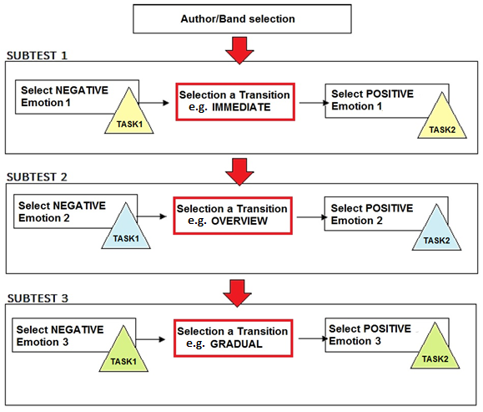
Figure 8. Example of the three subtests (one for each transition).
Starting from a neutral page (where no affective design criteria was applied), each user had to: a) select an author, b) choose an initial design by selecting one of the three negative emotions (hate, anxiety or boredom), c) perform Task 1 on the initial interface, d) select one of the three transition types, e) choose a target design eliciting one of the three positive emotions (fun, serenity or love), f) look at the transition execution and g) perform another Task 2 on the new interface.
In order to better understand the impact of the transition before and after the transformation of the interface design, we instructed the participants to perform one task (Task1) on the initial interface and another (Task2) on the interface after its transformation. For each subtest, Task1 and Task2 were equal in terms of cognitive effort (to compare the same conditions), but different in terms of the required contents to access or information to find. Each subtest had a different assigned task pair, and each pair corresponded to different task types. In particular, for Task1 and Task2 users were required to find a) a piece of information in the biography section of the Web site during Subtest1, b) a song in the album section during Subtest2, and c) the date of a specific concert in the events section and fill in the associated form during Subtest3.
Because the users were free to choose the emotions elicited by the initial and target designs for each transition, different Task 1 and Task 2 were associated randomly to each affective design. The only constraint was that users could choose each emotion just once, until all had been selected and the three transitions evaluated. Considering that the initially chosen emotion was negative and the final one positive, we sought to understand the impact of the transitions in terms of users’ perceptions.
Before having the users fill out the questionnaire, we informed them of the characteristics we wished to elicit from them during a transition experience. In this phase we did not mention usability or UX as too specialised (they were not aware of human-computer interaction literature), so we preferred to use simpler language. We explained that we wanted to understand if the three designed transition types allowed them to experience the Web design changes without disorientating them, and then whether it was easy to continue interacting with the new interface. We also told them that we aimed to understand whether the transitions were attractive, and stimulated pleasant continuity of interaction. See Appendix for details on the questionnaire used and how it has been developed.

Results
Answers (Figure 9) to the question “Do transitions benefit your experience during the interface design transformation?” (Figure 9): fifteen users declared perceiving substantial benefits (corresponding to value 5 of the Likert scale); nineteen users answered that the support of these transition techniques provide substantial aesthetic and functional benefits (corresponding to value 4); and only two users considered (with value 3) them significant only from the aesthetic point of view. Finally, only three users noticed few benefits (value 2 of Likert scale) and one user did not notice any kind of benefit (value 1).
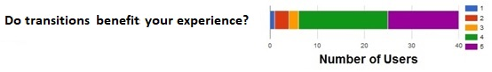
Figure 9. Results of the 5-point Likert scale assessment on the perceived benefits of transitions.
Then, users were asked to be more specific, choosing just one of the three transitions that they preferred most, leaving a comment to explain their choice. The results (Figure 10) indicate that 47.5% of the users preferred the gradual transition (where animations and dynamic effects were appreciated, as they clearly highlighted the Web design changes), while 30% of the users considered the overview transition more efficient and intuitive to understand the global changes through animations with graphics icons in the supported additional window, and 22.5% of the users preferred the immediate transition for its simplicity and speed.
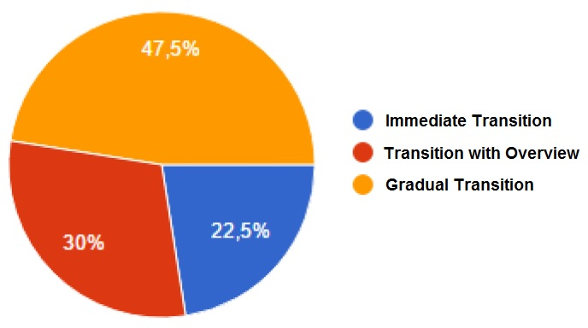
Figure 10. Preferences of the three transitions.
The questionnaire also asked users to score (on a 5-point Likert scale) each transition (as shown in Figure 11), evaluating its ability to provide the desired characteristics explained at the beginning of the user test. Asking users only their preferences for just one of the three transitions (Figure 10) does not give detailed information on what they thought about the other transitions. So, we had them evaluating each transition on the 5-point scale in order to gather more detailed indications. In fact, considering the ratings 5 (very appreciated) and 4 (appreciated), as a clear indication of positive user perception of the transition, the results show (Figure 11) that the majority of the users preferred the gradual (77.5%) and overview (67.5%) transitions, highlighting that the immediate transition is considered less convincing (37.5%). This is due to a more varied distribution of ratings between 1 to 5, which indicates its controversial impact and non-homogeneous appreciation by the participants.
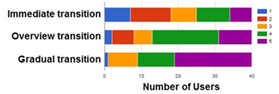
Figure 11. Results of the 5-point Likert scale assessment of the three types of transitions.
More specifically, the questionnaire also asked users to pay attention to the design characteristics we explained at the beginning, and choose the transition they considered:
- more suitable to perceive and orient themselves during the user interface transformation, while keeping the new interface easy to use. This was taken as a measure of transition usability.
- stimulating in a pleasant way to continue to use the new interface after the transformation. This question was aimed at determining their perception of UX.
Users indicated the gradual transition as the least disorientating and also considered it the most pleasant and stimulating when changing the Web user interface (Table 2).
 | Gradual | Overview | Immediate
Allow users to perceive changes without disorientation maintaining the new interface still easy to use | 42.5% | 32.5% | 25%
Suitable to stimulate a pleasant continuity of interaction | 57.5% | 25% | 17.5%
Table 2. Perceived impact of each transitions on usability and emotional effectiveness.
We took into consideration the answers of the participants on both aspects A and B (related to usability an UX) of the transitions in Table 2 and calculated Cohen’s Kappa index (Table 3) to check if they were strictly connected. The high values of Kappa index 0.922 for aspect A (which we call for simplicity Usability) and 0.837 for B aspect (which we call for simplicity UX), emphasize that both characteristics are strictly connected, and when users chose a transition, they perceived both characteristics similarly.
 |  | Usability |  |  |  | UX
 |  | Immediate | Overview | Gradual |  | Immediate | Overview | Gradual
Preference | Immediate | 90.0% | 0% | 0% |  | 100.0% | 0% | 8.7%
Preference | Overview | 0% | 92.3% | 0% |  | 0% | 100.0% | 8.7%
Preference | Gradual | 10.0% | 7.7% | 100.0% |  | 0% | 0% | 82.6%
Table 3. Cohen’s Kappa index of usability and UX aspects of transitions.
Considering the results, we checked whether there was a particular association with some aspects of the user’ profile (such as gender, qualification, age classes). Statistical analysis using Fisher’s test on Usability and UX for the three transitions (Table 4), indicated that participants with a high level of qualification (in comparison with participants with a low one), chose the immediate transition as most usable. No other significant association emerged regarding gender, qualification or age classes. The participant sample does not allow checking the influence of their Web development experience on the results, due to the fact that the majority of the participants has no such expertise.
 |  | Usability |  |  |  |  | UX
 |  | Immediate | Overview | Gradual | P-value |  | Immediate | Overview | Gradual | P-value
Gender | Female | 50.0% | 46.2% | 70.6% | .349 |  | 57.1% | 30.0% | 69.6% | .097
Gender | Male | 50.0% | 53.8% | 29.4% | .349 |  | 42.9% | 70.0% | 30.4% | .097
Qualification | High | 70.0% | 53.8% | 23.5% | .043 |  | 71.4% | 50.0% | 34.8% | .258
Qualification | Low | 30.0% | 46.2% | 76.5% | .043 |  | 28.6% | 50.0% | 65.2% | .258
Age Classes | >20-30 | 60.0% | 53.8% | 52.9% | .326 |  | 57.1% | 50.0% | 56.5% | .257
Age Classes | 31-50 | 20.0% | 30.8% | 5.9% | .326 |  | 14.3% | 40.0% | 8.7% | .257
Age Classes | >50 | 20.0% | 15.4% | 41.2% | .326 |  | 28.6% | 10.0% | 34.8% | .257
Table 4. Fisher’s test to see association between Usability and UX in the three transitions and profile of users.
Even if the three proposed transition types are general, they do not represent all possible solutions, thus we asked the participants for suggestions, and they indicated additional variants as potential improvements to the three proposals. In particular, the suggestions were: an intermediate transition supporting both the characteristics of the overview and gradual modality, the possibility of personalizing the effects and the movements of the elements during the transition, the support of some acoustic sounds with a vocal guide explaining the changes, and the option of simulating the transformation of each element of the page before the transition happens (for example hovering with the mouse).

Log Analysis
The EMS application was equipped with a logging system that saved the users’ interaction events. The beginning of the user test started when the user clicked the “Start Test” button and finished with the click of the “Finish Test” button (Figure 1). The logging system stored: a) the url of the page, b) the type of event (click, scroll, selection of one element, etc.), and c) the time of each event.
Analysing the users’ logs, the data show that the average number of “scroll” events is lower after each transition type (Table 5). It is interesting to note that the gradual transition seems to reduce more the numbers of users’ scrolls in comparison with the immediate solution. Applying the t-test to the number of scrolls of each participant during execution of Task1 and Task2 before and after each transition, indicates a significant improvement in terms of orientation in the new interface, despite the user interface transformation (p-values in Table 5).
 | Immediate | Overview | Gradual
Interface before transition | 181 | 206 | 320
Interface after transition | 123 | 92 | 163
Average scrolls number reduction for Task 2 compared with Task 1 | -57 | -114 | -157
p-value t-test | .008 | 000 | 000
Table 5. Average scroll number reduction for Task 2 compared with Task 1.
Analysis of the logs also provided some information about timings.
 | Average time of Subtest i (min.:sec) | Standard  Deviation of Subtest i (sec.) |  | Average time of Task 1 (sec.) | Standard  Deviation of Task 1 (sec.) |  | Average time of Task 2 (sec.) | Standard  Deviation of Task2 (sec.)
Immediate | 52 | 10 |  | 18 | 9 |  | 23 | 5
Overview | 1:42 | 23 |  | 44 | 20 |  | 34 | 10
Gradual | 1:28 | 29 |  | 42 | 10 |  | 40 | 28
Table 6. Average timings of each Subtest, Task1 and Task2.
Table 6 shows the average times (and standard deviations) for participants to complete respectively the whole Subtest i (with i=[1,3], where i=1 corresponds to the immediate transition and i=2 and i=3 to the overview and gradual ones), together with average times to complete Task1 and Task 2 for each Subtest i. The times necessary to complete Task1 and Task2 of a Subtask i depend on the ability of each user, while the time required for a transition execution depends on the complexity of the design to be transformed. The times to execute Task1 (or Task2) of one Subtest cannot be comparable with those for Task1 (or Task2) of another Subtest because of the differences between the tasks in each Subtest (i.e. find a piece of information in the biography for Subtest 1, find a song in the album section for Subtest 2, find the date of one specified concert in the events section and fill in the form for Subtest 3). On the contrary, the execution times for Task1 can be compared with the Task2 times in the same Subtest because both tasks are similar, except the information to find or to insert. From this consideration, an important aspect emerges looking at Table 6: the differences in the task performance times before and after each transition.
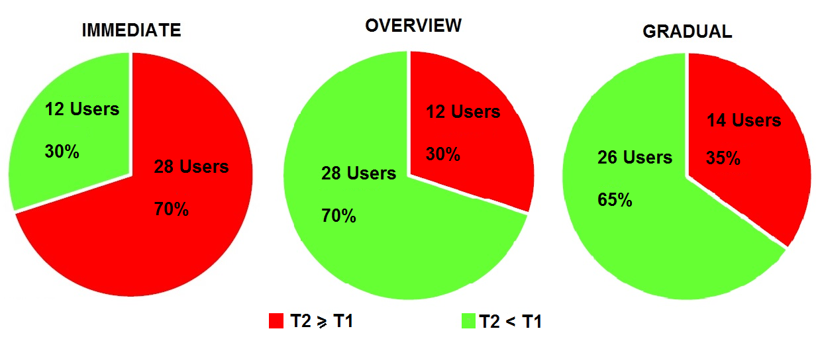
Figure 12. User performance trends comparing the average T1 and T2 times for the three transitions.

In fact, if we define T1 and T2 as the average times to perform respectively the tasks before (Task 1) and after (Task 2) a transition, analysis of times T1 and T2 reveals an interesting aspect: T2 was lower than T1 for the entire sample with the gradual and overview transitions. In more detail, the average T2 for the gradual transition was 2 seconds lower than T1, while the average T2 for the overview transition was 10 seconds lower than T1. On the contrary, the average T2 for the immediate transition was 5 seconds longer than T1. Figure 12 shows the user performance trends obtained by comparing the performance time of Task 1 and Task 2 for each transition. There is an evident increase in T2 for the immediate transition, while T2 is shorter for the overview and gradual ones.
This motivated us to check whether the detected T2 reduction (perceived as an indicator of users’ awareness of the interface changes) with the overview and gradual transitions was statistically significant.

Statistical Analysis
The decrease of task performance time after the overview and gradual transitions has been analysed. We considered for each transition the difference between task performance times (Diff=T2-T1). We applied an ANOVA with three groups corresponding to the time differences Diff_{I,} Diff_{O,} Diff_{G}, for the immediate, the overview and the gradual transitions. Statistical analysis was performed by using the software SPSS (www-01.ibm.com/software/analytics/spss) version 20.0. Categorical variables are expressed as percentages, while all continuous variables are expressed as mean, variance, min and max (Table 7). The Kolmogorov-Smirnov test applied to the data of the three groups (Table 7) showed that their distribution resulted normal: (p_{immediate}=0.431) > 0.05, (p_{overview}=0.591) > 0.05, (p_{gradual}=0.116) > 0.05. However, applying the Levene test, the variances resulted not homoscedastic (p=0.33) > 0.05.
 | N | Mean | Variance | Min | Max
Immediate | 40 | 4.68 | 9.92 | -22 | 20
Overview | 40 | -10.22 | 19.41 | -63 | 25
Gradual | 40 | -2.32 | 29.31 | -46 | 147
Table 7. Characteristics of Diff_{i}=T₂-T₁ for the three transitions.
Thus, we applied non parametric statistics, using test on the median (p=.000, i.e. smaller than .001) and then test of Mann-Whitney for two sets of data each time. The results showed that Diff_{O} compared with Diff_{I} was significant (p=.000) < 0.05. In addition, Diff_{G} compared with Diff_{I} was still significant (p=.001) < 0.05, while comparison of Diff_{O} with Diff_{G} was not significant (p=.384) > 0.05. This indicates that the overview and gradual transitions contributed to a significant decrease of time to complete Task 2.

DISCUSSION
Considering the results analysis, the significant shorter average T2 with respect to T1 to complete a task after the two animated transitions (the overview and gradual) was not obvious, if compared with higher T2 of the immediate transition, where changes are instantaneous. The results of the test show that time required by the transitions can facilitate the comprehension of the users, and help them to clearly perceive the changes, and thus can be considered an investment to obtain seamless interactions with applications when they adapt their user interfaces.
In fact, the large majority (75%) of the users who preferred the overview and gradual transitions as more appropriate for the adaptation indicated in their comments the following benefits: ease of identifying the parts of the new interface, stimulation of curiosity and more concentration following the changes, more gradual familiarization with the modifications, and better awareness of the interface change. So the overview and gradual transitions were perceived as important to avoid user disorientation. Comments specified also that once the participants had understood the interface changes, they appreciated the benefits for the new affective design applied in comparison with the initial design stimulating negative emotions. The participants who preferred the overview transition appreciated the overview window as an interactive map for better identification of the sections and contents and information retrieval, while participants who preferred the gradual transition considered dynamicity and animations an essential condition for the emotional involvement with the application. In other words, a lack of awareness of the interface transformation after an abrupt change (as for the immediate solution) disoriented users, and prevented them perceiving the affective benefits of the newly applied design.
So, while the immediate transition can avoid lag time (introduced by an animated transition), as expressed by the comments of the participants who preferred it for its speed and simplicity, in reality, the comments of the majority of the sample (75%) said that it increases users’ confusion by requiring longer time for them to understand the changes, with consequently longer additional delays to continue the interaction or discouraging them from doing it. The users’ emotional and usability preferences (as shown in Table 2) for the overview and gradual transitions show a connection between these two aspects, in addition to the observed task performance improvement.
Considering the results and comments of the participants about their affective reactions, we think that the affective Web design criteria could have several concrete implications not only for users but also for UX designers, Web designers and developers. In particular, Web designers can be more aware from the beginning of the emotional effects they can stimulate on users through the application of specific design criteria. Developers can derive concrete guidelines to follows instead of relying on improvisation, and such guidelines could be supported by associated tools. UX professional can use the affective design criteria to analyze the possible interactions, optimizing the potential experience that the application can generate, tuning and emphasizing the benefits and refining and fixing the weak aspects of their application. A continuous collaboration of these actors can allow them to improve the application in terms of pleasant user experience, affective state of the users, and intuitive use. This concept is not trivial and often is underestimated. Sometimes HCI specialists and developers work together to design the user interface, while other UX aspects are downplayed or UX-related tasks are handled by developers alone (Forbrig, 2016).
The field of Continuous Requirement Engineering shows the importance of adaptation to changing requirements not only during design time but also during actual use, because in case of changing requirements, maintenance should be well managed in a flexible way together with an agile development process. Analyzing the approach considered for emotion-based adaptation in terms of Continuous Requirement Engineering, we can note that the human-centered approach (Dittmar et al., 2008; Forbrig, 2016; Hoppenbrouwers, 2018) is addressed because it considers tasks that users have to perform, usability and UX aspects.
While in some cases usability and user experience are considered in a separate way, relegating usability to technical design aspects of the application interface, and hedonistic aspects to the user experience, previous work (Mori et al., 2015) has indicated that they are strictly connected in a tight synergy. In fact, looking at Table 1 concerning the more significant features to elicit a specific affective state, some are related to usability (such as an ordered/confused layout of the interface, difficulty/easiness of interaction, type and quantity of contents), and others concern more visual and hedonistic aspects, which involve a mix of several features (such as graphics, dynamic/static effects and animation, appealing/ugly colours, blur/clear effects, the presence of stressing or reassuring elements, etc.). As a consequence, each transition responsible of a transformation from a design eliciting a bad emotional state towards a design eliciting a positive one has been evaluated in terms of its effectiveness to obtain this synergy between usability and UX. The statistical analysis in Table 3 has confirmed this strict connection between usability and UX for Overview and Gradual transitions, and improvements in terms of task performance time, scrolling, and orientation after the transformation (see Log Analysis section).
Even if the statistical analysis has shown a particular association with aspects of the user’s profile (such as the level of study qualification, see Table 4), from this study we are not able to indicate whether the preference for the transition solution is influenced by other personal characteristics, such as the attitude to change, cold/warm personality in terms of emotions, etc. This can be a topic for future work.
We designed three transition solutions (independent of the characteristics of the six affective designs) based on general and clear principles: a sudden transformation (Immediate), changes showed through a sort of fading effect (Gradual), and the addition of an overview window showing the main changes (Overview). These types of concepts can be applied and experimented in many other Web applications by transforming the main design features of an interface (in this study we focused on features responsible to elicit an emotion and transforming them for targeting another emotional state). Although the three transition solutions proposed are general, we are aware that a deeper study and analysis taking also into account the specific application domains (e.g. e-commerce, public administration, journal online, e-learning, booking travels, tele-medicine, social environments, cooperative platforms, etc.) can allow us to understand if the general principles gathered at this point will need additional adjustments and tunings.
The presented criteria are based on general concept. The immediate and gradual transitions can be easily extended to mobile devices, while the overview solution may need to be refined for taking into account the limited screen size available. Further studies are necessary to understand if additional criteria should be introduced to consider the specific aspects of mobile interaction.

ConclusionS AND FUTURE WORK
This work investigated appropriate ways to support adaptation when moving from a Web design stimulating negative emotions to one oriented to obtain positive ones. Such results can also be useful in other applications in which adaptation is relevant. In particular, we analysed whether and how three types of transitions, which are representative of the wide range of possibilities, could facilitate the switch between a Web design eliciting a negative emotional state to a design stimulating a positive one, thereby avoiding user disorientation. The results found and discussed are encouraging, indicating that some appropriately designed transition types could improve usability and affective stimulation.
Our study considered a specific application, in the future we plan to investigate how to apply and extend such techniques for transitions to other types of adaptive Web applications for different domains (e.g. e-commerce, games, …). In this way it will be possible to identify affective criteria for Web design that depend more specifically on the domain, and their emotional impact on the users. In addition, we wish to investigate further whether there are any differences in the perception of affective Web design depending on gender, age and education, as an interesting possibility for designing personalized applications. We also plan to exploit various sensors to detect physiological parameters in order to monitor any changes in the user’s emotions and automatically adapt the design to elicit a more positive emotional state. One further potential research area is to design authoring tools able to implement the adaptation techniques described in the paper.

Acknoledgements
We thank Luca Bastiani (IFC – CNR of Pisa) for his support in statistical analysis.

REFERENCES
- Bànziger Tanja, Tran Veronique, Scherer R. Klaus. 2005. The Geneva emotion wheel. Journal, Social Science Information 44, 4: 23–34.
- Baudisch Patrick, Tan Desney, Collomb Maxime, Robbins Dan, Hinckley Ken, Agrawala Maneesh, Zhao Shengdong, Ramos Gonzalo. 2006. Phosphor: Explaining Transitions in the User Interface Using Afterglow Effects. In Proceedings of the Symposium on User Interface Software Technology (UIST 2006), 169-178. DOI: 10.1145/1166253.1166280
- Bladh Thomas, Carr A. David, Kljun Matjaž. 2005. The Effect of Animated Transitions on User Navigation in 3D Tree-Maps. In Proceedings of the Information Visualization (InfoVis 2005), 297-305. http://doi.ieeecomputersociety.org/10.1109/IV.2005.122
- Bederson Ben, Angela Boltman. 1999. Does Animation Help Users Build Mental Maps of Spatial Information? In: Proceedings of the Information Visualization 1999, 28-35. DOI: 10.1109/INFVIS.1999.801854
- Chevalier Fanny, Dragicevic Pierre, Bezerianos Anastasia, Fekete Jean-Daniel. 2010. Using Text Animated Transitions to Support Navigation in Document Histories. In Proceedings of the Human Aspects in Computing Systems (CHI 2010), 683-692. http://doi.acm.org/10.1145/1753326.1753427
- Cowie Roddy, Douglas-Cowie Ellen, Savvidou Susie, McMahon Edelle. 2000: Feeltrace: an instrument for recording perceived emotion in real time. In: Proceedings of the ISCA Workshop on Speech and Emotion 2000, 19–24. DOI=10.1.1.58.7528
- Cyr Dianne. Emotion and web site design. 2014. In: The Encyclopedia of Human Computer Interaction (2nd. ed.), Interaction Design Foundation. Chapter 40: http://www.interaction-design.org/encyclopedia/emotion_and_website_design.html
- Desmet Pieter, Hekkert Paul. 2007. Framework of Product Experience. International Journal of Design 1, 1: 57-66.
- Dessart Charles-Eric, Motti Genaro Vivian, Vanderdonckt Jean. 2012. Animated Transitions between User Interface Views. In Proceedings of the International Working Conference on Advanced Visual Interfaces (AVI'2012), 341-348.
http://doi.acm.org/10.1145/2254556.2254623
- Dessart Charles-Eric, Motti Genaro Vivian, Vanderdonckt Jean. 2011. Showing User Interface Adaptivity by Animated Transitions. In Proceedings of Symposium on Engineering Interactive Computing Systems (EICS 2011), 95-104. DOI: 10.1145/1996461.1996501
- Diefenbach Sarah, Hassenzahl Marc. 2001. The Dilemma of Hedonic – Appreciated, but hard to justify. Interacting with Computers 23, 5: 461–472.
- Dittmar Anke, Forbrig Peter. 2008. Some Thoughts about the Horizontal Development of Software Engineers. In: Proocedings of the 2nd Human-Centered Software Engineering (HCSE 2008), 213-229. DOI: 10.1007/978-3-540-85992-5_19
- Dragicevic Pierre, Bezerianos Anastasia, Javed Waqas, Elmqvist Niklas, Fekete Jean-Daniel. 2011. Temporal distortion for animated transitions. In Proceedings of the Human Factors in Computing Systems (CHI 2011), 2009-2018.
http://doi.acm.org/10.1145/1978942.1979233
- Ekman Paul, Friesen V. Wallace. 1971. Constants across cultures in the face and emotions. Journal of Personality and Social Psychology 17, 2: 124–129.
- Forbrig Peter. 2016. Continuous Software Engineering with Special Emphasis on Continuous Business-Process Modeling and Human-Centered Design. In: Proceedings of the 8th International Conference on Subject-oriented Business Process Management (S-BPM 2016), article n° 11. DOI: 10.1145/2882879.2882895
- Gilbertson Scott. 2009. Debunking the Myth of the Page Fold in Web Design. Retrieved October 16, 2009 from: http://www.webmonkey.com/2009/10/debunking_the_myth_of_the_page_fold_in_web_design/
- Gonzalez Cleotilde. 1996. Does animation in user interfaces improve decision making? In Proceedings of the Human Aspects in Computing Systems (CHI 1996), 27-34. DOI: 10.1145/238386.238396
- Hartmann Jan, Sutcliffe Alistair, De Angeli Antonella. 2007. Investigating Attractiveness in Web User Interfaces. In: Proceedings of the SIGCHI Conference on Human Factors in Computing Systems (CHI 2007), 387-396. DOI=10.1.1.98.8968
- Hassenzahl Marc. 2005. The Think and I: Understanding the relationship between user and product. In Funology, From Usability to Enjoyment, Human Computer Interaction Series 3, Kluwer Academic Publishers Norwell, MA, USA, 31–42.
- Heer Jeffrey, Robertson George. 2007. Animated Transitions in Statistical Data Graphics. IEEE Transactions on Visualization and Computer Graphics 13, 6: 1240-1247.
- Hoppenbrouwers Stijn. 2018. The Collaboration Perspective on Continuous Development. In: Joint Proceedings of REFSQ-2018 Workshops, Doctoral Symposium, Live Studies Track, and Poster Trackco-located with the 23rd International Conference on Requirements Engineering: Foundation for Software Quality (REFSQ 2018)
- Huhtala Jussi, Sarjanoja Ari-Heikki, Mäntyjärvi Jani, Isomursu Minna, Häkkilä Jonna. 2010. Animated UI transitions and perception of time: a user study on animated effects on a mobile screen. In Proceedings of the Human Factors in Computing Systems (CHI'2010), 1339-1342. DOI: 10.1145/1753326.1753527
- International Organization for Standardization (ISO) 9241-11 “Ergonomic requirements for office work with visual display terminals (VDTs) - Part 11: Guidance on usability”. 1998. Retrieved form UU Department Information Technology: http://www.it.uu.se/edu/course/homepage/acsd/vt09/ISO9241part11.pdf
- Karlsson Marianne. 2007. Expressions, Emotions, and website design. CoDesign 3, 1: 75–89.
- Kim Jinwoo, Lee Jooeun, Choi Dongseong. 2003. Designing Emotionally Evocative Homepages: An Empirical Study of the Quantitative Relations Between Design Factors and Emotional Dimensions. International Journal of Human-Computer Studies 56, 6: 899–940.
- Kuniavsky Mike. 2014. Smart Things: Ubiquitous Computing User Experience Design (1st Edition). Morgan Kaufmann.
- Lindgaard Gitte, Fernandes Gary, Dudek Cathy, Brown M. Judith. 2006. Attention web designers: you have 50 milliseconds to make a good first impression! Behaviour and Information Technology 25, 2: 115–126.
- McCarthy Chris. 2013. To Scroll or Not to Scroll: the age-old question. In Proceedings Computing and Information Technology Research and Education New Zeland, 198-199. DOI=10.1.1.680.2742
- Mori Giulio, Paternò Fabio, Furci Ferdinando. 2015. Design Criteria for Stimulating Emotions in Web Applications. In: proceedings of the International Conference on Human-Computer Interaction (INTERACT 2017), 165-182. DOI: 10.1007/978-3-319-22701-6_12
- Mori Giulio, Paternó Fabio, Furci Fernando. 2014. Design criteria for web applications adapted to emotions. In: proceedings of the International Conference on Web Engineering (ICWE 2014), 400–409. DOI: 10.1007/978-3-319-08245-5_25
- Nielsen Jakob. 2000. Designing Web Usability: The Practice of Simplicity. New Riders Publishing Thousand Oaks, CA, USA.
- Nielsen Jakob, Loranger Hoa. 2006. Prioritizing Web Usability. New Riders Publishing Thousand Oaks, CA, USA.
- Nielsen Jakob. 2010. Scrolling and Attention. Retrieved August 28, 2013 from the Nielsen Norman Group website: http://www.nngroup.com/articles/scrolling-and-attention/
- Nielsen Jakob. 1993. Usability engineering. Morgan Kaufmann Publishers Inc. San Francisco, CA, USA.
- Sanchez A.Christopher, Wiley Jennifer. 2009. To scroll or not to scroll: scrolling, working memory capacity, and comprehending complex texts. The Journal of the Human Factors and Ergonomics Society 51, 5: 730-8.
- Scherer R. Klaus. 2005. What are emotions? And how can they be measured? Social Science Information 44, 4: 695–729.
- Schwartz Tal, Yavilevich Arik. 2006. Unfolding the Fold. Retrieved August 29, 2013 from the Web Analytics & Usability Blog website: http://blog.clicktale.com/2006/12/23/unfolding-the-fold
- Stasko T. John. 1993. Animation in User Interfaces: Principles and Techniques. In Trends in Software, Special issue on User Interface Software, Bass, Len and Dewan, Prasun, editors, 81-101.
- Tuch N. Alexandre, Presslaber E. Eva, Stoecklin Markus, Opwis Klaus, Bargas-Avila A. Javier. 2012. The Role of visual complexity and prototypically regarding first impression of web sites: working towards understanding aesthetic judgments. International Journal of Human-Computer Studies 70, 11: 794–811.
- User Experience. International Organization for Standardization (2010). Ergonomics of human system interaction - Part 210: Human-centered design for interactive systems (formerly known as 13407). ISO F±DIS 9241-210:2010. Retrived 2015 from: https://www.iso.org/obp/ui/#iso:std:iso:9241:-210:ed-1:v1:en
- Voss E. Kevin, Spangenberg R. Eric, Grohmann Bianca. 2003. Measuring the hedonic and utilitarian dimensions of consumer attitude. Journal of Marketing Research 40, 3: 310–320.
- Watson David, Clark Lee Anna. 1988. Development and Validation of Brief Measures of Positive and Negative Affect: the PANAS Scales. Journal of Personality and Social Psychology 54, 6: 1063–1070.
- Zheng Xianjun Sam, Chakraborty Ishani, Lin James Jeng-Weei, Rauschenberger Robert. 2009. Correlating low-level image statistics with users’ rapid aesthetic and affective judgments of web pages. In: Proceedings of the SIGCHI Conference on Human Factors in Computing Systems CHI (2009), 1-10. DOI: 10.1145/1518701.1518703

APPENDIX
The experience with many people involved in the user tests of previous studies (Mori et al., 2014; Mori et al., 2015) has convinced us to use a specific questionnaire, instead of making use of standard questionnaire such as the System Usability Scale (SUS), the User Experience Questionnaire (UEQ). Considering the users had to evaluate three different versions of Web transitions and answering other questions related to other aspects (such as personal information, evaluations of some specific characteristics, suggestions, etc.), instead of filling in additional long questionnaires for each transition version to extract ratings for its usability (through i.e. the SUS), its User Experience (through i.e. the UEQ) or its work needed load (through i.e. the NASA-TLX), we preferred to lighten the effort of each participant with a preliminary explanation on the aspects we wanted to investigate.

PHASE 1: CONVERSATIONAL EXPLANATIONS WITH USER
This phase has the goal to clarify with simple words which aspects and characteristics the user has to evaluate during the interaction, in particular paying attention to two main issues:
FEATURES A (characteristics typical of usability): if Web design changes are not disorienting after the transformation, if the new interface is maintained ease and intuitive to use, if the user perceives continuity of interaction with the new interface after the transformation;
FEATURES B (all characteristics typical of User Experience): if the user perceives the new interface as more attractive after the transformation, if the continuity of interaction during and after the transformation is pleasant, if the new interface makes the user feel confident or at ease.
Users received a paper with these indications so they could have clear in mind the goals of their evaluations.

PHASE 2: USER TEST

PHASE 3: QUESTIONAIRE

PERSONAL INFORMATION (SECTION 1 of the QUESTIONAIRE)
1) Please indicate your gender (Male or Female):
2) Indicate your age:
3) Indicate your qualification:
Middle school diploma High school diploma Bachelor's degree Master degree PhD
4) How much experience do you have in the design and / or realization of Web interfaces?
(5=work creating websites, 4=I have made at least 20 web pages, 3=I have made at least 5 and less than 20 web pages, 2=I have made less than 5 pages Web and with the help of tools, 1=never realized websites)
Very Inexperienced 1 2 3 4 5 Very Experienced
5) How much experience do you have in using the Internet?
(4=connected to the Web every day, 3= navigate three times per week, 2=utilize the Web once every week/ten days, 1=I do not have a computer or a mobile device and I navigate when it happens)
Very Inexperienced 1 2 3 4 Very Experienced
6) Have you ever interacted with a website that substantially changes the adaptive way before?
7) If you answered "Yes" to the previous question, which site is it?

EVALUATION OF TRANSITIONS (SECTION 2 of the QUESTIONAIRE)
8) Give an assessment of Immediate Transition (in a scale from 1 to 5):
Very Unsatisfactory 1 2 3 4 5 Very Effective
9) Give an assessment of Overview Transition (in a scale from 1 to 5):
Very Unsatisfactory 1 2 3 4 5 Very Effective
10) Give an evaluation of the Gradual Transition (in a scale from 1 to 5):
Very Unsatisfactory 1 2 3 4 5 Very Effective
11) Which of the three transitions do you prefer (one choice)?
Immediate Overview Gradual
12) Justify your choice
13) Which of the three transitions is considered more effective to improve the FEATURES A of the application (one choice)?
Immediate Overview Gradual
14) What are the main reasons that led you to this choice?
15) Which of the three transitions is considered more effective to enhance emotional stimulation and FEATURES B (one choice)?
Immediate Overview Gradual
16) What are the main reasons that led you to this choice?

SUGGESTIONS FOR IMPROVEMENTS (SECTION 3 of the QUESTIONAIRE)
17) Which improvements could make the Transition with Overview more satisfying?
18) What improvements could the Gradual Transition make more satisfying?
19) Do you think that use of transitions improves the interaction with the Web application (in a scale from 1 to 5)?
No Improvement 1 2 3 4 5 Many Improvements
20) Suggestions for other transition modes

