Computing metal-binding proteins for therapeutic benefit

Angelo Spinello¹, Jure Borišek², Matic Pavlin³, Pavel Janoš¹ and Alessandra Magistrato^{1,}*

1) National Research Council of Italy (CNR) - Institute of Materials (IOM) c/o International School for Advanced Studies (SISSA), via Bonomea 265, 34136 Trieste, Italy
2) National Institute of Chemistry, Hajdrihova ulica 19, 1000 Ljubljana, Slovenia
3) Laboratory of Microsensor Structures and Electronics, Faculty of Electrical Engineering, University of Ljubljana, Tržaška cesta 25, 1000 Ljubljana, Slovenia

Abstract
Over one third of biomolecules rely on metal ions to exert their cellular functions. Metal ions can play a structural role by stabilizing the structure of biomolecules, a functional role by promoting a wide variety of biochemical reactions, and a regulatory role by acting as messengers upon binding to proteins regulating cellular metal-homeostasis. These diverse and ubiquitous roles in biology ascribe critical implications to metal-binding proteins in the onset of many diseases.
Hence, it is of utmost importance to exhaustively unlock the different mechanistic facets of metal-binding proteins and to harness this knowledge to rationally devise novel therapeutic strategies to prevent or cure pathological states associated with metal-dependent cellular dysfunction.
In this compendium, we illustrate how the use of a computational arsenal based on docking, classical, and quantum-classical molecular dynamics simulations can contribute to extricate the minutiae of the catalytic, transport, and inhibition mechanisms of metal-binding proteins at the atomic level. This knowledge represents a fertile ground and an essential prerequisite for selectively targeting metal-binding proteins with small-molecule inhibitors aiming to (i) abrogate deregulated metal-dependent (mis)functions or (ii) leverage metal-dyshomeostasis to selectively trigger harmful cells death.

1. Introduction

Approximately 30-40% of biomolecules require metal ions to exert their cellular function.¹ Metals in biomolecules can be classified to have (i) a structural role, when they contribute to the proper folding and confer stability to proteins or RNA structures;^{2,3} (ii) a functional role, when metals are present in the active site of metallo-enzymes to promote catalysis;⁴ (iii) a regulatory role, when they trigger a metal induced-structural/dynamical response of the hosting protein to stimulate/initiate a specific cellular process,² or maintain a dynamic equilibrium of metal availability (Figure 1).⁵

As an example of proteins where metals exert a structural role are the zinc-finger proteins, in which zinc contributes to stabilize a peculiar structural motif involved in many important cellular functions, among which DNA binding in transcription factors, remodeling cytoskeleton interaction and focal adhesion, and DNA damage response.⁶ As well, RNA enzymes or protein/RNA complexes require metal ions like Mg²⁺ to screen the negative charge of the RNA phosphate backbone, to reach a folded functional state and to ensure specific substrate selection.³

Among the proteins where the metal ions play a functional role are metallo-enzymes. These are ubiquitous in biology, playing key roles in many critical processes and cell functions. For these reasons, altered functions of endogenous metallo-enzymes due to their overexpression and enhanced or misregulated activity, are linked to the onset of a wide variety of human diseases. Conversely, metallo-enzymes of bacterial and viral origin take advantage of the metal ions to propagate a pathogenic infection, thus being harmful for human cells.² Among these, the most abundant functional metal ions in metallo-enzymes are zinc, magnesium and iron. Metallo-enzymes, involved in human diseases, can be targeted by small molecules. These often possess a metal-binding group (MBG) that blocks the function of the enzyme by establishing a direct coordination bond with the metal ion(s). Some of the drugs directly targeting these proteins received FDA approval in the last decades to treat cancer, hypertension, viral and bacterial infection. Among Mg²⁺-aided enzymes targeted by inhibitor possessing a MBG are the enzymes of viral origin such as the HIV-1 integrase and the polymerase enzyme of influenza H1N1, triggering the AIDs and seasonal flu, respectively,² and the small Rho GTPase enzymes that by regulating signal transduction, play a critical role in cellular differentiation, proliferation, and movements, being upregulated in many infiltrative cancer types (brain, ovarian and melanoma).⁷

A very broad class of metallo-enzymes depend on zinc ions. These have been object of intense investigations to address both the catalytic and metal-targeted inhibition mechanisms: (i) zinc-dependent histone deacetylases, regulatory enzymes taking part in DNA transcriptional regulation,⁸ and (ii) matrix metallo proteinases, responsible for protein degradation in the extracellular matrix, are typically targeted by anticancer compounds;⁹ (iii) human carbonic anhydrase, promoting reversible hydration of carbon dioxide to bicarbonate, is targeted by inhibitors exhibiting distinct medical applications (i.e. diuretics, anticonvulsants, anticancer agents/diagnostic tools for tumors, antiobesity agents);¹⁰ (iv) angiotensin-converting enzyme (ACE), in charge of the conversion of the angiotensin decapeptide I to the angiotensin II octapeptide, is inhibited in the treatment of hypertension.¹¹

Figure 1. Schematic presentation of metal trafficking and delivery routes. Me^{n+} stands for a generic metal ion. The metal ions after being transported in the cytoplasm can bind enzymes (red), transporters (dark blue), and structural proteins (light blue). The membrane bilayers are reported in a simplified representation as well as the specific transporters which regulate in/out cell transport of the metal ions.

Recently, the 3'-end-processing endonuclease machinery, which acts as an endonuclease enzyme orchestrating 3’-end pre-mRNA cleavage via an atypical two Zn²⁺ ions motif, have been observed to be directly inhibited by small molecules directly chelating the metal ions or indirectly by molecules occupying a cavity at the end of the binding site. These inhibitors have potential applications in anti-cancer,¹² anti-inflammatory,¹³ and anti-protozoal therapies.¹⁴

Considering the Zn-dependent enzymes from bacterial strains, the metallo-β-lactamases, bearing one or two metal ions, represent a large family of enzymes involved in the cleavage of the β-lactam antibiotics, thus being responsible for multidrug resistance. For many of these enzymes the catalytic and inhibition mechanism has been extensively assessed,¹⁵⁻²⁰ aiming to identify common inhibitors, in spite of their different active site structure, β-lactam specificity and metal content.²¹ To this category of bacterial enzyme belongs also the Antrax lethal factor from Bacillus Anthracis. This enzyme selectively hydrolyzes the MAPKK protein family, compromising its signaling and resulting in cell lysis. This bacterium is known since the ancient time of Egyptian and Romans, and it is still highly relevant for its use in biological warfare programs. The hydrolytic cleavage of MAPKK proteins is activated by the Zn²⁺ ion,^{22,23} as such effective inhibitors chelate this metal ions to block catalysis.²

Iron heme-dependent enzymes encompass an enormous number of functional metal-binding proteins. To name a few of them, indolamine and tryptophane 2,3-dioxygenase catalyzes the catabolism of tryptophan into N-formylkynurenine and other metabolites. These enzymes are immunosuppressive with respect to T-lymphocytes, becoming an appealing target for immunotherapy intervention in cancer.² The Fe-heme cytochrome P450 46A1 (CYP46A1 or cholesterol 24-hydroxylase) controls cholesterol elimination from the brain, thus playing a central role in higher order brain functions. For this reason, its inhibitors are used to cure cancer and neurodegeneration.^{24,25} Conversely, other CYP450s are involved in the synthesis of steroid hormones, among which CYP17A1 and CYP19A1 promote the biosynthesis of androgens and estrogens. Their inhibitors are used in first line therapy of prostate and breast cancers, respectively.²⁶ While the direct targeting of the metal-moiety is the conventional strategy adopted to counteract the function of metallo-enzymes, recent evidence pinpoints the possibility of indirectly regulating the function of metallo-enzymes by targeting peripheral allosteric sites.^{27,28} This approach can in principle gain selectivity and ameliorate the side effects associated with off-target interactions, possibly caused by similarities among the metal-motifs of different metallo-enzymes.²

Metal-binding proteins not only actively participate in catalysis, but also play a regulatory role as metal-sensors. Namely, these proteins, upon metal binding, trigger a structural/dynamical response to stimulate a specific cellular process. As an example, the binding of a specific metal to its cognate sensor protein regulates transcription by modulating its DNA binding affinity.^{29,30} These biological sensors are often involved in the expression of proteins which regulate metal-trafficking. These latter also play a functional role by selectively capturing and meticulously promoting metal ions transport, storage, and distribution, thus ensuring that the correct metal is delivered to the right place at the right time. The concentration of metal ions must be stringently regulated in human and pathogenic microbe cells, owing to metals’ beneficial/toxic action at right/exceeding amounts.⁵ If the tight dynamic equilibrium underling metals availability (also referred as metal-homeostasis) is altered (metal-dyshomeostasis), the risk of potential metal-induced damage can lead to pathological states, such as neurodegenerative,^{31,32} genetic diseases and cancers.⁵ In this scenario, the use of small-molecules interfering with cells’ ability to maintain metal-homeostasis represents an emerging opportunity to induce harmful cells death. Indeed, the use of small molecules targeting Cu or Fe trafficking has shown interesting applications in cancer.^{33,34} Conversely, interfering with Zn-regulatory processes opens windows of therapeutic intervention against osteoarthritis,³⁵ insulin resistance and diabetes.³⁶

Understanding the molecular mechanism of metal-binding proteins and the molecular basis of their inhibition by small molecules is increasingly perceived as an essential prerequisite for rational design of novel and more effective inhibitors exploiting conventional (metal-site) or innovative (allosteric site) targeting strategies. In this context, all-atom simulations can contribute to unlock the mechanisms underlying the function of metal-binding proteins and to assess the mechanism of already identified inhibitors, possibly contributing to decrypt and maximize their observed efficacy profile. In this compendium, we showcase selected informative cases to exemplify the potential, strengths, and limitations of all-atom simulations in assessing the function and inhibition mechanisms in the realm of metal-aided catalysis and metal-trafficking. Given the large number of functional and regulatory metal-binding proteins underlying human diseases, this review is not intended to be comprehensive, but it should rather outline the value and the breadth, the actual state and challenges of computing of metal-binding proteins for therapeutic intervention.

2. Strengths and challenges of computing metal-binding proteins

2.1. Molecular Dynamics Simulations
Being the smallest functional engines of living matter, biomolecules are in constant motion with their function and inhibition being intertwined with their inherent dynamics.³⁷ The use of all-atom molecular dynamics (MD) simulations allows to directly follow the motion of every atom of a biomolecule as a function of time at a temporal (from fs to 100s of µs) and spatial (atomic-level) resolution, which complements the static picture provided by the atomic-level structures obtained from cryo-EM, X-ray, and NMR techniques (Figure 2). In classical all-atom MD simulations, the atoms move on a potential energy surface based on a set of predefined empirical parameters (also referred as molecular mechanics force field (FF)). FFs account for intramolecular and intermolecular interactions, building the potential energy as the sum of different contributions based on bonded (stretching, bending, torsional vibrational modes) and non-bonded (dispersion and electrostatic interactions) terms. By knowing the positions of all atoms, it is possible to calculate the force exerted on every atom of the system by all other atoms and use the Newton’s laws of motion to predict its new position as a function of time. By repeatedly performing the calculations, one can collect the position of each atom at every point of the simulated time-frame, with the resulting trajectory supplying an atomic-level movie of the studied biomolecular system.

MD simulations are of widespread use for assessing the mechanism of complex biomolecules.³⁸ Nevertheless, FFs, commonly used in biomolecular simulations do not contain suitable parameters to study d-block metal ions and exhibit severe flaws even in the description of divalent alkali earth metal ions.³⁹ Different approaches are used to describe the metals in classical FFs, as extensively reviewed by Li and Merz in ref:⁴⁰ (i) A non-bonded model, in which the metal atoms interact with the ligands via dispersion and electrostatic non-bonded interactions, thus requiring appropriate charges and van der Waals (vdw) parameters.³⁰ This approximation works for monovalent ions, but it is also often used for divalent metal ions. One of the main drawbacks of this approach is the neglection of charge-induced dipole and dipole-induced dipole interactions. To this end, a modified Lennard-Jones potential, including an additional term to reproduce ion-induced dipole interactions, has been introduced to better account for the physicochemical properties of divalent metal ions.⁴¹ (ii) Dummy cation models have been introduced for many divalent metal ions from main and d-blocks of the periodic table.^{42,43} In this approach, the mass and the charge of the metal ion is distributed among the metal core and fictitious (dummy) atoms surrounding the catalytic center. Here, the number of dummy atoms depends on the hallmarked coordination number and geometry of the metal thus being suitable to reproduce these properties.^{39,44} (iii) A bonded approach, in which the metal ion is connected to its coordination ligands by bonded parameters (bond, angles, torsional), in addition to the non-bonded ones, thus requiring a system specific parametrization via quantum mechanical (QM) calculations of small model systems of the metal site⁴⁵ or from mixed quantum/classical simulations of the whole biomolecular system.⁴⁶

Figure 2. Different applicability of the computational arsenal employed to study the function and inhibition of metal-binding proteins. The temporal (abscissa, s) and dimensional (ordinate, number of atoms) resolutions of each methods are shown as colored boxes.

2.2. Quantum Mechanics/Molecular Mechanics (QM/MM) methods
In spite of the different strengths and limits, in each of the approaches detailed above the set of parameters used to describe the metal coordination sphere remains fixed. This presents severe limitations for properly describing any biophysical phenomena, in which the metal electronic structure changes during the simulation as in bond breaking/formation within the metal’ coordination sphere, in a metal-mediated catalytic processes,⁴⁷ in changes of charge density owing to metal-induced polarization and charge transfer effects due to the binding/recognition of a substrate or an inhibitor.⁴⁸ In these situations, the use of parameter-free QM-based MD (ab initio MD, AIMD) becomes mandatory. AIMD, being plagued by the high computational cost of QM calculations, cannot be routinely applied to the study of biomolecules in their environment. A compromise to overcome limitations of the two approaches is the use of a hybrid quantum/classical (QM/MM) method, which elegantly combines and leverages the strengths of both the QM and MM approaches.^{49,50} QM/MM methods accurately describe a limited portion of the system, such as the metal and its coordination sphere (organic ligands and residues/nucleic acids), at a QM level, while treating the remainder (the rest of the biomolecule in explicit solution, and, eventually, in a membrane mimic) at the classical level.^{51,52}

In QM/MM MD methods, AIMD relies on either the Car-Parrinello or Born-Oppenheimer approaches, usually based on Density Functional Theory (DFT) for the QM part, owing to its favorable scaling with the number of atoms and its reasonable accuracy for metal ions.⁵³ The higher accuracy and increased computational cost of QM/MM MD simulations is paid by a large decrease in the accessible time-scale (100s ps - 1 ns). Independently of the description of the underlying potential energy surface, MD simulations are routinely applied for time-scales of tens-hundreds of µs at most. Thus, the sampling of many biologically relevant phenomena, such as large conformational rearrangements or ions transport, cannot be directly monitored. To overcome this limit, MD simulations can be coupled with methods that accelerate the sampling of the configurational space such as enhanced sampling techniques (i.e. metadynamics,⁵⁴ accelerated MD,⁵⁵ and transition path sampling⁵⁶), or free energy methods (i.e. free energy perturbation, umbrella sampling, and adaptive biasing force).⁵⁷ These biased simulations allow to study also biophysical processes occurring at longer time scales (µs-to-ms) and extract the underlying physicochemical properties (Figure 2).

All-atom MD simulations, either in the biased or unbiased form, have been in the last decades applied to study the binding/dissociations of biologically-active compounds,⁵⁸⁻⁶² metal ions,^{63,64} and endogenous substrates.^{65,66} They have enabled the dissection of relevant structural/dynamical traits of best performing drugs,^{57,67} the relevant functional motion of complex molecular machineries,^{68,69} the impact of post-transcriptional modification,^{70,71} and mutations on proteins,^{72,73} the prediction and characterization of protein-protein interactions,^{74,75} while QM/MM MD simulations have been of widespread use in studying enzymatic reactions.^{47,76-79} These studies elucidated the structural features of transition states as well as their physicochemical traits. This information is of utmost relevance to identify potent inhibitors mimicking the transition state.

2.3. Molecular Docking Simulations
Besides being used to predict the unknown binding mode of substrate or approved drugs to their biomolecular targets, molecular docking simulations are employed in virtual screening (VS) studies to quickly predict the binding pose of large libraries of compounds, estimating the ligand/target complementarity and binding affinity.⁸⁰ Molecules that target metal-binding proteins rely either on small-molecules bearing a MBG to directly interfere with metallo-enzyme functions, or on small-molecules that indirectly modulate the metal-dependent activity of the proteins by binding at peripheral (allosteric) sites linked to the protein function.⁸¹

Traditional (static) docking calculations can target the desired pocket of a metal-binding protein and identify several hit molecules possessing a MBG.⁸² Drug-target binding in docking simulations relies on van der Waals and electrostatic interactions captured in empirical, knowledge-based or force field-based scoring function. Unless specifically developed for a class of metallo-enzymes, FF-based scoring functions meet the same challenges of classical MD simulations due to lack of charge transfer and polarization effects and to their inability to account for the plasticity and adaptability of the metal coordination sphere. The first issue can be overcome by implementing partial point charges derived from ab initio calculations. Indeed, QM and QM/MM based scoring functions have been also developed to account for atomic charge fluctuations, thus improving the prediction of the drug-target geometry and the estimation of the binding free energy (ΔG_{b}). This approach ameliorates the shortcomings of static docking calculations.⁸²⁻⁸⁷

Accounting for the plasticity and adaptability of the metal coordination sphere, and more in general for ligand and target flexibility, is also pivotal to accurately describe their dynamical interplay, hence being of paramount importance for the prediction of binding poses, the assessment of mechanisms of action of already known drugs, and for further optimization of lead compounds.⁸⁸ Indeed, dynamic docking simulations. based on QM/MM or FF-MD, enable refining the binding pose of the drug, taking into account the plasticity of the metal coordination sphere, when the inhibitor possesses a MBG, or enable to characterize the binding mode and the affinity of allosteric inhibitors, which often bind to flexible and/or poorly defined pockets.⁸⁹

3. Application of all-atom simulations to study the molecular and inhibition mechanism of metal-binding proteins
In the following section we will review some recent results, in part selected from our work, aiming to exemplify how FF and QM/MM MD modeling has contributed to understanding the function and inhibition mechanism of metal-containing biomolecules. We will first address iron-mediated catalysis in CYP450s, followed by the catalytic role of Mg²⁺-ions in nucleic acids processing engines, and finally the Cu⁺ trafficking mechanism, along with the recent exploitation of their inhibition in viral and cancer therapy.

3.1 Iron-dependent enzymes metabolizing hormones
CYP450s are involved in a wide variety of distinct chemical reactions entailed in the metabolism of thousands of substrates. CYP450s underly the biotransformation of xenobiotic (e.g. the vast majority of marketed drugs)⁹⁰ and endogenous compounds (the biosynthesis of steroid hormones).^{26,91} An altered hormone regulation by steroidogenic CYP450s is at the basis of many endocrine-related disorders, inducing the onset of important pathologies, such as hypertension, polycystic ovary syndrome, and breast and prostate cancer (BC and PC, respectively).^{91,92}

CYP450s act as monooxygenases, catalyzing hydroxylation reactions. These take place by inserting an oxygen atom from molecular oxygen into the substrate. According to the most accredited mechanism, hydroxylation occurs via an oxygen rebound process promoted by the reactive porphyrin complex known as Compound I (Cpd I).⁹³ CYP450s’ catalytic functions are entwined with the environment. Indeed, all mammalian CYP450s are attached to lipid membranes via their N-terminal α-helices,⁹⁴ with the lipid composition finely regulating their substrate selectivity,⁹⁵ and ligand routing to/from CYP450 active site.^{96,97} As well, their interactions with other membrane-bound protein partners supply the electrons needed for catalysis.^{98,99}

Understanding the mechanism of intricate CYP450s metabolome is of utmost importance in tackling pathologies related to an altered steroid metabolism, such as the very diffused BC and PC. In this regard, all-atom simulations have provided precious mechanistic insights into the various steps of steroidogenesis and its regulation by small molecules. In this section, we will focus on three pharmacologically relevant steroidogenic CYP450s: i) CYP19A1 (called Human Aromatase, HA), catalyzing the biosynthesis of estrogens; ii) CYP17A1, promoting androgens catalysis, and iii) CYP11A1 (cholesterol side-chain cleavage enzyme, P450scc), implicated in very first step of cholesterol cleavage, at the verge of steroid metabolism (Figure 3).

Figure 3. Schematic picture of the catalytic activity exerted by CYP11A1, CYP17A1 and CYP19A1. The structures of these metallo-enzyme are shown as red (PDB ID 3NA0),¹⁰⁰ blue (PDB ID 4NKW),¹⁰¹ and green (PDB ID 3EQM)¹⁰² new cartoons, respectively. The heme moiety and the respective endogenous substrates are shown in a ball and sticks representation.

3.1.1 CYP19A1 - Human Aromatase
CYP19A1, commonly called Human Aromatase (HA), catalyzes estrogens biosynthesis via a three-steps conversion of androgens (testosterone, androstenedione, and 16α-hydroxytestosterone) to estrogens (17β-estradiol, estrone, and 17β,16α-estriol).^{103,104} To fulfill this role, HA requires a constant supply of electrons and protons, which are furnished by the cytochrome P450 reductase (CPR)⁹⁸ and by solvent water molecules, respectively. Being an abnormal estrogen biosynthesis linked to cancer proliferation in estrogen receptor positive (ER+) BC, shedding light into the HA catalytic mechanism has been the objective of an intense investigation.¹⁰⁵⁻¹⁰⁸ The commonly accepted view of the HA mechanism builds on the reactive Cpd I species, as responsible for mediating the first two hydroxylation steps,⁹³ while for the last catalytic step, recent studies disclosed a non-canonical dual hydrogen abstraction mechanism being involved in the complete substrate aromatization.^{109,110} More in detail, classical and QM/MM metadynamics simulations, enlightened the complete HA catalytic cycle, showing that the enzyme performs estrone biosynthesis in the following steps: i) androstenedione enolization and compound 0 (Cpd 0) formation through a proton network mediated by Asp309; ii) subsequent formation of Cpd I, upon rearrangement of the Asp309 side chain and the establishment of a proton network involving Asp309 and Thr310, and iii) after two hydroxylation reactions, 19,19‐gem‐diol is converted into estrone by Cpd I, through an uncommon dehydrogenase‐like dual hydrogen abstraction mechanism.¹¹⁰

HA inhibition is a common and effective first line pharmacological therapy to tackle BC.¹¹¹ This strategy is, nevertheless, plagued by the onset of adverse side effects (e.g. skeletal complications and cardiovascular diseases).¹¹² This along with the intrinsic and acquired resistance phenomena to adjuvant therapies represent a major clinical problem.^{113,114} Historically, the lack of any HA crystal structure, along with the challenges met by docking simulations to predict the coordination of small molecules to metal ions,^{48,51} prevented the discovery of aromatase inhibitors (AIs) containing MBG. For this reason, the design of novel AIs was mostly guided by ligand-based strategies.^{115,116} Structure-activity relationship studies performed on a series of active compounds ranging from aminoglutethimide, which lacked selectivity, to Fadrozole, superior to aminoglutethimide in terms of potency, selectivity, and safety, led to the discovery of the first completely selective AI letrozole.¹¹⁷ This, along with anastrozole, belongs to the third-generation non-steroidal AIs. The release of the first HA crystal structure (Protein data bank (PDB) ID 3EQM)¹⁰² set a milestone in the rational structure-based design of novel inhibitors.

However, no structural data hitherto assessed the binding mode of non-steroidal AIs,¹¹⁸ which is believed to owe to the direct coordination of their imidazole ligand to the Fe atom of the heme moiety. This hypothesis, supported by EPR measurements,¹¹⁹ was more recently questioned on the basis of kinetic measurements of letrozole and a series of azole-based fungicides.¹²⁰ In this context, FF and QM/MM MD simulations allowed to predict the binding mode of letrozole in the HA active site,¹²¹ but, complemented with free energy simulations, enabled to assess the preferential access route and the kinetic profile for letrozole binding/dissociation mechanism as compared to the endogenous substrate,¹²² and to design dual-mode inhibitors able to coordinate the iron atom of the heme via an imidazole ring, and occupy the nearby HA access channel with a hydrophobic tail.^{121,123,124} In this case, the pose predicted by static docking calculations, with an imposed constraint to force the coordination bond of the ligand’s azole moiety to the heme iron,¹²⁵ was refined by QM/MM MD simulations. This information provided a rational to the observed potency of the new series of inhibitors and supplied precious guidelines to boost their activity.¹²¹

An atomic-level understanding of the many mechanistic facets of the CYP450s metabolome may be of aid also in devising novel inhibition strategies. The possibility of an allosteric modulation of HA was speculated for letrozole and endoxifen, a metabolite of the estrogen receptor antagonist tamoxifen,^{120,126} by kinetic and computational studies.^{127,128} Building on this evidence, two functionally relevant allosteric pockets were identified in MD simulation studies:¹²⁹ one adjacent to an access/egress channel of substrates or AIs to the active site¹²² and the other located at the binding site of CPR (HA redox partner),⁹⁹ potentially entailed in hampering the electron supply for estrogen production. The druggability of these sites was confirmed in a structure-based virtual screening (SBVS) study, based on static and dynamic docking, resulting in the discovery of non-active site-directed inhibitors with IC₅₀s in the low µM range.²⁸ A recent study further supported these findings.¹³⁰

3.1.2 CYP17A1
CYP17A1 converts pregnenolone and progesterone to dehydroepiandrosterone and androstenedione by merging two catalytic functions (17-hydroxylase and 17,20-lyase).⁹¹ Although, being well-established that the first hydroxylation step occurs with a canonical oxygen rebound mechanism, the identification of the reactive species of the lyase reaction, involving a C-C bond scission, has been object of debate.^{131,132} The latter step was suggested to be performed either by Cpd I¹³³ or via a nucleophilic attack of the ferric peroxo moiety on the steroid.^{134,135} A recent computational study,¹³⁶ based on FF MD simulations and static DFT calculations revealed that the hydroxylase step overcomes a free energy barrier (ΔG#) of 13-14 kcal mol⁻¹, while the lyase step may occur via either stepwise or concerted mechanism, with ΔG# of 20 kcal mol⁻¹.¹³⁶

CYP17A1 has always been a key target in the treatment of PC since androgens stimulates cancer cells proliferation and growth.¹³⁷ Thus, the use of small-molecule inhibitors to reduce the production of androgens represents the gold-standard therapy against PC.¹³⁸ Abiraterone is the first drug approved for the treatment of metastatic PC.¹³⁹ Its crystal structure in complex with CYP17A1¹⁴⁰ showed that its action relies on the coordination of the pyridine moiety to the heme iron, thus competing with the endogenous substrate. As such, SBVS, performed on libraries of compounds containing imidazole and pyridine rings, and combined with QM/MM calculations, led to the identification of new compounds,¹⁴¹ which were subsequently employed to further expand and optimize the active inhibitors.¹⁴²

3.1.3 CYP11A1 – P450scc
At the verge of steroid biosynthesis is the conversion of cholesterol to pregnenolone catalyzed by CYP11A1, also called P450scc. This is performed in three catalytic steps: i) first, the cholesterol is hydroxylated to 22R-hydroxycholesterol, ii) which is then converted to 20R,22R-dihydroxycholesterol; iii) lastly, the C20-22 bond is cleaved to finally obtain pregnenolone and isocaproic aldehyde.

In analogy with most CYP450s, Cpd I is responsible for the first hydroxylation step, via a canonical oxygen rebound mechanism¹⁴³ and, most likely, even for the second catalytic step. The third step, which is not typified into a canonical CYP450 reaction, was object of debate. Initially, it was suggested, based on evidence of retention of C20 oxygen and C22 hydrogen atoms in the products, that a C20-peroxy intermediate was present.¹⁴⁴ Recently, on the basis of EPR measurements and resonance Raman spectra,¹⁴⁵ it was suggested that Cpd I is the reactive species even for the last step. This was also supported by a QM/MM study elucidating that the C-C bond cleavage occurs via the deprotonation of a hydroxyl group, followed by Cpd I-mediated electron transfer and the immediate breakage of the C–C induced by the deprotonated C22-O⁻ substrate to Cpd I.¹⁴⁶

CYP11A1 deficiency or overexpression has been linked to human pathologies like lipoid congenital adrenal hyperplasia or pre-eclampsia.¹⁴⁷ CYP11A1 inhibition was recently suggested as a novel therapeutic strategy for the treatment of castration resistant PC (CRPC). Remarkably, the non-steroidal inhibitor, ODM-208, undergoing phase II clinical trials, exhibited an antitumor activity in CRPC models, along with a favorable toxicological profile.¹⁴⁸ Nevertheless, the molecular terms of its inhibition mechanism remain elusive. Other azole heterocycle containing compounds were demonstrated to inhibit CYP11A1, with a mechanism compatible with their coordination to metal-moiety.¹⁴⁹ SBVS studies should be applied to further exploit this novel therapeutic route.

3.2 Mg²⁺-aided enzymes metabolizing nucleic acids

Almost three decades ago, Steitz and Steitz postulated a general two-Mg²⁺-ions mechanism to hold in DNA/RNA processing enzymes. This assumes that both metals actively promote the endonuclease and polymerase reactions by stabilizing their transition states.¹⁵⁰ Moreover, the first metal is supposed to act as a Lewis acid, activating the nucleophile, while the second metal stabilizes the leaving group. This mechanism has been confirmed in mechanistic studies of a variety of enzymes relevant to human diseases.¹⁵¹

3.2.1 Viral DNA metabolism
3.2.1.1 Human immunodeficiency virus (HIV)
The life cycle of the human immunodeficiency virus (HIV) relies on three enzymes: protease (PR), reverse transcriptase (RT), and integrase (INT). The latter two rely on a two-Mg²⁺-ions mechanism. HIV-1 infected patients are treated with a cocktail of PR and RT inhibitors, which unavoidably lead to an emergence of resistance to treatments, and, finally, result in efficacy loss of the therapies. Many efforts have been devoted to the discovery of inhibitors with clinical applicability.¹⁵² The relevance of these enzymes for the cure of HIV fostered many QM/MM studies to unravel their mechanism.¹⁵³ MD simulations, combined with thermodynamic integration, and QM/MM calculations uncovered the mechanism of 3’-end processing of INT, elucidating that DNA is hydrolyzed via a nucleophilic attack of the active site water to the phosphorous atom of the scissile phosphate, with the nucleophile being deprotonated by a Mg²⁺-bound hydroxide. The reaction occurs by overcoming a ΔG# of 15.4 kcal mol⁻¹.¹⁵⁴ The inhibition mechanism of INT relies on the chelation of keto-enol or carboxylic acid moieties to the Mg²⁺-ions of the active site, such as that induced by raltegravir (Figure 4A).¹⁵⁵ A QM/MM MD study assessed the binding mode of selected INT inhibitors, rationalizing the molecular basis of their different inhibitory potency,¹⁵⁶ or enabling to understand the resistance mechanism induced by specific mutations.¹⁵⁷

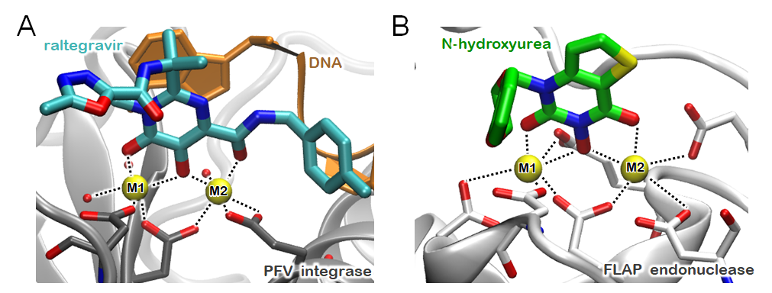

Figure 4. Binding of (A) raltegravir and (B) N-hydroxyurea inhibitors to the two catalytic Mg²⁺-ions of Prototype Foamy Virus used as a proxy of Integrase enzyme (PDB ID 3OYA)¹⁵⁵ and human Flap endonuclease enzyme (PDB ID 5FV7),¹⁵⁸ respectively. The enzymes are shown in gray new cartoons, while the residues forming the coordination spheres are reported in gray licorice. DNA is shown as orange ribbon and the two Mg²⁺-ions are shown as yellow van der Waals spheres.

As well, the RT promotes the reverse transcription of viral genetic material (RNA) into double-stranded DNA. The reaction mechanism has been investigated by a semiempirical QM(AM1)/MM and QM(PM3)/MM studies.^{159,160} This latter, based on umbrella sampling simulations, assessed that the Asp185, acts as general base of the catalytic process, deprotonating the nucleophile via a ΔG# of 15.0 kcal mol⁻¹, while DNA polymerization occurs with an overall ΔG# of 18.4 kcal mol⁻¹.¹⁶⁰ Interestingly, multicopy MD simulations elucidated the mechanism by which a non-competitive inhibitor modulates RT catalysis. This study showed that the main effect of this type of inhibitors was to constrain a rigid-body motion between critical subdomains of the RT enzyme by acting as “molecular wedge”.²⁷

3.2.1.2 Influenza Virus and Severe Acute Respiratory Syndrome Coronavirus 2 (SARS-CoV-2)
The influenza virus is a respiratory pathogen responsible for seasonal illnesses, causing mortality among high-risk individuals. Its RNA polymerase enzyme, composed by three domains (PA_{N}, PB1, and PB2), promotes the replication of the viral genome. The metal-dependent PA_{N} endonuclease domain of the polymerase, highly conserved among various historic influenza strains, represents an attractive target for the development of antivirals. Its endonuclease activity is aided by a canonical two-Mg²⁺-architecture, common to viral and eukaryotic nucleases,¹⁵¹ in which 5’-cap of a host mRNA is trapped by the PB2 domain and cleaved at the 8-14 nucleotide to serve as a primer for the viral RNA synthesis, which is, instead, promoted by the RNase PB1 domain. Among the selected antivirals, epigallocatechin, a major polyphenol component of green tea, has been shown to bind to PA_{N} by chelating the two Mg²⁺-ions.²

The interest for developing antivirals became a burgeoning research field in the last year due to the current (SARS-CoV-2) pandemic. This prompted unprecedented research efforts to unlock the molecular mechanism of the viral infection and to design strategies able to prevent and ameliorate the coronavirus disease 19 (COVID-19)-induced morbidity and mortality. Although most of the studies were focused on understanding the mechanism underlying the molecular recognition and binding of the viral particle to with its human receptor,^{68,161,162} and on the catalytic and inhibition mechanism of its main proteases,^{163,164} few studies focused on the inhibition of Mg²⁺-dependent enzymes.¹⁶⁵

A recent MD and QM/MM simulations study addressed the molecular mechanism of RNA dependent RNA polymerases (RdRp) of SARS-CoV-2, gathering a first picture of the reaction and inhibition mechanism of this enzyme. RdRp consists of three non-structural protein (nsp) subunits, the catalytic one nsp12 and the two accessory subunits nsp8 and nsp7. RdRp promotes the RNA-dependent elongation by which the 3ʹ-terminal nucleotide of the RNA product chain residues binds an incoming nucleoside triphosphate.¹⁶⁶ This QM/MM study disclosed that RdRp follows a mechanism similar to other viral or human polymerases, with the transferred phosphate being stabilized by two Mg²⁺-ions. The incorporation of the incoming nucleotide requires a ΔG# of 15.8 kcal mol⁻¹ and is exothermic by 5 kcal mol⁻¹. Conversely, the inhibition of RdRp was studied with the nucleoside analogue of remdesivir, the only FDA-approved drug so far for the treatment of COVID-19 patients.¹⁶⁷ This study revealed that remdesivir triphosphate (the active form of the drug) is incorporated into the nascent RNA, leading to a very similar RNA duplex to the canonical one. Its incorporation into the nascent viral RNA strand requires only a slighter higher ΔG# of 17.4 kcal mol⁻¹ as compared to the natural substrate. The similar ΔG# for inhibitor crosslinking and substrate polymerization suggest a competition between the two processes (Figure 5).¹⁶⁶
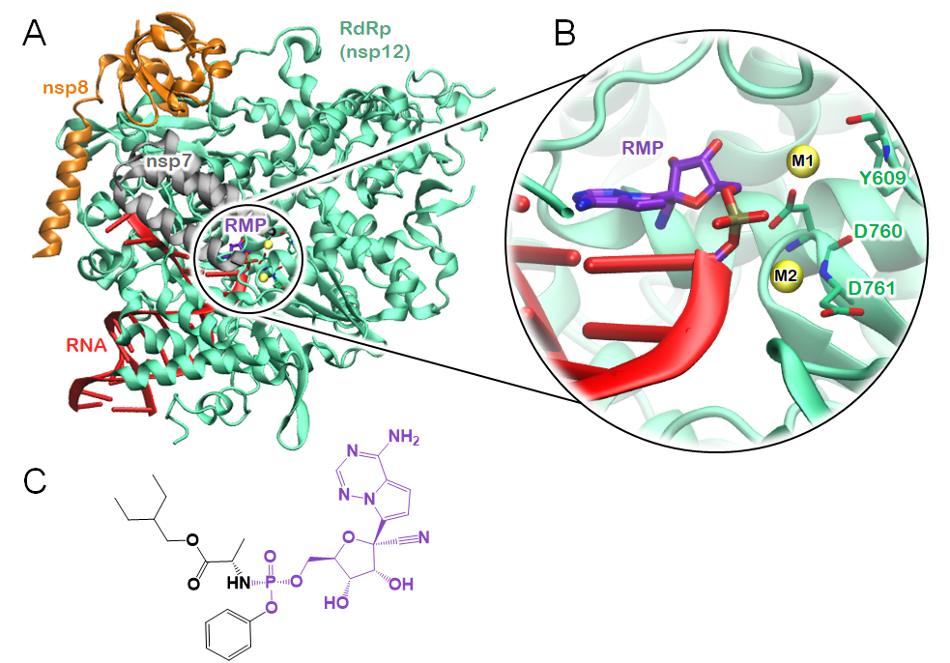
Figure 5. Model of the viral RNA-dependent RNA polymerase (RdRp) enzyme of SARS-CoV-2, a target of the antiviral drug remdesivir (remdesivir monophosphate, RMP) (PDB ID 7BV2).¹⁶⁸ (A) Proteins of the RdRp complex nsp12 (green), nsp7 (gray), nsp8 (orange), and primer and template RNA filaments (red) are depicted as cartoons, the Mg²⁺-ions are represented as yellow van der Waals spheres, and RMP as violet sticks. (B) Inset of the catalytic/remdesivir binding site featuring the Mg²⁺-ions, labelled as M1 and M2, the RNA strands, the RdRp residues coordinating the metal ions (Y609, D760 and D761), and covalently bound RMP. (C) Sketch of the remdesivir inhibitor prior to its conversion to remdesivir trinucleotide. In violet is shown the remdesivir monophosphate part that remains bound to the RNA strand.

3.2.2 Human Mg²⁺-dependent enzymes metabolizing DNA and precursor messenger RNA

3.2.2.1 Human flap endonucleases

The human Flap endonuclease 1 (hFEN1) enzyme spans the cellular pathways involved in DNA replication and genome maintenance. It promotes the excision of 5’-small DNA/RNA strand fragments (referred as flaps) on the lagging strand of DNA during replication or during the long-path base excision repair process. A semiempirical QM(AM1/dPhoT)/MM MD study, combined with enhanced sampling simulations, revealed that the rate determining step of the catalytic mechanism (ΔF# value of 16 ± 2 kcal mol⁻¹) is the nucleophilic attack of a water molecules, occurring simultaneously with its deprotonation co-adjuvated by a phosphate flanking the scissile phosphate, similarly to the mechanism observed in other RNase enzymes.⁷⁹

Given its critical replicative function, hFEN1 is overexpressed in multiple cancers, thus being a biomarker for cancer prognosis and progression, and a potential therapeutic target. High throughput VS experiments lead to the discovery of an N-hydroxyurea based series of hFEN1 inhibitors able to inhibit the enzyme by chelating the Mg²⁺-ions, similarly to raltegravir (Figure 4B).¹⁵⁸ In spite of its importance, this field of research has been largely overlooked by computational studies.

3.2.2.2 Metabolism of precursor messenger RNA by the spliceosome

In eukaryotic cells, the newly transcribed precursor messenger RNA (pre-mRNA) is transformed into mature mRNA. During this process, known as splicing, the introns (the non-coding regions) have to be removed and the exons (the coding regions) have to be joined together before protein translation can take place.^{169,170} This process in eukaryotes is carried out by the spliceosome (SPL), a macromolecular engine composed by 100s of proteins and 5 filaments of RNA, which precisely promotes pre-mRNA splicing aided by two Mg²⁺-ions. SPL ensures splicing fidelity,¹⁷¹ thanks to the relentless, timely coordinated movements and association/dissociation of specific splicing factors, fueled by the hydrolysis of ATP molecules. Splicing plays a central role in gene expression and diversification, and its deregulation or the mutations of specific components of the SPL (splicing factors), or pre-mRNA are entwined with a wide variety of distinct pathological states, including several cancer types and neurodegeneration.¹⁷² The SPL acts as a protein-directed metallo-ribozyme where two Mg²⁺-ions promote pre-mRNA splicing in two steps. In the first, the 2'OH of the specific nucleotide located in the intron attacks the phosphate at the 5'-splice site of 5’-exon, whereas the second splicing step entails the attack of the 3'-OH of the 5'-exon at the 3'-splice site, thus joining exons and releasing free intron-lariat (Figure 6).

Due to the complexity of the machinery and the lack of the structural information at the atomic-level resolution, the splicing reaction was first elucidated in the group II intron ribozyme, a SPL ancestor, by QM/MM MD simulations in combination with thermodynamic integration¹⁷³ and later, confirmed by the first QM/MM study done on a cryo-EM SPL structures of the C complex from the yeast Saccharomyces cerevisiae.¹⁷⁴ Both studies revealed an uncommon dissociative two-Mg²⁺ ions-aided mechanism, in which the breaking of the substrate bond occurs prior to the bond formation with the nucleophile.

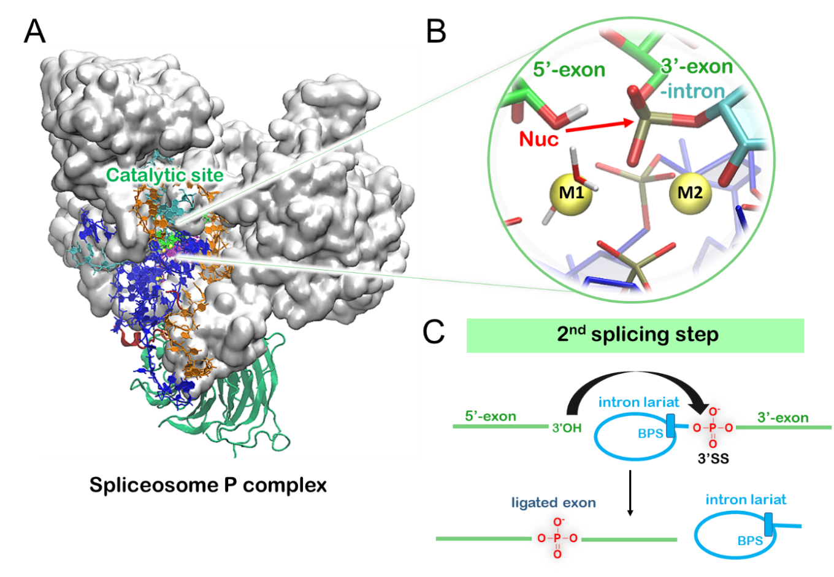
Figure 6. Second splicing step of the spliceosome studied by QM/MM MD simulations. (A) Spliceosome P complex model build on yeast cryo-EM structure (pdb ID 5YLZ)¹⁷⁵ comprising proteins (gray surface) and RNA filaments (blue and orange new cartoons). (B) Molecular representation of the catalytic site with red arrow indicating the nucleophilic attack. M1 and M2 Mg²⁺-ions are represented as yellow van der Waals spheres. (C) Schematic representation of the second splicing step, in which nucleophilic 3’-OH at the 3’-end of the 5’-exon attacks the phosphate at the 5’-end of the 3’-exon, resulting in ligated exon and intron lariat. BPS denotes branch point site. Adapted with permission from ref¹⁷⁶ Copyright ACS 2020.

More recently, building on the structure of P complex from Saccharomyces cerevisiae,¹⁷⁵ the second exon-ligation step was also addressed by QM/MM MD studies showing that the reaction takes place via an associative two-Mg²⁺-ions mechanism, featuring a direct proton transfer from the nucleophile to the leaving group, mediated by the scissile phosphate (Figure 6).¹⁷⁶ In both studies, only the RNA strand, supported by the two metal ions, directly promoted catalysis, thus enforcing the notion of the SPL acting as a protein-directed metallo-ribozyme.

Splicing enables the production of a variety of transcripts that can code for proteins with different and sometimes opposite functions, so their deregulation can lead to different pathological states. In such a case, small-molecule splicing modulators (SM) can amend erroneous splicing and, thus, act as a potential therapeutic approach to many hematological cancers.¹⁷⁷ Due to the complexity of the machinery, no inhibitor directly targeting the Mg²⁺-aided catalytic core has been hitherto identified. Research efforts have been mostly devoted to the SPL multi-protein complex SF3b, which hosts SF3B1 and is endowed with frequent cancer mutations associated with hematological malignancies.¹⁷⁸ SF3b is entailed in the recognition of the branch point adenosine (BPA), one of the key intronic sequences, which have to be precisely selected in order to perform faithful splicing. SF3b is also the target of known SMs belonging to the spliceostatin, herboxidiene and pladienolide family (Figure 7), initially discovered as natural products and later chemically optimized with the most promising compound, named as H3B-8800, entering clinical trials.^{179,180}
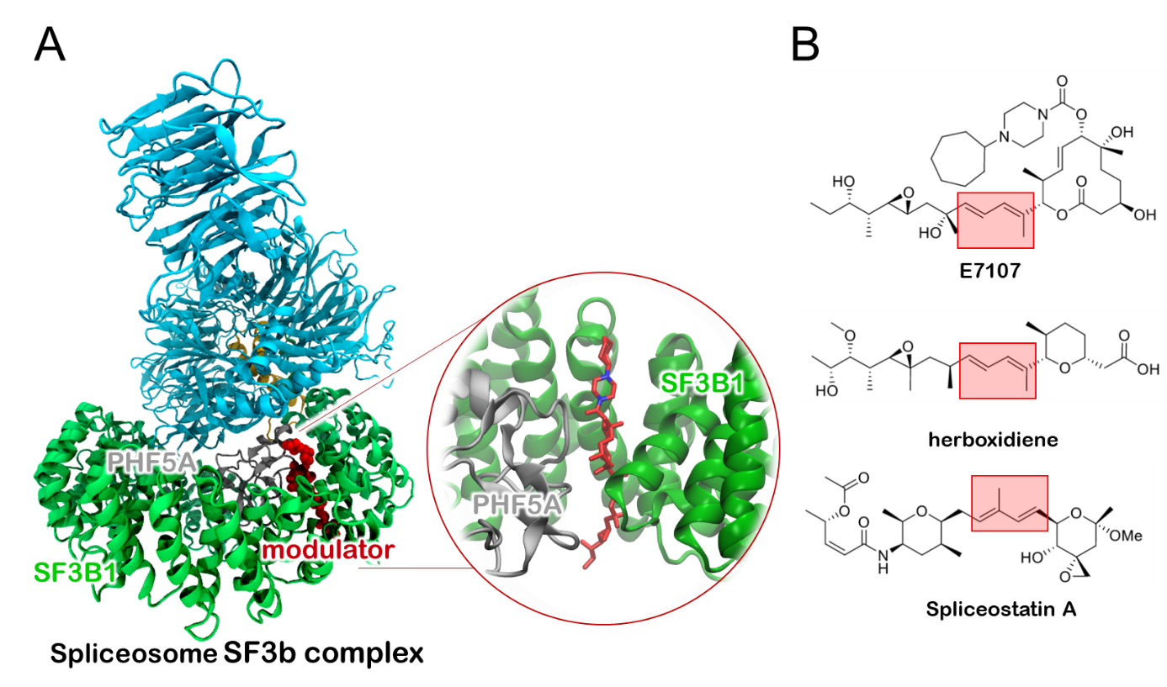
Figure 7. Splicing modulators acting at the SF3B1/PHF5A interface of the SF3b complex. (A) Model of the SF3b spliceosome system build on the human cryo-EM structure (PDB ID 5ZYA)¹⁸¹ consisting of four proteins in complex with the splicing inhibitor E7107 (red) with zoom-in inset of the modulator binding site. (B) Structures with the highlighted crucial diene motif of the splicing modulators E7107, herboxidiene, and Spliceostatin A. Adapted with permission from ref¹⁸² Copyright ACS 2019.

In this respect, a MD simulation study of splicing inhibitors, based on the structural information obtained from cryo-EM data of the human SF3b protein complex with SM pladienolide type inhibitor E7017,¹⁸¹ assessed the dynamic behavior of selected SMs binding the SF3B1/PHF5A proteins interface further supporting the notion that SMs’ action, in addition to competitive inhibition, also impact the functional dynamics of SF3B1. These simulations contributed to elucidate the modulation mechanism of SF3b by SMs, setting the basis for the rational-based discovery of drugs tackling diseases caused by dysregulated splicing.¹⁸² The complexity of the machineries and of the collective motions, underlying the recognition of key intronic sequences and instrumental to remodel these sequences to perform the splicing reactions, opens new avenues to modulate the SPL dynamic by targeting key allosteric pockets located along critical signaling pathways with small molecules.¹⁸³

3.3 Metal homeostasis
Sophisticated and meticulous mechanisms orchestrate the maintenance of a dynamic equilibrium of metal availability, while protecting cells against metal-induced toxicity. As an example, the concentration of free metal ions in Salmonella cells is stringently regulated to 10⁻⁶ M for Mn²⁺, 10⁻¹² M for Zn²⁺ and 10⁻¹⁸ M for Cu²⁺.⁵ When cells depart from their comfort zone of metal availability, windows of therapeutic opportunities open. Metal homeostasis may, indeed, be manipulated by restoring the opportune amount of in-cell available metal ions with ionophores or by decreasing their concentration with the addition of metal-chelators. A brand new emerging therapeutic strategy relies, instead, on taking advantage of the vulnerabilities offered by metal dyshomeostasis to trigger death in harmful cells, such as cancer cells and pathogenic microbes.⁵ The potential of sabotaging Cu homeostasis against cancer has been recently demonstrated as a compelling strategy.³⁴ Nevertheless, the discovery of drugs exploiting transition metal dyshomeostasis against harmful cells, without jeopardizing healthy cells, requires a detailed knowledge of the underlying metal-trafficking paths. Among the different metal ions, the Cu-trafficking routes appear as the most characterized by experimental and computational means.¹⁸⁴ For this reason, in the following section we review selected mechanistic aspects of the Cu(I)-trafficking route.

3.3.1 Cu(I) internalization by Ctr1
Copper transporter 1 (Ctr1) is an entrance point of Cu(I) into the cell. The recently solved X-ray crystallographic structure of Ctr1 disclosed that the channel contains three transmembrane domains in a 3-helix bundle fold arranged into a homotrimer with a central channel (Figure 8).¹⁸⁵ The extracellular N-terminal region is responsible for catching the Cu(II) ion from the extracellular space and for facilitating its reduction into Cu(I).¹⁸⁶ The central transmembrane part contains the filtration layer composed of two methionine triads, which selectively recruit and transport the Cu(I) ion into the cell. The disordered intracellular part of Ctr1 is, instead, responsible for transferring Cu(I) from Ctr1 to Atox1.¹⁸⁷

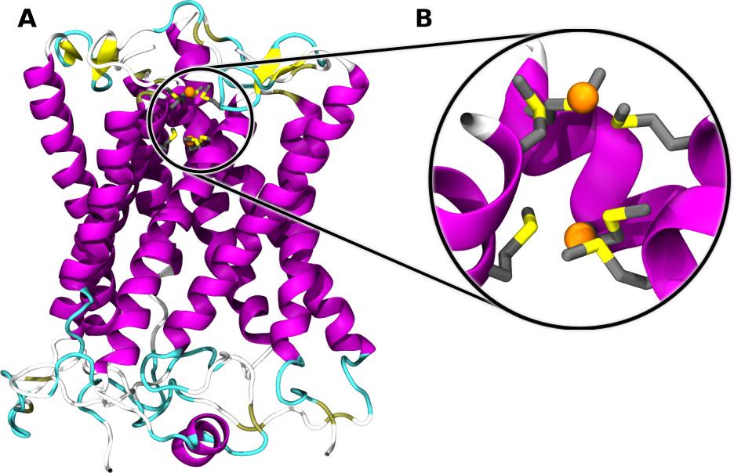
Figure 8. Structure of Ctr1 channel along with an inset of the metal binding site of Cu(I) (PDB ID: 6M98).¹⁸⁵ The protein is shown as magenta ribbons, the Cu(I) ions are depicted as orange van der Waals spheres and the methionine binding the metals are shown in licorice.

The potential of Ctr1 as a drug target has been confirmed by a study in which reducing Ctr1 expression levels with siRNA interference inhibited tumor angiogenesis,¹⁸⁸ but, so far, no small-molecules inhibitors targeting Ctr1 have been developed. The striking importance of Ctr1 is also remarked by its involvement in the uptake of platinum (Pt) drugs, such as cisplatin¹⁸⁹ and by the fact that Cu(I) selectivity of Ctr1 can be exploited for radio-imagining purposes using the radioactive ⁶⁴Cu(I) isotope as a marker for hypoxia, which is indicative of malignant tumors.¹⁹⁰ In spite of the importance of Ctr1 as the main route of Cu(I) internalization and its strong entwinement with the onset of major diseases, the molecular mechanism of Cu(I) transport has not yet been computationally addressed.

3.3.2 Cu(I) transport from Atox1 to ATP7a/b
After Cu(I) internalization by Ctr1, specific chaperones deliver the metal to the appropriate cellular pathways. Among the different chaperones, in the Golgi Apparatus the Atox1 one transfers Cu(I) to the ATPases ATP7a and ATP7b. These, in turn, deliver Cu(I) to the secretory pathway for metalation of cuproenzymes and export excess Cu(I) out of the cell, respectively. Somatic mutations of ATP7a and ATP7b proteins alter normal Cu(I) metabolism, triggering distinct human pathologies such as Menkes and Wilson's disease (MD and WD, respectively). Conversely, the chaperones CCS and Cox17 are required for Cu(I) incorporation into Cu/Zn superoxide dismutase and for its delivery to cytochrome c oxidase, respectively.¹⁸⁴ Here, we focus on the first route since it is the most characterized path at the computational level. EPR experiments, along with by hybrid QM/MM MD simulations using a semiempirical DFT approach for copper, allowed a better understanding of Cu(I) binding to dimeric Atox1. This study disclosed that, the coordination mode of Cu(I) to Atox1 depends on the Atox1 conformations, which exist in equilibrium between an open and a closed state. Namely, when Cu(I) binds to the closed Atox1 dimer the metal flips between three- and four-coordinated sulfur-Cu(I) states, whereas, when Cu(I) binds to the open Atox1 state, it exists in an equilibrium of two- and three-coordinated states.¹⁹¹

After having received Cu(I) from Ctr1 in its dimeric state, monomeric Atox1 interacts with the N-terminal domain of ATP7a/b, which contains six metal-binding domains (MBDs) connected by linkers. Each MBD has a similar fold and a conserved metal-binding motif MXCXXC (X stands for any amino acid). The high structural similarity between the Atox1 and the target proteins is a hallmark of Cu(I)-transporters. The transfer mechanism of Cu(I) from monomeric Atox1 to the ATP7b is believed to involve the MBD3 or 4 of the latter. The Lys60 plays an important role in the formation of the Atox1/MBD4 complex as observed in the crystal structures¹⁹² and in a mutational study.¹⁹³ Recent EPR/MD studies suggested that Atox1 preferentially forms a heterodimer with MBD4 with respect to MBD3 and that the resulting adduct is stabilized by metal-mediated protein-protein interactions.^{194,195} Nevertheless, the chemical mechanism of Cu(I) transfer between Atox1 and MBD4 remains hitherto elusive. Several studies considered that transport can occur via the formation of bi-, tri- and/or tetracoordinated Cu(I) intermediate complexes (Figure 9).
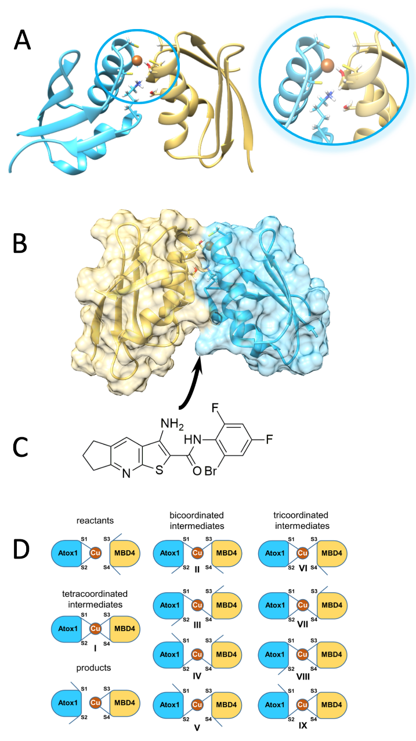
Figure 9. (A) Cu(I) coordination by two Atox1 monomers based on the crystal structure (PDB ID 1FEE).¹⁹⁶ One monomer is shown in turquoise and the other in gold. Sulphur atoms are colored in yellow, nitrogen in blue, copper in brown, and hydrogens in white. (B) Surface view of the Atox1/MDB4 adduct shown with the same color code. (C) Sketch of the DC_AC50 inhibitor that binds at the proteins interface. (D) Reactants, products, and all theoretically possible intermediates in the Cu(I) transport from Atox1 to MBD4 of Atp7b. S1 and S2 correspond to SG@Cys12 and SG@Cys15 of Atox1, while S3 and S4 correspond to SG@Cys370 and SG@Cys373 of MBD4 of Atp7b.

The first mechanism of Cu(I) transfer from Atox1 to the MBD of Atp7b was proposed on the basis of the crystal structure of the Cu(I) bound Atox1 dimer (PDB code: 1FEE).¹⁹⁶ This structure shows that not all four Cu(I)-S@Cys distances are of equal length, with three of them having length of 2.3 Å, similar to the distance observed in mononuclear and polynuclear tricoordinated Cu(I)-thiolate model complexes, while the fourth distance, exhibiting value of 2.4 Å, is outside of the primary binding distance for known Cu(I) complexes. This suggests that the Cu(I) transfer mechanism must pass through the formation of an at-most tricoordinated intermediate (Figure 9). This was followed by computational studies, based on QM and classical MD simulations, which have addressed the transfer of Cu(I) between Atox1 and MBD of ATP7a. Here, the existence of a tetra-coordinated intermediate complex was ruled out as energetically unfavorable,¹⁹⁷ suggesting a two-steps mechanism of Cu(I) transport taking place via two tricoordinated intermediate complexes (VII and IX, Figure 9D). The same problem was more extensively addressed by Rodriguez-Granillo et al. who studied with QM/MM simulations all possible bi-, tri-, and tetracoordinated intermediate complexes, reactants, and products for Cu(I) transfer from Atox1 to MBD4 of ATP7b.¹⁹⁸ This study excluded again the formation of bi- and tetracoordinated complexes. In the first step, a tricoordinated complex is formed in a barrierless process (VI; complex VII was not obtained in the simulations), while the second step leads to a second tricoordinated complex (VIII) with a ΔE# of 9.5 kcal mol⁻¹. Since the calculated ΔE for the transport process resulted to be endergonic by +7.7 kcal mol⁻¹, the authors suggested that other factors (e.g. ATP hydrolysis) must ensure the direction Cu(I) transfer in vivo.

The relevance of copper ions metabolism in cancer has been recently proved by distinct studies.³⁴ Cancer cells are known to accumulate copper ions beyond the needs of healthy cells. Indeed, Atox1 has been demonstrated to be upregulated in breast cancer. Stunningly, Atox1 silencing reduced breast cell migration in vitro,¹⁹⁹ while its inhibition by small molecules was demonstrated to be effective in breast, lung, leukemia, head, and neck cancer cells in vitro and in mouse xenograft model.³⁴ This was achieved via a SBVS study on Atox1 and CCS, leading to the DC_AC50 inhibitor (Figure 9C), which binds at the Atox1/CCS interface with an affinity in the low μM, thus inhibiting cancer cell proliferation, while eliciting minimal effects to healthy cells. This set the basis for the potential of sabotaging metal-trafficking to selectively trigger cancer cells death.³⁵

4. Conclusion
This compendium encompasses an overview of the relevance of metal-binding proteins in drug design, highlighting traditional and emerging strategies to tackle diseases linked to enhanced function or mis-function of metal-binding proteins. We illustrate how the computational challenges imposed by metal ions compel the use of a hierarchical computational arsenal to bridge the gaps among the QM accuracy, needed to properly account for the metal-dependent electronic or chemical rearrangements, the need of accounting for the flexibility of metals and of protein/drug reciprocal adaptability, and the time-scales necessary to assess biologically relevant phenomena. All these are essential ingredients to decrypt the function and inhibition mechanism of metal-binding proteins at an atomic-level of detail.

By focusing on three main categories of proteins binding the highly abundant Fe^{2+/3+}, Cu^{2+/+} and Mg²⁺ metal ions, we exemplify how multiscale simulations have contributed to disentangle the intricacies of metal-aided catalysis and of metal-trafficking, as well as the mechanistic minutiae of the inhibitory strategies based on drugs engaging in coordination bonds to the metal(s),² or preventing functionally relevant motion/interactions of the metal-binding protein by targeting peripheral sites (non-competitive inhibition).²⁷ Among these strategies, compelling evidence emerged on the viability of triggering metal dyshomeostasis to elicit cell deaths in harmful cells. Small molecules able to alter metal-trafficking represent a nascent class of drug-candidates and open new opportunities to tackle unmet needs in anti-cancer therapies.³⁴ Nevertheless, taking advantage of the dyshomeostasis of transition metals, other than copper, may prove more difficult as their trafficking routes are often intertwined and may, therefore, lead to selectivity problems and unpredictable side effects.³⁵ Ostensibly, bringing this opportunity to fruition depends on a detailed atomic-level understanding of the molecular basis of metals trafficking/transport mechanisms and routes.

As well, the growing structural information provided by single particle cryo-EM enables the study of majestic molecular machineries, in which the modulation of the metal-dependent functions by targeting an allosteric site may become a popular and viable approach to identify selective inhibitors for challenging targets. Due to the development of more accurate and faster computational techniques, and the constant increase in the power and performance of modern computational platforms, we unreservedly expect that an increasing contribution of all-atom simulations to this niche of medicinal chemistry will further accelerate discoveries that will markedly improve human health conditions.

Acknowledgements
AS was supported by a FIRC-AIRC “Mario e Valeria Rindi” fellowship for Italy. AM thanks the financial support of the Italian Association for Cancer Research (AIRC) (IG grant 24514) and of the project ‘Against bRain cancEr: finding personalized therapies with in Silico and in vitro strategies‘(ARES) CUP: D93D19000020007 POR FESR 2014 2020 - 1.3.b - Friuli Venezia Giulia.

References
[1] V. Putignano, A. Rosato, L. Banci, C. Andreini, Nucleic Acids Res. 2018, 46, D459-D464.
[2] A. Y. Chen, R. N. Adamek, B. L. Dick, C. V. Credille, C. N. Morrison, S. M. Cohen, Chem. Rev. 2019, 119, 1323-1455.
[3] L. Casalino, A. Magistrato, Inorg. Chim. Acta 2016, 452, 73-81.
[4] J. Liu, S. Chakraborty, P. Hosseinzadeh, Y. Yu, S. Tian, I. Petrik, A. Bhagi, Y. Lu, Chem. Rev. 2014, 114, 4366-4469.
[5] E. W. Hunsaker, K. J. Franz, Inorg. Chem. 2019, 58, 13528-13545.
[6] M. Cassandri, A. Smirnov, F. Novelli, C. Pitolli, M. Agostini, M. Malewicz, G. Melino, G. Raschella, Cell Death Discov. 2017, 3, 17071.
[7] M. D. M. Maldonado, S. Dharmawardhane, Cancer Res. 2018, 78, 3101-3111.
[8] Y. Li, F. Wang, X. Chen, J. Wang, Y. Zhao, Y. Li, B. He, Curr. Top. Med. Chem. 2019, 19, 223-241.
[9] A. T. Negmeldin, G. Padige, A. V. Bieliauskas, M. K. Pflum, ACS Med. Chem. Lett. 2017, 8, 281-286.
[10] C. T. Supuran, A. Scozzafava, A. Casini, Med. Res. Rev. 2003, 23, 146-189.
[11] I. Derad, A. Dendorfer, P. Dominiak, H. L. Fehm, J. Born, Am. J. Hypertens. 1998, 11, 1290-1296.
[12] N. T. Ross, F. Lohmann, S. Carbonneau, A. Fazal, W. A. Weihofen, S. Gleim, M. Salcius, F. Sigoillot, M. Henault, S. H. Carl, J. B. Rodriguez-Molina, H. R. Miller, S. M. Brittain, J. Murphy, M. Zambrowski, G. Boynton, Y. Wang, A. Chen, G. J. Molind, J. H. Wilbertz, C. G. Artus-Revel, M. Jia, F. A. Akinjiyan, J. Turner, J. Knehr, W. Carbone, S. Schuierer, J. S. Reece-Hoyes, K. Xie, C. Saran, E. T. Williams, G. Roma, M. Spencer, J. Jenkins, E. L. George, J. R. Thomas, G. Michaud, M. Schirle, J. Tallarico, L. A. Passmore, J. A. Chao, R. E. J. Beckwith, Nat. Chem. Biol. 2020, 16, 50-59.
[13] E. Sonoiki, C. L. Ng, M. C. Lee, D. Guo, Y. K. Zhang, Y. Zhou, M. R. Alley, V. Ahyong, L. M. Sanz, M. J. Lafuente-Monasterio, C. Dong, P. G. Schupp, J. Gut, J. Legac, R. A. Cooper, F. J. Gamo, J. DeRisi, Y. R. Freund, D. A. Fidock, P. J. Rosenthal, Nat. Commun. 2017, 8, 14574.
[14] J. Kakegawa, N. Sakane, K. Suzuki, T. Yoshida, Biochem. Biophys. Res. Commun. 2019, 518, 32-37.
[15] F. Simona, A. Magistrato, D. M. Vera, G. Garau, A. J. Vila, P. Carloni, Proteins 2007, 69, 595-605.
[16] H. Park, E. N. Brothers, K. M. Merz, Jr., J. Am. Chem. Soc. 2005, 127, 4232-4241.
[17] M. Dal Peraro, A. J. Vila, P. Carloni, M. L. Klein, J. Am. Chem. Soc. 2007, 129, 2808-2816.
[18] K. Zhu, J. Lu, Z. Liang, X. Kong, F. Ye, L. Jin, H. Geng, Y. Chen, M. Zheng, H. Jiang, J. Q. Li, C. Luo, J. Comput. Aided Mol. Des. 2013, 27, 247-256.
[19] F. Simona, A. Magistrato, M. Dal Peraro, A. Cavalli, A. J. Vila, P. Carloni, J. Biol. Chem. 2009, 284, 28164-28171.
[20] M. N. Lisa, A. R. Palacios, M. Aitha, M. M. Gonzalez, D. M. Moreno, M. W. Crowder, R. A. Bonomo, J. Spencer, D. L. Tierney, L. I. Llarrull, A. J. Vila, Nat. Commun. 2017, 8, 538.
[21] P. Hinchliffe, M. M. Gonzalez, M. F. Mojica, J. M. Gonzalez, V. Castillo, C. Saiz, M. Kosmopoulou, C. L. Tooke, L. I. Llarrull, G. Mahler, R. A. Bonomo, A. J. Vila, J. Spencer, Proc Natl Acad Sci U S A 2016, 113, E3745-3754.
[22] R. Hong, A. Magistrato, P. Carloni, J. Chem. Theory Comput. 2008, 4, 1745-1756.
[23] C. R. Smith, G. K. Smith, Z. X. Yang, D. G. Xu, H. Guo, Theor. Chem. Acc. 2011, 128, 83-90.
[24] N. Mast, A. Saadane, A. Valencia-Olvera, J. Constans, E. Maxfield, H. Arakawa, Y. Li, G. Landreth, I. A. Pikuleva, Neuropharmacology 2017, 123, 465-476.
[25] N. Mast, M. Linger, M. Clark, J. Wiseman, C. D. Stout, I. A. Pikuleva, Mol. Pharmacol. 2012, 82, 824-834.
[26] A. Spinello, I. Ritacco, A. Magistrato, Catalysts 2019, 9, 81.
[27] A. Ivetac, J. A. McCammon, J. Mol. Biol. 2009, 388, 644-658.
[28] A. Spinello, S. Martini, F. Berti, M. Pennati, M. Pavlin, J. Sgrignani, G. Grazioso, G. Colombo, N. Zaffaroni, A. Magistrato, Eur. J. Med. Chem. 2019, 168, 253-262.
[29] F. Musiani, B. Bertosa, A. Magistrato, B. Zambelli, P. Turano, V. Losasso, C. Micheletti, S. Ciurli, P. Carloni, J. Chem. Theory Comput. 2010, 6, 3503-3515.
[30] D. Sala, F. Musiani, A. Rosato, Eur J Inorg Chem 2018, 4661-4677.
[31] A. Spinello, R. Bonsignore, G. Barone, B. K. Keppler, A. Terenzi, Curr. Pharm. Des. 2016, 22, 3996-4010.
[32] M. Innocenti, E. Salvietti, M. Guidotti, A. Casini, S. Bellandi, M. L. Foresti, C. Gabbiani, A. Pozzi, P. Zatta, L. Messori, J. Alzheimers Dis. 2010, 19, 1323-1329.
[33] A. L. Turcu, A. Versini, N. Khene, C. Gaillet, T. Caneque, S. Muller, R. Rodriguez, Chemistry 2020, 26, 7369-7373.
[34] J. Wang, C. Luo, C. L. Shan, Q. C. You, J. Y. Lu, S. N. Elf, Y. Zhou, Y. Wen, J. L. Vinkenborg, J. Fan, H. B. Kang, R. T. Lin, D. L. Han, Y. X. Xie, J. Karpus, S. J. Chen, S. S. Ouyang, C. H. Luan, N. X. Zhang, H. Ding, M. Merkx, H. Liu, J. Chen, H. L. Jiang, C. He, Nat Chem 2015, 7, 968-979.
[35] C. M. Weekley, C. He, Curr. Opin. Chem. Biol. 2017, 37, 26-32.
[36] J. Adulcikas, S. Sonda, S. Norouzi, S. S. Sohal, S. Myers, Nutrients 2019, 11.
[37] S. A. Hollingsworth, R. O. Dror, Neuron 2018, 99, 1129-1143.
[38] M. Karplus, J. A. McCammon, Nat. Struct. Biol. 2002, 9, 646-652.
[39] L. Casalino, G. Palermo, N. Abdurakhmonova, U. Rothlisberger, A. Magistrato, J. Chem. Theory Comput. 2017, 13, 340-352.
[40] P. Li, K. M. Merz, Jr., Chem. Rev. 2017, 117, 1564-1686.
[41] P. Li, K. M. Merz, Jr., J. Chem. Theory Comput. 2014, 10, 289-297.
[42] P. Oelschlaeger, M. Klahn, W. A. Beard, S. H. Wilson, A. Warshel, J. Mol. Biol. 2007, 366, 687-701.
[43] F. Duarte, P. Bauer, A. Barrozo, B. A. Amrein, M. Purg, J. Aqvist, S. C. Kamerlin, J. Phys. Chem. B 2014, 118, 4351-4362.
[44] J. Sgrignani, A. Magistrato, J. Phys. Chem. B 2012, 116, 2259-2268.
[45] P. Li, K. M. Merz, Jr., J. Chem. Inf. Model. 2016, 56, 599-604.
[46] K. Spiegel, A. Magistrato, P. Maurer, P. Ruggerone, U. Rothlisberger, P. Carloni, J. Reedijk, M. L. Klein, J. Comput. Chem. 2008, 29, 38-49.
[47] P. Campomanes, U. Rothlisberger, M. Alfonso-Prieto, C. Rovira, J. Am. Chem. Soc. 2015, 137, 11170-11178.
[48] G. Palermo, A. Spinello, A. Saha, A. Magistrato, Expert Opin. Drug Dis. 2020, DOI: 10.1080/17460441.2021.1851188.
[49] E. Brunk, U. Rothlisberger, Chem. Rev. 2015, 115, 6217-6263.
[50] P. Vidossich, A. Magistrato, Biomolecules 2014, 4, 616-645.
[51] P. Janos, A. Spinello, A. Magistrato, Curr. Opin. Chem. Biol. 2020, 61, 1-8.
[52] J. Sgrignani, L. Casalino, F. Doro, A. Spinello, A. Magistrato, Future Med. Chem. 2019, 11, 771-791.
[53] C. J. Cramer, D. G. Truhlar, Phys. Chem. Chem. Phys. 2009, 11, 10757-10816.
[54] A. Laio, M. Parrinello, Proc Natl Acad Sci U S A 2002, 99, 12562-12566.
[55] Y. Miao, J. A. McCammon, Mol. Simul. 2016, 42, 1046-1055.
[56] P. G. Bolhuis, D. Chandler, C. Dellago, P. L. Geissler, Annu. Rev. Phys. Chem. 2002, 53, 291-318.
[57] M. De Vivo, M. Masetti, G. Bottegoni, A. Cavalli, J. Med. Chem. 2016, 59, 4035-4061.
[58] D. Wragg, A. de Almeida, R. Bonsignore, F. E. Kuhn, S. Leoni, A. Casini, Angew Chem Int Ed Engl 2018, 57, 14524-14528.
[59] D. Franco, A. V. Vargiu, A. Magistrato, Inorg. Chem. 2014, 53, 7999-8008.
[60] A. Biancardi, A. Burgalassi, A. Terenzi, A. Spinello, G. Barone, T. Biver, B. Mennucci, Chemistry 2014, 20, 7439-7447.
[61] D. Wragg, A. de Almeida, A. Casini, S. Leoni, Chemistry 2019, 25, 8713-8718.
[62] R. Bonsignore, F. Russo, A. Terenzi, A. Spinello, A. Lauria, G. Gennaro, A. M. Almerico, B. K. Keppler, G. Barone, J. Inorg. Biochem. 2018, 178, 106-114.
[63] M. Turner, S. T. Mutter, J. A. Platts, J. Biomol. Struct. Dyn. 2019, 37, 4590-4600.
[64] A. Spinello, A. de Almeida, A. Casini, G. Barone, J. Inorg. Biochem. 2016, 160, 78-84.
[65] J. Park, L. Czapla, R. E. Amaro, J. Chem. Inf. Model. 2013, 53, 2047-2056.
[66] I. Bisha, A. Rodriguez, A. Laio, A. Magistrato, PLoS Comput. Biol. 2014, 10, e1004017.
[67] J. D. Durrant, J. A. McCammon, BMC Biol. 2011, 9, 71.
[68] L. Casalino, Z. Gaieb, J. A. Goldsmith, C. K. Hjorth, A. C. Dommer, A. M. Harbison, C. A. Fogarty, E. P. Barros, B. C. Taylor, J. S. McLellan, E. Fadda, R. E. Amaro, ACS Cent. Sci. 2020, 6, 1722-1734.
[69] L. Casalino, G. Palermo, A. Spinello, U. Rothlisberger, A. Magistrato, Proc Natl Acad Sci U S A 2018, 115, 6584-6589.
[70] H. Yalinca, C. J. C. Gehin, V. Oleinikovas, H. A. Lashuel, F. L. Gervasio, A. Pastore, Front. Mol. Biosci. 2019, 6, 95.
[71] I. Ritacco, A. Spinello, E. Ippoliti, A. Magistrato, J. Chem. Inf. Model. 2019, 59, 2930-2940.
[72] Y. Karami, T. Bitard-Feildel, E. Laine, A. Carbone, Sci. Rep. 2018, 8, 16126.
[73] J. Borisek, A. Saltalamacchia, A. Galli, G. Palermo, E. Molteni, L. Malcovati, A. Magistrato, Biomolecules 2019, 9, 633.
[74] A. C. Pan, D. Jacobson, K. Yatsenko, D. Sritharan, T. M. Weinreich, D. E. Shaw, Proc Natl Acad Sci U S A 2019, 116, 4244-4249.
[75] A. Spinello, E. Vecile, A. Abbate, A. Dobrina, A. Magistrato, J Chem Inf Model 2019, 59, 351-359.
[76] V. Genna, M. Marcia, M. De Vivo, J. Am. Chem. Soc. 2019, 141, 10770-10776.
[77] L. Casalino, L. Nierzwicki, M. Jinek, G. Palermo, ACS Catal. 2020, 10, 13596-13605.
[78] P. Piazzetta, T. Marino, N. Russo, Inorg. Chem. 2014, 53, 3488-3493.
[79] J. Sgrignani, A. Magistrato, ACS Catal. 2015, 5, 3864–3875.
[80] L. Pinzi, G. Rastelli, Int. J. Mol. Sci. 2019, 20, 4331.
[81] J. Sgrignani, A. Magistrato, Curr. Comput. Aided Drug Des. 2013, 9, 15-34.
[82] L. Riccardi, V. Genna, M. De Vivo, Nat. Rev. Chem. 2018, 2, 100-112.
[83] K. Raha, K. M. Merz, Jr., J. Am. Chem. Soc. 2004, 126, 1020-1021.
[84] A. E. Cho, D. Rinaldo, J. Comput. Chem. 2009, 30, 2609-2616.
[85] S. A. Hayik, R. Dunbrack, Jr., K. M. Merz, Jr., J. Chem. Theory Comput. 2010, 6, 3079-3091.
[86] P. Chaskar, V. Zoete, U. F. Rohrig, J. Chem. Inf. Model. 2014, 54, 3137-3152.
[87] A. Spinello, A. Magistrato, Expert Opin. Drug Discov. 2017, 12, 813-825.
[88] J. Iglesias, S. Saen-oon, R. Soliva, V. Guallar, WIREs Comput. Mol. Sci. 2018, 8, e1367.
[89] D. Gioia, M. Bertazzo, M. Recanatini, M. Masetti, A. Cavalli, Molecules 2017, 22, 2029.
[90] S. Rendic, F. P. Guengerich, Chem. Res. Toxicol. 2015, 28, 38-42.
[91] W. L. Miller, R. J. Auchus, Endocr. Rev. 2011, 32, 81-151.
[92] A. Spinello, I. Ritacco, A. Magistrato, Expert Opin. Drug Discov. 2019, 14, 1065-1076.
[93] J. T. Groves, G. A. McClusky, J. Am. Chem. Soc. 1976, 98, 859-861.
[94] S. D. Black, FASEB J 1992, 6, 680-685.
[95] C. Barnaba, K. Gentry, N. Sumangala, A. Ramamoorthy, F1000Res 2017, 6, 662.
[96] M. Srejber, V. Navratilova, M. Paloncyova, V. Bazgier, K. Berka, P. Anzenbacher, M. Otyepka, J. Inorg. Biochem. 2018, 183, 117-136.
[97] J. Sgrignani, A. Magistrato, J. Chem. Inf. Model. 2012, 52, 1595-1606.
[98] P. P. Tamburini, J. B. Schenkman, Mol. Pharmacol. 1986, 30, 178-185.
[99] I. Ritacco, A. Saltalamacchia, A. Spinello, E. Ippoliti, A. Magistrato, J. Phys. Chem. Lett. 2020, 11, 1189-1193.
[100] N. Strushkevich, F. MacKenzie, T. Cherkesova, I. Grabovec, S. Usanov, H. W. Park, Proc Natl Acad Sci U S A 2011, 108, 10139-10143.
[101] E. M. Petrunak, N. M. DeVore, P. R. Porubsky, E. E. Scott, J. Biol. Chem. 2014, 289, 32952-32964.
[102] D. Ghosh, J. Griswold, M. Erman, W. Pangborn, Nature 2009, 457, 219-223.
[103] E. R. Simpson, M. S. Mahendroo, G. D. Means, M. W. Kilgore, M. M. Hinshelwood, S. Graham-Lorence, B. Amarneh, Y. Ito, C. R. Fisher, M. D. Michael, et al., Endocr. Rev. 1994, 15, 342-355.
[104] J. Sgrignani, A. Cavalli, G. Colombo, A. Magistrato, Mini Rev. Med. Chem. 2016, 16, 1112-1124.
[105] J. C. Hackett, R. W. Brueggemeier, C. M. Hadad, J. Am. Chem. Soc. 2005, 127, 5224-5237.
[106] J. Sgrignani, M. Iannuzzi, A. Magistrato, J. Chem. Inf. Model. 2015, 55, 2218-2226.
[107] B. Kramos, J. Olah, J. Phys. Chem. B 2014, 118, 390-405.
[108] F. K. Yoshimoto, F. P. Guengerich, J. Am. Chem. Soc. 2014, 136, 15016-15025.
[109] K. Xu, Y. Wang, H. Hirao, ACS Catal. 2015, 5, 4175-4179.
[110] A. Spinello, M. Pavlin, L. Casalino, A. Magistrato, Chemistry 2018, 24, 10840-10849.
[111] F. Cardoso, A. Costa, E. Senkus, M. Aapro, F. Andre, C. H. Barrios, J. Bergh, G. Bhattacharyya, L. Biganzoli, M. J. Cardoso, L. Carey, D. Corneliussen-James, G. Curigliano, V. Dieras, N. El Saghir, A. Eniu, L. Fallowfield, D. Fenech, P. Francis, K. Gelmon, A. Gennari, N. Harbeck, C. Hudis, B. Kaufman, I. Krop, M. Mayer, H. Meijer, S. Mertz, S. Ohno, O. Pagani, E. Papadopoulos, F. Peccatori, F. Penault-Llorca, M. J. Piccart, J. Y. Pierga, H. Rugo, L. Shockney, G. Sledge, S. Swain, C. Thomssen, A. Tutt, D. Vorobiof, B. Xu, L. Norton, E. Winer, Ann. Oncol. 2017, 28, 16-33.
[112] F. Khosrow-Khavar, K. B. Filion, S. Al-Qurashi, N. Torabi, N. Bouganim, S. Suissa, L. Azoulay, Ann. Oncol. 2017, 28, 487-496.
[113] T. V. Augusto, G. Correia-da-Silva, C. M. P. Rodrigues, N. Teixeira, C. Amaral, Endocr. Relat. Cancer 2018, 25, R283-R301.
[114] M. Pavlin, A. Spinello, M. Pennati, N. Zaffaroni, S. Gobbi, A. Bisi, G. Colombo, A. Magistrato, Sci. Rep. 2018, 8, 649.
[115] S. Gobbi, A. Cavalli, A. Rampa, F. Belluti, L. Piazzi, A. Paluszcak, R. W. Hartmann, M. Recanatini, A. Bisi, J. Med. Chem. 2006, 49, 4777-4780.
[116] M. A. Neves, T. C. Dinis, G. Colombo, M. L. Sa e Melo, J. Med. Chem. 2009, 52, 143-150.
[117] A. S. Bhatnagar, Breast Cancer Res Treat 2007, 105 Suppl 1, 7-17.
[118] D. Ghosh, J. Lo, C. Egbuta, J. Med. Chem. 2016, 59, 5131-5148.
[119] S. Maurelli, M. Chiesa, E. Giamello, G. Di Nardo, V. E. Ferrero, G. Gilardi, S. Van Doorslaer, Chem. Commun. 2011, 47, 10737-10739.
[120] C. Egbuta, J. Lo, D. Ghosh, Endocrinology 2014, 155, 4622-4628.
[121] J. Caciolla, A. Spinello, S. Martini, A. Bisi, N. Zaffaroni, S. Gobbi, A. Magistrato, ACS Med. Chem. Lett. 2020, 11, 732-739.
[122] A. Magistrato, J. Sgrignani, R. Krause, A. Cavalli, J. Phys. Chem. Lett. 2017, 8, 2036-2042.
[123] D. Ghosh, J. Lo, D. Morton, D. Valette, J. Xi, J. Griswold, S. Hubbell, C. Egbuta, W. Jiang, J. An, H. M. Davies, J. Med. Chem. 2012, 55, 8464-8476.
[124] F. M. F. Roleira, C. Varela, C. Amaral, S. C. Costa, G. Correia-da-Silva, F. Moraca, G. Costa, S. Alcaro, N. A. A. Teixeira, E. J. Tavares da Silva, J. Med. Chem. 2019, 62, 3636-3657.
[125] F. Caporuscio, G. Rastelli, C. Imbriano, A. Del Rio, J. Med. Chem. 2011, 54, 4006-4017.
[126] W. J. Lu, Z. Desta, D. A. Flockhart, Breast Cancer Res. Treat. 2012, 131, 473-481.
[127] S. Rampogu, M. Son, C. Park, H. H. Kim, J. K. Suh, K. W. Lee, Biomed. Res. Int. 2017, 2017, 2105610.
[128] C. Zhang, T. Schiliro, M. Gea, S. Bianchi, A. Spinello, A. Magistrato, G. Gilardi, G. Di Nardo, Int. J. Environ. Res. Public Health 2020, 17, 5664.
[129] J. Sgrignani, M. Bon, G. Colombo, A. Magistrato, J. Chem. Inf. Model. 2014, 54, 2856-2868.
[130] S. A. Souza, A. Held, W. Lu, B. Drouhard, B. Avila, R. Leyva-Montes, M. Hu, B. R. Miller III, H. L. Lg, bioRxiv 2020, DOI: 10.1101/2020.10.15.340745.
[131] M. Akhtar, D. Corina, S. Miller, A. Z. Shyadehi, J. N. Wright, Biochemistry 1994, 33, 4410-4418.
[132] M. Akhtar, J. N. Wright, P. Lee-Robichaud, J. Steroid Biochem. Mol. Biol. 2011, 125, 2-12.
[133] F. K. Yoshimoto, E. Gonzalez, R. J. Auchus, F. P. Guengerich, J. Biol. Chem. 2016, 291, 17143-17164.
[134] Y. Khatri, M. C. Gregory, Y. V. Grinkova, I. G. Denisov, S. G. Sligar, Biochem. Biophys. Res. Commun. 2014, 443, 179-184.
[135] P. J. Mak, M. C. Gregory, I. G. Denisov, S. G. Sligar, J. R. Kincaid, Proc Natl Acad Sci U S A 2015, 112, 15856-15861.
[136] S. Bonomo, F. S. Jorgensen, L. Olsen, J. Chem. Inf. Model. 2017, 57, 1123-1133.
[137] G. Attard, A. H. Reid, D. Olmos, J. S. de Bono, Cancer Res. 2009, 69, 4937-4940.
[138] M. Roach, 3rd, Clin. Oncol. 2016, 28, 475-478.
[139] G. Attard, A. H. Reid, T. A. Yap, F. Raynaud, M. Dowsett, S. Settatree, M. Barrett, C. Parker, V. Martins, E. Folkerd, J. Clark, C. S. Cooper, S. B. Kaye, D. Dearnaley, G. Lee, J. S. de Bono, J. Clin. Oncol. 2008, 26, 4563-4571.
[140] N. M. DeVore, E. E. Scott, Nature 2012, 482, 116-119.
[141] S. Bonomo, C. H. Hansen, E. M. Petrunak, E. E. Scott, B. Styrishave, F. S. Jorgensen, L. Olsen, Sci. Rep. 2016, 6, 29468.
[142] M. Larsen, C. H. Hansen, T. B. Rasmussen, J. Islin, B. Styrishave, L. Olsen, F. S. Jorgensen, Chem. Commun. 2017, 53, 3118-3121.
[143] R. Davydov, A. A. Gilep, N. V. Strushkevich, S. A. Usanov, B. M. Hoffman, J. Am. Chem. Soc. 2012, 134, 17149-17156.
[144] C. Duque, M. Morisaki, N. Ikekawa, M. Shikita, B. Tamaoki, Biochem. Biophys. Res. Commun. 1978, 85, 317-325.
[145] Q. Zhu, P. J. Mak, R. C. Tuckey, J. R. Kincaid, Biochemistry 2017, 56, 5786-5797.
[146] H. Su, B. Wang, S. Shaik, J. Am. Chem. Soc. 2019, 141, 20079-20088.
[147] T. Sahakitrungruang, M. K. Tee, P. R. Blackett, W. L. Miller, J. Clin. Endocrinol. Metab. 2011, 96, 792-798.
[148] R. Oksala, M. Karimaa, R. Riikonen, K. Rasanen, M. Ramela, P. Vehmaan-Kreula, P. Rummakko, G. Wohlfahrt, M. Mustonen, J. Endocr. Soc. 2019, 3.
[149] N. Mast, M. Linger, I. A. Pikuleva, Mol. Cell Endocrinol. 2013, 371, 100-106.
[150] T. A. Steitz, J. A. Steitz, Proc Natl Acad Sci U S A 1993, 90, 6498-6502.
[151] G. Palermo, A. Cavalli, M. L. Klein, M. Alfonso-Prieto, M. Dal Peraro, M. De Vivo, Acc. Chem. Res. 2015, 48, 220-228.
[152] W. G. Gu, X. Zhang, J. F. Yuan, AAPS J 2014, 16, 674-680.
[153] M. W. van der Kamp, A. J. Mulholland, Biochemistry 2013, 52, 2708-2728.
[154] A. J. Ribeiro, M. J. Ramos, P. A. Fernandes, J. Am. Chem. Soc. 2012, 134, 13436-13447.
[155] S. Hare, A. M. Vos, R. F. Clayton, J. W. Thuring, M. D. Cummings, P. Cherepanov, Proc Natl Acad Sci U S A 2010, 107, 20057-20062.
[156] N. Nunthaboot, S. Pianwanit, V. Parasuk, J. O. Ebalunode, J. M. Briggs, S. Kokpol, Biophys. J. 2007, 93, 3613-3626.
[157] C. N. Alves, S. Marti, R. Castillo, J. Andres, V. Moliner, I. Tunon, E. Silla, Biophys. J. 2008, 94, 2443-2451.
[158] J. C. Exell, M. J. Thompson, L. D. Finger, S. J. Shaw, J. Debreczeni, T. A. Ward, C. McWhirter, C. L. Sioberg, D. Martinez Molina, W. M. Abbott, C. D. Jones, J. W. Nissink, S. T. Durant, J. A. Grasby, Nat. Chem. Biol. 2016, 12, 815-821.
[159] T. Rungrotmongkol, A. J. Mulholland, S. Hannongbua, J. Mol. Graph. Model. 2007, 26, 1-13.
[160] T. Rungrotmongkol, A. J. Mulholland, S. Hannongbua, MedChemComm 2014, 5, 593.
[161] A. Spinello, A. Saltalamacchia, A. Magistrato, J. Phys. Chem. Lett. 2020, 11, 4785-4790.
[162] Y. Wang, M. Liu, J. Gao, Proc Natl Acad Sci U S A 2020, 117, 13967-13974.
[163] K. Swiderek, V. Moliner, Chem. Sci. 2020, 11, 10626-10630.
[164] K. Arafet, N. Serrano-Aparicio, A. Lodola, A. J. Mulholland, F. V. Gonzalez, K. Swiderek, V. Moliner, Chem. Sci. 2021, 12, 1433-1444.
[165] N. A. Murugan, S. Kumar, J. Jeyakanthan, V. Srivastava, Sci. Rep. 2020, 10, 19125.
[166] J. Aranda, M. Orozco, BioRxiv 2020, DOI: 10.1101/2020.06.21.163592.
[167] G. Kokic, H. S. Hillen, D. Tegunov, C. Dienemann, F. Seitz, J. Schmitzova, L. Farnung, A. Siewert, C. Hobartner, P. Cramer, Nat. Commun. 2021, 12, 279.
[168] W. Yin, C. Mao, X. Luan, D. D. Shen, Q. Shen, H. Su, X. Wang, F. Zhou, W. Zhao, M. Gao, S. Chang, Y. C. Xie, G. Tian, H. W. Jiang, S. C. Tao, J. Shen, Y. Jiang, H. Jiang, Y. Xu, S. Zhang, Y. Zhang, H. E. Xu, Science 2020, 368, 1499-1504.
[169] J. Borisek, L. Casalino, A. Saltalamacchia, S. G. Mays, L. Malcovati, A. Magistrato, Acc. Chem. Res. 2021, 54, 144-154.
[170] P. Papasaikas, J. Valcarcel, Trends Biochem. Sci. 2016, 41, 33-45.
[171] L. Casalino, A. Magistrato, Front. Mol. Biosci. 2019, 6, 62.
[172] S. C. Bonnal, I. Lopez-Oreja, J. Valcarcel, Nat. Rev. Clin. Oncol. 2020, 17, 457-474.
[173] L. Casalino, G. Palermo, U. Rothlisberger, A. Magistrato, J. Am. Chem. Soc. 2016, 138, 10374-10377.
[174] W. Huang, Y. Huang, J. Xu, J. L. Liao, J. Phys. Chem. B 2019, 123, 6049-6055.
[175] R. Bai, C. Yan, R. Wan, J. Lei, Y. Shi, Cell 2017, 171, 1589-1598 e1588.
[176] J. Borisek, A. Magistrato, ACS Catal. 2020, 10, 5328–5334.
[177] C. Cretu, J. Schmitzova, A. Ponce-Salvatierra, O. Dybkov, E. I. De Laurentiis, K. Sharma, C. L. Will, H. Urlaub, R. Luhrmann, V. Pena, Mol. Cell. 2016, 64, 307-319.
[178] D. A. Landau, S. L. Carter, P. Stojanov, A. McKenna, K. Stevenson, M. S. Lawrence, C. Sougnez, C. Stewart, A. Sivachenko, L. Wang, Y. Wan, W. Zhang, S. A. Shukla, A. Vartanov, S. M. Fernandes, G. Saksena, K. Cibulskis, B. Tesar, S. Gabriel, N. Hacohen, M. Meyerson, E. S. Lander, D. Neuberg, J. R. Brown, G. Getz, C. J. Wu, Cell 2013, 152, 714-726.
[179] K. A. Effenberger, V. K. Urabe, B. E. Prichard, A. K. Ghosh, M. S. Jurica, RNA 2016, 22, 350-359.
[180] M. Seiler, A. Yoshimi, R. Darman, B. Chan, G. Keaney, M. Thomas, A. A. Agrawal, B. Caleb, A. Csibi, E. Sean, P. Fekkes, C. Karr, V. Klimek, G. Lai, L. Lee, P. Kumar, S. C. Lee, X. Liu, C. Mackenzie, C. Meeske, Y. Mizui, E. Padron, E. Park, E. Pazolli, S. Peng, S. Prajapati, J. Taylor, T. Teng, J. Wang, M. Warmuth, H. Yao, L. Yu, P. Zhu, O. Abdel-Wahab, P. G. Smith, S. Buonamici, Nat. Med. 2018, 24, 497-504.
[181] L. I. Finci, X. Zhang, X. Huang, Q. Zhou, J. Tsai, T. Teng, A. Agrawal, B. Chan, S. Irwin, C. Karr, A. Cook, P. Zhu, D. Reynolds, P. G. Smith, P. Fekkes, S. Buonamici, N. A. Larsen, Genes Dev. 2018, 32, 309-320.
[182] J. Borisek, A. Saltalamacchia, A. Spinello, A. Magistrato, J. Chem. Inf. Model. 2020, 60, 2510-2521.
[183] A. Saltalamacchia, L. Casalino, J. Borisek, V. S. Batista, I. Rivalta, A. Magistrato, J. Am. Chem. Soc. 2020, 142, 8403-8411.
[184] A. Magistrato, M. Pavlin, Z. Qasem, S. Ruthstein, Curr. Opin. Struct. Biol. 2019, 58, 26-33.
[185] F. Ren, B. L. Logeman, X. Zhang, Y. Liu, D. J. Thiele, P. Yuan, Nat. Commun. 2019, 10, 1386.
[186] Y. Shenberger, O. Marciano, H. E. Gottlieb, S. Ruthstein, J. Coord. Chem. 2018, 71, 1985-2002.
[187] A. R. Levy, V. Yarmiayev, Y. Moskovitz, S. Ruthstein, J. Phys. Chem. B 2014, 118, 5832-5842.
[188] G. Narayanan, B. S. R, H. Vuyyuru, B. Muthuvel, S. Konerirajapuram Natrajan, PLoS One 2013, 8, e71982.
[189] S. Ishida, J. Lee, D. J. Thiele, I. Herskowitz, Proc Natl Acad Sci U S A 2002, 99, 14298-14302.
[190] E. A. Peres, J. Toutain, L. P. Paty, D. Divoux, M. Ibazizene, S. Guillouet, L. Barre, A. Vidal, M. Cherel, M. Bourgeois, M. Bernaudin, S. Valable, EJNMMI Res 2019, 9, 114.
[191] O. Perkal, Z. Qasem, M. Turgeman, R. Schwartz, L. Gevorkyan-Airapetov, M. Pavlin, A. Magistrato, D. T. Major, S. Ruthstein, J. Phys. Chem. B 2020, 124, 4399-4411.
[192] L. Banci, I. Bertini, F. Cantini, A. C. Rosenzweig, L. A. Yatsunyk, Biochemistry 2008, 47, 7423-7429.
[193] F. Hussain, A. Rodriguez-Granillo, P. Wittung-Stafshede, J. Am. Chem. Soc. 2009, 131, 16371-16373.
[194] Z. Qasem, M. Pavlin, I. Ritacco, L. Gevorkyan-Airapetov, A. Magistrato, S. Ruthstein, Metallomics 2019, 11, 1288-1297.
[195] M. Pavlin, Z. Qasem, H. Sameach, L. Gevorkyan-Airapetov, I. Ritacco, S. Ruthstein, A. Magistrato, Int. J. Mol. Sci. 2019, 20, 5536.
[196] A. K. Wernimont, D. L. Huffman, A. L. Lamb, T. V. O'Halloran, A. C. Rosenzweig, Nat. Struct. Biol. 2000, 7, 766-771.
[197] B. T. Op't Holt, K. M. Merz, Jr., Biochemistry 2007, 46, 8816-8826.
[198] A. Rodriguez-Granillo, A. Crespo, D. A. Estrin, P. Wittung-Stafshede, J. Phys. Chem. B 2010, 114, 3698-3706.
[199] S. Blockhuys, X. Zhang, P. Wittung-Stafshede, Proc Natl Acad Sci U S A 2020, 117, 2014-2019.

