Pyrolysis of Bulk Molding Compound: Mechanisms, Products Characterization, and Recovery Potential
  - Supporting Information

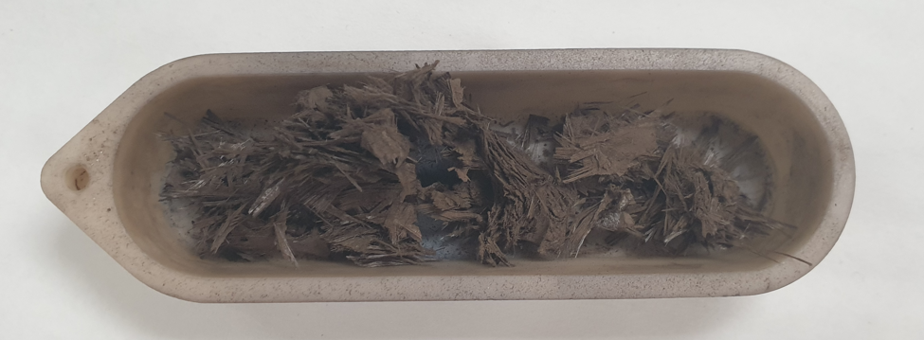
Figure S1 - Solid residue obtained at the end of the pyrolysis process, exhibiting a brown color due to the presence of a carbonaceous char.

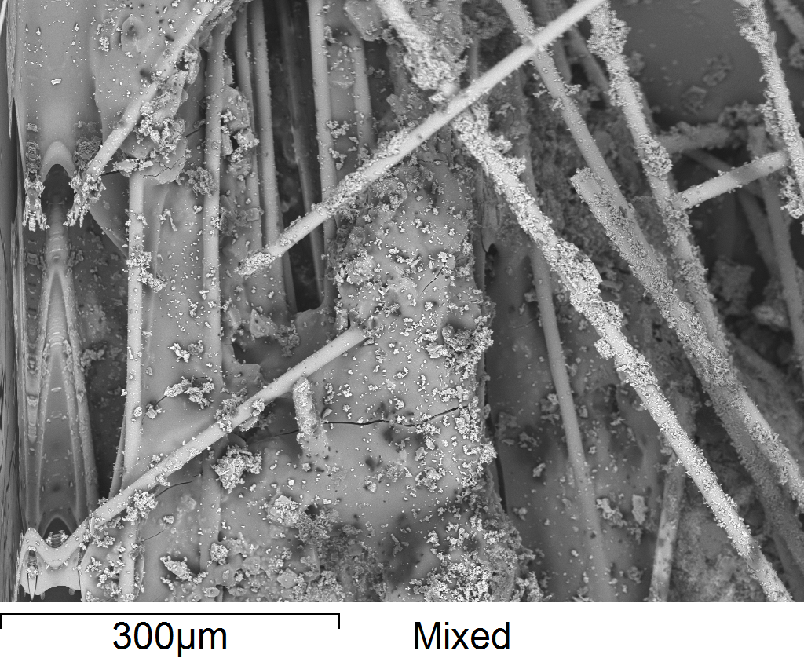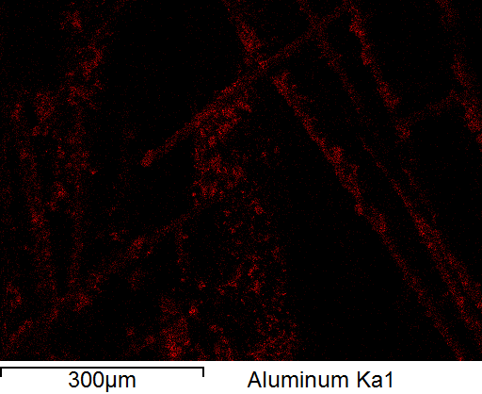

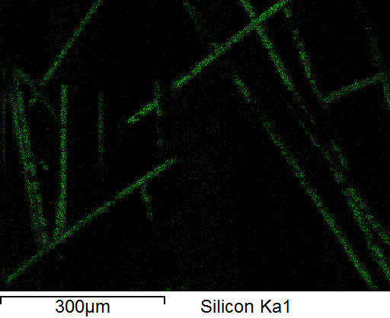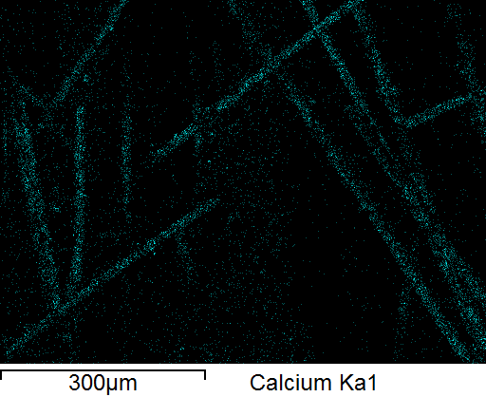

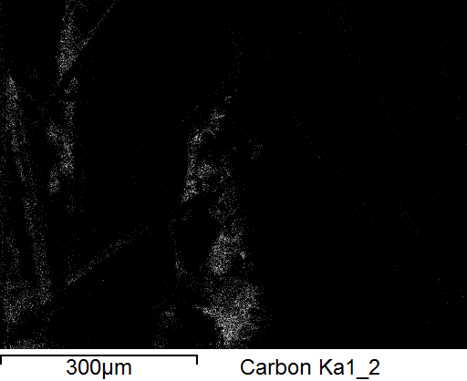
Figure S2 – EDX mapping of the main elements present on the solid pyrolysis residue, highlighting the presence of a carbonaceous deposition.

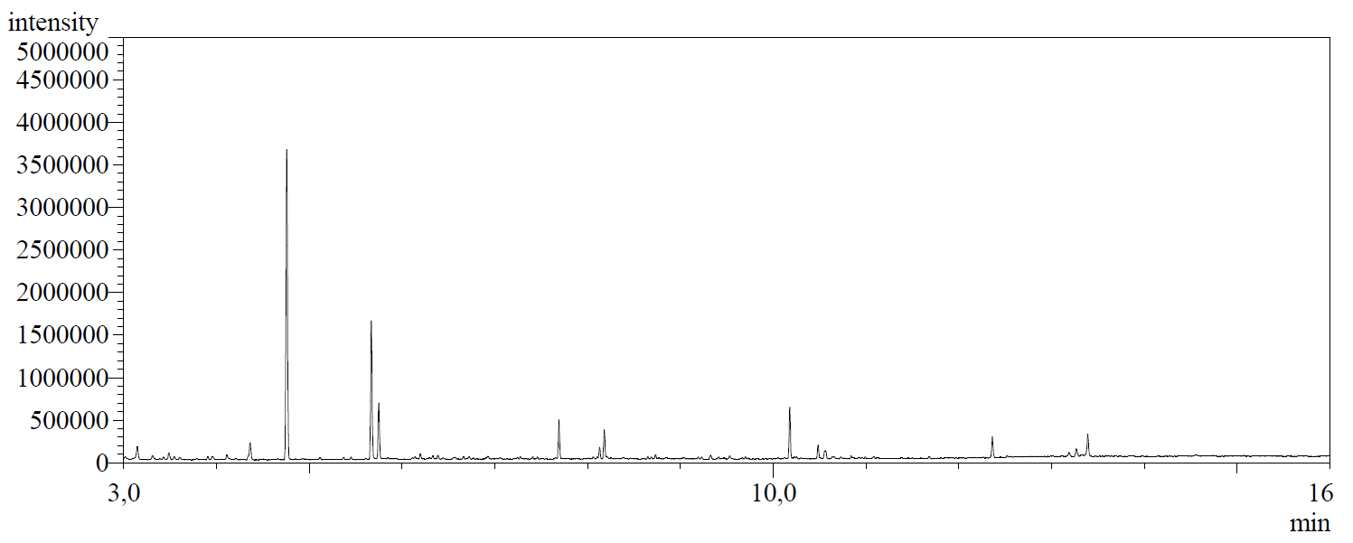
Figure S3 - Chromatogram obtained from the CG analysis of the light liquid phase

