CHEMICAL MODIFICATION OF PLA FOR THE REALIZATION OF 3D PRINTED NANOCOMPOSITE SCAFFOLDS WITH ENHANCED DEGRADATION RATE FOR BONE REGENERATION
G. Dal Poggetto1, A. Soriente2, A. Ronca2, U. D’Amora2, M.G. Raucci2, G. Gomez
d’Ayala1, P. Laurienzo1
1 Institute of Polymers, Composites and Biomaterials (IPCB), National Research Council, Via Campi Flegrei 35, 80078, Pozzuoli (Naples), Italy
email: giovanni.dalpoggetto@ipcb.cnr.it
2 Institute of Polymers, Composites and Biomaterials (IPCB), National Research Council, Viale J.F. Kennedy
54, Mostra d’Oltremare Pad 20, 80125 Naples, Italy

Introduction
Currently, bone scaffold materials include bioceramics, biometals, and biopolymers. Both natural [1] , such as collagen, chitosan, fibrin, and synthetic polymers [2] (PLA, PGA, PHBV, PVA), are widely studied due to their ease of processing. Among synthetic polymers, PLA is particularly promising for bone tissue engineering. Indeed, it is FDA-approved due to its biocompatibility, biodegradability, and processability, and it exhibits good mechanical strength. However, PLA with high molecular weight degrades slowly, hindering bone tissue growth. There are several pathways to improve degradability. Among them, functionalization involving chemical insertion of unsaturated molecules along the polymer chain via radical grafting is the least explored. Functionalization can decrease crystallinity and improve hydrophilicity, thus enhancing degradation. In this context, nanocomposites of PLA and PLA functionalized with itaconic anhydride (PLAf) containing 5 and 10 wt% hydroxyapatite (HA) nanoparticles as fillers were prepared via solution mixing. Obtained materials were characterized using 1H NMR. Scaffolds of PLA, PLAf, and their nanocomposites with HA were then fabricated using 3D printing technology. The mechanical properties, structure, and hydrolytic degradation behavior of the scaffolds were evaluated. Additionally, a biological investigation was conducted to study cell proliferation and osteogenic differentiation, using human bone marrow mesenchymal stromal cells (hMSCs) as the cellular model.

Results and Discussion
Characterization of PLAf
PLAf obtained by radical grafting was analyzed through different tecniques [3]. In the 1H NMR spectrum of PLAf, a small signal at 2.5 ppm corresponding to grafted itaconic anhydride (IAH), along with the absence of the -C=CH2 signal of free anhydride in the 4.5–5.5 ppm range, confirms the chemical grafting of IAH onto the PLLA chains. The weight percentage of grafted IAH was determined by UV-Vis spectroscopy using a previously reported method [4], resulting in a grafting degree of 0.5 wt%. GPC analysis revealed a decrease in both Mw and Mn, indicating that some chain degradation occurs during the radical functionalization reaction.
Characterization of nanocomposites
SEM analysis was conducted on the surface of films obtained by solution casting to observe differences in the adhesion and dispersion of HA within the polymer matrix. In the PLA-based nanocomposite, aggregates of nanoparticles pulled out from the matrix are visible. In contrast, such aggregates are absent in PLAf-HA, indicating improved adhesion and dispersion of HA in the PLAf matrix. Regarding PLA and PLAf 3D printed scaffolds, SEM images showed that PLAf scaffolds exhibited a more interconnected pore network and well-defined architecture. This morphology is expected to influence their mechanical properties. In fact, it was observed that PLA functionalization slightly improved the mechanical properties of the scaffolds, resulting in a stiff behavior. PLAf scaffolds exhibited higher values of modulus (E) and maximum stress (σmax) compared to pristine PLA scaffolds. Additionally, the incorporation of HA nanoparticles acted as a reinforcement for both PLA and PLAf matrices. Consequently, the nanocomposite scaffolds based on PLA and PLAf showed higher E values than their respective neat polymer counterparts.
Due to the different hydrophilicity of PLA, PLAf and their nanocomposites, different degradation
behaviors were expected, based on their ability to hydrate and swell. Degradation was assessed over a 6-month period by immersing the samples in PBS (pH 7.4) at 37°C. It was observed that all samples maintained their physical integrity throughout the entire degradation period. (Tab.1& Tab.2)
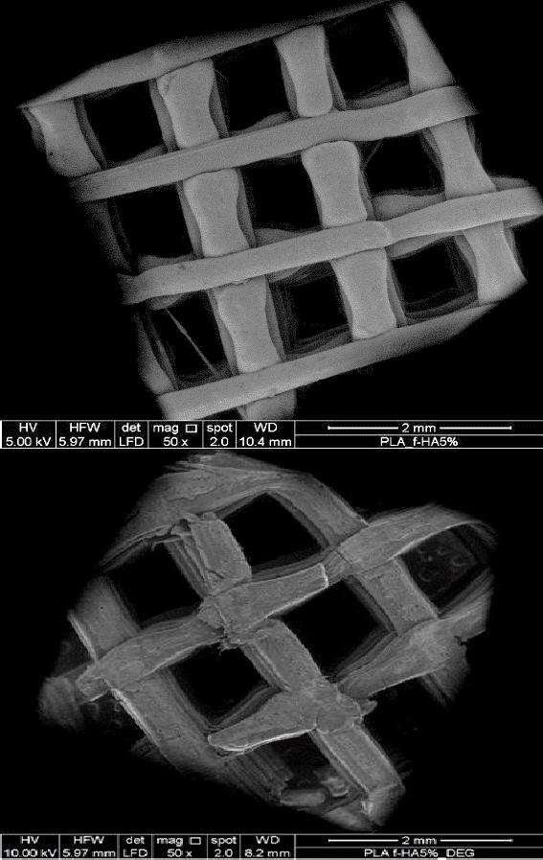
Table 1: Swelling and weight loss of scaffolds as a function of degradation time.
Sample | Sw.%  1 mth | Wt. loss (%)
Sample | Sw.%  1 mth | 1mth | 3mths | 6mths
PLA | 3.0 | 0.21 | 0.4 | 0.6
PLA-HA5 | 3.3 | 0.10 | 0.4 | 1.0
PLA-HA10 | 4.8 | 0.45 | 0.8 | 1.4
PLAf | 7.4 | 1.60 | 2.4 | 3.5
PLAf-HA5 | 7.3 | 0.43 | 1.1 | 2.7
PLAf-HA10 | 5.3 | 0.95 | 1.7 | 2.9

Table 2: Molecular weight decrease of PLA and PLAf as a function of degradation time.
Sample | Mw (Da)/PDI
Sample | t0 | 6 mths
PLA | 26135/2.04 | 16988/2.34
PLA-HA5 | 25635/2.08 | 21790/2.80
PLA-HA10 | 23123/2.21 | 20117/2.73
PLAf | 28079/1.76 | 13816/2.33
PLAf-HA5 | 21252/2.55 | 13605/2.50
PLAf-HA10 | 25734/2.34 | 14025/2.61

Figure 1: a) scaffold before degradation; b) scaffold after 6 months degradation

PLAf, PLAf-HA5, and PLAf-HA10 scaffolds exhibited more significant weight loss (approximately 3%) and notable molecular weight reduction (50%, 36%, and 45%, respectively), indicating accelerated hydrolysis.
SEM images of scaffolds before and after degradation showed that degraded PLA-based scaffolds present a smooth surface with numerous cracks, characteristic of a bulk degradation mechanism. In contrast, PLAf-based scaffolds exhibit few cracks but display a noticeable surface roughness, suggesting a double degradation mechanism including both surface erosion and bulk degradation. (Fig.1 a, b)
Finally, the effect of 3D scaffolds on cell proliferation and differentiation was evaluated. Results highlited that all scaffolds were able to promote cell proliferation until 7 days. Moreover, alkaline phosphatase (ALP) values increased as a function of HA amount for both PLA and PLAf scaffolds, whereas functionalization has not effect on ALP levels. Increased ALP levels indicate osteoblastic differentiation of hMSCs in basal medium.

Conclusions
In this study, nanocomposites of PLA and PLA functionalized with itaconic anhydride (PLAf) containing 5 and 10 wt% of hydroxyapatite (HA) nanoparticles were prepared and characterized, as well as their 3D printed counterparts. Results highlighted that functionalization and presence of HA at different percentages affect chemico- physical and mechanical properties, structure, and hydrolytic degradation behavior. In particular, functionalization was found to speed up the hydrolytic degradation of scaffolds. Moreover, a biological investigation aimed to study cell proliferation and osteogenic differentiation, highlited that all scaffolds promoted cell proliferation until 7 days and differentiation of hMSCs in osteoblasts phenotype.

Acknowledgements
Project: "MICS – Made in Italy Circolare Sostenibile" id code PE00000004, PNRR MISSION 4 COMPONENTS 2 - (CUP B53C22004100001)

References
- L. Guo, Z. Liang, L. Yang, W. Du, T. Yu, H. Tang, C. Li, H. Qiu, Journal of Controlled Release, 338, 571-582 (2021).
- A. Bharadwaz, A. C. Jayasuriya, Materials Science and Engineering: C, 110, 110698 (2020).
- A. Longo, G. Dal Poggetto, M. Malinconico, P. Laurienzo, E. Di Maio, M. L. Di Lorenzo, Polymer, 227, 123852 (2021)
- W. Liu, T. Liu, T. Liu, T. Liu, J. Xin, W. C. Hiscox,
H. Liu, L. Liu, J. Zhang, Industrial & Engineering Chemistry Research, 56, 3920–3927 (2017)

