Figure S1
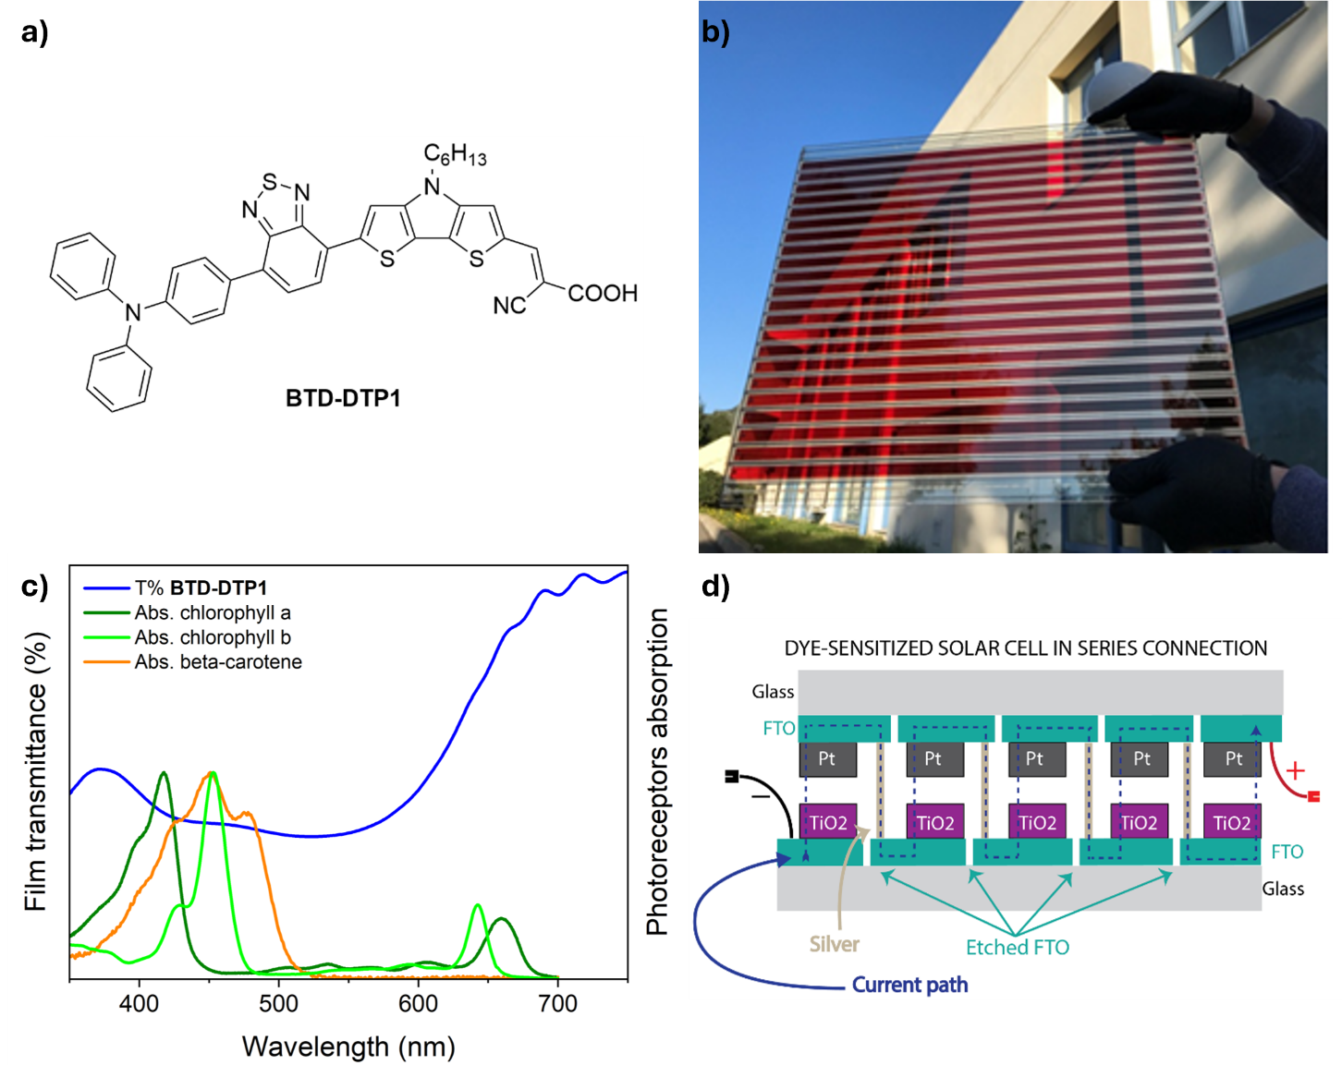
Figure S1. a) Structure of the BTD-DTP1 dye; b) The semi-transparent BTD-DTP1-based DSSC module (47×38 cm²) with 22 serially connected individual solar stripes used for the experiments; c) Comparison between the transmission spectra of dye BTD-DTP1 adsorbed on a thin transparent TiO₂ film and the UV-Vis absorption spectra of the most common plant photoreceptors (chlorophyll a, chlorophyll b, β-carotene); d) Schematic representation of the electrical interconnection among individual solar cells in the DSSC panel.

Figure S2
Figure S2. Representative SEM cross section image for determination of TiO₂ layer thickness.

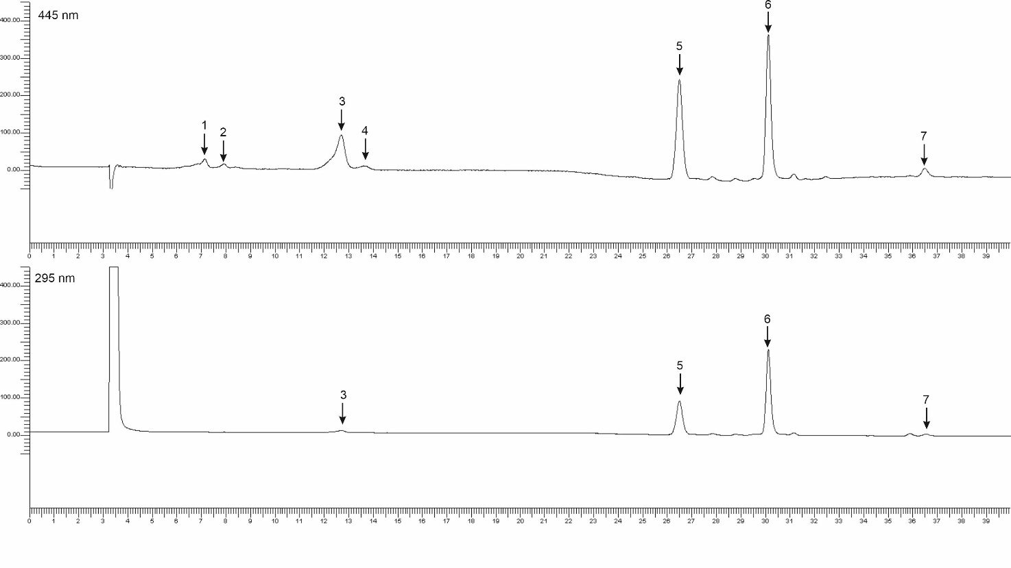
Figure S3
Figure S3. Representative chromatograms of the Cichorium intybus leaf extracts, acquired at 445 and 295 nm, showing the main carotenoids detected. Peaks: 1–neoxanthin; 2-violaxanthin; 3-lutein; 4-zeaxanthin; 5-chlorophyll b; 6-chlorophyll a; 7-β-carotene.

Figure S4
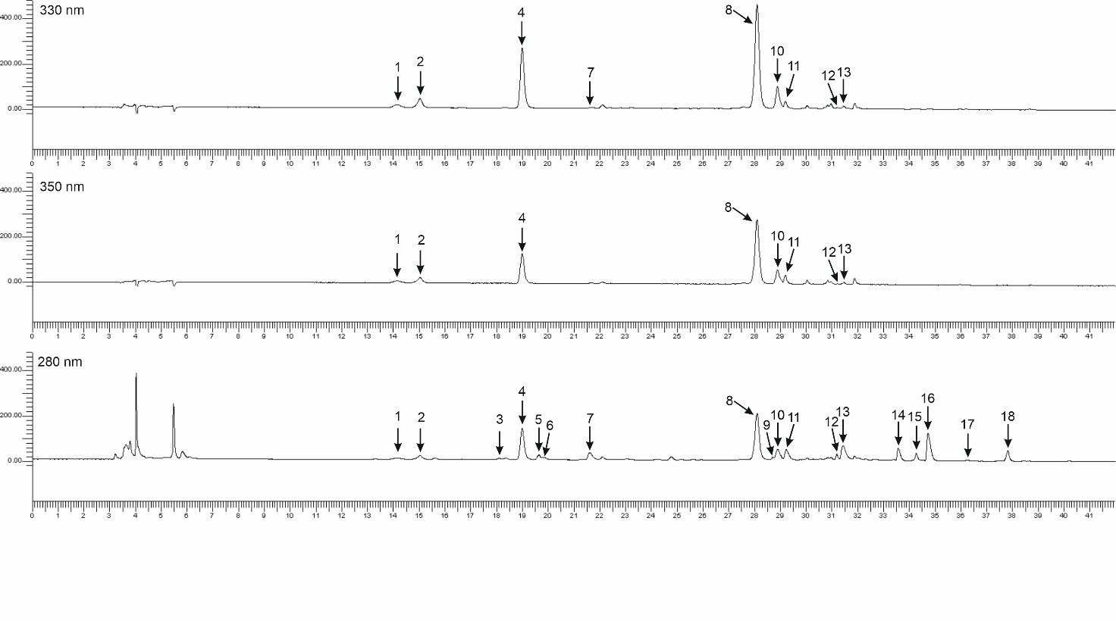
Figure S4. Representative chromatograms of the Cichorium intybus dry leaf extracts, acquired at 330, 350 and 280 nm, showing the main compounds detected. Peaks: 1-caffeic acid derivative, 2- caftaric acid, 3- epigallocatechin derivative, 4-chlorogenic acid, 5-epigallocatechin derivative, 6-epigallocatechin, 7-epigallocatechin derivative, 8- cichoric acid, 9-epigallocatechin derivative, 10-caffeic acid derivative, 11- kaempferol-3-O-glucuronide, 12-18- epigallocatechin derivatives.

