Impact behaviour of a novel composite structure made of a polymer reinforced composite with a 3D printed metallic coating
I. Papaª, P. Russo^{b}, A. Astarita^{a,c}, A. Viscusi^{a,⁎}, A.S. Perna^{a,c}, L. Carrinoª, V. Loprestoª
ª Department of Chemical, Materials and Production Engineering, University of Naples “Federico II”, P.le Tecchio 80, Naples 80125, Italy
^{b} Institute for Polymers, Composites and Biomaterials, National Research of Council, Pozzuoli, Naples, Italy
^{c} University of Bergamo, Bergamo, Italy

A R T I C L E I N F O

Keywords:
Cold spray Composite material
Additive manufacturing Basalt
Low-velocity impact
A B S T R A C T

The low-velocity impact behaviour of novel composite structures, made of a polymer matrix composite with a superﬁcial 3D printed metallic layer, was studied. The metallic layer was produced through cold spray de- position which is a relatively new additive coating technique allowing for the deposition of metallic coatings on thermal-sensitive substrates, such as the polymeric materials. Micron-sized aluminium particles were used to metallise the surface of basalt-nylon 6 (PA6) laminates manufactured by the compression moulding technique. Three diﬀerent energy levels (10 J, 20 J, 30 J) were set for the impact tests. The results obtained pointed out the beneﬁcial contributions of the metallic coating on the energy absorbing modes of the polymeric substrates; the positive eﬀects on the damage mechanisms as well as the crack propagation were detected by plastic de- formation analyses and ultrasonic damage controls.

- Introduction

Recently, the increasing apprehension about environmental matters has motivated extensive research interest towards new composite ma- terials based on intrinsically recyclable thermoplastic matrices [1–3], for innovative applications too. Moreover, the use of natural reinforcing ﬁbres in place of conventional ones highlights the renewability aspect and, therefore, the ability to provide a minimal environmental impact at the end of their useful life [4]. Among natural ﬁbres, basalt ones, derived from basalt rocks, have recently gained outstanding attention [5,6] due to their low cost, simple manufacturing process, as well as their high thermal stability and durability, compared to glass ﬁbres. Moreover, the environmentally friendly thermoplastic nylon 6 (PA6) seems to ensure a good interfacial adhesion with the basalt ﬁbres. On these premises, these composite materials are gaining an increasing interest and some properties should be improved to enhance their ﬁeld of applications.
The low-velocity impact strength is a very important issue for polymer matrix composites [7], due to these impacts are known to signiﬁcantly reduce the laminate strength and stiﬀness, mainly as a consequence of multiple stacked delaminations produced by the impact loading at many interfaces through the thickness [8]. Even without any visible external damage, microcracks in the resin can produce internal
delaminations, thus reducing the composite strength [9]. The damage induced by impact loading on composites is more critical than in me- tals: it is often not detectable, beginning in the form of internal dela- mination that starts from matrix cracking [10]. The problem is that the damages caused by a dynamic load are complicated due to the non- homogeneous and anisotropic nature of the laminates. They are not always observable by visual inspections and hard to observe by de- structive and non-destructive techniques. Since the importance of the topic, many studies were devoted to solving the problem in the last years, and several methods were proposed in literature to reduce the low-velocity impact damages [11–14].
A promising solution could be the manufacturing of 3D printed metallic coating on the composite surface conceived to reduce the da- mages under low-velocity impacts, this novel composite structure will lead to a noticeable increase in the impact strength.
Nowadays, additive manufacturing techniques are ﬁnding a wide- spread increasing use due to their intriguing potentialities, among these the cold spray deposition seems to be suitable for the production of metallic layers on polymeric substrates [15]. In CS processes, ﬁne particles (typically in the range 1–50 μm) are dragged and accelerated by a supersonic gas stream (air, argon, nitrogen) to velocities on the order of 300 to about 1200 m/s [16]. Upon powder particles impact the target surface, conversion of kinetic energy to plastic deformation

occurs, the solid particles deform and bond together, making it possible the coating formation and build-up [17].
The CS deposition does not degrade substrates made by thermally sensitive materials through oxidation and it does not transfer a large amount of heat to the same; moreover, any residual tensile stresses associated with typical solidiﬁcation shrinkage phenomena can be eliminated by CS [18].
In the past decades, many papers have been devoted to under- standing phenomena taking place in cold spraying processes primarily applied to metallic substrates [19–23]. Low attention was turned on polymeric substrates and, in particular, on composite materials [15,24,25]. In this frame, CS candidates as a potential method to create a metallic coating on composite surfaces improving their wear prop- erties as well as ﬂame resistance, electrical conductivity and damage start and inspection, so extending their application ﬁelds.
At this regard, Lupoi and O’Neill [26] reported the results obtained by spraying diﬀerent material particles on PC/ABS substrates ﬁnding that the sprayed particle typology aﬀects the CS deposition mechanism; Che et al. [27] pointed out the beneﬁcial eﬀects on CS deposition ef- ﬁciency of mixed metal powders for coated CFRPs substrates. Ganesan et al. [15] studied the inﬂuence of the substrate typology on the particle bonding mechanism ﬁnding that if the particles deeply penetrate into thermoplastic substrate, they can bond with the surrounding polymer matrix. Zhou et al. [24] analyzed the phase structure of Al/Cu coatings on CFRPs by XRD and measured the microhardness of the coatings and the surface conductivity of the sprayed aluminum. Electrical con- ductivity measurements were also performed by the authors [27] that sprayed various Sn-Cu coatings on polymeric substrates proving that the bonding in the cold-sprayed state is not as conductive as the “100%” metallic bonding in the bulk material.
Despite CS deposition on polymer-based substrate was proved to be a subject with great technological interest, no papers investigate the possibility to improve the low-velocity impact behaviour of composite materials by using a metallic coating.
However, there are very few papers dealing with the study of the deposition of metal particles on natural ﬁbre composites (NFC_{s}) through cold spray technique [28] and none of these deals with the low- velocity impact response of coated products. Moreover, the thermo- plastic matrix PA6 composites reinforced with the basalt ﬁbres were proved to be potentially suitable for the automotive sector given to their established crashworthiness [29]. In this context, NFCs applica- tions could be extended for the manufacturing of other engineering components, perhaps surrounding the engine compartment, for which an improved heat dissipation is necessary. In this frame, the cold spayed metallic layer manufactured on the surface of these components could also enhance the impact behaviour of the systems, so further extending their application ﬁelds.
On the base of these premises, in this paper a novel composite structure, made of a basalt-PA6 substrate with a superﬁcial cold sprayed aluminium layer, is proposed and tested to present and discuss its impact behaviour. Micron-sized aluminium particles were used to metallise the surface of basalt-PA6 thermoplastic laminates, impact tests were carried out on both neat and coated systems at diﬀerent energy levels to study the start and propagation of the damage in both cases.

- Materials and methods

Composite laminates reinforced with a basalt plain wave-type fabric (BS) (weight: 210 g/m²) from Incology GmbH (Germany) were pre- pared using the following thermoplastic matrix: nylon 6 (PA6), Lanxess Durethan B30S-000000 (MFI@260 °C, 5 kg: 102 g/10 min).
The laminates were prepared by a typical ﬁlm stacking procedure by which stacks of alternated layers of plastic ﬁlms and woven ﬁbres are subjected to a hot-compression step under pre-optimized conditions using a lab press Collin GmbH (Edersberg, Germany) mod. P400E to obtain 380 mm × 380 mm plates. In this way, samples constituted by 16 layers, symmetrically stacked concerning the middle plane, were obtained with a thickness equal to 2.60 ± 0.01 mm and a volumetric content of reinforcement of about 45% (ASTM D 3171–04, Test Method II).
A low-pressure CS equipment (Dymet 423) with nitrogen as a carrier gas was used for the cold spray depositions. Micron-sized powders of aluminium alloy Al-Si12 (particle mean size of 40 μm) were cold sprayed on the basalt composite substrate.
The strategy adopted for the 3D metallic coating manufacturing process was based on preliminary experimental tests as well as litera- ture results [6,15,25,26,28,30]. In fact, diﬀerent coating tracks with a travel speed of the spraying gun equal to 8 mm/s were preliminary produced by varying the process parameters in a wide range (inlet gas temperature: 150 – 600 °C, inlet gas pressure: 4 – 8 bar, stand-oﬀ dis- tance (SoD): 10 – 80 mm [28]).
In particular, as for the inlet gas temperature, its value was chosen by taking into account that the temperature of the gas ﬂow on the target surface was below the melting point of the polymeric material and, at the same time, greater than the glass-transition one; this was done in order to avoid the deterioration phenomena of the substrate and ensure the softening, so that the metallic particles can penetrate the polymeric surface. Concerning the gas pressure, the correct value was set taking into account that the higher the pressure, the higher the substrate erosion due to the strong shot peening eﬀect of the particles. Finally, as for the stand-oﬀ distance, the larger values of SoD, the lower the mo- mentum of the particles upon impact with the substrate, resulting in particles rebounding, thus in a poor and thin coating. This result was corroborated by the available literature [6], for which a higher mo- mentum of the particles leads to the formation of a denser coating.
In details, a 90x90 mm square form coating was developed on the BS/PA6 specimens’ surface by spraying the one-single layer of Al-Si12 particles according to the schematization of the pattern imposed to the spray gun, here reported in Fig. 1.
After a ﬁrst visual inspection, the coated samples were observed through both optical (ZEISS Axioskop 40) and SEM (Hitachi3000) mi- croscopy in order to highlight the morphology of the coating, thus to set the best CS process parameters.
On the base of these premises, the optimal CS process parameters were found and reported in Table 1.
Low-velocity impact tests (maximum impact velocity, V_{i} = 4 m/s) were carried out by a falling weight machine, Ceast Instron Fractovis FK4 (Turin, Italy), at three diﬀerent energy levels (U = 10 J, 20 J, 30 J) to avoid the penetration and to measure the indentation depth. The rectangular specimens, 100x150 mm, cut by a diamond saw from the original panels, were supported by the clamping device suggested by the ASTM D7137 Standard and were centrally loaded by an in- strumented cylindrical impactor with a hemispherical nose, 19.8 mm in diameter. Tests were conducted using an impactor with a mass equal to 3.640 kg that combined with the drop heights allowed to obtain the selected impact energy. After the impact tests on both the original material and the aluminium cold sprayed substrate, the specimens were observed by visual inspection to investigate the coating quality and the surface damage, whereas a confocal microscope, Leica DCM3D, was used to measure the indentation depth with a magniﬁcation of 10x. Also, the delaminated areas were inspected using a US Multi2000 Pocket 16x64 system by M2M: examinations were performed with a linear phased array probe, 5 MHz, 64 elements. The phased array sys- tems could be used for all inspection types, traditionally made using conventional ultrasonic ﬂaw detectors. The advantages of phased array technology, in comparison to conventional ultrasonic, derive from the possibility of being able to use several elements assembled in a single transducer to guide, focus and scan the beams [31].

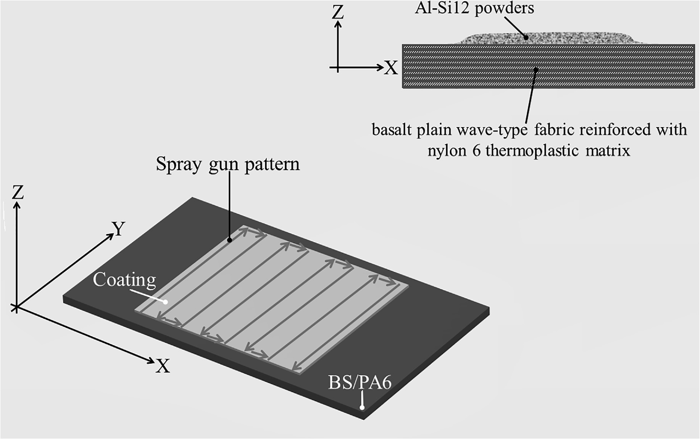
Fig. 1. Schematization of the spray gun pattern.

Table 1
Optimal CS process parameters used in this experimentation.

CS parameter | Used value
Travel speed gun [mm/s] | 8
Inlet gas temperature [°C] | 150
Inlet gas pressure [bar] | 6
SoD [mm] | 35

- Results

The macrograph of the coated sample made with the CS coating protocol selected is shown in Fig. 2. It can be seen that the metal par- ticles seem to bond on the polymeric surface without inducing notice- able damages and failure of the substrate. In fact, the particles bom- bardment can lead to the substrate erosion and degradation, also
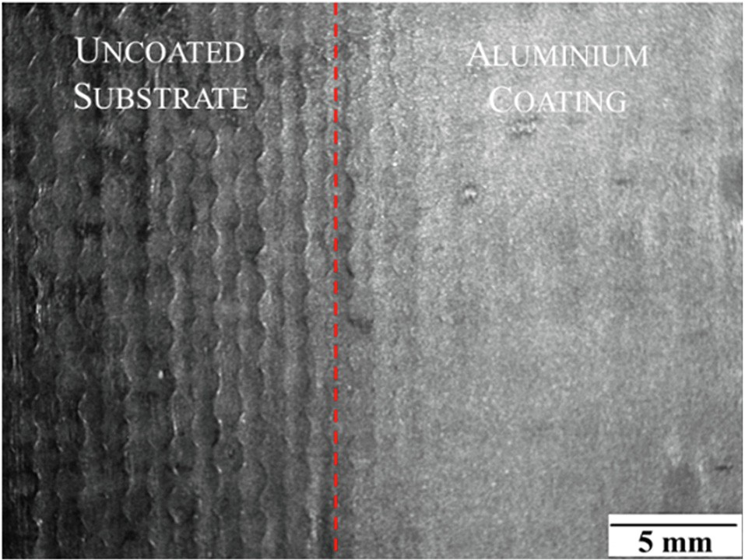
Fig. 2. Macrograph of the coating produced on BS/PA6 substrate by using the proper CS process parameters.
resulting in ﬁbres failure which are exposed to the shoot peening eﬀect. Moreover, the coating grow-up on polymer-based substrate was proved to be very diﬃcult being determined by the bonding strength between the ﬁrst layer and the substrate. If the ﬁrst layer is not ﬁrmly anchored, the shot peening eﬀect of the upcoming particles can destroy the ﬁrst layer making it impossible to build-up a coating.
Therefore, aiming to investigate in details on the deposition me- chanism at the particle–substrate interface, the cross sections of the coated sample were analysed and the SEM image is shown in Fig. 3.
It can be seen that the coating appears to be quite dense and com- pact with the particles well embedded by the polymeric surface. The thin metallic layer can prevent the ﬁbre damage under impact loads, positively aﬀecting the surface properties of the BS/PA6 polymeric substrates. This is a key factor for the low-velocity impact performances of the hybrid surface.
At this regard, the impact analyses were focused on BS/PA6 and the comparison between neat and coated samples was carried out and
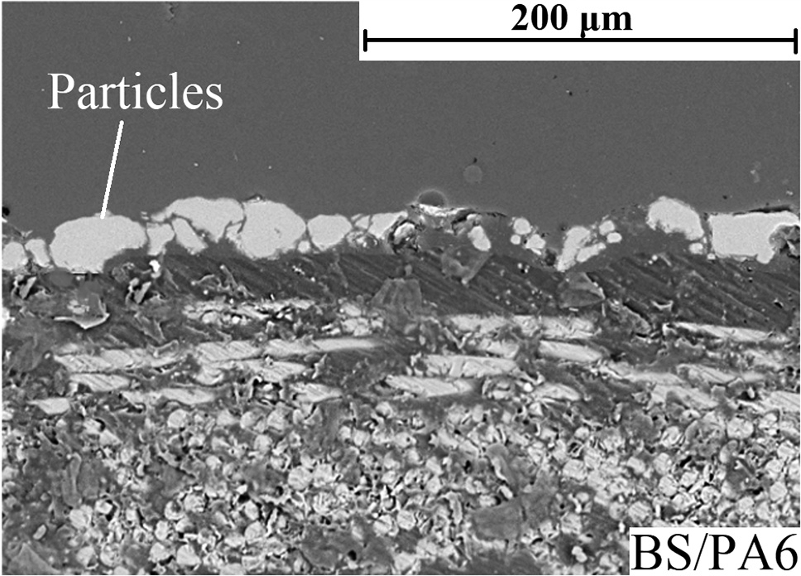
Fig. 3. SEM image of the cross section of the coating produced on BS/PA6 substrate by using the proper CS process parameters.

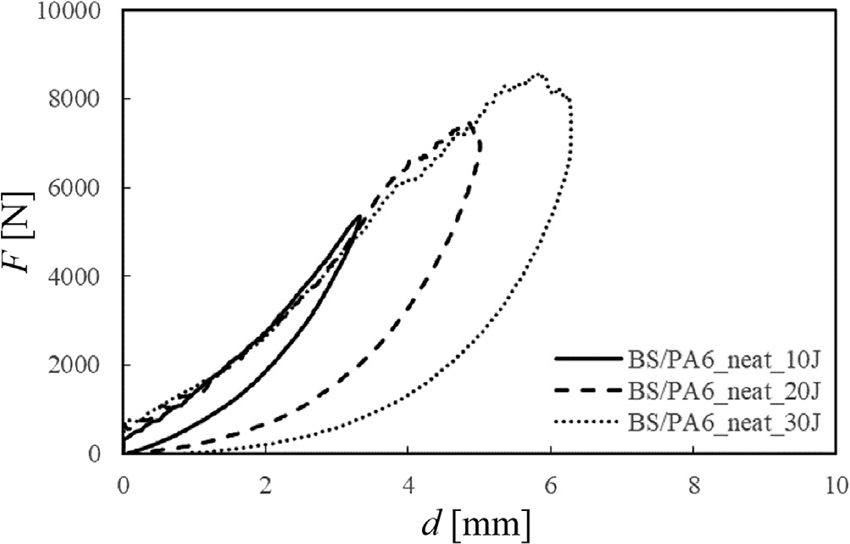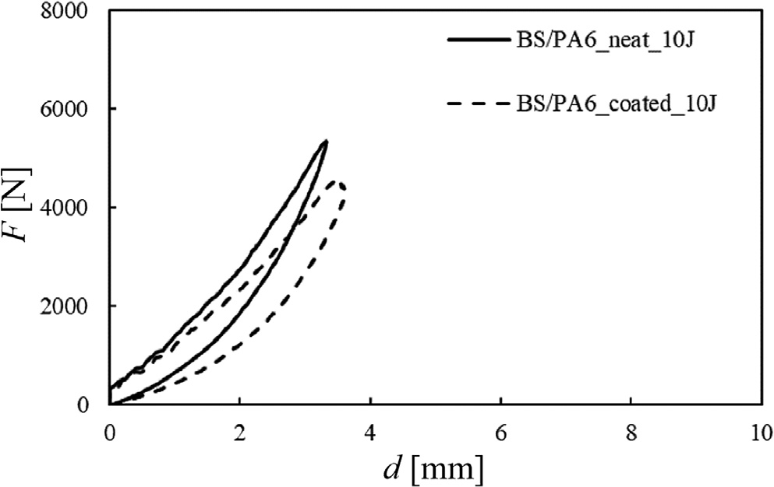

Fig. 4. Load-displacement curves comparison for three impact energy levels (U = 10 J, 20 J, 30 J) relative to neat composites systems (BS/PA6_neat).
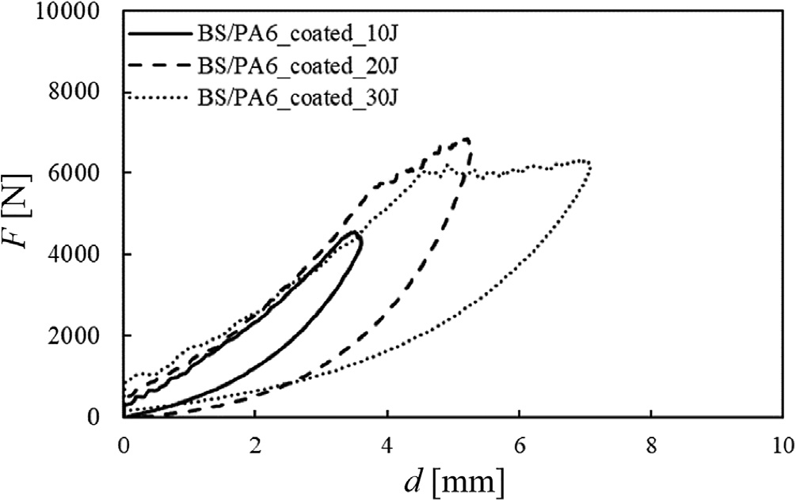
Fig. 5. Load-displacement curves comparison for three impact energy levels (U = 10 J, 20 J, 30 J) relative to coated composites systems (BS/PA6_coated).

extensively discussed.
Representative load–displacement curves obtained for the three impact energy levels are reported in Fig. 4 and Fig. 5, for both neat and coated basalt composite systems, respectively.
The pictures clearly show that, for all the tested conditions, closed type curves are obtained: the samples are not penetrated/perforated by the impactor that rebounds from the impacted surface and the area enclosed in the loop of the loading/unloading part of each curve is the energy absorbed by the laminate to create damage or to bend.
In particular, from the ﬁgures above it can be seen that, for both neat and coated samples, the impact energy, U, increases and an in- crease of the maximum load, F_{max}, the maximum deﬂection, d_{max}, and the absorbed energy, U_{a}, occurs. These results are summarised in Table 2. The impact strength of the coated systems results lower for the coated composite that, on the other hand, shows a higher maximum deﬂection for all the impact energy levels used.
In particular, observing the comparison between the load–displa- cement curves for both the systems keeping the energy level constant (Figs. 6, 7 and 8), it is possible to notice a variation of the rigidity of the
Fig. 6. Load-displacement comparison between neat and coated composite at U = 10 J.
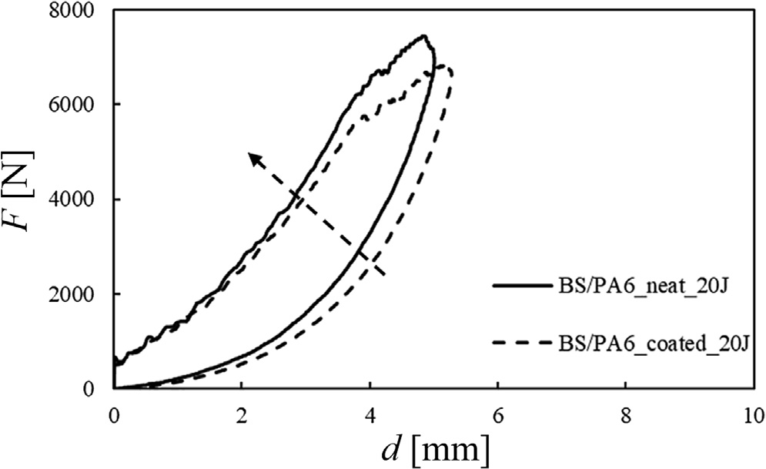
Fig. 7. Load-displacement comparison between neat and coated composite at U = 20 J.
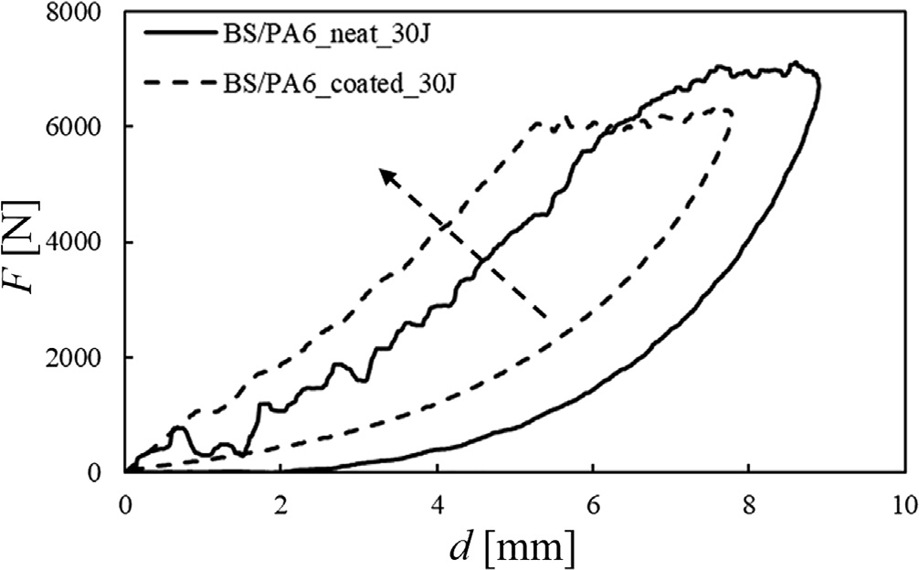
Fig. 8. Load-displacement comparison between neat and coated composite at U = 30 J.

Table 2
Impact parameters at the indentation tests.
BS\PA6 neat |  |  |  | BS\PA6 coated
U [J] | F_{max} [N] | U_{a} [J] | d_{max} [mm] | F_{max} [N] | U_{a} [J] | d_{max} [mm]
10 | 5584.44 ± 55 | 3.25 ± 0.5 | 3.33 ± 0.3 | 4774.53 ± 30 | 2.36 ± 0.5 | 3.61 ± 0.4
20 | 7445.92 ± 73 | 10.82 ± 0.5 | 5.01 ± 0.5 | 6851.55 ± 65 | 10.34 ± 0.6 | 5.27 ± 0.6
30 | 6302.91 ± 90 | 21.59 ± 0.9 | 6.10 ± 0.2 | 6319.24 ± 105 | 16.24 ± 1.0 | 7.08 ± 0.3

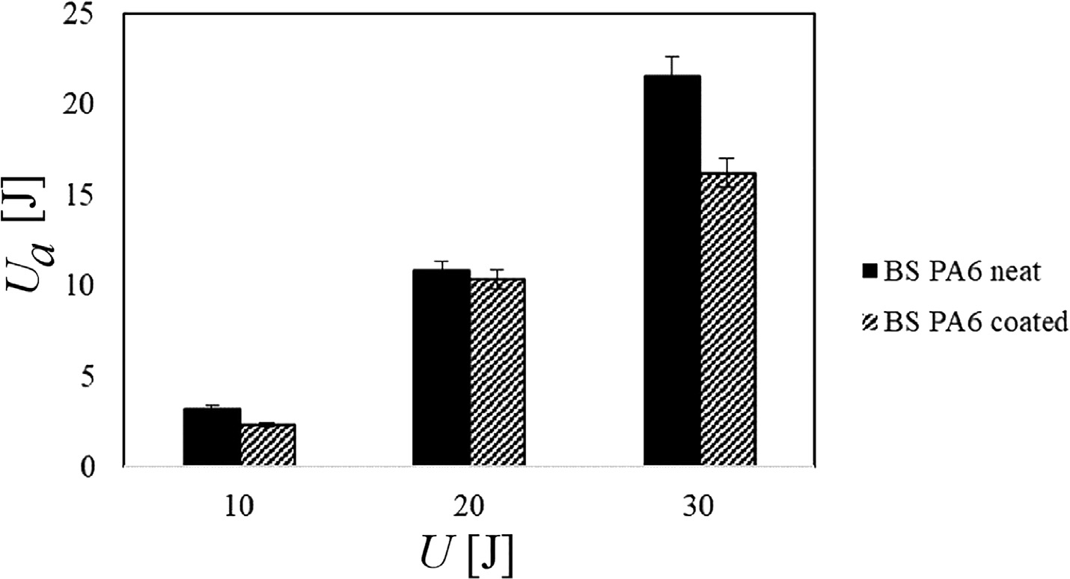
Fig. 9. Comparison of absorbed energy, U_{a}, versus impact energy U for BS/PA6 neat and coated samples.

composite coated system. The rigidity is indicated by the slope of the ﬁrst linear part of the curve and can be noted that it is aﬀected by the cold spray deposition in diﬀerent way for the diﬀerent impact energy values. The coated system rigidity results lower for U = 10 J and in- creases as the impact energy increases (see black arrow) changing the behaviour for U = 30 J. That means the tested coated composites are systems very sensitive to the impact velocity variation.
In the case of the coated materials, it is easy to observe that the ﬁrst signiﬁcant load drop occurs in correspondence of the maximum load, while, in the case of neat BS/PA6 laminates, several load drops were observed on the increasing part of the curve, denoting delaminations initiation and propagation, as well as matrix cracks and ﬁbre failures. Probably the metallic coating acts as a protection for the matrix and the matrix ﬁbre interface, reducing the matrix breaks before the ﬁbre failure. What we read is predominantly the responsibility of the metal which, being anisotropic structure, also reduces the presence of noise. In part, the impact energy is absorbed by the coating, reducing the impact energy transmitted to the composite surface. That means that the aluminium coating inﬂuences the damage mechanisms by pro- tecting the ﬁbres.
The absorbed energy, U_{a}, which is the energy used by the composite material to create the damage, versus the impact one is reported in Fig. 9. As expected, U_{a} increases as the impact energy, U, increases for both systems. No large diﬀerences of the absorbed energies were re- corded between the two tested systems at 10 J and 20 J. A signiﬁcate diﬀerence exists in the case of U = 30 J (see Table 2 for details). In this condition, the energy absorbed by the neat system is signiﬁcantly greater indicating a higher propensity to damage of this composite with respect to the coated one.
The front and rear side of the neat and coated systems impacted at U = 30 J are reported in Fig. 10. It is possible to note the typical diamond shape of the impact damage after impact tests. In particular, in both front and rear side of the coated sample the damage seems to be smaller and more concentrated in the impact point showing a minor delamination extension.
The beneﬁcial eﬀect of the metallic coating is also conﬁrmed by the limited extension of the plastic deformation that seems to be localised under the material-impactor contact point (see Fig. 11(a)) for the coated sample.
Recalling that the indentation depth, I, is the footprint left by the impactor on the impacted specimen surface, from Table 3 it is possible to note that the coated composite shows a lower indentation and a lower extension of the in-plane plastic deformation (yellow areas in Fig. 11(a) and (b)) respect to the neat composite.
Correlating the indentation depth, I, to the impact energy, U, for
both systems (Fig. 12) it is possible to observe that I increases as the impact energy increases and a higher indentation depth for the BS/PA6 neat sample is shown. Since the indentation represents the plastic de- formation of the surface of the laminate, it might be thought that the metallic layer is more prone to this deformation. The conclusion re- ported above can be due to a diﬀerent mechanisms of energy absorption of the entire new system as hereafter highlighted.
The delaminated area, A, detected by C-scan and the indentation data, I, for both systems are indicated in Table 3 for all tested impact energies, U.
The US detections were carried out by phased array systems for all inspection types, traditionally made using conventional ultrasonic ﬂaw detectors. The advantages of phased array technology, in comparison to conventional ultrasonic, derive from the possibility of being able to use several elements assembled in a single transducer to guide, focus and scan the beams.
The apparatus operates in the form of reﬂection: the probe me- tallised for the emission and the reception of the ultrasonic waves. During the acquisition, the pulse Echo technique was adopted: short- duration ultrasound pulses are transmitted into the region to be studied, and echo signals resulting from scattering and reﬂection are detected and displayed as a C-scan. The latter is the reconstruction of the ma- terial ply for ply and reported on a single plane. In this way, it is pos- sible to obtain the maximum extension and shape of the damage present in the material. Using an undamaged sample, the correct thickness plate is obtained, and the acquisition system is calibrated. According to [32], the propagation velocity equal to 3075 m/s is registered. So, in terms of C-scan, the damage seems to be localised under the material-impactor contact point in a more conﬁned area on laminates for the coated composite, as reported in Fig. 13 for the impact energy U = 30 J, only. In Fig. 14, the comparison between the neat and the coated dela- minated area, A, detected by ultrasound technique versus the impact energy is reported. Conﬁrming what said above, the damage area in- creases as the impact energy increases and a more considerable dela- mination extension measured on neat basalt laminates for all tested
impact energies was recorded.
Very interesting is the correlation found between the two damage modes: indentation depth, I and delaminated area, A, for both the conditions as reported in Fig. 15. Approximately a linear trend was found between I and A indicating the existence of an essential corre- lation between the external and internal non-visual damage: so, if the indentation depth is known, the delaminated area could always be measured and for each impact condition seems to be possible to vi- sualize always the presence of the damage.

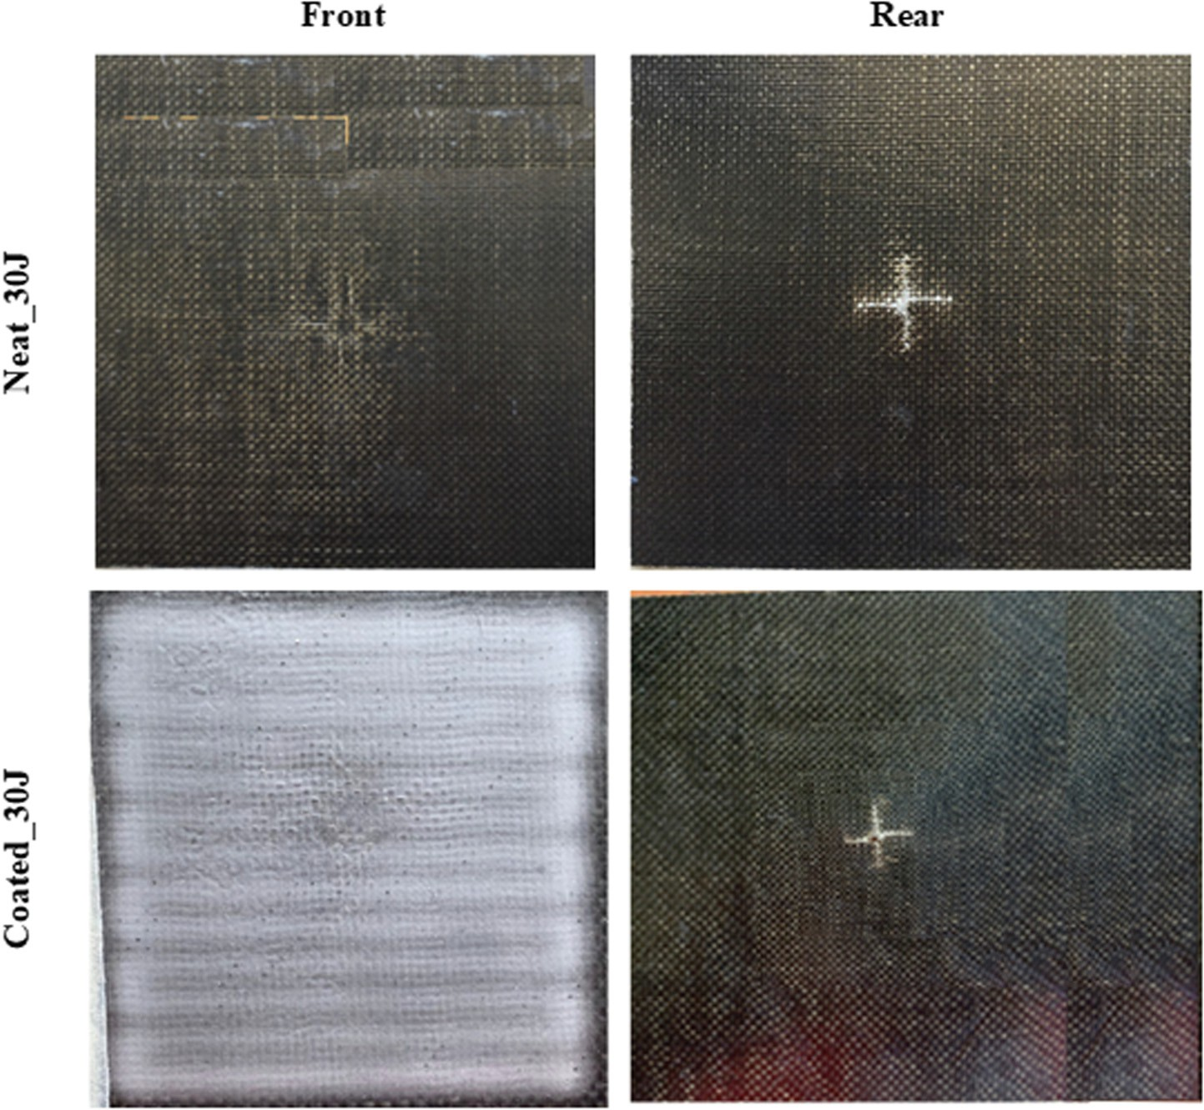
Fig. 10. Front and rear pictures of BS/PA6 systems impacted at U = 30 J, a) neat; b) coated.

- Discussion of the results

To better explain the beneﬁcial eﬀects of the metallic coating on BS/
PA6 low-velocity impact behaviour, the simple energy-based analytical model is here proposed. In particular, the impact energy (U = ¹ mV ²),
BS PA6 | neat |  | BS PA6 | coated
U [J] | I [µm] | A [mm²] | U [J] | I [µm] | A [mm²]
10 | 100.00 ± 18 | 452.00 ± 25 | 10 | 93.00 ± 9 | 354.00 ± 18
20 | 210.00 ± 12 | 529.00 ± 13 | 20 | 113.70 ± 16 | 492.00 ± 20
30 | 339.00 ± 30 | 678 ± 21 | 30 | 274.00 ± 24 | 622 ± 25

Table 3
Plastic deformation extension.

2 I

that is the available energy of the impactor system, can be expressed as the combination of three diﬀerent contributions: i) the energy trans- mitted to the substrate, U_{a}; ii) the residual energy used by the impactor to rebound from the impacted surface, U_{r}, and iii) the dissipated energy, U_{d}, due to the propagation of elastic waves and vibrational motions that start from impact point and propagate throughout the structure; this last energy contribution can be more or less neglected depending on the speed or type of impact. For the neat basalt composite, U_{a} is the sum of two contributions: the energy used to load the basalt ﬁbres (U_{af,neat}) and that used to deform the polymeric matrix (U_{am,neat}), namely, the energy absorbed by the composite material to create the damage (U_{a,neat}); the residual impact energy is spent by the impactor for the rebounding

(called as U_{r,neat}) and for dissipative phenomena (U_{d,neat}). Similarly, for the coated sample, U_{a} takes also account for the energy absorbed by metallic particles (U_{ap}) constituting the coating; that means the energy transmitted to the coated substrate is the sum of two rates, U_{a,coated} and U_{ap}, where the ﬁrst term is the absorbed energy by the undercoated composite material to load the ﬁbres (U_{af,coated}) and to deform the matrix (U_{am,coated}). Again, U_{r,coated} and U_{d,coated} are the residual impact

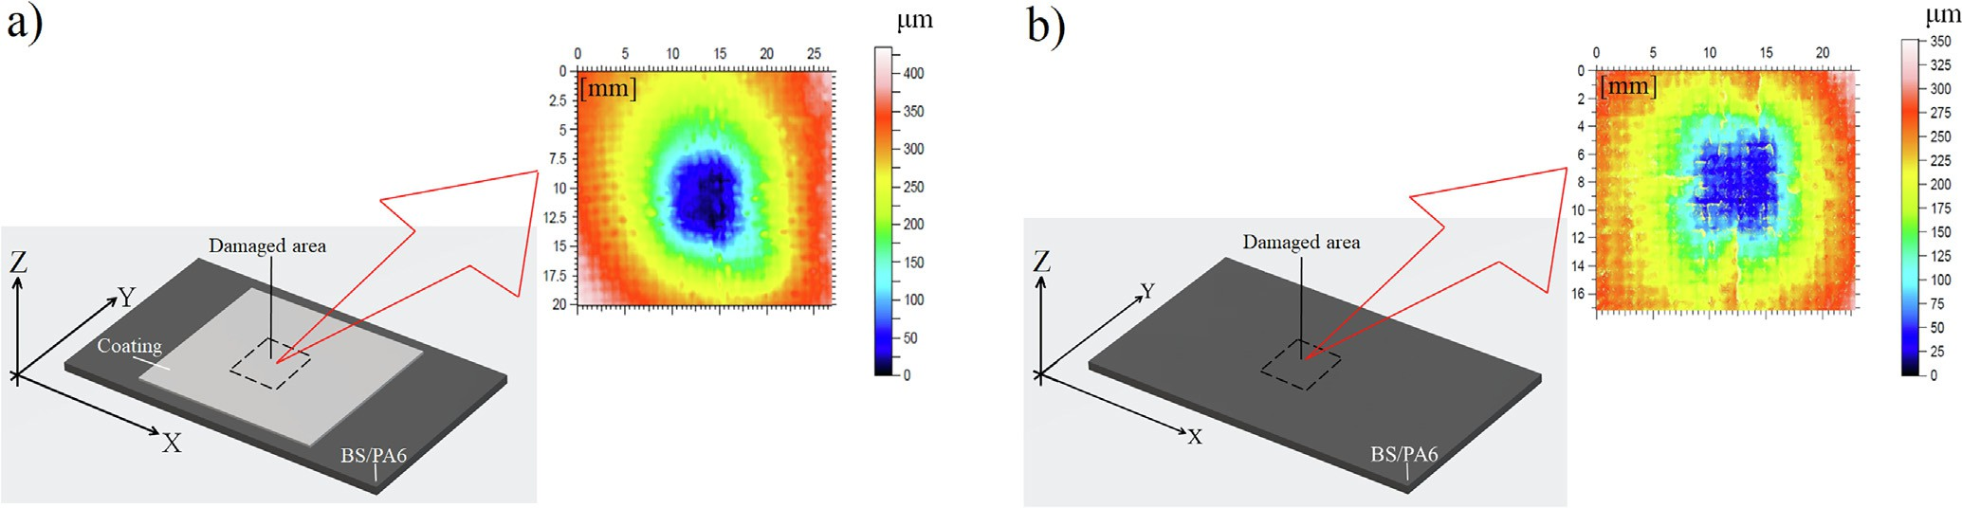
Fig. 11. Visual inspection image obtained by the confocal microscopy, Leica DCM3D for the indentation depth measurement: a) BS/PA6-coated; b) BS/PA6-neat.

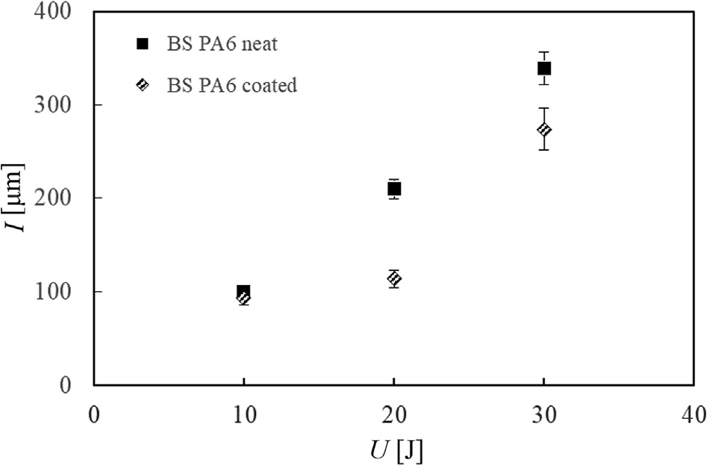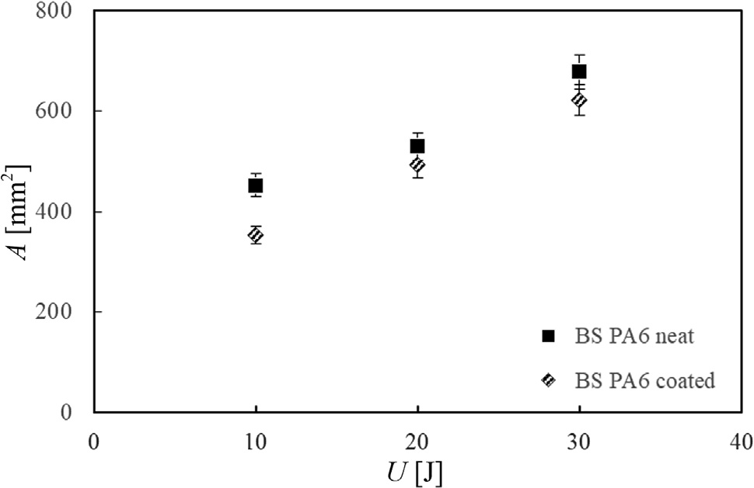

Fig. 12. Indentation depth, I, versus impact energy, U, for BS/PA6_coated and BS/PA6_neat samples.
Fig. 14. Delaminated area, A, versus impact energy, U, for BS/PA6_neat and BS/PA6_coated samples.

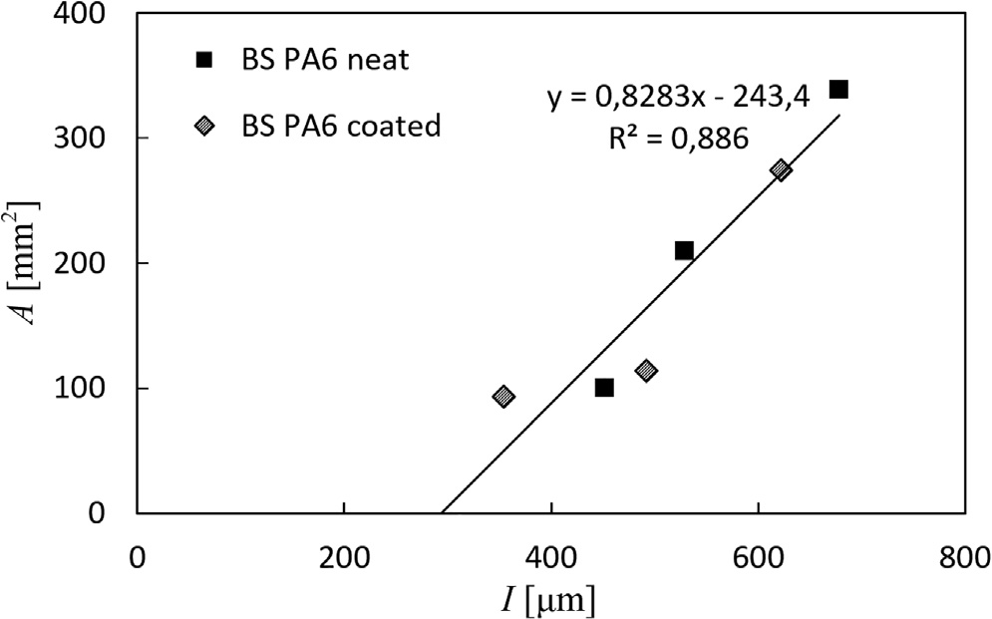
energy used by the impactor to rebound from the coated surface and that used for dissipative phenomena, respectively. On the base of these premises, the following analytical model can be drawn (Eq. (1)):
U = 1 mV2 = Ua + Ur + Ud = Ua,neat + Ur,neat + Ud,neat
2 I

= Ua,coated + Uap + Ur,coated + Ud,coated=
= (Uaf ,neat + Uam,neat ) + Ur,neat + Ud,neat = (Uaf ,coated + Uam,coated) + Uap
+ Ur,coated + Ud,coated

(1)

For all the tested conditions (U = 10 J, 20 J, 30 J), the ratio be- tween U_{r} and U, for both neat and coated samples, is shown in Fig. 16. It can be seen that U_{r,neat} is approximately equal to U_{r,coated} meaning that the impactor rebound velocity is around the same for neat and coated BS/PA6 substrates.
Taking into account for the results above, Eq. (1) can be rewritten as follow (Eq. (2)):

Fig. 15. Delaminated area, A, versus indentation depth, I, for BS/PA6_neat and BS/PA6_coated.

Ua,neat + Ud,neat = Ua,coated + Uap + Ud,coated
(2)
results for U = 30 J in Fig. 9), indicating, even more, a lower damage propensity of the metallised system. The reasons can be attributed to

Again, at relatively low impact energies, the dissipative energy contribution, U_{d}, can be usually considered negligible for both the neat and the coated samples, and Eq. (2) can be simpliﬁed as shown in Eq. (3).
the strain rate eﬀects of the metal coating that prevail at 30 J for BS/ PA6 coated sample. In fact, the variation of the impact energy is ob- tained by shifting the height of the penetrator resulting in a higher impact speed. Even if the impact test remains in the low-velocity range,

Ua,neat ≈ Ua,coated + Uap
(3)
the strain rate eﬀect inﬂuences the material behaviour of BS/PA6 coated system for U = 30 J. In this case, during the relatively higher

This result was experimentally found for the lower impact energy values (10 J and 20 J in Fig. 9). The experimental outcomes from C-scan analyses showed that a smaller delamination extension was measured on coated BS/PA6 substrates, for all tested impact energies, proving that U_{a,coated} is lower than U_{a,neat}. This means that a given amount of the impact energy was absorbed by the metallic particles (U_{ap}), so reducing the damage and the crack propagation of the undercoated composite substrate. A diﬀerent behaviour was detected when the system was impacted at 30 J. It was found that the energy absorbed by the coated system is considerably lower than that absorbed by neat sample (see the
impact energy test, the coated system behaves as a more rigid and mechanically more performant material that absorbs a lower amount of impact energy, namely a lower value of U_{a}. Moreover, in this case, the dissipative energy contribution in Eq. (2) cannot be neglected as it takes account for the phenomena involved at relatively higher impact speed, such as vibrational modes and the complicated eﬀects of the composite anisotropy [33–35]. Furthermore, for the coated system, the dissipative contribution, U_{d,coated}, becomes much more critical because of the higher anisotropy of the system, so reducing the value of the absorbed

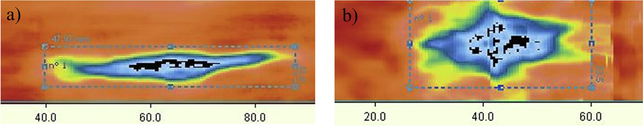
Fig. 13. C-scan acquisition for BS/PA6 system impacted at U = 30 J, a) neat; b) coated.

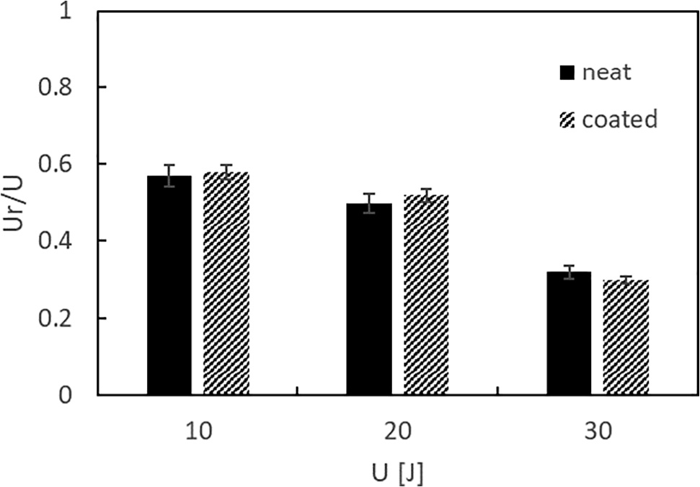
Fig. 16. Ratio between rebounding and impact energy, U_{r}/U, versus the impact energy, U, for BS/PA6 coated and neat.

energy and the consequent damage, as indicated also by the C-scan results.
As reported in Table 2, the CS metallization seems to have an eﬀect also on the maximum load values, F_{max}. When the impactor impinges the substrate, the impact force starts to increase reaching the highest values at the maximum deﬂection of the substrate (see Table 2 for details), for both neat and coated samples. In particular, lower values of the impact force were found for BS/PA6 coated sample for all impact energies used. The reason is that the stress induced into the cross-sec- tion of the impacted area increases linearly away from the neutral axis until the maximum values at the extreme ﬁbres at the top and bottom of the structure for elastic materials [34]. This kind of behaviour is re- presentative of composite materials which exhibit a linear-elastic re- sponse. On the contrary, for metallic ductile materials, when the stress induced into the cross-section of the structure overcomes the material plastic ﬂow tension, the plastic deformation occurs and the stress is going to follow the plastic ﬂow rules. A simple sketch of these me- chanisms is reported in Fig. 17.
In agreement with the scheme reported above, when the impactor impinges the metallic-coated sample, the ductile behaviour of the
coating promotes the plastic deformation of the same, also reducing the composite substrate damage. The result of this mechanism is a lower reaction force due to impact for BS/PA6 coated sample compared to that measured for neat substrate, as proved by the above experimental results.
For making more speciﬁc results, impact tests were carried out on BS/PA6 substrate coated with a solid metallic sheet by imposing an energy equal to 20 J. The comparison of the results between the neat sample and the coated solid sheet surface (BS Al) are shown in Fig. 18 in terms of load–displacement curves.
It can be seen that also in the case of the BS Al composite, the maximum load reached is lower than the neat composite due to the mechanism reported above (Fig. 17). However, in this case, the ab- sorbed energy, evaluated as the area enclosed in the curve, is higher than the neat material due to the extensive plastic deformation of the metal sheet that seems to reduce the damage of the composite substrate.

- Conclusions

The eﬀectiveness of the deposition of metallic particles on a com- posite laminate made by basalt ﬁbres in PA6 matrix through the cold spray process was studied. Based on the above discussed experimental results, the conclusions are as follow:

The CS process was proved to be a suitable technique for the man- ufacturing of a 3D printed metallic coating on BS/PA6 substrate if the process parameters are properly set (travel speed gun = 8 mm/ s, inlet gas temperature = 150 °C, inlet gas pressure = 6 bar and SoD = 35 mm);
•
•
After impact tests carried out at diﬀerent energy levels, it seems that fewer damages are created on the treated laminates; an increase of the initial rigidity and a lower maximum load were obtained;
•
The aluminium deposition inﬂuences the damage mechanisms: a lower indentation depth but a more considerable plastic deforma- tion in the plane was observed.
•
The coated systems result more inﬂuenced by the velocity variation justifying the less absorbed energy than the neat system in particular at U = 30 J, indicating a minor propensity to damage of the BS/PA6 coated.

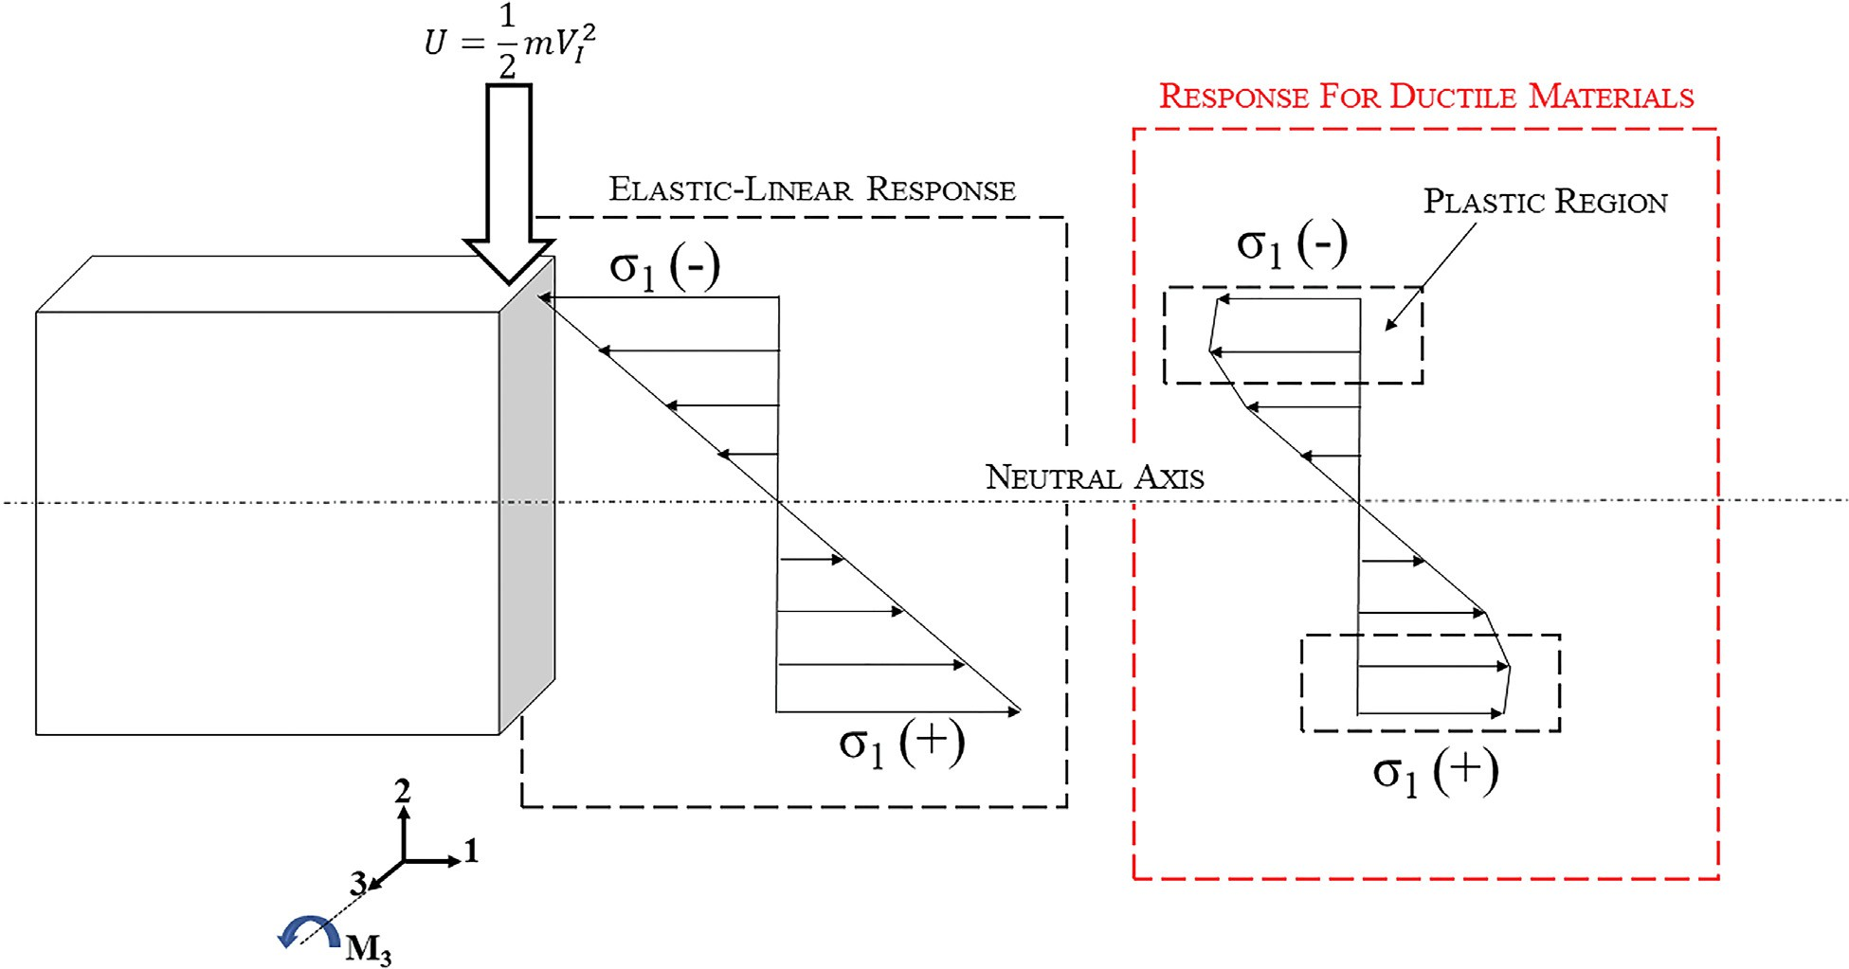
Fig. 17. Simple exempliﬁcation sketch of plastic ﬂow mechanisms.

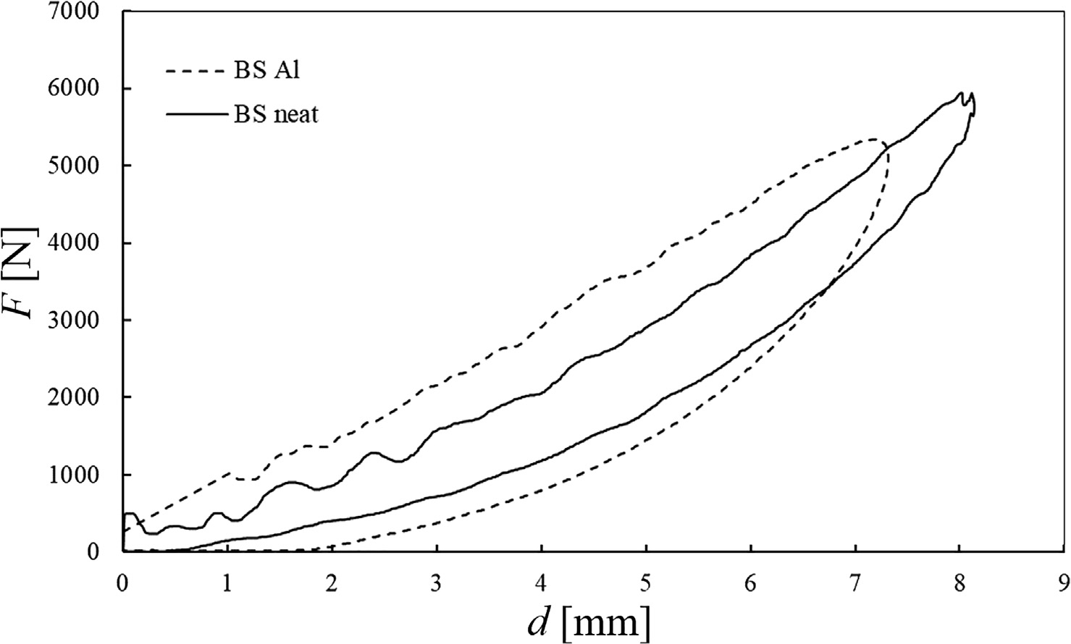
Fig. 18. Load-displacement comparison between metallic coated substrate, BS Al, and the neat composite, BS/PA6, at U = 20 J.

Also, the ultrasonic inspection of the damage has detected a larger delamination extension measured on neat basalt laminates for all tested impact energies. An interesting correlation between the ex- ternal and internal non-visual damage was found indicating that it is always possible to see the damage thanks to a plastic deformation always diﬀerent from zero. Once the latter is known, it is possible to easily calculate the delaminated area by means of a linear law to be deﬁned with a greater number of experimental data.
•

Future works go in the direction of an increase of the coating thickness by varying the process parameters. Due to the great potenti- ality of the solution here proposed, further tests need to be carried out in the future to evaluate the beneﬁcial eﬀects of the metallic coating as well as provide more detailed analytical formulations able to explain the complex physical impact phenomena.

CRediT authorship contribution statement

I. Papa: Conceptualization, Data curation, Formal analysis, Investigation, Methodology, Validation, Visualization, Writing - ori- ginal draft, Writing - review & editing. P. Russo: Methodology, Data curation, Resources. A. Astarita: Conceptualization, Formal analysis, Funding acquisition, Methodology, Project administration, Supervision, Validation, Writing - original draft, Writing - review & editing. A. Viscusi: Conceptualization, Data curation, Formal analysis, Investigation, Methodology, Validation, Visualization, Writing - ori- ginal draft, Writing - review & editing. A.S. Perna: Validation, Formal analysis, Investigation, Data curation, Visualization. L. Carrino: Supervision, Project administration, Funding acquisition. V. Lopresto: Conceptualization, Formal analysis, Methodology, Validation, Supervision, Project administration, Funding acquisition.

Declaration of Competing Interest

The authors declare that they have no known competing ﬁnancial interests or personal relationships that could have appeared to inﬂu- ence the work reported in this paper.

Acknowledgement

The authors gratefully acknowledge the ONR Solid Mechanics Program, in the person of Dr Yapa D.S. Rajapakse, Program Manager,
for the ﬁnancial support provided to this research.

References

- RUSSO P, PAPA I, LOPRESTO V. Impact Damage Behavior of Basalt Fibers Composite Laminates: Comparison Between Vinyl Ester and Nylon 6 Based Systems. Am. Soc. Compos. 2018, vol. 5, Lancaster, PA: DEStech Publications, Inc.; 2018, p. 3347–60. doi:10.12783/asc33/26177.
- Simeoli G, Acierno D, Sorrentino L, Iannace S, Sarasini F, Tirillò J, et al. COMPARISON OF LOW VELOCITY IMPACT BEHAVIOUR OF THERMOPLASTIC COMPOSITES REINFORCED WITH GLASS AND BASALT WOVEN FABRICS. 2014.
- Shokrieh MM, Memar M. Stress corrosion cracking of basalt/epoxy composites under bending loading. Appl Compos Mater 2010;17:121–35. https://doi.org/10. 1007/s10443-009-9116-4.
- Varley RJ, Tian W, Leong KH, Leong AY, Fredo F, Quaresimin M. The eﬀect of surface treatments on the mechanical properties of basalt-reinforced epoxy com- posites. Polym Compos 2013;34:320–9. https://doi.org/10.1002/pc.22412.
- Manikandan V, Winowlin Jappes JT, Suresh Kumar SM, Amuthakkannan P. Investigation of the eﬀect of surface modiﬁcations on the mechanical properties of basalt ﬁbre reinforced polymer composites. Compos Part B Eng 2012;43:812–8. https://doi.org/10.1016/j.compositesb.2011.11.009.
- Astarita A, Boccarusso L, Durante M, Viscusi A, Sansone R, Carrino L. Study of the production of a metallic coating on natural ﬁber composite through the cold spray technique. J Mater Eng Perform 2018;27:739–50. https://doi.org/10.1007/s11665- 018-3147-7.
- Papa I, Ricciardi M, Antonucci V, Langella A, Tirillò J, Sarasini F, et al. Comparison between diﬀerent non-destructive techniques methods to detect and characterize impact damage on composite laminates. J Compos Mater 2019;002199831986441. https://doi.org/10.1177/0021998319864411.
- Lopresto V, Papa I, Langella A. Residual strength evaluation after impact tests in extreme temperature conditions. New equipment for CAI tests. Compos Part B Eng 2017;127:44–52. doi:10.1016/j.compositesb.2017.03.013.
- Azouaoui K. Modelling of damage and failure of glass/epoxy composite plates subject to impact fatigue. Int J Fatigue 2001;23:877–85. https://doi.org/10.1016/ S0142-1123(01)00050-0.
- Caprino G, Lopresto V, Langella A, Durante M. Irreversibly absorbed energy and damage in GFRP laminates impacted at low velocity. Compos Struct 2011;93:2853–60. https://doi.org/10.1016/j.compstruct.2011.05.019.
- David-West OS, Nash DH, Banks WM. An experimental study of damage accumu- lation in balanced CFRP laminates due to repeated impact. Compos Struct 2008;83:247–58. https://doi.org/10.1016/j.compstruct.2007.04.015.
- DOREY G. An overview of impact damage in composites. 1989.
- Delfosse D, … AP-IC on CM, 1995 undeﬁned. Experimental parameter study of static and dynamic out-of-plane loading of CFRP laminates n.d..
- Caprino G. Residual strength prediction of impacted CFRP laminates. J Compos Mater 1984;18:508–18. https://doi.org/10.1177/002199838401800601.
- Ganesan A, Yamada M, Fukumoto M. Cold spray coating deposition mechanism on the thermoplastic and thermosetting polymer substrates. J Therm Spray Technol 2013;22:1275–82. https://doi.org/10.1007/s11666-013-9984-x.
- Villafuerte J. Current and future applications of cold spray technology. Met Finish 2010;108:37–9. https://doi.org/10.1016/S0026-0576(10)80005-4.
- Villafuerte J. Recent trends in cold spray technology: looking at the future. Surf Eng 2010;26:393–4. https://doi.org/10.1179/026708410X12687356948715.
- Irissou E, Legoux J-G, Arsenault B, Moreau C. Investigation of Al-Al2O3 Cold Spray

Coating Formation and Properties. J Therm Spray Technol 2007;16:661–8. https:// doi.org/10.1007/s11666-007-9086-8.
- Concustell A, Henao J, Dosta S, Cinca N, Cano IG, Guilemany JM. On the formation of metallic glass coatings by means of Cold Gas Spray technology. J Alloys Compd 2015;651:764–72. https://doi.org/10.1016/j.jallcom.2015.07.270.
- Henao J, Concustell A, G.Cano I, Dosta S, Cinca N, Guilemany JM, et al. Novel Al- based metallic glass coatings by Cold Gas Spray. Mater Des 2016;94:253–61. doi:10. 1016/j.matdes.2016.01.040.
- Goldbaum D, Shockley JM, Chromik RR, Rezaeian A, Yue S, Legoux J-G, et al. The eﬀect of deposition conditions on adhesion strength of Ti and Ti6Al4V cold spray splats. J Therm Spray Technol 2012;21:288–303. https://doi.org/10.1007/s11666- 011-9720-3.
- Zhang P, Santoro G, Yu S, Vayalil SK, Bommel S, Roth SV. Manipulating the as- sembly of spray-deposited nanocolloids. in situ study and monolayer ﬁlm pre- paration. Langmuir 2016;32:4251–8. https://doi.org/10.1021/acs.langmuir. 6b00892.
- Russo P, Langella A, Papa I, Simeoli G, Lopresto V. Thermoplastic polyurethane/ glass fabric composite laminates: Low velocity impact behavior under extreme temperature conditions. Compos Struct 2017;166:146–52. https://doi.org/10. 1016/j.compstruct.2017.01.054.
- Zhou XL, Chen AF, Liu JC, Wu XK, Zhang JS. Preparation of metallic coatings on polymer matrix composites by cold spray. Surf Coatings Technol 2011;206:132–6. https://doi.org/10.1016/j.surfcoat.2011.07.005.
- Che H, Chu X, Vo P, Yue S. Metallization of various polymers by cold spray. J Therm Spray Technol 2018;27:169–78. https://doi.org/10.1007/s11666-017-0663-1.
- Lupoi R, O’Neill W. Deposition of metallic coatings on polymer surfaces using cold spray. Surf Coatings Technol 2010;205:2167–73. https://doi.org/10.1016/j. surfcoat.2010.08.128.
- Che H, Chu X, Vo P, Yue S. Cold spray of mixed metal powders on carbon ﬁbre reinforced polymers. Surf Coatings Technol 2017;329:232–43. https://doi.org/10. 1016/j.surfcoat.2017.09.052.
- Boccarusso L, Viscusi A, Durante M, Astarita A, De Fazio D, Sansone R, et al. Deposition of aluminum coatings on bio-composite laminates. AIP Conf. Proc., vol. 1960, American Institute of Physics Inc.; 2018, p. 100004. doi:10.1063/1.5034944.
- Jacob GC, Fellers JF, Simunovic S, Starbuck JM. Energy absorption in polymer composites for automotive crashworthiness. J Compos Mater 2002;36:813–50. https://doi.org/10.1177/0021998302036007164.
- Perna AS, Viscusi A, Astarita A, Boccarusso L, Carrino L, Durante M, et al. Manufacturing of a metal matrix composite coating on a polymer matrix composite through cold gas dynamic spray technique. J Mater Eng Perform 2019. https://doi. org/10.1007/s11665-019-03914-6.
- Russo P, Simeoli G, Cimino F, Papa I, Ricciardi MR, Lopresto V. Impact damage behavior of vinyl ester-, epoxy-, and nylon 6-based basalt ﬁber composites. J Mater Eng Perform 2019;28:3256–66. https://doi.org/10.1007/s11665-019-04037-8.
- Olsson R. Mass criterion for wave controlled impact response of composite plates. Compos Part A Appl Sci Manuf 2000;31:879–87. https://doi.org/10.1016/S1359- 835X(00)00020-8.
- Abrate S. Modeling of impacts on composite structures. Compos Struct 2001;51:129–38. https://doi.org/10.1016/S0263-8223(00)00138-0.
- Caprino G, Langella A, Lopresto V. Elastic behaviour of circular composite plates transversely loaded at the centre. Compos Part A Appl Sci Manuf 2002;33:1191–7. https://doi.org/10.1016/S1359-835X(02)00087-8.
- Evci C, Gülgeç M. An experimental investigation on the impact response of com- posite materials. Int J Impact Eng 2012;43:40–51. https://doi.org/10.1016/j. ijimpeng.2011.11.009.

