Supporting Information
Magnetism of TbPc₂ on ferromagnetic iron oxide surface.
Niccolò Giaconi,¹ Leonardo Tacconi,¹ Fabio Santanni,¹ Marta Albanesi,¹ Guglielmo Pio Cesare Battista Albani,² Isheta Majumdar,² Luca Schio,³ Matteo Briganti,¹ Gianlorenzo Bussetti,² Edwige Otero,⁴ Luca Floreano,³ Andrea Caneschi,^{1,5} Matteo Mannini,¹ Giulia Serrano,^{1,5} Alberto Calloni,^{2*} Lorenzo Poggini.^{1,6*}
¹ Department of Chemistry “Ugo Schiff” DICUS & INSTM Research Unit, University of Florence, Via della Lastruccia 3-13, 50019, Sesto Fiorentino, Italy.
² Department of Physics, Politecnico di Milano, Piazza Leonardo da Vinci 32, Milan, 20133, Italy.
³ Istituto Officina dei Materiali – CNR-IOM Laboratorio TASC s.s. 14 km 163.5, 34149 Trieste, Italy⁴ Synchrotron-SOLEIL, L'Orme des Merisiers, Saint-Aubin, 91192 France.
⁵ Department of Industrial Engineering – DIEF – and INSTM Research Unit, University of Florence, Via Santa Marta 3, Florence, 50139 Italy.
⁶ Institute for Chemistry of Organo-Metallic Compounds (ICCOM-CNR), Via Madonna del Piano, Sesto Fiorentino, Firenze, 50019 Italy

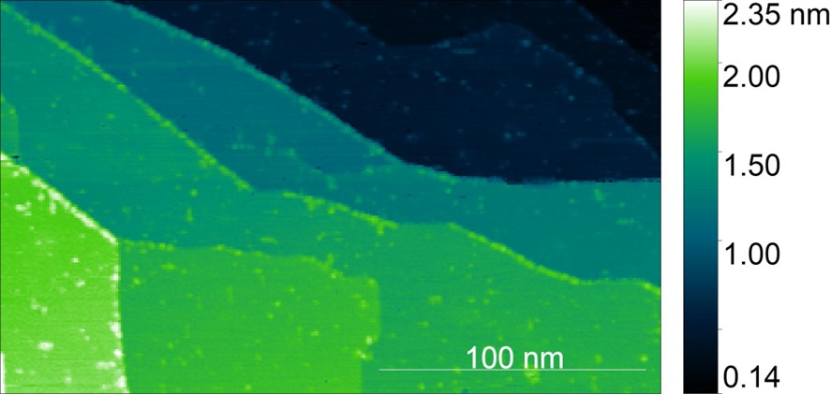
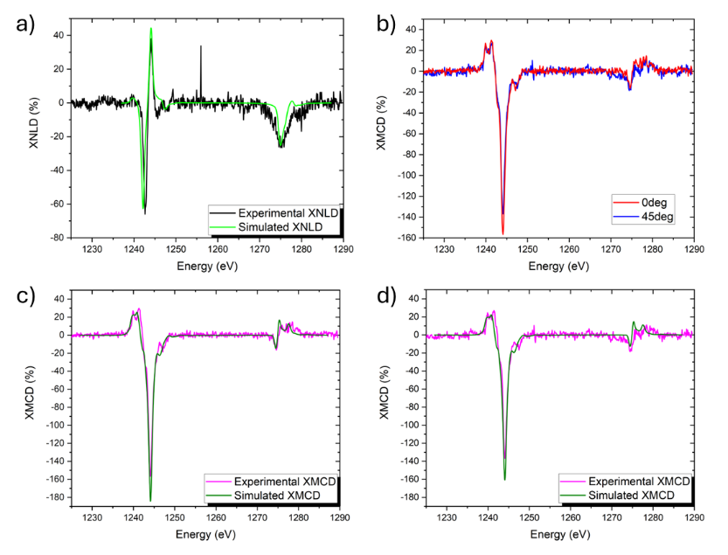
Figure S1. STM image of the ultra-thin FeO layer grown on Fe(001) (dimension 250x150nm², I_{t}=150pA, V_{b}= 500mV).
Figure S2. a) Simulated and experimental XNLD spectrum at the Tb M_{4,5} edge; b) XMCD spectra at the Tb M_{4,5} edge collected at 0° and 45° degree; c) and d) Simulated vs Experimental intensity of XMCD at the Tb M_{4,5} edge at 0° and 45° degree, respectively
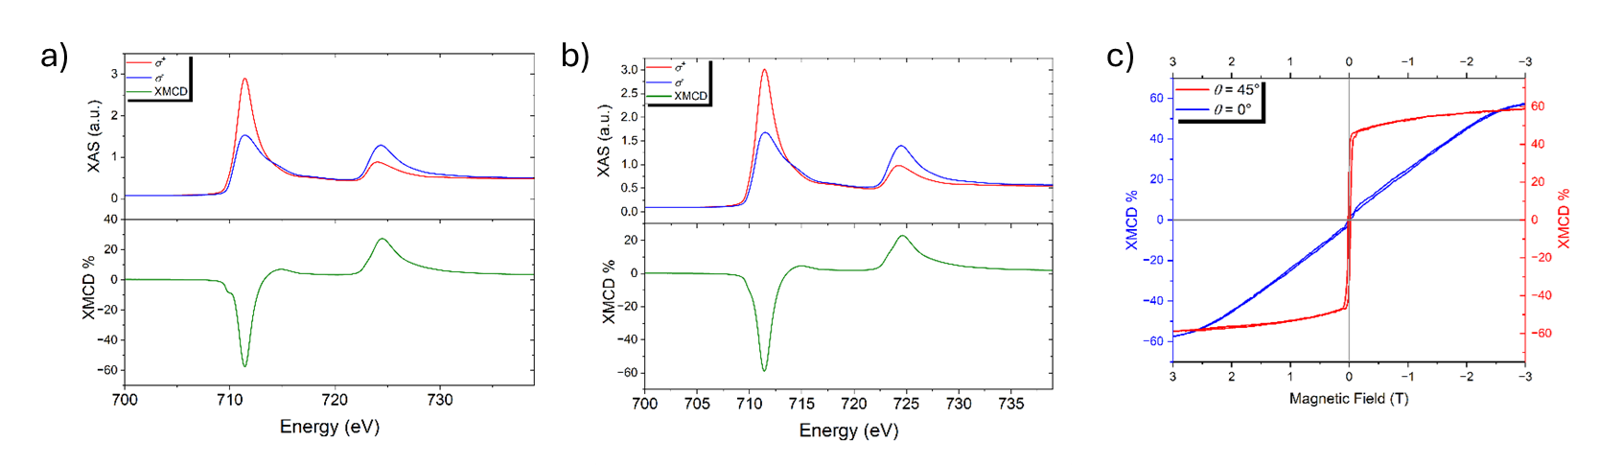
Figure S3. a) XMCD spectra at the Fe L_{2,3} edge at theta 0° and b) at theta 45°. c) Hysteresis loop recorded at the Fe L_{2,3} edge at angle (θ) 0° and at 45°.

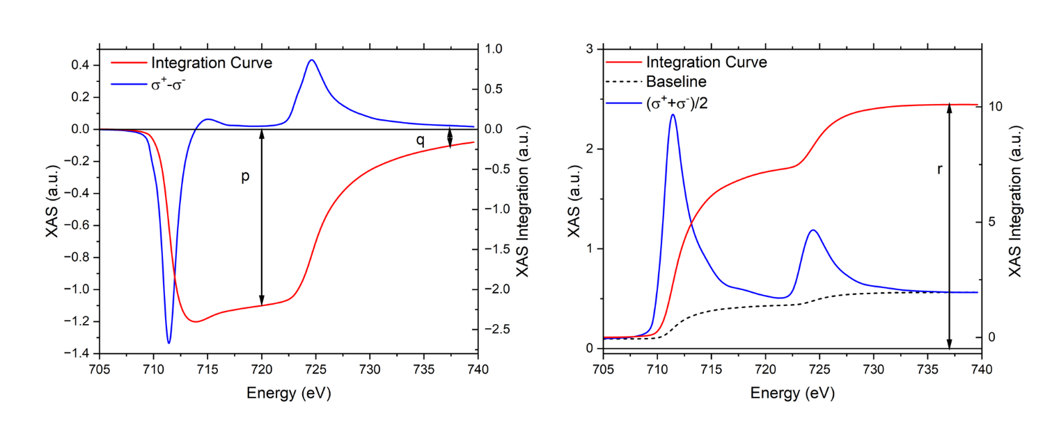
Table S1. Comparison between the simulated and the experimental XMCD percentages at the Tb M₅ edge, collected at 0° and 45°, and the relative intensity variation.
 | 0° (%) | 45° (%) | Variation
XMCD experimental | -156.6 | -136.8 | +19.3 (10%)
XMCD simulated | -184 | -160.7 | +19.8 (12.6%)
Figure S4. a) XMCD (σ⁻ - σ ⁺ ) (blue line) spectrum acquired at the Fe L_{2,3} edge and the resulting integration (red line); b)(σ⁺+σ ⁻ )/2 spectra (blue curve) with a double step baseline and the resulting integrated curve (red line).

The moments and the m_{orb}/m_{spin} ratio were calculated as reported in ref [1]:
$$m_{orb}=\frac{-4q*n_{3d}}{6r}$$
$$m_{spin}=\frac{-(6p-4q)*n_{3d}}{2r}$$

where n_{3d} is the number of d holes, p and q are the integrated areas of the XMCD spectrum at the L₃ and L₂ edges, respectively, while r corresponds to the total area of the (σ⁻+σ⁺)/2 spectrum after subtraction of a double step baseline (with a step height ratio L₃:L₂ of 2:1). From this analysis, by imposing n_{3d} = 3.39 we estimated m_{orb} = 0.08 µB, m_{spin} = 2.217 µB and the resulting ratio m_{orb}/m_{spin} = 0.034.

Table S2. Parameters employed during simulations of polarised XAS spectra. Parameters with the subscript $i$ refer to the initial electronic state $3d^{10}4f^{8}$, while those with the subscript $f$ refer to the final electronic state $3d^{9}4f^{9}$. The letters d and f in parentheses indicate the electronic shell on which the parameters act.
Parameter | Value (eV) | Parameter | Value (eV)
$$F_{i}^{2}\left(f\right)$$ | 11.929 | $$F_{f}^{6}\left(f\right)$$ | 5.640
$$F_{i}^{4}\left(f\right)$$ | 7.486 | $$F_{f}^{2}\left(df\right)$$ | 8.042
$$F_{i}^{6}\left(f\right)$$ | 5.386 | $$F_{f}^{4}\left(df\right)$$ | 3.766
$$ζ_{i}\left(f\right)$$ | 0.221 | $$G_{f}^{1}\left(df\right)$$ | 5.788
$$B_{2}^{0}$$ | 0.0515 | $$G_{f}^{3}\left(df\right)$$ | 3.394
$$B_{4}^{0}$$ | -0.0283 | $$G_{f}^{5}\left(df\right)$$ | 2.345
$$B_{6}^{0}$$ | 0.00382 | $$ζ_{f}\left(f\right)$$ | 0.251
$$F_{f}^{2}\left(f\right)$$ | 12.468 | $$ζ_{f}\left(d\right)$$ | 13.368
$$F_{f}^{4}\left(f\right)$$ | 7.834

Table S3. Comprehensive table summarizing literature data on the deposition of TbPc₂ SMM on different substrates and their physicochemical properties.
Substrate | Electronic Nature | Band Gap (Eg​) | Thickness | Observed TbPc₂ Magnetic Behaviour | Interaction Mechanism | Ref.
FeO / Fe(001) | Correlated Metallic Overlayer (Substrate-hybridized 3d bands) | ~0 eV | 1 ML | Preserved Magnetic Behaviour/ Quenched Hysteresis | f-π-d hybridization; mediated exchange via narrowed 3d-states. | [2- this paper]
MgO / Ag(100) | Wide-gap Insulator | ~7.8 eV | 1–5 ML | Preserved SMM / Giant Butterfly Hysteresis | Pure electronic decoupling; suppression of substrate-mediated relaxation. | [3]
TiO₂ / Ag(100) | Band Insulator | ~3.0 eV | 1 ML (Lepidocrocite) | Preserved SMM / Small Butterfly Hysteresis | Partial decoupling; efficiency comparable to Graphene. | [4]
Graphene / SiC(0001) | Semi-metal (Dirac Cone, Zero gap) | 0 eV | 1 ML | Preserved SMM / Small Butterfly Hysteresis | Weak π-π interaction; weak coupling to the metallic substrate. | [5]
Au(111) | Metal (Noble, highly delocalized s/p bands) | 0 eV | Bulk | Quenched Hysteresis / Kondo Effect | Strong hybridisation; direct exchange screening by conduction electrons. | [6]

References
[1] Chen C T, et al., Phys. Rev. Lett. 75 152–5. DOI:10.1103/PhysRevLett.75.152
[2] This paper;
[3] C. Wäckerlin et al., Adv. Mater., 2016, 28, 5195–5199. DOI: 10.1002/adma.201506305
[4] A.L Sorrentino et al., J. Mat. Chem. C, 2021, 9, 14949–14958. DOI: 10.1039/D1TC03408A
[5] G. serrano et al., Nanoscale, 2018, 10, 2733–2740. DOI: 10.1039/C7NR08372F
[6] K. Katoh et al., ", JACS, 2009, 131, 9967–9976. DOI: 10.1021/ja902349t

