Supplementary material
A. Kivimäki¹ and R. Richter²
¹CNR – Istituto officina dei materiali (IOM), Laboratorio TASC, 34149 Trieste, Italy
²Elettra – Sincrotrone Trieste, Area Science Park Basovizza, 34149 Trieste, Italy

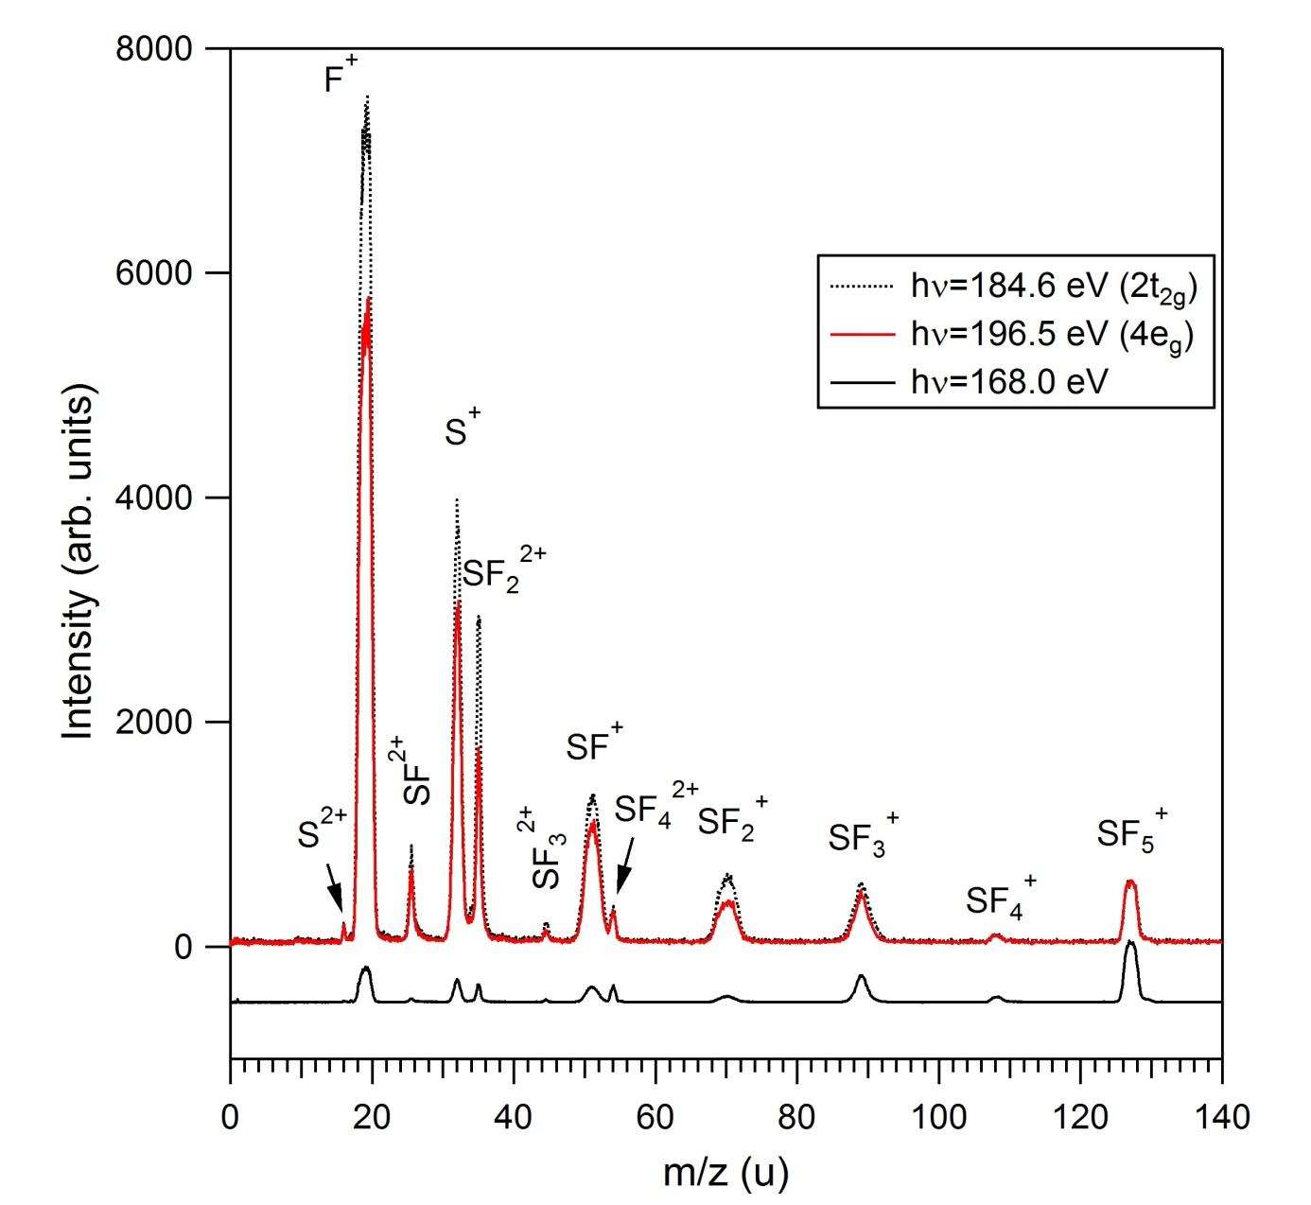
Figure S1. The photoelectron-photoion coincidence (PEPICO) spectra of SF₆ measured at the photon energies of 168.0 eV (corresponding to valence ionization), 184.6 eV (S 2p_{1/2} → 2t_{2g} shape resonance) and 196.5 eV (S 2p → 4e_{g} shape resonance). The spectra were measured at the low-energy branch of the Gas Phase Photoemission beamline (Elettra, Trieste, Italy) [1] using a time-of-flight spectrometer with a 105 mm long drift tube. According to simulations performed with the SIMION software package, F⁺ ions with kinetic energies up to 25 eV were collected. The spectra have been scaled in intensity at the position of the SF₅⁺ ion, which originates only (or predominantly) from valence ionization processes [2] (see also Fig. S2).
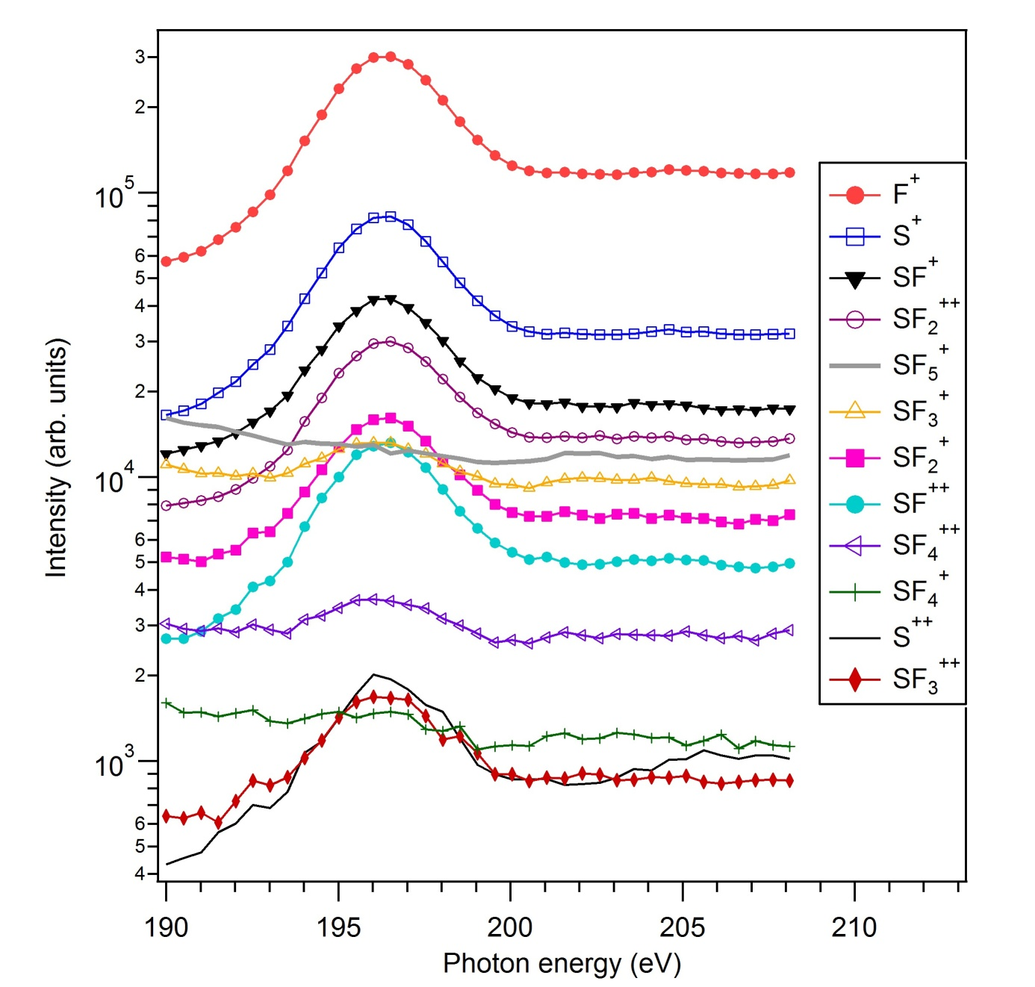

Figure S2. The intensities of different positive ions around the energy range of the S 2p→4e_{g} shape resonance of the SF₆ molecule, determined by integrating relevant time windows in the PEPICO spectra (like those in Fig. S1). The spectra were measured for 3 min at each energy point. The intensities have been normalized to the photon flux, but no correction was attempted for possible detection efficiency dependence on the mass and charge of the ions.

References
[1] K.C. Prince et al, J. Synchrotron Radiation 5 (1998) 565.
[2] A.P. Hitchcock, C.E. Brion, M.J. Van der Wiel, J. Phys. B: At. Mol. Phys. 11 (1978) 3245.

