Analysis of the Effects of Hf and Zr substitution in a reference High-Entropy Alloy

Rolando Pedicini^{1*}, Antonino Aricò¹
¹Consiglio Nazionale delle Ricerche – Istituto di Tecnologie Avanzate per l’Energia “Nicola Giordano”, via S. Lucia sopra Contesse 5 – 98126 Messina

Abstract. This study investigates the synthesis and characterization of high-entropy alloys (HEAs) for hydrogen storage applications, focusing on two alloy systems: a reference alloy (TiVZrHfNb) and a modified version (TiVCrFeNb) in which Zr and Hf are replaced by Cr and Fe, respectively. The alloys were synthesized using mechanical ball milling with equimolar metal ratios. The goal was to obtain a body-centered cubic (BCC) single-phase alloy capable of storing hydrogen efficiently near ambient temperatures. The influence of milling times (5h, 7h, 14h, 24h, and 48h) on the alloy formation was evaluated while keeping other parameters constant. Preliminary results from X-ray diffraction (XRD) analyses indicate that longer milling times slightly increase crystallinity but do not yet result in complete alloy formation, as individual metal peaks and partial alloy phases such as FeTiV and VCrFe remain visible. The TiVZrHfNb alloy appears more prone to oxidation during handling and analysis, suggesting greater sensitivity to air exposure compared to TiVCrFeNb. The ongoing work includes further synthesis with extended milling durations and in-depth characterizations to assess alloy homogeneity and resistance to oxidation, aiming to optimize the material for hydrogen storage.

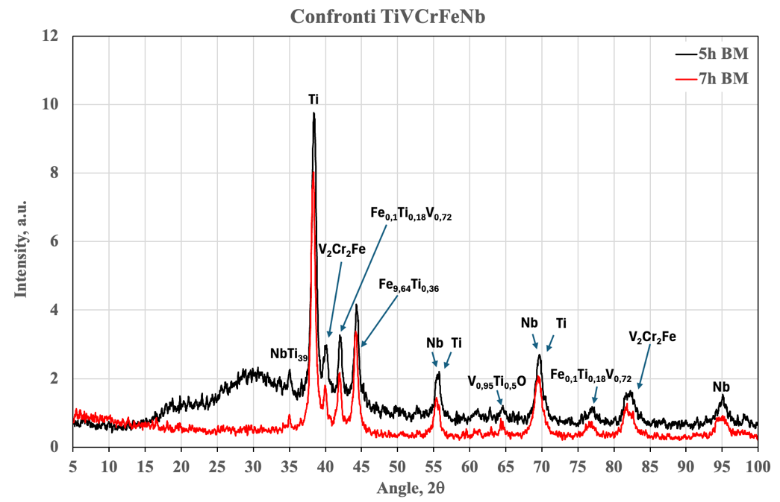
Fig. 1. XRD patterns comparison of TiVCrFeNb

Corresponding author: rolando.pedicini@cnr.it

