MCSim: A Multi-Access Edge Computing Mobile CrowdSensing Simulator (Short title: MCSim: A MEC MCS Simulator)

Dimitri Belli^{a,∗}, Paolo Barsocchiª, Antonino Crivelloª, Davide La Rosaª, Michele Girolamiª

ª National Research Council (CNR), Institute of Information Science and Technologies (ISTI), Via G. Moruzzi 1, 56124, Pisa (PI), Italy
e-mail: {dimitri.belli,paolo.barsocchi,antonino.crivello,michele.girolami,davide.larosa}@isti.cnr.it
* Corresponding author

Abstract
This paper introduces MCSim, a modular and extensible simulator designed to support the planning and evaluation of Mobile CrowdSensing (MCS) campaigns in urban environments. MCSim integrates a useful approximation of urban mobility patterns based on real-world street networks, as well as the simulation of task execution effectiveness within configurable data transmission ranges. Unlike other simulators, MCSim is built to accommodate future extensions, such as edge/fog computing architectures. The current version of the software offers a user-friendly interface, customizable configuration options, and robust output analysis. By combining realistic mobility modeling, configurable task logic, and architectural flexibility, MCSim provides researchers and practitioners with a powerful tool for optimizing MCS strategies while minimizing deployment costs and risks.

Keywords
MCS, MEC, FC, Task Execution

Metadata

Nr | Code metadata description | Metadata
C1 | Current code version | v1.1.0
C2 | Permanent link to code/repository used for this code version | https://github.com/Lafcadio79/Multi-Access-Edge-Fog-Crowd-Sensing-Simulator
C3 | Permanent link to reproducible capsule | https://codeocean.com/capsule/2064804/tree
C4 | Legal code license | GNU General Public License version 3 (GPLv3)
C5 | Code versioning system used | Git
C6 | Software code languages, tools and services used | Python
C7 | Compilation requirements, operating environments and dependencies | Python version 3.8 or higher; support for Windows and Linux; required networkx, osmnx, haversine, and tqdm dependencies
C8 | If available, link to developer documentation/manual | https://github.com/Lafcadio79/Multi-Access-Edge-Fog-Crowd-Sensing-Simulator/blob/master/README.md
C9 | Support email for questions | dimitri.belli@isti.cnr.it

Motivation and significance
In recent decades, the proliferation of mobile and wearable devices, such as smartphones, smartwatches, and tablets, has grown exponentially. Each generation of these devices boasts increased processing power, while advancements in sensor technology pave the way for the future integration of additional capabilities, such as environmental and biosensors. These devices are also equipped with a variety of short-, medium-, and long-range communication interfaces. As a result, because of the pervasiveness of such devices, Mobile CrowdSensing (MCS) has emerged as a promising sensing paradigm for collecting large amounts of information in several type of environment [1].
The uniqueness of the MCS paradigm lies in the active involvement of individuals who contribute sensor data to monitor large-scale phenomena. A key objective is to reinvest this data in the environment where it was collected, for instance, to enhance urban infrastructure, monitor air pollution, or manage city traffic.
MCS leverages the sensing capabilities of smart mobile devices for crowd-based data collection campaigns [2]. These campaigns typically involve three core components: (1) users carrying sensor-equipped mobile devices, (2) the devices themselves, which facilitate both data collection and transmission, and (3) a cloud server that aggregates and processes the collected data. The server may also dynamically assign sensing tasks to participants.
Due to the large volume of data and the need for timely processing, MCS systems are frequently integrated with edge or fog computing architectures. These architectures enable more efficient data exchange and allow for the use of more capable edge devices for local analysis [3].
These campaigns provide an innovative approach to collect data, especially in urban and rural areas where traditional sensing infrastructure is limited. However, planning and deploying such campaigns is resource-intensive and requires extensive user recruitment. To mitigate these challenges, it is helpful to first evaluate the feasibility and effectiveness of an MCS campaign in a simulated environment that closely mirrors real-world conditions. To this end, we have developed software that simulates the assignment of sensing tasks by an MCS server and their execution by one or more users within customizable, real-world scenarios.
In this work we present MCSim (Mobile CrowdSensing Simulator), a software solution designed to optimize the simulation of critical tasks in large-scale data collection campaigns, focusing on overcoming the challenges of high set-up costs. The software is partly inspired by the work of Fiandrino et al. [4], who developed CrowdSenSim, a discrete-event simulation platform that facilitates the simulation of large-scale crowd-sensing activities in urban environments. While the latter work focuses on the sensing activities of mobile devices, our work focuses on executing data collection tasks assigned to multiple users. In particular, our software focuses on simulating task assignment and execution for collecting data in hard-to-reach locations [5].
MCSim supports the development of solutions for task assignment and task execution, as well as the predisposition for their deployment in different architectural scenarios. Moreover, the simulator is designed to support the future implementation of Multi-access Edge Computing (MEC) and Fog Computing (FC) architectures. For example, it could enable the selection of deployment points based on dynamically identified hot spots, such as areas with high user density or activity [6] [7]. Although these mechanisms are not yet implemented, the simulator is structured to facilitate their integration by third-party developers or in future releases.
Existing MCS simulation systems primarily focus on aspects directly related to MCS campaigns, often assuming that task allocation is performed exclusively by a centralized MCS cloud server. Among the most notable MCS simulators, we highlight the Opportunistic Network Environment (ONE) simulator [8] , a Java-based tool designed to evaluate delay-tolerant network protocols; LEPTON [9], a lightweight emulation platform for opportunistic network systems; and TACSim [10], a simulator tailored to evaluate task allocation mechanisms in participatory MCS in realistic urban settings. While ONE, LEPTON, and TACSim are well-established tools with distinct strengths, they share a common limitation: none fully addresses the needs of modern MCS systems that rely on distributed architectures such as edge/fog. The latter brings computing resources closer to data sources, improving efficiency, scalability, and responsiveness, critical aspects that MCSim explicitly supports.
MCSim enables the simulation of resource offloading and low-latency data processing, which are essential for modern MCS systems. In contrast, ONE focuses on delay-tolerant networks and opportunistic communications that often do not meet real-time requirements. LEPTON, while powerful, requires significant computing resources and lacks support for distributed computing. TACSim takes a centralized approach to task allocation, making it less suitable for distributed architectures.
Finally, we mention the Crowdsensing-supported Interactive World-scale Environment Simulator (CATLES) [11], a world-scale simulator designed to test, evaluate, and demonstrate context-aware systems, including location-based services, in realistic virtual environments, and VirtualCrowd [12], a simulation platform designed to facilitate the design, configuration, execution, and analysis of microtask crowdsourcing campaigns. Both CATLES and VirtualCrowd are tailored to provide highly realistic world-scale simulation environments, but without explicit support for edge/fog principles.
Table 2 provides an overview of the main features implemented in each of the aforementioned simulators and compares them with our proposed solution. Specifically, the comparison considers user mobility management, task execution logic, customization of data transmission range, and support for edge/fog extensibility.

Table 2: Comparison of Main Mobile CrowdSensing simulator solutions (an empty cell means absence; means presence).
Name | User Mobility Management | Task Execution Logic | Customized Data Transmission Range | Edge/Fog Extensibility
ONE [8] | 
LEPTON [9]
TACSim [10]
CATLES [11]
VirtualCrowd [12]
CrowdSenSim [4]
MCSim

Software description
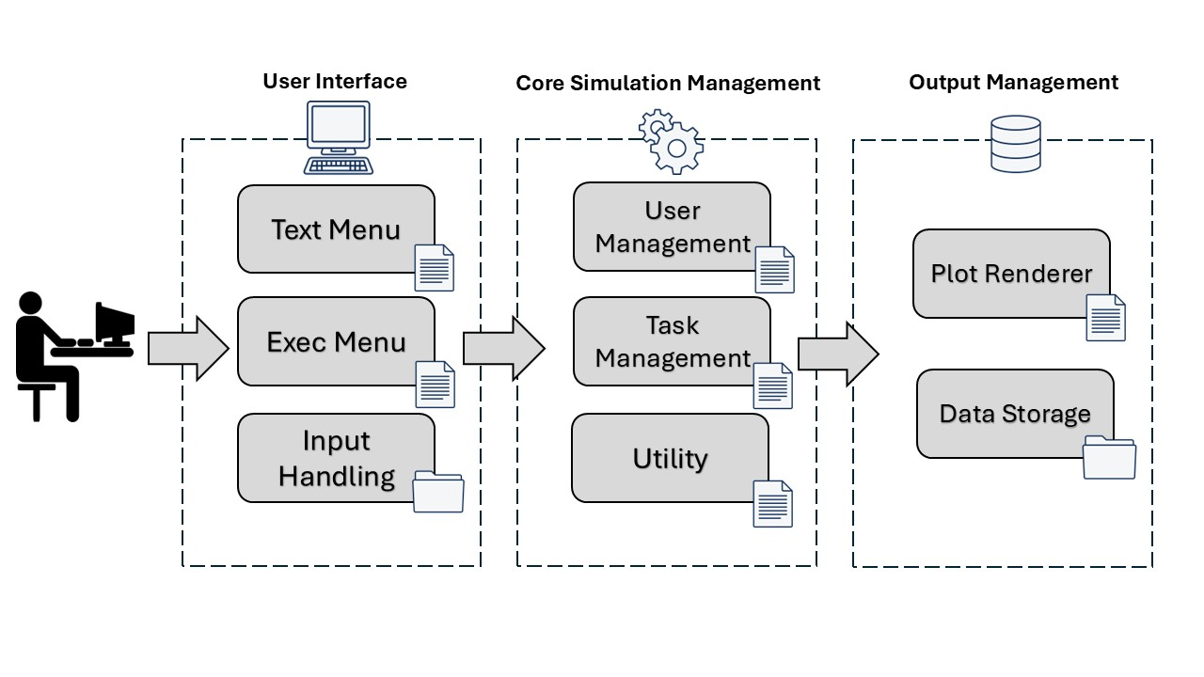
The software addresses the significant setup costs associated with real-world massive data collection by allowing the simulation of a key component: task execution by MCS participants. In real-world campaigns, these tasks encompass a variety of sensing operations performed using mobile devices, such as capturing photos or measuring environmental brightness levels. In the following are introduced both the software architecture and its main functionalities.
Figure 1: Architectural diagram showing the layout of the main system components

Software architecture

Briefly, MCSim is a Python-based tool designed for simulating mobile crowd sensing in edge computing environments. It takes a geographic location as input and generates a list of user movements and tasks. The simulator computes how many users can complete tasks based on their proximity to the tasks. It leverages libraries like osmnx==1.9.2 [13], r-tree==1.0_43, tqdm==4.65.0, and haversine==2.8.1, and supports Python 3.x version.

Figure 1 shows a schematic of the software architecture for managing I/O operations and core processing. The system is divided into three main modules, each of which consists of several submodules: User Interface, Core Simulation Management, and Output Management.

The User Interface module handles input operations through text and execution menu files, using an input folder to store setup configurations and initial data. The Core Simulation Management module includes submodules responsible for generating user movement traces and managing task deployment. It also includes utilities for calculating candidate assignments for each task, handling auxiliary modules, and reserving empty slots for future scenario extensions (i.e., edge/fog architectures).

Finally, the output management module is responsible for rendering results via a plot renderer and ensuring data persistence via a dedicated storage system.

Finally, the output management module is responsible for rendering results via a plot renderer and ensuring data persistence via a dedicated storage system.

Software functionalities

The user can interact with the system via a Command Line Interface (CLI), where each option is assigned a sequential number. The system displays the default settings from the previous simulation at the top of the initial screen, separated by a dotted line. The CLI enables users to interact with and modify simulation settings. As shown in Figure 2, the main menu consists of two sections: the top section displays the current simulation parameters, ensuring that they remain visible at all times, while the bottom section presents the available menu options and the command prompt, allowing users to navigate and modify settings by typing the appropriate number.

The main menu allows the user to run a saved simulation (1), create a new list of events (2), initiate a new simulation using the settings at the top of the screen (3), delete a saved simulation (4), edit the simulation parameters (5), or exit without a prompt (6).

If the user selects option 1, the program will display a list of saved simulations. For each saved simulation, the following details are shown: the city, the number of users, the number of tasks, the duration in days, and the platform in use (currently, only the MCS platform is available, but the code is ready to implement MEC and FC platforms).

Selecting option 2 allows the creation of a new list of events using the settings displayed at the top of the screen. Upon selection, the program prompts the user to enter the name of a city. After confirmation, the program downloads the relevant data and creates a geo-referenced data frame that includes information on the urban fabric. Using this information, the program generates a list of user movements, distributes various tasks within the urban fabric, and calculates the potential users suitable for performing these tasks. It then informs the user about the number of records, files, and tasks generated during the computation. Finally, it allows the user to save the calculation results. Option 3 allows the user to delete a saved simulation. Selecting this option redirects the user to a menu listing all saved simulations. Choosing the last item in the list returns the user to the main menu. Option 4 allows the user to modify the simulation parameters. The sub-menu for Option 4 includes the following choices: days, number of users, number of tasks, data transmission range, and type of platform. There are no minimum or maximum limits for any of the options. However, for satisfactory results, it is advisable to stay within a time range that does not exceed one week and to choose a data transmission range that matches the communication interface intended for real-world use (e.g., 100 meters for Wi-Fi, 10 meters for Bluetooth, etc.). Note that there is no limit to the number of users or tasks. However, many users and tasks will increase the simulation time, as the simulator must generate many user movement events.

The settings for each simulation are stored in a text file setup.txt, which is rewritten each time the user changes information related to the duration of the simulation, the number of users, the number of tasks, the transmission range or the type of platform.

The simulation environment is configured to generate user movements on foot or by other means (e.g., bicycle, car, or both). By default, however, the simulator creates a list of events featuring pedestrian movements.

The program generates user movement patterns using Dijkstra's algorithm to compute the most efficient paths through the network. For task assignment, it verifies that the user stays within the data transmission range long enough during the scheduled time slot. As for limitations, the current version of the software does not have an automatic procedure for processing real-world data, and it only generates random user movements based on the shortest path from point A to point B.

For the sake of clarity, we must point out that the current approach selects start and end points from network vertices, which can introduce spatial bias. Areas with a high vertex density, such as curved roads composed of many short segments, are overrepresented compared to long, straight segments with fewer vertices. While this approach simplifies path computation, it affects the spatial distribution of simulated paths. Nevertheless, the simulator has a modular design that allows developers to implement alternative mobility models. Depending on their simulation goals, users can define custom sampling strategies. For instance, they can select points uniformly along road segments or weight them based on population density.

To execute the program efficiently, the user can create an isolated environment using Anaconda tool, install the required libraries as specified in the README.md file, and utilize the shell script for Linux or the batch script for Windows.

Finally, at the end of each simulation, the program automatically displays the results, terminates the current session, and returns the user to the CLI. To start a new simulation, the user must execute the launcher script again, which navigates them back to the main menu.

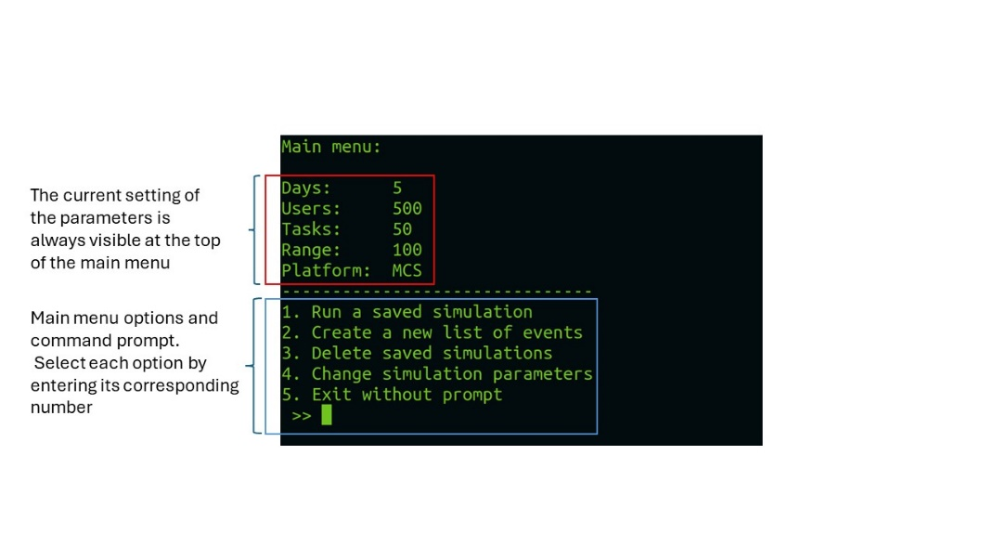
The final list generated at the end of the simulation displays, on the left, the sequential number associated with each key, and on the right, the number of users able to complete the given task within the simulation timeframe.

Figure 2: The main menu is divided into two sections: the upper section (red box) consistently displays the current simulation parameters, while the lower section (blue box) presents the available options and the command prompt.

The above description focuses solely on user interaction with the menu, providing limited insight into the inner work of the simulator, which is noteworthy as well. Specifically, it is important to note the deployment and operation of users and tasks, two entities that play crucial roles in the MCS scenario in terms of mobility and execution, respectively.
User mobility and task execution are modeled as two distinct processes. Users follow predefined routes and are unaware of task locations. If a user remains in the data transmission range long enough, any task within transmission range can be executed. Once users are deployed at their starting location, they follow predefined paths that are generated using the shortest-path routing method over the street network. Currently, the simulator does not allow users to know the locations of their tasks, and they do not alter their trajectories in response to task placement. Tasks, on the other hand, remain fixed at their assigned locations for a predefined duration. Any user who enters the transmission range of a task during this time can execute it, provided they remain within the data transmission range of the task long enough to complete it. This design prioritizes simplicity and general applicability over adaptive or opportunistic behavior. Furthermore, there is no limit to the number of users who can execute a given task. Lastly, it is worth noting that both the placement of users and tasks depend on the Mersenne Twister pseudorandom number generator. This generator randomly selects nodes from the graph of street intersections extracted via osmnx. This ensures that the spatial distribution of agents and tasks is statistically robust and reproducible across simulation runs.

Illustrative examples
- The simulation begins with a welcome message displayed on the screen, which introduces the user to the developing information. The user is then presented with a main menu containing five options: the ability to run a saved simulation, create a new list of events, delete an existing saved simulation, change the simulation parameters, or exit the program without further prompts. If the user chooses to create a new list of events by selecting option 2, the system prompts them to enter the name of a city for which the simulation is to be created. For instance, when the user enters "Pamplona", the system begins downloading the map of the city from the open street map repository, displaying a series of messages as it constructs the city graph. It then proceeds to generate a list of events based on the current simulation parameters, which include the number of days, users, tasks, data transmission range, and platform type. The system informs the user that the events for Pamplona have been generated and starts calculating the task assignments based on these parameters. Afterward, the system asks if the user wishes to save the simulation. Once saved, the results of the simulation will be displayed on the screen and the application will exit. An illustrative video of the above description, showing in detail how the simulator works, is available for download at https://github.com/Lafcadio79/Multi-Access-Edge-Fog-Crowd-Sensing-Simulator/blob/master/pamplona.mp4
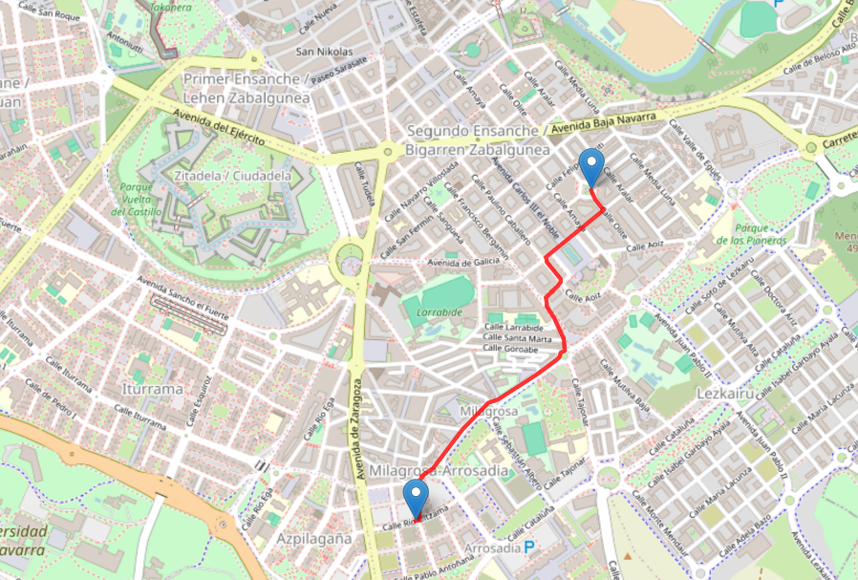
Figure 3 illustrates a user path generated by the simulator based on the movement list of events associated with a given user. Figure 4, instead, presents a bar plot showing the number of candidates capable of executing each task, derived from the processed data. A Jupyter notebook has been added to the source code of the simulator to generate these images.
Figure 3: Exemplificative representation of a user path as generated by the simulator
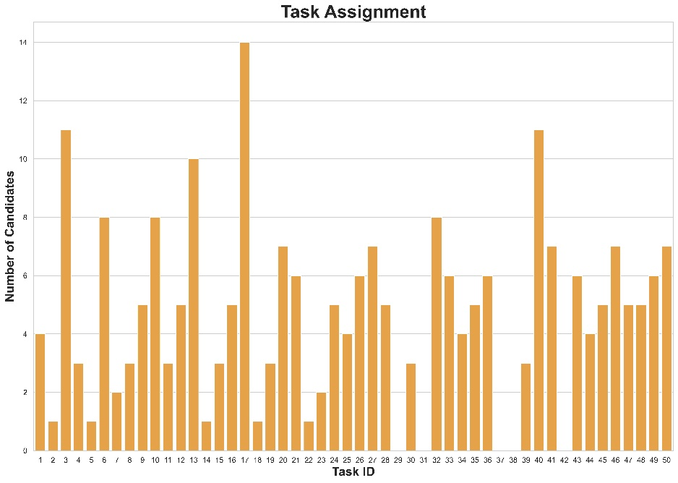
Figure 4: Exemplificative representation of the simulator's results

- Impact
The proposed software solution, MCSim, enhances MCS campaigns by allowing users to simulate task execution and data collection in urban environments. It reduces the high setup costs of real-world campaigns by modeling mobility patterns and task effectiveness. By integrating edge and fog computing, MCSim optimizes network efficiency, reduces data latency and supports scalability, making it a flexible and cost-effective tool for both research and real-world infrastructure planning.
In addition to these benefits, efficient task planning with MCS campaigns can further enhance data collection by balancing task quality with cost-effectiveness.
Specifically, efficient task planning in MCS campaigns can significantly enhance data collection and is critical for balancing task quality with cost-effectiveness [14]. One approach involves targeting untraveled urban landscape areas and incentives users to gather data in these less explored regions. This strategy addresses the challenge of achieving comprehensive spatial coverage. However, it may divert users from high-density 'hotspots' where peripheral edge nodes could be deployed for local data processing and analysis. This localized approach would reduce the need to transmit large volumes of data to the cloud, optimizing network efficiency and data latency.
Conventional MCS service implementations typically rely on cloud-based centralized servers for data processing and task management. However, this architecture incurs significant costs in computing resources and bidirectional network traffic between the devices and the cloud. To address these challenges, MEC and FC architectures have emerged as viable alternatives, bringing computation closer to end nodes by offloading tasks to edge servers or fog nodes [15]. By processing and aggregating data in real time at these one-hop network edges, these architectures enhance performance and reduce traffic loads on the mobile core network, thereby enabling the scalable deployment of MCS solutions. In line with recent architectural trends, we designed MCSim with a modular structure that allows for future extensions, such as modeling the upload of sensor data to edge/fog nodes throughout the simulation environment. Future developments of the simulator will include:

- Support for MEC and FC platforms to run in synergy with MCS campaigns;
- extension to non-pedestrian networks;
- identification of hot spots (i.e., most travelled areas) where to install static edge nodes;

Finally, MCSim is designed to support both research and practical applications. For researchers, the modular architecture and open-source release under the GPLv3 license facilitate the integration of additional features and experimental extensions. For practitioners aiming to deploy real-world infrastructure, MCSim offers a cost-effective tool for the preliminary evaluation of data collection campaigns. Ultimately, although privacy is not a built-in feature, the modular design of MCSim allows for the future integration of privacy-preserving mechanisms, a topic commonly explored in MCS research [16].

Conclusions

In this paper we introduce MCSim, a software solution that allows users to simulate task execution by MCS participants, addressing the significant setup costs of real-world data collection. The simulator offers a useful approximation of urban mobility patterns, by generating user mobility movements and evaluating their effectiveness in performing sensing tasks within a defined transceiver range in urban environments. It also provides a flexible interface that enables users to explore the impact of various mobility and task parameters on campaign performance. We provide details of the functionality of the simulator, including the user interface, configuration options, execution process and result interpretation. While the current version supports MCS campaigns, the codebase has been designed with a modular architecture that allows developers to extend core components and integrate custom functionalities, including edge/fog computing scenarios tailored to specific research or deployment needs.

Acknowledgements

This work was supported by CHIPS - Cyber and Human Intelligence for Physical Systems - Award number B53C24000490005.

References
[1] Ganti, R. K., Ye, F. and Lei, H.: Mobile crowdsensing: current state and future challenges. IEEE Communications Magazine, 49(11); 2011, p. 32-39

[2] Chessa, S., Foschini L. and Girolami, M.: Understanding Human Mobility for CrowdSensing Strategies with the ParticipAct Data Set. 2020 IEEE Global Communications Conference (GLOBECOM), Taipei, Taiwan; 2020, p. 1-6

[3] Belli, D., Chessa, S., Kantarci, B. and Foschini, L.: Toward Fog-Based Mobile Crowdsensing Systems: State of the Art and Opportunities. IEEE Communications Magazine, 57(12); 2019, p. 78-83

[4] Fiandrino, C., Capponi, A., Cacciatore, G., Kliazovich, D., Sorger, U., Bouvry, P. et al.: Crowdsensim: a simulation platform for mobile crowdsensing in realistic urban environments. IEEE Access, 5; 2017, p. 3490-3503

[5] Gong, W., Zhang, B. and Li, C.: Task assignment in Mobile Crowdsensing: Present and Future Directions. IEEE network, 32(4); 2018, p. 100-107

[6] Belli, D., Chessa, S., Corradi, A., Foschini, L. and Girolami M.: Optimization strategies for the selection of mobile edges in hybrid crowdsensing architectures. Computer Communications, 157; 2020, p. 132-142

[7] Belli, D., Chessa, S., Kantarci, B. and Foschini, L.: A Capacity-Aware User Recruitment Framework for Fog-Based Mobile Crowd-Sensing Platforms. 2019 IEEE Symposium on Computers and Communications (ISCC), Barcelona, Spain; 2019, p. 1-6

[8] Keränen, A., Ott, J. and Kärkkäinen, T.: The ONE Simulator for DTN Protocol Evaluation. In Proceedings of the 2nd International Conference on Simulation Tools and Techniques (SIMUtools); 2009, p. 1-10

[9] Pietiläinen, A. K. and Diot, C. : Dissemination in Opportunistic Social Networks: The Role of Temporal Communities. In Proceedings of the Thirteenth ACM International Symposium on Mobile Ad Hoc Networking and Computing; 2012, p. 165-174

[10] Bassem, C. : "TACSim: An Extendable Simulator for Task Allocation Mechanisms in CrowdSensing," 2023 IEEE International Conference on Smart Computing (SMARTCOMP); 2023, p. 74-81

[11] Rodriguez Garzon, S., Deva, B., Hanotte, B., and Küpper, A. : CATLES: A Crowdsensing-supported Interactive World-scale Environment Simulator for Context-aware Systems. In Proceedings of the International Conference on Mobile Software Engineering and Systems (MOBILESoft '16); 2016, p. 77-87

[12] Qiu, S., Bozzon, A. and Houben, G.-j. : VirtualCrowd: A Simulation Platform for Microtask Crowdsourcing Campaigns. In Companion Proceedings of the Web Conference 2020 (WWW '20); 2020, p. 222-225

[13] Boeing, G. : Modeling and analyzing urban networks and amenities with OSMnx. Geographical Analysis, Wiley Online Library; 2025

[14] Tan, W., Zhao, L., Li, B., Xu, L. and Yang, Y.: Multiple Cooperative Task Allocation in Group-oriented Social Mobile Crowdsensing. IEEE Transactions on Services Computing, \textbf{15(6)}; 2021, p. 3387-3401

[15] Marjanovi'c, M., Antoni'c, A. and Zarko, I. P.: Edge computing architecture for mobile crowdsensing, IEEE Access, 6; 2018, p. 10662-10674

[16] Cheng, Y., Ma, J., Liu, Z., Li, Z., Wu, Y., Dong, C., and Li, R.: A privacy-preserving and reputation-based truth discovery framework in mobile crowdsensing. IEEE Transactions on Dependable and Secure Computing, 20(6), 2023, p. 5293-5311

https://pypi.org/project/osmnx/
https://pypi.org/project/Rtree/
https://pypi.org/project/tqdm/
https://pypi.org/project/haversine/
In this context, an event refers to a user's specific geographic movement.

