Gas diffusion as a probe for intrinsic microporosity.

Alessio Fuoco¹, Elena Tocci¹, Peter M. Budd², Mariolino Carta³, Neil B. McKeown³, Marek Lanc⁴, Karel Friess⁴, John Jansen¹
¹ Institute on Membrane Technology, Consiglio Nazionale delle Ricerche, ITM-CNR, Via P. Bucci 17/C, 87036 Rende (CS), Italy.
² School of Chemistry, University of Manchester, Manchester M13 9PL, UK
³ School of Chemistry, University of Edinburgh, David Brewster Road, EH9 3FJ, UK
⁴ University of Chemistry and Technology, Prague, Department of Physical Chemistry, Technická 5, 166 28 Prague 6, Czech Republic

Polymers of intrinsic microporosity (PIMs) form a novel class of polymers with promising performance in the field of gas and vapour separation membranes. They owe a series of remarkable properties to their rigid and highly contorted polymer backbone, which prevents efficient packing [1] and causes a high free volume and unusually high gas permeabilities.
In the present paper, we will study the transport properties of PIMs in comparison with other polymers commonly used for gas separation membranes via detailed analysis of the diffusion behavior. Fig. 1 shows the diffusion coefficient of PIM-BTrip-TB [2] in comparison with the rubbery poly(ether-amide) PEBAX® 2533 [3] and another high free volume polymer Teflon AF2400 [4]. The figure confirms the high molecular sieve-like [5] size-selectivity for the larger gas molecules due to the extremely stiff polymer structure. It also evidences the presence of two distinct trends in the size-dependence of the diffusion coefficient for small (He and H₂) and large molecules (N₂, O₂, CO₂, CH₄), which seems to be a typical characteristic of PIMs.
In this work, we will discuss how this behavior is related to the polymer structure via experimental analysis of the diffusion coefficient and via molecular modelling of the polymer structure and its free volume distribution.
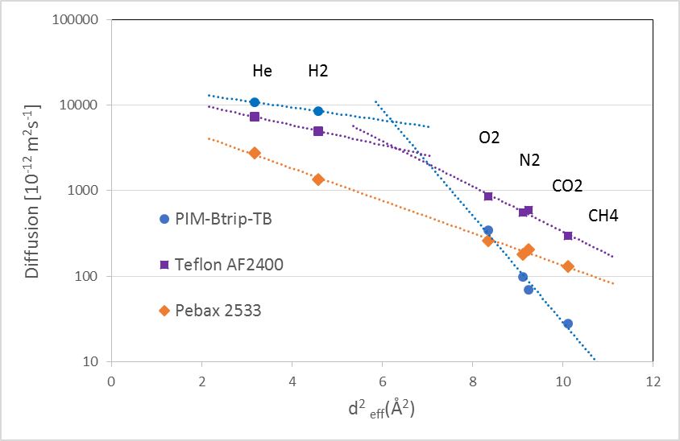
Figure 1. Diffusion coefficient in different polymers as a function of the effective molecular diameter of the gas [6].
Acknowledgements: This research received funding from the EU’s Seventh Framework Program, GA 608490, project M⁴CO₂.

[1] NB McKeown, PM Budd; Macromolecules, 2010, 43, 5163–5176.
[2] I Rose et al.; ACS Macro Lett, 2015, 4, 912–915.
[3] P Bernardo et al.; Sep Purif Technol 2012, 97, 73–82.
[4] JC Jansen, K Friess, E Drioli; J Memb Sci, 2011, 367, 141–151.
[5] M Carta et al.; Science, 2013, 339, 303-307.
[6] V Teplyakov, P Meares; Gas Sep Purif, 1990, 4, 66–74.

