Modelling coastal connectivity in the Mediterranean Sea: similar effects of changes in hydrodynamics and reduction in planktonic duration
Marco Andrello, Mohammadreza Mirzaei, Giovanni Quattrocchi, Matteo Sinerchia

Supplementary Figures

Figure S1
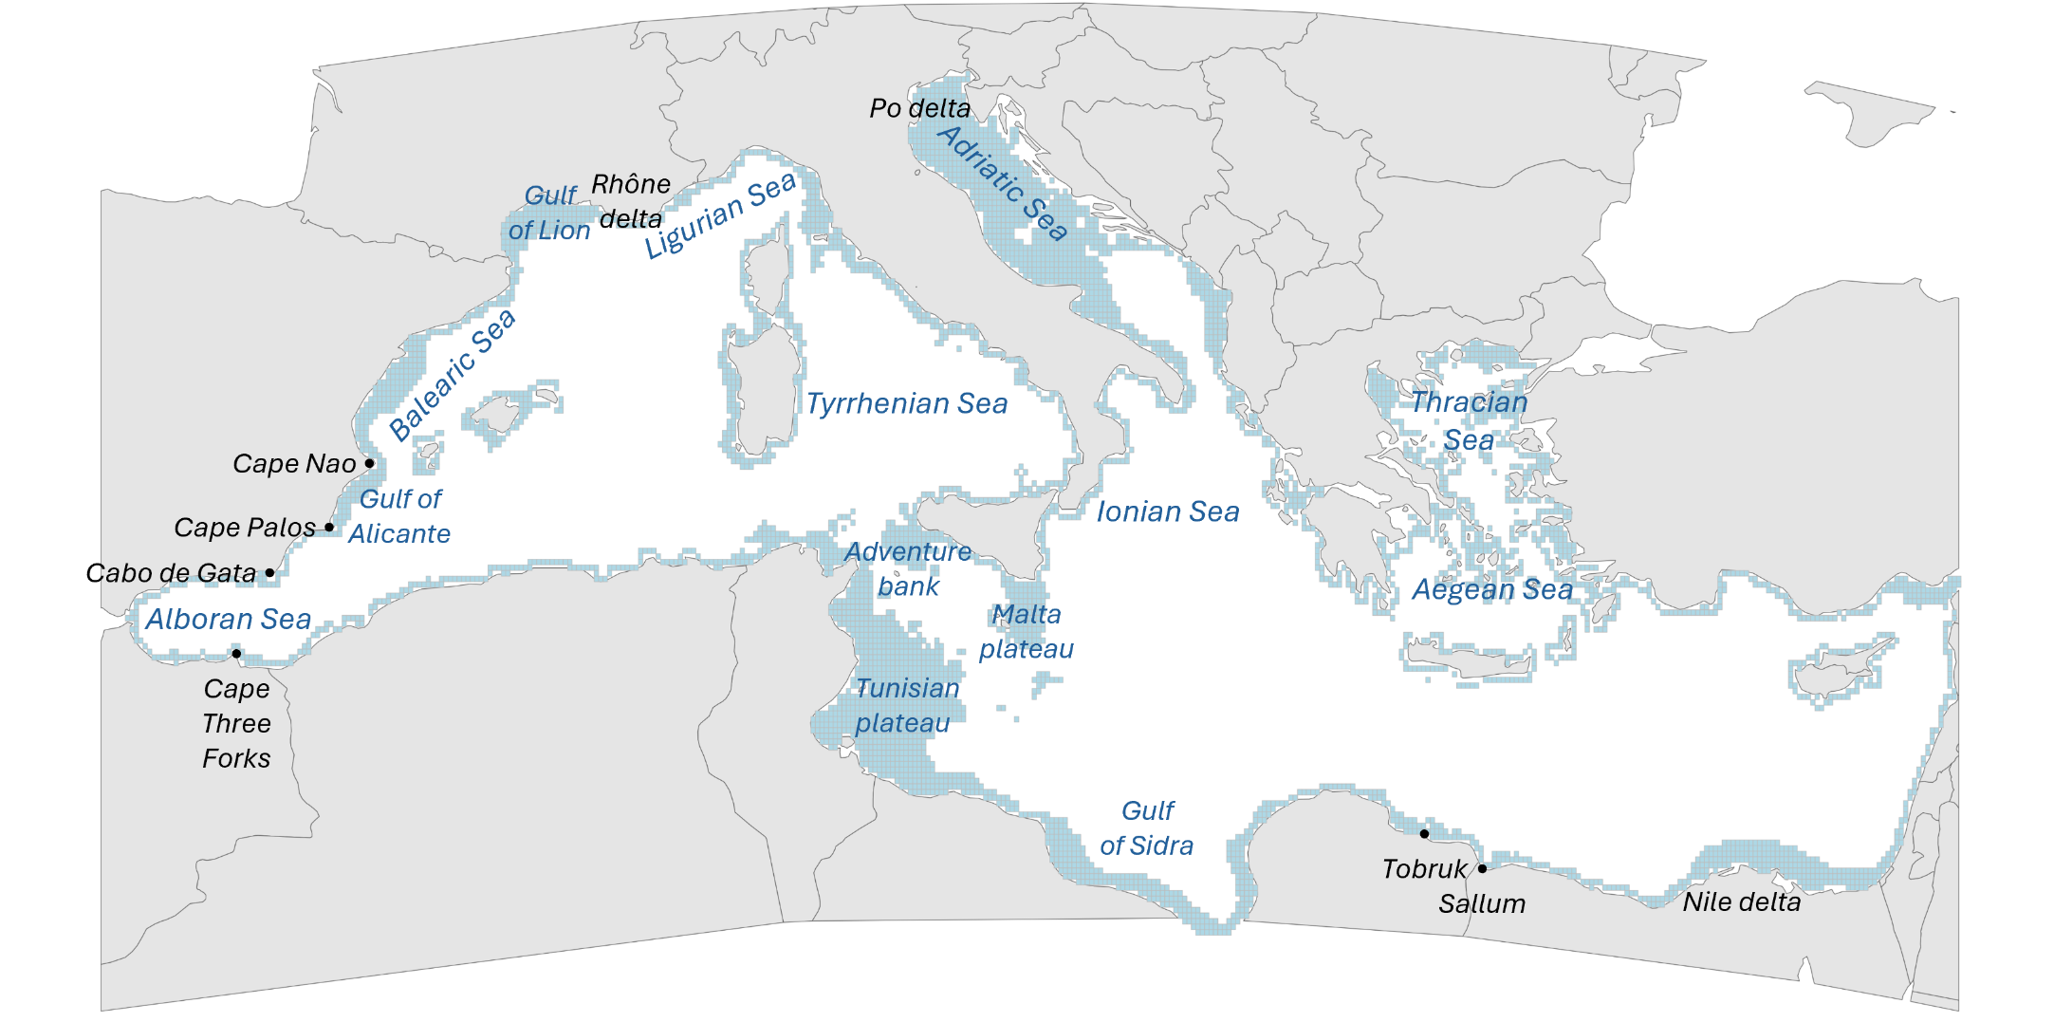
Figure S1. Map of the study region. The map shows the 5055 release sites used in the particle tracking simulations (square polygons colored in light blue), the names of the Mediterranean subbasins, and the geographic features mentioned in the main text.
Figure S2
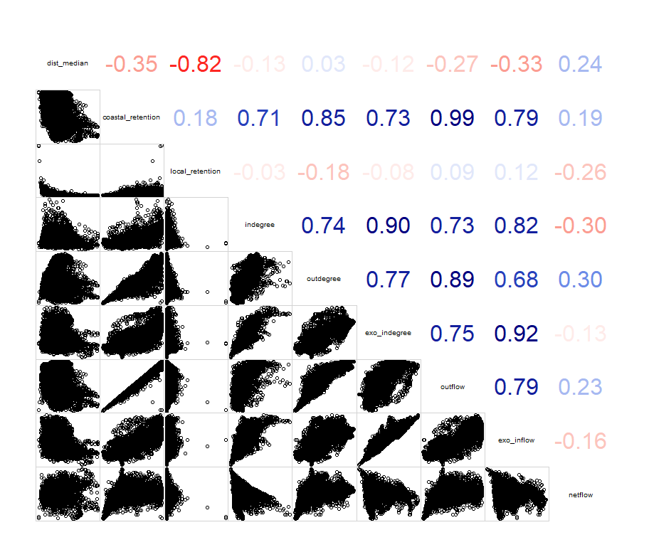
Figure S2. Correlation among connectivity variables. The corrgram shows the biplot distribution (lower half) and the calculated Spearman’s rank correlation coefficient (upper half) for each pair of connectivity variables. See Table 1 for definition of connectivity variables.
Figure S3
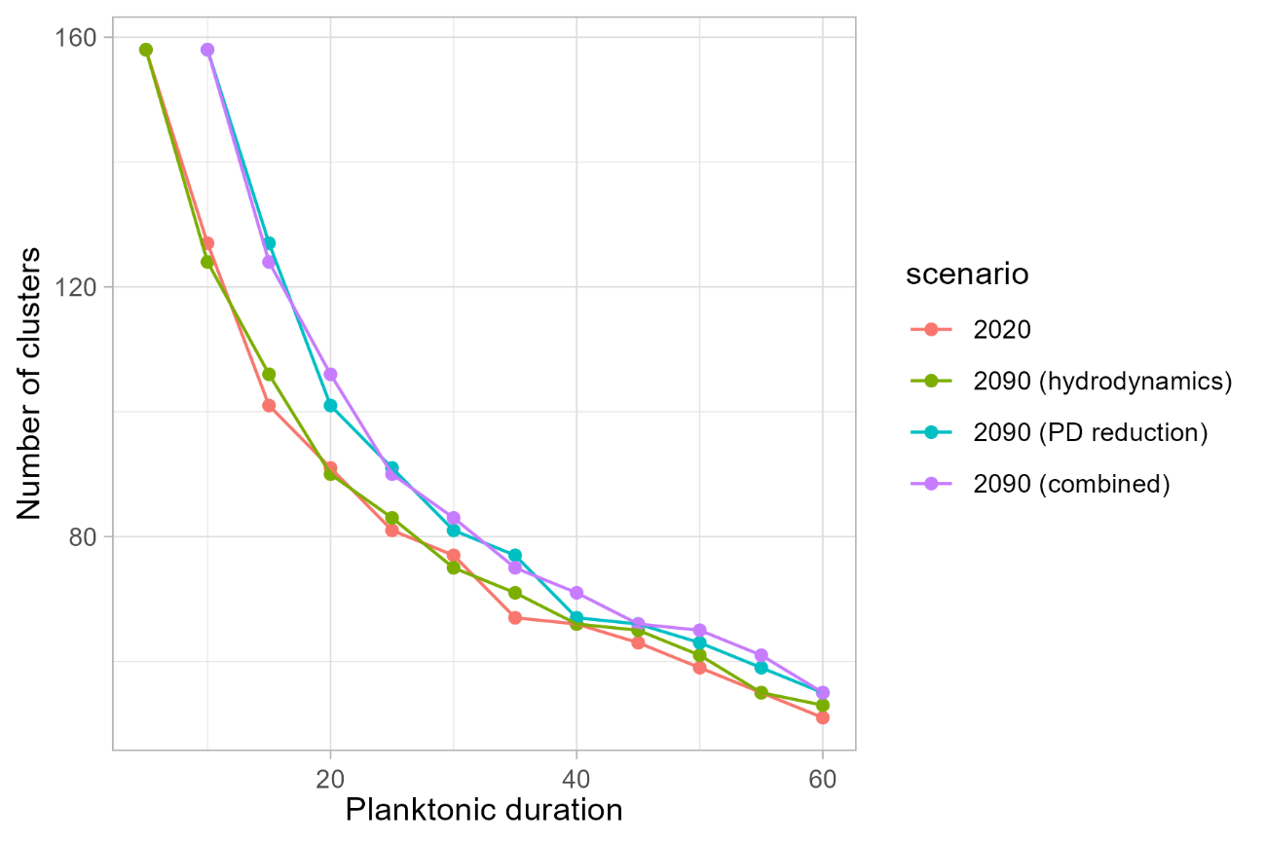
Figure S3. Effect of planktonic duration on dispersal clusters. Number of clusters identified by the Infomap algorithm for each of the considered planktonic duration (n = 12) in the 2020-decade (red), in the 2090-decade considering the effects of changes in hydrodynamics only (green), in the 2090-decade considering the effects of reduction in planktonic duration only (teal), and in the 2090-decade considering the effects of both changes in hydrodynamics and reduction in planktonic duration (purple).
Figure S4
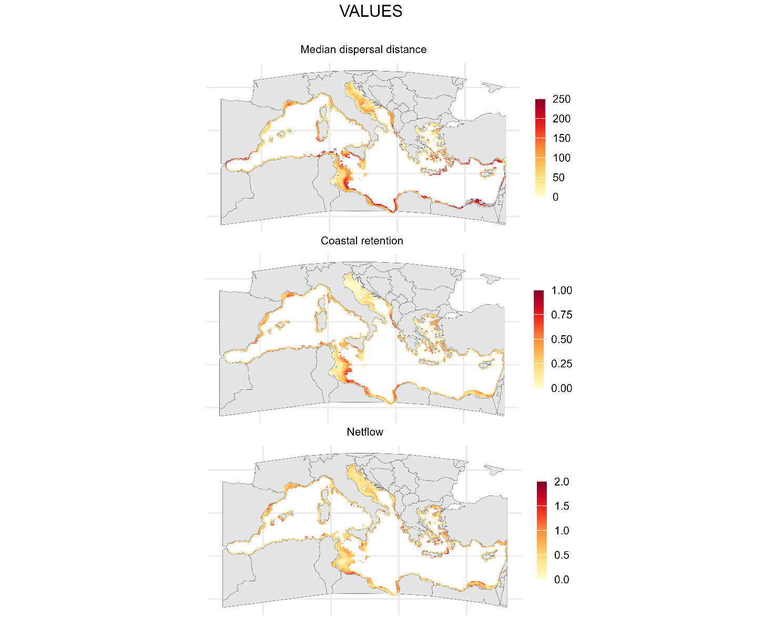
Figure S4. Seasonal variation in connectivity in the 2020-decade. Seasonal variation of the values of connectivity, calculated as difference between the maximum and minimum monthly averages of the three connectivity variables (median dispersal distance, in km; coastal retention; and netflow) for a planktonic duration of 30 days in the 2020-decade.
Figure S5
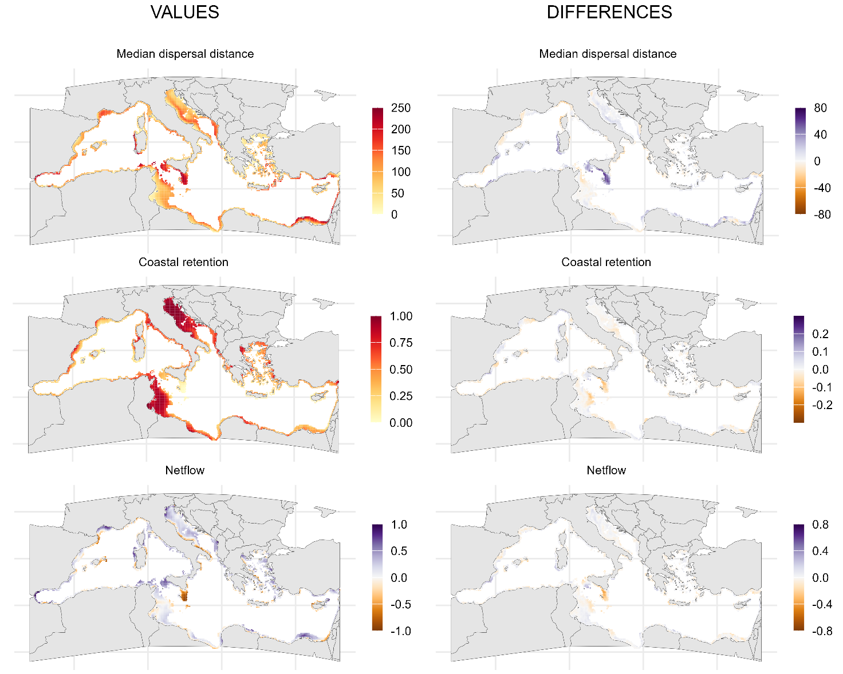
Figure S5. Connectivity in the 2050-decade considering the effects of changes in hydrodynamics only. Left: values of median dispersal distance (in km), coastal retention and netflow for each release site (n = 5055) and for a planktonic duration of 30 days calculated considering the effects of changes in hydrodynamics only and averaged over the 118 release dates of the 2050-decade. Right: differences in the three connectivity variables between the averages of the 2050-decade and the averages of the 2020-decade considering the effects of changes in hydrodynamics only.
Figure S6
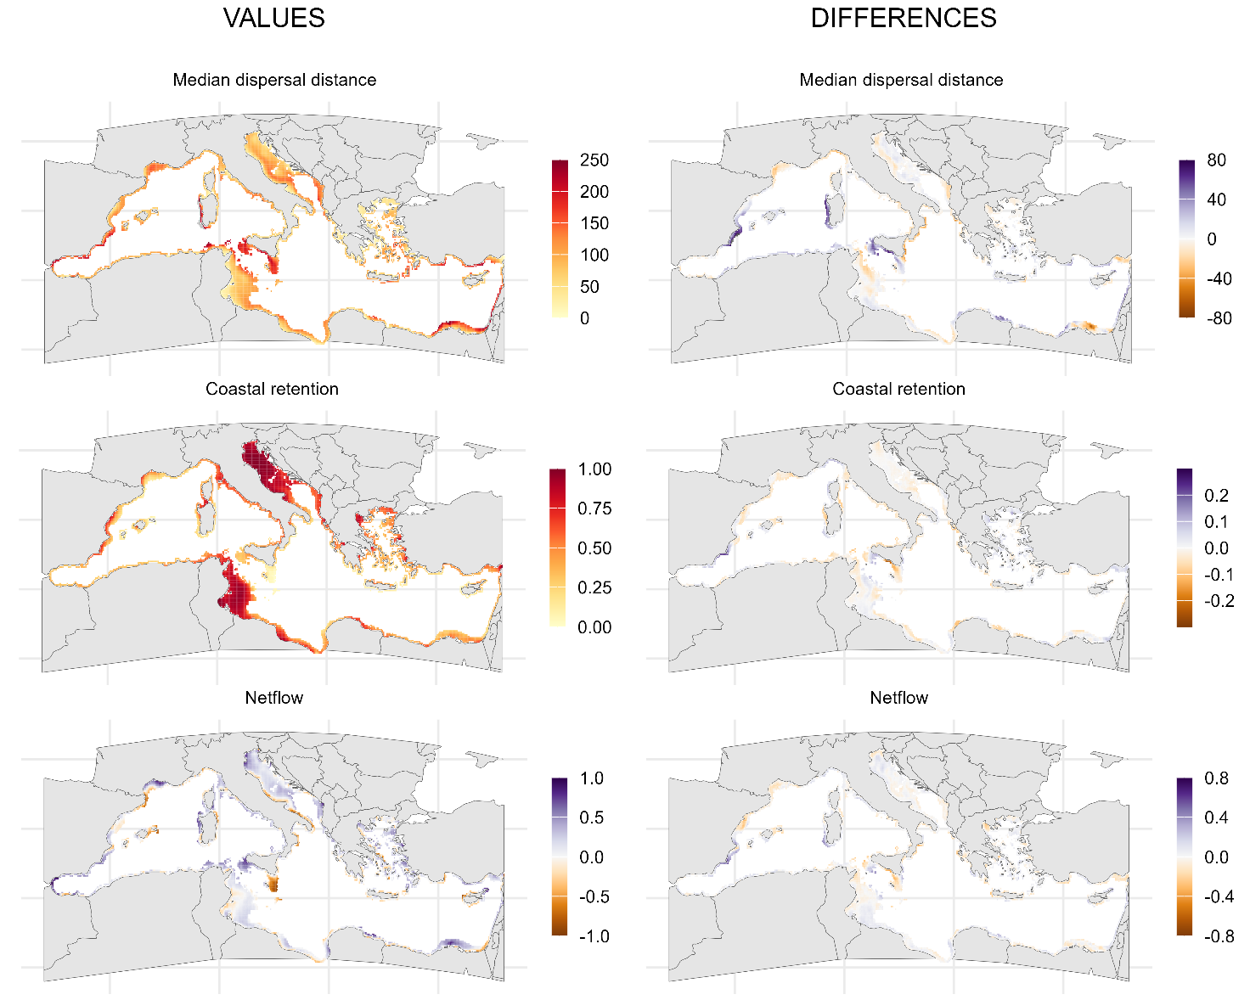
Figure S6. Connectivity in the 2090-decade considering the effects of changes in hydrodynamics only. Left: values of median dispersal distance (in km), coastal retention and netflow for each release site (n = 5055) and for a planktonic duration of 30 days calculated considering the effects of changes in hydrodynamics only and averaged over the 118 release dates of the 2090-decade. Right: differences in the three connectivity variables between the averages of the 2090-decade and the averages of the 2020-decade considering the effects of changes in hydrodynamics only.
Figure S7
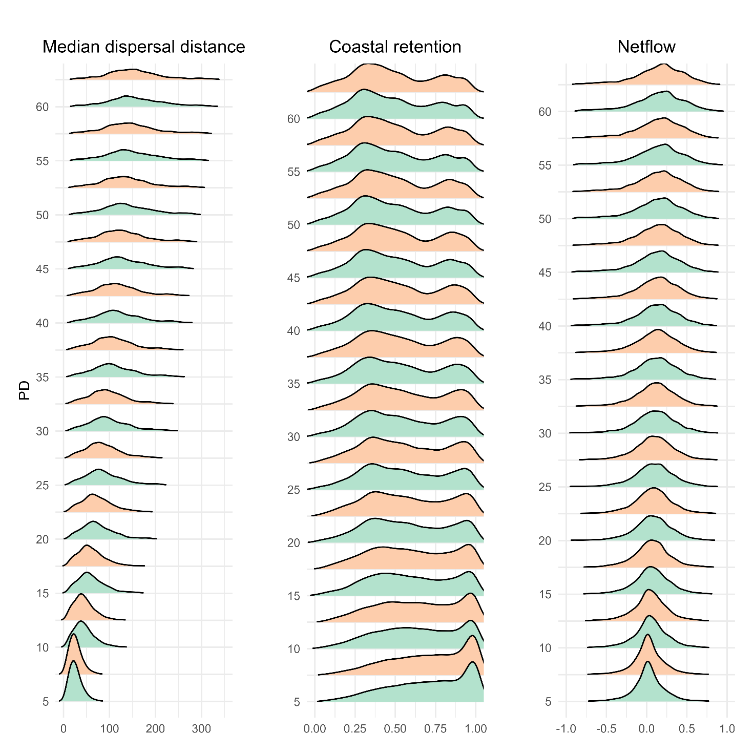
FigureS7. Variation in future connectivity with planktonic duration of propagules considering the effects of changes in hydrodynamics only. Density distributions of the values of the three connectivity variables (median dispersal distance, in km; coastal retention; netflow). For each planktonic duration (PD, n = 12), the graphs show the distribution of the values of each release site (n = 5055), calculated as averages over the 118 release dates of the 2050-decade (green) and the 2090-decade (orange), calculated considering the effects of changes in hydrodynamics only.
Figure S8
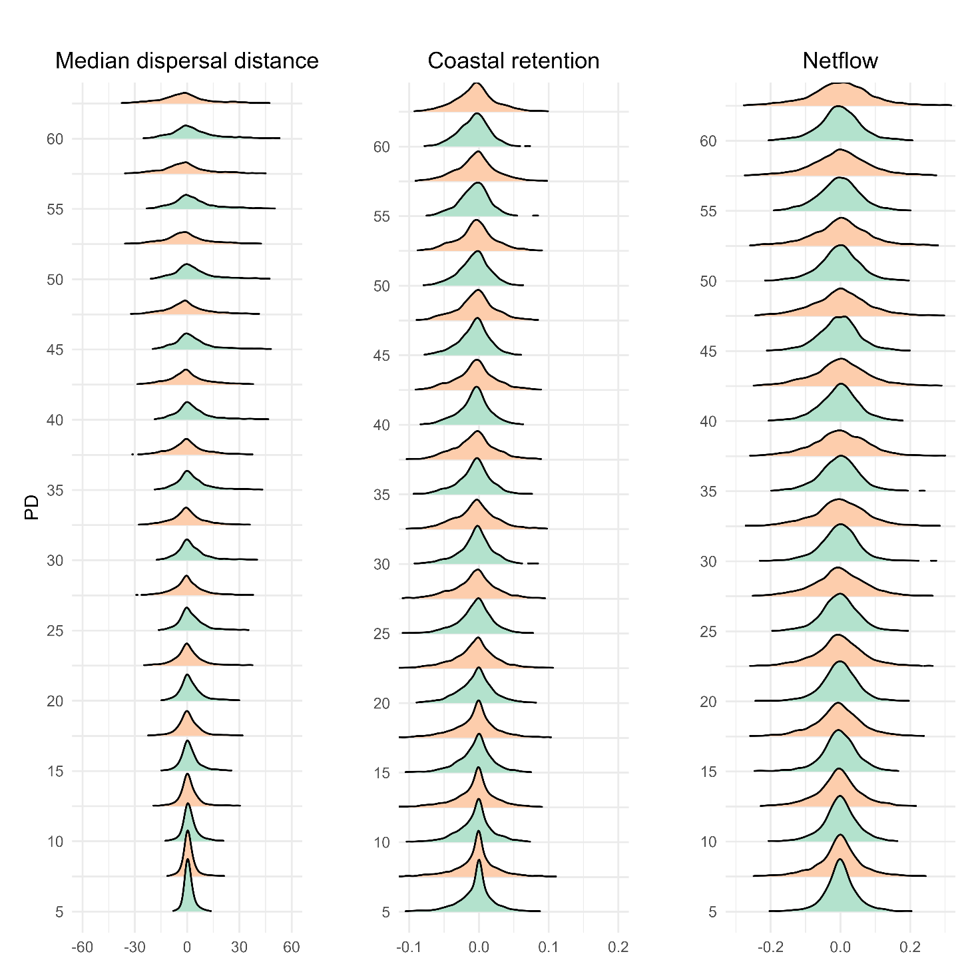
Figure S8. Variation in the difference between future and present connectivity with planktonic duration of propagules considering the effects of changes in hydrodynamics only. Density distributions of the differences in the three connectivity variables (median dispersal distance, in km; coastal retention; netflow) between the 2050-decade (green) or the 2090-decade (orange) and the 2020-decade considering the effects of changes in hydrodynamics only. For each planktonic duration (PD, n = 12), the graphs show the distribution of the differences for each release site (n = 5055), calculated as differences between the averages over the 118 release dates of the focal decade.
Figure S9
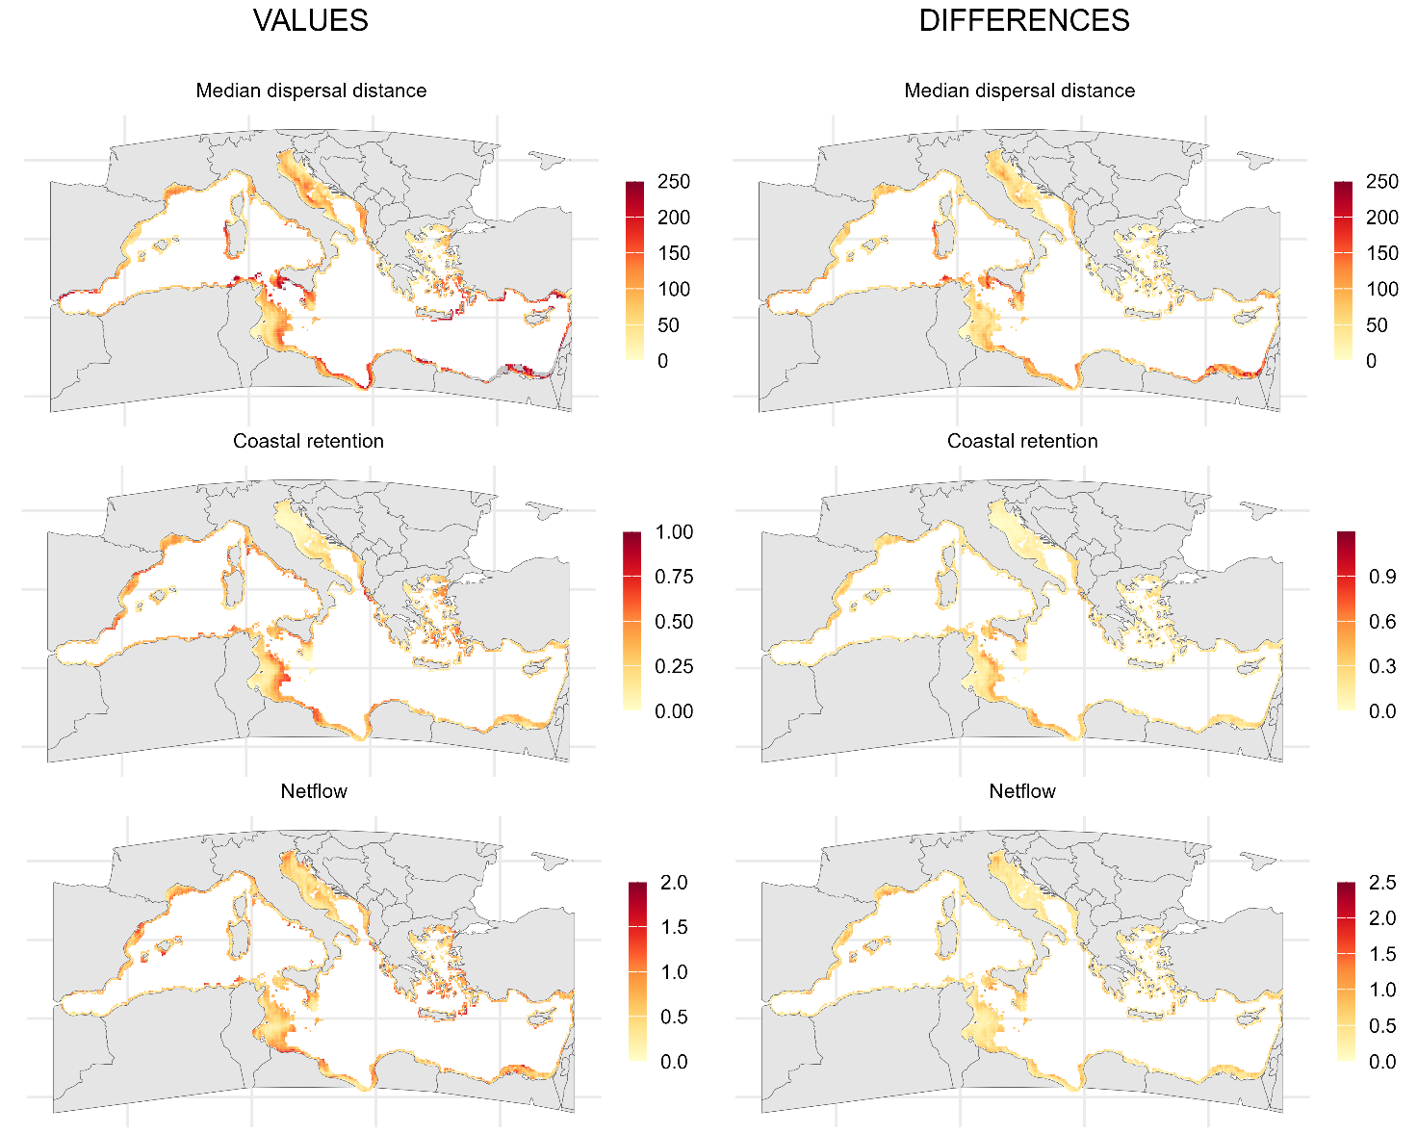
Figure S9. Seasonal variation in connectivity in the 2050-decade, considering the effects of changes in hydrodynamics only. Left: seasonal variation of the values of connectivity, calculated as difference between the maximum and minimum monthly averages of the three connectivity variables (median dispersal distance, in km; coastal retention; and netflow) for a planktonic duration of 30 days in the 2050-decade; larger values indicate areas where future connectivity will be more seasonally variable. Right: seasonal variation of the differences of connectivity between the 2050-decade and the 2020-decade, calculated as the difference between the maximum and the minimum monthly differences (thus, it is always positive); larger values indicate areas where the difference between future and present connectivity will be more seasonally variable. Calculations are for a planktonic duration of 30 days considering the effects of changes in hydrodynamics only.
Figure S10
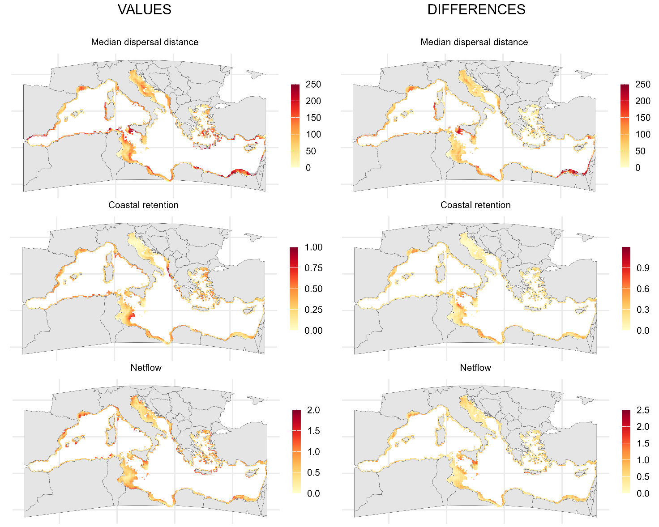
Figure S10. Seasonal variation in connectivity in the 2090-decade, considering the effects of changes in hydrodynamics only. Left: seasonal variation of the values of connectivity, calculated as difference between the maximum and minimum monthly averages of the three connectivity variables (median dispersal distance, in km; coastal retention; and netflow) for a planktonic duration of 30 days in the 2090-decade; larger values indicate areas where future connectivity will be more seasonally variable. Right: seasonal variation of the differences of connectivity between the 2090-decade and the 2020-decade, calculated as the difference between the maximum and the minimum monthly differences (thus, it is always positive); larger values indicate areas where the difference between future and present connectivity will be more seasonally variable. Calculations are for a planktonic duration of 30 days considering the effects of changes in hydrodynamics only.
Figure S11
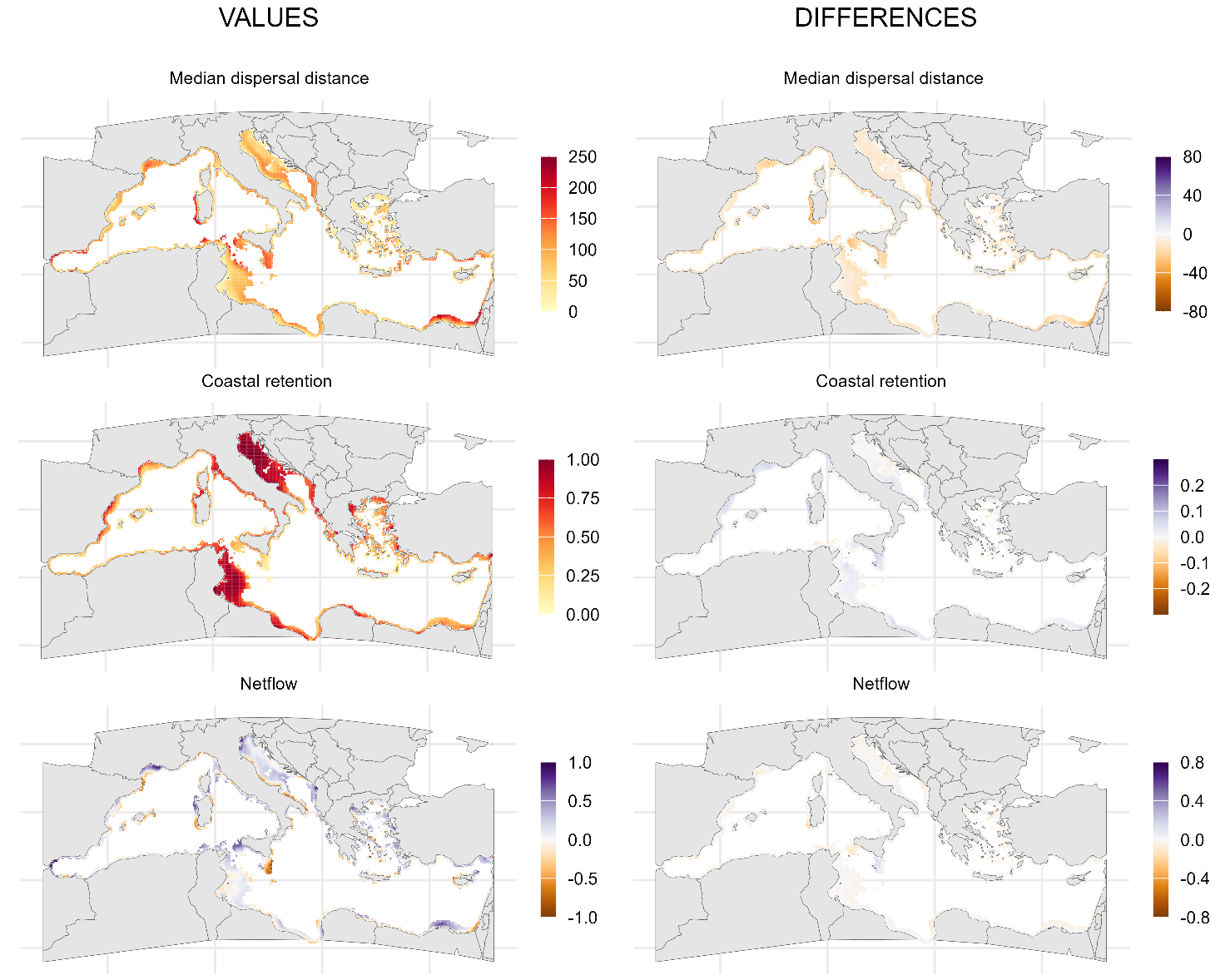
Figure S11. Connectivity in the 2090-decade considering the effects of reduction in planktonic duration only. Left: values of median dispersal distance (in km), coastal retention and netflow for each release site (n = 5055) and for a planktonic duration of 30 days calculated considering the effects of reduction in planktonic duration only and averaged over the 118 release dates of the 2090-decade. Right: differences in the three connectivity variables between the averages of the 2090-decade and the averages of the 2020-decade considering the effects of reduction in planktonic duration only.
Figure S12
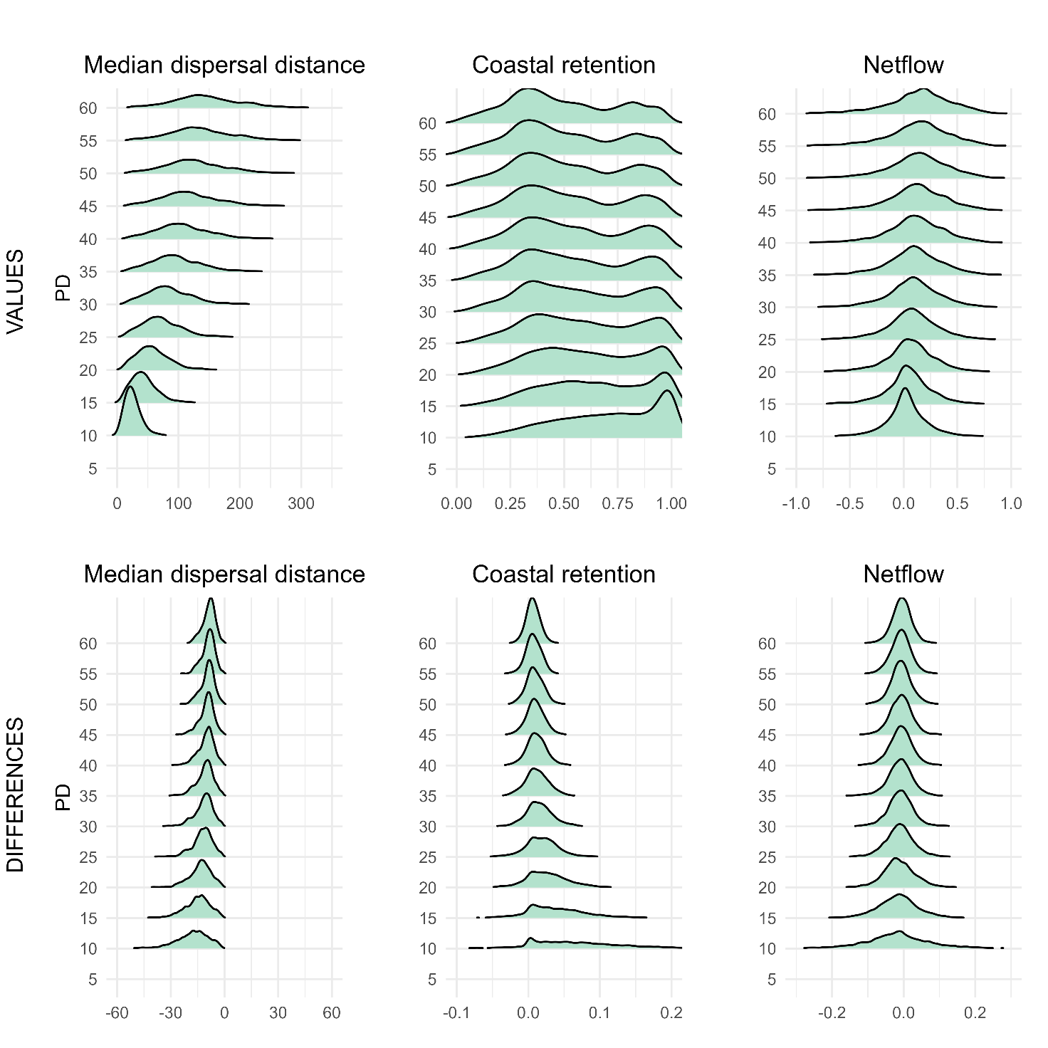
Figure S12. Variation in future connectivity with planktonic duration of propagules, considering the effects of reduction in planktonic duration only.
Top row: density distributions of values of the three connectivity variables (median dispersal distance, in km; coastal retention; netflow). For each planktonic duration (PD), the graphs show the distribution of the values of each release site (n = 5055), calculated as averages over the 118 release dates of the 2020-decade. Bottom row: density distributions of the differences of the three connectivity variables between the 2090-decade and the 2020-decade considering the effects of reduction in planktonic duration only. For each planktonic duration, the graphs show the distribution of the differences for each release site (n = 5055), calculated as differences between the averages over the 118 release dates of the focal decade
Figure S13
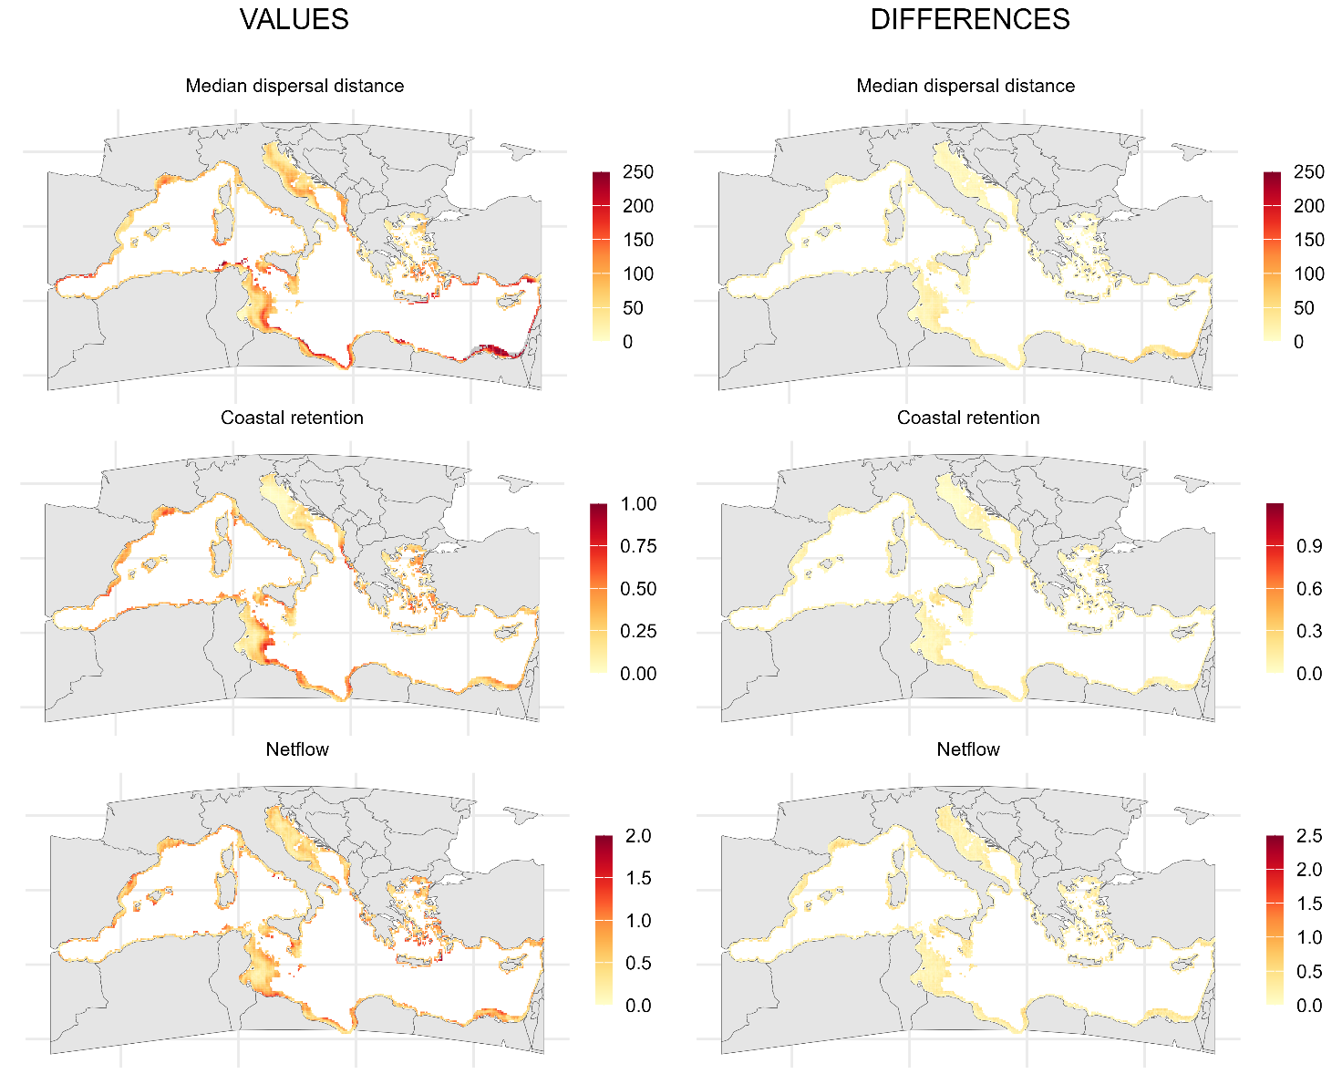
Figure S13. Seasonal variation in connectivity in the 2090-decade, considering the effects of reduction in planktonic duration only. Left: seasonal variation of the values of connectivity, calculated as difference between the maximum and minimum monthly averages of the three connectivity variables (median dispersal distance, in km; coastal retention; and netflow) for a planktonic duration of 30 days in the 2090-decade; larger values indicate areas where future connectivity will be more seasonally variable. Right: seasonal variation of the differences of connectivity between the 2090-decade and the 2020-decade, calculated as the difference between the maximum and the minimum monthly differences (thus, it is always positive); larger values indicate areas where the difference between future and present connectivity will be more seasonally variable. Calculations are for a planktonic duration of 30 days considering the effects of reduction in planktonic duration only.
Figure S14
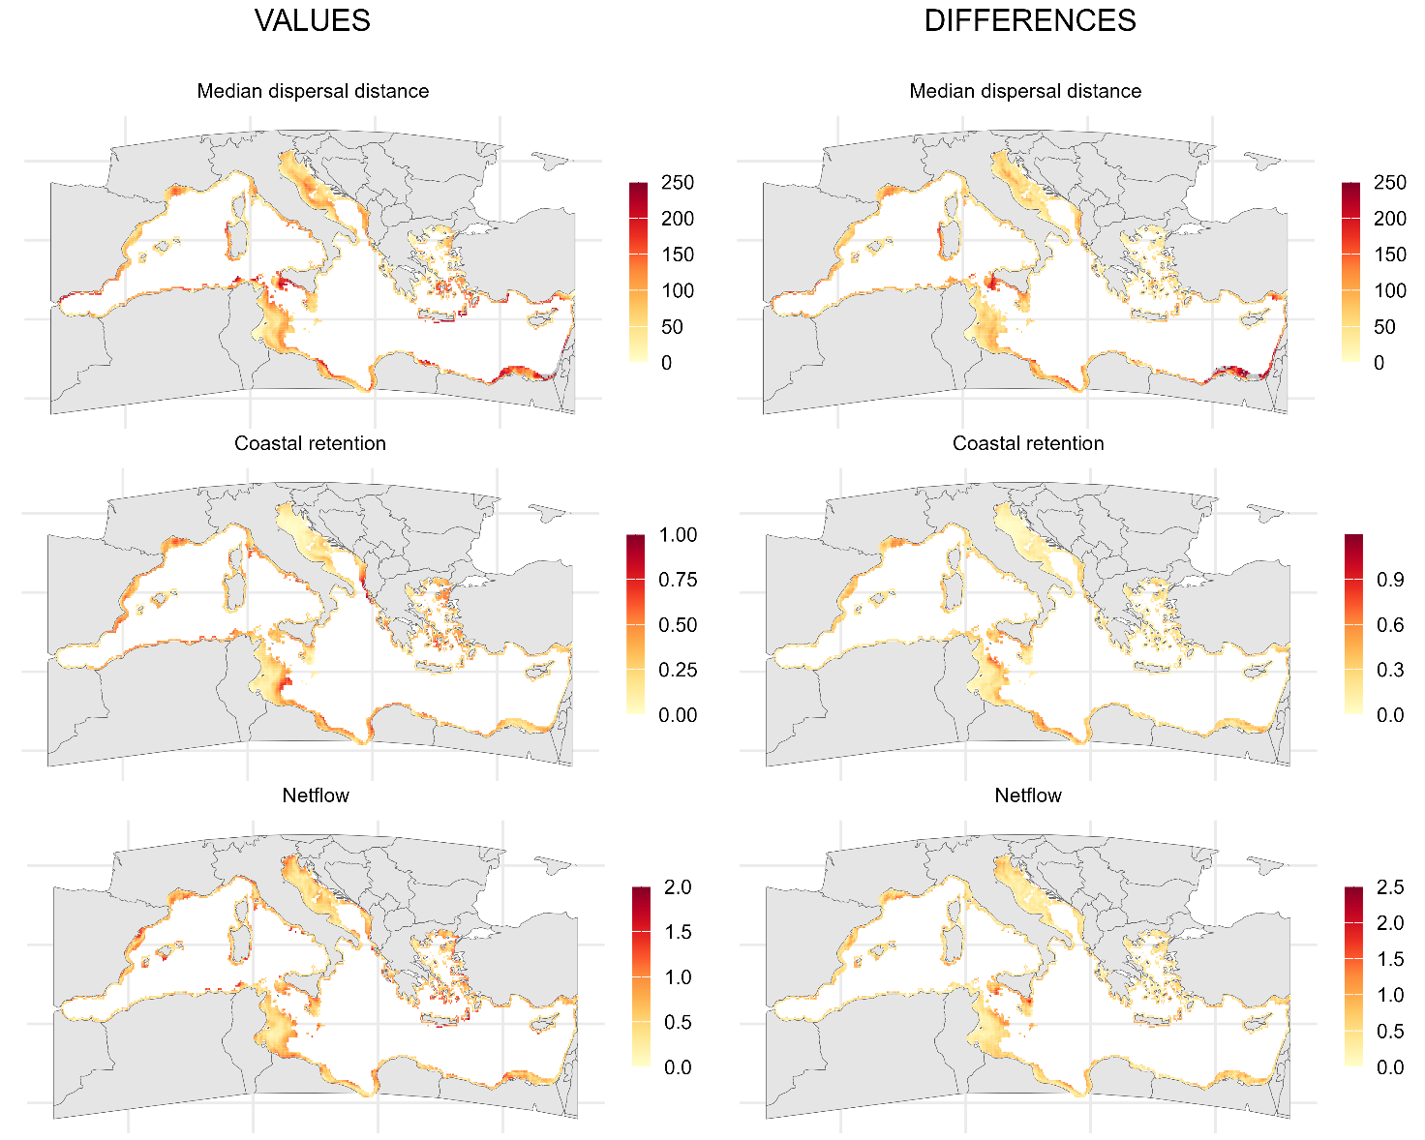
Figure S14. Seasonal variation in connectivity in the 2090-decade, considering the effects of both changes in hydrodynamics and reduction in planktonic duration. Left: seasonal variation of the values of connectivity, calculated as difference between the maximum and minimum monthly averages of the three connectivity variables (median dispersal distance, in km; coastal retention; and netflow) for a planktonic duration of 30 days in the 2090-decade; larger values indicate areas where future connectivity will be more seasonally variable. Right: seasonal variation of the differences of connectivity between the 2090-decade and the 2020-decade, calculated as the difference between the maximum and the minimum monthly differences (thus, it is always positive); larger values indicate areas where the difference between future and present connectivity will be more seasonally variable. Calculations are for a planktonic duration of 30 days considering the effects of both changes in hydrodynamics and reduction in planktonic duration.
Figure S15
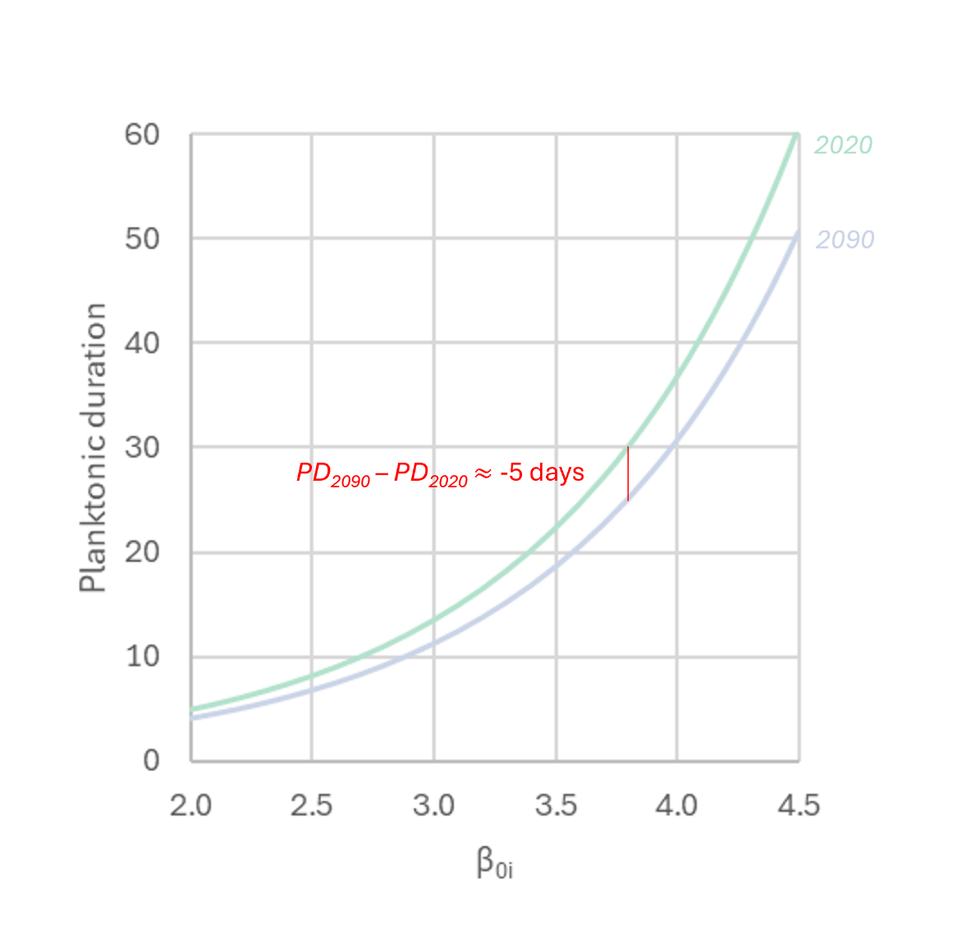
Figure S15. Planktonic duration and temperature. Planktonic duration as a function of the species-specific parameter $β_{0,i}$ of equation 1 and 2 in Supplementary Methods for temperatures equal to 19.8 °C and 22.3 °C, which are equal to the expected average sea surface temperatures over release sites in the 2020-decade and the 2090-decade, respectively. The red vertical line shows the expected difference between future and present planktonic duration for a present planktonic duration of 30 days.

