Supporting information for

Highly sustainable multilayer fluorescent devices for solar energy harvesting

A. Picchi¹, M. Bartolini², E. Ermini^{2,3}, L. Zani³, A. Pucci^{1,4}, M. Carlotti¹*

¹Dipartimento di Chimica e Chimica Industriale, Università di Pisa, Via Moruzzi 13, 56124 Pisa, Italy, ²Institute of Chemistry of Organometallic Compounds (CNR-ICCOM), Via Madonna del Piano 10, 50019 Sesto Fiorentino, Italy; ³Department of Chemistry ‘‘U. Schiff’’, University of Florence, Via della Lastruccia 13, 50019 Sesto Fiorentino, Italy. ⁴INSTM, UdR Pisa, Via Moruzzi 13, 56124 Pisa, Italy

Figure S1: Chemical structure of BDT-H2 (above) and DQ1 (below)

Figure S3: Probability of photons not undergoing reabsorption for LSCs containing LR305, DQ1, BDT-H2 and other organic dyes previously characterised and described in publications.
Figure S2: Stacked configurations of multilayer LSCs with (left) the BDT-H2 layer on top of the DQ1 layer; (right) DQ1 on top and BDT-H2 below.

Table S1: Quantum yield (%) values for LSCs containing DQ1 and BDT-H2 at increasing concentrations.

LSC performance and reabsorption determination
An LCS-100 94011A solar simulator (S/N: 322, AM filter 1.5G std: 69 mW cm⁻² at 254 mm, Oriel Instruments, USA) was used as a light source. The incident, transmitted and edge-emitted irradiance spectra were recorded by using a commercially available Arkeo instrument (Cicci research s.r.l., Italy) containing a CMOS-based spectrometer (CCARK.A.4 Spectroradiometer, Fiber Optic VIS/NIR spectrometer, 2048 pixels, grating VA 360-1100nm, slit-50, OSC, DCL- UV/VIS), with a symmetrical Czerny-Turner optical bench connected to an integrating sphere. The spectrally-resolved edge output photon count was collected from the CMOS-based spectrometer, converted into optical power (W) and then in irradiance (W m⁻²). The cylindrical integrating sphere has a circular aperture with a diameter of 1 cm. By placing the integrating sphere directly under the light of a solar simulator at the correct distance to obtain an irradiance of about 1 Sun, the incident irradiance spectrum (E_{,in}) is acquired. Subsequently, by placing the sample over the integrating sphere hole, the transmitted irradiance spectrum (E_{l,tr}) is acquired. The transmitted irradiance spectrum used in the calculations is the average of three transmittance spectra acquisitions in different positions of the same LSC.
Four edge-emitted irradiance spectra are then acquired by placing the integrating sphere horizontally, in contact with each edge of the LSC one at a time, under the light of the solar simulator. The average edge-emitted irradiance spectrum (Ē_{l,tr}) is then calculated. A black adhesive tape layer has been applied to the uncovered aperture portion of the LSC to minimize the detection of stray light. For all the irradiance acquisitions, an absorbing matte black background was placed in contact with the LSC rear side to limit reflections of unabsorbed light.
Since the photon density flux is the number of photons passing through a surface in the unit of time, we define the density flux of incident photons (F_{ph,in}), the density flux of absorbed photons (F_{ph,abs}), and the average density flux of photons emitted from the edges (F_{ph,out}) as follows (in m⁻² s⁻¹):
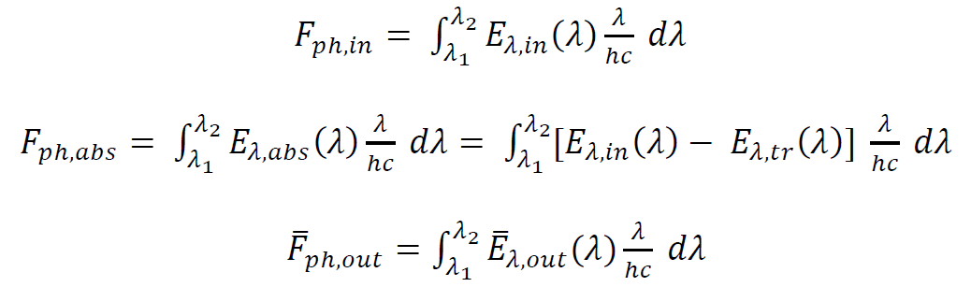
where λ is the wavelength of photons (in nm), ℎ is Planck’s constant (in J s), c is the speed of light (in nm s⁻¹), λ₁ and λ₂ the extremes of the wavelength acquisition range. The units for all the irradiance spectra are W m⁻² nm⁻¹. The incident light irradiance spectrum was integrated in the 350–1100 nm range. The absorbed irradiance spectrum was derived subtracting the incident and transmitted irradiance spectra and integrating the result, covering only the absorption range. The edge-emitted irradiance spectrum was integrated covering the emission range exclusively, where possible, to minimize overestimates due to the scattering of the incident light.
LSC photon efficiencies were then calculated as follows:
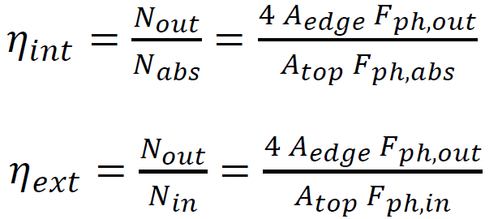
where A_{edge} is the surface area of the single edge (the LSC side length multiplied by the average thickness), A_{top} is the area of the top surface of the LSC, N_{in} is the total flux of photons incident on the top surface of the LSC, N_{out} is the total flux of edge-emitted photons summed over all LSC edges and N_{abs} is the total flux of photons absorbed by the LSC. All the photon fluxes are expressed in s⁻¹ unit.
The determination of the reabsorption probability was adapted from a procedure found in the literature (Wilson et al. 2010). Using the integrating sphere connected to the CMOS-based spectrometer, the edge-emission irradiance spectrum (330-1100 nm) was acquired exciting the sample with a 405 nm laser diode at a distance of 1 mm from the edge. This spectrum, denoted as $E_{ZR}(λ)$, was considered to be free of reabsorption. The acquisition was repeated exciting the sample at the centre of the LSC, at a distance of 25 mm from the edges, obtaining $E_{C}(λ)$. The ratio $E_{C}(λ)/E_{ZR}(λ)$, given the absence of reabsorption at high wavelengths, tends to a constant value, different for each sample depending on the fluorophore and its concentration. This ratio value was then used as a scaling factor to multiply the zero-reabsorption spectrum $E_{ZR}\left(λ\right)$ and thereby obtain $E_{ZR, scaled}\left(λ\right)$. Consequently, the tail of the scaled zero-reabsorption spectrum and that of the spectrum acquired from the centre coincided. Finally, the ratio $E_{C}(λ)/E_{ZR,scaled}(λ)$ returned the value of $P_{0}$.

