Supporting Information for

Mild hydrolytic depolymerisation of poly(lactic acid) waste to added-value chemicals promoted by alkali and alkaline-earth metal carbonates
Francesca Buco, Pierluigi Barbaro,* Francesco Brandi, Lorenzo de Chiara and Francesca Liguori

Consiglio Nazionale delle Ricerche, Istituto di Chimica dei Composti Organo Metallici, Via Madonna del Piano 10, 50019 Sesto Fiorentino, Firenze, Italy. E-mail: pierluigi.barbaro@iccom.cnr.it

ORCID IDs
Francesca Buco: https://orcid.org/0000-0003-1200-1935
Pierluigi Barbaro: https://orcid.org/0000-0002-7298-5756
Francesco Brandi: https://orcid.org/0000-0002-6765-6755
Lorenzo de Chiara: https://orcid.org/0009-0002-7962-8396
Francesca Liguori: https://orcid.org/0000-0002-5520-1550

TABLE OF CONTENTS

1. General information 2
2. Depolymerisation reactions 3
2.1. Hydrolytic depolymerisation of PLA with potassium carbonate 4
2.2. Recovery of lactic acid 5
2.2.1. Solvent extraction 5
2.2.2. Ion exchange 5
2.3. Hydrolytic depolymerisation of PLA with calcium carbonate 5
2.4. Calcium carbonate recycling 6
2.5. Hydrolytic depolymerisation of PLA waste materials 6
3. Reaction data tables 7
4. NMR data and spectra 8
5. Other figures and tables 10
6. References 19

1. General information
Poly(lactic acid) (PLLA, T_{m} 149-154 °C, powder) was obtained from Aldrich (product 764590), stored at 4 °C and used as received without further treatments. GPC analysis (CHCl₃) indicated a Mn 10100 and a Mw 12300. ¹H NMR analysis (CDCl₃) indicated a 5630 Mn. PLLA with Mn 49000, Mw 56000 (GPC) and Mn 30963 (¹H NMR) was obtained from Aldrich (product 94829).
PLA disposable cups were purchased from PAPSTAR (product code 16176). White waste PLA from 3D printing was obtained from prints produced using white PLA filament purchased from Shenzhen eSUN Industrial Co. Ltd (PLA content 99,8 %). Yellow waste PLA+ from 3D printing was obtained from prints produced using yellow PLA+ filament purchased from Shenzhen eSUN Industrial Co. Ltd (PLA content 92-96 %; Calcium carbonate powder 2-4%; other additives 2-5%).

Table S1. Characterization data (Mn calculated by NMR Spectroscopy; Mn, Mw and Ð calculated by GPC) of Commercial PLA, PLA disposable cup, white PLA waste from 3D printing process, yellow PLA waste from 3D printing process
Sample | ¹H NMR (CDCl₃) | GPC (CHCl₃)
Sample | Mn (g/mol) | Mn (g/mol) | Mw (g/mol) | Ð
Commercial PLA | 5630 | 10100 | 12300 | 1.2
Commercial PLA | 30963 | 49000 | 56000 | 1.3
PLA Disposable Cup | Undetectable | 57400 | 127700 | 2.2
White waste PLA 3D print | Undetectable | 59900 | 125300 | 2.0
Yellow waste PLA 3D print | Undetectable | 92800 | 179900 | 1.9

The sulfonated DOWEX 50WX2–400 strong cation-exchange resins (H⁺ form, 2% cross-linked, gel-type, 4.8 meq g⁻¹ exchange capacity, 200–400 mesh bead size) was obtained from Aldrich (product 217476) and purified prior of use according to a reported procedure.
L(+) Lactic acid (LA) was obtained from Aldrich (product 1356734). Calcium carbonate and Calcium L-lactate pentahydrate were obtained from Thermo Scientific. HPLC-grade water was obtained from Carlo Erba and used for catalytic experiments as received, without further purifications. All other reagents were commercial products and were used as received without further purifications.
Cryo-milling of waste PLA materials was performed using a Cryomill Retsch apparatus equipped with Zirconia holders and balls. For 1 gram of sample, 4 cycles were performed (3 min of cooling at 5 Hz, 2.5 min of milling at 30 Hz, 0.3 min of cooling 5 Hz). Cooling was carried out using liquid nitrogen.
¹H NMR and ¹³C{¹H} NMR (Nuclear Magnetic Resonance) spectra were recorded at 300.13 MHz and 75.468 MHz, respectively, on a Bruker Avance DRX-300 spectrometer. The assignments of the NMR signals resulted from 1D spectra, 2D ¹H-COSY and proton detected ¹H-¹³C correlations. When aqueous reaction mixtures were examined, a coaxial insert filled with D₂O was used for lock, and pulse sequences suitable for water resonance suppression were used. Chemical shift in ppm were relative to tetramethylsilane as external reference.
FT-IR spectra were recorded using a ThermoScientific Nicolet 6700 infrared spectrophotometer.
For the pH measurements a portable waterproof pH/ORP/ISE meter HI98191 (Cat. No. 41HI9891) was used together with a HI1330B probe electrode (Cat. No. 25HI1330).
SEM and EDS analyses were performed using an FEI Quanta 200 Environmental Scanning Electron Microscope (ESEM) equipped with an energy-dispersive X-ray spectroscopy (EDS) detector, operated at 15 kV.
Inductively Coupled Plasma Optical Emission Spectroscopy (ICP-OES) was performed to quantify the metal content leached in the catalytic reaction solutions, using a Perkin Elmer-Optima 4300DV instrument (Power 1300W) equipped with a Cross-Flow nebulizer and a Ryton Scott® Spray Chamber. Internal standard (0.10 mL) Scandium 1000 µg/ml was added to 1 mL of the solution in PP vials and brought to the volume of 10 mL with HNO₃ 4% w/w.
HPLC (High Pressure Liquid Chromatography) analyses were performed on a HPLC-Shimadzu apparatus equipped with a refraction index detector (RID) and a HPX-87H Aminex Bio-RAD column (300 mm x 7.8 mm), using 0.005 M sulphuric acid as eluent (flow 0.4 ml min⁻¹ at 35 ºC) for LA analysis.
GC-analyses were performed on a Shimadzu GC 2010 Plus gas chromatograph equipped with flame ionization detector and a Nukol fused silica capillary column (30 m, 0.32 mm ID, 0.25 μm FT). GC-MS (Gas chromatography–mass spectrometry) analyses were performed on a Shimadzu QP2010SE apparatus equipped with a VF-WAXms capillary column (30 m, 0.25 mm ID, 0.25 μm FT) (Oven ramp: 80°C for 5 min, 5°C/min to 200°C, 200°C for 10 min then 10°C/min to 220°C; linear velocity: 25 cm sec⁻¹).
Powder X-ray diffraction (PXRD) diffractograms were acquired at room temperature with a PANalytical X’PERT PRO powder diffractometer, using CuKα radiation (λ = 1.5418 Å), a parabolic MPD-mirror and a PIXcel detector. PXRD patterns were acquired in the 2Θ range from 4.0 to 80.0 ° with a step size of 0.0263 ° at room temperature using a Si wafer (i.e. zero background) as sample holder.
A Scienceware® mini-sieve set (catalog n° F37845-1000) was used to separate the powder based on particle size. A 500 mg sample of the powder was placed on the sieve stack with cut-off sizes of 500, 354, 177, and 88 μm and agitated for 2 minutes. After sieving, the fractions retained on each sieve were collected and weighed to determine the particle size distribution.
Average molecular weight number (Mn), average molecular weight (Mw) and dispersity (Đ = Mw/Mn) of PLLA were determined using Gel Permeation Chromatography (GPC). The instrument for GPC analysis was the Agilent Technologies 1200 Series, which was equipped with an Agilent degasser, an isocratic HPLC pump, an Agilent refractive index (RI) detector, one pre-column PLgel 5 µm guard and two PLgel MiniMIX-D 5 µm columns conditioned at 35°C. Chloroform was used as mobile phase at a flow rate of 0.3 mL/min. The system was calibrated with polystyrene standards. Samples were dissolved in CHCl₃ (2 mg/mL) and filtered through a 0.20 µm syringe filter before analysis. Mn and Mw were determined using Agilent ChemStation software.

2. Depolymerisation reactions
Hydrolytic depolymerisation experiments under batch conditions were performed using an Ace-Glass Pressure Tube reactor (capacity 15 mL), equipped with a magnetic stirrer, and able to withstand internal pressures up to 10 atm. Heating was achieved using a pre-heated oil bath equipped with a temperature controller. Reaction temperature was that of the bath. The reaction products were unequivocally identified by comparison of the HPLC retention times, ¹H NMR and FT-IR, with those of authentic specimens, whenever commercially available. Quantitative analysis of the water-soluble reaction products, particularly LA, was carried out via HPLC based on calibration curves of the pure compounds in water. Calibration curves had R² values between 0.998 and 0.999.
In line with literature data, the starting PLA polymer used in our catalytic experiments was insoluble in water at room temperature., Thus, analogously to previous reports,,, PLA conversion was calculated on the basis of mass loss, i.e. by weighting the residual solid polymer recovered at the end of the catalytic runs, as follows:

$$\text{Conv}\text{. }\left(\text{PLA}\right)\text{ (\%) }\text{=} \frac{{\text{W}}_{\text{i}}\left(\text{PLA}\right)\text{-}{\text{W}}_{\text{f}}\left(\text{PLA}\right) }{{\text{W}}_{\text{i}}\left(\text{PLA}\right)}\text{ ·100 }$$

where Wi(PLA) and Wf(PLA) is the weight of the initial PLA used and the solid PLA recovered at the end of the catalytic experiments, respectively.
LA yield (Y(LA)) was calculated with respect to the number of PLA repetition units in the starting polymer used and the molar amount of LA in water solution quantified by HPLC analysis.
Selectivity to LA (Sel. (LA)) refers to the molar amount % of LA among all soluble products detected in the aqueous phase recovered at the end of the catalytic runs, thus:

$$\text{Sel}\text{. }\left(\text{LA}\right)\text{(\%) = }\frac{Y(LA) \text{ (\%)}}{{\text{Conv.}}_{\text{.}}\left(\text{PLA}\right)\text{(\%) }}\text{ ·100 }$$

The determination of Mn of the residual PLA by ¹H NMR was achieved by integration of signal at 5.18 ppm (internal methine CH_{a}, 1H, q, J = 6.8 Hz) with respect to the signal at 4.37 ppm (external methine CH_{a’}, 1H, q, J = 6.8 Hz) (300.13 MHz, 294 K, CDCl₃).

2.1. Hydrolytic depolymerisation of PLA with potassium carbonate
In a typical experiment, PLA (8 mg, 0.112 mmol based on PLA repetition units, 0.028 M) and solid K₂CO₃ (28 mg, 0.2 mmol, 0.05 M, carbonate/PLA molar ratio 1.8, starting pH = 11.5) were loaded into an Ace-Glass Pressure Tube. Water (4 mL) was added and the suspension was heated at the desired temperature, with stirring at 750 rpm. After the desired time, the reactor was cooled down to room temperature and the suspension obtained was filtered using a gas-tight syringe equipped with a PTFE syringe filter (0.45 μm pore size).
The filtered aqueous solution was examined by ¹H NMR, for qualitative analysis, and by HPLC, for qualitative analysis and quantification of LA, after acidification to pH 2 with H₂SO₄.
The unreacted solid PLA and the insoluble PLA oligomers formed, if any, were recovered by accurate washing with CHCl₃ of the tubular reactor, the syringe and the PTFE filter used for filtration. CHCl₃ was then evaporated to dryness under vacuum and the solid residue weighted, and analysed by ¹H NMR (CDCl₃) for molecular weight determination.
Analogous experiments were performed at different PLA and K₂CO₃ loadings, and K₂CO₃ / PLA molar ratios.

2.2. Recovery of lactic acid
2.2.1. Solvent extraction
A 0.5 mL sample of the reaction solution obtained from the hydrolysis of PLA (1.0 M, based on PLA repetition units) with K₂CO₃ (0.5 M) at 130 °C for 24 h (100% LA yield) was diluted with 2.5 mL of H₂O. The solution obtained was acidified with a 37% solution of HCl (50 µL) to reach pH = 1.9 (pKa LA ~ 3.8). The solution was extracted with n-heptanol (4x6 mL).
The residual aqueous extract was analysed by HPLC, confirming LA was quantitatively removed. Water was then evaporated under vacuum, to yield 22 mg of KCl. (ca. 80%). Purity of KCl was ascertained by ICP-OES analysis: K found 52.42%; K calculated 52.45%. No organic compounds were detected by ¹H NMR spectroscopy analysis of the recovered KCl in D₂O solution.
The organic phase was analysed by HPLC for LA quantification, indicating a 90% recovery of the starting lactic acid. ICP-OES analysis was performed showing the concentration of potassium ion was below the detection limit. After solvent evaporation, no other products than LA were identified by ¹H and ¹³C NMR analysis in D₂O.

2.2.2. Ion exchange
A 2.0 mL sample of the reaction solution obtained from the hydrolysis of PLA (0.11 mmol) with K₂CO₃ (0.40 mmol) at 130°C for 7 hours (100% LA yield) was eluted over 850 mg of DOWEX 50WX2–400 strong cation-exchange resin (exchange capacity 4.8 meq/g, SO₃H/K⁺ = 10.2), followed by 7 mL water, to convert the potassium lactate product in lactic acid. HPLC quantification of the as-obtained aqueous solution, indicated a 98% recovery of lactic acid. ICP-OES analysis was performed to confirm the decrease in potassium ion concentration. The ion-exchange resin used can be regenerated to the protonated form by washing with 10 mL of 10⁻¹ M aqueous HCl.

2.3. Hydrolytic depolymerisation of PLA with calcium carbonate
In a typical experiment, PLA (8 mg, 0.112 mmol, based on PLA repetition units, 0.028 M) and solid CaCO₃ (40 mg, 0.4 mmol, carbonate/PLA molar ratio 3.57, starting pH 10) were loaded into an Ace-Glass Pressure Tube. Water (4 mL) was added and the suspension was heated at 130 °C with stirring at 750 rpm for 48 h. After that time, the reactor was cooled down to room temperature and the suspension obtained was filtered using a gas-tight syringe equipped with a PTFE syringe filter (0.45 μm pore size).
The filtered aqueous solution was examined by ¹H NMR, for qualitative analysis, and by HPLC, for qualitative analysis and quantification of LA, after acidification to pH 2 with H₂SO₄. No other organic fragments than lactate were detected by ¹H NMR spectroscopy analysis of the water solution. The calcium lactate obtained, which is fully water soluble under the concentrations adopted, was recovered after solvent evaporation under vacuum, to give 11.5 mg of white solid (yield 94%). Purity of calcium lactate was ascertained by ICP-OES and elemental analysis. Calculated for CaC₆H₁₀O₆: Ca 18.37%, Ca found 18.32% (ICP-OES). Elemental analysis calculated for CaC₆H₁₀O₆: C 33.02%, C found 33.09%; H 4.62%, H found 4.64%. The FT-IR spectrum of the recovered calcium lactate was compared to that of a commercial sample, as reported in Fig. S2.
The unreacted solid PLA and the insoluble PLA oligomers left at the end of the depolymerisation experiment, if any, were recovered by accurate washing with CHCl₃ of the tubular reactor, the residual CaCO₃, the syringe and the PTFE filter used for filtration. CHCl₃ was then evaporated to dryness under vacuum and the solid residue weighted, and analysed by ¹H NMR (CDCl₃) for molecular weight determination. Analogous experiments were performed at different PLA and CaCO₃ loadings, and CaCO₃ / PLA molar ratios.

2.4. Calcium carbonate reusability
A typical hydrolysis experiment was carried out as above described for PLA (8 mg, 0.112 mmol, 0.028M) and CaCO₃ (40 mg, 0.4 mmol) in neat water (4 mL) at 130°C for 48 h. After cooling down the reactor to room temperature, the resulting solution was decanted off from the unreacted solid and analysed by HPLC. PLA (8 mg, 0.112 mmol) and water (4 mL) were then transferred into the reactor containing the solid material recovered. The suspension was stirred at 750 rpm and heated using an oil bath at 130 °C for 48h. After this time, the reactor was cooled down to room temperature and the reusability procedure and analysis protocol was repeated as above described.

2.5. Hydrolytic depolymerisation of PLA waste materials
In a typical experiment, PLA waste materials and carbonates were loaded into an Ace-Glass Pressure Tube. Water was added and the suspension was heated using an oil bath at the desired temperature, with stirring at 750 rpm. After selected times (24 hours for K₂CO₃ reactions, 48 hours for CaCO₃ reactions), the reactor was cooled down to room temperature and the suspension obtained was filtered using a gas-tight syringe equipped with a PTFE syringe filter (0.45 μm pore size). This filtration produced a clear and transparent aqueous solution, with the separation of any residual dyes. The water solution was analysed by HPLC following acidification with H₂SO₄ to quantify lactic acid content. ¹H NMR analysis of the filtered aqueous solutions was performed. The formation of calcium lactate was confirmed by ICP-OES calcium quantification and FT-IR analysis of the dried product.

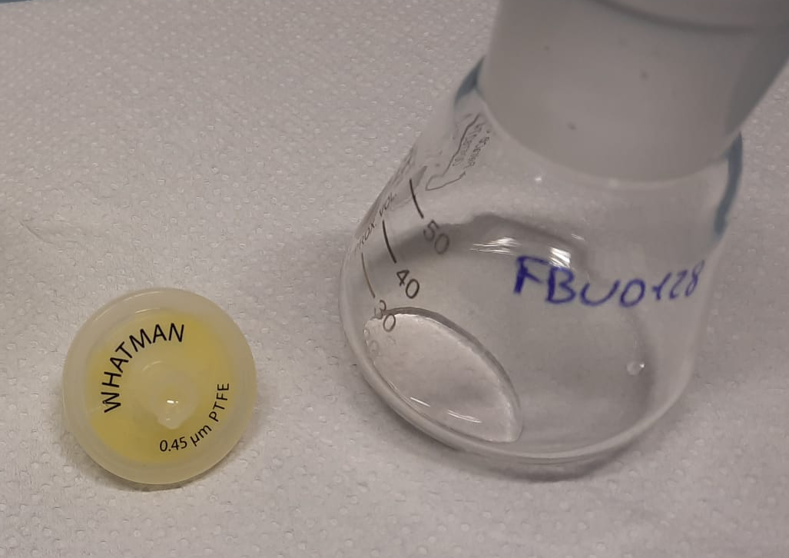
Fig. S1. Right: clear solution obtained after filtration of the reaction mixture of yellow waste PLA 3D print. Left: PTFE syringe filter used.

Fig. S2. Spectra of calcium lactate from yellow waste PLA 3D print (A, blue), calcium lactate obtained from PLA disposable cups (B, red), calcium lactate obtained from white waste PLA 3D print (C, green), commercial calcium lactate (D, purple). Left: enlarged section of the ¹H NMR spectrum (300.13 MHz, 294 K, D₂O coaxial insert), CH₃CN as internal standard. Right: FT-IR spectra.

3. Reaction data tables

Table S2. Representative data for the hydrolysis reaction of PLA in aqueous K₂CO₃.
Entry | K₂CO₃ concentration | Carbonate/PLA ratio ^{b} | Reaction temperature | Reaction time | LA yield^{a,b} | Final pH | Mn recovered polymer
 | [M] | [mol/mol] | [°C] | [h] | [% mol]
1 | 0.00 | n.a. | 130 | 24 | 11 | 3.3 | Mn 4568
2 | 0.00 | n.a. | 100 | 24 | 14 | 3.3 | Mn 4352
3 | 0.10 | 3.6 | 130 | 24 | 100 | 10.5 | No insoluble polymer recovered.
4 | 0.10 | 3.6 | 100 | 24 | 100 | 10.5 | No insoluble polymer recovered.
5 | 0.10 | 3.6 | 80 | 24 | 89 | 10.7 | -
6 | 0.10 | 3.6 | 60 | 24 | 43 | 11.0 | Mn 3272
7 | 0.05 | 1.8 | 130 | 24 | 76 | 10.4 | Mn 1040
8 | 0.05 | 1.8 | 100 | 24 | 78 | 9.5 | Mn 1832
9 | 0.05 | 1.8 | 80 | 24 | 36 | 10 | Mn 2696
10 | 0.05 | 1.8 | 60 | 24 | 36 | 10 | Mn 2696
11 | 0.50 | 18 | 130 | 24 | 100 | 12 | No insoluble polymer recovered.
12 | 0.50 | 18 | 100 | 24 | 100 | 12 | No insoluble polymer recovered.
13 | 0.50 | 18 | 80 | 24 | 93 | 12 | No measurable amount recovered.
14 | 0.50 | 18 | 60 | 24 | 64 | 12 | Mn 2120
15 | 0.10 | 0.5 | 130 | 24 | 60 | 7.4 | -
16 | 0.10 | 1.0 | 130 | 24 | 65 | 9.9 | -
17 | 0.50 | 0.5 | 130 | 24 | 90 | 8.5 | No measurable amount recovered.
18 | 0.50 | 1.0 | 130 | 24 | 100 | 9 | No insoluble polymer recovered.
19 | 0.50 | 2.0 | 130 | 24 | 100 | 10.4 | No insoluble polymer recovered.
20 | 0.50 | 0.25 | 130 | 24 | 71 | 4.6 | -
21 | 0.50 | 2.00 | 100 | 24 | 99 | 10.4 | No insoluble polymer recovered.
22 | 0.50 | 1.00 | 100 | 24 | 65 | 9.5 | Mn 4568
23 | 0.50 | 0.5 | 100 | 24 | 49 | 9.5 | Mn 3128
24 | 0.10 | 2.00 | 130 | 24 | 98 | 10.2 | No measurable amount recovered.
25 | 0.10 | 2.00 | 100 | 24 | 94 | 10.2 | No measurable amount recovered.
26 | 0.50 | 0.25 | 130 | 48 | 76 | 4.4 | -
27 | 0.50 | 0.125 | 130 | 24 | 50 | 4.0 | Mn 968
ª Calculated on the basis of PLA repetition units. ^{b} Data from HPLC analysis, after filtration and acidification with H₂SO₄.

Table S3. Representative data for the hydrolysis reaction of PLA over aqueous CaCO₃.
Entry | CaCO₃ amount | Carbonate/PLA ratio ^{b} | Reaction temperature | Reaction time | LA yield^{a,b} | Final pH | Mn recovered polymer
 | [mmol] | [mol/mol] | [°C] | [h] | [% mol]
1 | 0.00 | n.a. | 100 | 48 | 14 | 3.3 | -
2 | 0.00 | n.a. | 130 | 48 | 14 | 3.3 | -
3 | 0.4 | 3.6 | 100 | 48 | 46 | 6.8 | -
4 | 0.4 | 3.6 | 130 | 48 | 100 | 6.7 | No insoluble polymer recovered.
5 | 2 | 18 | 100 | 48 | 58 | 6.8 | Mn 1832
6 | 2 | 18 | 130 | 48 | 96 | 6.7 | No measurable amount recovered.
7 | 0.4 | 2 | 130 | 48 | 99 | 6.6 | No insoluble polymer recovered.
8 | 0.4 | 1 | 130 | 48 | 36 | 6.6 | Mn 3776
9 | 2 | 1.7 | 130 | 48 | 100 | 6.1 | No insoluble polymer recovered.
10 | 2 | 1 | 130 | 48 | 48 | 6.2 | Mn 3128
ª Calculated on the basis of PLA repetition units. ^{b} Data from HPLC analysis, after filtration and acidification with H₂SO₄.

4. NMR data and spectra
Fig. S3. Enlarged section of the ¹H NMR spectrum (300.13 MHz, 294 K, CDCl₃) of the disposable cup PLA (in red), white PLA waste from 3D printing process (in green), yellow PLA waste from 3D printing process (in blue).
Fig. S4. Enlarged section of the ¹H NMR spectrum (300.13 MHz, 294 K, D₂O coaxial insert) of the aqueous phase reaction mixture recovered at the end of catalytic hydrolysis of commercial PLA (in purple), PLA disposable cup (in red), white PLA waste from 3D printing process (in green), yellow PLA waste from 3D printing process (in blue) with K₂CO₃. CH₃CN as internal standard.

¹H NMR data for lactic acid (LA), 294 K, H₂O, 300.13 MHz, 0.03 M: δ 4.24 ppm (1H, CH, q, J_{HH} 7.0 Hz); δ 1.28 ppm (3H, CH₃, d, J_{HH} 7.0 Hz).

¹H NMR data for lactate dimer, 294 K, H₂O, 300.13 MHz: δ 5.0 ppm (1H, CH) masked by water resonance; δ 4.19 ppm (1H, CH, q, J_{HH} 7.0 Hz); δ 1.37 ppm (3H, CH₃, d, J_{HH} 7.0 Hz); δ 1.33 ppm (3H, CH₃, d, J_{HH} 7.0 Hz). Data from reference n. 8.

5. Other figures and tables

Fig. S5. Typical HPLC chromatogram of the of the aqueous phase reaction mixture recovered at the end of the hydrolysis reaction of PLA over alkali carbonates (RID detector, HPX-87H Aminex Bio-RAD column (300 mm x 7.8 mm), 0.005 M sulphuric acid as eluent (flow 0.4 ml min⁻¹ at 35 ºC)).

Table S4. HPLC analytical data for PLA hydrolytic depolymerisation mixtures.ª
Retention time  (min) | Product | Abbreviation | Formula
18.87 | Lactic acid | LA
38.02 | LA dimer
ª RID detector, HPX-87H Aminex Bio-RAD column (300 mm x 7.8 mm), 0.005 M sulphuric acid as eluent (flow 0.4 ml min⁻¹ at 35 ºC))

Fig. S6. HPLC calibration curve for Lactic Acid in two concentration ranges (peak area versus analyte concentration).

Fig. S7. GC chromatogram of the PLA hydrolysis of reaction mixture (Nukol fused silica capillary column (30 m, 0.32 mm ID, 0.25 μm FT). Oven ramp: 80°C for 5 min, 5°C/min to 200°C, 200°C for 10 min then 10°C/min to 220°C; linear velocity: 25 cm sec⁻¹). Reaction conditions: PLA 0.11 mmol, K2CO3 0.40 mmol (0.10 M, mol ratio carbonate/PLA = 3.6), water 4 mL.

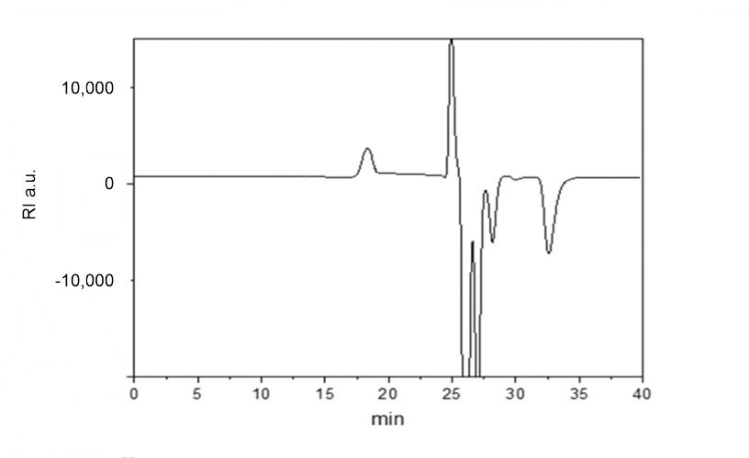
Fig. S8. Typical GPC pattern of the solid residue recovered at the end of the hydrolytic depolymerisation reaction of PLA over K₂CO₃ (refractive index detector, PLgel MiniMIX-D 5 µm columns at 35°C, CHCl₃ 0.3 mL min⁻¹). No GPC peaks are detectable in the aqueous phase reaction mixture recovered.

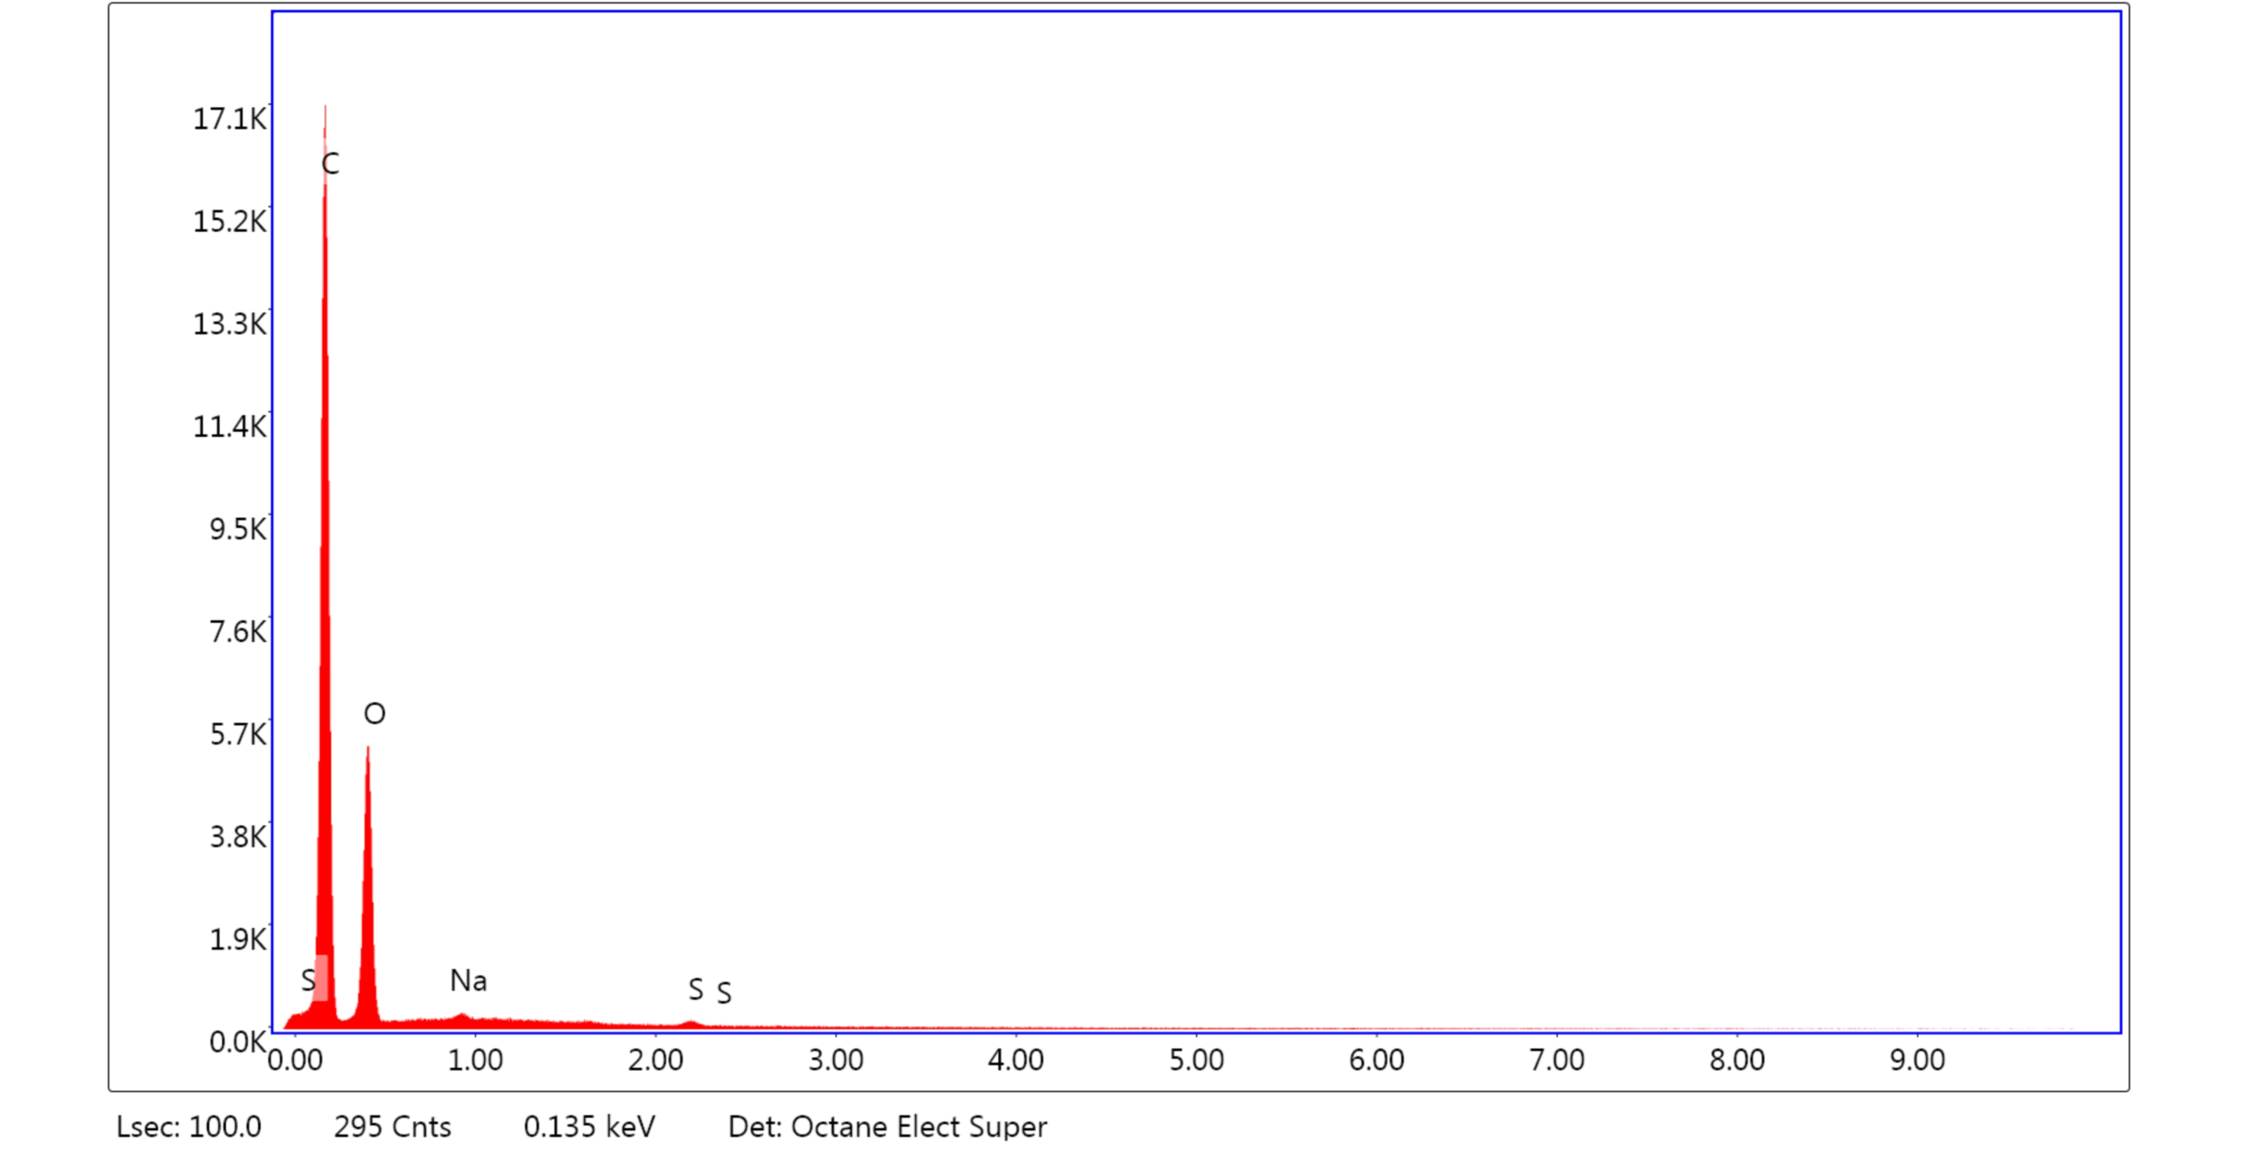

Element |  | Weight % |  |  |  | Atomic %
C K |  | 66.94 |  |  |  | 73.15
O K |  | 32.19 |  |  |  | 26.4
NaK |  | 0.08 |  |  |  | 0.04
S K |  | 0.25 |  |  |  | 0.1

Fig. S9. EDS spectrum and representative analysis data of PLA disposable cups (15 keV).

Element |  | Weight % |  |  |  | Atomic %
C K |  | 70.8 |  |  |  | 76.51
O K |  | 28.68 |  |  |  | 23.27
NaK |  | 0.02 |  |  |  | 0.01
S K |  | 0.5 |  |  |  | 0.2

Fig. S10. EDS spectrum and representative analysis data of white PLA waste from 3D printing (15 keV).

Element |  | Weight % |  |  |  | Atomic %
C K |  | 69.98 |  |  |  | 76.04
O K |  | 28.71 |  |  |  | 23.42
NaK |  | 0.22 |  |  |  | 0.13
SiK |  | 0.19 |  |  |  | 0.09
S K |  | 0.46 |  |  |  | 0.19
CaK |  | 0.43 |  |  |  | 0.14

Fig. S11. EDS spectrum and representative analysis data of yellow PLA+ waste from 3D printing (15 keV).

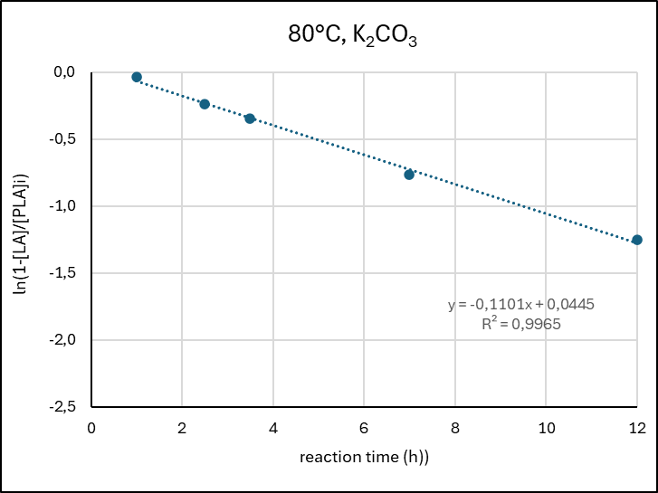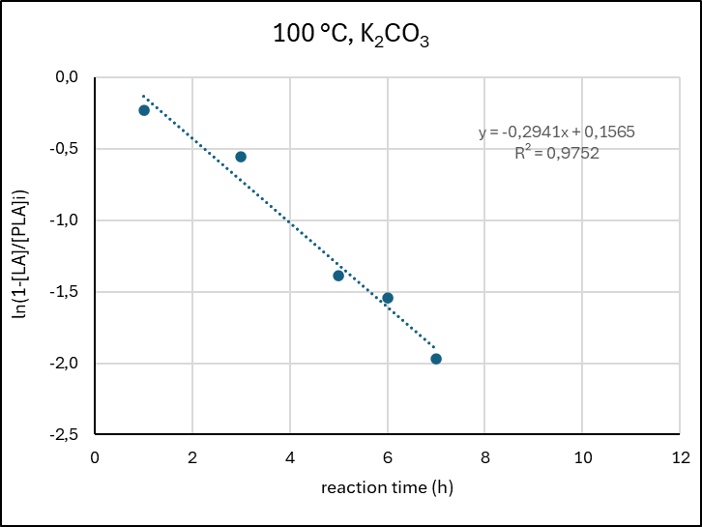
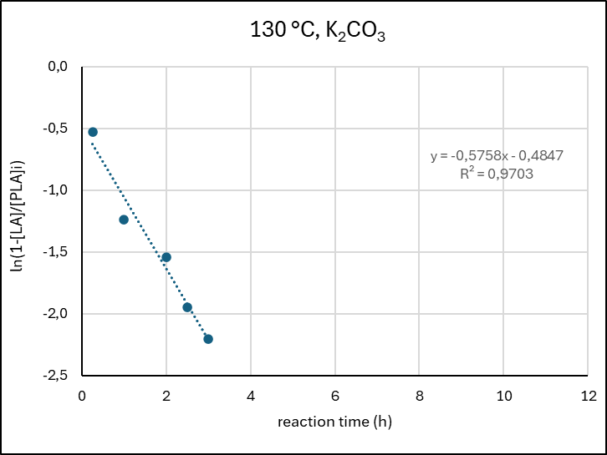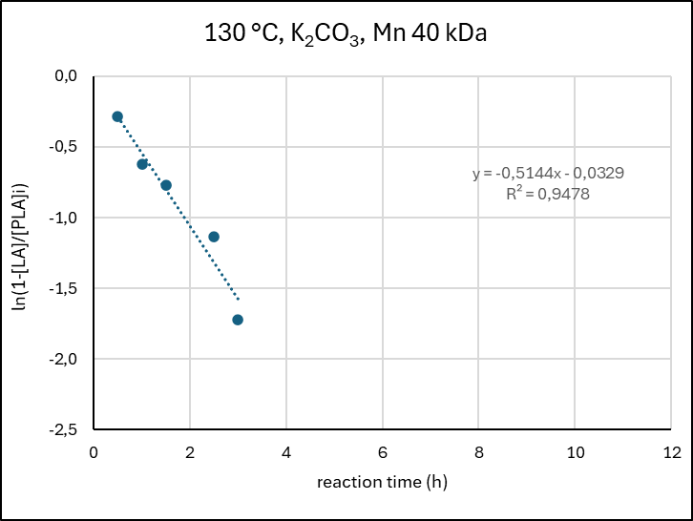
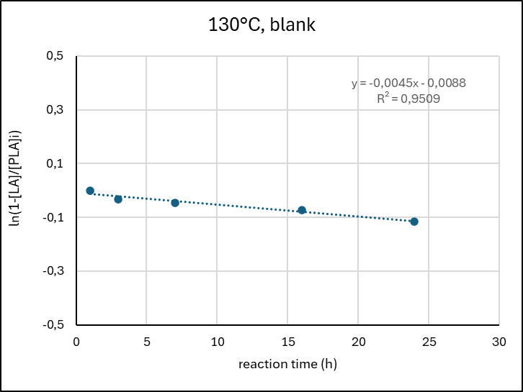
Fig. S12. Plot of ln(1-[LA]/[PLA]_{i}) versus reaction time, for the hydrolytic depolymerisation reaction of PLA in the presence of K₂CO₃. Reaction conditions: PLA Mn 10100, 0.11 mmol (based on PLA repetition units), K₂CO₃ 0.40 mmol (0.1 M, mol ratio carbonate/PLA = 3.6), water 4 mL. Data from HPLC analysis. It was assumed that: - d[PLA]/dt = k[PLA]; [LA] = [PLA]i - [PLA]f, where [PLA]_{i} and [PLA]_{f} are the starting and final concentration of PLA at the end of the depolymerisation experiment, respectively, and 100% selectivity to LA.

Fig. S13. Arrhenius plot for the hydrolytic depolymerisation reaction of PLA in the presence of K₂CO₃, in the range 80-130 °C. Reaction conditions: PLA Mn 10100, 0.11 mmol (based on PLA repetition units), K₂CO₃ 0.40 mmol (0.1 M, mol ratio carbonate/PLA = 3.6), water 4 mL. Data from HPLC analysis

Fig. S14. PXRD patterns acquired at room temperature for commercial CaCO₃ before (left), and recovered after use in the hydrolysis reaction of PLA (right). Reaction conditions: 8 mg PLA (0.112 mmol), 40 mg CaCO₃ (0.4 mmol), mol ratio carbonate / PLA = 3.6, 4 mL water, 130 °C, 48 h reaction time.

Fig. S15. FTIR spectra of commercial CaCO₃ before (red), and recovered after use in hydrolysis reaction of PLA (black). Reaction conditions: 8 mg PLA (0.112 mmol), 40 mg CaCO₃ (0.4 mmol), mol ratio carbonate / PLA = 3.6, 4 mL water, 130°C, 48 h reaction time.

Fig. S16. Typical particle size distribution of cryo-milled PLA waste materials measured by mesh range weighting.

Fig. S17. LA yield in the hydrolytic depolymerisation reaction of commercial PLA (Mn 40 kDa) and the mixture thereof with 5 % wt CaCO₃ and Na₂SO₄, in the presence of K₂CO₃ promoter. LA yield (% mol, based on PLA repetition units). Data from HPLC analysis. Reaction conditions: K₂CO₃ 0.5 M (carbonate/PLA molar ratio 0.5, based on PLA repetition units), 130° C; 24 h.

Table S5. Selected literature data for the chemically-promoted hydrolytic depolymerisation reaction of neat PLA in water.
Promoter  (P) | Type | Temp.  (°C) ª | Time  (h) ^{b} | Ratio PLA/P  (mol/mol) | Conv.  (%) ^{c} | Sel.  (%) ^{d} | Yield  (%) ^{e} | Notes | Ref.
K₂CO₃ | Soluble | 130 | 24 | 1.0 | 100 | 100 | 100 | K-lactate product. Requires neutralisation to free LA. KCl recovery. Adaptable to PLA waste. | This work
CaCO₃ | Insoluble | 130 | 48 | 0.59 | 100 | 100 | 100 | Ca-lactate product. Recoverable promoter. Adaptable to PLA waste. | This work
HCl | Soluble | 70 | 240 | pH 1 | 50 | n.a. | n.a. | Corrosion issues. Adaptable to PLA fibres. | ,
NaOH | Soluble | 90 | 24 | 0.71 | n.a. | n.a. | 95 | In the presence of ethyl lactate. Na-lactate product. Corrosion issues. LA recovery not explored. Adaptable to PLA fibres. | , 10
NaOH | Soluble | 35 | 144 | pH 13 | 10 | n.a. | n.a. | Na-lactate product. LA recovery not explored.
NaOH | Soluble | 160 | 1 | pH 13.8 | 100 | 100 | 100 | Na-lactate product. LA recovery not explored.
PO₄ buffer | Soluble | 37 | 100 | n.a. | n.a. | n.a. | n.a.
PO₄ buffer | Soluble | 37 | 1080 | n.a. | 70 | n.a. | n.a. | LA recovery not explored.
PO₄ buffer | Soluble | 37 | 3120 | n.a. | 10 | n.a. | n.a.
p-BNPP ^{f} | Soluble | 160 | 0.5 | 28.6 ^{g} | n.a. | n.a. | 92 | Synthetic organic promoter. Oligo(lactic acid) product. Adaptable to PLA waste.
2-HEAA | Soluble | 140 | 3 | 0.4 ^{g} | n.a. | n.a. | 72 | Ionic liquid promoter.
Zn acetate | Soluble | 200 | 6 | 250 | n.a. | n.a. | 98 | Lactide product. Solvent-free. Use of toxic Zn species. Under 0.006 bar pressure.
Zn lactate | Soluble | 195 | 6 | 667 ^{g} | n.a. | n.a. | 74.2 | Lactide product. Solvent-free. Use of toxic Zn species. Under 0.006 bar pressure.
ZnO | Insoluble | 130 | 24 | 0.4 | 100 | 100 | 100 | ZnO erosion and partial recovery. | 8
ZnO-ZrO₂ | Insoluble | 130 | 72 | 0.38 ^{g} | 100 | 100 | 100 | Synthetic promoter.
Ru@CeO₂ | Insoluble | 200 | 0.33 | 4.6 ^{g} | 98 | 96 | 94 | Synthetic promoter. Expensive metals. Efficiency decay. Under 100 bar H₂.
none |  | 250 | 0.25 | n.a | 100 | 90 | 90 |  | 7
none |  | 130 | 24 | n.a. | 11 | 100 | 11 |  | This work
ª Reaction temperature. ^{b} Reaction time. ^{c} PLA conversion. ^{d} Selectivity to LA. ^{e} Yield of LA or LA-containing product. ^{f} p-Bis-nitrophenyl phosphate. ^{g} Ratio PLA/promoter (P) in (w/w).

An extensive table summarising the literature data for the hydrolytic depolymerisation reaction of PLA prior of year 2010 can be found in: H. Tsuji, Hydrolytic degradation, in Poly(Lactic Acid): Synthesis, Structures, Properties, Processing, and Applications, Eds.: R. A. Auras, L. T. Lim, S. E. M. Selke, H. Tsuji, Wiley, 2010, Hoboken, Chapter 21, https://doi.org/10.1002/9780470649848

6. References

. C. Moreno-Marrodan, P. Barbaro, Green Chem. 2014, 16, 3434–3438.
. V. Sklenar, M. Piotto, R. Leppik, V. Saudek, J. Magn. Reson., Series A 1993, 102, 241-245.
. S. Sato, D. Gondo, T. Wada, S. Kanehashi, K. Nagai, J. Appl. Polym. Sci. 2013, 129, 1607-1617.
. H. Sawada, Y. Takahashi, S. Miyata, S. Kanehashi, S. Sato, K. Nagai, Trans. Mater. Res. Soc. Jpn. 2010, 35, 241-246.
. V. Piemonte, F. Gironi, J. Polym. Environ. 2013, 21, 275-279.
. R. Vaid, E. Yildirim, M. A. Pasquinelli, M, W. King, Molecules 2021, 26, 7554-7571.
. T. Goto, M. Kishita, Y. Sun, T. Sako, I. Okajima, Polymers 2020, 12, 2434-2448.
. F. Liguori, C. Moreno-Marrodán, W. Oberhauser, E. Passaglia, P. Barbaro, RSC Sustain. 2023, 1, 1394-1403
. E. J. Rodriguez, B. Marcos, M. A. Huneault, J. Appl. Polym. Sci 2016, 44152.
. R. Vaid, E. Yildirim, M. A. Pasquinelli, M. W. King, Molecules 2021, 26, 7554-7570.
. P. Coszach, J. C. Bogaert, J. Willocq (Galactic S.A.), Patent No. US 2012/0142958 A1, 2012.
. H. Chen, J. Chen, J. Chen, J. Yang, T.Huang, N. Zhang, Y.Wang, Polym. Degrad. Stabil. 2012, 97, 2273-2283.
. M. Yagihashi, T. Funazukuri, Ind. Eng. Chem. Res. 2010, 49, 1247–1251.
. L. Xu, K. Crawford, C. B. Gorman, Macromolecules 2011, 44, 4777–4782.
. C.S. Proikakis, N.J. Mamouzelos, P.A. Tarantili, A.G. Andreopoulos, Polym. Degrad. Stabil. 2006, 91, 614-619.
. A. Larranaga, P. Aldazabal, F.J. Martin, J.R. Sarasua, Polym. Degrad. Stabil. 2014, 110, 121-128.
. H. Zhai, Y. Fang, S. Fan, W. Wu, T. Sun, W. Rao, J. Ding, L. Yu, Green Chem. 2025, 27, 15639–15653.
. A. Cháfer, O. Gil-Castell, A. Björling, R. Ballesteros-Garrido, J. P. Cerisuelo-Ferriols, J. D. Badia, Resour. Conserv. Recycl. 2024, 210, 107826.
. C. Alberti, S. Enthaler, Chemistry Select 2020, 5, 14759-14763.
. Y. Zhang, Y. Qi, Y. Yin, P. Sun, A. Li, Q. Zhang, W. Jiang, ACS Sustainable Chem. Eng. 2020, 8, 2865−2873.
. F. Liguori, W. Oberhauser, E. Berretti, L. Poggini, P. Barbaro, C. Moreno-Marrodán, Adv. Energy Sustainability Res. 2024, 2400349.
. M.S. Lehnertz, J. B. Mensah, R. Palkovits, Green Chem. 2022, 24, 3957-3963.

