Supporting Information

Revealing the true nature of double-peak emission in 2D perovskite single crystals using Polariton Waveguides

Annalisa Coriolano, Anna Moliterni*, Francesco Todisco, Laura Polimeno, Rosanna Mastria, Vincent Olieric, Carlotta Giacobbe, Milena De Giorgi, Dario Ballarini, Aurora Rizzo, Giuseppe Gigli, Cinzia Giannini, Ilenia Viola, Daniele Sanvitto* and Luisa De Marco*

Experimental details
Chemicals and reagents
Hydroiodic acid (HI), 1,6-Diaminohexane, N,N-Dimethyl-1,3-diaminopropane, Hydrophosphorous acid (H₃PO₂), Diethyl Ether (DE), Dimethyl sulfoxide (DMSO), N,N-Dimethylformamide (DMF), Acetone, Isopropanol (IPA), Dichloromethane (DCM), Lead Oxide (PbO) and Polydimethylsiloxane (PDMS) Sylgard 184 were purchased from Dow- Corning. 4-fluoro-phenethylammonium iodide (PEAI-F) was purchased from GreatCell Solar. Lead (II) iodide (PbI₂) was purchased from Alfa Aesar. γ-butyrolactone (GBL) was purchased from TCI. All chemicals were used as received without any further purification.

HEPbI₄ and DMPAPbI₄ synthesis
Figure S1 shows a sketch of the solution-based growth method synthesis^{[1,2]} used for HE and DMPA perovskites. The micrometer-size single crystals obtained were finally dried in vacuum for 12h on filter paper and then transferred onto the final substrate. High quality and millimeter – sized perovskite single crystals were obtained (Figure S2).

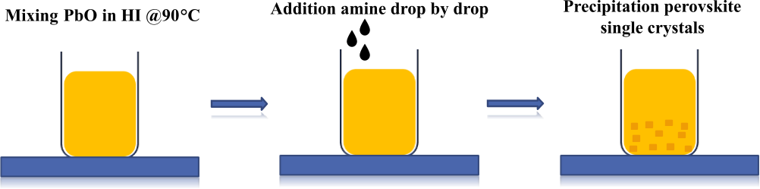
Figure S1. Sketch of the DJ perovskites synthetic process.

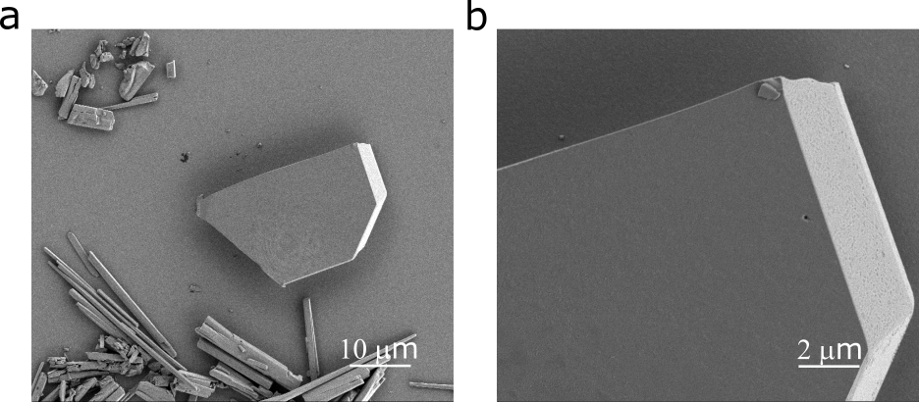

Figure S2. (a-b) SEM images of HE single crystals obtained through precipitation.

XRD measurements
Synchrotron micro-diffraction
Single-crystal X-ray diffraction data for HE and DMPA (2) were collected at the beamline 1D11 at the European Synchrotron Radiation Facility (ESRF) in Grenoble, France^{[3]} using a monochromatic beam. Main experimental details are summarized in Table S1. The crystals were centred in the beam with the help of the standard deviation signal recorded by the diffraction camera. The diffracted signals have been collected at ambient temperature (T = 293 K) by a photon counting detector (Eiger2 4M, 75 μm pixel size) placed at 119.06 mm from the sample. The sample-to-detector-distance and detector tilt have been calibrated using a CeO₂ powder. A series of images (typically 360) have been collected using a continuous rotation scan with an exposure time of 0.5 s. Images were then converted into the “Esperanto” format using the Eiger2esperanto script, which is part of FabIO^{[4]} version 0.11 in order to be processed with the Crysalis software.^{[5]} Bragg peaks were indexed, and their intensities were integrated and corrected for Lorentz polarization effects, using the Crysalis package. The semi-empirical ABSPACK routine implemented in Crysalis applied scaling and correction for absorption.
In the case of DMPA (1), single-crystal X-ray diffraction data measurements were carried out at the beamline PXII (X10SA-PXII, https://www.psi.ch/en/sls/pxii) at the Swiss Light Source (SLS), Villigen, Switzerland. The principal experimental details are given in Table S1. Diffraction data were processed by XDS,^{[6]} a software organized in eight subroutines able to perform the main data reduction steps; the integrated intensities were scaled and corrected for absorption effects by the XSCALE subroutine.
Crystal structure was solved by Direct Methods^{[7]} using SIR2019^{[8]} and refined by SHELXL2014/7^{[9]}. Additional applied computer programs were: Mercury^{[10]} and VESTA^{[11]} for molecular graphics; WinGX^{[12]} and publCIF^{[13]} for preparing the published material.
Structure solution and refinement
The structure solution process for the HE, DMPA (2) and DMPA (1) crystals was carried out by SIR2019,^{[8]} a package able to determine the space group and the crystal structure by exploiting minimal prior information concerning the unit cell parameters, the observed diffraction intensities and the expected chemical formula. The space group determination step was performed by considering the Laue group compatible with the monoclinic (HE and DMPA (2)) or the orthorhombic (DMPA (1)) unit cell and by calculating, for each possible extinction symbol, a suitable probability value via a statistical analysis based on the experimental intensities. The structure model was completed by locating the missing non-H light atoms via difference Fourier synthesis and refined using full-matrix least-squares techniques by SHELXL2014/7.^{[9]} All non-hydrogen atoms were refined anisotropically. The H atoms were placed at calculated positions and their atomic coordinates were refined according to a riding model, except for one of the H atoms of DMPA (2), i.e., HN1, bonded to the N1 nitrogen atom; HN1 was located via a careful inspection of the electron density map calculated by difference Fourier synthesis and its fractional coordinates were freely refined. The constraints on the isotropic U value of H atoms bonded to C and N atoms, were U_{iso}(H)=1.2 U_{eq}(C) and U_{iso}(H)=1.5 U_{eq}(N), respectively.
Main details on data collection and structure refinement are given in Table S1.

Crystal | HE | DMPA (2) | DMPA (1)
Chemical formula | C₆H₁₈N₂PbI₄ | C₅H₁₆N₂PbI₄ | C₅H₁₆N₂PbI₄
Data collection
Diffractometer | ID11 nanoscope | ID11 nanoscope | X10SA-PXII beamline, single-axis
Absorption correction | Empirical (using intensity measurements)  SCALE3 ABSPACK; Rigaku Oxford Diffraction, (2015) | Empirical (using intensity measurements)  SCALE3 ABSPACK; Rigaku Oxford Diffraction, (2015) | Empirical (using intensity measurements)
T_{min}, T_{max} | 0.34, 1.00 | 0.32, 1.0 | 0.33, 0.99
No. of measured, independent and observed [I > 2σ(I)] reflections | 14269, 2126, 1867 | 18428, 3336, 2810 | 27262, 4401, 4149
R_{int} | 0.044 | 0.070 | 0.050
(sin θ/λ)_{max} (Å⁻¹) | 0.667 | 0.625 | 0.685
Refinement
R[F² > 2σ(F²)], wR(F²), S | 0.042, 0.114, 1.10 | 0.037, 0.094, 1.04 | 0.027, 0.073, 1.06
No. of reflections | 2126 | 3336 | 4401
No. of parameters | 62 | 115 | 112
H-atom treatment | H-atom parameters constrained | H atoms treated by a mixture of independent and constrained refinement | H-atom parameters constrained
Δρ_{max}, Δρ_{min} (e Å⁻³) | 4.03, -1.21 | 2.25, −1.66 | 1.46, −1.28
CCDC number | 2253676 | 2253678 | 2253677
Table S1. HE, DMPA (2), DMPA (1): data collection and refinement details.

For each compound, two additional tables (i.e., Table S2 and S3 for HE, Table S4 and S5 for DMPA (2) and Table S6 and S7 for DMPA (1)) supplying refined fractional atomic coordinates, displacement parameters, bond distances and angles, torsion angles and hydrogen bonds, are provided.
The Pb-I bond lengths in the PbI₆ octahedron belonged to the intervals 3.1859(6) - 3.2269(5) Å for HE (see Table S2), 3.1789(5) - 3.2467(5) Å for DMPA (2) (see Table S4) and 3.1238(4) - 3.3015(4) Å for DMPA (1) (see Table S6). The ranges of the I_{ap}-Pb-I_{eq} octahedral bond angles were 87.665(15) ° - 92.335(15) ° for HE (see Table S2), 83.150(16) °- 101.236(17)° for DMPA (2) (see Table S4) and 83.731(11)° - 94.899(16)° for DMPA (1) (see Table S6), with I_{ap} and I_{eq} the apex and equatorial I atoms of the octahedron, respectively.
In the case of HE, a view of the asymmetric unit and its local environment is given in Figure S3, showing also the main directional H-bonds, i.e., N—H··· I intra and intermolecular interactions, for which the hydrogen-acceptor distances vary in the range 2.76-3.26 Å (see Table S3 and Figure S3b) and their influence in the equatorial distortion (see Figure S4). This results in a high level of octahedral distortion in HE compound with a Pb_{eq}–I–Pb_{eq} angle of 148.63° (see Figure S3b and Table S2), far from the ideal value (180.0°).
In the case of DMPA (2), the view of the asymmetric unit and its local environment is provided in Figure S5, showing the equatorial distortion Pb_{eq}–I–Pb_{eq} angle (i.e., 156.83°, see Figure S5b, Table S4). The main intermolecular interactions consist of N—H··· I and C—H··· I interactions for which the minimum and maximum values of the hydrogen-acceptor distances are 2.77 and 3.28 Å, respectively (see Table S5). The tilting of adjacent polyhedra is clearly visible in Figure S6.
In the case of DMPA (1), the view of the asymmetric unit and its local environment is given in Figure S7, showing, in addition to the equatorial distortion Pb_{eq}–I–Pb_{eq} angle (i.e., 163.13°, see Figure S7b and Table S6) also some directional H-bonds (i.e., three intramolecular interactions, for which the hydrogen-acceptor distances vary in the range 2.88-3.31 Å; see Table S7 for the list of all the main H-bonds). The tilting of adjacent polyhedra is clearly shown in Figure S8.

Computing details
Program used for cell refinement and data reduction CrysAlis PRO (Rigaku Oxford Diffraction, 2015); program used to solve structure: SIR2019 (Burla et al., 2015); program used to refine structure SHELXL2014/7 (Sheldrick, 2015); molecular graphics: Mercury (Macrae et al., 2020) and VESTA (Momma & Izumi, 2011); software used to prepare material for publication: WinGX (Farrugia, 2012) and publCIF (Westrip, 2010).

Table S2. HE: main experimental and crystallographic details.

Crystal data
C₆H₁₈N₂PbI₄ |  |  |  |  |  |  | F(000) = 724
M_{r} = 833.01 |  |  |  |  |  |  | D_{x} = 3.169 Mg m⁻³
Monoclinic, P2₁/c |  |  |  |  |  |  | Synchrotron radiation, λ = 0.29339 Å
a = 11.8712 (4) Å |  |  |  |  |  |  | Cell parameters from 4356 reflections
b = 8.4911 (2) Å |  |  |  |  |  |  | θ = 3.6–20.4°
c = 9.0503 (3) Å |  |  |  |  |  |  | μ = 4.67 mm⁻¹
β = 106.856 (3)° |  |  |  |  |  |  | T = 293 K
V = 873.07 (5) Å³ |  |  |  |  |  |  | Block, pale yellow
Z = 2 |  |  |  |  |  |  | 0.10 × 0.09 × 0.07 mm
Data collection
ID11 nanoscope diffractometer |  |  |  |  |  |  | R_{int} = 0.044
Radiation source: synchrotron |  |  |  |  |  |  | θ_{max} = 11.3°, θ_{min} = 1.8°
rotation scans |  |  |  |  |  |  | h = -15→15
Absorption correction: empirical (using intensity measurements) SCALE3 ABSPACK; Rigaku Oxford Diffraction, (2015)  T_{min} = 0.34, T_{max} = 1.0 |  |  |  |  |  |  | k = -11→11  l = -12→12
14269 measured reflections |  |  |  |  |  |  | 2126 standard reflections every 0.1 reflections
2126 independent reflections |  |  |  |  |  |  | intensity decay: none
1867 reflections with I > 2σ(I)
Refinement
Refinement on F² |  |  |  |  |  |  | 0 restraints
Least-squares matrix: full |  |  |  |  |  |  | Hydrogen site location: inferred from neighbouring sites
R[F² > 2σ(F²)] = 0.042 |  |  |  |  |  |  | H-atom parameters constrained
wR(F²) = 0.114 |  |  |  |  |  |  | w = 1/[σ²(F_{o}²) + (0.0718P)² + 1.8531P]  where P = (F_{o}² + 2F_{c}²)/3
S = 1.10 |  |  |  |  |  |  | (Δ/σ)_{max} < 0.001
2126 reflections |  |  |  |  |  |  | Δρ_{max} = 4.03 e Å⁻³
62 parameters |  |  |  |  |  |  | Δρ_{min} = -1.21 e Å⁻³
Special details
Geometry. All estimated standard deviations (esds), except the esd in the dihedral angle between two least squares (l.s.) planes, are estimated using the full covariance matrix. The cell esds are taken into account individually in the estimation of esds in distances, angles and torsion angles; correlations between esds in cell parameters are only used when they are defined by crystal symmetry. An approximate (isotropic) treatment of cell esds is used for estimating esds involving l.s. planes.
Fractional atomic coordinates and isotropic or equivalent isotropic displacement parameters (Å²)
 |  | x |  |  | y |  |  |  | z |  |  | U_{iso}*/U_{eq}
Pb1 |  | 0.0000 |  |  | 0.0000 |  |  |  | 0.0000 |  |  | 0.04071 (15)
I1 |  | 0.04945 (5) |  |  | 0.19317 (7) |  |  |  | 0.31951 (6) |  |  | 0.05344 (18)
I2 |  | -0.27305 (5) |  |  | 0.08024 (7) |  |  |  | -0.07629 (7) |  |  | 0.05551 (19)
C1 |  | -0.3399 (9) |  |  | -0.0987 (12) |  |  |  | 0.2875 (13) |  |  | 0.061 (2)
H1A |  | -0.3117 |  |  | -0.1990 |  |  |  | 0.2610 |  |  | 0.074*
H1B |  | -0.3966 |  |  | -0.0580 |  |  |  | 0.1955 |  |  | 0.074*
C2 |  | -0.4010 (9) |  |  | -0.1253 (12) |  |  |  | 0.4107 (13) |  |  | 0.061 (2)
H2A |  | -0.4590 |  |  | -0.2081 |  |  |  | 0.3766 |  |  | 0.073*
H2B |  | -0.3433 |  |  | -0.1617 |  |  |  | 0.5039 |  |  | 0.073*
C3 |  | -0.4611 (8) |  |  | 0.0180 (10) |  |  |  | 0.4491 (11) |  |  | 0.0509 (19)
H3A |  | -0.5085 |  |  | 0.0656 |  |  |  | 0.3540 |  |  | 0.061*
H3B |  | -0.4018 |  |  | 0.0940 |  |  |  | 0.5011 |  |  | 0.061*
N1 |  | -0.2402 (8) |  |  | 0.0113 (10) |  |  |  | 0.3349 (12) |  |  | 0.063 (2)
H1NA |  | -0.2003 |  |  | 0.0099 |  |  |  | 0.2654 |  |  | 0.095*
H1NB |  | -0.1929 |  |  | -0.0175 |  |  |  | 0.4265 |  |  | 0.095*
H1NC |  | -0.2670 |  |  | 0.1082 |  |  |  | 0.3414 |  |  | 0.095*
Atomic displacement parameters (Å²)
 | U¹¹ |  |  | U²² |  | U³³ |  | U¹² |  | U¹³ |  |  | U²³
Pb1 | 0.0516 (2) |  |  | 0.0356 (2) |  | 0.0403 (2) |  | 0.00085 (13) |  | 0.02174 (17) |  |  | -0.00031 (13)
I1 | 0.0667 (4) |  |  | 0.0468 (3) |  | 0.0515 (3) |  | -0.0017 (2) |  | 0.0245 (3) |  |  | -0.0169 (2)
I2 | 0.0527 (3) |  |  | 0.0516 (3) |  | 0.0640 (4) |  | 0.0042 (2) |  | 0.0199 (3) |  |  | 0.0069 (2)
C1 | 0.067 (6) |  |  | 0.059 (5) |  | 0.071 (6) |  | -0.008 (4) |  | 0.040 (5) |  |  | -0.016 (4)
C2 | 0.061 (5) |  |  | 0.059 (5) |  | 0.073 (6) |  | -0.001 (4) |  | 0.037 (5) |  |  | -0.003 (5)
C3 | 0.052 (4) |  |  | 0.052 (5) |  | 0.054 (5) |  | -0.007 (3) |  | 0.024 (4) |  |  | -0.003 (3)
N1 | 0.066 (5) |  |  | 0.061 (5) |  | 0.074 (6) |  | 0.005 (3) |  | 0.038 (5) |  |  | 0.004 (4)
Geometric parameters (Å, º)
Pb1—I2 |  |  | 3.1859 (6) |  |  |  | C1—H1B |  |  |  | 0.9700
Pb1—I2^{i} |  |  | 3.1860 (6) |  |  |  | C2—C3 |  |  |  | 1.501 (13)
Pb1—I1^{ii} |  |  | 3.2181 (5) |  |  |  | C2—H2A |  |  |  | 0.9700
Pb1—I1^{iii} |  |  | 3.2181 (5) |  |  |  | C2—H2B |  |  |  | 0.9700
Pb1—I1 |  |  | 3.2268 (5) |  |  |  | C3—C3^{v} |  |  |  | 1.513 (17)
Pb1—I1^{i} |  |  | 3.2269 (5) |  |  |  | C3—H3A |  |  |  | 0.9700
I1—Pb1^{iv} |  |  | 3.2182 (5) |  |  |  | C3—H3B |  |  |  | 0.9700
C1—N1 |  |  | 1.471 (13) |  |  |  | N1—H1NA |  |  |  | 0.8900
C1—C2 |  |  | 1.513 (13) |  |  |  | N1—H1NB |  |  |  | 0.8900
C1—H1A |  |  | 0.9700 |  |  |  | N1—H1NC |  |  |  | 0.8900
I2—Pb1—I2^{i} |  |  | 180.0 |  |  |  | C2—C1—H1B |  |  |  | 108.9
I2—Pb1—I1^{ii} |  |  | 92.335 (15) |  |  |  | H1A—C1—H1B |  |  |  | 107.7
I2^{i}—Pb1—I1^{ii} |  |  | 87.665 (15) |  |  |  | C3—C2—C1 |  |  |  | 114.3 (9)
I2—Pb1—I1^{iii} |  |  | 87.665 (15) |  |  |  | C3—C2—H2A |  |  |  | 108.7
I2^{i}—Pb1—I1^{iii} |  |  | 92.335 (15) |  |  |  | C1—C2—H2A |  |  |  | 108.7
I1^{ii}—Pb1—I1^{iii} |  |  | 180.000 (12) |  |  |  | C3—C2—H2B |  |  |  | 108.7
I2—Pb1—I1 |  |  | 89.701 (16) |  |  |  | C1—C2—H2B |  |  |  | 108.7
I2^{i}—Pb1—I1 |  |  | 90.300 (16) |  |  |  | H2A—C2—H2B |  |  |  | 107.6
I1^{ii}—Pb1—I1 |  |  | 91.764 (6) |  |  |  | C2—C3—C3^{v} |  |  |  | 113.1 (9)
I1^{iii}—Pb1—I1 |  |  | 88.236 (6) |  |  |  | C2—C3—H3A |  |  |  | 109.0
I2—Pb1—I1^{i} |  |  | 90.299 (16) |  |  |  | C3^{v}—C3—H3A |  |  |  | 109.0
I2^{i}—Pb1—I1^{i} |  |  | 89.700 (16) |  |  |  | C2—C3—H3B |  |  |  | 109.0
I1^{ii}—Pb1—I1^{i} |  |  | 88.236 (5) |  |  |  | C3^{v}—C3—H3B |  |  |  | 109.0
I1^{iii}—Pb1—I1^{i} |  |  | 91.764 (5) |  |  |  | H3A—C3—H3B |  |  |  | 107.8
I1—Pb1—I1^{i} |  |  | 180.0 |  |  |  | C1—N1—H1NA |  |  |  | 109.5
Pb1^{iv}—I1—Pb1 |  |  | 148.63 (2) |  |  |  | C1—N1—H1NB |  |  |  | 109.5
N1—C1—C2 |  |  | 113.4 (8) |  |  |  | H1NA—N1—H1NB |  |  |  | 109.5
N1—C1—H1A |  |  | 108.9 |  |  |  | C1—N1—H1NC |  |  |  | 109.5
C2—C1—H1A |  |  | 108.9 |  |  |  | H1NA—N1—H1NC |  |  |  | 109.5
N1—C1—H1B |  |  | 108.9 |  |  |  | H1NB—N1—H1NC |  |  |  | 109.5
N1—C1—C2—C3 |  |  | 65.4 (12) |  |  |  | C1—C2—C3—C3^{v} |  |  |  | 169.8 (10)

Symmetry codes: (i) -x, -y, -z; (ii) x, -y+1/2, z-1/2; (iii) -x, y-1/2, -z+1/2; (iv) -x, y+1/2, -z+1/2; (v) -x-1, -y, -z+1.

Table S3. HE: Hydrogen-bond geometry (Å,°)
D—H···A | D—H | H···A | D···A | D—H···A
N1—H1NA···I1 | 0.89 | 3.26 | 3.808 (9) | 122
N1—H1NA···I2 | 0.89 | 3.02 | 3.674 (10) | 132
N1—H1NB···I1^{vi} | 0.89 | 2.85 | 3.717 (10) | 164
N1—H1NC···I2^{vii} | 0.89 | 2.76 | 3.607 (8) | 161

Symmetry codes: (vi) -x, -y, -z+1; (vii) x, -y+1/2, z+1/2.

Table S4. DMPA (2): main experimental and crystallographic details.
Crystal data
C₅H₁₆N₂PbI₄ | F(000) = 1416
M_{r} = 818.99 | D_{x} = 3.268 Mg m⁻³
Monoclinic, P2₁/c | Synchrotron radiation, λ = 0.2852 Å
a = 11.2176 (4) Å | Cell parameters from 4122 reflections
b = 12.5073 (3) Å | θ = 4.0–21.0°
c = 12.8819 (3) Å | μ = 4.55 mm⁻¹
β = 112.929 (3)° | T = 293 K
V = 1664.55 (9) Å³ | Prism, red
Z = 4 | 0.10 × 0.10 × 0.03 mm
Data collection
ID11 nanoscope  diffractometer | 2810 reflections with I > 2σ(I)
Radiation source: synchrotron | R_{int} = 0.070
rotation scans | θ_{max} = 10.3°, θ_{min} = 1.5°
Absorption correction: empirical (using intensity measurements) SCALE3 ABSPACK; Rigaku Oxford Diffraction, (2015) | h = -14→14
T_{min} = 0.32, T_{max} = 1.0 | k = -15→15
18428 measured reflections | l = -16→16
3336 independent reflections
Refinement
Refinement on F² | 0 restraints
Least-squares matrix: full | Hydrogen site location: mixed
R[F² > 2σ(F²)] = 0.037 | H atoms treated by a mixture of independent and constrained refinement
wR(F²) = 0.094 | w = 1/[σ²(F_{o}²) + (0.0478P)² + 4.5716P]  where P = (F_{o}² + 2F_{c}²)/3
S = 1.04 | (Δ/σ)_{max} < 0.001
3336 reflections | Δρ_{max} = 2.25 e Å⁻³
115 parameters | Δρ_{min} = -1.66 e Å⁻³
Special details
Geometry. All esds (except the esd in the dihedral angle between two l.s. planes) are estimated using the full covariance matrix. The cell esds are taken into account individually in the estimation of esds in distances, angles and torsion angles; correlations between esds in cell parameters are only used when they are defined by crystal symmetry. An approximate (isotropic) treatment of cell esds is used for estimating esds involving l.s. planes.

Fractional atomic coordinates and isotropic or equivalent isotropic displacement parameters (Å²)
 |  | x |  |  | y |  |  |  | z |  |  | U_{iso}*/U_{eq}
Pb1 |  | 0.49944 (3) |  |  | 0.25715 (2) |  |  |  | 0.23207 (2) |  |  | 0.03569 (11)
I1 |  | 0.51730 (6) |  |  | 0.24316 (5) |  |  |  | -0.01024 (4) |  |  | 0.04902 (17)
I2 |  | 0.55931 (7) |  |  | 0.00786 (4) |  |  |  | 0.25501 (5) |  |  | 0.05060 (18)
I3 |  | 0.80521 (6) |  |  | 0.30314 (5) |  |  |  | 0.33832 (5) |  |  | 0.05465 (18)
I4 |  | 0.19420 (6) |  |  | 0.22222 (6) |  |  |  | 0.10462 (6) |  |  | 0.05936 (19)
N1 |  | 0.1456 (8) |  |  | 0.5211 (6) |  |  |  | -0.1477 (7) |  |  | 0.0492 (18)
HN1 |  | 0.161 (11) |  |  | 0.565 (9) |  |  |  | -0.179 (9) |  |  | 0.059*
C3 |  | 0.0373 (11) |  |  | 0.4522 (9) |  |  |  | -0.2150 (9) |  |  | 0.063 (3)
H3A |  | 0.0141 |  |  | 0.4070 |  |  |  | -0.1646 |  |  | 0.076*
H3B |  | 0.0652 |  |  | 0.4060 |  |  |  | -0.2618 |  |  | 0.076*
C4 |  | 0.2681 (11) |  |  | 0.4617 (9) |  |  |  | -0.0997 (9) |  |  | 0.064 (3)
H4A |  | 0.2953 |  |  | 0.4415 |  |  |  | -0.1590 |  |  | 0.096*
H4B |  | 0.2559 |  |  | 0.3987 |  |  |  | -0.0625 |  |  | 0.096*
H4C |  | 0.3330 |  |  | 0.5061 |  |  |  | -0.0463 |  |  | 0.096*
C5 |  | -0.0845 (12) |  |  | 0.5155 (9) |  |  |  | -0.2917 (10) |  |  | 0.070 (3)
H5A |  | -0.1291 |  |  | 0.5435 |  |  |  | -0.2465 |  |  | 0.084*
H5B |  | -0.0581 |  |  | 0.5755 |  |  |  | -0.3256 |  |  | 0.084*
C6 |  | -0.1711 (12) |  |  | 0.4478 (10) |  |  |  | -0.3792 (9) |  |  | 0.077 (3)
H6A |  | -0.2009 |  |  | 0.3904 |  |  |  | -0.3447 |  |  | 0.093*
H6B |  | -0.1238 |  |  | 0.4158 |  |  |  | -0.4203 |  |  | 0.093*
C7 |  | 0.1265 (12) |  |  | 0.5831 (11) |  |  |  | -0.0592 (11) |  |  | 0.086 (4)
H7A |  | 0.1966 |  |  | 0.6327 |  |  |  | -0.0272 |  |  | 0.129*
H7B |  | 0.1240 |  |  | 0.5356 |  |  |  | -0.0015 |  |  | 0.129*
H7C |  | 0.0463 |  |  | 0.6216 |  |  |  | -0.0908 |  |  | 0.129*
N2 |  | -0.2848 (10) |  |  | 0.5053 (6) |  |  |  | -0.4597 (8) |  |  | 0.067 (2)
HN2B |  | -0.2589 |  |  | 0.5521 |  |  |  | -0.4987 |  |  | 0.101*
HN2C |  | -0.3246 |  |  | 0.5399 |  |  |  | -0.4220 |  |  | 0.101*
HN2A |  | -0.3392 |  |  | 0.4587 |  |  |  | -0.5067 |  |  | 0.101*
Atomic displacement parameters (Å²)
 | U¹¹ |  |  | U²² |  | U³³ |  | U¹² |  | U¹³ |  |  | U²³
Pb1 | 0.04126 (19) |  |  | 0.03428 (17) |  | 0.03304 (18) |  | -0.00026 (11) |  | 0.01613 (13) |  |  | -0.00059 (10)
I1 | 0.0626 (4) |  |  | 0.0582 (3) |  | 0.0322 (3) |  | 0.0094 (3) |  | 0.0249 (3) |  |  | 0.0032 (2)
I2 | 0.0647 (4) |  |  | 0.0297 (3) |  | 0.0552 (3) |  | -0.0009 (2) |  | 0.0210 (3) |  |  | 0.0001 (2)
I3 | 0.0428 (3) |  |  | 0.0681 (4) |  | 0.0493 (3) |  | -0.0075 (3) |  | 0.0138 (3) |  |  | 0.0091 (3)
I4 | 0.0395 (3) |  |  | 0.0673 (4) |  | 0.0699 (4) |  | 0.0004 (3) |  | 0.0198 (3) |  |  | 0.0019 (3)
N1 | 0.049 (5) |  |  | 0.050 (4) |  | 0.051 (4) |  | 0.001 (4) |  | 0.022 (4) |  |  | 0.000 (3)
C3 | 0.060 (7) |  |  | 0.065 (6) |  | 0.065 (6) |  | 0.000 (5) |  | 0.026 (5) |  |  | -0.012 (5)
C4 | 0.059 (7) |  |  | 0.065 (6) |  | 0.063 (6) |  | 0.010 (5) |  | 0.017 (5) |  |  | -0.004 (5)
C5 | 0.053 (7) |  |  | 0.076 (7) |  | 0.080 (7) |  | 0.006 (5) |  | 0.026 (6) |  |  | -0.009 (6)
C6 | 0.081 (9) |  |  | 0.081 (7) |  | 0.052 (6) |  | 0.003 (6) |  | 0.007 (5) |  |  | -0.010 (5)
C7 | 0.060 (7) |  |  | 0.110 (10) |  | 0.088 (8) |  | 0.006 (7) |  | 0.030 (6) |  |  | -0.047 (7)
N2 | 0.063 (6) |  |  | 0.070 (6) |  | 0.066 (5) |  | -0.009 (4) |  | 0.021 (5) |  |  | 0.005 (4)
Geometric parameters (Å, º)
Pb1—I2 |  |  | 3.1789 (5) |  |  |  | C4—H4A |  |  |  | 0.9600
Pb1—I4 |  |  | 3.1985 (7) |  |  |  | C4—H4B |  |  |  | 0.9600
Pb1—I1 |  |  | 3.2096 (5) |  |  |  | C4—H4C |  |  |  | 0.9600
Pb1—I3 |  |  | 3.2110 (7) |  |  |  | C5—C6 |  |  |  | 1.442 (16)
Pb1—I2^{i} |  |  | 3.2218 (5) |  |  |  | C5—H5A |  |  |  | 0.9700
Pb1—I1^{ii} |  |  | 3.2467 (5) |  |  |  | C5—H5B |  |  |  | 0.9700
I1—Pb1^{iii} |  |  | 3.2467 (5) |  |  |  | C6—N2 |  |  |  | 1.480 (15)
I2—Pb1^{iv} |  |  | 3.2218 (5) |  |  |  | C6—H6A |  |  |  | 0.9700
N1—C7 |  |  | 1.463 (13) |  |  |  | C6—H6B |  |  |  | 0.9700
N1—C3 |  |  | 1.466 (13) |  |  |  | C7—H7A |  |  |  | 0.9600
N1—C4 |  |  | 1.469 (13) |  |  |  | C7—H7B |  |  |  | 0.9600
N1—HN1 |  |  | 0.74 (10) |  |  |  | C7—H7C |  |  |  | 0.9600
C3—C5 |  |  | 1.556 (16) |  |  |  | N2—HN2B |  |  |  | 0.8900
C3—H3A |  |  | 0.9700 |  |  |  | N2—HN2C |  |  |  | 0.8900
C3—H3B |  |  | 0.9700 |  |  |  | N2—HN2A |  |  |  | 0.8900
I2—Pb1—I4 |  |  | 93.374 (19) |  |  |  | N1—C4—H4B |  |  |  | 109.5
I2—Pb1—I1 |  |  | 86.901 (16) |  |  |  | H4A—C4—H4B |  |  |  | 109.5
I4—Pb1—I1 |  |  | 87.323 (19) |  |  |  | N1—C4—H4C |  |  |  | 109.5
I2—Pb1—I3 |  |  | 89.093 (19) |  |  |  | H4A—C4—H4C |  |  |  | 109.5
I4—Pb1—I3 |  |  | 174.492 (19) |  |  |  | H4B—C4—H4C |  |  |  | 109.5
I1—Pb1—I3 |  |  | 87.895 (18) |  |  |  | C6—C5—C3 |  |  |  | 110.8 (10)
I2—Pb1—I2^{i} |  |  | 171.838 (10) |  |  |  | C6—C5—H5A |  |  |  | 109.5
I4—Pb1—I2^{i} |  |  | 87.699 (19) |  |  |  | C3—C5—H5A |  |  |  | 109.5
I1—Pb1—I2^{i} |  |  | 101.236 (17) |  |  |  | C6—C5—H5B |  |  |  | 109.5
I3—Pb1—I2^{i} |  |  | 90.555 (19) |  |  |  | C3—C5—H5B |  |  |  | 109.5
I2—Pb1—I1^{ii} |  |  | 88.690 (16) |  |  |  | H5A—C5—H5B |  |  |  | 108.1
I4—Pb1—I1^{ii} |  |  | 98.740 (19) |  |  |  | C5—C6—N2 |  |  |  | 113.3 (10)
I1—Pb1—I1^{ii} |  |  | 172.71 (2) |  |  |  | C5—C6—H6A |  |  |  | 108.9
I3—Pb1—I1^{ii} |  |  | 86.229 (18) |  |  |  | N2—C6—H6A |  |  |  | 108.9
I2^{i}—Pb1—I1^{ii} |  |  | 83.150 (16) |  |  |  | C5—C6—H6B |  |  |  | 108.9
Pb1—I1—Pb1^{iii} |  |  | 172.77 (2) |  |  |  | N2—C6—H6B |  |  |  | 108.9
Pb1—I2—Pb1^{iv} |  |  | 156.83 (3) |  |  |  | H6A—C6—H6B |  |  |  | 107.7
C7—N1—C3 |  |  | 115.7 (9) |  |  |  | N1—C7—H7A |  |  |  | 109.5
C7—N1—C4 |  |  | 109.7 (8) |  |  |  | N1—C7—H7B |  |  |  | 109.5
C3—N1—C4 |  |  | 112.0 (8) |  |  |  | H7A—C7—H7B |  |  |  | 109.5
C7—N1—HN1 |  |  | 100 (9) |  |  |  | N1—C7—H7C |  |  |  | 109.5
C3—N1—HN1 |  |  | 115 (9) |  |  |  | H7A—C7—H7C |  |  |  | 109.5
C4—N1—HN1 |  |  | 103 (9) |  |  |  | H7B—C7—H7C |  |  |  | 109.5
N1—C3—C5 |  |  | 113.4 (9) |  |  |  | C6—N2—HN2B |  |  |  | 109.5
N1—C3—H3A |  |  | 108.9 |  |  |  | C6—N2—HN2C |  |  |  | 109.5
C5—C3—H3A |  |  | 108.9 |  |  |  | HN2B—N2—HN2C |  |  |  | 109.5
N1—C3—H3B |  |  | 108.9 |  |  |  | C6—N2—HN2A |  |  |  | 109.5
C5—C3—H3B |  |  | 108.9 |  |  |  | HN2B—N2—HN2A |  |  |  | 109.5
H3A—C3—H3B |  |  | 107.7 |  |  |  | HN2C—N2—HN2A |  |  |  | 109.5
N1—C4—H4A |  |  | 109.5
C7—N1—C3—C5 |  |  | 68.3 (13) |  |  |  | N1—C3—C5—C6 |  |  |  | 162.3 (10)
C4—N1—C3—C5 |  |  | -165.0 (10) |  |  |  | C3—C5—C6—N2 |  |  |  | -176.1 (10)

Symmetry codes: (i) -x+1, y+1/2, -z+1/2; (ii) x, -y+1/2, z+1/2; (iii) x, -y+1/2, z-1/2; (iv) -x+1, y-1/2, -z+1/2.
Table S5. DMPA (2): Hydrogen-bond geometry (Å, °)
D—H···A | D—H | H···A | D···A | D—H···A
N1—HN1···I3^{i} | 0.74 (10) | 2.77 (11) | 3.496 (8) | 167 (11)
C3—H3B···I4^{ii} | 0.97 | 3.09 | 4.055 (11) | 171
C5—H5B···I3^{i} | 0.97 | 3.28 | 4.097 (13) | 143
C6—H6B···I3^{iii} | 0.97 | 3.22 | 3.979 (11) | 137
C7—H7A···I3^{iv} | 0.96 | 3.24 | 3.815 (11) | 120
C7—H7C···I4^{v} | 0.96 | 3.28 | 4.192 (12) | 160
N2—HN2B···I4^{vi} | 0.89 | 2.77 | 3.654 (8) | 171
N2—HN2C···I1^{vi} | 0.89 | 3.23 | 3.875 (9) | 131
N2—HN2C···I2^{vii} | 0.89 | 3.09 | 3.808 (10) | 139
N2—HN2A···I1^{vii} | 0.89 | 2.99 | 3.727 (9) | 142
N2—HN2A···I2^{vi} | 0.89 | 3.25 | 3.851 (9) | 127
Symmetry codes: (i) -x+1, -y+1, -z; (ii) x, -y+1/2, z-1/2; (iii) x-1, y, z-1; (iv) -x+1, y+1/2, -z+1/2; (v) -x, -y+1, -z; (vi) -x, y+1/2, -z-1/2; (vii) x-1, -y+1/2, z-1/2.

Table S6. DMPA (1): main experimental and crystallographic details.

Crystal data
C₅H₁₆I₄N₂Pb |  |  |  |  |  |  | D_{x} = 3.297 Mg m⁻³
M_{r} = 818.99 |  |  |  |  |  |  | Synchrotron radiation, λ = 0.64997 Å
Orthorhombic, Pbca |  |  |  |  |  |  | Cell parameters from 15256 reflections
a = 18.406 (1) Å |  |  |  |  |  |  | θ = 0.8–24.9°
b = 8.650 (2) Å |  |  |  |  |  |  | μ = 13.88 mm⁻¹
c = 20.726 (1) Å |  |  |  |  |  |  | T = 293 K
V = 3299.8 (8) Å³ |  |  |  |  |  |  | Thin plate, red
Z = 8 |  |  |  |  |  |  | 0.03 × 0.02 × 0.01 mm
F(000) = 2832
Data collection
X10SA-PXII beamline, single-axis  diffractometer |  |  |  |  |  |  | 4149 reflections with I > 2σ(I)
Radiation source: synchrotron |  |  |  |  |  |  | R_{int} = 0.050
ω scan, shutter–less continuous rotation |  |  |  |  |  |  | θ_{max} = 26.4°, θ_{min} = 2.0°
Absorption correction: empirical (using intensity measurements) |  |  |  |  |  |  | h = -25→24
T_{min} = 0.33, T_{max} = 0.99 |  |  |  |  |  |  | k = -11→11
27262 measured reflections |  |  |  |  |  |  | l = -28→28
4401 independent reflections
Refinement
Refinement on F² |  |  |  |  |  |  | 0 restraints
Least-squares matrix: full |  |  |  |  |  |  | Hydrogen site location: inferred from neighbouring sites
R[F² > 2σ(F²)] = 0.027 |  |  |  |  |  |  | H-atom parameters constrained
wR(F²) = 0.073 |  |  |  |  |  |  | w = 1/[σ²(F_{o}²) + (0.0388P)² + 4.574P]  where P = (F_{o}² + 2F_{c}²)/3
S = 1.06 |  |  |  |  |  |  | (Δ/σ)_{max} = 0.002
4401 reflections |  |  |  |  |  |  | Δρ_{max} = 1.46 e Å⁻³
112 parameters |  |  |  |  |  |  | Δρ_{min} = -1.28 e Å⁻³
Special details
Geometry. All esds (except the esd in the dihedral angle between two l.s. planes) are estimated using the full covariance matrix. The cell esds are taken into account individually in the estimation of esds in distances, angles and torsion angles; correlations between esds in cell parameters are only used when they are defined by crystal symmetry. An approximate (isotropic) treatment of cell esds is used for estimating esds involving l.s. planes.
Fractional atomic coordinates and isotropic or equivalent isotropic displacement parameters (Å²)
 |  | x |  |  | y |  |  |  | z |  |  |  |  | U_{iso}*/U_{eq}
Pb1 |  | 0.37723 (2) |  |  | 0.37067 (2) |  |  |  | 0.23012 (2) |  |  |  | 0.04002 (6)
I1 |  | 0.39912 (2) |  |  | 0.37664 (4) |  |  |  | 0.08068 (2) |  |  |  | 0.05919 (10)
I2 |  | 0.51056 (2) |  |  | 0.59165 (4) |  |  |  | 0.25600 (2) |  |  |  | 0.05961 (10)
I3 |  | 0.34568 (2) |  |  | 0.33551 (5) |  |  |  | 0.38625 (2) |  |  |  | 0.06824 (11)
I4 |  | 0.26526 (2) |  |  | 0.64975 (4) |  |  |  | 0.21626 (2) |  |  |  | 0.06071 (10)
N1 |  | 0.3772 (2) |  |  | 0.7922 (6) |  |  |  | 0.0523 (2) |  |  |  | 0.0616 (11)
HN1 |  | 0.3703 |  |  | 0.7007 |  |  |  | 0.0606 |  |  |  | 0.074*
C1 |  | 0.4090 (3) |  |  | 0.7797 (9) |  |  |  | -0.0128 (3) |  |  |  | 0.0773 (17)
H1A |  | 0.4565 |  |  | 0.7315 |  |  |  | -0.0102 |  |  |  | 0.093*
H1B |  | 0.4150 |  |  | 0.8820 |  |  |  | -0.0312 |  |  |  | 0.093*
C2 |  | 0.3584 (4) |  |  | 0.6812 (11) |  |  |  | -0.0567 (3) |  |  |  | 0.088 (2)
H2A |  | 0.3501 |  |  | 0.5817 |  |  |  | -0.0364 |  |  |  | 0.105*
H2B |  | 0.3118 |  |  | 0.7328 |  |  |  | -0.0606 |  |  |  | 0.105*
C3 |  | 0.3086 (4) |  |  | 0.8759 (10) |  |  |  | 0.0530 (4) |  |  |  | 0.100 (3)
H3A |  | 0.2718 |  |  | 0.8149 |  |  |  | 0.0323 |  |  |  | 0.150*
H3B |  | 0.3142 |  |  | 0.9721 |  |  |  | 0.0305 |  |  |  | 0.150*
H3C |  | 0.2946 |  |  | 0.8959 |  |  |  | 0.0969 |  |  |  | 0.150*
C4 |  | 0.3862 (5) |  |  | 0.6584 (14) |  |  |  | -0.1161 (5) |  |  |  | 0.118 (4)
H4A |  | 0.4322 |  |  | 0.6047 |  |  |  | -0.1115 |  |  |  | 0.141*
H4B |  | 0.3965 |  |  | 0.7587 |  |  |  | -0.1349 |  |  |  | 0.141*
C5 |  | 0.4287 (5) |  |  | 0.8563 (10) |  |  |  | 0.0980 (4) |  |  |  | 0.097 (2)
H5A |  | 0.4704 |  |  | 0.7899 |  |  |  | 0.1009 |  |  |  | 0.145*
H5B |  | 0.4062 |  |  | 0.8644 |  |  |  | 0.1397 |  |  |  | 0.145*
H5C |  | 0.4436 |  |  | 0.9571 |  |  |  | 0.0838 |  |  |  | 0.145*
N2 |  | 0.3409 (3) |  |  | 0.5710 (7) |  |  |  | -0.1617 (2) |  |  |  | 0.0762 (14)
HN2A |  | 0.2954 |  |  | 0.6056 |  |  |  | -0.1598 |  |  |  | 0.114*
HN2B |  | 0.3418 |  |  | 0.4712 |  |  |  | -0.1513 |  |  |  | 0.114*
HN2C |  | 0.3581 |  |  | 0.5833 |  |  |  | -0.2015 |  |  |  | 0.114*
Atomic displacement parameters (Å²)
 | U¹¹ |  |  | U²² |  | U³³ |  | U¹² |  |  | U¹³ |  |  |  |  | U²³
Pb1 | 0.03485 (9) |  |  | 0.03864 (9) |  | 0.04655 (10) |  | 0.00044 (5) |  | -0.00120 (5) |  |  |  |  | 0.00026 (5)
I1 | 0.05734 (19) |  |  | 0.0740 (2) |  | 0.04621 (16) |  | 0.00896 (14) |  | 0.00173 (13) |  |  |  |  | 0.00028 (13)
I2 | 0.05219 (18) |  |  | 0.05186 (18) |  | 0.0748 (2) |  | -0.01901 (14) |  | -0.00041 (15) |  |  |  |  | -0.00699 (15)
I3 | 0.0643 (2) |  |  | 0.0923 (3) |  | 0.04806 (16) |  | -0.00127 (18) |  | -0.00170 (14) |  |  |  |  | -0.00504 (15)
I4 | 0.05421 (19) |  |  | 0.05191 (17) |  | 0.0760 (2) |  | 0.02034 (13) |  | 0.00764 (15) |  |  |  |  | 0.00426 (14)
N1 | 0.060 (3) |  |  | 0.058 (2) |  | 0.067 (3) |  | -0.0034 (18) |  | -0.0035 (19) |  |  |  |  | 0.003 (2)
C1 | 0.059 (3) |  |  | 0.113 (5) |  | 0.060 (3) |  | 0.019 (3) |  | -0.004 (2) |  |  |  |  | -0.018 (3)
C2 | 0.079 (4) |  |  | 0.114 (6) |  | 0.070 (4) |  | -0.015 (4) |  | -0.009 (3) |  |  |  |  | -0.001 (4)
C3 | 0.074 (5) |  |  | 0.132 (7) |  | 0.093 (5) |  | 0.030 (4) |  | 0.027 (4) |  |  |  |  | 0.029 (4)
C4 | 0.081 (5) |  |  | 0.153 (9) |  | 0.119 (7) |  | -0.013 (5) |  | -0.006 (5) |  |  |  |  | -0.066 (7)
C5 | 0.111 (7) |  |  | 0.104 (6) |  | 0.076 (4) |  | -0.023 (5) |  | -0.014 (4) |  |  |  |  | -0.017 (4)
N2 | 0.085 (4) |  |  | 0.079 (3) |  | 0.064 (3) |  | 0.009 (3) |  | -0.001 (2) |  |  |  |  | -0.019 (2)
Geometric parameters (Å, º)
Pb1—I1 |  |  | 3.1238 (4) |  |  |  | C2—C4 |  |  |  |  | 1.347 (12)
Pb1—I2 |  |  | 3.1565 (4) |  |  |  | C2—H2A |  |  |  |  | 0.9700
Pb1—I4 |  |  | 3.1872 (5) |  |  |  | C2—H2B |  |  |  |  | 0.9700
Pb1—I2^{i} |  |  | 3.1895 (5) |  |  |  | C3—H3A |  |  |  |  | 0.9600
Pb1—I4^{ii} |  |  | 3.2578 (4) |  |  |  | C3—H3B |  |  |  |  | 0.9600
Pb1—I3 |  |  | 3.3015 (4) |  |  |  | C3—H3C |  |  |  |  | 0.9600
I2—Pb1^{iii} |  |  | 3.1895 (5) |  |  |  | C4—N2 |  |  |  |  | 1.470 (9)
I4—Pb1^{iv} |  |  | 3.2577 (4) |  |  |  | C4—H4A |  |  |  |  | 0.9700
N1—C5 |  |  | 1.451 (9) |  |  |  | C4—H4B |  |  |  |  | 0.9700
N1—C3 |  |  | 1.455 (9) |  |  |  | C5—H5A |  |  |  |  | 0.9600
N1—C1 |  |  | 1.475 (7) |  |  |  | C5—H5B |  |  |  |  | 0.9600
N1—HN1 |  |  | 0.8200 |  |  |  | C5—H5C |  |  |  |  | 0.9600
C1—C2 |  |  | 1.556 (10) |  |  |  | N2—HN2A |  |  |  |  | 0.8900
C1—H1A |  |  | 0.9700 |  |  |  | N2—HN2B |  |  |  |  | 0.8900
C1—H1B |  |  | 0.9700 |  |  |  | N2—HN2C |  |  |  |  | 0.8900
I1—Pb1—I2 |  |  | 93.335 (11) |  |  |  | C4—C2—H2A |  |  |  |  | 109.1
I1—Pb1—I4 |  |  | 88.936 (10) |  |  |  | C1—C2—H2A |  |  |  |  | 109.1
I2—Pb1—I4 |  |  | 93.404 (17) |  |  |  | C4—C2—H2B |  |  |  |  | 109.1
I1—Pb1—I2^{i} |  |  | 91.058 (11) |  |  |  | C1—C2—H2B |  |  |  |  | 109.1
I2—Pb1—I2^{i} |  |  | 86.532 (14) |  |  |  | H2A—C2—H2B |  |  |  |  | 107.8
I4—Pb1—I2^{i} |  |  | 179.935 (13) |  |  |  | N1—C3—H3A |  |  |  |  | 109.5
I1—Pb1—I4^{ii} |  |  | 91.492 (11) |  |  |  | N1—C3—H3B |  |  |  |  | 109.5
I2—Pb1—I4^{ii} |  |  | 174.941 (12) |  |  |  | H3A—C3—H3B |  |  |  |  | 109.5
I4—Pb1—I4^{ii} |  |  | 85.165 (14) |  |  |  | N1—C3—H3C |  |  |  |  | 109.5
I2^{i}—Pb1—I4^{ii} |  |  | 94.899 (16) |  |  |  | H3A—C3—H3C |  |  |  |  | 109.5
I1—Pb1—I3 |  |  | 174.858 (12) |  |  |  | H3B—C3—H3C |  |  |  |  | 109.5
I2—Pb1—I3 |  |  | 91.494 (11) |  |  |  | C2—C4—N2 |  |  |  |  | 116.5 (8)
I4—Pb1—I3 |  |  | 92.544 (11) |  |  |  | C2—C4—H4A |  |  |  |  | 108.2
I2^{i}—Pb1—I3 |  |  | 87.468 (11) |  |  |  | N2—C4—H4A |  |  |  |  | 108.2
I4^{ii}—Pb1—I3 |  |  | 83.731 (11) |  |  |  | C2—C4—H4B |  |  |  |  | 108.2
Pb1—I2—Pb1^{iii} |  |  | 167.679 (15) |  |  |  | N2—C4—H4B |  |  |  |  | 108.2
Pb1—I4—Pb1^{iv} |  |  | 163.126 (15) |  |  |  | H4A—C4—H4B |  |  |  |  | 107.3
C5—N1—C3 |  |  | 111.7 (7) |  |  |  | N1—C5—H5A |  |  |  |  | 109.5
C5—N1—C1 |  |  | 111.5 (5) |  |  |  | N1—C5—H5B |  |  |  |  | 109.5
C3—N1—C1 |  |  | 113.0 (5) |  |  |  | H5A—C5—H5B |  |  |  |  | 109.5
C5—N1—HN1 |  |  | 109.5 |  |  |  | N1—C5—H5C |  |  |  |  | 109.5
C3—N1—HN1 |  |  | 110.1 |  |  |  | H5A—C5—H5C |  |  |  |  | 109.5
C1—N1—HN1 |  |  | 100.5 |  |  |  | H5B—C5—H5C |  |  |  |  | 109.5
N1—C1—C2 |  |  | 109.7 (6) |  |  |  | C4—N2—HN2A |  |  |  |  | 109.5
N1—C1—H1A |  |  | 109.7 |  |  |  | C4—N2—HN2B |  |  |  |  | 109.5
C2—C1—H1A |  |  | 109.7 |  |  |  | HN2A—N2—HN2B |  |  |  |  | 109.5
N1—C1—H1B |  |  | 109.7 |  |  |  | C4—N2—HN2C |  |  |  |  | 109.5
C2—C1—H1B |  |  | 109.7 |  |  |  | HN2A—N2—HN2C |  |  |  |  | 109.5
H1A—C1—H1B |  |  | 108.2 |  |  |  | HN2B—N2—HN2C |  |  |  |  | 109.5
C4—C2—C1 |  |  | 112.7 (7)
C5—N1—C1—C2 |  |  | 168.7 (7) |  |  |  | N1—C1—C2—C4 |  |  |  |  | -176.8 (9)
C3—N1—C1—C2 |  |  | -64.5 (8) |  |  |  | C1—C2—C4—N2 |  |  |  |  | -177.9 (8)

Symmetry codes: (i) -x+1, y-1/2, -z+1/2; (ii) -x+1/2, y-1/2, z; (iii) -x+1, y+1/2, -z+1/2; (iv) -x+1/2, y+1/2, z.

Table S7. DMPA (1): Hydrogen-bond geometry (Å,°)
D—H···A | D—H | H···A | D···A | D—H···A
N1—HN1···I1 | 0.82 | 2.88 | 3.665 (5) | 160
C1—H1A···I1^{v} | 0.97 | 3.17 | 4.035 (6) | 149
C1—H1B···I3^{vi} | 0.97 | 3.24 | 4.101 (7) | 148
C2—H2A···I1 | 0.97 | 3.14 | 3.950 (8) | 142
C2—H2B···I3^{vii} | 0.97 | 3.16 | 3.940 (8) | 139
C3—H3C···I4 | 0.96 | 3.31 | 3.988 (8) | 129
C4—H4A···I1^{v} | 0.97 | 3.17 | 4.030 (9) | 148
C5—H5B···I2^{iii} | 0.96 | 3.30 | 3.814 (7) | 116
N2—HN2A···I3^{vii} | 0.89 | 2.81 | 3.665 (6) | 161
N2—HN2B···I3^{viii} | 0.89 | 2.77 | 3.655 (6) | 178
N2—HN2C···I2^{v} | 0.89 | 3.07 | 3.644 (5) | 124

Symmetry codes: (iii) -x+1, y+1/2, -z+1/2; (v) -x+1, -y+1, -z; (vi) x, -y+3/2, z-1/2; (vii) -x+1/2, -y+1, z-1/2; (viii) x, -y+1/2, z-1/2.

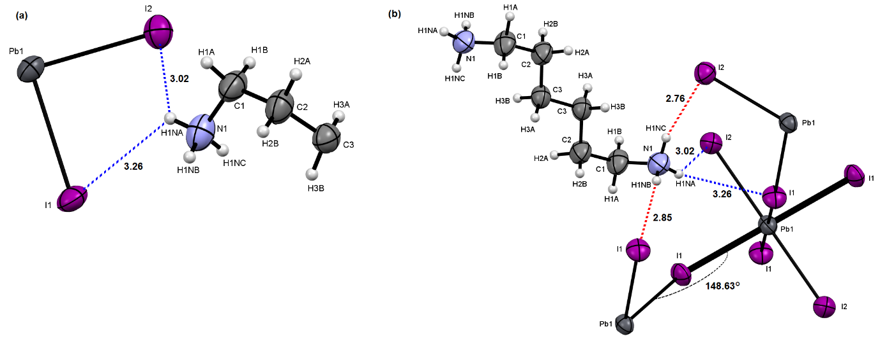
Figure S3. HE: (a) A view of the asymmetric unit with the atomic labelling scheme. (b) A view of the local environment of the asymmetric unit showing the distortion of the in-plane inorganic layer [the Pb1–I1–Pb1 angle is 148.63(2)°, see Table S2]. The broken blue lines indicate two of the N—H···I hydrogen bonds listed in Table S3 (i.e., hydrogen-acceptor distances 3.26 and 3.02 Å), involving one hydrogen atom and two iodine atoms of the asymmetric unit. The broken red lines relate hydrogen atoms of the asymmetric unit and symmetry equivalent iodine atoms (i.e., hydrogen-acceptor distances 2.85 and 2.76 Å, see Table S3). Ellipsoids are drawn at 50% of probability level.

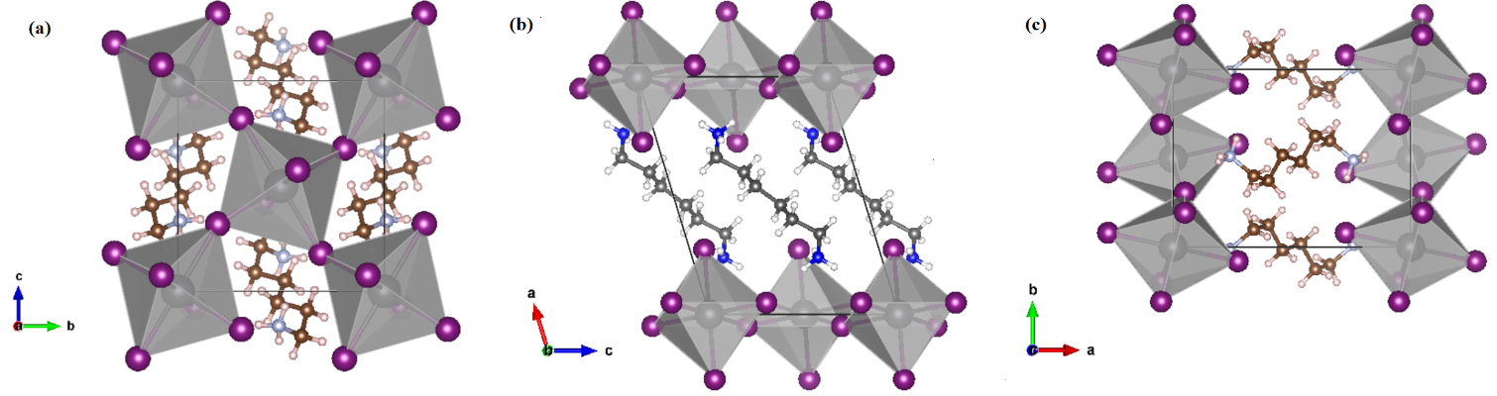
Figure S4. HE: A view along a (a), along b (b) and along c (c) of the crystal packing.
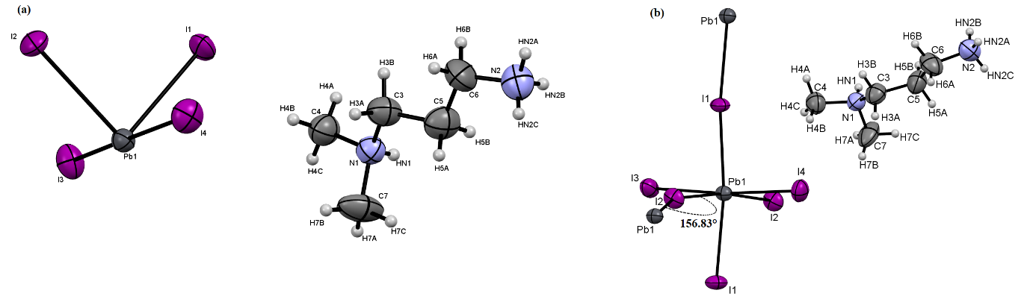
Figure S5. DMPA (2): (a) A view of the asymmetric unit with the atomic labelling scheme. (b) A view of the local environment of the asymmetric unit showing the distortion of the in-plane inorganic layer [the Pb1–I2–Pb1 angle is 156.83°, see Table S4]. Ellipsoids are drawn at 50% of probability level.

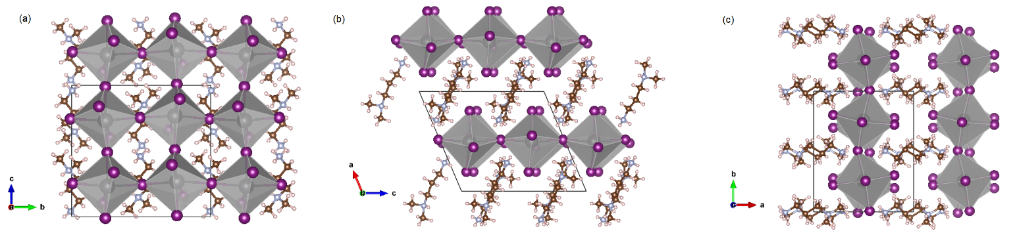
Figure S6. DMPA (2): A view along a (a), along b (b) and along c (c) of the crystal packing.

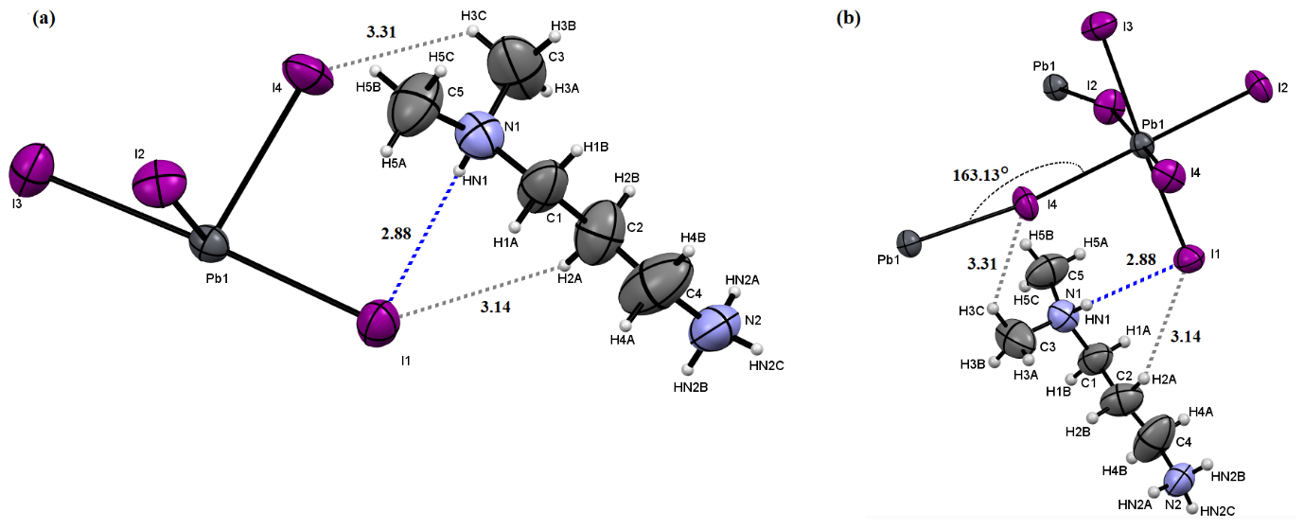
Figure S7. DMPA (1): (a) A view of the asymmetric unit with the atomic labelling scheme. (b) A view of the local environment of the asymmetric unit showing the distortion of the in-plane inorganic layer [the Pb1–I4–Pb1 angle is 163.13°, see Table S6]. The broken blue lines indicate the N1—HN1···I1 hydrogen bond listed in Table S7 (i.e., hydrogen-acceptor distance 2.88 Å), involving one hydrogen atom and one iodine atom of the asymmetric unit. The broken dark grey lines relate hydrogen (bonded to a carbon atom) and iodine atoms of the asymmetric unit (i.e., hydrogen-acceptor distances 3.14 and 3.31 Å, see Table S7). Ellipsoids are drawn at 50% of probability level.

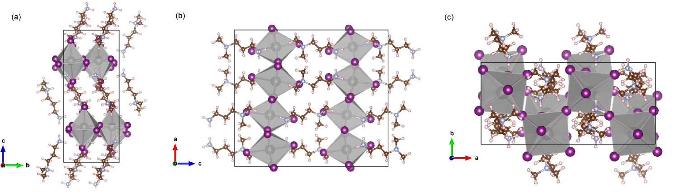
Figure S8. DMPA (1): A view along a (a), along b (b) and along c (c) of the crystal packing.

Penetration depth

Table S8 shows NH₃ penetration in terms of average distance of nitrogen atoms for each compound studied in this work. To properly argue the penetration depth, we reported also the value estimated for PEAI-F perovskite single crystals (Figure S13).

Perovskite | Pb-I-Pb (°) | <d_{N}>_{U&L} ($Å$)
DMPA (1) | 163.13° | 1.0565
DMPA (2) | 156.83° | 0.9315
PEAI-F | 151.77° | 0.576
HE | 148.63° | 0.373

Table S8. DMPA (1), DMPA (2), PEAI-F and HE: in-plane distortion angle (Pb_{eq}–I–Pb_{eq}) and average distance between the nitrogen atoms belonging to the terminal NH₃ group and the nearest least-squares planes through the upper and lower axial iodine atoms of the PbI₆ octahedra (<d_{N}>_{U&L}).

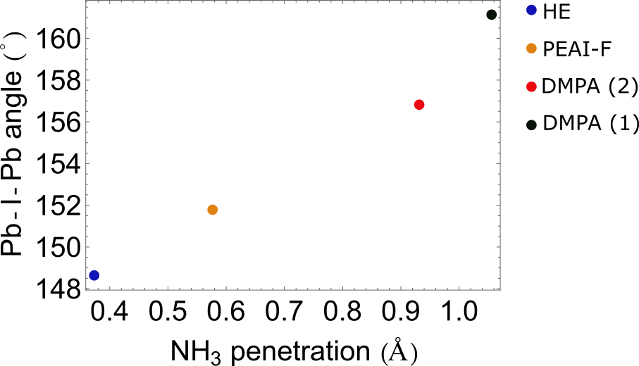

Figure S9. DMPA (1), DMPA (2), PEAI-F and HE: Pb_{eq}–I–Pb_{eq} bond angle as a function of the organic cation penetration.

In Figure S10, S11, S12 and S13 a view of the inorganic chain, the two nearest organic layers and the two least-squares planes through the upper and lower axial iodine atoms of the PbI₆ octahedra (i.e., plane_{U} and plane_{L}, the pink planes in Figure S10, S11, S12 and S13) is given in the case of DMPA (1), DMPA (2), HE and PEAI-F, respectively.

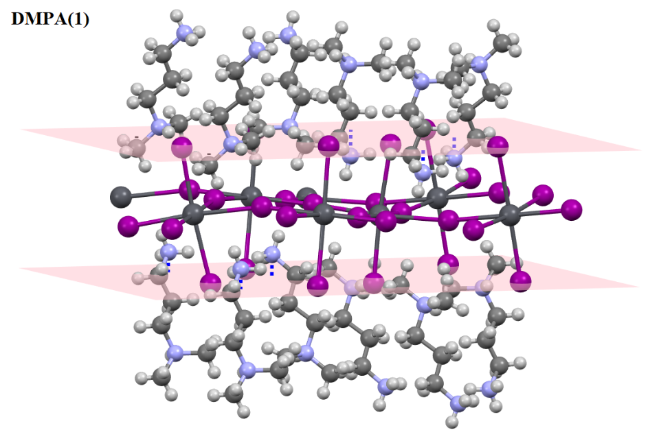
Figure S10. DMPA (1): a view of the inorganic chain, the two nearest organic layers and the two least-squares planes through the upper and lower axial iodine atoms of the PbI₆ octahedra (pink planes). The distances between the N atoms of the terminal NH₃ group and the two least-squares planes are drawn as broken blue lines.

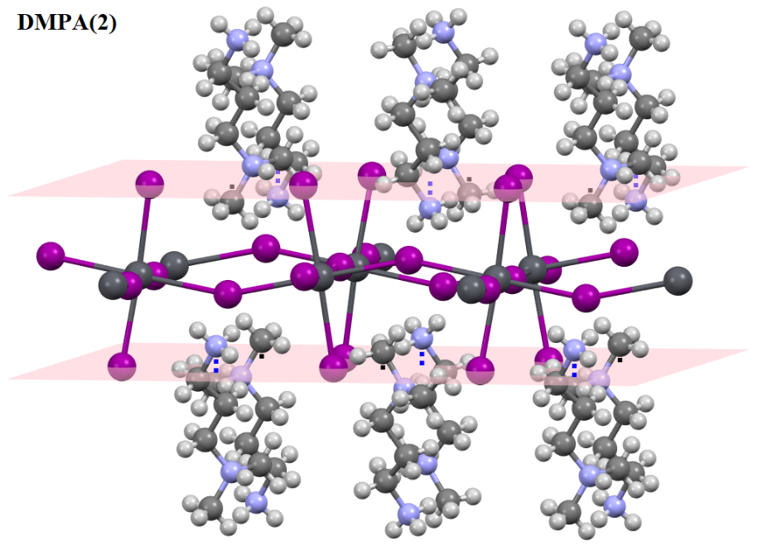
Figure S11. DMPA (2): a view of the inorganic chain, the two nearest organic layers and the two least-squares planes through the upper and lower axial iodine atoms of the PbI₆ octahedra (pink planes). The distances between the terminal N atoms of the NH₃ group and the two least-squares planes are drawn as broken blue lines.

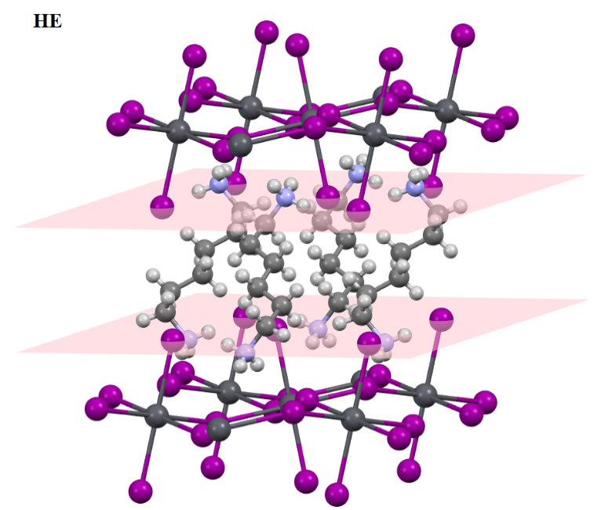
Figure S12. HE: a view of the inorganic chain, the two nearest organic layers and the two least-squares planes through the upper and lower axial iodine atoms of the PbI₆ octahedra (pink planes).

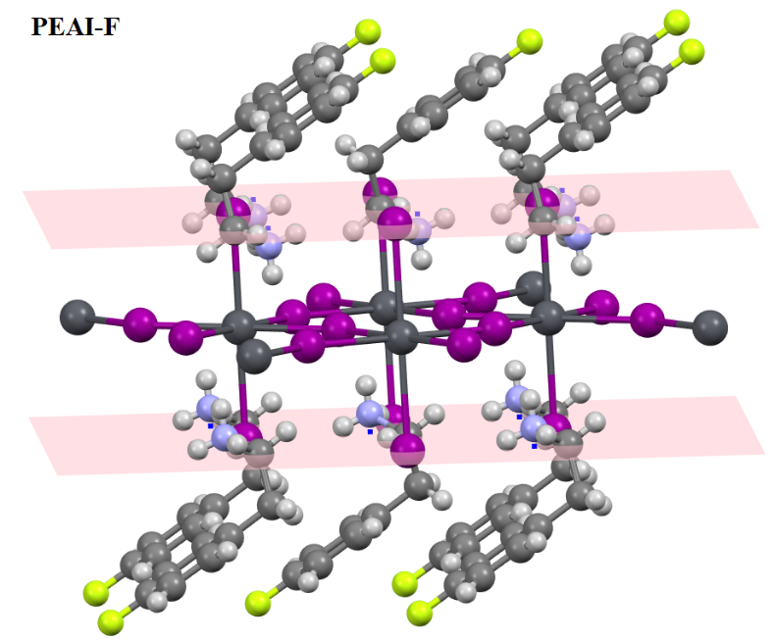
Figure S13. PEAI-F: a view of the inorganic chain, the two nearest organic layers and the two least-squares planes through the upper and lower axial iodine atoms of the PbI₆ octahedra (pink planes). The distances between the N atoms of the terminal NH₃ group and the two least-squares planes are drawn as broken blue lines.

Optical measurements
Figure S14 presents the photoluminescence (PL) spectra collected from HE single crystals synthesized using two different PbO:amine molar ratios: (a) 1:1 and (b) 1:2.5. These measurements allow us to evaluate the impact of the precursor composition on the optical properties of the resulting crystals.
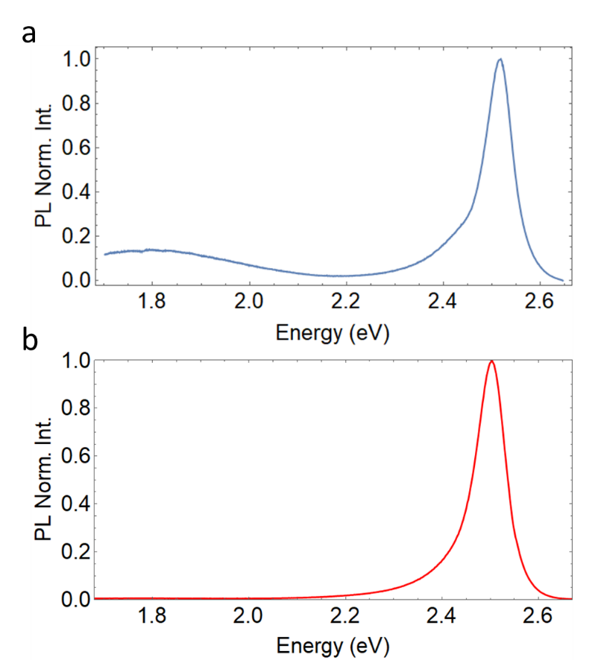

Figure S14. Normalized PL spectra collected from HE single crystals synthesized with (a) a PbO:amine molar ratio = 1:1 and (b) a PbO:amine molar ratio = 1:2.5.

Temperature-dependent PL
Figure S15a and S15b show temperature-dependent photoluminescence of HE and stable DMPA (2) phase perovskites from 14K to RT.
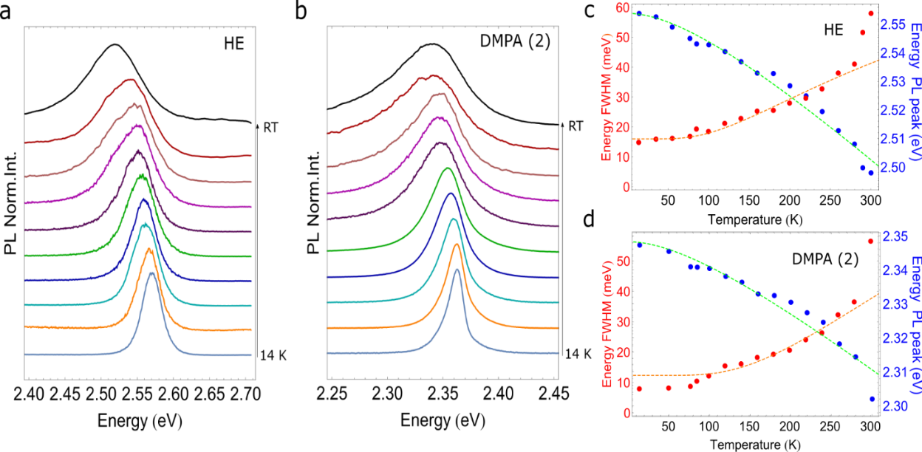
Figure S15. Temperature-dependent PL spectra of HE (a) and DMPA (2) (b) single crystal on glass substrate. The spectra are vertically spaced for clarity. Temperature dependence of the maximum of the photoluminescence peak (blue dots) and of FWHM (red dots) for HE-based perovskite (c) and DMPA (2) (d)-based perovskite (d). Green and orange dashed line are obtained by fitting the experimental data with the Varshni and Boson equation respectively.

The temperature dependence of PL energy peak and FWHM for the two perovskites is quite similar. Figures S15c and S15d report the dependence of the energy position of the excitonic resonance ($E(T)$) for HE (Figure S15c) and DMPA (2) (Figure S15d) marked as blue dots. Green dashed lines are obtained by fitting the experimental data with the Varshni equation^{[14]} S1:
$$E(T)=E_{0}-\frac{αT^{2}}{T+β}$$ | $$(Eq. S1)$$
where $E_{0}$ is the energy gap at 0K, α is a constant and β is related to the Debye temperature. The extracted parameters are reported in Table S9.
Perovskite | $E_{0}$ (eV) | α (eV/K) | β (K)
HE | 2.553 | $2.7 x {10}^{-4}$ | 168.01
DMPA (2) | 2.348 | $$1.95 x {10}^{-4}$$ | 165.68
Table S9. Extracted parameters from the Varshni model for HE and DMPA (2) perovskites.
Moreover, by increasing the temperature, the broadening of the PL peak for both HE and DMPA (2) perovskites is clearly measurable, analysing the FWHM trend as function of the temperature ($Γ\left(T\right)$) (Red dots in Figure S15c and S15d). The experimental data are fitted with the Boson model (3) (orange dashed line):
$$Γ\left(T\right)=Γ_{0}+Γ_{LO}*{exp\left(\frac{E_{LO}}{k_{b}T}-1\right)}^{-1}$$ | $$(Eq. S2)$$
where $Γ_{0}$ is the inhomogeneous broadening contribution, that is not dependent from the temperature and is caused by the inhomogeneity of the sample; $Γ_{LO}$the excitonic longitudinal-mode optical phonon coupling coefficient and $E_{LO}$ is the longitudinal-mode optical phonon energy. It is possible to neglect the exciton-acoustic-phonon coupling associated with the linear term of the boson equation, as its energy is much smaller than k_{B}T over the typical observation range, and it will exhibit linear broadening.^{[15]}
Perovskite | $Γ_{0}$ (meV) | $Γ_{LO}$ (meV) | $E_{LO}$(meV)
HE | 16.02 | 199.07 | 59.04
DMPA (2) | 12.33 | 180.05 | 50.74
Table S10. Extracted parameters from the Boson model for HE and DMPA (2) perovskites.

Time Resolved Photoluminescence (TRPL)
The crystals were excited by using the second harmonic generation of a fs pulsed laser Mai Tai (Spectra-Physics), centred at 800 nm. The signals were detected in a spectrometer coupled with a streak camera. The experimental data were fitted by using a bi-exponential decay function (black dashed lines).

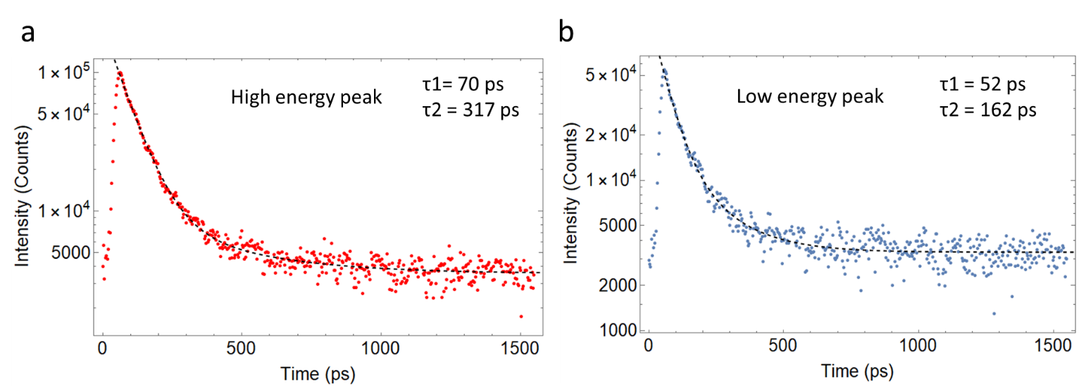
Figure S16. TRPL of HE single crystal at room temperature

Spatial Resolved photoluminescence (PLs) in HE polycrystalline film
Spatial resolved PL measurements carried out on HE single crystal and HE spin-coated film (Figures S17a and b) show that by exciting the center of the crystal strong emission is observed at the edges; on the contrary, in a polycrystalline film no PL signal is detected at the edges. This is because in a single crystal PL propagates to the edges, whereas in a polycrystalline film there are scattering losses due to the presence of intergrain voids or grain boundaries.
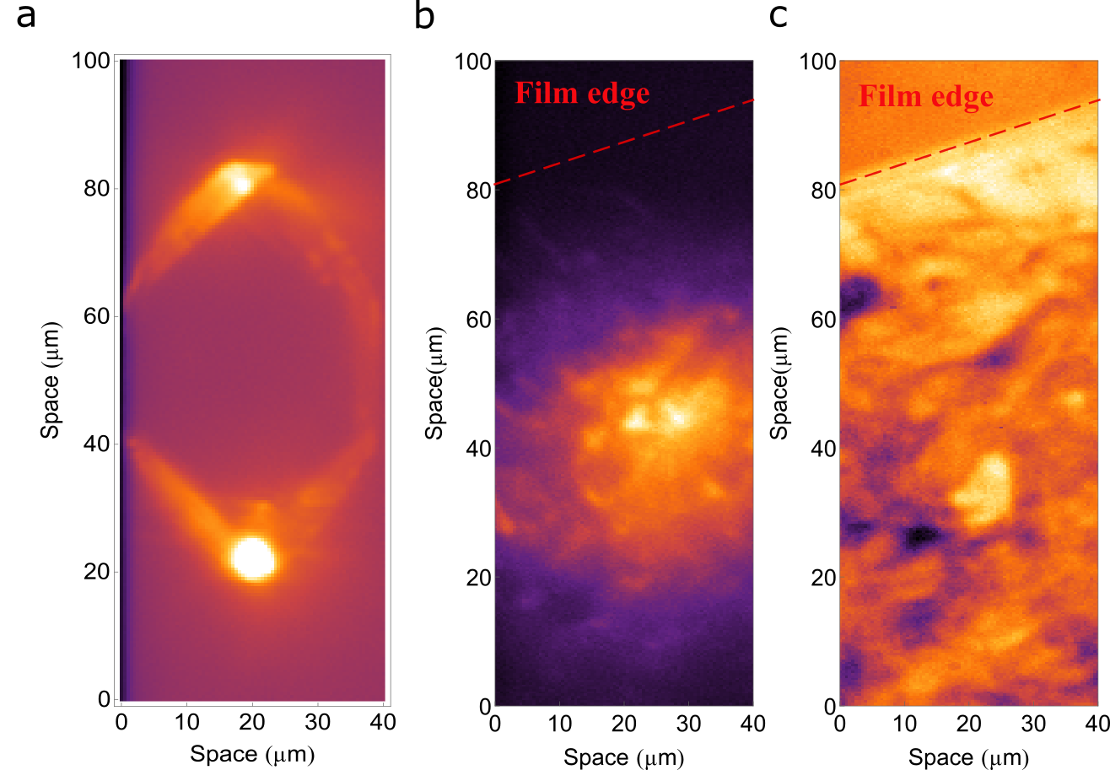

Figure S17. PL in real space of (a) HE single crystal and (b) HE polycrystalline film. (c) Corresponding real-space image collected with white light on the polycrystalline film.

Consequently, in polycrystalline films it is not possible to capture PL signal outside the laser spot. The following Figure S18 shows the PL spectrum of a HE film from which only a single peak centered at 2.54 eV can be observed.

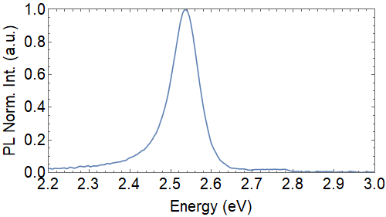

Figure S18. Normalized PL (light blue line) spectra collected on HE polycrystalline film.

Template confined growth
PDMS template fabrication
The patterned elastomeric template, realized by a conventional soft-lithography technique, was obtained starting from a silicon master (ThunderNIL) having an array of microchannels with a height (h) of 300 nm and a width (w) of 6 µm.
PDMS (Sylgard 184, Dow-Corning) was obtained by mixing base and curing agent in a 9:1 ratio and kept it in a desiccator for 30 minutes. After all air bubbles have been carefully removed from PDMS, the liquid elastomer was casted on the silicon master. The system was then cured in an oven for 15 minutes at 140°C. Finally, the elastomeric replica is peeled off from the master thus obtaining a patterned microfluidic device.

Precursor solution
An amount of HE and DMPA (2) (290.8 mg and 286.6 mg respectively) crystals obtained from solution-based growth method and washed with DE were redissolved in GBL (1 ml) in order to obtain a 0.35 M solution, under stirring and heating at 90°C.

Figure S19 shows a SEM image of the as- grown HE single crystals on glass substrate.

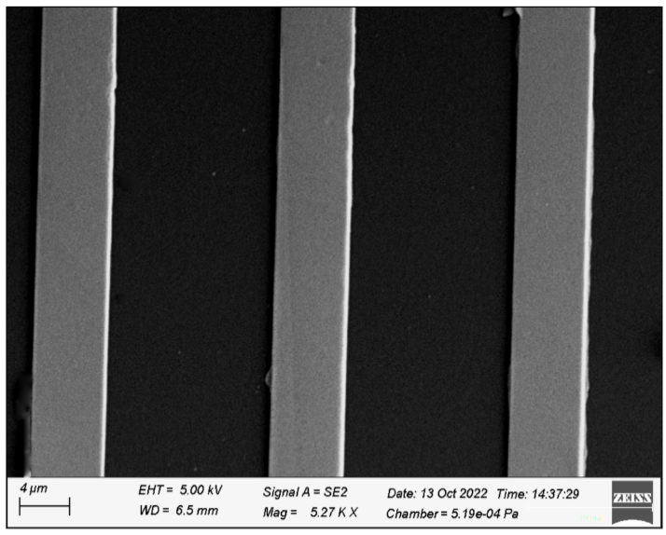
Figure S19. SEM image of HE perovskite microwires grown on glass substrate.

Electron – beam lithography (EBL)
The grating consists in an array of stripes, with a pitch of 300 nm and a filling factor (FF) of 0.5; these parameters were obtained by simulating the system with S4 package^{[16]} to extract the propagating mode in a 300nm-thick perovskite, considering a background refractive index of 1.8.

Theoretical calculations
Figure S20a and b show fitted dispersions in TE polarization for HE (Figure S20a) and DMPA (2) (Figure S20b) perovskite with a PMMA grating on top. The Rabi splitting for HE is 100 meV, while for DMPA (2) is 125 meV.
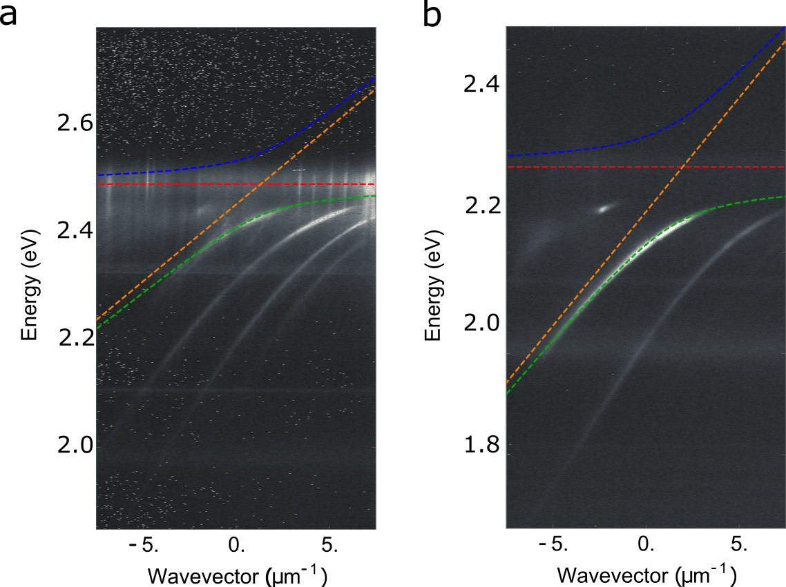
Figure S20. Fitted dispersions in TE polarization for HE (a) and DMPA (2) (b).

References
[1] L. Mao, Y. Wu, C. C. Stoumpos, M. R. Wasielewski, M. G. Kanatzidis, J. Am. Chem. Soc. 2017, 139, 5210–5215.
[2] X. Li, P. Guo, M. Kepenekian, I. Hadar, C. Katan, J. Even, C. C. Stoumpos, R. D. Schaller, M. G. Kanatzidis, Chem. Mater. 2019, 31, 3582–3590.
[3] J. Wright, C. Giacobbe, M. Majkut, Curr. Opin. Solid State Mater. Sci. 2020, 24, 100818.
[4] E. B. Knudsen, H. O. Sørensen, J. P. Wright, G. Goret, J. Kieffer, J. Appl. Crystallogr. 2013, 46, 537–539.
[5] O. D. Rigaku, Rigaku Oxf. Diffr. Ltd Yarnton Oxfs. Engl. 2015.
[6] W. Kabsch, Acta Crystallogr. D Biol. Crystallogr. 2010, 66, 125–132.
[7] C. Giacovazzo, Phasing in Crystallography: A Modern Perspective, 2013.
[8] M. C. Burla, R. Caliandro, B. Carrozzini, G. L. Cascarano, C. Cuocci, C. Giacovazzo, M. Mallamo, A. Mazzone, G. Polidori, J. Appl. Crystallogr. 2015, 48, 306–309.
[9] G. M. Sheldrick, Acta Crystallogr. Sect. C Struct. Chem. 2015, 71, 3–8.
[10] C. F. Macrae, I. Sovago, S. J. Cottrell, P. T. Galek, P. McCabe, E. Pidcock, M. Platings, G. P. Shields, J. S. Stevens, M. Towler, J. Appl. Crystallogr. 2020, 53, 226–235.
[11] K. Momma, F. Izumi, J. Appl. Crystallogr. 2011, 44, 1272–1276.
[12] L. J. Farrugia, J. Appl. Crystallogr. 2012, 45, 849–854.
[13] S. P. Westrip, J. Appl. Crystallogr. 2010, 43, 920–925.
[14] Y. P. Varshni, physica 1967, 34, 149–154.
[15] T. Zhang, C. Zhou, X. Feng, N. Dong, H. Chen, X. Chen, L. Zhang, J. Lin, J. Wang, Nat. Commun. 2022, 13, 1–11.
[16] V. Liu, S. Fan, Comput. Phys. Commun. 2012, 183, 2233–2244.

