Towards realistic models of the electrocatalytic oxygen evolution reaction

  - Travis E. Jones^{1,2,*}, Detre Teschner^{2,3,*}, Simone Piccinin^{4,*}
- Theoretical Division, Los Alamos National Laboratory, Los Alamos, NM, 87545, USA.
- Department of Inorganic Chemistry, Fritz-Haber-Institute of the Max-Planck-Society, Berlin, 14195, Germany.
- Department of Heterogeneous Reactions, Max-Planck-Institute for Chemical Energy Conversion, Mülheim an der Ruhr, 45470, Germany.
- Consiglio Nazionale delle Ricerche, Istituto Officina dei Materiali, Trieste, 34136, Italy.
  - *Email: tejones@lanl.gov, teschner@fhi-berlin.mpg.de, piccinin@iom.cnr.it

Abstract

The electrocatalytic oxygen evolution reaction (OER) supplies the protons and electrons needed to transform renewable electricity into chemicals and fuels. However, the OER is kinetically sluggish; it operates at significant rates only when the applied potential far exceeds the reversible voltage. The origin of this overpotential is hidden in a complex mechanism involving multiple electron transfers and chemical bond making/breaking steps. Our desire to improve catalytic performance has then made mechanistic studies of the OER an area of major scientific inquiry, though the complexity of the reaction has made understanding difficult. While historically, mechanistic studies have relied solely on experiment and phenomenological models, over the past twenty years ab initio simulation has been playing an increasingly important role in developing our understanding of the electrocatalytic OER and its reaction mechanisms. In this review we cover advances in our mechanistic understanding of the OER, with the review organized by increasing complexity in the way through which the OER is modeled. We begin with phenomenological models built using experimental data before reviewing early efforts to incorporate ab initio methods into mechanistic studies. We go on to cover how the assumptions in these early ab initio simulations—no electric field, electrolyte, or explicit kinetics—have been relaxed. Through comparison with experimental literature, we explore the veracity of these different assumptions. We summarize by discussing the most critical open challenges in developing models to understand the mechanisms of the OER.

Abstract 1
1. Introduction 3
2. Kinetic theories relevant to OER before the advent of DFT 5
2.1. Fundamental electrode kinetics 5
2.2. Kinetics of multistep OER mechanisms 8
2.3. Coverage-dependent Tafel slopes 11
2.4. Some cautionary observations and comments related to experiments 16
3. Ab initio atomistic thermodynamics and the Computational Hydrogen Electrode 19
3.1. Development of ab initio atomistic thermodynamics 19
3.1.1. Multicomponent systems 21
3.1.2. Constrained equilibrium and reactive systems 22
3.2. Development of the computational hydrogen electrode 24
3.2.1. CHE model of the OER on metal surfaces 25
3.2.2. CHE model of the OER on rutile-type oxides 31
3.2.3. Scaling relationships 33
3.2.4. Impact of computational methodology 36
3.2.5. Further evidence for scaling relationships and attempts to break them 37
3.2.6. Lattice oxidation 43
3.3. Mechanistic details over Ir-based materials and active phases from the CHE 50
4. Electrolyte effects in the experimental OER 61
5. Modeling the electrified solid/liquid interface 68
5.1. Effects of the liquid environment on the relative stability of the OER reaction intermediates 68
5.2. Modeling electrochemical systems at fixed potential 71
5.3. Modeling electrochemical systems at fixed pH 77
6. Kinetics of the elementary steps 79
6.1. Barriers obtained from constant charge calculations 79
6.2. Barriers obtained from constant potential calculations 83
7. Microkinetic models 86
7.1. Rutile oxides 87
7.2. Oxyhydroxides 94
7.3. pH and electrolyte effects in MK models 98
7.4. Photoelectrochemical OER 102
8. Conclusion 107
9. References 111

Introduction

Electrocatalytic transforms have seen a resurgence of scientific interest in what Markovic refers to as the renaissance of electrocatalysis.¹ This renaissance is a direct consequence of increased interest in a hydrogen economy, or more broadly a renewable energy economy.² ³ Electrocatalysts play an essential role in such an energy economy; they transform renewable electricity—from, for instance, solar and wind—into chemicals and fuels. To facilitate this transformation, an electrocatalyst must accelerate both electron transfer⁴ and chemical bond making/breaking.⁵ This involvement of two fundamental chemistries challenges our ability to develop mechanistic understanding of electrocatalytic reactions and leads to a reliance on phenomenology.⁶ However, more fundamental principles of electrocatalytic reactions are being developed⁷⁻¹⁴, much of it with the help of ab initio simulation.¹⁵⁻²⁴ One of the topics where such advances have had the largest impact on our mechanistic understanding is the oxygen evolution reaction, the OER.

The OER has become the topic of intense scientific inquiry and debate owing to both its prominent role in the renewable energy economy and its complex kinetics.²⁵⁻³⁵ As a technology, the OER (2H₂O→4H⁺+4e⁻+O₂) supplies the protons and electrons needed to produce chemicals and fuels from renewable energy sources, whether these are hydrogen³⁶⁻³⁹, ammonia⁴⁰⁻⁴³, or carbon based.⁴⁴⁻⁴⁶ As a scientific challenge, the OER is a complex reaction; at a minimum, it involves the transfer of 4 electrons across the electrode/electrolyte interface, the generation of 4 protons, breaking O-H chemical bonds, and forming an O-O chemical bond. This complexity is often considered to be the underlying reason for the kinetic sluggishness of the OER⁴⁷, which has spurred significant interest in mechanistic studies.

The slow kinetics of the OER have been known⁴⁸, and the concept of slow kinetics can be understood by considering that, while thermodynamics sets the onset potential of the OER at 1.23 V, a higher potential is required to drive oxygen evolution.²⁵⁻³⁴ The origin of this overpotential lies in the mechanism(s) of the OER, understanding this overpotential has long motivated mechanistic studies of the OER, where early mechanistic suggestions included: slow recombination of oxygen adsorbed on the electrode surface⁴⁹, rate limiting oxidation of hydroxide to hydroxyl^{50, 51}, and slow proton transfer from the electrode surface to water in the electrolyte. ⁵² And while even early experimental evidence supported a catalytic mechanism^{53, 54}, we have yet to come to a consensus about the nature of that mechanism or the nature of electrocatalytic OER. In this review we will discuss the history of our mechanistic understanding of the OER with a particular focus on how modeling has contributed to that understanding. We will also provide a critical comparison between the results of those models and experiment.

To help guide the reader through the history of the OER we have framed this review by organizing sections into the types of models used to gain mechanistic understanding, see Figure 1. In so doing we will not always move through the literature chronologically but rather organize the sections of the review by the complexity included in the different models of, and approaches used to simulate, the OER. By way of example, the simplest description of the OER, the first type of model in Figure 1, is purely thermodynamic. In it we make no assumptions of the mechanism and simply consider that the free energy of reaction (ΔG_{rxn}) is the free energy of formation of liquid water. At standard conditions, 25 °C and 1 atm H₂ pressure, ΔG_{rxn} is then 2.46 eV.⁵⁵ Because 2 water molecules are consumed in the OER and 4 electrons liberated, the OER onset potential is then 1.23 V. This value is the reversible potential, and while identifying it is not sufficient to give any insight into the reaction mechanism or the OER overpotential, knowing the reversible potential does allow us to define the overpotential, η, as the potential beyond 1.23 V required to drive O₂ production through the OER.

One can extend this thermodynamic picture by considering that the OER converts liquid water into gaseous products. By doing so, we see that producing gaseous products during the OER requires additional heat beyond the 1.23 V reversible voltage. The need for additional heat limits the steady-state OER at standard conditions to an enthalpic voltage of 1.48 V.⁵⁶ Yet, while this thermodynamic requirement may be viewed as suggesting a thermodynamic potential of 1.48 V, the required heat need not come from the applied potential. It can be supplied by an external source. Thus, in the laboratory, potentials below 1.48 V are routinely observed^{57, 58}. Mechanistic studies then tend to focus on the overpotential needed to drive the reaction due to the intrinsically slow kinetics. This kinetic overpotential will be our focus.

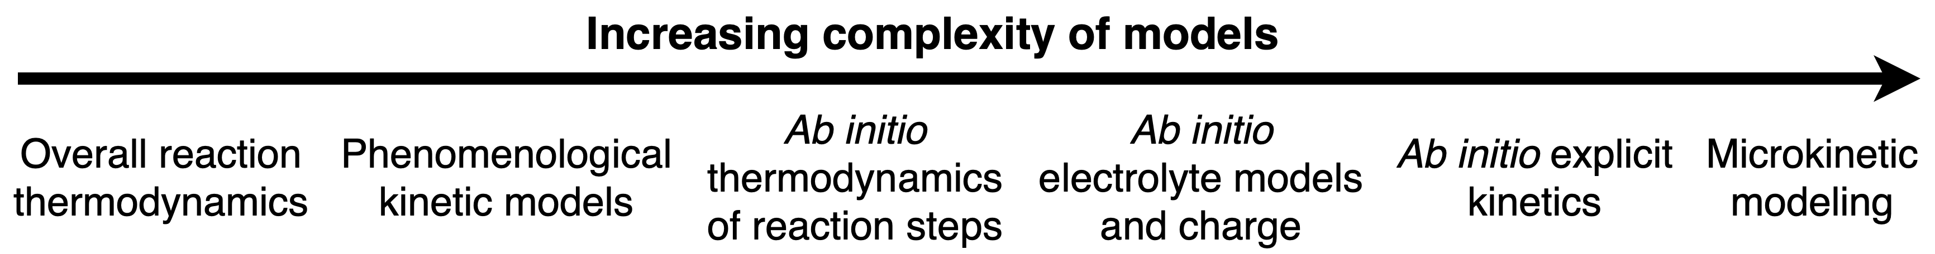

Figure 1 Increasing complexity of the models used to organize the review. Each section includes additional effects in models of the OER. The first represents the simplest description of the reaction in terms of its overall thermodynamics. The second type of models include phenomenological models built using experimental data. The third type brings ab initio simulation to bear on the OER by considering the thermodynamics of individual reaction steps through a simplified model that ignores the electrolyte and capacitive charge. The fourth type introduces both electrolyte and capacitive charge to ab initio simulations. The fifth type introduces explicit reaction kinetics by computing activation energies using ab initio methods. The sixth uses kinetic and thermodynamic data to produce microkinetic models beyond simple steady-state assumptions.
In the following we will examine the OER by considering five more broad classes of models, where we introduce additional effects in each new class. We will begin by reviewing kinetic modeling based on experiment in Section 2, which forms the second type of model, see Figure 1. Such modeling forms the foundation of our knowledge of OER mechanisms, but it is largely based on phenomenology and therefore often offers questionable insights.

We will then move to the introduction of ab initio simulations for the OER by reviewing techniques and models of the third class in Section 3. Here, a methodology developed to link experimental potential scales to ab initio simulations will be reviewed.⁵⁹ This computational hydrogen electrode underlies a thermodynamic description of possible elementary steps of the OER. It gives a means of directly incorporating of ab initio simulations into mechanistic studies of the OER and has become a transformative tool. However, the computational hydrogen electrode is a thermodynamic description that ignores activation energies as well as the explicit effects of electric fields in charged electrodes. While doing so can greatly reduce the computational costs of ab initio simulations, as it often allows electrolyte to be ignored, it is a simplification that the literature demonstrates is often not warranted.^{60, 61}

In Section 4 we motivate the need to include electrolyte by reviewing its effects in experiment. Then in Section 5 we define the fourth type of model to be those that incorporate capacitive charging in ab initio simulations, which necessarily involves electrolyte and higher computational costs. We will focus on explicit electrolyte and refer the interested reader to a recent review of implicit electrolyte.⁶² While far less work has been completed in this area than the previous ones, explicit electrolyte appears to be critical in the description of surface phases and the OER mechanism.⁶³ For the fifth class of model considered in Section 6, we will review studies focused on computing activation energies to gain more insight into explicit reaction kinetics, which have strongly impacted our mechanistic understanding and have shown the critical need to go beyond a thermodynamic description of the electrocatalytic OER.⁶³⁻⁶⁵ Finally, Section 7 will cover microkinetic modeling and discuss the need to go beyond the quasi-equilibrium approximation when modeling the OER.⁶⁶ ⁶⁷ We will end by discussing the most critical open challenges in modeling and understanding the mechanism of the OER.

Kinetic theories relevant to OER before the advent of DFT

Fundamental electrode kinetics

Electrochemical reaction kinetics is the arena of electrochemistry that investigates the rates of electrochemical reactions. Independent of the complexity of the system studied, reactions consist of at least one electron transfer step. When an applied potential can generate a constant current, a steady reaction rate is observed. The rate ($v$) is proportional to the current (i) and the proportionality constant is related to the number of electrons ($n$) transferred per reactant involved in the reaction and the Faraday constant ($F$):
 | $$v = \frac{i}{nF}$$ | Equation 1
When the current is normalized to the surface area, A, we talk about the current density, j. The magnitude of such a current density (anodic or cathodic) and its dependence on the potential is the topic of electrochemical kinetics and the relevant theories to OER will be briefly summarized here.

Historically, the theories of electrochemical kinetics are based on the early works of Tafel⁶⁸, Erdey-Grúz and Volmer⁶⁹, Butler⁷⁰, Horiuti and Polanyi⁷¹, as well as classical concepts from chemical kinetics and Eyring’s transition state theory⁷². These earlier phenomenological works were later expanded by microscopic theories of charge transfer, by Marcus,⁷³ Hush,⁷⁴ Gerischer⁷⁵ and Dogonadze⁷⁶ to name but a few. Detailed derivation of these theories can be found in textbooks⁷⁷⁻⁷⁹ and we only focus on some key concepts here. At the core of these theories, we find the following ingredients. First, a simple (unimolecular) one-electron chemical step is considered to transform a reduced species (Red) to an oxidized one (Ox) by liberating an electron, and vice versa:
 | $$Red \begin{aligned}k_{f} \\ ⇋ \\ k_{b}\end{aligned} Ox+(1e^{-})$$ | Equation 2
Complex reactions are assumed to be a network of simple one-electron elementary steps, sometimes in combination with purely chemical steps. Based on fundamental chemical kinetics, the rate of such one-electron elementary steps is given by the difference between the forward and backward rates:
 | $$v = k_{f}c_{Red}-k_{b}c_{Ox}$$ | Equation 3
where $c_{Red}$and $c_{Ox}$ denote concentrations, and in particular surface concentrations for heterogeneous electrocatalytic reactions. By definition, the forward and backward rates are equal at equilibrium. Then, transition state theory is invoked to describe the rate constants, k_{f}:
 | $$k_{f}=\frac{κk_{B}T}{h}e^{-ΔG_{f}^{‡}/RT}$$ | Equation 4
where $κ$ is the transmission coefficient, related to the tunneling probability in electron-transfer theory ($κ$ being dependent on the distance from the electrode; at small distances it equals 1), $k_{B}$ and $h$ are the Boltzmann and Planck constants, respectively, and $ΔG_{f}^{‡}$ is the Gibbs free energy of activation for the forward reaction. $ΔG_{f}^{‡}$ is the energy required for the educt $Red$ to overcome the activation barrier at the transition state by moving on the potential energy surface along the reaction coordinate and form the product $Ox;$ Figure 2. More often than not, the application of a potential bias ($ΔE$) is assumed to act on the reaction coordinate and thus shift the free energy of educt or product states. When the reaction is a sole electron transfer and the electrode is a metal, driving the potential of the electrode to more positive/negative values (in V) is equivalent to decreasing/increasing the energy of the electrons by a corresponding magnitude (in eV). In our example in Figure 2, this gives rise to a decrease of the Gibbs free energy of activation by a portion $βFΔE$, $β$ being the symmetry factor. Hence, the symmetry factor can be defined as:
 | $$β≡d(ΔG_{f}^{‡})/ d(FΔE)$$ | Equation 5
Consequently, $ΔG_{f}^{‡}$ is a function of the electrode potential. Then, for an anodic process, such as the OER, the energy of electrons can be lowered enough by an anodic potential that

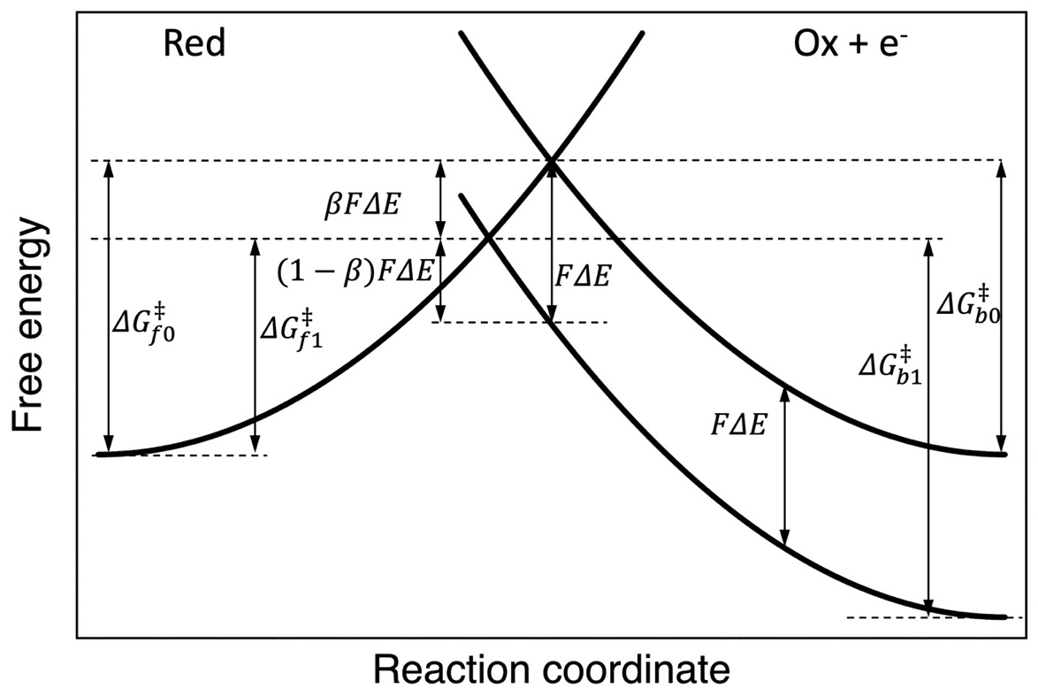
Figure 2 A schematic potential energy surface illustrating the effect of a potential change on the free energy of activation.
the species to be oxidized will be able to transfer an electron and hence we observe an oxidation current. When the free energy curves near the transition states are assumed to be locally linear, the symmetry factor itself will be independent of the potential applied. In case the barrier is symmetric, as in Figure 2, $β$ = 0.5, which is a frequent assumption in the literature.
Combining our above equations, using the Nernst equation and defining the overpotential, $η$, as $ΔE$ with respect to the equilibrium potential, we can arrive at the Butler-Volmer equation:
 | $$j=j_{0}\left[e^{βFη/RT}-e^{-(1-β)Fη/RT}\right]$$ | Equation 6
where
 | $$j_{0}=Fk_{0}({c_{Red})}^{\left(1-β\right)}{(c_{Ox})}^{β}$$ | Equation 7
is the exchange current density; $k_{0}$ the rate constant at equilibrium. At large enough overpotentials, 100 mV or more at RT, the cathodic current density in our oxidation reaction (Equation 2) becomes small enough to be neglected and hence the Butler-Volmer equation takes the form of the Tafel equation:
 | $$j=j_{0}e^{βFη/RT} or η=\frac{RT}{βF}lnj_{0}-\frac{RT}{βF}lnj$$ | Equation 8
In a less phenomenological model, Marcus and Hush considered a microscopic picture, equivalent to a quadratic potential energy surface, as opposed to the simplified linearized form presented above. They show that the Gibbs free energy of activation is then:
 | $$ΔG_{f}^{‡}={(λ-FΔE)}^{2}/4λ$$ | Equation 9
where, $λ$, the reorganization energy, is a hypothetical energy requirement to reorganize the initial to the final state in case no charge transfer occurred. Hence, in this case, $ΔG_{f}^{‡}$ is not a linear but a quadratic function of the applied potential. Current density potential equations based on the models of Marcus and Hush will only take the form of the Butler-Volmer equation when the symmetry factor is redefined to include the reorganization energy. And, the symmetry factor in Marcus and Hush is potential dependent. At small overpotentials the deviation from the Butler-Volmer picture will be small but at higher overpotentials the linearity of the $η≈lnj$ dependence is distorted by the potential dependence of the symmetry factor and hence the Tafel slope is expected to bend.
These theories describe outer-sphere electron-transfer reactions, in which no chemical bonds are broken and no new bonds are made. The electrochemical electron transfer reactions can be classified based on the electronic interaction strength between the electrode surface and the reactant. Because of this electronic coupling, the potential energy surfaces, as opposed to the schematic representation in Figure 2, do not intersect, rather they avoid crossing and separate. This splitting is related to the interaction strength. At very low interaction strength, the system can pass the saddle point without an electron transfer and return to its initial state. These reactions (and their rate constants) will depend on the strength of the interaction, mostly linearly. At larger interaction strength, the electron transfer takes place every time when the transition state is reached. We can refer to these two types of electron transfer reaction as nonadiabatic and adiabatic, respectively. They differ primarily in the pre-exponential factors, which for adiabatic reactions are independent of the electrode material and the rate of adiabatic reactions will be governed by dynamics of solvent reorganization. These are outer-sphere electron-transfer reactions, where the theories of Marcus and Hush hold and the nature of the electrode material is unimportant, hence these are not catalytic reactions. At even higher interaction strength, specific adsorption of reactants and products takes place at the electrode surface; this is the realm where catalytic effects can dominate reaction mechanisms and rates.

To treat multi-step reactions where n electrons are transferred, a number of simplifications and assumptions are typically made. It can be assumed that there is one irreversible rate-determining step (RDS) and all other steps are in equilibrium. The number of electrons transferred prior to the RDS is n_{p}, the number of electrons transferred after the RDS is n_{a}. The number of electrons transferred during RDS, n_{rds}, is either zero (chemical step) or one (electron transfer), though the validity of only single electron transfer steps was questioned by Gileadi.⁸⁰ Hence,
 | $$n=n_{p}+n_{rds}+n_{a}$$ | Equation 10
Assuming steady state, no transport limitations, $j_{0}$ of the RDS being much smaller than that of the other steps, and the same RDS of the reaction for both cathodic and anodic direction one can derive a Butler-Volmer type current density voltage equation with the symmetry factor ($β$ and 1-$β$) exchanged to $α_{f}$ and $α_{b}$, the transfer coefficients of the forward and backward reaction, respectively:
 | $$α_{f}=n_{p}+n_{rds}*β_{f}$$ | Equation 11
and
 | $$α_{b}=n_{a}+n_{rds}*β_{b}$$ | Equation 12
The sum of the forward and backward symmetry factors is 1, whereas the sum of the forward and backward transfer coefficients equal n. The Tafel slope, b, is then
 | $$b=\left(\frac{∂η}{∂logj}\right)=2.303RT/Fα_{f}$$ | Equation 13
where, $2.303RT/F$ = 59.2 mV.
The definition of the anodic (forward) and cathodic (backward) transfer coefficients is hence:⁸¹
 | $$α_{f}=\frac{2.303RT}{F\left(\frac{∂η}{∂logj_{a}}\right)} and α_{b}=-\frac{2.303RT}{F\left(\frac{∂η}{∂logj_{c}}\right)}$$ | Equation 14
Equation 13 is regularly used as a diagnostic tool to derive mechanistic information from analyzing experimental Tafel slopes, see also our next section 2.2. A simple one electron transfer reaction, such as Equation 2, with $n_{p}$ and $n_{a}$ being 0 and $n_{rds}$ being 1 gives rise to a Tafel slope of $\frac{1}{β_{f}}$ 59.2 mV/dec. Hence, if $β_{f}$ is 0.5, as often assumed, we end up with the classical Tafel slope of 118.4 mV/dec. A two-step two electron transfer process, with the second step being RDS then yields a Tafel slope of 39.5 mV/dec. As the number of electrons transferred after the RDS does not enter Equation 11, a four-step four electron transfer process with the second step being RDS gives the same 39.5 mV/dec Tafel slope.
Although it is enticing to derive mechanistic information from Tafel analysis for electrocatalytic processes, such analyses should be treated with great caution. To start with, the above sketched kinetic theories were either phenomenological in nature or were derived for outer-sphere electron transfer reactions. Although Fletcher⁸² derived Tafel slopes for multi-step electrochemical reactions from first principles, weak orbital overlap between reactants and electrodes was assumed in the derivation. That is, catalytic effects were not considered. Hence, it is a priori not a given that these models are appropriate for electrocatalytic reactions. As we have seen, the shape of the potential energy surface can give rise to potential dependent symmetry factors and hence the Tafel slope can intrinsically change with potential. Assuming quasi-equilibrium in multi-step reactions and the same RDS for the forward and backward reaction is also sometimes not justified. Moreover, numerous reaction schemes can produce the very same theoretical Tafel slope, and their differentiation based solely on kinetic experiments is often not possible. To make matter worse, transport limitations can also skew the experimental observations. To aid electrochemical kinetic investigations, some potentially useful diagnostic experiments may include the temperature and pH dependence of the Tafel slope, and hence of the transfer coefficient.

Before we close this section, let us briefly consider the quasi-equilibrium and steady-state approximations often invoked in modeling the kinetics of the OER. As was mentioned above, in the quasi-equilibrium approximation a specific reaction model is built, one elementary step is assumed to be the RDS and all other steps are taken to be equilibrated. Since all steps prior to the RDS are pre-equilibrated, the resting state of the catalyst is defined by the equilibrium constants of the steps prior to the RDS. Then, rates for the RDS can be expressed with the help of the rate constant of the RDS and the unknown intermediate concentration is replaced using the equilibrium constants and potential dependence of the preceding steps as well as the educt concentrations. The advantage (and danger) of the quasi-equilibrium approach is that it may be used phenomenologically, without the necessity of knowing catalyst-specific rate constants and hence by comparing predicted and observed Tafel slopes (or transfer coefficients) a certain mechanistic model can be proposed or ruled out. In the steady-state approximation surface coverages of intermediates, $θ_{i}$, do not change with time, that is,
 | $$\frac{∂θ_{i}}{∂t}=0$$ | Equation 15
Then, the rates of the forward and backward reaction steps, such as in Equation 3 are inserted in Equation 15. The rate constants, Equation 4, are assumed to be overpotential dependent, either in linear or quadratic form. As we will see later, rate constants are often calculated from density functional theory (DFT)-based free energy calculations of intermediates. When a Langmuir adsorption model is used, which is frequently the case, the sum of all surface coverages, including those of empty sites, is equal to 1. Then, the set of equations are solved to get surface coverages and reaction rates as a function of the overpotential, the reaction rates can then finally be converted into current densities. Since the solution provides the surface coverages, no prior assumption is needed as to the RDS. Recently, Exner⁸³ compared the applicability of the two approximations, especially for cases where experimentally two or more Tafel slopes are observed and concluded that the quasi-equilibrium approximation may fail in the evaluation of a Tafel plot in the transition zone.

Kinetics of multistep OER mechanisms

There exists a vast body of literature of proposed OER mechanisms based on kinetic experiments with electrocatalysts of various kinds. Since the topic of our review is not to recite and re-analyze a half a century or more of experimental work done on the OER, we arbitrarily selected two publications to illustrate mechanistic evaluations of the OER based on kinetic estimates. One is a seminal work by Bockris and Otagawa⁸⁴, who analyzed perovskite-type oxides and compared their kinetic results with the contemporary common OER pathways of the time. The work is from 1983, hence prior to the advent of DFT studies of the OER. The second is a perspective article by Doyle et al.,⁸⁵ who reviewed the field of hydrous transition metal oxide/oxyhydroxide from their experimentalist perspective 30 years later. Our choice is motivated by the fact that while nowadays all reviews on OER focus heavily on progress made by DFT calculations, Doyle et al. acknowledged the strength of DFT-based theories, nevertheless their views reflected their strong experimental electrochemistry background. Hence, we have here two articles, one without any influence by DFT and a second with only a minor “bias” towards DFT, which is useful at this junction of our review.

Table 1 Kinetic parameters observed experimentally for selected perovskites and theoretically derived for common OER mechanistic pathways. Adapted with permission from Ref. ⁸⁴. Copyright 1983 American Chemical Society.
Tafel slopes, approximately |  | Perovskites and their [OH⁻] reaction order in bracket
2RT/3F |  | LaNiO₃ (0.95)
RT/F |  | LaCoO₃ (0.7); La_{0.9}Sr_{0.1}CoO₃ (0.98); La_{0.6}Sr_{0.4}CoO₃ (0.84); La_{0.9}Ce_{0.1}CoO₃ (0.95); Nd_{0.9}Sr_{0.1}CoO₃ (0.85);
2RT/F |  | LaCoO₃ (0.75); La_{0.6}Sr_{0.4}CoO₃ (0.94); La_{0.9}Ce_{0.1}CoO₃ (0.83); Nd_{0.9}Sr_{0.1}CoO₃ (0.85); La_{0.7}Sr_{0.3}FeO₃ (0.82); La_{0.5}Sr_{0.5}FeO₃ (0.75); LaMnO₃ (0.65); La_{0.9}Sr_{0.1}MnO₃ (0.65); La_{0.6}Sr_{0.4}MnO₃ (0.6); La_{0.8}K_{0.2}MnO₃ (0.65)
Rate-determining step |  | Langmuir |  |  |  |  |  |  | Temkin
 |  |  | $∂E/∂lni$ ª |  | $${[∂lni/∂lnC_{{OH}^{-}}]}_{E{,ζ}^{c}}$$ |  |  | $∂E/∂lni$ ª
 |  | v^{b} | $$θ →0$$ | $$θ →1$$ | $$θ →0$$ | $$θ →1$$ |  | NA^{d} |  | A^{e} | NA^{d} | A^{e} | Conditions^{f}
(I) Bockris’s oxide path
1. $M+ {OH}^{-} →MOH+ e^{-}$ |  | 4 | 2RT/F |  | 1
2. $2MOH →MO+ M+ H_{2}O$ |  | 2 | RT/2F | $$∞$$ | 2 | 0 |  | 2RT/F |  |  | 0.5 |  | $$r_{OH} \sim r_{O}$$
 |  |  |  |  |  |  |  | RT/F |  |  | 1 |  | $$r_{OH}≫ r_{O}$$
3. 2$MO →2M+ O_{2}$ |  | 1 | RT/4F | $$∞$$ | 4 | 0 |  | RT/2F |  | RT/F | 2 | 1 | $$K_{2} \sim 1$$
 |  |  |  |  |  |  |  | RT/4F |  | RT/3F | 2 | 1 | $$K_{2}≪ 1$$
(II) Bockris’s electrochemical path
1. $M+ {OH}^{-} →MOH+ e^{-}$ |  | 2 | 2RT/F |  | 1
2. $MOH + {OH}^{-} →MO+ H_{2}O+ e^{-}$ |  | 2 | 2RT/3F | 2RT/F | 2 | 1 |  | 2RT/F |  |  | 1 |  | $$r_{OH} \sim r_{O}$$
 |  |  |  |  |  |  |  | RT/F |  |  | 1.5 |  | $$r_{OH}≫ r_{O}$$
3. 2$MO →2M+ O_{2}$ |  | 1 | RT/4F | $$∞$$ | 4 | 0 |  | RT/2F |  | RT/F | 2 | 1 | $$K_{2} \sim 1$$
 |  |  |  |  |  |  |  | RT/4F |  | RT/3F | 4 | 3 | $$K_{2}≪ 1$$
(III) Krasil’shchikov’s path
1. $M+ {OH}^{-} →MOH+ e^{-}$ |  | 2 | 2RT/F |  | 1
2. $MOH + {OH}^{-} →MO^{-}+ H_{2}O$ |  | 2 | RT/F | $$∞$$ | 2 | 1 |  | $$∞$$ |  |  | 1 |  | $$r_{OH} \sim r_{O^{-}}$$
 |  |  |  |  |  |  |  | 2RT/F |  |  | 1.5 |  | $$r_{OH}≫ r_{O^{-}}$$
3. $MO^{-} →MO+ e^{-}$ |  | 2 | 2RT/3F | 2RT/F | 2 | 0 |  | 2RT/F |  |  | 0 |  | $$K_{2} \sim 1$$
 |  |  |  |  |  |  |  | 2RT/F |  |  | 1 |  | $$K_{2}≪ 1$$
4. 2$MO →2M+ O_{2}$ |  | 1 | RT/4F | $$∞$$ | 4 | 0 |  | RT/2F |  | RT/F | 2 | 1 | $$K_{3} \sim 1$$
 |  |  |  |  |  |  |  | RT/4F |  | RT/3F | 2 | 1 | $$K_{3}≪ 1$$
(IV) O’Grady’s path
1. $M^{z}+ {OH}^{-}→M^{z}OH+ e^{-}$ |  | 2 | 2RT/F |  | 1
2. $M^{z}OH →M^{z+1}OH+ e^{-}$ |  | 2 | 2RT/3F | 2RT/F | 1 | 0 |  | 2RT/F |  |  | 0 |  | $$r_{1} \sim {r_{2}}^{g}$$
 |  |  |  |  |  |  |  | RT/F |  |  | 0.5 |  | $$r_{1}≫ r_{2}$$
3. $M^{z+1}OH + 2{OH}^{-}→M^{z}+ H_{2}O+ O_{2}$ |  | 1 | RT/4F | $$∞$$ | 4 | 2 |  | RT/2F |  | RT/F | 4 | 3 | $$K_{2} \sim 1$$
 |  |  |  |  |  |  |  | RT/4F |  | RT/3F | 4 | 3 | $$K_{2}≪ 1$$
(V) Kobussen’s path
1. $M+ {OH}^{-} →MOH+ e^{-}$ |  | 1 | 2RT/F |  | 1
2. $MOH + {OH}^{-} →MO+ H_{2}O+ e^{-}$ |  | 1 | 2RT/3F | 2RT/3F | 2 | 1 |  | 2RT/F |  |  | 1 |  | $$r_{OH} \sim r_{O}$$
 |  |  |  |  |  |  |  | RT/F |  |  | 1.5 |  | $$r_{OH}≫ r_{O}$$
3. $MO + {OH}^{-} →M{O_{2}H}^{-}$ |  | 1 | RT/2F | $$∞$$ | 3 | 1 |  | $$∞$$ |  |  | 1 |  | $$K_{2} \sim 1$$
 |  |  |  |  |  |  |  | RT/F |  |  | 2 |  | $$K_{2}≪ 1$$
4. $MO_{2}H^{-} + {OH}^{-} →M{O_{2}}^{-}+ H_{2}O+ e^{-}$ |  | 1 | 2RT/5F | 2RT/F | 4 | 1 |  | 2RT/F |  |  | 1 |  | $$K_{3} \sim 1$$
 |  |  |  |  |  |  |  | 2RT/F |  |  | 2 |  | $$K_{3}≪ 1$$
5. $M{O_{2}}^{-} →M+ O_{2}+ e^{-}$ |  | 1 | 2RT/7F | $$∞$$ | 4 | 0 |  | RT/F |  | 2RT/F | 1 | 0.5 | $$K_{4} \sim 1$$
 |  |  |  |  |  |  |  | RT/2F |  | 2RT/3F | 1 | 1.5 | $$K_{4}≪ 1$$
ª Symmetry factors were taken as 0.5. ^{b} Stoichiometric number. ^{c} $ζ$ is the potential difference between the outer Helmholtz plane and the bulk of the solution. ^{d} Nonactivated desorption of O₂. ^{e} Activated desorption of O₂. ^{f} r is a coefficient determining the variation of heat of adsorption of a particular species with coverage. Unless stated, r values for each species were taken as equal. K_{i} is the equilibrium constant of the ith step. ^{g} r₁ and r₂ refer to r for M^{z}OH and r for M^{z+1}OH, respectively.

Bockris and Otagawa⁸⁴ investigated almost 20 different perovskites synthesized by high-temperature solid-state reactions and evaluated their kinetics in alkaline OER by steady-state polarization and temperature and pH dependence, among others. The Tafel slopes were 2RT/3F, RT/F, and 2RT/F for the nickelates, cobaltites, and ferrites and/or manganites, respectively, see Table 1. (Note, these slopes correspond to $∂η/∂\ln{i}$plots, and hence, the factor 2.303 is absent, due to the use of base e rather than base 10 logarithm.) The 2RT/3F slope was observed only in the pure nickelate, while a multiphase sample of the same substance gave a slope of RT/F. A change in Tafel slopes from RT/F to 2RT/F at higher overpotentials was observed on cobaltites. The reaction order with respect to [OH⁻] was found to be close to 1. They also found that the surface area-normalized current density at a constant 0.3 V overpotential showed a broad linear dependence on the enthalpy of formation of the corresponding hydroxide. Hence, they assumed that these perovskites have a common mechanism and a common RDS, the breaking of an M-OH bond. The authors calculated diagnostic criteria under Langmuir and/or Temkin adsorption conditions, which are reproduced in Table 1, for five mechanisms often considered at that time. All these pathways start with a discharge of a hydroxide ion, which if rate limiting, would give a Tafel slope of 118.4 mV/dec (first electron transfer step limiting) with the assumption of a symmetry factor of 0.5. Then, the mechanisms start to deviate. In Bockris’s oxide path we find a chemical step next to form surface oxo, which then recombine in the formation of O₂. Bockris’s electrochemical path is similar, but in the second step the surface oxo forms in an electrochemical step. Depending on the surface coverage of OH, approaching zero or 1, the Tafel slope is then expected to be either 39.5 or 118.4 mV/dec when this step 2 is the RDS. In Krasil’shchikov’s path we find a chemical second step followed by an electrochemical step to form an oxo species. These then recombine as in the previous two mechanisms. O’Grady’s path emphasizes the importance of metal redox. Kobussen’s mechanism⁸⁶ is the early version of the adsorbate evolution mechanism, which became the popular mechanism of the early DFT studies, see later. Comparing their observations with the 5 mechanisms, the authors find that either Bockris’s electrochemical oxide path with the second step as the RDS, or O’Grady’s path with the second step as the RDS, might account for the observed Tafel slopes. They, however, argue that other observations and considerations make these mechanisms unlikely. Instead, they proposed a new mechanism, in which the electrochemical adsorption of OH⁻ is followed by the rate-determining electrochemical desorption of OH, forming H₂O₂ as an intermediate, which then undergoes catalytic decomposition to O₂. Although only 5 potential mechanisms were included in Table 1, and one can envision many-many more, the table highlights an obvious and inherent issue with such kinetic analysis, namely, that predicted Tafel slopes are not unique and one cannot prove a mechanism based on Tafel analysis of OER kinetics.

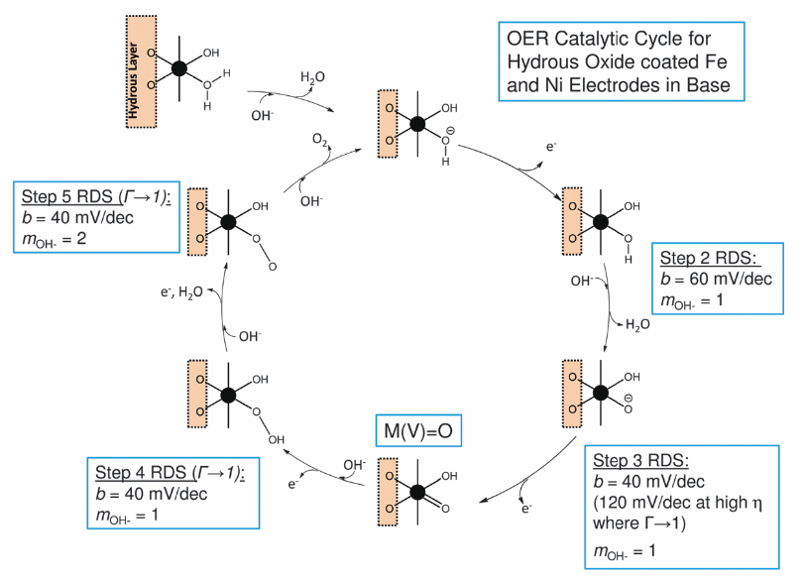
Figure 3 OER mechanism at hydrous oxide coated Fe and Ni electrodes in alkaline solution, reproduced from Ref⁸⁵ with permission from the PCCP Owner Societies. The symmetry factor is assumed to be 0.5, Langmuir adsorption and quasi-steady-state approximation was used to predict Tafel slopes and reaction orders.

Doyle et al.⁸⁵ reviewed the large body of experimental OER literature on various oxide and oxyhydroxide electrocatalysts and for hydrous oxide coated metal substrates came up with a mechanism inspired by the work of Kobussen⁸⁶, the DFT-based adsorbate evolution mechanism by Rossmeisl and colleagues^{87, 88} and works done in the field of homogeneous oxygen evolution catalysis^{89, 90}. They interpreted the active sites in terms of hydrated interlinked oxymetal complexes, which they termed as surfaquo groups; their mechanism is summarized in Figure 3. Langmuir adsorption and the quasi-steady-state approximation was used to predict Tafel slopes and reaction orders. Under strongly alkaline conditions water deprotonation is facile and appears as a pre-step in the reaction cycle. As we have seen before with first electron transfer steps being the RDS, a first discharge step of adsorbed OH⁻ would give rise to a Tafel slope of 118.4 mV/dec. The reaction order with respect to the electrolyte [OH⁻] is then zero. The next step is chemical in nature and gives a Tafel slope of 59.2 mV/dec and the reaction order is expected to be 1. The electrochemical oxo generation step in the limit of low surface coverage is expected to give rise a Tafel slope of 39.5 mV/dec but at high overpotentials and high coverage the slope would be 118.4 mV/dec. In both cases the reaction order comes out as first order. The authors mention that instead of M(V)=O, the species might be a metal-oxyl moiety, M(IV)-O*. Then they proposed hydroperoxo and superoxo formation steps completed with an O₂ desorption and concomitant OH⁻ adsorption step. The authors argue that this mechanism is in line with their kinetic data for hydrous Fe and Ni oxide films. In the limit of low surface coverage of intermediates, step 2 is rate-determining for hydrous Ni oxide films in low base concentrations and for hydrous Fe oxide films grown in high base concentrations, whereas step 3 is assumed to be rate-determining for hydrous Ni oxide films in concentrated base solutions and for Fe hydrous oxide films grown in low base concentrations (<1.0 M). On the other hand, at high overpotentials the surface coverage tends towards unity and step 3 becomes rate-determining for the whole range of hydrous oxide catalysts. Although the authors base their mechanistic model on a large body of experimental evidence, their model rests on a large number of assumptions we encountered in this chapter. We also note that in both of our examples the Tafel slopes were estimated at limiting low and high coverage situations. In the next section 2.3 we explore what happens when this limit is lifted and how the Tafel slopes behave when the coverage is allowed to change.

Coverage-dependent Tafel slopes

The use of Tafel slopes in the kinetic studies of electrocatalytic reactions is ubiquitous, though in much of the contemporary literature, Tafel analysis is either an afterthought or emphasized only when a particularly low slope is found to highlight the “quality” of the electrocatalyst. Both our previous examples have one point in common: for the very same RDS, different Tafel slopes might be predicted at the surface coverage limits. Hence, there needs to be a transient and a bending section of the slope as the coverage of the rate limiting species changes. In a thought exercise, Shinagawa et al.⁹¹ performed a theoretical microkinetic analysis describing coverage-dependent Tafel slopes for hydrogen evolution (HER) and oxidation (HOR) as well as oxygen evolution (OER) and reduction (ORR) reactions within the context of certain mechanisms with any of the steps potentially rate limiting. They were not interested in knowing the Tafel slopes at the limits of coverages, rather, they wanted to understand how the coverage changes by changing the overpotential within a framework of a particular mechanism and selected RDS and what effect this has on the Tafel slope. They assumed plausible reaction mechanisms and wrote down the kinetic equations of every reaction step. Electrochemical steps were assumed to be potential dependent, conforming with our Equation 5, using a symmetry factor of 0.5. Simulations were carried out with fixed electrolyte activities and by arbitrarily selected rate constants to conform the choice of the RDS. Steps before the RDS were assumed to be quasi-equilibrated. For the OER, they considered the alkaline adsorbate evolution mechanism on a single active site, well known from DFT works, see later, and very similar to the Kobussen path in Table 1, with the only difference that the hydroperoxo species forming in step 3 in Shinagawa does not have a negative charge. The authors observe a Tafel slope of 120 mV/dec when the surface species formed in the step just before the rate-determining step is predominant. (120 mV/dec is the rounded version of 118.4 mV/dec discussed before.) In the other cases, the Tafel slope is lower than 120 mV/dec. In case the first step (discharge of an OH⁻) is the RDS, the Tafel slope is 120 mV/dec and the active surface site is empty throughout the whole potential window. When the second step (discharge of the second OH⁻ to form a surface oxo) is the RDS, the initial Tafel slope is 30 mV/dec and the surface is predominantly empty. Then the coverage of OH (the surface species before the RDS) builds up and the Tafel slope bends. As the OH coverage is close to 1, the Tafel slope reaches 120 mV/dec. In case the 3rd step is rate limiting, the Tafel slope starts at 21 mV/dec and the surface is predominantly empty, followed by the build-up of OH intermediate and the concomitant increase of the Tafel slope to 40 mV/dec. At even higher overpotentials (and current densities), the OH intermediate turns to O and the Tafel slope is back to 120 mV/dec. When later steps are the RDS, more intermediate species build up and transform in waves, giving rise to changes in the concomitant Tafel slopes. Also, these authors find that certain Tafel slopes (not only 120 mV/dec) appear more than once, that is, different combinations of predominant intermediate species and rate limiting steps can yield the same Tafel slope. Hence Tafel slopes alone, even considering only one single reaction mechanism, is not predictive enough to prove a particular step is the RDS.

Others have also repeated, and to a certain extent even extended, these Tafel slope simulations.^{19, 92} Here, we reproduce one such prediction from a review by Alsac et al., as it provides some additional insights.⁹² Again, inspired by DFT, they used a slightly modified version of the single-site adsorbate evolution mechanism; their four steps read:
 | $$M^{II}(OH)_{2}+ {OH}^{-} ⇋ M^{III}O\left(OH\right)+{ e}^{-}+H_{2}O$$ | Equation 16
 | $$M^{III}O\left(OH\right)+{OH}^{-} ⇋ M^{IV}OO+ { e}^{-}+H_{2}O$$ | Equation 17
 | $$M^{IV}OO+ {OH}^{-} ⇋ M^{II}O(OOH)^{-}$$ | Equation 18
 | $$M^{II}O(OOH)^{-}+ {OH}^{-} ⇋M^{II}(OH)_{2}+{ 2e}^{-}+O_{2}$$ | Equation 19
where M is a single transition metal site. They used the steady-state approximation and considered the situations, where Equation 17 or Equation 18 is the rate determining step.

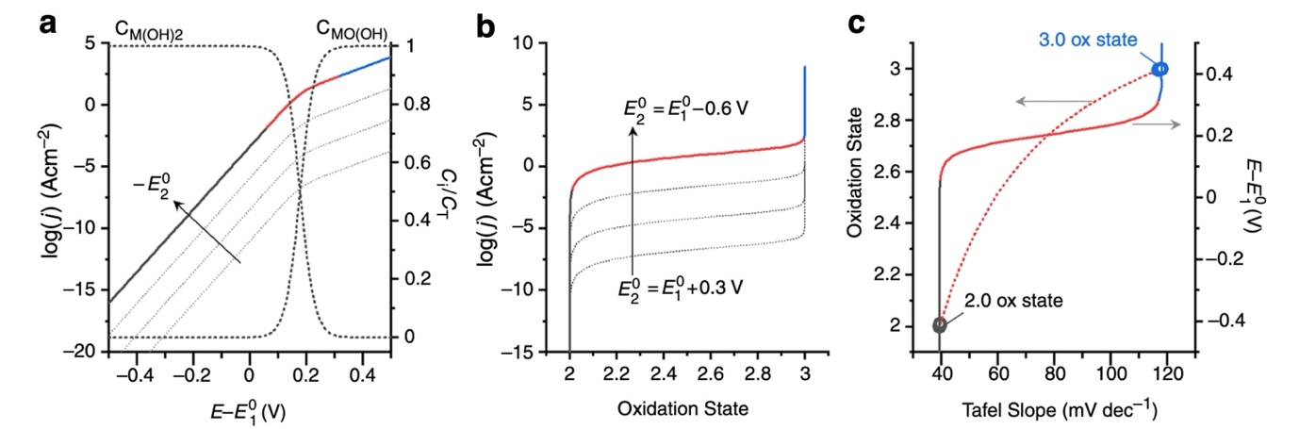
Figure 4 Electrocatalytic behavior and relative surface speciation for the situation where Equation 17 is rate limiting for OER. (a) Predicted Tafel plots and relative concentration of reactants and intermediates. (b) Catalytic performance as a function of transition metal oxidation state. (c) Oxidation state and voltage as a function of Tafel slope with hollow black and blue circles signifying oxidation states within their respective colored regions. Dotted lines in panels (b) and (c) indicate changes in current as a function of $E_{2}^{0}$. Black, red, and blue segments demonstrate the same regions across the three panels. Reproduced with permission from Ref⁹². Copyright 2021 AIP Publishing.

For our discussion, we reproduce only the first case, in which Equation 17 is the RDS, but the overall conclusions were the same for Equation 18, as well. Voltage-dependent changes in electrocatalytic performance, transition metal oxidation state changes, and performance descriptors are shown in Figure 4. As expected, only intermediates preceding the RDS are found, and in line with the predictions of Shinagawa et al.⁹¹, the Tafel slope is a straight line in the regions where no visible coverage change occurs. That is, the Tafel slope change is restricted to the potential window in which significant coverage change happens. The influence of the formal reduction potential of the second (rate limiting) electron transfer step ($E_{2}^{0}$) shifts the current density curves when $E_{2}^{0}$ shifts cathodically. Transformation of the mainly OH covered surface to an oxyhydroxide, $M^{III}O\left(OH\right)$, will alter oxidation states in the sample, enabling the data to be recast as log(j) vs metal oxidation state plot, Figure 4b. The result suggests that, as with the coverage, oxidation state change will only be observed in the transition period, where the Tafel slope changes, Figure 4c. As we have seen before, when the second electron transfer step is the RDS, as with Equation 17, the Tafel slope is 39.5 mV/dec. This, however, only applies in the potential window until the coverage of the reacting species of the RDS is negligible. Once deprotonation of OH in the first step is complete, the Tafel slope is 118.4 mV/dec. As pointed out by Alsac et al., once the first step has been completed, the catalytic cycle is best viewed as starting from a new point in the overall cycle, in which Equation 17 becomes the first step, and hence the 118.4 mV/dec Tafel slope. This exercise was based on a hypothetical mechanism, but there are frequently cases in the experimental literature when a close to 40 mV/dec Tafel slope is found, which at higher potentials starts to bend. Such a situation can be found in Nong et al.⁶³, with an amorphous iridium oxide OER catalyst.
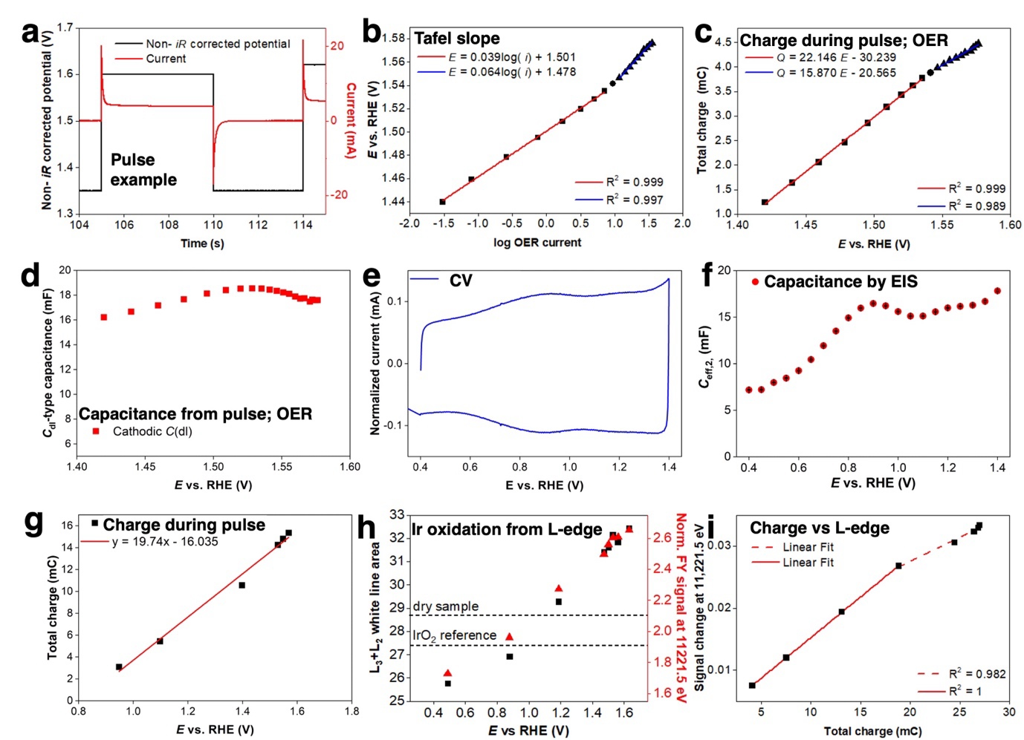
Figure 5 Electrocatalytic and operando X-ray absorption experiments with an amorphous Ir-oxide (IrO_{x}/Ti-250 °C) catalysts. (a) Section of the pulse voltammetry protocol (black) showing an oxidative and reductive pulse with the current response (red). The cathodic current response is integrated. (b) Tafel plot (potential versus log(current) in milliamperes) from pulse voltammetry (c) Charge integral versus potential from pulse voltammetry (d) C_{dl}-type capacitance derived from fitting the current profiles of the pulse voltammetry measurement (e) Cyclic voltammetry between 0.4 V to 1.4 V vs. RHE with 100 mV s⁻¹ scan rate. (f) Effective capacitance (derived from PEIS fitting) as a function of potential. (g) Charge determined by integral pulse voltammetry in the broad potential window (h) The L₃ + L₂ integrated white line area as a measure of Ir oxidation (left) and the normalized fluorescence yield (FY) signal at 11,221.5 eV (right) of steady-state operando Ir L-edge XAS versus the potential, together with the dry sample and reference IrO₂ (i) Correlation of the signal change of the Ir L₃ edge at 11,221.5 eV versus total charge during a broad potential window pulse voltammetry. Reproduced with permission from Ref.⁶³ Copyright 2020 Springer Nature.

Nong et al.⁶³ used pulse voltammetry, operando X-ray absorption spectroscopy (XAS) and a number of standard electrochemical methods in conjunction with DFT calculations to understand the OER mechanism of Ir-based catalysts under acidic conditions. Some of the DFT results will be reviewed in later chapters, so here we will only discuss their experimental results, which can be nicely compared and contrasted to the above thought experiment by Alsac et al.
Figure 5 highlights the relevant results of an amorphous Ir-oxide, adapted from Nong et al. The core idea of their work is that the degree of surface deprotonation has a strong influence on the OER performance and that the deprotonation under the OER can be followed by pulse voltammetry. As we have seen above in various mechanisms, surface deprotonated sites play a role as active sites in the OER reaction cycle. The authors devised a pulse protocol between a fixed cathodic potential below the onset of the OER and changing anodic potentials. The cathodic current spikes emerging upon reversing the potential from anodic to cathodic points, Figure 5a, were integrated. The absolute value of this integral reflects the positive charge accumulated at the certain anodic potential with respect to the cathodic (reference) potential, and hence can be related to the steady-state concentration of deprotonated sites created by the magnitude of the anodic bias. In practice, the potential was kept at a low potential (E_{cat} = 1.35 V) for 4 s, then switched and kept at a higher potential (E_{an}) for 5 s before returning to E_{cat} for 4 s. This cycle was repeated while increasing non-iR corrected E_{an} from 1.42 V to 1.80 V in 20 mV/step and keeping E_{cat} unchanged. Fast current sampling is needed to facilitate accurate current integration. Another pulse voltammetry protocol was applied to a broad potential window, E_{cat} = 0.75 V and 0.95 V ≤ E_{an} ≤ 1.7 V, to relate charge accumulation estimates to other classical electrochemical techniques, below the onset of OER, thereby assessing pseudocapacitance.
Figure 5b plots the (iR-corrected) potential – log OER current dependence as obtained during the pulse protocol. The Tafel plot shows the expected behavior: up to 1.54 V the Tafel slope is 39 mV dec⁻¹, in line with other amorphous Ir electrocatalysts, however, anodic of 1.54 V, the Tafel slope increases to about 64 mV dec⁻¹. Other Ir-based catalysts have shown similar bending profiles after the initial low (typically 39-45 mV/dec) slope region. Charge, based on the cathodic current spike integrals, is also bilinear in potential (Figure 5c), with the slope change at 1.54 V indicating that the capacitance drops from about 22.1 mF to about 15.9 mF. When explored with Ir-samples with known BET surface area, capacitance values calculated in this method exceed the expected double-layer capacitance; areal capacitances are 1–2 orders of magnitude greater than that of an ideally polarizable electrode. Therefore, these measurements probe pseudocapacitance and not classical double-layer capacitance. The decaying transient current response to the voltage steps can be fitted and the exponentially decaying contribution extracted. This, formally double-layer type capacitance depicted in Figure 5d shows that the magnitude of the capacitance is very close to that determined by integration and again at around 1.53-1.54 V, the slightly increasing trend changes.
The cyclic voltammogram (CV) of Ir-oxides, Figure 5e, under acidic conditions are typically strongly pseudocapacitive and hence only weakly structured. This suggests that the surface deprotonation processes are not localized in a narrow potential window, rather, they spread out and cover a very broad potential range. Outer and total capacitance values can be evaluated by performing CV cycling in narrow potential window (in our case 0.93-1.03 V) with varying scan rates. The total capacitance of the sample, evaluated by scan rate variation was 17.9 mF, in reasonable agreement with the above capacitance values. Also, potentiostatic electrochemical impedance spectroscopy was performed from 0.4 to 1.4 V and analyzed with an appropriate equivalent circuit model. The derived effective capacitance (including double layer and pseudocapacitance terms) is shown in Figure 5f as a function of potential. Although the capacitance is somewhat reduced below 0.8 V, the values above 0.8 V are in good agreement with all the previous capacitance values derived by the other electrochemical means. Not surprisingly, the shape of the capacitance profile follows the fine-structure of the CV curve. The above-mentioned narrow pulse voltammetry protocol was extended to cover a broader potential window, with E_{cat} = 0.75 V. Although the data points scatter around the trendline (Figure 5g), which is expected considering a slightly structured shape of the CV, the average capacitance derived by charge integration is 19.74 mF. This is again in excellent agreement with the above results.
As the pseudocapacitive deprotonation process is accompanied by an oxidation process of the catalyst, this latter process can be followed by operando XAS. Figure 5h and i provide operando spectroscopic information collected at the Ir L-edges. The integral intensity of the L₃₊₂ white lines, measured as a function of applied potential, quantifies the number of empty 5d states and hence the oxidation state of Ir.⁹³ The plot of the steady-state white line integral of the sample shows that the Ir oxidation state increases linearly with increasing anodic potential. Furthermore, the white line intensity at a properly selected energy (11221.5 eV) tracks the white line area, enabling potentiodynamic XAS experiments. Such an experiment (Figure 5i) shows that the Ir oxidation state increases linearly with charge (deduced from the pulse voltammetry experiment during operando L-edge measurement at 11221.5 eV) up to about 20 mC (corresponding to 1.4 V) and from approximately 1.5 V Ir oxidation cannot fully account for the stored charge, suggesting that additional means are active. This finding is consistent with Ir oxides entering a negative charge-transfer regime for oxidation states beyond Ir(IV), resulting in the formation of electrophilic oxygen species (O^{I-}), see later.⁹⁴

We have seen that cathodic current integration upon potential reversal in pulse voltammetry provides an excellent tool to assess charge accumulation under OER. From the above data we can draw some conclusions. (1) There is a continuous (de)protonation process as a function of potential: the stronger the anodic bias, the larger the degree of deprotonation. (2) Presumably due to electrolyte effects and lateral interaction of intermediates (and/or alternatively due to the, a priori, heterogeneity of adsorption/desorption sites), the pseudocapacitance of the amorphous Ir-oxide is only weakly potential dependent. (3) Electrochemical techniques and more sophisticated operando XAS techniques seem to track the same process from a different angle. (4) Comparing Figure 5b and c clearly suggests that a continuous deprotonation process takes place in the constant Tafel-slope region of 39 mV/dec, and hence the coverage cannot be constant. (5) Interestingly, the change of the Tafel slope was associated with the changing rate of the deprotonation process with respect to potential. The microkinetic simulations (e.g. Figure 4) we discussed above are clearly at odds with the experimental data presented in Figure 5. The simulation predicted that Tafel slope will stay fixed when the coverage (and metal oxidation state) does not change and slope bending will only occur when the coverage of a relevant intermediate changes, accompanied by oxidation of the catalyst. Instead, experiments suggest that the oxidative charge accumulation and catalyst’s oxidation state change is continuous and seemingly constant Tafel slopes can be observed under continuously changing metal oxidation state. Instead of coverage (and oxidation state) change, the above experimental results indicate that the changing rate of oxidation (and charge accumulation) with respect to potential seems to correlate with bending Tafel slopes.

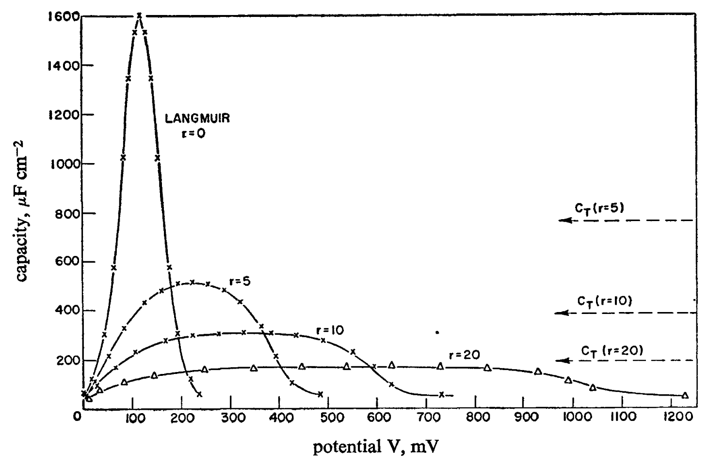
Figure 6 Variation of the pseudocapacitance with potential. Cases of Langmuir adsorption and Temkin conditions with different values of Temkin coefficients are shown. C_{T} indicates Temkin capacitance. Reproduced from Ref.⁹⁵ with permission from the Royal Society of Chemistry.

At this juncture, it is worth taking a detour back to the 1940s-1960s. Back in these days, when the role of the heat of adsorption of a species was discussed for catalysis, it was recognized that in many instances the standard Langmuir model may not be able to properly account for experimental observations. Hence, a coverage dependent heat of adsorption was introduced by Frumkin and Temkin, in the form of:
 | $$ΔH= ΔH^{0}-rθ$$ | Equation 20
where, $ΔH^{0}$ is the initial heat of adsorption at zero coverage and r is a coefficient with the same energy/mole unit as $ΔH$. Among others, Conway recognized the potential implications of coverage dependent adsorption/desorption and coverage dependent reaction intermediates in electrocatalysis. Conway and Gileadi⁹⁵ compared HER and OER kinetics under Langmuir and Temkin conditions. Steady-state or quasi-equilibrium conditions for Langmuir adsorption leads to exponential dependence of the coverage of intermediates on the potential, though only at limiting low and high coverages. The pseudocapacitance has a maximum value at a certain potential determined by the relative values of the rate constants involved and the concentration of reacting ions, and varies symmetrically about this potential, falling to practically zero within about $±0.12 V$ of the potential of the maximum, Figure 6. This is identical to the case in Figure 4, in which Equation 17 gave rise to a full change in the coverage of $M^{II}(OH)_{2}$ to $M^{III}O\left(OH\right)$ in a narrow potential window of approximately 0.25 V. Introducing a Temkin coefficient makes the pseudocapacitance less potential dependent; already a 10 kcal/mole Temkin coefficient can spread out the pseudocapacitance to make it quasi potential independent in a potential window of 300 mV. A large Temkin coefficient hence makes the coverage essentially linear with potential. The situation of a sizable Temkin coefficient is reminiscent of the experimental observation of weakly dependent pseudocapacitance of amorphous IrO_{x} (Figure 5). Conway and Gileadi have shown that when more than one intermediate is adsorbed, a constant pseudocapacitance is still obtained and the apparent value of the rate of change of heat of adsorption with coverage is simply a weighted average of the values for the species involved. Hence, for IrO_{x} we might have the case that the explored broad potential window involves adsorbates of H₂O, OH, and O, in varying portions, the two deprotonation reactions overlapping with each other to a certain degree. Moreover, different types of surface sites can additionally contribute to broadening the potential dependent pseudocapacitance. Then, a largely potential independent pseudocapacitance is compatible with a potential dependent free energy of activation due to the potential dependent heat of adsorption of intermediates.^{63, 95}

Some cautionary observations and comments related to experiments

Before we leave the experimental reaction kinetics behind and embark on a long journey of DFT-based exploration of the OER mechanisms, we want to point out a few potential pitfalls and peculiarities of kinetic experiments. Our examples are again arbitrarily chosen, and we could have selected other studies.

Bai et al.⁹⁶ used plated porous and smooth bright Pt electrodes in HER under alkaline in 0.1-4.0 M KOH. They found that the iR-corrected Tafel behavior for the HER on the activated bright Pt is independent of the concentrations of the KOH solutions used. The low Tafel slope region started bending already at low current density and low overpotential and practically continuously bent over the whole potential window studied, curve 6 in Figure 7a. This contrasts to the behavior of the porous Pt sample, which, apart from the smallest overpotential region, did show a pH dependence. The higher the KOH concentration, and hence the pH, the higher current densities the low Tafel slope region was accessible. Open-circuit potential relaxation experiments were performed to calculate the pseudocapacitance of the porous electrode in these different electrolytes and an apparent roughness factor with respect to the bright electrolyte was estimated. It was found that the porous electrode in 4 M KOH has a roughness factor of approximately 300 as compared to the bright electrode but only 15-30 in 0.1-0.2 M KOH, the roughness factor continuously changing with the KOH concentration. That is, the apparent roughness factor was ca. 20 times lower when the concentration of KOH electrolyte decreased by factor 40. The electrolyte ohmic resistance inside pores is large in dilute KOH solution, which renders only a rather small fraction of the surface inside the pores accessible for HER. Hence, when enough surface area is accessible, by using concentrated KOH with the porous sample, the low Tafel slope can be maintained up to larger current densities.

Anantharaj and Kundu⁹⁷ investigated the influence of NiO loading on the OER performance. As expected, the overall geometric current density of NiO in 1 M KOH increased with increasing catalyst loading, which implies that the potential to reach any fixed current densities will be loading- dependent. The Tafel slopes were catalyst loading dependent, too (Figure 7b); at the lowest loading the Tafel slope was 118 mV/dec, continuously decreasing to roughly 90 mV/dec with increasing catalyst loading. These Tafel slopes were assessed close to the OER onset. Hence, they reflect intrinsically large slope values and were not the effect of bended Tafel slopes. The authors went on and estimated the electrochemically accessible surface based on the integral of the Ni(II)/Ni(III) redox peak at around 1.35 V. When the OER activity was normalized to the electrochemically accessible surface area, the highest surface area-normalized activity was found with the 0.2-0.4 mg/cm² samples. The intrinsic activity decreased with increasing catalyst loading, suggesting that the highest Tafel slope with the lowest catalyst loading is most likely not rooted in any experimental artifact.
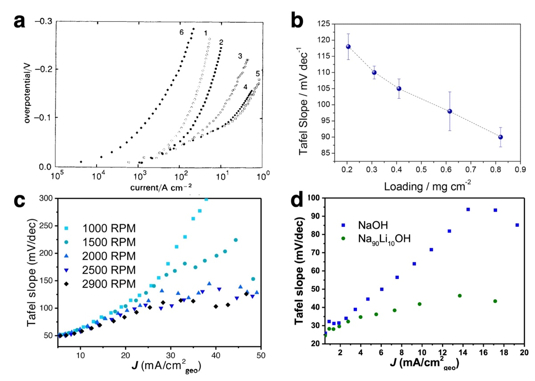
Figure 7 Some selected experiments showing peculiarities with Tafel slopes. (a) Tafel plots for HER on plated Pt electrode in (1) 0.1 (2) 0.2, (3) 1.0, (4) 2.0 and (5) 4.0 M KOH solutions, respectively. Curve 6 is for the HER on the bright Pt electrode in 4.0 M KOH solution. Reproduced from Ref.⁹⁶ with permission from the Royal Society of Chemistry. (b) OER Tafel slopes of NiO/carbon-cloth electrodes in 1 M KOH as a function of catalyst loading. Tafel slopes from 100% iR-corrected linear sweep voltammetry (LSV). The error bars reflect the mean deviation calculated from 5 independent experiments. Reproduced with permission from Ref.⁹⁷ Copyright 2019 American Chemical Society. (c) OER Tafel slope of Ni₈₀Fe₂₀OOH from 100% iR-corrected LSV vs. average current density (Tafel slope obtained over a 20 mV interval). The rotation rate of the rotating disk electrode was changed between 1000 and 2900 RPM. Reproduced with permission from Ref.⁹⁸ Copyright 2023 John Wiley and Sons. (d) OER Tafel slope of Ni₈₀Fe₂₀OOH from 100% iR-corrected LSV vs. average current density (Tafel slope obtained over a 20 mV interval) Experiments performed either in 0.1 M NaOH or 0.1 M Na₉₀Li₁₀OH electrolytes Reproduced with permission from Ref.⁹⁹ Copyright 2024 John Wiley and Sons.
As to the variability of Tafel slope with experimental conditions, the group of Koper studied Ni₈₀Fe₂₀OOH layered double hydroxide in OER and explored the influence of various experimental conditions and parameters.⁹⁸ They showed that, at low current density (<5 mA/cm²), the Tafel slope was approximately 30 mV/dec. At higher polarization, though, the Tafel slope continuously increased and was dependent on the rotation rate (Figure 7c), catalyst loading, hydroxide concentration and sonication. They argue that the intrinsic Tafel slope value is hence convoluted by non-kinetic effects, such as bubble formation within and on the catalyst layer, resulting changes in ohmic resistance, and OH⁻ gradients in the pores. As a result, they interpret their data in the context of no secondary Tafel slope region with the sample. They suggest that the data show no indication for a change in rate determining step, as opposed to some claims in the relevant literature. The authors propose that Tafel slopes should be plotted in Tafel slope plots (Tafel slope values vs potential or current density, as in Figure 7c,d), and when the slope is continuously changing, this would be an indication of intrinsic kinetic data being convoluted (and polluted) by non-kinetic effects. We definitely agree that these effects exist and can have an effect on the apparent Tafel slopes. But the authors likely underplay other effects, some of them mentioned above, that can intrinsically change the Tafel slope. From the opposite perspective, the authors of Ref⁹⁸ overestimate the predictive power of Tafel analysis, which based on the cited references and discussion in this chapter should appear more and more noticeable. To further illustrate the point, Figure 7c indicates that the influence of the rotation rate in the 5-10 mA/cm² range was marginal at best and still (1) there is an apparent increase of the Tafel slope in this low current density range and (2) even at 5 mA/cm², the Tafel slope is approximately 50 mV/dec while the intrinsic slope is claimed to be 30 mV/dec. Also, in Figure 7d, the same group assessed the OER Tafel slope of the same material in two different settings.⁹⁹ Once in 0.1 M NaOH and also in a mixed electrolyte of 0.1 M Na₉₀Li₁₀OH. Although similar, the Tafel slope of the two cases at the reaction onset is not identical. Moreover, already at 2 mA/cm², the slopes start to increase; less so in the mixed electrolyte and more in 0.1 M NaOH. From these plots one can get the impression that the Tafel slope does not reflect any intrinsic kinetic property, deeply rooted in the reaction mechanism. Rather, it is a convoluted consequence of intrinsic kinetics, the number of available sites relative to the current density demanded, the rate of coverage change of reaction intermediates, the capability of the catalyst to accommodate the oxidative charge imposed by the potential bias as well as experimental influences affecting the ohmic resistance and pH gradients in the catalysts layer and pores. We mention in passing that Park et al¹⁰⁰ investigated the influence of grain size of electrochemically oxidized Ni₆₀Fe₄₀ binary alloys, hence a similar NiFe-based oxyhydroxide catalyst and found that the grain size had a profound impact on the OER performance. Catalysts with nm scale grains were more active than larger $μm$ grain-sized counterparts, even after surface area normalization. The catalyst with nm scale grains showed a Tafel slope of 38 mV/dec (though some bending is apparent in their underlying data), whereas the Tafel slope increased to 54 and 115 mV/dec for 20 and 440 $μm$ grain-sized samples. The authors, using operando optical microscopy, demonstrated that bubble formation commenced preferentially at grain boundaries. Whether the grain boundaries acted as the location of the active sites or, rather the opposite, they trapped oxygen via bubble formation, are two diametrically opposite ideas that need further exploration.

In closing this chapter, we have shown that depending on the electrochemical model applied (Butler-Volmer vs Marcus-Hush), the $η≈lnj$ dependence might be distorted by the potential dependence of the symmetry factor and hence the Tafel slope may intrinsically bend when the latter model applies. Since none of these models are built for electrocatalytic reactions, it is not a priori clear, though, whether they should be applicable for OER kinetics. This is particularly evident as for outer-sphere electron-transfer reactions, where theories of Marcus and Hush hold, the nature of the electrode material is unimportant. Based on these fundamental electron transfer theories and taking into account a long list of assumptions, the symmetry factor of a single electron transfer step can be redefined to the transfer coefficient of a multi-step reaction. Then, based on an assumed mechanism and the rate determining step, one can obtain an estimate of the Tafel slope. This procedure is regularly used as a diagnostic tool to derive “mechanistic” information from analyzing experimental Tafel slopes. As we have seen, numerous reaction schemes can produce the very same theoretical Tafel slope and their differentiation based solely on kinetic experiments is simply not possible. Most of the predictions are built on the premise of coverage of critical intermediate being at the limit of either zero or one. Some of the predictions were also extended to intermediate coverage situations, but as we have seen in our amorphous IrO_{x} example, it is doubtful that these predictions are applicable for a broad range of OER catalysts. Instead, coverage dependent heat of adsorption/desorption seems to be an enticing concept to account for an often observed weakly potential dependent pseudocapacitance that can yield a potential dependent free energy of activation. At last, we have seen that the Tafel slope can be a function of catalyst loading, electrolyte concentration and type, even the size of grains and grain boundaries might have a role, and indeed, also non-kinetic effects can pollute the observed Tafel slope. A rather disappointing state-of-affairs. With this, we put aside OER experiments for now and embark on our exploration of how DFT calculations can improve our understanding of the OER.

Ab initio atomistic thermodynamics and the Computational Hydrogen Electrode

The challenge in relating DFT computed energetics to an experimental potential scale long prevented the wide-spread use of first principles simulations in the study of the OER. This changed with the introduction of the computational hydrogen electrode (CHE) ⁵⁹, which has also been referred to as the computational standard hydrogen electrode (computational SHE)¹⁰¹. Although this approach was originally developed and applied to study the oxygen reduction reaction (ORR)⁵⁹, it was quickly used to study the OER^{87, 88}. These early reports still have had far- reaching implications, and the approach is arguably the most significant single advance in the computational study of the OER made to date. As such, we will cover the background of the CHE in some detail.

The term CHE appears to have first been coined several years after the introduction of the method¹⁰², which results from applying ab initio atomistic thermodynamics¹⁰³⁻¹⁰⁶ to electrochemical processes. To understand the fundamentals of the CHE it is then important to review the foundations of ab initio atomistic thermodynamics as it was originally developed for gas-phase thermochemistry, particularly identifying surface phases on catalysts under equilibrium conditions, though it was extended to reactive conditions.

Development of ab initio atomistic thermodynamics

As the CHE is based on ab initio atomistic thermodynamics, it is worthwhile to review this approach as it was originally developed and applied to thermal chemistry. Because ab initio atomistic thermodynamics is a well-developed approach that has been the subject of numerous reviews, we will focus on those aspects most germane to understanding the CHE and refer the reader to several excellent reviews for more details on thermal catalysis applications¹⁰⁷⁻¹⁰⁹. In ab initio atomistic thermodynamics, DFT total energies are used in conjunction with thermodynamics to predict equilibrium (T, p) phase diagrams. Take for example the (110) surface of rutile-type RuO₂ in an oxygen atmosphere that was treated by Reuter and Scheffler in their development of the approach¹⁰⁵. At constant pressure, the Gibbs free energy, G(T, p, N_{Ru}, N_{O}), is the appropriate thermodynamic potential, however DFT is typically performed at 0 K and yields total energies at fixed volume, E_{total}(V, N_{Ru}, N_{O}), which is akin to a Helmholtz free energy, F(T, V, N_{Ru}, N_{O}), at 0 K if zero-point energies (E_{ZPT}) are included. Reuter and Scheffler showed that DFT total energies can be used to approximate G(T, p, N_{Ru},N_{O}) by first noting the Gibbs free energy is related to the Helmholtz free energy as:
 | G(T, p, N_{Ru}, N_{O}) = F(T, V, N_{Ru}, N_{O}) + pV(T, p, N_{Ru}, N_{O}) | Equation 21
The pV term in Equation 21 can be shown to contribute on the order of 10⁻³ meV/Å² to the surface free energy, when the surface energy is normalized by area. Considering that the Helmholtz free energy is on the order of 100s of meV/Å², the pV term in Equation 21 can generally be neglected if the desired accuracy is on the 10-15 meV/Å². The Helmholtz free energy in Equation 21 can be written as:
 | F(T, V , N_{Ru}, N_{O}) = E_{total}(V, N_{Ru}, N_{O}) + F_{vib}(T, V, N_{Ru}, N_{O})  = E_{total}(V, N_{Ru}, N_{O}) + E_{vib}(T, V, N_{Ru} ,N_{O}) – TS_{vib}(T, V, N_{Ru}, N_{O}) | Equation 22
where E_{vib}(T, V, N_{Ru} ,N_{O}) is the zero-point energy and TS_{vib}(T, V, N_{Ru}, N_{O}) the non-zero temperature vibrational free energy contribution to F(T, V , N_{Ru}, N_{O}). Reuter and Scheffler showed these vibrational contributions can be ignored in RuO₂, which allows the surface free energy to be written as:
$$γ\left(T, p\right)=\frac{1}{2A}∆G(T, p, N_{Ru}, N_{O})≈\frac{1}{2A}\left[E_{surface}\left(V, N_{Ru}, N_{O}\right)-\frac{N_{O}}{2}μ_{O2}\left(T,p\right)-N_{Ru}E_{Ru,bulk}\left(V\right)\right]$$ | Equation 23
where $E_{surface}\left(V, N_{Ru}, N_{O}\right)$ is the total energy of a cell with $N_{Ru}$ ruthenium atoms and $N_{O}$ oxygen atoms computed from DFT. The $E_{Ru,bulk}\left(V\right)$ term is the total energy of bulk ruthenium metal; it represents the thermodynamic reservoir for ruthenium, which is assumed to be independent of temperature, thus allowing the DFT total energy to be used. The final term in Equation 23, $\frac{N_{O}}{2}μ_{O2}\left(T,p\right)$, is the essence of ab initio atomistic thermodynamics. It is the chemical potential of the thermodynamic reservoir of oxygen with which the surface is assumed to be equilibrated. This chemical potential depends strongly on $\left(T,p\right)$. Reuter and Scheffler showed for gas-phase species, in this case oxygen, the chemical potential can be written as:
$$μ_{O2}\left(T,p\right)=E_{O2}+\left[H_{O2}\left(T,p^{0}\right)-H_{O2}\left(0,p^{0}\right)\right]-T\left[S_{O2}\left(T,p^{0}\right)\right]+k_{B}T ln\left(p/p^{0}\right)$$ | Equation 24
where the computed or tabulated⁵⁵ gas-phase enthalpies and entropies can be used to set the oxygen chemical potential with p⁰= 1 atm. That is, the total energy from DFT ($E_{O2}$) can be corrected for non-zero temperature to place the gas-phase chemical potential on an experimental (T, p) scale. Note that, while we have written Equation 24 using the total energy of an O₂ molecule, in practice alterative definitions of $E_{O2}$ are used¹¹⁰⁻¹¹³ due to the well-known overbinding of the O₂ molecule in the local spin density approximation (LDA), generalized gradient approximation (GGA)s¹¹⁴, and hybrid functionals¹¹⁵. For instance, the energy of oxygen can be written in terms of the computed total energies of gas-phase water and hydrogen together with the measured heat of formation of water as: ${\frac{1}{2}E}_{O2}=E_{H2O,gas}-E_{H2,gas}-∆H_{f,H2O,gas}$. Such approaches to compute the energy of oxygen are not always used, but they may offer a chance to reduce computational errors, and care must be taken when comparing results from different authors to ensure similar schemes were used to compute the oxygen energy. An example of the error reduction that is possible can be seen in, for instance, Ref. ¹¹³. The authors computed the energy of formation of rutile type oxides using H₂ and H₂O as reference states, rather than O₂, resulting in a mean absolute error of 0.29 eV within the revised Perdew-Burke-Ernzerhof GGA¹¹³. This error is significantly less than the 0.60 eV error in the O₂ bond energy within the same approximation. The choice of oxygen reference state can have a significant impact on predicted oxygen electrochemistry^{112, 115}.
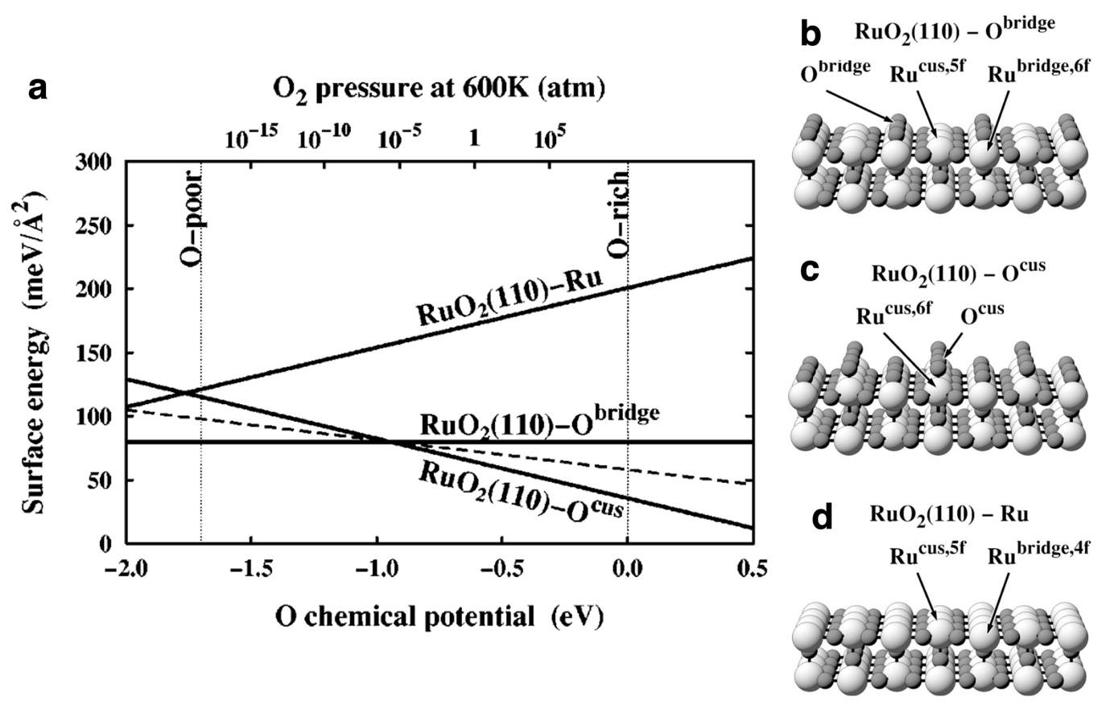
Figure 8 Surface phase diagram for the (110) surface of rutile-type RuO₂ in a gas-phase oxygen atmosphere together with the corresponding ball and stick models. RuO₂(110)-O^{bridge} is the stoichiometric surface termination. RuO₂(110)-O^{CUS} is a polar surface termination where the coordinatively unsaturated sites (CUS) are occupied with adsorbed oxygen, μ₁-O oxyl. The dashed line shows a RuO₂(110)-O^{CUS} surface where half of the CUS sites are occupied with μ₁-O oxyl. RuO₂(110)-Ru shows the metal terminated surface. Reproduced from Ref. ¹⁰⁵ under the Creative Commons Attribution 3.0 License.
An example of applying ab initio atomistic thermodynamics to thermal chemistry can be seen in the surface phase diagram of RuO₂(110) in an O₂ atmosphere in Figure 8¹⁰⁵. The phase diagram shows the energies of various surface terminations between an oxygen rich limit—
defined as the chemical potential of a free oxygen molecule at T=0 K—and an oxygen poor limit—defined as the oxygen chemical potential below which RuO₂ is reduced to metal—given by: ${∆G_{f,RuO2}\left(0,0\right)≤μ}_{O}\left(T,p\right)-\frac{1}{2}E_{O2}≤0$. Inspection of Figure 8 reveals that at high oxygen chemical potentials within this range, $μ_{O}\left(T,p\right) ≥-0.9 eV$, the surface where all the coordinatively unsaturated sites (CUS) on RuO₂(110) are occupied with μ₁-O oxyl is the lowest energy surface and thus the thermodynamically stable phase, Figure 8c. At these high oxygen chemical potentials, the stoichiometric termination, RuO₂(110)-O^{bridge} (Figure 8b), and the reduced surface, RuO₂(110)-Ru (Figure 8d), are both metastable, with the stoichiometric termination being of lower energy than the reduced surface. As the oxygen chemical potential is lowered, the stoichiometric termination becomes the stable phase. The power of ab initio atomistic thermodynamics is in its ability to predict both stable and metastable phases of surfaces in equilibrium with a thermodynamic reservoir. And while these results are in the gas-phase, we will see similar behavior and structures emerge in studies of the OER over rutile-type oxides. Moreover, the CHE is a simple extension of this ab initio atomistic thermodynamic methodology first developed for gas-phase thermal chemistry.

Multicomponent systems

Before moving on to the CHE formulation of ab initio atomistic thermodynamics, we note that in electrochemical environments, we must define thermodynamic reservoirs for multiple species. In Equation 23 this was the trivial result of assuming changes in the entropic contributions in the solid phases are small, hence the total energy of bulk ruthenium metal was used as the ruthenium chemical potential. In aqueous environments, however, the chemical potentials of hydrogen and oxygen must be defined. Consider, for instance, the RuO₂(110) surface in a humid atmosphere. The surface free energy of this system is a function of three chemical potentials, μ_{Ru}, μ_{O}, and μ_{H}. By assuming the surface is equilibrated with the bulk oxide the authors were able write the surface free energy in terms of the oxygen and hydrogen chemical potentials. Both μ_{O} and μ_{H} depend on their corresponding thermodynamic reservoir. In thermodynamic equilibrium the surface and gas-phase components are all equilibrated. This so-called, complete equilibrium condition, allows us to uniquely identify the μ_{O} and μ_{H} chemical potentials. Sun, Reuter, and Scheffler showed that for the case of RuO₂(110) in a humid atmosphere the complete equilibrium condition is likely satisfied¹¹⁶. In this case, the hydrogen chemical potential is determined by the water and oxygen chemical potentials as:
$$μ_{H}\left(T,p_{H2O}, p_{O2}\right)=\frac{1}{2}\left[μ_{H2O}\left(T,p_{H2O}\right)-\frac{1}{2}μ_{O2}\left(T,p_{O2}\right)\right]$$ | Equation 25
The gas-phase water chemical potential can be written in a form like Equation 24:
$$μ_{H2O}\left(T,p\right)=E_{H2O}+\left[H_{H2O}\left(T,p^{0}\right)-H_{H2O}\left(0,p^{0}\right)\right]-T\left[S_{H2O}\left(T,p^{0}\right)\right]+k_{B}T ln\left(p/p^{0}\right)$$ | Equation 26
Now with the necessary chemical potentials defined using Equation 24-26 the surface phase diagram can be generated as with the example in dry oxygen. However, Equation 23 cannot be used directly because the O-H bonds have high zero-point energies. Instead, the vibrational contribution to the free energy from adsorbed water and hydroxide must be included to achieve an accuracy of 10-15 meV/Å². Thus, the surface free energy becomes:
$$γ\left(T, {p_{H2O},p}_{O2}\right)≈\frac{1}{2A}\left[E_{surface}\left(V, N_{Ru}, N_{O},N_{H}\right)-\frac{N_{O}}{2}μ_{O2}\left(T,p_{O2}\right)-N_{H}μ_{H}\left(T,p_{H2O}, p_{O2}\right)-N_{Ru}E_{Ru,bulk}\left(V\right)+ E_{vib}(T, V, N_{Ru}, N_{O},N_{H}) – TS_{vib}(T,V, N_{Ru}, N_{O},N_{H})\right]$$ | Equation 27
In Ref. ¹¹⁶ these vibrational contributions were computed by diagonalizing the complete dynamical matrix with the substrate held fixed^{116, 117}. The resultant surface phase diagram, Figure 9, is like what was found in a dry oxygen atmosphere¹⁰⁵ when the water chemical potential is low. As the water chemical potential increases, the surface becomes covered in hydroxide and water. Thus, ab initio atomistic thermodynamics can be used to determine the equilibrium surface terminations in multi-component gas-phase systems when assumptions about the equilibria are made. And as with the single component case¹⁰⁵, metastable phases can also be identified, though these are not shown in Figure 9 because this would require a 3D representation.

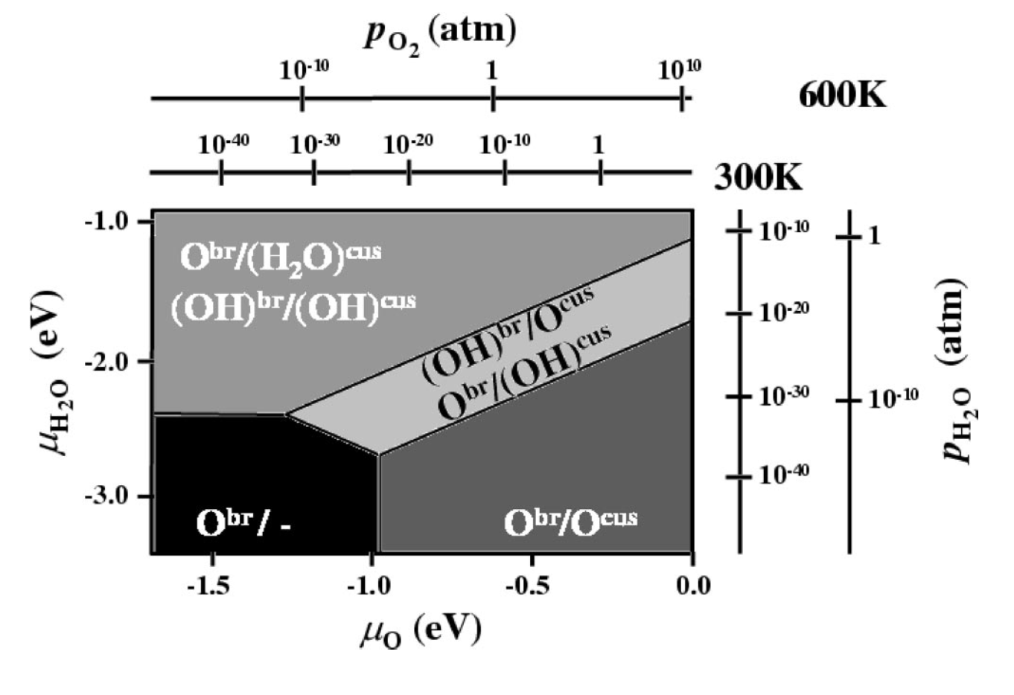
Figure 9 Surface phase diagram for the (110) surface of rutile-type RuO₂ in a humid oxygen atmosphere under the assumption of complete equilibrium, where labels show the species on the bridge and CUS sites as: O(H)^{br}/O(H)^{cus}. At low water chemical potentials, the surface phase diagram matches that computed in dry oxygen with the stoichiometric surface (O^{br}/-) appearing at low oxygen chemical potential and the polar surface (O^{br}/O^{cus}) appearing as the stable phase at high oxygen chemical potential. At higher water chemical potentials hydroxide and water populate the surface sites. Reproduced with permission from Ref. ¹¹⁶. Copyright 2003 American Physical Society.

Constrained equilibrium and reactive systems

Studying the OER necessarily involves studying surface catalyzed reactions. Here too, ab initio atomistic thermodynamics has played a prominent role in gas-phase thermal chemistry. Before going to the details of such studies for the OER, it is worthwhile covering the development of ab initio atomistic thermodynamics in reactive systems by again focusing on RuO₂(110). In Ref. ¹¹⁸, Reuter and Scheffler argued ab initio atomistic thermodynamics can be applied to model the surface of heterogeneous catalyst in a reactive flow, in this case CO and O₂, if the catalyst is operated near thermodynamic equilibrium. Because ruthenium, carbon, and oxygen are present, three chemical potentials are required, μ_{Ru}, μ_{O}, and μ_{C}. And since RuO₂ is being used as a catalyst for CO combustion, the authors argued it is reasonable to assume the rate of CO₂ formation in the gas phase is negligible. As such, the catalyst surface is in constrained equilibrium with the CO and O₂ gas-phase species, while the gas-phase species are not equilibrated with one another. In that case, the thermodynamic reservoirs can be chosen as ruthenium metal and O_{2,gas}, as before, together with CO_{gas}. The use of CO_{gas} as an independent thermodynamic reservoir is the constrained equilibrium assumption—as opposed to the total equilibrium assumption which would yield the following: $μ_{C}\left(T,p_{CO2}, p_{O2}\right)=μ_{CO2}\left(T,p_{CO2}\right)-μ_{O2}\left(T,p_{O2}\right)$. The constrained equilibrium condition can then be seen as a means of approximating thermodynamic equilibrium in an open (reactive) system, though such a system can only reach steady-state and not thermodynamic equilibrium. We will see that this approximation proves to be powerful but is also prone to failure if not mindfully applied.
With the chemical potentials defined it is straightforward to compute the surface energies as:
$$γ\left(T, {p_{CO},p}_{O2}\right)≈\frac{1}{2A}\left[E_{surface}\left(V, N_{Ru}, N_{O},N_{CO}\right)-\frac{N_{O}}{2}μ_{O2}\left(T,p_{O2}\right)-N_{CO}μ_{CO}\left(T,p_{CO}\right)-N_{Ru}E_{Ru,bulk}\left(V\right)+ E_{vib}\left(T, V, N_{Ru}, N_{O},N_{CO}\right)– TS_{vib}\left(T,V, N_{Ru}, N_{O},N_{CO}\right)\right]$$ | Equation 28
where the CO chemical potential is given by:
$$μ_{CO}\left(T,p\right)=E_{CO}+\left[H_{CO}\left(T,p^{0}\right)-H_{CO}\left(0,p^{0}\right)\right]-T\left[S_{CO}\left(T,p^{0}\right)\right]+k_{B}T ln\left(p/p^{0}\right)$$ | Equation 29
Once the surface free energies are known the stable and metastable phases can be identified. In Ref. ¹¹⁸ oxygen and carbon monoxide adsorption on the bridge and CUS sites of RuO₂(110) were examined under the assumption that the vibrational contributions to the free energies of the solid phases can be ignored. The resulting surface phase diagram is shown in Figure 10.
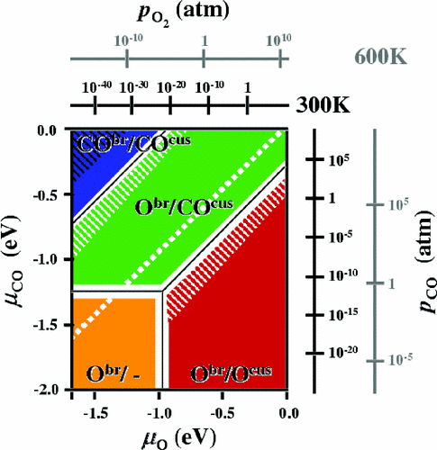
Figure 10 Surface phase diagram for the (110) surface of rutile-type RuO₂ in a reactive atmosphere composed of CO_{gas} and O₂,_{gas} computed under constrained equilibrium conditions. Under constrained equilibrium CO_{gas} and O₂,_{gas} are assumed to only react to form CO₂ on the surface, and the formation of adsorbed CO₂ is assumed to be much slower than any adsorption/desorption reaction. Near the phase boundaries, white hatches, the assumption of slow CO₂ formation on the surface breaks down and the thermodynamic approach is not expected to be predictive. Figure reproduced with permission from Ref. ¹¹⁸. Copyright 2003 American Physical Society.

The phase diagram in Figure 10 shows that at low CO pressure the surface phases are predicted to be those seen in dry O₂, which is not unexpected. Similarly, at high CO pressure and low O₂ pressure the surface is predicted to be covered in adsorbed CO. Perhaps more significantly is the observation that, when the CO and O₂ chemical potentials are similar a mixed phase is predicted where CO populates CUS sites and O populates bridge sites. In Ref. ¹¹⁸ the authors argue this wide mixed phase region is catalytically interesting since both reactants are present on the surface and can therefore react through a Langmuir–Hinshelwood mechanism. However, one must keep in mind this phase diagram was created under the assumption of constrained equilibrium wherein: i) CO₂ cannot be formed in the gas-phase and ii) CO₂ formation on the surface is slower than the adsorption/desorption of any species. The second of these assumptions begins to break down near the phase boundaries that are shaded white in Figure 10, and kinetic effects lead to significant deviations from the predictions¹⁰⁸. The thermodynamic approach can then, at best, be used to identify these kinetically interesting regions of a phase diagram. We will see that the assumptions of constrained equilibrium are critical when studying the OER with an ab initio atomistic thermodynamic approach.

From the preceding examples and discussions, it can be seen that ab initio atomistic thermodynamics is a powerful and flexible computational tool. We saw the accuracy of the method can be systematically improved by including additional contributions to the free energy, e.g. vibrational free energy¹⁰⁸, which makes ab initio atomistic thermodynamics particularly attractive for electrochemical applications where various levels of model complexity can be envisioned and explored. We also saw how careful use of constrained equilibrium conditions can be used to garner some insight into reactive chemistry by pushing ab initio atomistic thermodynamics from a true thermodynamic model to a useful thought experiment to gain insight into the structure of a catalyst surface under reactive conditions where complete thermodynamic cannot be attained. We now turn to the development of ab initio atomistic thermodynamics for electrochemistry, the computational hydrogen electrode.

Development of the computational hydrogen electrode

The CHE builds on traditional gas-phase ab initio atomistic thermodynamics by linking DFT total energies to an experimental electrode scale. This was first done to study the ORR on platinum electrodes in Ref. ⁵⁹. The key development in the CHE model was the recognition that DFT total energies can be used to define an electrode potential through the 2H⁺/H₂ redox couple:
$${\frac{1}{2}H}_{2,gas}⇌{H^{+}}_{aq}+e^{-}$$ | Equation 30
Since this reaction is equilibrated at zero pH and zero potential (U) on the standard hydrogen electrode (SHE) scale, the energy of the proton/electron pair at pH=0 and U=0 can be defined as:
$$μ_{H+}+μ_{e-}=\frac{1}{2}μ_{H2,gas}\left(298.15 K, 1 atm.\right)$$ | Equation 31
Note that the chemical potential of the electron in Equation 31 is controlled by the electrode potential; thus, the influence of electrode potential can be captured by including a -eU term in the free energy expression. Similarly, Nernstian changes in pH can be captured through the inclusion of a k_{B}T ln (10) pH term to give:
$$\left(μ_{H+}+μ_{e-}\right)={\frac{1}{2}μ_{H2}-k}_{B}T ln (10) pH -eU$$ | Equation 32
where the proton and electron chemical potential are placed in brackets to emphasize that they are coupled as a proton coupled electron transfer (PCET). Note that PCET is a well-developed area of chemistry that is beyond the scope of what we can cover here, thus we turn the interested reader to excellent reviews in Refs.¹¹⁹ ^{120, 121}. Equation 32 can then be used to compute the electrochemical contribution to a general PCET reaction; though it should be noted that more complex pH relationships are expected ^{122-124,125, 126}. When Equation 32 is used together with DFT computed total energies, the free energy of electrochemical PCET reactions can be computed and placed on the SHE scale within an ab initio atomistic thermodynamic model. For instance, the Gibbs free energy of reaction for the removal of a proton and electron from a surface can be written:
$$∆G\left(U, pH\right)=∆G=E_{surface}\left(V, N_{H-1}\right)-E_{surface}\left(V, N_{H}\right)+\left[{\frac{1}{2}μ_{H2}\left(298.15 K,1 atm\right)-k}_{B}T ln (10) pH -eU\right]$$ | Equation 33
where
$$μ_{H2}\left(298.15 K,1 atm\right)≈E_{H2}-298.15\left[S_{H2}\left(298.15 K,1 atm\right)\right]+E_{ZPT,H2}$$ | Equation 34
In Equation 34, $E_{H2}$is the DFT total energy of H_{2gas}, $S_{H2}\left(298.15 K,1 atm\right)$ is the (tabulated) entropy of H_{2gas} at standard conditions, and $E_{ZPT,H2}$ is the zero-point energy of H_{2,gas}. This term is needed because H-H and O-H bonds have high energy vibrational modes, meaning vibrational free energy contributions cannot be ignored¹¹⁶. Note that Equation 34, developed in Ref. ⁵⁹, ignores the enthalpic contribution to $μ_{H2}$ previously included to correct the 0 K DFT total energy to a non-zero temperature chemical potential. Including such a contribution would yield:
$$μ_{H2}\left(298.15 K,1 atm\right)≈E_{H2}+\left[H_{H2}\left(T,p^{0}\right)-H_{H2}\left(0,p^{0}\right)\right]-298.15\left[S_{H2}\left(298.15 K,1 atm\right)\right] +E_{ZPT,H2}$$ | Equation 35
where $\left[H_{H2}\left(T,p^{0}\right)-H_{H2}\left(0,p^{0}\right)\right]≈87 meV$. That is, ignoring the enthalpic contribution to $μ_{H2}$ results in a nearly 90 meV difference in energy compared to including these contributions. Currently authors vary on their use of Equation 34^{59, 87, 88} or Equation 35¹⁰² and readers must carefully check which approximation was made when comparing results between different groups and reports.

Similarly, the oxygen chemical potential can be defined using water as the thermodynamic reservoir, which the authors of Ref. ⁵⁹ noted can be written as:
$${μ_{O}\left(298.15 K\right)=μ}_{H2O,gas}\left(298.15 K,0.035 atm\right){-μ}_{H2}\left(298.15 K,1 atm\right)$$ | Equation 36
where $μ_{H2O,gas}$ at 0.035 atm pressure can be used in place of $μ_{H2O,liq,}$ since 0.035 atm is the equilibrium pressure of the gas phase at room temperature. As with $μ_{H2}$, there is variation on whether an enthalpic correction is included for the chemical potential of oxygen. Furthermore, other authors¹²⁷ have chosen to define:
$${μ_{O}\left(298.15 K\right)=μ}_{H2O,gas}\left(298.15 K,1 atm\right)+{∆G}_{liq-gas}$$ | Equation 37
where ${∆G}_{liq-gas}$ is the difference in free energy of water in the liquid phase and gas phase at standard conditions. Unlike the inclusion of enthalpic contributions, the choice of Equation 36 or Equation 37 will lead to equivalent results.

A major advantage of defining all entropic, and if used enthalpic, contributions to the chemical potentials of the thermodynamic reservoirs using gas-phase species is that it allows the thermodynamic reservoirs to be written in terms of gas-phase total energies form DFT and tabulated thermochemical data. Unlike liquids, it is straightforward to compute total energies of gas-phase molecules using DFT.

At this point, all that is left to determine free energies of electrochemical reactions is determining sufficiently accurate means of computing the $E_{surface}$ terms in Equation 33. Here, a major obstacle for ab initio simulation is the effect of the field on the electrode surface that is set up by the electrochemical double layer. In Ref. ⁵⁹, the authors estimated such effects by considering the coupling between the dipole moment of adsorbed species and an applied field. They argued that a typical electrochemical double layer thickness is ~3 Å. Thus, at 1 V relative to the potential of zero charge, the average field is ~0.3 V/Å. Using dipole moments of 0.035 and 0.05 eÅ for O and HO adsorbed on Pt(111), respectively, this equates to electric field effects on the order of 15 meV for adsorbed hydroxide, *OH, and 11 meV for adsorbed oxygen, *O. In Ref. ⁸⁷ this analysis was extended to adsorbed hydroperoxide, *OOH, where the field results in an 18 meV change in adsorption energy. All of these energies equate to only ~2 meV/Å² at 1 monolayer (ML) adsorbate coverage, well below energy changes typically achievable using ab initio atomistic thermodynamics. Thus, the authors of Refs. ⁵⁹ and ⁸⁷ argued that field effects can be neglected, which may come as a surprise for an electrochemical system. However, field effects are now routinely ignored in CHE studies due to these estimates and others where explicit electric fields were included^{128, 129}, evidence is emerging that electric fields in microkinetic models may be important¹³⁰. When the electric field is ignored, the energetics of PCET reactions can be computed using DFT total energies and tabulated thermochemical data through Equation 33 under either complete or constrained thermodynamic equilibrium. This is the CHE.

CHE model of the OER on metal surfaces

The first application of the CHE to the OER was on oxidized surfaces of platinum and gold⁸⁷. This initial investigation set the stage for a significant fraction of the computational work on the OER that has been published to date. The authors began by noting that the OER can be written as four PCET steps, which we will refer to as the single-site nucleophilic attack mechanism; more recent literature has adopted the term adsorbate evolution mechanism (AEM). It can be written as follows in acid:
 | $$2 H_{2}O→{HO}^{*}+H_{2}O+e^{-}+H^{+}$$ | Equation 38
 | $${HO}^{*}+H_{2}O+e^{-}+H^{+}→O^{*}+H_{2}O+{2e}^{-}+{2H}^{+}$$ | Equation 39
 | $$O^{*}+H_{2}O+{2e}^{-}+{2H}^{+}→{HOO}^{*}+{3e}^{-}+{3H}^{+}$$ | Equation 40
 | $${HOO}^{*}+{3e}^{-}+{3H}^{+}→O_{2}+{4e}^{-}+{4H}^{+}$$ | Equation 41
or in alkaline conditions it can be written as:
 | $$4{OH}^{-}→{HO}^{*}+3{OH}^{-}+e^{-}$$ | Equation 42
 | $${HO}^{*}+3{OH}^{-}+e^{-}→O^{*}+H_{2}O+{2e}^{-}+2{OH}^{-}$$ | Equation 43
 | $$O^{*}+H_{2}O+{2e}^{-}+2{OH}^{-}→{HOO}^{*}+H_{2}O+{3e}^{-}+{OH}^{-}$$ | Equation 44
 | $${HOO}^{*}+H_{2}O+{3e}^{-}+{OH}^{-}→O_{2}+{4e}^{-}+2H_{2}O$$ | Equation 45
where * denotes an adsorbed species. These reaction networks were argued to be plausible because they avoid reactions involving direct coupling of adsorbed oxygen, which were assumed to be slow owing to the large barrier associated with that reaction (2*O → O₂) on gold and platinum in gas-phase thermal chemistry¹³¹. This suggestion was a major departure from many mechanisms involving direct oxygen coupling evidenced by isotope labeling studies^{132, 133} or postulated from classical electrochemical kinetics.^{134,135-140} Rather, the authors of Ref. ⁸⁷ employed Kobussen’s path involving the formation of an adsorbed hydroperoxo (*OOH) through the reaction of an aqueous OH⁻ (Equation 44), H₂O in acid (Equation 40), with adsorbed oxygen (*O) ^{86, 141}. The same type of O-O coupling step had also been noted as a possible elementary step in the OER over Pt by Bockris¹³⁵. Equation 38-41 and Equation 42-45 are referred to as the single-site nucleophilic attack mechanisms since they involve water (Equation 38-41) or hydroxide (Equation 42-45) nucleophilic attack on adsorbed oxygen.

Because writing the OER using Equation 38-41 and/or Equation 42-45 involves only PCET steps, the free energy change of each elementary step depends on the electrode potential for each step of the reaction. It should be noted that this implies that at fixed potential and pH the free energy cost for each elementary step depends only on the adsorbates and not the proton acceptor, H₂O in acid and OH⁻ in alkaline conditions¹⁴². The CHE is then not tied to a particular scale, it is rather a grand-canonical concept¹²⁵. It is thus trivial to recast Equation 32, which is written for the SHE, for the reversible hydrogen electrode (RHE) as:
 | $$\left(μ_{H+}+μ_{e-}\right)=\frac{1}{2}μ_{H2} -eU_{RHE}$$ | Equation 46
where U_{RHE} is the potential on the RHE scale. An analogous expression for Equation 33 can then be used to compute the free energy change for removing a proton and electron from a surface on the RHE scale. However, most authors employ the SHE scale. For simplicity we will then continue to use U for the potential on the SHE scale and explicitly indicate when a different scale is used.

As we saw earlier, on the case of the SHE scale, the electrode potential dependence in the CHE model is expressed via Equation 32, which allows the surface energy or reaction energy for each step to be computed for a given applied potential using DFT total energies and tabulated or computed thermochemistry data using Equation 33. As noted previously, this calculation requires the DFT total energies of all species involved, which for O₂ is problematic^{114, 115} with modern functionals. Thus, in Ref. ⁸⁷ the authors used gas-phase H₂O and H₂ as reference states, which are well described by DFT within the GGA. The entropic contributions to the chemical potentials were taken from tabulated values, where the entropy of gas-phase water at 0.035 bar was employed since this is the equilibrium pressure at room temperature. Enthalpic contributions were ignored. H₂O and H₂ were used as reference states; the authors computed the energy of O₂ by fixing the free energy of $H_{2}O→\frac{1}{2}O_{2}+H_{2}$ to 2.46 eV. By ignoring field effects, the authors were then able to compute free energies of reaction by correcting adsorption energies using the CHE framework.

With all chemical potentials defined, the authors of Ref. ⁸⁷ turned to the role of solvent of the OER reaction free energies on Pt(111). The interfacial water structure was modeled using a 2D structure proposed from XAS, XPS, and XES studies of water-ice on Pt(111)¹⁴³. The authors found such 2D ice stabilized polar species, *OH and *OOH by ~0.3 eV on Pt(111), whereas adsorbed O is not stabilized by the ice layer. The authors go on to point out that on oxidized surfaces the stabilization of polar molecules is reduced to 0.2 eV because the ice layer is on top of the adsorbates rather than in the plane of the adsorbed molecules. Since 0.2-0.3 eV is ~25% of the adsorption free energy of *OH, ignoring this contribution would lead to unacceptably large errors; by way of example, ΔE_{ZPT} is in the range of 0.1-0.2 eV when hydrogen is present and ΔE_{ZPT} is included in ab initio atomistic thermodynamics to avoid an unacceptable error^{87, 116}.

The CHE approach was then applied to model the OER on Pt(111) via Equation 38-41⁸⁷. Doing so requires several assumptions. First, the system must be under constrained equilibrium like we saw for the example of gas-phase CO oxidation on RuO₂ ¹¹⁸. That is, the OER half reaction is assumed to only occur on the catalyst surface and the system is in thermodynamic equilibrium. The first assumption is likely a good assumption owing to the high barriers involved in water electrolysis; the second assumption will be below the thermodynamic onset of the OER (1.23 V vs RHE) if there is no dissolution current. Above 1.23 V the assumption of thermodynamic equilibrium relies on slow kinetics, hence no OER activity; once the OER starts the system is open and can no longer be considered to be in thermodynamic equilibrium. With these caveats in mind, these assumptions allow one to generate a surface (pH, U) phase diagram akin to a surface Pourbaix diagram^{144, 145}, though the surface Pourbaix diagram would describe the global thermodynamics of the surface. Another assumption is required to make predictions about catalytic activity from a constrained thermodynamic picture; the reaction barriers are assumed to be captured by thermodynamics alone. We must also assume we know the form of this description. For instance, the Bronsted-Evans-Polanyi (BEP) relationship¹⁴⁶⁻¹⁵⁰ links activation energies and reaction enthalpies via a linear relationship (E_{a} = αΔH_{rxn} + β) with unknown, but possibly universal ^{131, 151-155}, coefficients (α, β). These BEP coefficients should not be confused with the transfer and symmetry coefficients introduced in Section 2.1. While the linearity of this relationship may be surprising, it can be rationalized through bond order conservation, and while linearity tends to break down when reaction barriers are low¹⁵⁶, such a breakdown may be unimportant for kinetics since low barriers will likely not be rate determining.

In Ref. ⁸⁷ the authors implicitly use the BEP relationship and assume all reaction steps must be exergonic for the OER to run. These assumptions allowed the authors to define a theoretical overpotential (η_{CHE}) for the OER on Pt(111) as the potential beyond 1.23 V required to make all the PCET steps downhill in free energy. Figure 11 shows that on Pt(111), an overpotential of 1.32 V was computed, where the figure shows the relative free energies at 4 different electrode potentials along the 4 step reaction coordinate; the electrode potential is the $eU$ term in Equation 33. At 0 V each step can be seen to increase the free energy of the system, while at 1.23 V the formation of *OOH can still be seen to require energy. It is not until 2.55 V that each step is downhill, resulting in a 1.32 V theoretical overpotential (η_{CHE}). Thus, the formation of *OOH is deemed to be the potential determining step (PDS) in the reaction as the thermodynamics of *OOH formation determines η_{CHE}. Since there are no barriers, we cannot refer to this as a rate determining step (RDS), though such claims are common in the literature, see for instance Refs. ¹⁵⁷⁻¹⁷⁴ ^{175-177,178}. However, the PDS need not be the RDS^{179, 180}. The authors of Ref. ⁸⁷ ignore this possible issue and use η_{CHE} as a metric of catalytic performance, though it should be recognized that η_{CHE} does not necessarily correlate with activity and hence with the experimental overpotential. Semantics aside, the type of stair step diagram shown in Figure 11, and its use in the identification of a PDS and η_{CHE}, has become ubiquitous in computational OER work.
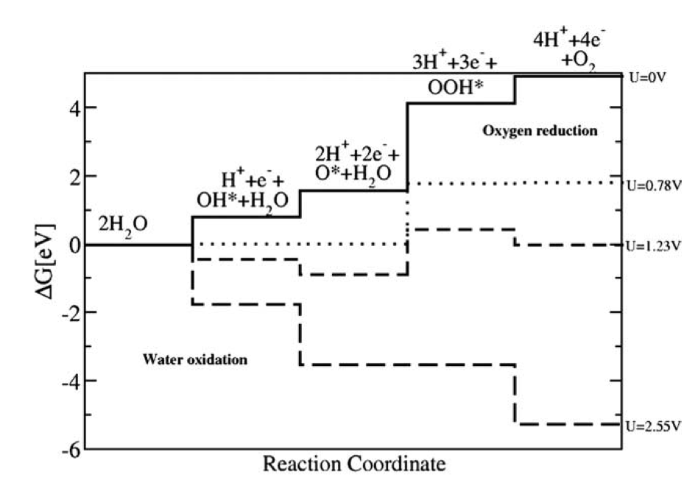
Figure 11 Free energy diagrams for the OER over Pt(111) at 4 electrode potential computed using the CHE. When the electrode potential reaches 2.55 V all steps become downhill in free energy and the reaction is assumed to proceed. Reproduced with permission from Ref. ⁸⁷. Copyright 2005 Elsevier.

In generating Figure 11, the authors of Ref. ⁸⁷ found coverage effects are critical for the thermodynamics. They showed that *OOH on Pt(111) could dissociate into *O and *OH, as the latter species are lower in total energy. The authors then explored stabilizing the hydroperoxo by increasing the absorbed oxygen coverage to 2/3 ML, which was found to stabilize *OOH; they did the same with Au(111) and found 1/3 ML *O stabilizes *OOH on the Au(111) surface. Such considerations are crucial to accurately describe the surface of the electrode during operation. In fact, inspection of Figure 11 suggests it is reasonable to assume *O will be present on Pt(111) above 1.23 V, since it can be formed without any thermodynamic barrier under such conditions. When the Pt(111) surface is covered in 2/3 ML *O the authors found the PDS was reduced from 2.55 V to 1.90 V. That is, η_{CHE} dropped from 1.32 V to 0.67 mV. However, the PDS changes from third to the first step when the *O coverage reaches 2/3 ML, which makes it unclear if 2/3 ML *O would be maintained at 1.90 V. These findings demonstrate the importance of identifying the correct surface phase on which the OER occurs.

The authors of Ref. ⁸⁷ extended their analysis to show that there are linear relationships between the adsorption energies of the intermediates and both the type of metal and the oxygen coverage on that metal. Such relationships are commonly observed on transition metal surfaces^{156, 181-184}, where they arise due to bond order conservation of the adsorbed species. That is, the adsorption energy of a species AH_{x} can be written as:
 | $$E_{ads}\left({AH}_{x}\right)=\frac{x_{max}-x}{x_{max}}*E_{ads}\left(A\right)+ξ$$ | Equation 47
where the offset (ξ) depends on the local geometry of the adsorption site¹⁸⁵ and the slope is determined solely by bond order conservation, with x_{max} being the maximum number of bonds species A can accommodate. Such relationships offer a powerful means of studying catalytic behavior, and they even impose constraints on the catalytic performance^{183, 184}. Demonstrating that linear scaling relationships hold for metal surfaces during the OER was then a major breakthrough.
In Ref. ⁸⁷, the authors showed the adsorption energy of *OH, E_{*OH}, could be expressed as:
 | E_{*OH} = 0.50E_{*O} + 0.05 | Equation 48
and that of *OOH could be written as:
 | E_{*OOH} = 0.53E_{*O} + 3.18 | Equation 49
where E_{*O} is the adsorption energy of oxygen. Analogous expression can be written for the free energies as:
 | ΔG_{*OH} = 0.50ΔG_{*O} + 0.04 | Equation 50
and
 | ΔG_{*OOH} = 0.53ΔG_{*O} + 3.33 | Equation 51
As noted above, the slope of 0.5 in Equation 48-51 is thought to emerge because of bond order conservation of the adsorbed species^{47, 181, 182}. That is, *O is bound to the surface through a double O=M bond and both the *OH and *OOH are bound by a single O-M bond. These scaling relationships allow the thermodynamic contribution to the activation free energy to be expressed as a function of the oxygen adsorption energy computed from DFT and tabulated thermochemical data, see Figure 12. This linear scaling relationship analysis predicts that metals fall into two classes for the OER:

- metals that bind oxygen weakly and
- metals that bind oxygen strongly.

While such a distinction may appear trivial, it has powerful implications:

- On metals that bind oxygen too weakly, *OH formation (i.e. the first step in Figure 11) is the PDS and determines η_{CHE}.
- On metals that bind oxygen too strongly, *OOH formation (i.e. the third step in Figure 11) becomes the PDS and determines η_{CHE}.

Moreover, the scaling relationships among the adsorption energies of the adsorbates lead to the fact that the free energy cost of the first and second step depend on the adsorption energy of oxygen with a slope of -0.5, while the second step has a slope of 0.5. This constrains the sum of the free energy cost of the first and third step to a constant, which imposes an overpotential floor for η_{CHE} on metals. Since the free energy cost of the first and third step intersect at around 1.8 eV (see Figure 12a), while the free energy difference for each PCET step in the ideal catalyst is 1.23 eV, the minimum overpotential possible when the observed scaling relationships hold is then min(η_{CHE} ) ~ (1.8-1.23 eV)/e = 0.57 V.
Thus, the predicted overpotential is determined by the adsorption energy of *O and is constrained to a minimum value of ~0.57 V. This gives rise to a volcano plot when the OER activity (defined as the negative of η_{CHE} or, which Ref. ⁸⁷ refers to as -ΔG_{activation} though this should not be confused with an activation free energy) is plotted against the computed oxygen adsorption energy, Figure 12a. The OER activity of different metals is then predicted to be constrained to fall on the blue volcano curve shown in Figure 12a. Figure 12b shows a similar plot, extracted from Ref.⁸⁸, apparently based on the very same data used in Figure 12a. Notice, however, that in this case the free energy cost of the first and second step appear in the opposite order with respect to panel a. Therefore, according to Ref⁸⁸, when oxygen is bound weakly, the second, rather than the first, step is the PDS. Apart from this discrepancy, while one may consider that these scaling relationships were identified on (111) surfaces and are expected to differ for different surface terminations, a change in local adsorption site will only impact the offset (ξ) in the scaling relationships, Equation 44. Such changes are expected to impact all species in an identical manner¹⁸¹, which would not alter the predictions in Figure 12. And while catalysts are now known to show facet dependent OER activity¹⁸⁶, the picture presented in Figure 12 has had far reaching impacts on our understanding of the OER.
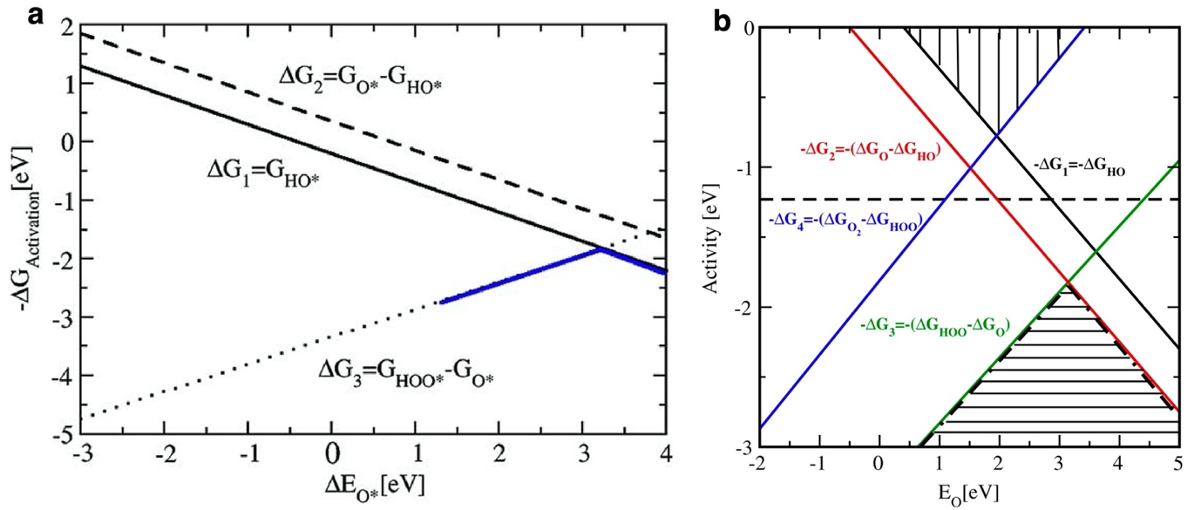
Figure 12 Thermodynamic contribution to the free energy barriers for the OER on metals computed from the linear scaling relationships, E_{*OH}(E_{*O}) and E_{*OOH}(E_{*O}). Panel (a) is reproduced with permission from Ref. ⁸⁷ Copyright 2005 Elsevier. Panel (b) is reproduced with permission from Ref.⁸⁸ Copyright 2007 Elsevier.

Applying the CHE to the OER on metal surfaces in Ref. ⁸⁷ led to several significant findings and set the way the CHE model would be used in future studies that continue to this day:
- It showed how DFT adsorption energies could be used to compute the thermodynamic contribution to reaction barriers for the OER in acidic or alkaline conditions.
- The authors popularized Kobussen’s path, or the nucleophilic attack mechanism, wherein the O-O bond is formed through the reaction of aqueous hydroxide or water with adsorbed oxygen rather than direct coupling of adsorbed oxygen/hydroxide.
- The effect of electric fields on the computed adsorption energies were argued to be small and thus can be neglected, which remains true for most studies.
- Explicit solvent stabilization effects were shown to be large for polar adsorbates on metal surfaces.
- Oxygen coverage was shown to have a significant impact on reaction energetics, making the correct choice of active surface phase critical, though this is often overlooked.
- The PDS can be determined as the potential required to make all steps downhill in free energy.
- The magnitude of the PDS can be predicted using a set of simple linear energy scaling relationships, which place limits on catalytic performance.
- The optimal metal has an OER overpotential of ~0.5-0.6 V.

Although this theoretical treatment by Rossmeisl et al. ⁸⁷ was very influential, and deservedly so, we should approach the above discussion as a thought exercise and as a guide to what is yet to come, rather than taking the results literally. We point out now a number of issues that will be of importance to our later considerations, but this should not be understood as harsh criticism of a milestone publication, rather a look at the work in hindsight.

As we mentioned above, the authors explored the stabilizing effect of adsorbed *O. The predicted binding energy range of *O on the Pt(111) surface was approximately +1.6 and +3.6 eV depending on the coverage of pre-adsorbed *O: 5/6 ML pre-adsorbed O coverage in the 3×2 surface unit cell employed by the authors weakened *O adsorption by 2 eV as compared to the clean surface. Experimental estimates of Gland et al.¹⁸⁷ suggest a heat of desorption of atomic oxygen changing between 5.2 eV and 2.1 eV in a similar coverage range. Thus, while the prediction is not exceptionally accurate, it is reasonably close to experiment. Based on the linear scaling relation, a change of 2 eV in the *O binding can give rise to approximately 1 V change in the thermodynamic overpotential, when not crossing the top of the volcano. But to put this in context, in experiments, the difference between a great and very bad OER catalyst is as perhaps 0.5 V, hence such calculations appear to be of limited value.

Now, let us consider in detail what happened during *O stabilization. It was reasonable to assume the presence of *O on the Pt(111) since it can be formed without a thermodynamic contribution to the free energy barrier at 1.23 V, see Figure 11. At 2/3 ML *O, the authors of Ref. ⁸⁷ found a reduction of the potential required to make all steps downhill, from 2.55 V to 1.90 V. But at this level of *O coverage not only has the magnitude of the thermodynamic overpotential changed but also the potential limiting step, changing from step 3 (*OOH formation) to step 1 (*OH formation). Notice, this raises the problem that now the surface is water covered as all steps after step 1 are downhill, and within this simplistic model, there should not be a buildup of any significant coverage of intermediate species on the surface. That is, the argument becomes circular, and we cannot a priori assume any *O coverage. In another words, *O coverage will drive the reaction towards the extinction of *O but the empty surface is also not stable and wants to build up *O again. And the cycle continues. Clearly, the root of the problem is that the coverages predicted by a model and the coverages used to compute the energetics of the model must be self-consistent. This will be further elaborated upon in the context of microkinetic models in Section 7.

Along the same line of adsorbate build up, the authors themselves point out that it is possible that the bulk of the metals also start oxidizing under potentials relevant for the OER. This additional pathway, with changing bulk and surface structure of the investigated metals, was not included in the model presented in Ref. ⁸⁷. As pointed out by Gileadi¹⁸⁸ in a thought-provoking review of some selected “problems in interfacial electrochemistry that have been swept under the carpet”, the oxygen evolution reaction has never been experimentally studied or observed on bare metals. By the time the potential is positive enough to afford the OER, any metal surface will always be covered with an oxide layer. Most of the time, even the bulk of the metals will be transformed into an oxide or oxyhydroxide phase. Transition metals, without a filled d band are typically oxidized on their surface already under standard conditions. Under OER conditions these metals form bulk oxide and oxyhydroxide phases. Even noble metals, like Pt¹⁸⁹⁻¹⁹¹ or Au^{192, 193} form oxides once they split water and produce O₂. One can intuitively understand that if modifying the oxygen coverage on Pt between zero and 5/6 ML gives rise to 2 eV shift in E_{*O}, the transformation of a metal to an oxide can induce the same or an even larger effect. As this phase transition undoubtedly makes a huge impact on the local geometric and electronic structure of the surface, estimating the outcome of an electrocatalytic process on an oxide by using (oxygen covered) metals is not a proper strategy. We can illustrate this with some numbers. Calle-Vallejo et al.¹⁹⁴ calculated the change of the binding strengths of OER intermediate as the metals form various formal oxidation state oxides or perovskites. By way of an example, on nickel, E_{*O} changed almost 2 eV to 3 eV when instead of the metal, its monoxide, or a III+ oxidation state perovskite, was considered, respectively. As we will see later, NiOOH is the active OER form of nickel, so we can expect a close to 3 eV weakening of *O binding with respect to metallic Ni; but also, the actual surface structure will play a role¹⁹⁵. With this, we say goodbye to metals for now and move to oxides. In the next section 3.2.2 we will explore how oxides can be implemented in the CHE model and whether or not doing so solves some of the problems we faced up to now.

CHE model of the OER on rutile-type oxides

While the first application of the CHE model to metal surfaces ⁸⁷ made significant contributions that still shape both our knowledge of the OER and means of modeling it, the application of the CHE to the OER on rutile-type oxides had arguably an even larger impact⁸⁸. In Ref. ⁸⁸ the authors studied the energetics of the OER over a series of rutile-type oxides by applying the same CHE approach and assumptions as were used in Ref. ⁸⁸ To do so the authors began by computing the (pH, U) surface phase diagram of RuO₂(110) by considering that the CUS, or μ₁-O(H) site, and bridge sites could be populated with O or OH, much like was shown for the (p,T) surface phase diagram shown in Figure 9. In the electrochemical reaction, however, the potential oxidizes the surface by stabilizing the electron liberated upon oxidation; that is stabilizing $\left(μ_{H+}+μ_{e-}\right)$ in the CHE model. The authors of Ref. ⁸⁸ found the RuO₂ (110) surface is oxidized above 1.4 V when the DFT simulations were performed in vacuum. By checking the effect of explicit solvation with five water molecules, the authors argued solvation effects can be ignored on oxides because they found energy changes of less than 0.05 eV, an observation the community took to be generally true across all oxides. The authors then assumed the OER takes place via the nucleophilic attack mechanism and modeled it under acidic conditions using Equation 38-41, where only the CUS, or μ₁-O(H), site participates directly in the reaction, see Figure 13. This results in *OOH formation being the PDS, which requires a potential of 1.60 V, giving η_{CHE} = 0.37 V, a modest discrepancy with the 0.1-0.2 V seen in experiment^{196, 197} ¹³⁹ that has been the subject of discussion^{198, 199}. The agreement between theory and experiment becomes worse if the *OH covered surface is employed rather than an *O covered surface. In the case of the protonated surface η_{CHE}=0.5 V, which again demonstrates the importance of identifying the correct surface phase.
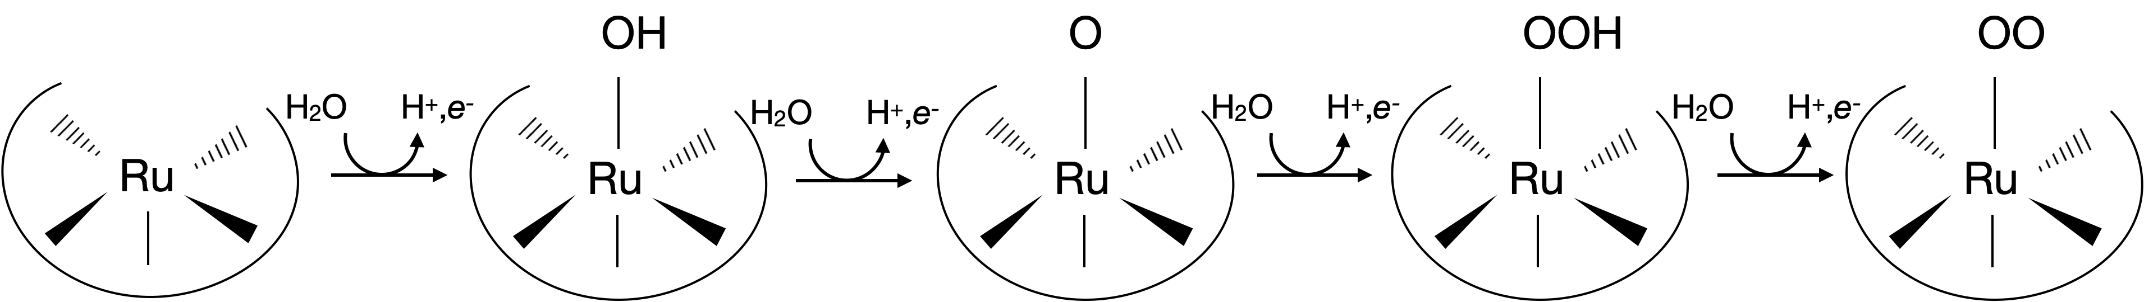
Figure 13 Schematic for the nucleophilic attack OER mechanism taking place on the CUS site of RuO₂(110). The reaction steps correspond to those in Equation 38-41. O atoms are red, Ru are blue, and H are cyan.

The preceding analysis was extended to rutile-type IrO₂ and TiO₂. *OOH formation was found to be the PDS on IrO₂. *O formation was found to be the PDS on TiO₂. The values ofη_{CHE} over IrO₂ and TiO₂ were given as 0.56 V and 1.18 V, respectively ⁸⁸. Like for RuO₂ (110), the computed value of η_{CHE} over IrO₂ (110) is also more than 200 mV higher than experiment¹²⁶. However, unlike the case of RuO₂ (110), where overpotentials significantly higher than experiment have been reported from CHE calculations ^{198, 199}, computational predictions for IrO₂ (110) are argued to be in line with experiment ^{199,198}.

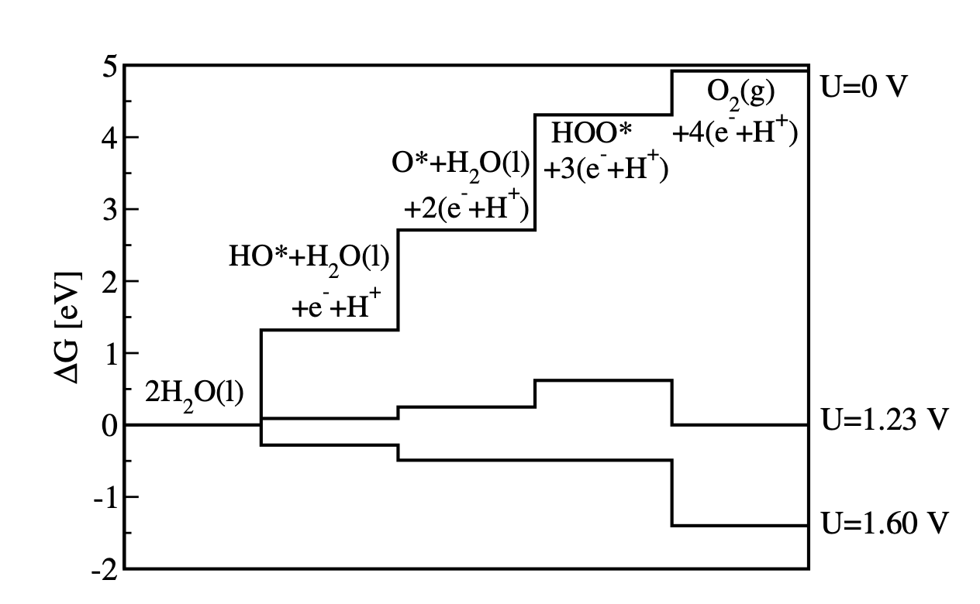
Figure 14 Free energy diagram for the intermediates in the OER along the single-site nucleophilic attack reaction coordinate on the fully oxidized RuO₂(110) surface computed using the CHE. The figure is reproduced with permission from Ref. ⁸⁸. Copyright 2007 Elsevier.
As with metallic surfaces, linear energy scaling relationships were also found on the rutile-type oxides⁸⁸. These can be summarized in terms of the oxygen adsorption energy as follows:
 | $$2 H_{2}O→{HO}^{*}+H_{2}O+e^{-}+H^{+}$$ | Equation 52
 | $$∆G_{1}=∆G_{OH}-∆G_{H2O}$$ | Equation 53
 | $$=∆E_{OH}+0.35 eV-eU$$ | Equation 54
 | $$=0.61∆E_{O}-0.55 eV-eU$$ | Equation 55
 | $${HO}^{*}+H_{2}O+e^{-}+H^{+}→O^{*}+H_{2}O+{2e}^{-}+{2H}^{+}$$ | Equation 56
 | $$∆G_{2}=∆G_{O}-∆G_{HO}$$ | Equation 57
 | $$=∆E_{O}+0.05 eV-∆E_{OH}-0.35 eV-eU$$ | Equation 58
 | $$=0.39∆E_{O}-0.60 eV-eU$$ | Equation 59

 | $O^{*}+H_{2}O+{2e}^{-}+{2H}^{+}→{HOO}^{*}+{3e}^{-}+{3H}^{+}$ | Equation 60
 | $$∆G_{3}=∆G_{HOO}-∆G_{O}$$ | Equation 61
 | $$=∆E_{HOO}+0.40 eV-∆E_{O}-0.05 eV-eU$$ | Equation 62
 | $$=-0.36∆E_{O}+2.38 eV-eU$$ | Equation 63

 | ${HOO}^{*}+{3e}^{-}+{3H}^{+}→O_{2}+{4e}^{-}+{4H}^{+}$ | Equation 64
 | $$∆G_{4}=∆G_{O2}-∆G_{HOO}$$ | Equation 65
 | $$=4.92 eV-∆E_{HOO}-0.40 eV-eU$$ | Equation 66
 | $$=-0.64∆E_{O}+2.49 eV-eU$$ | Equation 67

When these relationships hold, they both constrain the OER activity and offer a straightforward way to predict the activity for a series of catalysts. Again, we refer only to the thermodynamic contribution to the activity defined as η_{CHE} or, equivalently, -ΔG_{activation}. Such a plot showing the activity as a function of oxygen adsorption energy is shown in Figure 15.

Inspection of Figure 15 reveals a situation similar to that seen for the metals in Figure 12. A volcano curve emerges wherein catalysts that bind oxygen too strongly form *OOH in the PDS and those that bind oxygen too weakly form *O in the PDS. Note, however, that metals that bind oxygen too weakly form *OH in the PDS rather than *O like on the oxides. RuO₂(110) can be seen to sit near the top of the volcano, suggesting that among catalysts that follow the scaling relationships, RuO₂ is nearly optimal. It is worth noting that this result for RuO₂ is at odds with others, where RuO₂ is found to have a significant overpotential ^{199,198}. Furthermore, in Figure 15 RuO₂ sits on the weak binding energy side of the volcano, whereas from Figure 14 the third step is the PDS over RuO₂, which would suggest strong oxygen binding. Ignoring these discrepancies for the time being, the ideal catalyst would have an activity of -$1.23$ V, or equivalently η_{CHE}=0, which is far above the top of the volcano. Thus, like the metallic surfaces shown in Figure 12, the CHE predicts that if the OER occurs via a single-site nucleophilic attack mechanism, linear scaling relationships limit the achievable OER activity on rutile-type oxides. As with the metal surfaces, in the case of rutile-type oxides the overpotential floor is again fixed by the energy difference between *OH and *OOH. For the rutile-type oxides, however, ΔG_{*OOH} - ΔG_{*OH} = 3.09 eV, which gives min(η_{CHE} )= (3.09-2.46 eV)/2e = 315 mV. Thus, a 200-300 mV lower overpotential is predicted to be achievable on the rutile-type oxides than on the metals. While it should be cautioned that such a single descriptor approach may be insufficient²⁰⁰, these ideas have helped form the foundation of our mechanistic understanding of the OER, and the CHE has become the most widely used computational model for studying the OER.

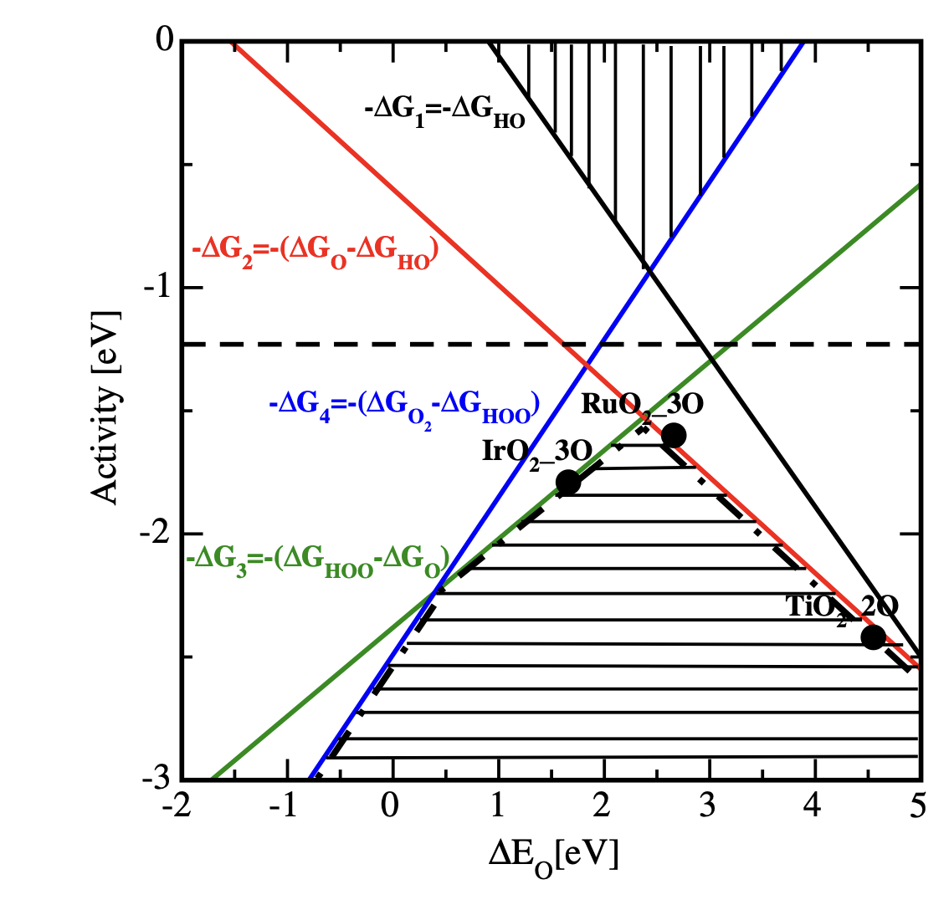
Figure 15 OER activity, defined as $-∆G$, as a function oxygen adsorption energy found using the linear free energy relationships, see Equation 48-51, for rutile-type oxides. Materials that obey the scaling relationships will fall on the volcano curve (dash-dot line), while the ideal catalyst would fall on the horizontal dashed line at -1.23 eV. Reproduced with permission from Ref.⁸⁸ Copyright 2007 Elsevier.

Scaling relationships

The development of the CHE model and its application to OER catalysis made DFT a viable and powerful tool to study the OER. This sparked a new area of computational investigations, with researchers quickly studying oxidation and photooxidation of water on TiO₂^{201, 202} and WO₃ ²⁰³, as well as making comparisons between biological and electrochemical water splitting²⁰⁴⁻²⁰⁶. These new results also began inspiring experiments and shaping their interpretations²⁰⁷⁻²⁰⁹ where, for instance, Differential Electrochemical Mass Spectrometry (DEMS) was used to support the plausibility of the nucleophilic attack mechanism over Ru-based oxides²¹⁰. The identification of linear scaling relationships, and the different limiting theoretical overpotentials on rutile-type oxides and metals, inspired deeper study into the universality of these scaling relationships in the OER, as well as the chemistry underlying these relationships ^{211,212-214}. Such studies revealed that linear adsorption energy relationships similar to those found for rutile-type oxides⁸⁸ also hold for perovskite-type and PtO₂-type oxides²¹¹, suggesting a universal scaling relationship may hold for the OER over wide classes of oxide.

A major breakthrough in the range of applicability of scaling relationships in the OER came through the detailed study of the origin of the OER overpotential over a wide variety of transition metal oxides¹⁰¹ using the CHE. The authors followed the same thermodynamic model and assumptions as were employed in Refs. ^{87, 88}, and while the computational approach was very similar to Refs. ^{87, 88}, the electronic structure calculations were modified to include spin-polarization for the magnetic oxides studied in Ref. ¹⁰¹. The authors of Ref. ¹⁰¹ computed the energetics of the OER via the single-site nucleophilic attack mechanism in acid, Equation 38-41, over a range of oxides. The PDS was then defined as the step with the maximum change in free energy. This is the same definition as used previously, and, as before, the magnitude of the overpotential is then given by:
$$η=\frac{1}{e}max{\left[∆G_{*OH}-∆G_{H2O*}, ∆G_{*O}-∆G_{*OH},∆G_{*OOH}-∆G_{*O},∆G_{O2}-∆G_{*OOH}\right]}_{U=0}-1.23 V$$ | Equation 68

While the analysis was performed at standard conditions, T=298.15 K and pH=0, the computed theoretical overpotential is independent of pH because the $∆G_{i}$ in Equation 68 vary as k_{B}T ln(10) pH with changes in pH since each reaction is a PCET, see Equation 32. From Equation 68 it can be seen that in the ideal catalyst, the free energy change for each step is 1.23 V, which yields ${}_{CHE} =0$, but in Refs. ^{87, 88}, it was shown that a linear relationship between the adsorption energies of *O and *OH and *O and *OOH tends to prevent rutile-type oxides from reaching this maximum, at least for RuO₂, IrO₂, and TiO₂. In Ref. ¹⁰¹ these scaling relationships were simplified and extended by exploring more than 30 different surfaces including, perovskites, rutile-type oxides, Mn_{x}O_{y}, anatase, Co₃O₄, and NiO. To make the problem more tractable the scaling relationships were simplified by exploiting the fact that the adsorption energy difference between *OH and *OOH can be written as ΔE_{*OOH}=ΔE_{*OH} + 3.20 eV⁴⁷, where the mean absolute error is 0.17 eV. The slope of 1 is expected since both the *OOH and *OH are bound to the surface by a single M-O bond^{47, 181, 182}, unlike the slope of 0.5 observed for the ΔE_{*OH}(ΔE_{*O}) and ΔE_{*OOH}(ΔE_{*O}) scaling relationships that emerges ostensibly because *O is bound to the surface by an M=O double bond or alternatively because *O requires 2 electrons and both *OH and *OOH require only one electron to complete their octet¹⁸².

Because the optimal catalyst has ΔE_{*OOH}=ΔE_{*OH} + 2.46 eV—recall the free energy of reaction for each PCET step at U=0 V should by 1.23 eV and two steps separate *OH and *OOH—the observed ΔE_{*OOH}=ΔE_{*OH} + 3.20 eV scaling relationship limits the (average) minimum theoretical overpotential to min(η_{CHE} )= (3.40 eV -2.46 eV)/ 2e = 0.37 V. Of course, this is true only so far as the assumptions in the model and the scaling relationships remain valid. With a mean absolute error of 0.17 eV, the assumptions underlying the scaling relationship appears to be hold empirically. In fact, the mean absolute error is in line with the intrinsic (i.e. exchange and correlation functional-related) error in DFT used to compute the adsorption energies.^{215, 216} We need to keep in mind that such an uncertainty in a barrier leads a ~3 order of magnitude uncertainty in a rate, hence improving the overpotential of an electrocatalyst by 0.17 V would be a great achievement. Quantitative predictions with this kind of uncertainty (originating from both the linear scaling approximation and from DFT errors) are therefore problematic; thus, this type of analysis is more suited to identifying trends.

From the preceding analysis, the authors of Ref. ¹⁰¹ noted that either step 2 or 3 is the PDS and the overpotential can then be written as:
$$η_{CHE}=\frac{1}{e}max{\left[\left( ∆G_{*O}-∆G_{*OH}\right),3.2 eV-\left(∆G_{*O}-∆G_{*OH}\right)\right]}_{U=0}-1.23 V$$ | Equation 69
Where the linear scaling relationships allow the overpotential to be written using the single descriptor, ${\left[ \left(∆G_{O*}-∆G_{HO*}\right)\right]}_{U=0}$. This simplification facilitates an efficient computational approach to material screening and also reveals compensation effects that tend to limit catalytic efficiency by enforcing the observed scaling relationships. Calculation of the overpotentials shows several materials perform ideally under the constraint of the scaling relationships. These points appear near the top of the volcano curve that results from the scaling relationships in Figure 16. Moreover, comparison of the computed η_{CHE} and the experimental overpotentials shows generally good agreement, which was interpreted as supporting the scaling-relationships and the limiting nature of the free energy difference between *O and *OH, $\left( ∆G_{O*}-∆G_{HO*}\right)$¹⁰¹. Because the slopes of the linear energy scaling relationships are fixed by the valence of the atom bound to the surface, and hence the bond order to the surface, only the binding site, which influences the offset in the scaling relationship offers the opportunity to improve the catalyst^{47, 181, 182, 185}. However, the diverse binding sites in Ref. ¹⁰¹ suggest there may be limited flexibility in altering the scaling relationships on perfect crystals because such changes in binding sites appear to impact all species in an identical manner¹⁸¹.
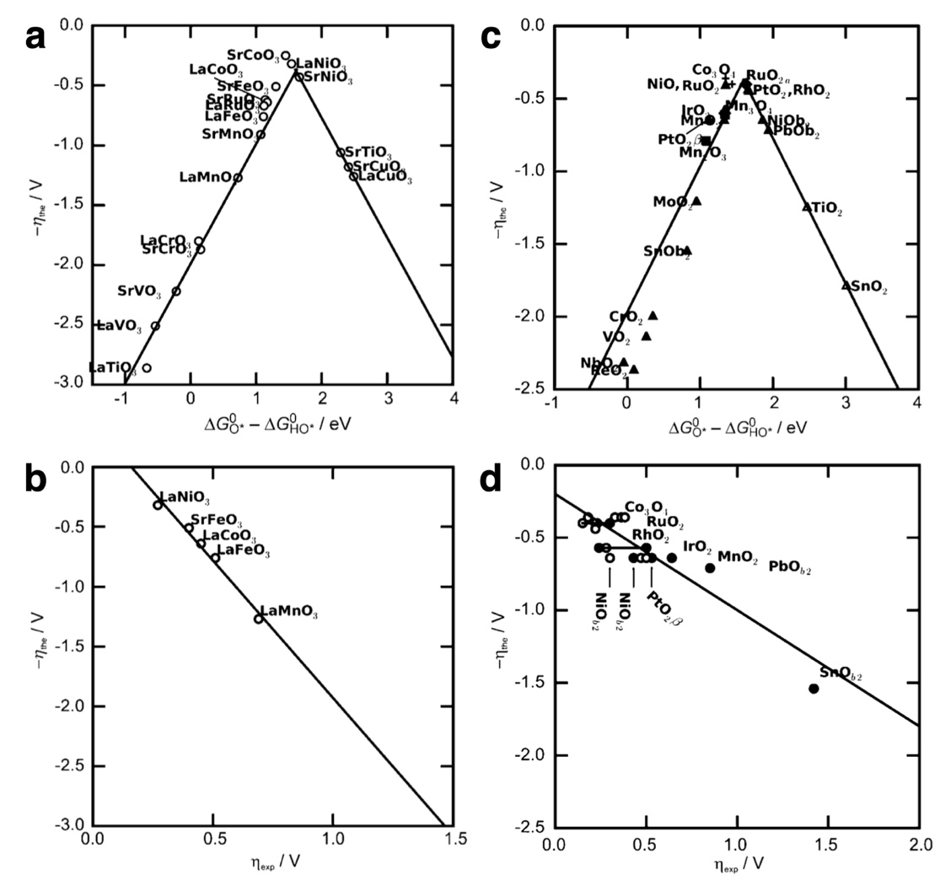
Figure 16 Predicted activity trends defined as -η_{CHE} plotted against $\left(∆G_{O*}-∆G_{HO*}\right)$ (a, c) and comparison of predicted and measured overpotentials (b, d) for perovskites (a, b) and rutile-type oxides (△), Mn_{x}O_{y}(□), anatase(⬦), Co₃O₄ (+), and NiO (c, d). The experimental perovskite data was obtained at 10 mA cm⁻² at room temperature and pH=14 ^{139, 217}. The experimental data for the other oxides was obtained at 10 mA cm⁻² and room temperature¹³⁹. Figure reproduced with permission from Ref. ¹⁰¹ Copyright 2011 John Wiley and Sons.
It should be noted that the above conclusions come from severe assumptions, including, for instance, constrained thermodynamic equilibrium, fully oxidized surface terminations, and, owing to the results from Ref. ⁸⁸, the assumption that double layer effects can be neglected. But perhaps more critical, the coefficients in the BEP relationships implicitly underlying the identification of a kinetic parameter (η_{CHE}) from thermodynamic data are known to be dependent on an oxide’s crystal structure and adsorption site²¹⁸, which opens the possibility that differences in oxide structure may lead to different BEP relationships and different values of η_{CHE}. Closer inspection of the comparison between theory and experiment in Figure 16, in fact, reveals rather poor agreement for all systems except the perovskites, with the SnO₂ point having excessive influence on the oxide fits. If, for instance, the SnO₂ datapoint is ignored, the correlation changes from η_{CHE} ~ -0.8η - 0.2 eV with R²~0.8 to η_{CHE} ~ -0.5η - 0.3 eV with R²~0.5. The origin of this disagreement is unclear. It may lie in part with the use of experimental data from varying sources, a breakdown in the basic assumptions underlying the CHE¹⁰⁷⁻¹⁰⁹ and the computation of η_{CHE} ²¹⁸, a deficiency in the use of a single descriptor²⁰⁰, or even an incorrect mechanism. Regardless, the observed level of agreement between theory and experiment demonstrates that care is required when trying to relate the thermodynamic calculation of η_{CHE} to a measured kinetic parameter like the overpotential.

Impact of computational methodology

While these early studies did not focus heavily on the method of electronic structure calculation, further efforts showed the scaling relationships are not heavily influenced by the methods of calculation but the η_{CHE} predicted for a particular material can be. For instance, in Ref. ¹⁰¹ spin polarization was only included for magnetic oxides, which cannot capture μ₁-O oxyl species correctly even on paramagnetic materials^{219, 220}; calculations using spin polarization showed that while adsorption energies are influenced, the scaling relationships are not altered²²¹. This behavior is summarized in Figure 17, where panel a shows the computed scaling relationships from spin-polarized DFT, panel b shows the volcano plot with both spin-polarized and spin-restricted data plotted as a function of ΔG_{*O}-ΔG_{*OH}, and panel c shows the difference in η_{CHE} computed without and with spin-polarization plotted as a function of ΔG_{*O}-ΔG_{*OH}.
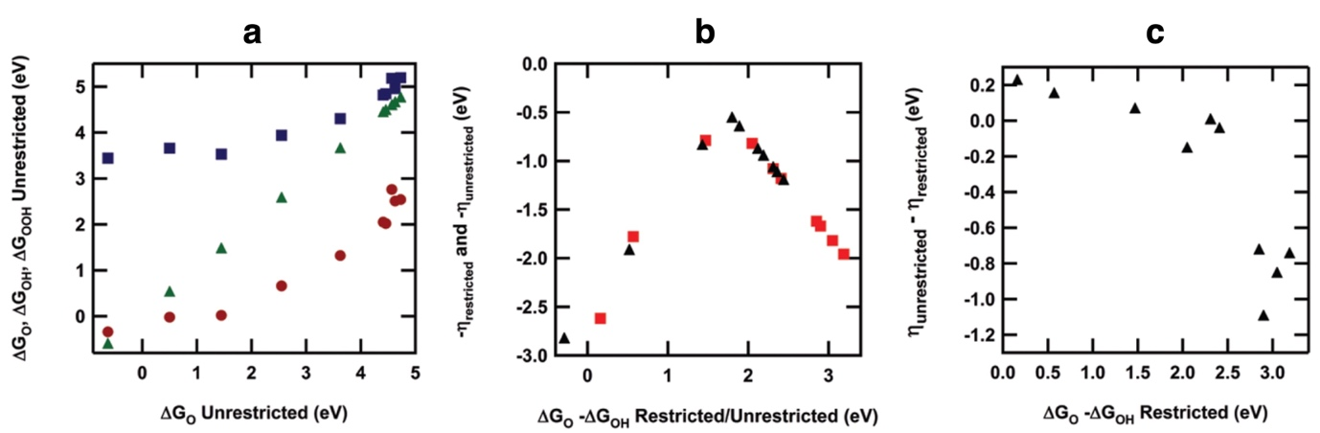
Figure 17 Free energy scaling relationships including spin-polarization with *O shown as triangles, *OH shown as circles, and *OOH shown as squares (a). Volcano plot, or activity trends defined as -η_{CHE} plotted against $\left(∆G_{O*}-∆G_{HO*}\right)$ for both spin-polarized (triangles) and non-polarized (squares) simulations (b). Difference in η_{CHE} between spin-unrestricted and spin-restricted simulations plotted as a function of $\left(∆G_{O*}-∆G_{HO*}\right).$ Reprinted with permission from Ref. ²²¹. Copyright 2014 American Chemical Society.
The observation that the scaling relationships are not changed by the inclusion of spin-polarization is perhaps surprising considering that these scaling relationships are argued to originate through bond order conservation. Recall that the slope of 0.5 in Equation 48-51 emerges because *OH (or *OOH) is bound to the surface through a single M-O bond while *O is bound by an M=O double bond, yielding E_{*OH} = 0.50E_{*O} + 0.05 and E_{*OOH} = 0.53E_{*O} + 3.18. However, terminal μ₁-O species tend to have a high degree of oxyl character ^{219, 220, 222-225}. In such cases oxygen is oxidized to O^{I-} to form M^{n+}-O^{I-} rather than M^{(n+1)+}=O^{II-}, and the oxyl is bound to the surface via single M-O bond ^{226, 227}. Moreover, in Ref. ²²¹ the authors show the degree of radical character—oxyl, hydroxyl, (hydro)peroxyl—varies with a species adsorption energy, where more strongly bound adsorbates show increased spin quenching. Thus, *O strongly bound to the surface has little oxyl character. In this case the scaling relationship holds and there are little differences between spin restricted and spin unrestricted simulations. Conversely when *O is weakly bound, η_{CHE} varies by over 1 V between spin restricted and spin unrestricted simulations but the volcano shape is fixed by definition²²¹.

Similar to spin polarization, the choice of exchange and correlation potential was shown to impact computed theoretical overpotentials but not break the scaling relationships; specifically the inclusion of a Hubbard U to capture onsite dd electron repulsion causes 0.2-0.4 V changes to η_{CHE}^{228, 229}; note that this Hubbard U should not be confused with an applied electrochemical bias. These findings underscore the necessity to capture correlations beyond the GGA level when modeling 3d oxides^{230, 231}, where hybrid functionals are expected to yield improved results over the inclusion of a Hubbard U^{223, 232-234}. The largest functional dependence in the CHE, however, emerges in the incorrect description of the OO bond, which motivated efforts to produce a functional independent scaling relationship that differs from the previous relationship by 0.1 eV²³⁵. That is, the so-called functional independent scaling relationship is given by ΔG_{*OOH} =ΔG_{*OH}+3.3 eV rather than ΔG_{*OOH} =ΔG_{*OH}+3.2 eV, though it should be noted this relationship is not truly functional independent.

Further evidence for scaling relationships and attempts to break them

The identification of universal scaling relationships mediating η_{CHE} for the OER on oxides established an entire body of literature aimed at identifying strategies to circumvent the observed scaling relationships^{209, 236-252}; for a detailed review see Ref. ²⁵⁰. An early effort sought to investigate how substitutional doping of Ti in a rutile-type TiO₂ (110) surface with various transition metals (M=V, Nb, Ta, Cr, Mo, W, Mn, Fe, Ru, Ir, Ni) would impact the theoretical OER overpotential²³⁶. The authors computed η_{CHE} by calculating the *O, *OH, and *OOH adsorption energies when the dopants were placed in various near surface positions and following the procedure discussed above. They found *OOH/*OH scaling relationships that limit the minimum achievable η_{CHE} remained almost unchanged by doping, see Figure 18, where the red star in Figure 18e indicates the adsorption energies of an ideal catalyst and the dashed line the ideal *OOH/*OH scaling. Thus, as with changing the atomic structure of a defect-free oxide, see Figure 16, doping rutile-type TiO₂ apparently does not break the *OOH/*OH scaling relationship that limits the minimum achievable η_{CHE}. However, the authors did find that doping could significantly reduce η_{CHE} on TiO₂ (110) while adhering to the scaling relationships, see Figure 18f. For each dopant, the reduction in η_{CHE} varied with the substitutional site. Interestingly, for some dopants the largest reduction did not occur for doping at the CUS site assumed to be active. Cr and Mo, in particular, show the largest reduction in η_{CHE} when substituting a surface bridge site Ti (Figure 18b) or the Ti below the bridge site (Figure 18d), respectively, with the subsurface Mo doping (Figure 18d) showing the largest reduction in η_{CHE} of all the investigated structures, see Figure 18f. This result suggests modifying the electronic structure at the active site through ligand effects can have a pronounced influence on the computed η_{CHE}. Following this report, this type of behavior has been predicted for a range of OER catalysts, including RuO₂ ²⁵³ and Ir-based materials²⁵⁴, as well as single atom catalysts²⁵⁵, Co/Fe oxyhydroxides²⁵⁶, and such effects have even aided in the design of W doped oxyhydroxide and the development of FeCoW oxyhydroxide OER catalysts²⁵⁷.

Different effects of ligand atoms have also been found. Rather than alter the energetics of an active site, ligand atoms may also participate directly in the OER. In these cases, the linear scaling relationships established up to this point fail. Take for example Ref. ²⁴⁰, where the OER performance of Co and Ni doped RuO₂ were studied within the CHE model. Doping rutile-type RuO₂ with 3d transition metals is known to result in single phase rutile-type materials for dopant concentrations below 30%^{258, 259}. In these materials the 3d dopants substitute for Ru(IV) as di- and tri-valent ions; the charge balance is maintained through oxygen vacancy formation^{259, 260} and a change in ruthenium oxidation state²⁶⁰. Such doped ruthenia catalysts are known to show enhanced OER performance experimentally, but the origins of the enhanced catalytic activity of the doped materials was debated²⁶¹ ^{249, 260, 262-264}. In general, the OER was thought to proceed by a mechanism involving the direct coupling of adsorbed oxygen²⁶¹, in which case the stabilization of Ru(VI) active sites by Co or Ni doping could explain the enhanced performance^{260, 261}. A very different picture emerged from studying the OER using the CHE model, wherein the ruthenium sites, including the active CUS sites, were not found to be altered by doping. Rather, doping transformed the mechanism from a single-site nucleophilic attack mechanism, Equation 38-41, to a two-site nucleophilic attack mechanism involving both a CUS Ru/μ₁-O oxyl and a bridging oxygen bound to a ruthenium and a dopant atom.
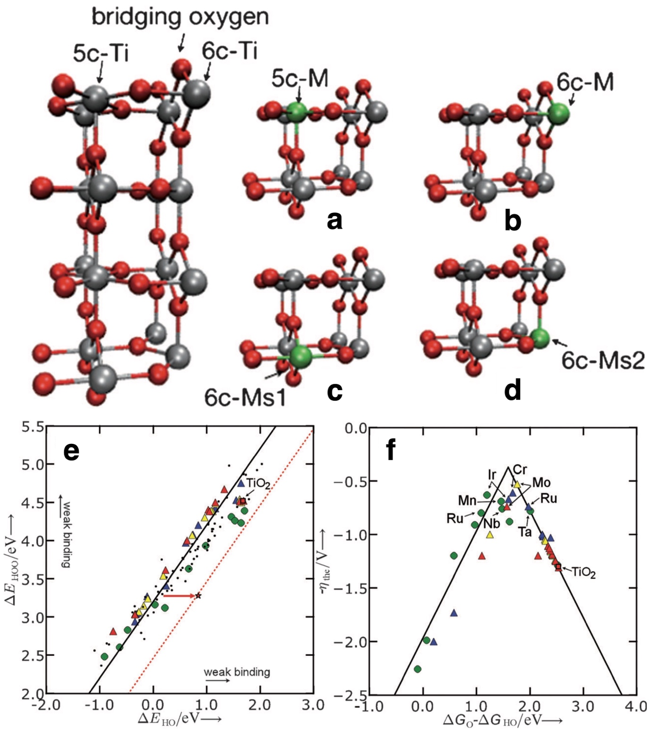
Figure 18 (a-d) Ball and stick model of dopant sites with the coloring indicated. (e) Correlation between *OOH and *OH adsorption energies. The red star shows the optimal catalyst, and the dashed line shows the optimal *OOH/*OH scaling. (f) A volcano plot showing the computed theoretical overpotential plotted as a function of $\left(∆G_{*O}-∆G_{*OH}\right)$. The solid line shows the scaling relationship result, while the green circles correspond to substitutions at CUS sites (5c-M); the blue triangles correspond to substitutions at surface bridging sites (6c-M); the red triangles correspond to substitutions below the surface CUS site (6c-Ms1); the yellow triangles correspond to substitutions at subsurface sites below the surface bridge positions (6c-Ms2). Reproduced with permission from Ref. ²³⁶ Copyright 2011 John Wiley and Sons.

In Ref. ²⁴⁰, the authors incorporated Ni and Co into RuO₂ to modify the electrocatalytic activity and compared measured performance with the computed η_{CHE}. Using the CHE model, they found that substitution of CUS Ru had no impact on the η_{CHE} computed for the single-site nucleophilic attack mechanism on a neighboring CUS Ru site. The authors did, however, find the substitution of a bridging Ru in RuO₂(110) with Co or Ni could optimize the proton donor/acceptor functionality of the doped bridge oxygen sites while leaving the CUS Ru sites unmodified. This change in functionality was predicted to lead to a substantial improvement in η_{CHE} beyond the limitations of the scaling relationships established for single-site nucleophilic attack on the (110) surface of RuO₂ ^{88, 101}, see Figure 19. In Figure 19 the single-site reaction scaling volcano is shown as a function of the free energy change associated with the formation of *O from *OH through the PCET step given in Equation 37, $\left( ∆G_{*O}-∆G_{*OH}\right)$. It can be seen that, when either Co or Ni are substituted at a (110) bridge site, the predicted η_{CHE} is significantly reduced.

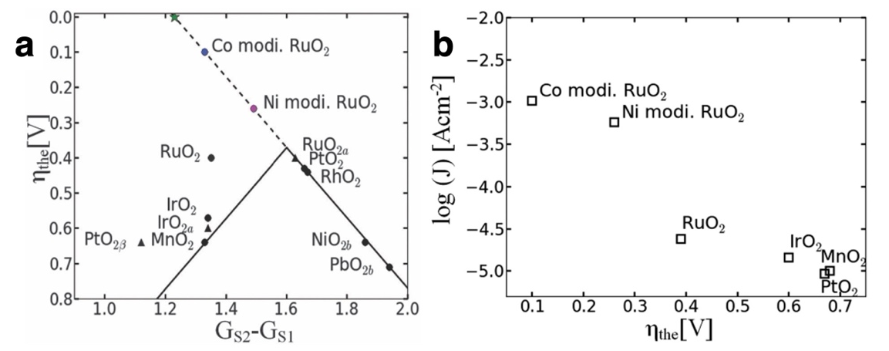
Figure 19 (a) Plot of the computed theoretical overpotential against $\left(∆G_{*O}-∆G_{*OH}\right)$ for a series of pristine oxides and rutile-type RuO₂(110) with Co or Ni substituting a surface Ru atom in the bridge position next to the active CUS site. The volcano curve shows the theoretical overpotential computed from the scaling relationships. As in Figure 15, the scaling volcano is found as $η_{CHE}=\frac{1}{e}max{\left[\left(∆G_{*O}-∆G_{*OH}\right),3.2 eV-\left(∆G_{*O}-∆G_{*OH}\right)\right]}_{U=0}-1.23 V$. By breaking the ΔG_{*OOH} =ΔG_{*OOH}+3.2 eV scaling relationship, the doped RuO₂ can be seen to follow $η_{CHE}=\frac{1}{e}max{\left[\left(∆G_{*O}-∆G_{*OH}\right)\right]}_{U=0}-1.23 V$ even at low values of $\left(∆G_{*O}-∆G_{*OH}\right).$ The dashed line shows the continuation of the $\left(∆G_{*O}-∆G_{*OH}\right)$ line to η_{CHE}=0, see Figure 15 for more details. (b) The correlation between the measured current density measured at 1.6 V (vs. RHE) and the theoretical overpotential for different oxides. For the mixed oxides a concentration of Ni or Co of 0.05 is chosen to represent the activity per site for the cation modified ruthenia. The figure reproduced from Ref. ²⁴⁰ with permission from the PCCP Owner Societies.

The reason for the significant change in η_{CHE} of RuO₂ (110) with Co or Ni doping lies in the activation of bridge sites, as the presence of Co or Ni in the bridge does not alter the oxygen adsorption energy on the Ru CUS site. Rather, by activating a bridge site, the dopants remove the problem that the free energy of the intermediates scales in the same fashion that gives rise to the scaling relationship seen in Figure 15 and Figure 16. Figure 20 shows what is meant by bridge site activation. The typical single-site nucleophilic attack mechanism is depicted for RuO₂ (110) in the top panels. Here, all PCET reactions, Equation 38-41, occur only on the CUS site, as with Figure 15 and Figure 16. When an Ru atom in a bridge position near this CUS site is substituted with Co or Ni, however, the energy of the *OH and *OOH intermediates can be lowered by placing the H from these species on the Ru-O-Co(Ni) bridge site. Comparing the undoped and doped materials shows that this hydrogen transfer changes the PDS from *OOH formation for pristine RuO₂, to *O formation on the Ni doped material, and *OH formation for the Co doped material. The Co doped material in particular falls outside the scaling relationships identified for perfect oxides as the PDSs in those cases are always *O or *OOH formation, see Equation 69. By breaking the scaling relationships, doping with Ni or Co then causes a large change in the theoretical overpotential, η_{CHE.} The computed values of η_{CHE} from Figure 20 are 0.39 V for RuO₂, O.26 V for Ni doped RuO₂, and 0.10 V for Co doped RuO₂.

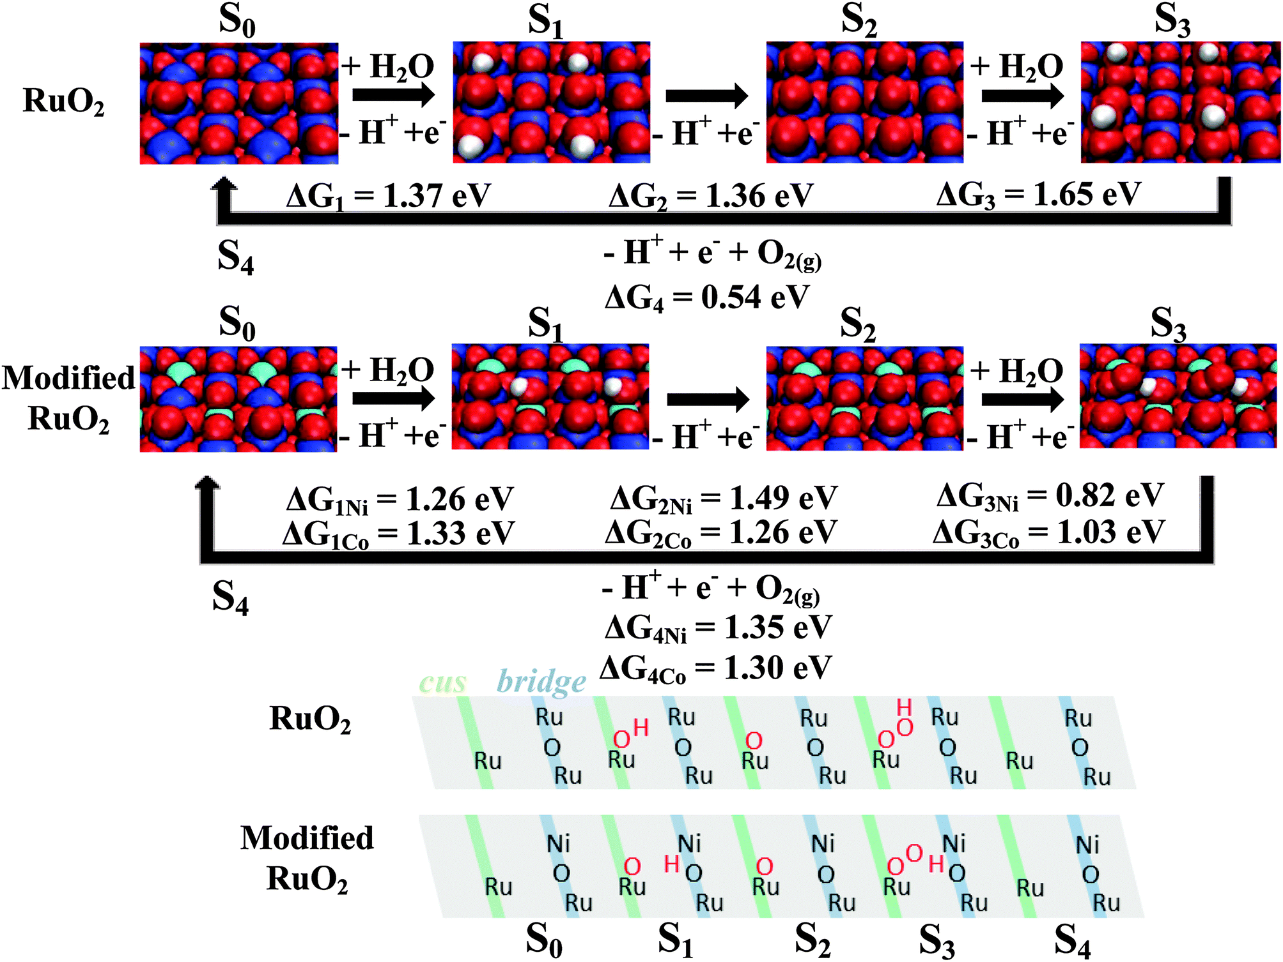
Figure 20 Reaction mechanism considered for the OER on the pristine (110) surface of rutile-type RuO₂ (top) and on the surface with Ni or Co substituting a Ru atom in the surface bridge position. Oxygen atoms are shown as red, ruthenium as blue, hydrogen as white, and Co/Ni as cyan. The schematic at the bottom of the figure shows the adsorption sites involved in the reactions. The green stripes indicate CUS sites and the blue stripes indicate bridge sites. Ni and Co can be seen to activate bridging oxygen such that the bridging oxygen accept a proton from adsorbed *OH and *OOH, resulting in a multi-site mechanism. Figure reproduced from Ref. ²⁴⁰ with permission from the PCCP Owner Societies.

The results of Ref. ²⁴⁰ suggest that multi-site nucleophilic mechanisms may circumvent or alter the scaling relationships found for single-site nucleophilic attack, and while those results were used to rationalize the improved performance of Co and Ni doped ruthenia, other results suggest the OER may occur through a multi-site mechanism even on undoped catalysts^{63, 175, 176, 265, 266}. For instance, the bridge sites on undoped RuO₂ (110) have been suggested to be active in removing a proton from *OOH ^{175, 176} ¹⁹⁸, which make the deprotonation of the bridge *OH the PDS and impacts the scaling relationships. Thus, while the prospect of using scaling relationships and the CHE for design appears powerful, the mechanistic reasons for the observed improvements Co and Ni doped ruthenia may not be bridge site activation. They could, for instance, be linked to Ru(VI) formation as experiments have suggested^{260, 261}, which would be more in-line with the formation of new sites due to Ni and Co dissolution under the acidic OER conditions, similar to what has been suggested for Ni doped Ir-based materials^{267, 268} and strontium leached SrIrO₃ ²⁶⁹⁻²⁷¹. Beyond this, recent work has even shown that breaking *OH/*OOH scaling may not improve predicted performance²⁵². Thus, care must be taken when attempting to use scaling relationships and the thermodynamic based CHE for the design of new catalysts or when rationalizing experimental results.

Despite the evidence against the relevance of the single-site nucleophilic attack mechanism63, 175, 176, 265, 266, 272, 273, it remains a mainstay in the literature, and the possibility to break the scaling relationships associated with it through the participation of multiple sites has prompted significant research into multi-site mechanisms within the CHE. These range from the cooperative effects of dopants²⁷⁴⁻²⁷⁸ ^{231, 249} and vacancies²⁷⁹⁻²⁸⁴, to metal ions in different oxidation states^{285, 286}, to using interfaces as the source of multiple sites^{254, 280, 287, 288}. Strain and geometric distortion too have often been invoked as possible means of breaking scaling relationships and increasing catalytic activity^{241-248, 289-291}. However, all such studies ultimately rely on both the assumptions underlying the CHE and the accuracy of the assumed mechanism, but there is often limited mechanistic proof. Without mechanistic evidence supporting the predictions made using the CHE, design may be accomplished more readily with other descriptions. Here too DFT has played a role, with various authors having attempted to develop physically sound descriptors that may offer intuitive insight into design^{194, 292-294} ^{295, 296} or rationalizing²⁹⁷ descriptors that are easier to access from experiment^{294, 298} and theory²⁹⁷. However, the ultimate aim of many researchers remains to develop mechanistic understanding of the OER.

At this juncture, let us revisit some of the results we have seen in this section. RuO₂ is known to be one of the best OER catalysts, though its stability is not sufficient for industrial applications.²⁹⁹ As we have seen in Figure 15, Rossmeisl et al.⁸⁸ correctly located RuO₂ close to the top of the theoretical overpotential volcano. Unfortunately, numerous later studies, even from the same authors, predicted much larger overpotentials, some up to 1.2 V.^{198, 199, 229} Briquet et al.¹⁹⁹ using the Perdew–Burke–Ernzerhof (PBE) and revised-PBE functionals from six different codes and various types of pseudopotentials has shown that IrO₂ was predicted with reasonable consistently, but the predictions of RuO₂ were very poor, with $η_{CHE}$ranging from 0.4-1.2 V. The inaccurate prediction for RuO₂ was attributed to the anomaly in the adsorption energies of OER intermediates. The predictions for RuO₂ were deemed to be correct if explicit water solvation and van der Waals interactions were included in the simulations. The effect of solvation is going to be the topic of a later section (5.1). Other theoretical explanations, like the need to include a Hubbard U term²²⁹ to account for d-d electron repulsion, magnetic ordering³⁰⁰, defects³⁰¹ surface terminations³⁰² and the role of dissolution intermediates³⁰³, or a bi-functional mechanism using proton acceptor sites at bridging O position¹⁹⁸ were also considered. Another aspect of inconsistency is the location of RuO₂ on the weak or strong binding side of the volcano. While the original publication located RuO₂ on the weak O binding side, later publications pushed its position to strong binding side¹⁹⁸, even significantly beyond that of IrO₂¹⁹⁹.

Figure 16b,d and Figure 19b show some interesting comparison between predicted overpotentials and experiments. As mentioned already, when the SnO₂ datapoint is ignored in Figure 16d, the trend is $η_{CHE}$~ -0.5$η$ - 0.3 eV, with a weak correlation. The intercept of 0.3 eV we might interpret as the overpotential wall baked into the single site adsorbate evolution mechanism. The slope however suggests an intrinsic issue, CHE predicts only half of the reported overpotentials. In Figure 16b with 5 perovskites, we see however just the opposite: the intercept is on the other side of the theoretical overpotential and the slope is now approximately 2.4, CHE strongly overestimating the experimental overpotential. As the experimental overpotential values were compiled from more than one publication, we searched for a number of publications in which some of these theoretically calculated perovskites were tested in the OER. Table 2 compares the predicted thermodynamic overpotential ($η_{CHE}$) and the experimental estimates. From the compiled data we can draw at least two conclusions. (1) The experimental data selected in Ref ¹⁰¹ might not perfectly match data when the experiment comes from one single laboratory, but with some minor deviations the data are comparable to the those in the selected publications. (2) Based on the compilation, but especially on the data of Suntivich²⁹² and Yamada³⁰⁴, which report oxide surface area normalized overpotentials, theory seems to overestimate the overpotential of those materials that are less active, even more so than what is plotted in Figure 16b. This suggests that either the CHE systematically overestimates the thermodynamic overpotential, maybe because it uses an unrealistic model or mechanism, or the experiment overestimates the OER activity of the targeted perovskites. This latter case may occur when the surfaces of these materials under OER conditions are no longer like the as-prepared perovskite surfaces. As we shall see, both of these possibilities are likely.

Table 2 comparison of thermodynamic overpotentials ($η_{CHE}$) and experimental estimates, in V.
Materials | $η_{CHE}$¹⁰¹ | Exp¹⁰¹ | Suntivich²⁹² | Yamada³⁰⁴ | Matienzo³⁰⁵ | Gao³⁰⁶
LaNiO₃ | 0.32 | 0.27 | 0.34 | 0.37 | 0.47 | -
SrFeO₃ | 0.5 | 0.4 | - | 0.34 | - | -
LaCoO₃ | 0.64 | 0.45 | 0.36 | 0.39 | 0.5 | -
LaFeO₃ | 0.76 | 0.51 | 0.4 | 0.4 | 0.65 | 0.51
LaMnO₃ | 1.26 | 0.68 | 0.45 | 0.51 | - | -
LaCrO₃ | 1.8 | - | ~0.6 | - | - | 0.54
Exp¹⁰¹: experimental data (as in Figure 16b) as compiled in Reference ¹⁰¹
Suntivich²⁹²: @0.1mA/cm² oxide surface in 0.1M KOH
Yamada³⁰⁴: @0.05mA/cm² oxide surface in 0.1M KOH
Matienzo³⁰⁵: @1mA/cm² geometric surface in 0.1M KOH
Gao³⁰⁶: @10mA/cm² geometric surface in 1M KOH

Also, in Figure 19b we see a comparison to experiments. Here, roughly 600 mV theoretical overpotential induces 2 decades of current density change. When assuming this to be factually correct, it is equivalent to a 300 mV/dec slope. In a thought experiment to match the activity of these samples we would find a Tafel slope of 300 mV/dec. Remember, active OER electrocatalysts have a Tafel slope of 30-50 mV/dec and when the 1st electron transfer step turns to potential limiting, the theoretical Tafel slope should increase to 118 mV/dec, the maximum theoretically possible Tafel slope with a (typically assumed) transfer coefficient of 0.5. Therefore, this comparison also strongly suggests that the CHE overestimates the thermodynamic overpotential.

One possible explanation to account for this inconsistency between theory and experiment is the often-assumed single site mechanism based on the adsorbate evolution mechanism (AEM), or nucleophilic attack mechanisms, considered in Equation 38-45. As discussed above, Halck et al.²⁴⁰ proposed that the bridging oxygen sites can assist some of the elementary steps of the OER in doped RuO₂ by functioning as proton acceptor sites. As we will discuss later, bridging sites seems to be involved in some un-doped rutile materials, too, and when theory properly accounts for solvation effects, the bridging sites seem to play an important part of the reaction.⁶³

Another important aspect that hampers direct comparison of theory and experiment is the size and structure sensitivity of the OER. Whereas calculations are typically performed on a selected low energy surface, actual catalysts include a large range of surface orientations and site ensembles^{186, 195, 302}. Rao et al.³⁰⁷ has observed surface orientation dependent water dissociation on RuO₂. By combining in situ characterization and DFT calculations, the authors find different surfaces exhibit unique binding energetics for H₂O and OH intermediates and can allow for different degrees of hydrogen bonding between the adsorbates. The degree of water dissociation was sensitive to the surface crystallographic orientation, maximum for the (101) surface, and decreasing in the order of (110), (001) and (100) surfaces. Interestingly, later the same group has found a surface orientation dependent OER activity in acidic condition, in the order of (100) being the most active and decreasing for (101) and worse with (110).¹⁷⁵ In alkaline electrolyte, the ordering was (001), (100), (101), (111) and (110), the latter two being equally the least active surface orientations.³⁰⁸ Hence, the trend of OER activity does not seem to follow the previously observed ordering in water dissociation. Also, the intrinsic OER activity has been reported to be particle size dependent. Interestingly, in acidic conditions for Ru_{0.8}Co_{0.2}O_{2-x} and RuO₂²⁶¹ opposite trends were found, or in alkaline for example with cobalt oxides²²³ smaller particles seem to be intrinsically more active. In these reports, the size dependence was not related to changes in the average surface orientation and other explanations were put forward, such as the influence on the reaction mechanism by Co substitution into rutile RuO₂ or a stronger Co surface oxidation under OER with the concomitant enhanced formation of an oxyl intermediate with radical character.

A major culprit of derailing structure-function correlations in general and particularly when comparing theory to experiments is the instability of materials under OER conditions, turning the as-prepared material into something else. This is often the case with perovskites but also transition metal oxides^{309, 310} can form amorphous surface oxyhydroxides. Highly active complex perovskites such as Ba_{0.5}Sr_{0.5}Co_{0.4}Fe_{0.6}O_{3−δ} , Ba_{0.5}Sr_{0.5}Co_{0.8}Fe_{0.2}O_{3−δ} and SrCo_{0.8}Fe_{0.2}O_{3−δ} undergo in OER selective leaching of A-site cations (Ba, Sr) and amorphization of the surface-near region.³¹¹⁻³¹³ Similar processes were found with La_{1-x}Sr_{x}CoO₃, which after leaching formed cobalt oxyhydroxide on the surface and with incorporated active Fe species from the KOH electrolyte created a dynamically stable state promoting the OER.³¹⁴ LaNiO₃, though to a much lesser extent, also undergoes reconstruction and structural evolution of its surface.^{315, 316} Other unsubstituted and less active perovskites, such as LaCoO₃ and LaMnO₃ did not undergo amorphization under OER in the time frame studied.^{311, 312} As to LaCoO₃, an intentional surface amorphization by a reductive post-synthesis treatment with urea, however, gave rise to improved OER performance.³¹⁷ Various ruthenates (SrRuO₃)³¹⁸, iridates (SrIrO₃)^{269, 319} and iridium-based double perovskites (Ba₂PrIrO₆)^{320, 321} in acidic electrolyte have a similar fate to the aforementioned active perovskites in alkaline and suffer Sr or Ba leaching accompanied by surface enrichment of Ru and Ir and forming amorphous oxides at the surface.

The above examples illustrate several potential reasons why the results of CHE calculations over oxides and perovskites may not correlate well with experiments. In the next section 3.2.6 we explore how the lattice oxygen evolution mechanism was rediscovered and its connection to the structural instability of perovskite surfaces.

Lattice oxidation

The CHE brought about a major change in the common view of the OER from a reaction that involves the direct coupling of adsorbed oxygen or hydroxide^{132-138,139, 140} to the single-site, and later multi-site, nucleophilic attack mechanism. This change was likely the result of the early apparent success of the CHE in ordering catalysts by η_{CHE}, which as we have seen above, roughly correlates with measured overpotentials. There is a useful analogue to this in thermal heterogeneous gas-phase catalysis. The change in mechanistic interpretation is analogous to the community moving away from assuming a reaction is described by a Langmuir–Hinshelwood, or Mars–Van Krevelen, type mechanism to an Eley-Rideal type³²². The fact that such a transformative change occurred in the OER literature with the introduction of the CHE underscores both the power of first-principles methods and the faith we place in them. Despite the overwhelming experimental evidence in support of direct oxygen coupling¹³²⁻¹³⁸ ^{139, 140, 323}, the single-site nucleophilic attack mechanism remained the dominant proposal until direct oxygen coupling was both re-discovered³²⁴⁻³²⁷ and, importantly, supported by CHE-based calculations^{324, 327}, which gave rise to a class of lattice oxidation mechanisms (LOM).

Before we dive into these CHE-based calculations employed for LOM, however, let us revisit some major experimental findings that cast doubts on the validity and/or exclusivity of the nucleophilic attack or AEM mechanism. Early oxygen evolution experiments based mostly on classical electrochemical kinetic analyses indicated the coupling of surface oxygen in the overall OER process. One of the first pieces of direct experimental evidence for the involvement of lattice oxygen came from the group of Heitbaum^{133, 328} By using DEMS in combination with ¹⁸O labeling experiments, they demonstrated that ¹⁶O¹⁸O was evolved from a H₂¹⁶O solution on an electrochemically formed Ru oxide layer previously prepared in H₂¹⁸O. In this case DEMS afforded the detection of m/e = 165 in the electrolyte, which was assigned to RuO₄, suggesting a corrosion pathway by overoxidation. ¹⁶O¹⁸O was also observed when oxygen is evolved on Ru¹⁶O₂ in H₂¹⁸O solution. Consequently, the oxide layer unequivocally contributed to the oxygen evolution process on both types of Ru-based electrodes. These results were in stark contrast to those by the same group on anodized Pt, in which after similar experiments no coevolution of ¹⁶O¹⁸O was detected and hence the oxide layer did not participate in the OER.³²⁸ Later, a number of further isotope experiments followed, confirming the involvement of lattice oxygen in the mechanism for a range of oxides and perovskites.^{132, 192, 315, 321, 329-333}

Detection of isotope labeled ¹⁶O¹⁸O and ¹⁸O¹⁸O with isotope labeled hydrous Ir-oxide confirms the participation of lattice oxygen atoms in the OER, though the majority of O₂ evolved contained no ¹⁸O.³³⁰ These observations were correlated to the higher Ir dissolution of hydrous Ir-oxide, compared to crystalline iridium oxide, the latter with an order of magnitude lower Ir dissolution rate and very-very little ¹⁶O¹⁸O formed. Later, Schweinar et al.³³¹ used a crystalline Ir¹⁸O₂ thin film and anodically polarized it at 1 mA cm⁻² for 10 minutes in a non-labeled 0.1 M HClO₄ electrolyte, and afterwards estimated the proportion of exchanged oxygen atoms by atom probe tomography. The analysis revealed a significant increase of ¹⁶O in the top 2.5 nm of the film, confirming lattice oxygen exchanged with electrolyte oxygen and thus the involvement of lattice O in the OER. The overall electrochemically active volume of the catalyst was however significantly lower than in the hydrous iridium oxide, which is in line with the higher stability of crystalline IrO₂ as compared to hydrous electrochemically prepared IrO_{x}.

Liu et al.³¹⁵, using well-defined ¹⁸O isotope-enriched epitaxial LaNiO₃ thin films, have shown that dynamic lattice oxygen exchange occurs during OER. Time-of-flight secondary ion mass spectrometry studies revealed that lattice oxygen exchange can affect the top 2 nm of the LaNiO₃ films, though after OER the surface largely remained crystalline and in the perovskite phase. Grimaud et al.³²⁹ using online electrochemical mass spectroscopy and isotope labeling has found the indication of LOM with La_{0.5}Sr_{0.5}CoO_{3−δ}, Pr_{0.5}Ba_{0.5}CoO_{3−δ} and SrCoO_{3−δ} , but not with LaCoO₃.

A number of studies noted that the pH dependence of the OER on the pH dependent RHE can help elucidate the importance of decoupled PCET steps in the mechanism. When the OER activity turns out to be pH independent of the RHE scale, this points to a rate-determining step that involves concerted proton–electron transfer. Conversely, a pH dependence on the RHE scale points to a mechanism with decoupled proton and electron transfer step being an important step in the OER mechanism. As we have seen, up to now in CHE we considered PCET steps with the water nucleophilic attack mechanism. Hence, it may not come as a surprise that a pH dependent OER on the RHE scale is often interpreted as a departure from this water nucleophilic attack mechanism and is argued to support the LOM. In support of the labeled O₂ produced with La_{0.5}Sr_{0.5}CoO_{3−δ}, Pr_{0.5}Ba_{0.5}CoO_{3−δ} and SrCoO_{3−δ}, but not with LaCoO₃, Grimaud et al.³²⁹ found pH dependent OER kinetics with the former three perovskites and pH-independence with LaCoO₃.

An interesting approach to prove oxygen exchange between catalyst and electrolyte is by combining ¹⁸O-labeling experiments with in situ Raman spectroscopy with ultrathin layered double hydroxide (LDH) samples.³³⁴ By preparing labeled catalysts and using unlabeled electrolyte (and vice versa), isotope shifts of various bending and stretching vibrations could be followed in situ. As-synthesized samples of the Ni, NiCo, and NiFe LDHs at open circuit potential, where the Ni ions were in the hydroxide form Ni(II), were able to exchange lattice O. However, once the Ni ions were oxidized to Ni(III), only Ni and NiCo LDHs were able to exchange their lattice O atoms through the OER, whereas the NiFe and NiCoFe LDHs could no longer exchange their lattice O atoms with the electrolyte. All these samples exhibited pH dependent OER, also the Fe-containing LDHs, which indicates that the correlation between pH dependence and LOM may not be universal.

For La_{1-x}Sr_{x}CoO_{3−δ} samples ($0 ≤x≤1)$, Mefford et al.³²⁷ observed a strong linear correlation between the OER activity and both the vacancy concentration, δ, and the oxygen diffusion rate. Since these parameters should not be of importance for the water nucleophilic attack mechanism, the authors invoked a lattice oxygen mediated OER mechanism. In the following we discuss this mechanism and its variants from the CHE perspective.

The first use of CHE to identify lattice redox mechanisms appears to have been in Ref. ³²⁴, though various authors incorrectly attribute the finding to Refs. ^{327, 329, 335}. In Ref. ³²⁴ the authors were motivated to explain the activity of perovskite-based catalysts that appeared to fall outside the scope of a popular a molecular orbital-based descriptor; that descriptor points out that the peak in OER activity should occur at an e_{g} occupation of one²⁹². However, variable activity was known from experiment for perovskites with equal orbital occupations^{292, 336, 337}, at odds with the e_{g} occupation argument. Experimentalists were ascribing these variations to the participation of lattice oxygen species^{325, 326}, as had been demonstrated for lanthanum nickelate⁸⁴. In Ref. ³²⁴, however, the authors showed a lattice oxygen mechanism (LOM) is predicted from application of the CHE model to LaNiO₃. They accomplished this by comparing the energetics for the OER via the typical single-site nucleophilic attack mechanism, Equation 42-45, denoted the adsorbate evolution mechanism (AEM) in Figure 21a, with the LOM involving a single metal site in Figure 21b; this is the single-metal-site LOM³³⁸. The nucleophilic attack mechanism uses a single metal site to oxidize two hydroxide ions to oxygen through a series of PCET steps, whereas a principal difference in the LOM is that the LOM forms the O-O bond by coupling an adsorbed hydroxide and lattice oxygen through the PCET step shown in Figure 21b. Since all steps in the LOM are PCET reactions, it is straightforward to model the energetics using the CHE.

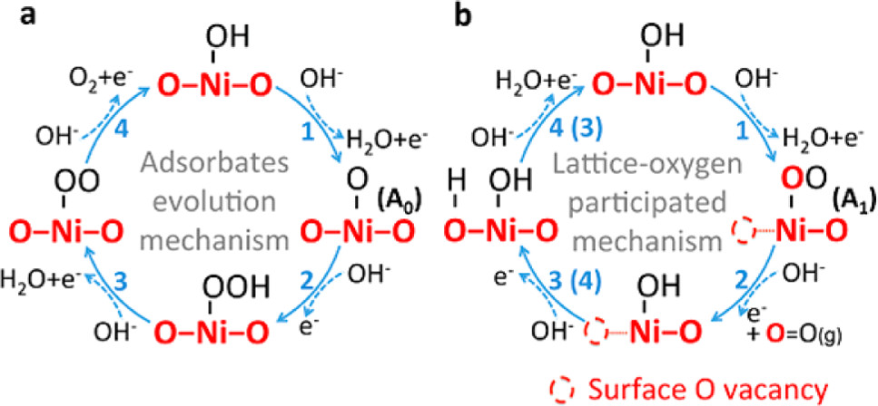
Figure 21 Schematic comparing the single site nucleophilic attack mechanism, referred to as the adsorbate evolution mechanism in panel (a) with the LOM (b) on LaNiO₃. Reprinted with permission from Ref. ³²⁴. Copyright 2016 American Chemical Society. 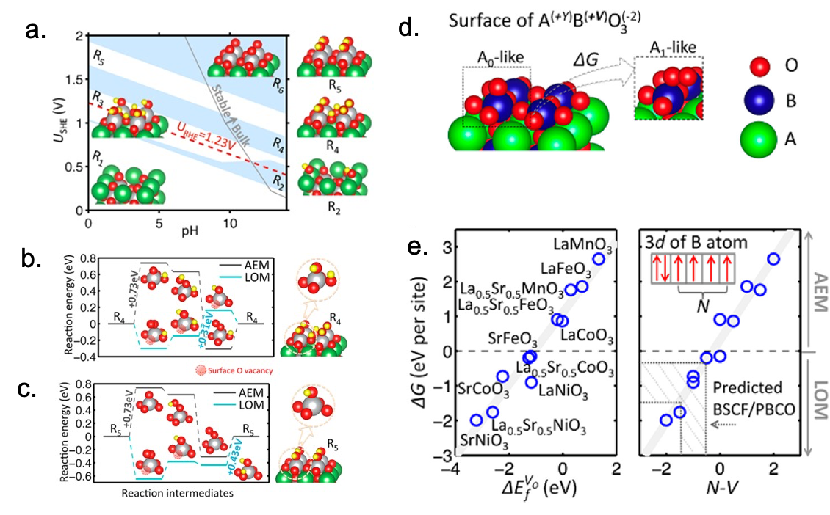
Figure 22 (a) Surface (pH, U) phase diagram for LaNiO₃ computed with the CHE model. Reaction energetics computed on the R₄ (b) and R₅ (c) surfaces using the CHE. In the space filling models O is red, Ni is grey, La is light green, and H is yellow. (d) Schematic of the descriptor of the propensity for the OER to proceed via the single metal site LOM, ΔG = ΔG(A₁)- ΔG(A₀), with coloring indicated. (e) Plots of ΔG vs the oxygen vacancy formation energy, ΔE_{f}^{VO}, and the difference between the number of unpaired B-site electrons on the free B (N) atom and the valency of the B atom (V). The latter is taken as a measure of the B-site ions ability to donate electrons. Adapted with permission from Ref. ³²⁴. Copyright 2016 American Chemical Society.
Figure 22 shows the results of CHE calculations of the OER energetics reported for the AEM and LOM over LaNiO₃ in Ref. ³²⁴. Noting that surface phases are expected to be important, the authors first computed the surface phase diagram within the CHE using the ideal NiO₂ termination as a reference, Figure 22a. They found that at increasing applied potential (U_{SHE}) and pH the surface becomes increasingly oxidized from a La-deficient surface (R₁) to a partially hydroxylated La-deficient surface (R₂), to fully hydroxylated NiO₂ surface with all (R₃) or half (R₄) the surface oxygen atoms protonated, to a fully hydroxylated surface with no surface oxygen protonated (R₅), to a fully oxidized surface (R₆), Figure 22a. They found that, like on other oxides^{88, 101, 219, 240, 339}, the formation of oxyl (μ₁-O) is a perquisite for the AEM. While oxyl is a predicted form on OER active rutile-type oxides at low overpotential, for LaNiO₃, inspection of the phase diagram in Figure 22a shows these terminal O sites are only deprotonated at potentials above 1.96 V vs RHE on the perovskite, well above the observed OER onset⁸⁴. However, using the CHE, the authors of Ref. ³²⁴ showed the LOM is already possible at 1.54 V vs RHE on the R₄ surface and 1.66 V vs RHE on the R₅ surface, assuming the reaction proceeds at η_{CHE}.

The authors of Ref. ³²⁴ went on to show how bulk properties of the perovskites influence the propensity for a particular catalyst to follow the nucleophilic attack mechanism, or AEM, originally proposed for CHE studies or the newly modeled LOM. They did so by defining the difference in free energy between the surface with terminal oxygen (μ₁-O), which is labeled the A₀-like state in Figure 22d and the LOM intermediate with the (*OO, O_{vac}) pair, labeled the A₁-like state in Figure 22d. This energy difference, ΔG = ΔG(A₁)- ΔG(A₀), is simply the difference in free energy change (computed using the CHE) between the first step in the two mechanisms shown in Figure 21. This choice reflects the observation that in Figure 22 this difference in energy determines the tendency for the OER on LaNiO₃ to follow the LOM. When this descriptor is applied to a wider range of materials it can be seen to correlate with the oxygen vacancy formation energy (ΔE_{f}^{VO}), Figure 22d. This intuitively appealing result can also be cast as the ability of B-site ions to donate electrons, which is captured in Figure 22e, where N-V shows the number of unpaired B-site electrons on the free B atom and V the valency of the B atom in the considered material. The authors of Ref. ³²⁴ suggest that at positive values of N-V the B-site ions are weakly oxidized and able to donate electrons, while at negative values the B-site ions are heavily oxidized and unable to donate electrons to lattice oxygen. The inability of highly oxidized B-site ions to donate electrons reduces the oxygen vacancy formation energy. This result hints at the importance of the charge transfer energy³⁴⁰ in determining the propensity for the OER via the LOM and also the possibility that the LOM is tied to instability.

Ref. ³³⁵, published within days of Ref. ³²⁴, furthered the evidence for an LOM and our understanding of such a mechanism. The authors of Ref. ³³⁵ noted that the anionic (2O²⁻ ↔ (O₂)^{n−}) redox processes giving rise to high capacity Li-ion batteries^{341, 342} may also participate in the OER over layered oxides and perovskites, which led the authors of Ref. ³³⁵ to propose the dual-metal-site³³⁸ LOM shown in Figure 23b. This mechanism can be contrasted to the classical single-site nucleophilic attack mechanism shown in Figure 23a and the single-metal-site LOM in Figure 21b. In the dual-metal-site LOM the O-O bond is formed by coupling two lattice oxygen atoms to form a bound peroxo intermediate, rather than coupling an adsorbed hydroxide and lattice oxygen like in the single-metal-site LOM. While the dual-metal-site LOM is consistent with some experimental isotope labeling studies^{132, 192, 343, 344}, it is not a pure PCET mechanism like the AEM in Figure 23a or the single-metal-site LOM in Figure 21b. Thus, the dual-metal-site LOM is beyond the scope of the CHE.
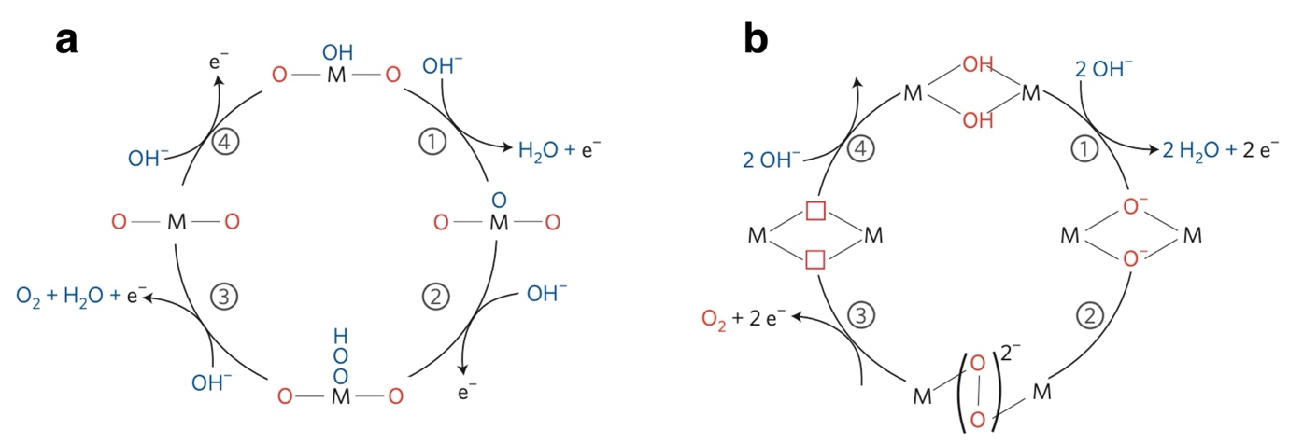
Figure 23 (a) The single site nucleophilic attack mechanism and (b) the dual-metal-site LOM. Figure Reproduced with permission from Ref. ³³⁵ Copyright 2016 Springer Nature.

Further evidence for a LOM for the OER and the importance of the fundamental importance of the charge transfer energy was reported in Ref. ³²⁷, where the redox activity of lattice oxygen in cobaltite perovskites was varied through Sr(II) substitution of La(III) in La_{1-x}Sr_{x}CoO_{3-δ}. The concept was based on the fact that substituting La(III) with Sr(II) requires either an increase in oxygen vacancies and/or an increase in Co oxidation state to maintain charge neutrality via:
$$LaCo\left(III\right)O_{3}+x{Sr}^{2+}-x{La}^{3+}→{La}_{1-x}{Sr}_{x}{Co}_{y}\left(III\right){Co}_{1-y}\left(IV\right)O_{3-δ}+\frac{δ}{2}O_{2}$$ | Equation 70
A high degree of oxygen non-stoichiometry is known in these materials under gas-phase conditions^{345, 346}, which suggests y~1 in Equation 70, though high oxygen chemical potentials can generate Co(IV)³⁴⁷. The highly oxidizing conditions of the OER may then be expected to result in Co(IV) formation leading to y<1 in Equation 70. However, because Co(IV) is in the negative charge transfer regime for most oxides³⁴⁷⁻³⁵⁰, its formation will introduce electron holes on the oxygen atoms in the lattice or, alternatively, Co(IV) increases in the covalency of the Co-O bond. In Ref. ³²⁷ the authors argued this increase in covalency would lead to the evolution of O₂ from the lattice oxygen, where the generation of lattice vacancies pins the Fermi energy at the top of the Co 3d band³⁵¹.

The authors of Ref. ³²⁷ reasoned that if the Fermi energy is pinned at the top of O 2p band by liberating O_{2,gas} through the creation of oxygen vacancies, varying the Fermi energy through the electrode potential will evolve lattice oxygen through an LOM, as the potential directly controls the number of oxygen vacancies. This view of the LOM differs somewhat from that developed in Ref. ³²⁴ in its reliance on Fermi level pinning, though it still stands in stark contrast to the nucleophilic attack mechanisms popularized by the CHE. This contrast can be seen in Figure 24, which compares hydroxide nucleophilic attack mechanism, Equation 42-45, in Figure 24a with the single-metal-site LOM in Figure 24b. The nucleophilic attack mechanism can be seen to occur via the familiar formation of *OOH, in this case on a single site, hence the authors using the term AEM. The single-metal-site LOM can be seen to involve the coupling of adsorbed and lattice oxygen to produce the O-O bond in step 1 of Figure 24b, in direct analogy to Ref. ³²⁴. From the figure, the direct participation of lattice oxygen can be seen to be tied to the ease with which an oxygen vacancy can be formed, again in analogy with Ref. ³²⁴, but in Ref. ³²⁷, and Figure 24, the driving force for lattice vacancy formation is tied to varying the Fermi energy of the electrode. The AEM can be seen to evolve the formation of Co(IV), whereas the LOM avoids Co(IV) formation by producing adsorbed superoxo and oxygen vacancy pair (*OO, O_{vac}), where the *OO forms by coupling a lattice oxygen with adsorbed hydroxl radical through a PCET step, see Figure 24b step 1.
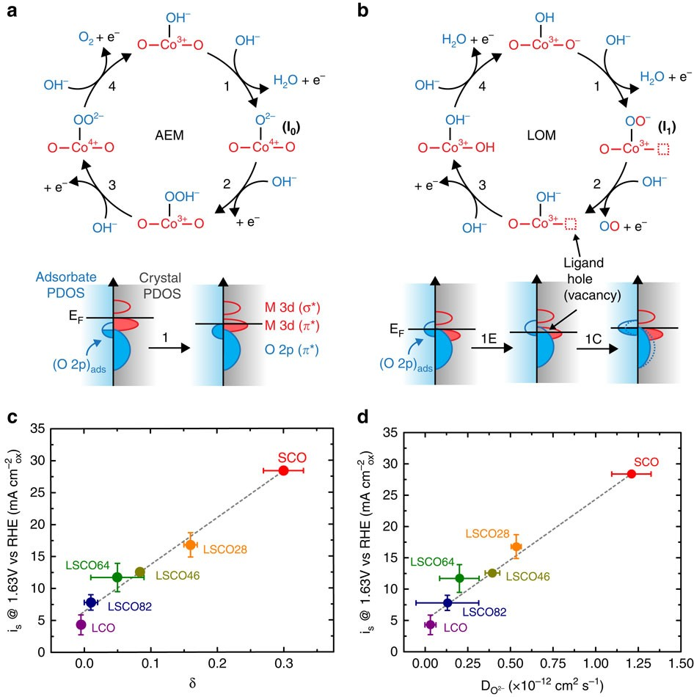
Figure 24 (a) Schematic of the single site nucleophilic attack mechanism, referred to at the adsorbate evolution mechanism (AEM), (b) Schematic of the lattice oxidation mechanism (LOM). The projected density of states show the change in oxidation states associated with the first step in each reaction, where the LOM is separated into electron hole formation via an electrochemical step and a chemical step. Electrolyte species are shown on the left of the energy axis and crystal states on the right of each projected density of states. Figure adapted from Ref. ³²⁷ under Creative Commons Attribution 4.0.

The picture developed in Ref. ³²⁷ was argued to be consistent with the high oxygen redox activity of cobaltites with high Sr(II) concentrations³⁵²⁻³⁵⁴ and consistent with XPS measurements^{341, 355}. But moreover, the authors employed the CHE to demonstrate the single-metal-site LOM has a lower η_{CHE} than the nucleophilic attack, or AEM, mechanism. In the AEM, *O is formed—again we can denote this as A₀ to be consistent with Ref. ³²⁴, though the authors of Ref. ³²⁷ use I₀ rather than A₀—while in the LOM, an (*OO, O_{vac}) pair is formed—denoted A₁ here to be consistent with Ref. ³²⁴. The energy difference between A₀ and A₁ was argued to determine which mechanism is operative, in complete analogy with Figure 22 and Ref. ³²⁴. The authors of Ref. ³²⁷ showed that like in Ref. ³²⁴, ΔG = ΔG(A₁)- ΔG(A₀) is largely determined by the oxygen vacancy formation energy, which is expected to be related to the Co 3d band center. Thus, for the formally Co(IV) in SrCoO₃, the intermediates of the single-metal-site LOM are lower in free energy within the CHE model than those along the path of the nucleophilic attack mechanism. This finding demonstrates the η_{CHE} for the single-metal-site LOM (η_{CHE}=0.22 V) is lower than the η_{CHE} for the AEM in SrCoO₃ (η_{CHE}=0.4 V).

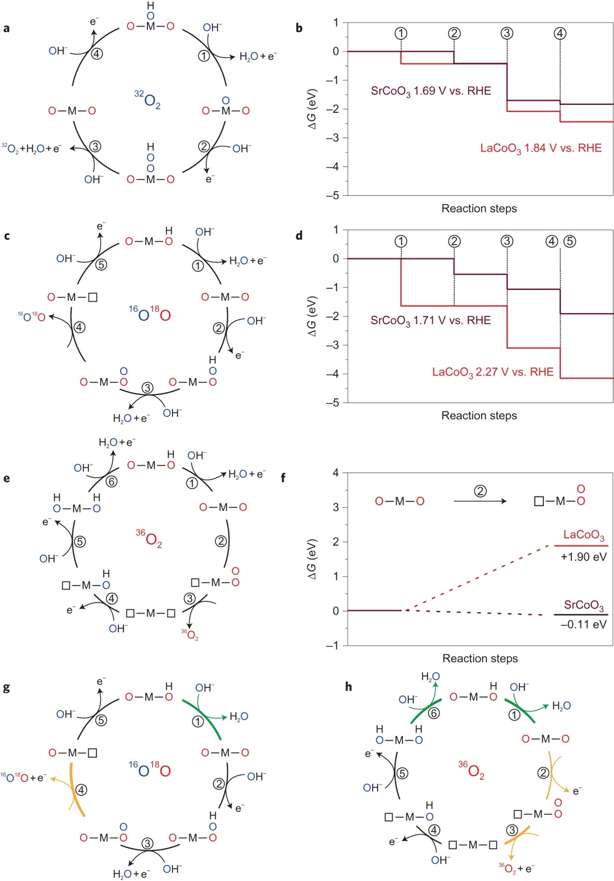
Figure 25 (a) The single-site nucleophilic attack OER mechanism. (b) Free energy profile computed within the CHE for the nucleophilic attack mechanism over SrCoO₃ and LaCoO₃. (c) and (e) proposed nucleophilic attack mechanisms involving lattice oxygen. (d) Free energy profile computed within the CHE for the nucleophilic attack on lattice oxygen (c) over SrCoO₃ and LaCoO₃. (f) computed free energy of O-O bond formation on lattice oxygen for LaCoO₃ and SrCoO₃, where only the latter is energetically favorable. (g), and (h) possible mechanisms involving non-concerted electron-proton transfer. Figure reproduced with permission from Ref. ³²⁹ Copyright 2017 Springer Nature.

Another critical step to cementing the LOM as one of the currently adopted OER mechanisms was made in Ref. ³²⁹. The authors employed similar arguments to the previous examples, but they performed online electrochemical mass spectrometry (OLEMS) measurements using ¹⁸O labeled perovskites in ¹⁶O electrolyte to provide direct experimental evidence for the participation of lattice oxygen in the OER. For different catalysts they observed ¹⁶O¹⁶O, ¹⁶O¹⁸O, and ¹⁸O¹⁸O gas-phase products. In particular, labeled oxygen was found in the gas-phase products for SrCoO₃ but not LaCoO₃, supporting the claims of Ref. ³²⁷. From this, the authors of Ref. ³²⁹ suggested the mechanisms shown in Figure 25. Note an RHE scale is used rather than SHE, which is a trivial change in the CHE^{125, 142}, compare Equation 46 and Equation 32.

Figure 25a shows the standard single-site nucleophilic attack mechanism, the AEM, argued to produce ¹⁶O¹⁶O over LaCoO₃, whereas Figure 25c represents a route to form ¹⁶O¹⁸O, and Figure 25e shows a route to ¹⁸O¹⁸O. All three examples involve only PCET reactions and so are amenable to calculations within the CHE. Notice, however, that both LOMs are distinct from the single-metal-site and dual-metal-site LOMs previously discussed; this demonstrates the large mechanistic diversity that was ignored when the AEM was the primary focus. Figure 25b shows the computed energetics for reactions on the metal sites though the AEM. LaCoO₃ can be seen to have a predicted η_{CHE} of 0.61 V vs RHE through the AEM over the Co site of the CoO₂ terminated (001) surface, while SrCoO₃ is predicted to have η_{CHE}=0.46 V vs RHE through the AEM operating on the metal sites of the CoO₂ terminated (001) surface.

When lattice oxygen is involved in O-O bond formation through the oxygen-vacancy-site LOM³³⁸ shown in Figure 25c, the computed energetics LaCoO₃ charge drastically while those over SrCoO₃ do not, Figure 25d. The authors claim these results can explain the appearance of ¹⁶O¹⁸O product over SrCoO₃, though it should be noted that the single-metal-site LOM was shown to have η_{CHE}=0.22 V in Ref. ³²⁷, suggesting the single-metal-site LOM may be more active than the oxygen-vacancy-site LOM shown in Figure 25c; both would produce ¹⁶O¹⁸O gas-phase product. Regardless of this mechanistic flexibility in the LOM, it appears the LOM is activated when the Fermi energy crosses the O 2p band^{327, 329} ³²⁴, which occurs with high M-O covalency either due to orbital overlap or when high metal oxidation states drive an oxide into the negative charge transfer regime^{340, 356-358}. Thus, both orbital overlap^{292, 339, 359, 360} and the charge transfer energy emerge as descriptors of OER activity and mechanism²⁹⁵ ^{268, 336, 361}. It should be noted that electron holes on oxygen are not only required for the LOM; the oxyl²¹⁹ needed to activate the AEM⁸⁸ ³²⁴ also requires an electron hole on oxygen. Tuning the oxygen to metal charge transfer to activate oxygen then becomes a power general design tool ^{338, 362}, and once the LOM is triggered, reduced oxygen separation distances can increase the participating of lattice oxygen³⁶³. However, the CHE cannot capture all aspects of the LOMs; besides the PCET steps that could be involved in the LOM, Ref. ³²⁹, suggested non-concerted proton electron transfer mechanisms to explain the pH dependence of the OER observed in their work, Figure 25g and Figure 25h. Such mechanisms are beyond the scope of the CHE model.

Lattice oxidation mechanisms are again widely accepted to be operative in perovskites^{32, 359, 364-370}, as well as oxides and oxyhydroxides ^{331, 371-375} ³⁷⁶ ³⁷⁷ ^{32, 378}, making LOM control a major design concept^{32, 363, 373, 379, 380}. And though initially the LOM was studied as means of enhancing OER activity, because the LOM is now viewed as a significant source of catalyst instability^{381, 382}, effort is now also going into finding means of suppressing it³⁸³, though there are reports that increased covalency could result in decreased dissolution of ions and increased stability^{359, 384}. Further work will be needed to understand if catalysts should be designed to have increased LOM activity, and if so, which type of LOM is preferred. Unfortunately, much of that work is outside the capabilities of the CHE.

Mechanistic details over Ir-based materials and active phases from the CHE

In the preceding examples we saw how the development and application of the CHE model within DFT influenced our mechanistic understanding of the OER by first popularizing a water/hydroxide nucleophilic attack mechanism proposed in Refs. ^{86, 141}. This path, which is now often referred to as the adsorbate evolution mechanism (AEM), quickly supplanted the more accepted mechanisms involving direct coupling of adsorbed and/or lattice oxygen that were derived from experiment¹³²⁻¹³⁷ ^{138-140, 323}. Ultimately, however, several lattice oxidation mechanisms (LOMs) were studied within the CHE ^{324, 327, 329} and direct oxygen coupling mechanisms are again accepted. With broader agreement between predictions made using the CHE and interpretations of experimental results, researchers have also turned to developing more accurate models of the active surfaces of catalysts within DFT. The first CHE studies of the OER revealed the importance of surface phases in the reaction mechanism^{87, 88}, which was only further underscored through the development of the LOM ^{324, 327}. Moreover, studies of the influence of crystal structure on η_{CHE} of Ir-based materials revealed η_{CHE} varies strongly with crystal structure and surface termination^{269, 385}. We will focus on efforts in Ir-based materials since they are the experimental benchmark.

A detailed investigation of the roles of crystal structure and surface termination on η_{CHE} over Ir-based materials was reported in Ref. ³⁸⁵, where the theoretical OER overpotential was computed over a variety of rutile-type IrO₂ surface as well as other IrO₂ and IrO₃ polymorphs. To ensure an accurate surface structure was modeled, surface (pH, U) diagrams were calculated using the CHE by assuming the surface sites were either empty or covered in *O or *OH. Regardless of the surface orientation, this approach predicts the rutile-type IrO₂ surfaces are fully oxidized before the oxygen stability limit (1.23 V vs RHE). In such a case, the authors show that the η_{CHE} computed for the AEM over rutile-type IrO₂ varied by as much as 440 mV across surface terminations. These results are shown Figure 26, where the computed value of η_{CHE} is indicated for each site considered. These results suggest that a terminal oxygen, μ₁-O, is always the active site but that the η_{CHE} of each μ₁-O species depends on the surface termination and local geometry. If we assume η_{CHE} correlates with activity, these results predict the (110) surface will show the lowest activity. Similar results have been found for defects on the RuO₂ (110) surface³⁰¹, which suggests such behavior may apply to rutile-type oxides.

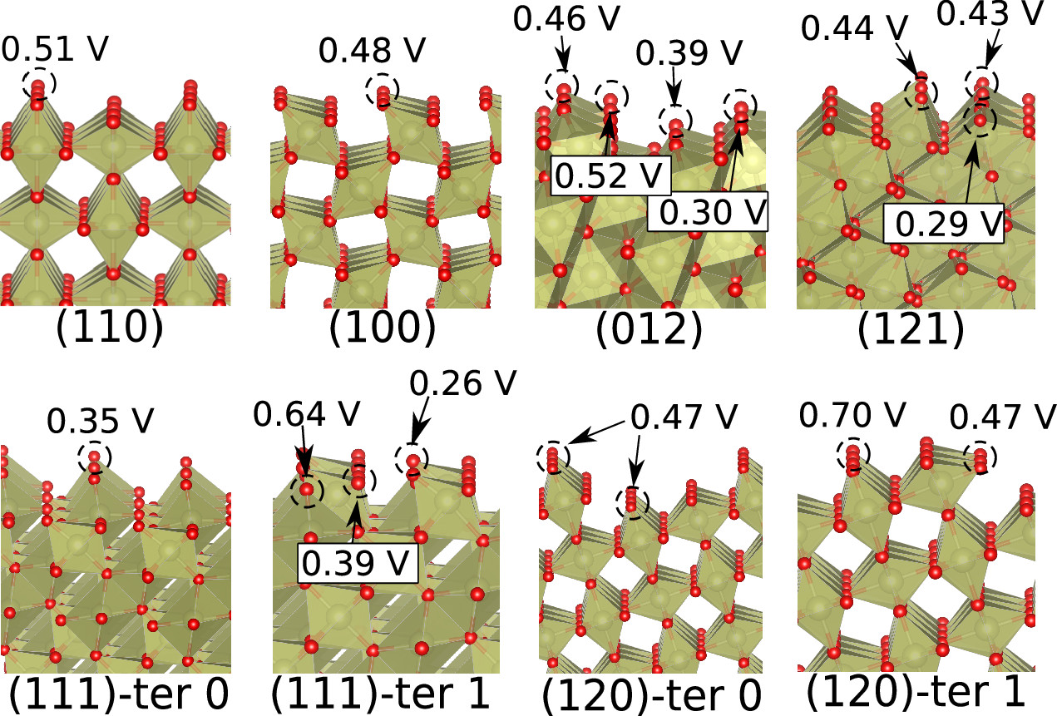
Figure 26 Ball and stick models of various rutile-type IrO2 surface terminations. The values of η_{CHE} computed at the different μ₁-O sites are indicated. Oxygen atoms are shown as red and iridium as light green. Reprinted with permission from Ref. ³⁸⁵ Copyright 2019 American Chemical Society.

The authors of Ref. ³⁸⁵ went on to compute η_{CHE} for 4 other polymorphs of IrO₂ and 3 polymorphs of IrO₃. Again, they began by identifying the active surface phase by way of computing the surface (pH, U) diagrams within the CHE by assuming sites are either empty, populated with *OH or populated with *O. As mentioned, all surfaces of all IrO₂ polymorphs were predicted to be fully deprotonated below 1.23 V vs RHE. The IrO₃ surface showed both *OH and *O surface phases at 1.23 V vs RHE depending on crystal structure and surface termination. However, among the IrO₃ (100) surfaces, which is the most active surface for each polymorph, only the Cmcm (100) is predicted to be *OH terminated under OER conditions. By computing the energetics on the surfaces identified in the surface (pH, U) diagrams the authors found that ΔG_{*OH} correlates linearly with ΔG_{*OOH} as ΔG_{*OOH} =0.98ΔG_{*OH}+3.04 eV across the entire dataset that includes 5 polymorphs of IrO₂ and 3 polymorphs of IrO₃. This result is in good agreement with the scaling relationship in Equation 69 that has been widely applied to a range of materials, including rutile-type IrO₂ (110)¹⁰¹ and IrO_{x}/SrIrO₃²⁶⁹.

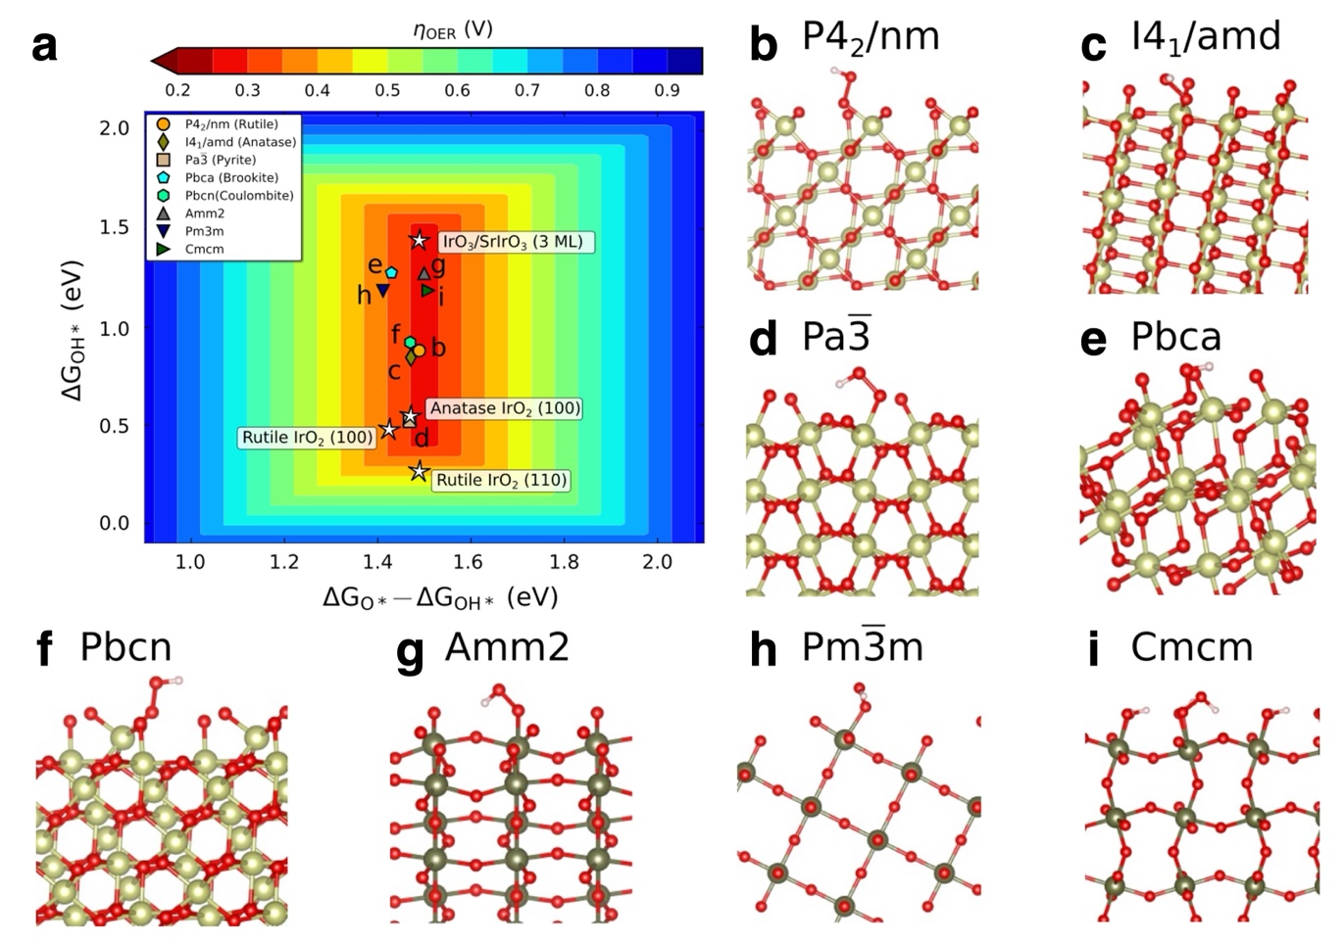
Figure 27 (a) 2D volcano plot computed from the standard AEM scaling relationships together with the structures with the lowest computed η_{CHE.} The IrO₂ structures include: (b) rutile-type, (c) anatase-type, (d) pyrite-type, (e) brookite-type, (f) columbite-type. The IrO₃ structures include: (g) Amm2, (h) Pm-3m, and (i) Cmcm. The theoretical overpotential was computed on the fully oxidized surfaces in all cases except for IrO₃ Cmcm, where a *OH terminated surface was used in accord with the computed surface (pH, U) diagram. Oxygen is shown as red, Ir in IrO₂ is light green, and Ir in IrO₃ is dark green. Reprinted with permission from Ref. ³⁸⁵ Copyright 2019 American Chemical Society.

A volcano plot showing the theoretical overpotential derived from the ΔG_{*OOH} =0.98ΔG_{*OH}+3.04 eV scaling relationship plotted against (ΔG_{*O}-ΔG_{*OH}) is shown in Figure 27. The data points on the figure show the DFT values of η_{CHE} computed for the most promising materials identified in Ref. ³⁸⁵, together with the surfaces considered in Ref. ²⁶⁹ (the white stars). A variety of IrO₂ and IrO₃ surfaces can be seen near the top of volcano. That is, many Ir-based oxides are predicted to have nearly ideal scaling. The computed value of η_{CHE} was shown to correlate with the Bader charge on the surface Ir atom involved in the OER through the AEM, where more oxidized metal sites showed a lower η_{CHE}. Hence, the OER seems to require μ₁-O sites, where the more heavily oxidized iridium centers show reduced theoretical overpotentials compared to the less reduced species in Figure 26 because higher Ir oxidation states tend to induce more oxyl character on μ₁-O ^{222, 224, 268}. This is nearly the same result as that was found in activating lattice oxygen through increased M-O covalency^{327, 329,324}, which results in a chemical intuitive picture for activation of oxygen. However, the opposite trend has also been claimed. That is, an increase in electron density on the active Ir centers has been suggested to improve the activity of supported IrO_{x}³⁸⁶⁻³⁸⁸. The formation of electron holes on oxygen appears to have more support and may also apply to other classes of materials. For instance, CHE results predict μ₁-O species are also active on doped Ni oxyhydroxides (doped-NiOOH)^{389, 390}, though bridge and threefold sites may also participate in the reaction^{231, 391, 392} and the LOM is easily activated^{372, 375}, which could indicate a higher degree of oxyl character on oxygen species in Ni oxyhydroxides than Ir-based oxides due to Ni(III) being in the negative charge transfer regime³⁵⁷.

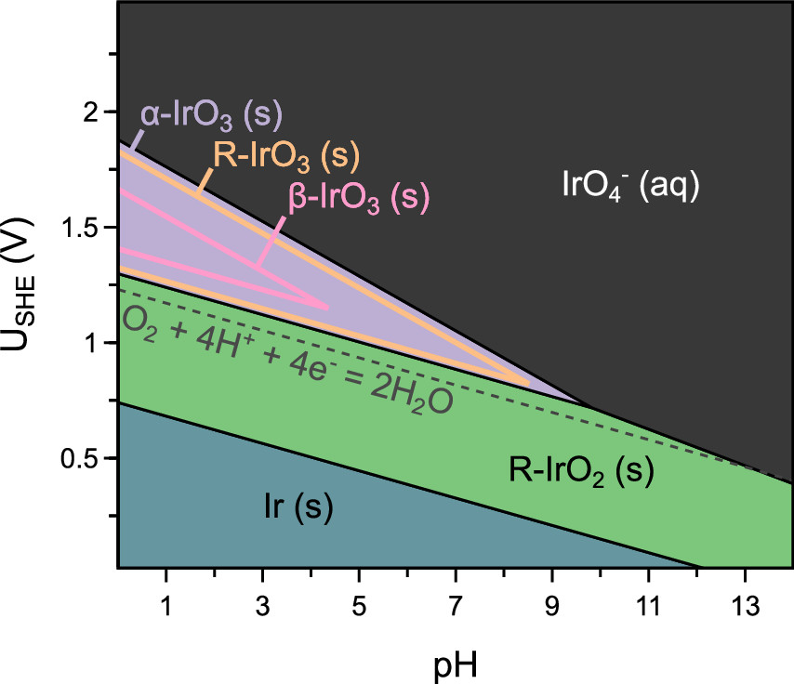
Figure 28 Computed (pH, U) diagram showing the appearance of IrO3 beyond the oxygen stability limit. One novel IrO3 phase, α-IrO₃, is predicted to be stable, while β-IrO₃, and R-IrO₃ are both predicted to be metastable, that is they are favored of the IrO₄²⁻(aq) phase. The phase boundaries show the regions of (meta)stability. Note that IrO₄²⁻(aq) is labeled IrO₄⁻(aq) in the original publication and the diagram. Reprinted with permission from Ref. ³⁹³ Copyright 2020 American Chemical Society.

Beyond Ref. ³⁸⁵, ample evidence demonstrates the importance of bulk and surface phases in the OER87, 88, 269, 301, 324, 327, 385. An accurate estimate of η_{CHE} then requires knowledge of the bulk and surface phases under OER conditions. As we saw in Refs. ^{87, 88, 385}, the CHE can be used to compute surface (pH, U) diagrams; however, ab initio atomistic thermodynamics can also be used to compute bulk phases, where it has proven powerful in predicting bulk Pourbaix diagrams ^{110, 394-397}. A major challenge in this effort is identifying phases to include in the thermodynamics screening procedure. In Ref. ³⁹³ the authors coupled ab initio atomistic thermodynamics with active learning to overcome the challenges associated with structural identification, which resulted in a significant modification of the proposed iridium (pH, U) diagram, see Figure 28.

Inspection of Figure 28 reveals 3 different IrO₃ polymorphs are predicted to appear either as stable or metastable phases under highly oxidizing potentials at low pH, well above the thermodynamic onset of the OER. This is a major change from the previously accepted iridium Pourbaix diagram, where IrO₂ is the most oxidized solid.³⁹⁸ The authors of Ref. ³⁹³ made their prediction by examining the thermodynamic equilibrium between metallic Ir, rutile-type IrO₂, three IrO₃ polymorphs (α-IrO₃, β-IrO₃, and R-IrO₃), and aqueous IrO₄⁻. The last species should be labeled IrO₄²⁻. The computed heat of formation of α-IrO₃ is sufficiently large to make it the predicted stable phase under acidic OER conditions, see Figure 28, whereas the β-IrO₃, and R-IrO₃ polymorphs are predicted to be metastable; both are lower in free energy than the competing metallic Ir, rutile-type IrO₂, and aqueous IrO₄²⁻ phases, but higher in energy than α-IrO₃. These metastability regions are indicated within the α-IrO₃ field of Figure 28.
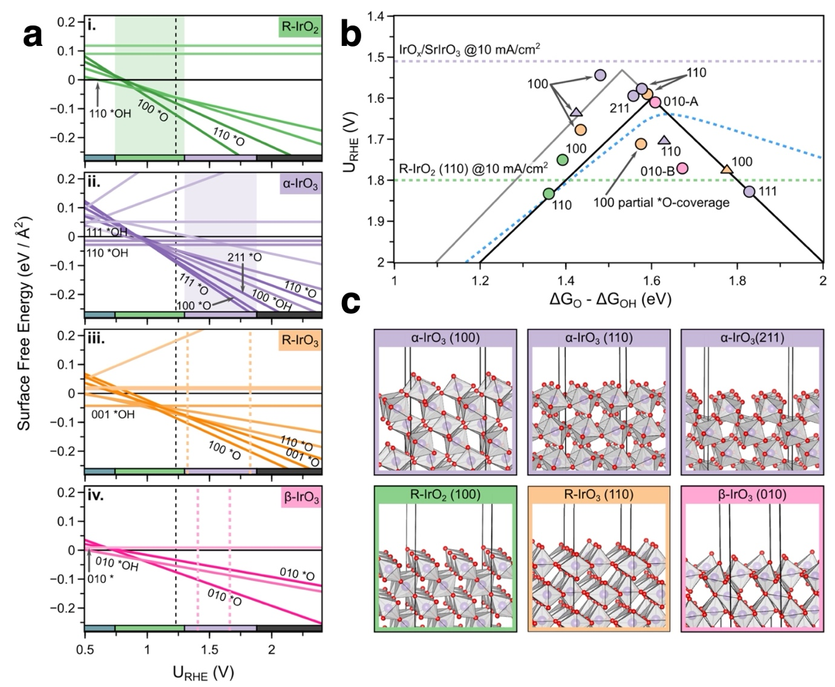
Figure 29 (a) Computed surface (pH, U) diagrams. The zero pH bounds of stability from Figure 28 are shown as horizontal bars at the bottom of the plots. The regions of β-IrO₃ and R-IrO₃ metastability are shown by way of vertical lines. (b) Volcano plot and computed η_{CHE} values. The solid black line shows the standard AEM scaling relationship result, while the dashed line shows the fit to the computed data. The horizontal lines show experimental data. (c) Ball and stick models of the structures. Oxygen is shown as red and iridium is purple. . Reprinted with permission from Ref. ³⁹³ Copyright 2020 American Chemical Society.

After identifying new bulk phases, the authors of Ref. ³⁹³ explored the surface (pH, U) diagrams and computed theoretical overpotentials on these surfaces, Figure 29. Note the authors employ an RHE scale rather than SHE, which is a trivial change in the CHE^{125, 142}, compare Equation 46 and Equation 32. They found that CHE calculations tend to predict oxidized surfaces at OER relevant potentials regardless of the surface orientation, in agreement with Ref. ³⁸⁵. As such, η_{CHE} was computed only on fully oxidized surfaces. The resultant values of η_{CHE} are plotted against (ΔG_{*O}-ΔG_{*OH}) in Figure 29b, where the standard scaling relationship is shown by way of the black line and the fitted relationship is indicated using a gray line. The dashed line shows a kinetic volcano plot³⁹⁹ that will be described later. The fitted volcano can be seen to be shifted from the traditional scaling relationships, with IrO₃ surfaces surpassing the top of the traditional volcano, at odds with the claims in Ref. ³⁸⁵ that the OER over all IrO₂ and IrO₃ polymorphs shows the same scaling. However, the general claim that high oxidation state Ir, Ir(VI), may be active in the OER is in agreement with the results of Ref. ³⁸⁵ and other studies^{224, 268}. While the formation of a stable and active IrO₃ phase under acidic OER conditions is an exciting prospect, experiment suggests such phases do not form during normal operation²²⁴.

Though bulk IrO₃ may not form under OER conditions, the surface iridium oxidation state may still reach V-VI through surface oxidation and defects^{224, 268}. High surface oxidation states have also been explored within the CHE model. In Ref. ¹²⁷ the CHE was used to compute the surface energies of the low index surface of rutile-type IrO₂ under varying electrochemical conditions. The authors first showed that the lowest energy surface termination in vacuum, the (110), is not the most stable under OER conditions. Rather the (111) termination begins to become more stable than the (110) termination under oxidizing potentials. At 1.3 V vs RHE, in fact, the (111) termination is predicted to dominate the Wulff shape⁴⁰⁰, suggesting iridium oxide nanoparticles should be (111) terminated during the OER. The change in facet stability was rationalized as originating from the number and types of oxygen species present on the different terminations, which is intuitively appealing.

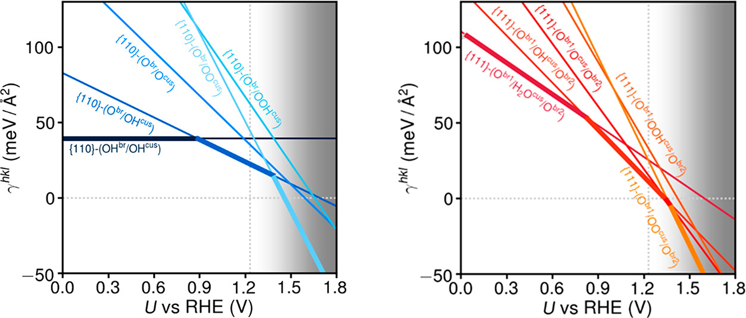
Figure 30 Surface phase diagrams computed for IrO₂ (110), left, and IrO₂ (111), right, with the CHE. The surface terminations indicated as follows: O^{br} and OH^{br} refer to bridging oxygen and hydroxide, respectively, OH^{cus}, O^{cus}, OOH^{cus}, and OO^{cus} refer to terminal, or μ₁, hydroxide, oxyl, hydroperoxo, and superoxo, respectively. The surface free energies become negative on IrO₂ (110) beyond 1.4 V and beyond 1.3 V for IrO₂ (111), predicting the materials become unstable. Reprinted with permission from Ref. ¹²⁷ Copyright 2019 American Chemical Society.

The authors of Ref. ¹²⁷ showed that the tendency to stabilize the most oxidized surfaces under oxidizing potentials results in the most oxidized surfaces becoming the lowest energy surface under OER conditions, that is, the CHE predicts a superoxo (*OO) surface phases. While most CHE studies have restricted allowed surface phases to *O and *OH ^{87, 385,88}, a similar claim was made for rutile-type RuO₂^{175, 176}, though operando XAS suggests *OO(H) does not accumulate on RuO₂ ⁴⁰¹. And while there is then debate about the experimental evidence for *OO(H) on RuO₂ under OER conditions, adsorbed superoxo (or peroxo) are not seen on IrO₂ either indirectly at the Ir L₃-edge ²²⁴ or directly through resonant photoemission at the O-edge ⁴⁰². This latter observation places an upper limit of <<1/10 ML for OO(H) species on Ir at potentials as high as 2 V vs RHE. The authors of Ref. ¹²⁷ point out that O-O overbinding in DFT may artificially stabilize the superoxo species, resulting in an incorrect prediction, as noted previously¹¹⁴. Regardless of the superoxo stability, however, the authors of Ref. ¹²⁷ also reported a surprising result. They showed that the surface energies of all facets become negative for potentials 1.4 V vs RHE; the transition to negative surface energies occurs at 1.3 V vs RHE for the (111) facet, see Figure 30. They noted that, while for the (110) termination this instability can be seen to derive largely from the stability of the superoxo (*OO) terminated surfaces—the *O surface phase has a positive surface free energy until ~1.6 V vs RHE for the (110) termination—the surface energy of the (111) termination becomes negative at 1.3 V vs RHE for both the *OO and *O surface phases. The impact of this claim is that Ir-based oxides should dissolve at potentials beyond 1.3 V vs RHE or transform in IrO₃ ³⁹³. Neither prediction is in agreement with experiment, as we will discuss in a moment ^{403, 404}.

Along the line of the superoxo terminated surface, an alternative OER mechanism with the involvement of two superoxo species was proposed by Binninger et al.^{405, 406} Similar to Ref. ¹²⁷, their surface phase diagram also predicted an abrupt switch from *OH (OH^{cus}) to a completely *OO (OO^{cus}) covered surface at around 1.35 V vs NHE. In a proposed elementary step, two neighboring *OO (OO^{cus}) would recombine, leaving behind two oxo/oxyl species, without the need of forming empty CUS sites. For the conventional O₂ desorption, the authors calculate an activation barrier of 0.95 eV, whereas the direct coupling of two *OO (OO^{cus}) only required 0.34 eV. This O₂ desorption step was calculated to be almost unaffected by capacitive charging. From their free energy profiles, they proposed that H₂O dissociation over two neighboring *O (O^{cus}) is the RDS of the novel OER mechanism on IrO₂(110) in the OER relevant potential range. However, at low overpotentials, close to the OER equilibrium potential, the O₂-evolution step via two *OO (OO^{cus}) is the critical elementary step, and hence, the RDS. Based on these mechanistic and kinetic arguments, the surface with a limiting *OO (OO^{cus}) recombination step would be dominantly covered by *OO (OO^{cus}), whereas at potentials with limiting H₂O dissociation the surface would be covered with *O (O^{cus}).

Before concluding on these models and predictions over the iridium oxide surface phase diagrams and their implication for OER, let us review some critical experimental observations. Pearce et al.⁴⁰⁷ prepared Li_{x}IrO₃ (x being 1, 0.5 and 0) from β-Li₂IrO₃, a model Li-ion battery electrode, under organic electrolytes containing no water by electrochemical delithiation. Then, the chemical reactivity of the delithiated products towards water and their stability was investigated (Figure 31). Ir L₃-edge XAS experiments suggested an iridium oxidation state close to formally Ir(V) of these materials, irrespective of the delithiation degree, indicative of a charge counterbalance by the oxygen ligand forming electrophilic O species. The electrophilic character of the oxygen ligand in a similar material after delithiated was demonstrated previously.⁴⁰⁸ The delithiated products reacted with water (1 M H₂SO₄) and based on X-ray and neutron diffraction analysis produced β-H₂IrO₃. While Ir L₃-edge XAS suggested an intermediate oxidation state between Ir(IV)/Ir(V) after soaking in water, ex situ XPS analysis confirmed the predominance of OH⁻ species on the surface. The (partially) delithiated products evolved oxygen in the acid solution without the application of an external potential; the stronger the material was delithiated, hence more oxidized, the more O₂ was produced. Almost no O₂ evolved when β-Li₁IrO₃ was contacted with the acid solution. Hence IrO₃ (and the other delithiated) products are unstable in acidic electrolyte, producing O₂ but also undergoing Ir leaching. Again, as with O₂ produced, the stronger the delithiation, the more Ir was leached into the electrolyte. When β-Li₂IrO₃ was CV cycled in 1 M H₂SO₄, it turned into β-H₂IrO₃. The redox charge under the CV measured for β-H₂IrO₃ was approximately 10% that of β-Li₂IrO₃, suggesting limited and slow proton diffusion in and out of β-H₂IrO₃. The structural stability and redox state of β-H₂IrO₃ was investigated by operando XRD and Ir L₃-edge XAS. When ramping up the potential to 1.65 V vs RHE, small amount of proton extraction and a positive shift of the L₃ white line were observed, slightly above that of the water reacted Li_{x}IrO₃ materials, indicative of some minor bulk proton extraction, surface deprotonation and the concomitant overall oxidation of the material, forming electrophilic oxygen species. When normalized by the oxide surface area, β-H₂IrO₃ with its amorphous surface layer provides a very good OER activity (0.34 mV overpotential at 10 mA cm⁻²_{oxide}) in 1 M H₂SO₄. These results clearly show that IrO₃ is not stable in acidic electrolyte, not even under the OER, and that deprotonation will drive formal oxidation state increase.

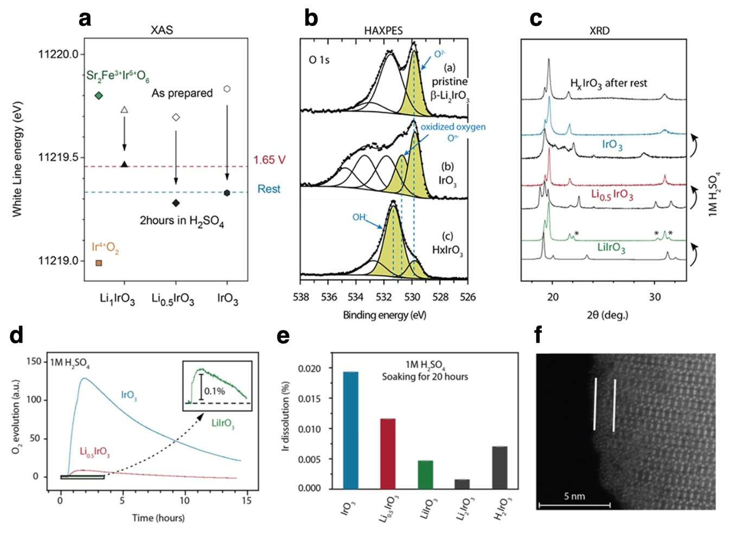
Figure 31 Chemical reactivity of oxidized β-Li₂IrO₃ with acid. (a) Evolution of the white line energy position of the Ir L₃-edge XAS for the different compounds before (open symbols) and after acid treatment (filled symbols). IrO₂ (orange square) and Sr₂FeIrO₆ (green diamond) are shown as references for Ir^{+IV} and Ir^{+V}, respectively. Dashed lines indicate the white line energy measured at 1.65 V vs RHE and after rest in operando measurements. (b) O 1s X-ray photoelectron spectra with the pristine β-Li₂IrO₃ phase (top), the fully delithiated IrO₃ phase (middle), and IrO₃ after exposure to 1 M H₂SO₄ solution (bottom). Colored areas indicate oxygen atoms bound to iridium, while the white areas correspond to adsorbed species on the surface of the material. To decrease the intensity of surface components, the spectrum in (b) was recorded with a 6900 eV photon energy on the GALAXIES beamline at the SOLEIL synchrotron (multiplying the probe depth by 4.5). Other spectra were recorded with 1487 eV (standard XPS). (c) XRD patterns for each compound before (black) and after acid treatment (colored line) compared to the XRD pattern collected after rest for β-H_{x}IrO₃. The stars indicate peaks that arise due to residual lithium in the phase, which are not present in other samples that fully convert to the hydrated iridate. (d) Online mass spectrometry for β-IrO₃, β-Li_{0.5}IrO₃, and β- LiIrO₃ upon chemical exposure to 1 M H₂SO₄. (e) Ir dissolution measured by ICP-OES after soaking the different intermediate phases in a solution of 1 M H₂SO₄. (f) HAADF-STEM image along the [110] zone axis of the resulting protonated iridate phase. Reproduced with permission from Ref. ⁴⁰⁷ Copyright 2019 American Chemical Society.

When Ir oxide materials are amorphous, deprotonation is extended to subsurface and deeper layers.⁴⁰⁴ When an Ir oxide is crystalline, that is, IrO₂, its redox chemistry is constrained to its surface by protonation/deprotonation. Mom et al. using operando X-ray photoelectron spectroscopy (XPS) and XAS at the O K-edge determined the near-surface structure of Ir oxides ranging from amorphous to crystalline during CV cycling and under OER.⁴⁰⁴ They showed that applying oxygen evolution potentials yields deprotonated bridging μ₂-O moieties and a mixture of terminal μ₁-O/μ₁-OH, with universal deprotonation energetics but in different amounts, crystalline IrO₂ being limited to surface deprotonation. This is in line with the much-reduced pseudocapacitance of crystalline iridium oxides in comparison to amorphous IrO_{x}.^{63, 409-412} Also, operando Ir L-edge experiments indicate much lower redox activity of crystalline oxides,⁴¹³ basically mimicking their reduced pseudocapacitance.⁴¹⁴ Similarly, effective charge accumulation with amorphous IrO_{x} was also evidenced by in situ evanescent wave spectroscopy.⁴¹⁵

Some controversy surrounds Ir L₃-edge experiments that suggest iridium reduction under OER potentials.⁴¹⁶⁻⁴¹⁸ These are in contrast to those reports that do not find reduction.^{63, 413, 414, 419, 420} The issue was discussed by Diklic et al.⁴²⁰ and concluded that radiation damage and subsequent catalyst dissolution/delamination greatly affect the acquired spectra and subsequent interpretation thereof. Such experimental artifacts can be avoided by a reduced beam flux and lower catalyst layer thickness. When operando Ir L-edge experiments are done properly, we find iridium oxidation over Ir(IV), see for example Figure 5h,i, the oxidation with the potential only slowing down when the electrochemically accessible sites all approach formally Ir(V).^{63, 414} This happens under OER potentials. Pulse voltammetry experiments prove pseudocapacitive changing under OER with close to identical capacitance as found below the OER onset (Figure 5), the capacitance decreasing only significantly once the Tafel slope bends.⁶³ This is a clear indication that the deprotonation process continue under OER when the potential gets further-further anodic, ruling out any observable reduction. This, however, also suggests that the surface phase diagrams discussed above overestimate the driving force of potential to deprotonate the surface, or in other words, underestimate the reluctance of the surface in getting rid of its surface protons.
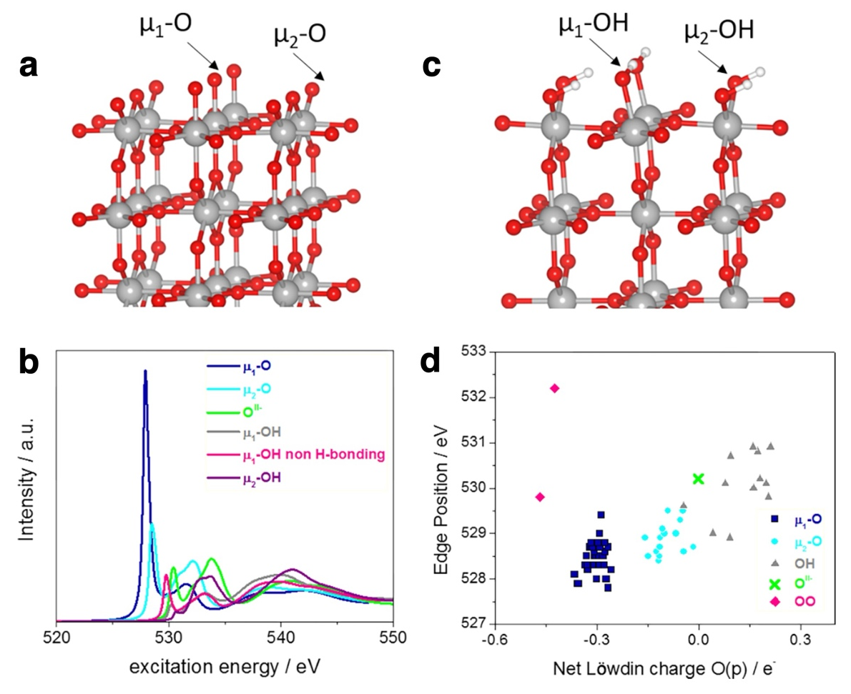
Figure 32 Ball and stick structural model of the (110) IrO₂ surface with O (a) and OH (c) termination. O K-edges (b) computed for μ₁-O and μ₂-O oxygen with O and OH termination as well as for bulk (O^{II-}) anions. Correlation of the O K-edge white line position at various surface terminations as a function of the net Löwdin charge with respect to the Löwdin charge of bulk O^{II-} in rutile IrO₂ (d). Reproduced with permission from Ref. ⁴²¹ Copyright 2018 American Chemical Society.

Numerous studies reported the appearance of electrophilic O species in O K-edge XAS under anodic polarization.^{63, 94, 404, 421} Generally, two types of species μ₂-O and μ₁-O can be distinguished, appearing at about 529 eV and 528.3 eV, respectively (Figure 32, Figure 33). These are the CUS and bridge O sites we have seen in the CHE calculations. Remember, the bridge O sites were long thought to be innocent spectator in the water nucleophilic attack mechanism, until recently they were re-considered as proton acceptor sites facilitating O-O bond formation. These electrophilic O species correspond to the formal Ir(V) seen by Ir L-edge experiments. According to DFT calculations, the white line intensity of the O K-edge resonance increases as the edge position decreases. There is also a rough correlation between the Löwdin charge and the edge position for the O/OH species: the lower the Löwdin charge, the lower the edge position. This indicates that the more electrophilic (“hole”) character an O species has the lower its edge position. The onset of μ₂-O formation under acidic conditions is around 0.9-1.0 V vs RHE and continues up to approximately 1.6 V vs RHE. The μ₁-O formation starts at around 1.2-1.3 V vs RHE and increases into OER conditions. Notice, however, the experimentally observed intensity of μ₁-O with respect to μ₂-O is in stark contrast to the predicted much increased white line intensity. This strongly suggests that while μ₂-O coverage may approach and reach saturation under OER, the coverage of μ₁-O is necessarily much lower. Although experiments are not unambiguous, they do not seem to support the presence of superoxo species, at least not with observable coverage. That is, theoretical surface phase diagrams predicting complete deprotonation of μ₁-OH to μ₁-O below the OER onset and/or their further transformation to superoxo seem to be erroneous.

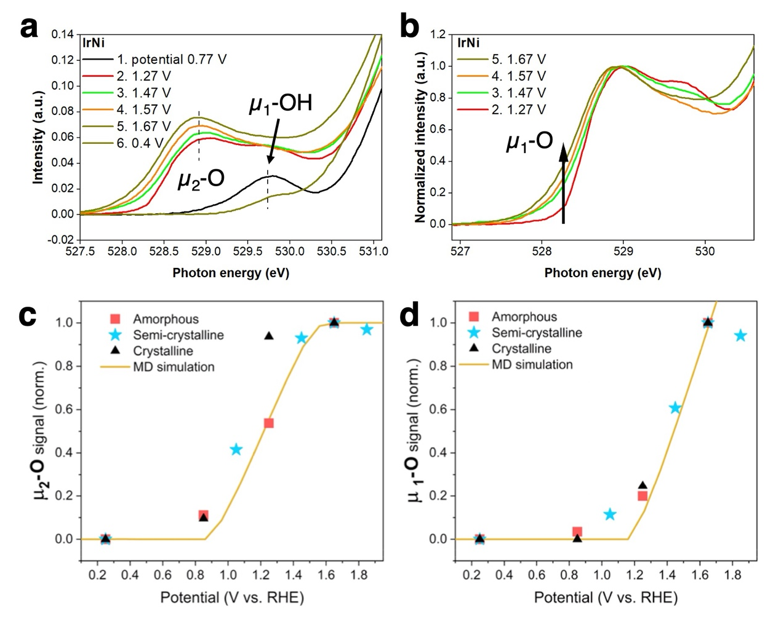
Figure 33 (a) Steady- state operando O K-edge X-ray absorption spectra of IrNi/Graphene at selected (non-iR corrected) potentials in the order indicated. (b) Steady-state operando O K-edge spectra of IrNi/Graphene at selected (non-iR corrected) potentials after scaling the spectra at 528.9 eV. Taken from Ref. ⁶³ supporting information. (c) and (d) Potential dependence of the μ₂-O and μ₁-O signals (c) μ₂-O signal at 529 eV. (d) μ₁-O signal obtained from integration between 528 and 528.35 eV. The experimental μ₁-O and μ₂-O signals were background-subtracted using the spectra at 0.25 V vs RHE, normalized to the μ₃-O intensity at 530 eV for the semicrystalline and crystalline samples, and finally normalized to one at 1.65 V vs RHE. The solid lines show the theoretical coverage curves (also normalized at 1.65 V vs RHE) extracted from MD simulations. Reproduced from Ref. ⁴⁰⁴ under the Creative Commons Attribution 4.0 License.

This disagreement may be related to the lack of explicitly considering solvation. Nong et al.⁶³ when constructing their surface phase diagram used ab initio molecular dynamics (MD). They observed that the chemical potential of adsorbed H is a function of hole coverage, that is, due to lateral interaction of adsorbates and the equilibration with solvent the adsorption energy of μ₂-OH and μ₁-OH will be a function of their coverage (See discussion on Frumkin/Temkin condition in Section 2.3). Consequently, the authors find a much wider deprotonation window of μ₂-OH and μ₁-OH, spanning together approximately 1 V, in better agreement to experiments. This behavior is also in accordance with the broad and less structured cyclo voltammogram of IrO₂(110)¹²⁶ and electrochemically prepared IrO_{x}^{422, 423} under acidic pH (See Figure 5). Redox transitions of amorphous IrO_{x} with broad potential window were found by the Durrant group using operando UV-Vis spectroscopy, matching the sample’s pseudocapacitive behavior in the cyclo voltammogram.^{409, 423, 424} They also argue that the broadness of the redox transitions are due to lateral interaction of adsorbates, giving rise to isotherms of Frumkin-type. We note by passing that early works by Conway^{95, 425} and later by Saraby-Reintjes⁴²⁶ emphasized the importance of Temkin/Frumkin isotherms in electrochemical gas evolution processes, as discussed in Section 2.3, either due to surface heterogeneity or due to lateral interactions of adsorbates.

Nattino et al.⁴²⁷ combined DFT simulations with a continuum description of solvent and electrolyte to investigate the interface stability of various IrO₂ terminations while simultaneously predicting O K-edge and Ir L₃-edge XAS cross-sections in the model electrochemical environment. O K-edge predictions support the interpretation of the appearance of pre-edge features at 529 eV (at ~1 V) and 528 eV (at ~1.4 V) with the formation of electrophilic oxygen atoms at bridge- and cus-sites, respectively. The Ir L₃-edge simulations were also consistent with experiments, showing that, starting with the fully hydroxylated surface, deprotonation continuously shifts the absorption cross section towards higher energies. This ties together operando XAS experiments at the O K- and Ir L-edge nicely, suggesting that once the hydrated surface states are passed and deprotonation continues from OH, these experiments look essentially at the same process from different aspects.

As we noted earlier, Ir dissolution from amorphous and hydrous Ir-oxides is typically much enhanced compared to well-crystallized iridium oxides.^{330, 428} Because OER activity and catalyst instability go often hand-in-hand, Geiger et al.³²¹ proposed a stability number, defined as the ratio between the amount of evolved oxygen and the amount of dissolved iridium, as a metric for electrocatalyst stability benchmarking. IrO₂(110), though being a less active surface orientation¹⁸⁶, is highly stable with very low Ir dissolution.⁴⁰³ Performing operando synchrotron-based high-energy X-ray reflectivity (XRR) and surface X-ray diffraction experiments, the authors found no measurable change of the IrO₂(110) thin-film thickness (49.6 ± 0.1 Å) after oxygen evolution for ∼26 h at a current density of 50 mA/cm⁻², only a slight increase of the film roughness from 3.0 to 3.9 Å. The crystallinity of the IrO₂ film remained intact.

In summary, experiments do not support the existence of IrO₃ catalytic phase under OER conditions, nor the completely oxidized surface states proposed by CHE. IrO_{x} catalysts accumulate charge by deprotonation, the process does not stop at the OER onset and continues deep into OER potentials. Highly crystalline IrO₂, and particularly IrO₂(110) single crystals are very stable under OER. They do not phase transform nor leach Ir into the electrolyte in significant quantities. The apparent disagreement between the computed thermodynamic results in Figure 28-30 and experiment stand in stark contrast to the apparent success of the CHE model in predicting values of η_{CHE} that mirror experimentally measured overpotentials and the widespread adoption of scaling relationships¹⁰¹. Such calculations are typically computed on surfaces oxidized to *OH or *O and no effort is typically made to identify the nature of the surface at potentials beyond η_{CHE}. This choice is roughly consistent with the assumptions of ab initio atomistic thermodynamics since the system is expected to behave effectively as a closed thermodynamic system when the OER, and dissolution, cannot proceed due to slow kinetics. At potentials beyond η_{CHE}, there is no thermodynamic contribution to the overpotential and kinetics become increasingly important; the assumption of a closed system breaks down. Thus, beyond η_{CHE} the use of kinetic stability diagrams rather than Pourbiax diagrams becomes necessary⁴²⁹. This issue is also known for thermal catalysis, as was discussed in relation to the development of ab initio atomistic thermodynamics and its use in open systems ^{108, 118}. The large driving forces accessible in electrochemical reactions, however, are expected to make this issue more problematic for the CHE than has been observed for thermal ab initio atomistic thermodynamics, where the experimentally accessible thermodynamic driving forces are smaller than those achievable in electrochemical reactions. Thus, the CHE should be expected to be most effective when applied to identify a PDS among homologous materials, and care must be taken to ensure the computational model corresponds to reality when considering the effects of applied potentials beyond 1.23 V vs RHE in the OER as kinetics become increasingly important. Such kinetic limitations may prevent (or enhance) metal dissolution and phase transitions from occurring⁴³⁰ and can impact reaction mechanisms through changes in surface phases⁴³¹. Even when used to identify the PDS and compute η_{CHE}, however, the absence of explicit kinetics casts doubt on mechanistic suggestions since the PDS need not be the RDS^{179, 180}.

Thus, while the CHE was a tremendous advance that heralded in new ideas and a significant change in our mechanistic views of the OER, not all of those changes improved our mechanistic understanding. Initially the nucleophilic attack mechanism, now broadly known as the AEM, supplanted other established concepts in the literature. However, over time, lattice oxidation and other alternative mechanisms have reemerged as likely candidates. While there appears to be strong evidence that highly oxidized adsorbed oxygen species facilitate the OER, the details of how the bulk and surface phases influence the mechanistic details do not appear be answerable within the ab initio atomistic thermodynamics alone. Rather, we must introduce additional model complexity and include the effects of electrolytes and explicit kinetics. These are going to be the topics of our next sections. Before turning to ab initio methods, however, we will briefly review the effects of electrolytes in experimental studies of the OER.

Electrolyte effects in the experimental OER

An electrolytic cell converts electrical energy into chemical energy by applying an external voltage between two electrodes immersed into an electrolyte. An electrolyte is a medium containing dissolved ions to provide the necessary ionic conductivity in the electrolyte. Upon the application of a potential, ions will migrate towards the electrodes of opposite charge. For practical reasons, electrolytes with high ionic conductivity are important. In the OER, we convert H₂O or OH⁻ into O₂, hence the electrolyte is typically at the strongly acid or alkaline side of the pH range. An exception to this is sea water electrolysis, which we only touch upon in passing.

Electrolytes can have profound effects on the activity of Faradaic reactions; a well-known example is the detrimental effect of alkaline electrolytes on the HER.⁴³²⁻⁴³⁴ Sometimes also the selectivity of electrocatalytic reactions is a strong function of the electrolyte. For example, the products of the CO₂ reduction reaction can vary depending on the electrolyte used.⁴³⁵ The standard potential of the chlorine evolution reaction (CER) and the OER are close enough that the electrolyte and the catalyst of choice can completely shift the reaction selectivity.^{272, 436} The above-mentioned sea-water electrolysis is also an interesting application, where chloride oxidation needs to be selectively avoided.⁴³⁷⁻⁴³⁹ Most of the time, the effects of the electrolytes can be traced back either to the pH, or to the influence of cations and the anions. This is in stark contrast to the models applied in CHE calculations we reviewed above based on PCET steps as they predict pH independent redox chemistry and OER activity (on the RHE scale). Furthermore, any potential effect of the electrolyte ions is usually neglected in those calculations. The lattice oxidation mechanism allowed us to circumvent this limitation, though we have seen that not all catalysts that show a pH dependent OER activity operate according to the LOM mechanism.³³⁴ In what follows, we briefly review the experimental literature and investigate the influence of the electrolyte on the OER activity of electrocatalysts. We start with pH and then move to the influence of dissolved cations and anions.

Perovskites are, for us, an appropriate starting point as many of them seem to fulfill the LOM mechanism. In an early study by Bockis and Otagawa (see Section 2.2), a large number of perovskites have shown an [OH⁻] reaction order of 0.6-0.95, the experiments performed using a pH-independent saturated calomel electrode.⁸⁴ They also found a linear trend with negative slope between the OER activity and the activation energies estimated from the temperature dependence. Their postulated mechanism via H₂O₂ formation and decomposition is nowadays largely abandoned in the literature. Li et al.³⁶³ and Liu et al.³¹⁵ both found strong effects of the pH, a first order or close to first order dependence of [OH⁻] on the activity of perovskites, CaCoO₃, SrCoO₃ and LiNiO₃, respectively. Both articles assigned the pH-dependence to the LOM mechanism. Duan et al.⁴⁴⁰ investigated the OER kinetics of La_{1−x}Sr_{x}CoO_{3−δ} perovskites (x = 0, 0.2, 0.4 and 0.5), amorphous CoOOH and Fe_{0.5}Co_{0.5}OOH (Figure 34a and c) and have found a strong effect of (iron purified) KOH concentration, and hence the pH, with the perovskites (when x > 0) and CoOOH. On the other hand, the OER activity of LaCoO₃ and Co_{0.5}Fe_{0.5}OOH showed no dependence on the concentration of KOH (nor with LiOH) in the range of 0.1-1 M.
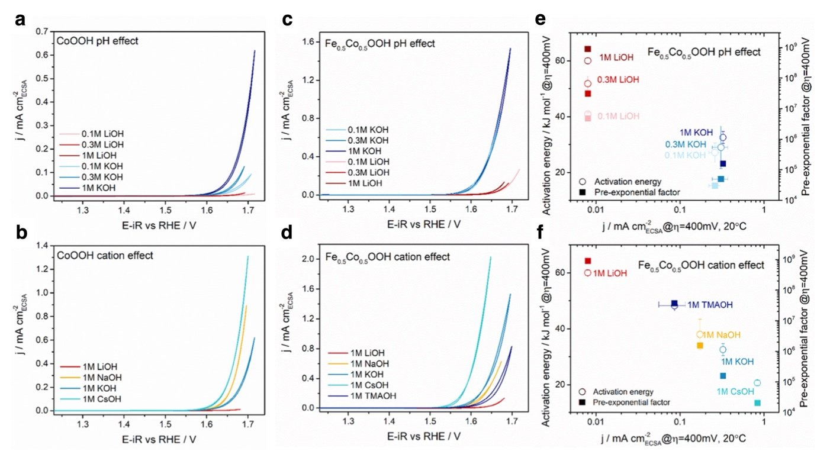
Figure 34 CV curves for CoOOH (a) and Fe_{0.5}Co_{0.5}OOH (c) measured at 20 °C in 0.1, 0.3, and 1 M LiOH and KOH. CV curves for CoOOH (b) and Fe_{0.5}Co_{0.5}OOH (d) measured at 20 °C in 1 M LiOH, NaOH, KOH, and CsOH. (e) and (f) Apparent activation energies and pre-exponential factors as a function of the OER activity at 20 °C and η = 400 mV, corresponding to (c) and (d), respectively. Reproduced with permission from Ref.⁴⁴⁰ Copyright 2020 American Chemical Society.

Though believed not to operate by the LOM, rutile oxides also show some peculiar behavior as a function of pH. The group of Suntivich^{126, 441} has grown IrO₂(110) and RuO₂(110) thin films on TiO₂(110) single crystals and studied their pH dependence in the range of 1.0-12.9. Cyclic voltammetry of IrO₂(110) reveals two reasonably separated redox transitions in alkaline pH, see Figure 35a, which, based on CHE calculations, the authors assign to the μ₁-OH₂ to μ₁-OH and μ₁-OH to μ₁-O transitions, respectively. Or, as the authors said, to the electro-adsorption of μ₁-OH and μ₁-O. This assignment neglects the potential influence of bridging sites. The electrolyte visibly shifts these CV redox transitions and by pH = 1.0, the first peak strongly broadens and the second oxidation peak is shifted into the OER region, seen only by the cathodic peak at the OER onset. The observed pH dependence (RHE) of these two redox transitions was different, 25 and 7.5 mV/pH units, respectively, Figure 35b. These are non-Nernstian peak shifts, not compatible with purely PCET processes. The authors estimate the free energy of formation of μ₁-OH and μ₁-O by considering the water covered surface as a reference state and assign the potential of first redox transition to $∆G_{OH}$ ($∆E_{1}$ in Figure 35c) and the sum of the two redox transitions to $∆G_{O}$ ($∆E_{2}$ in Figure 35c). By doing so, they find a scaling between these two, though the slope seems be roughly 0.75, hence more than the theoretical 0.5 would be based on bond order conservation arguments (=O vs -OH). A similar scaling was found for RuO₂(110), see Figure 36a. Linear sweep voltammetry and the Tafel plot (Figure 35d, e) suggest a pH dependent OER activity, with the ranking of pH 1.0 > pH 2.8 ≈ pH 12.9 > pH 6.5 > pH 9.6. Their Tafel slope changed from roughly 60 mV/dec in pH 1.0 to up to 120 mV/dec in pH 9.6. We note here, the authors used buffered solutions (at pH 2.8 and 6.5 phosphate buffer, and at pH 9.6 carbonate buffer). The authors compared a widely used OER descriptor $∆G_{O}$-$∆G_{OH}$ ($∆E_{2}$-$∆E_{1}$) in Figure 35f and in Figure 36b, to test the hypothesis of the Sabatier principle. As shown in these figures, the authors do not observe any volcano relationship between the OER activity and the oxygen electro-adsorption energy. As the trend of predicted and observed $∆G_{O}$-$∆G_{OH}$ for IrO₂(110) and RuO₂(110) were the same and the fact that also experimentally they find a scaling between $∆G_{O}$ and $∆G_{OH}$, Figure 36a, the authors speculate that the shortcoming is not a simple DFT problem but rather related to the lack of considering the microkinetic details of the OER. We note that $∆G_{O}$ and $∆G_{OH}$ were derived from CVs showing non-Nernstian peak shifts and hence the electrolyte itself can play a role.

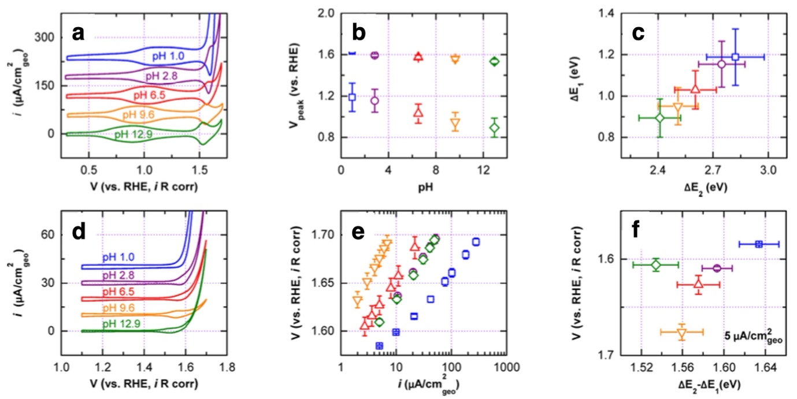
Figure 35 (a) Cyclic voltammograms of IrO₂(110) in Ar-saturated 0.1 M electrolytes with different pH values at a scan rate of 200 mV/s. (b) Shifts of the adsorption peak potentials with pH from (a). (c) Energy relationship between the adsorbates for peaks 1 and 2 from (a). (d) Cyclic voltammograms of IrO₂(110) in O₂-saturated 0.1 M electrolytes with different pH values at a scan rate of 10 mV/s. (e) Tafel plots for the OER kinetics of IrO₂(110) at different pH values. (f) Overpotentials for the OER at 5 μA cm⁻²_{geo} at different pH values. Reproduced with permission from Ref¹²⁶ Copyright 2017 American Chemical Society.

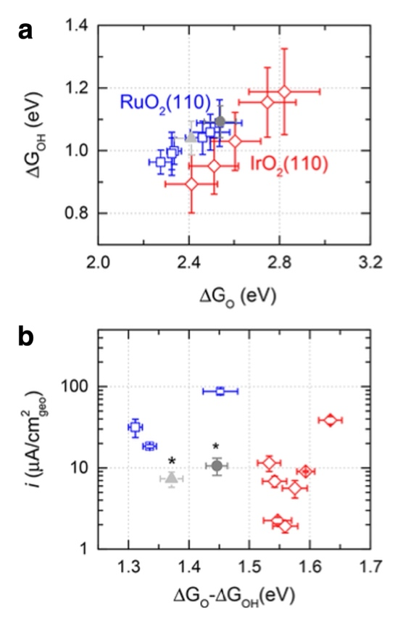
Figure 36 (a) Experimentally measured adsorption energies of O_{ad} and OH_{ad} on RuO₂(110) (blue: without phosphate; gray and light gray: with phosphate) and IrO₂(110) (red) at different pH. (b) Comparison of the OER current density at 1.63 V vs RHE of RuO₂(110) and IrO₂(110) at different pH. The labelled (*) symbols indicate the electrolytes with phosphate ion. Reproduced with permission from Ref⁴⁴¹ Copyright 2018 American Chemical Society.

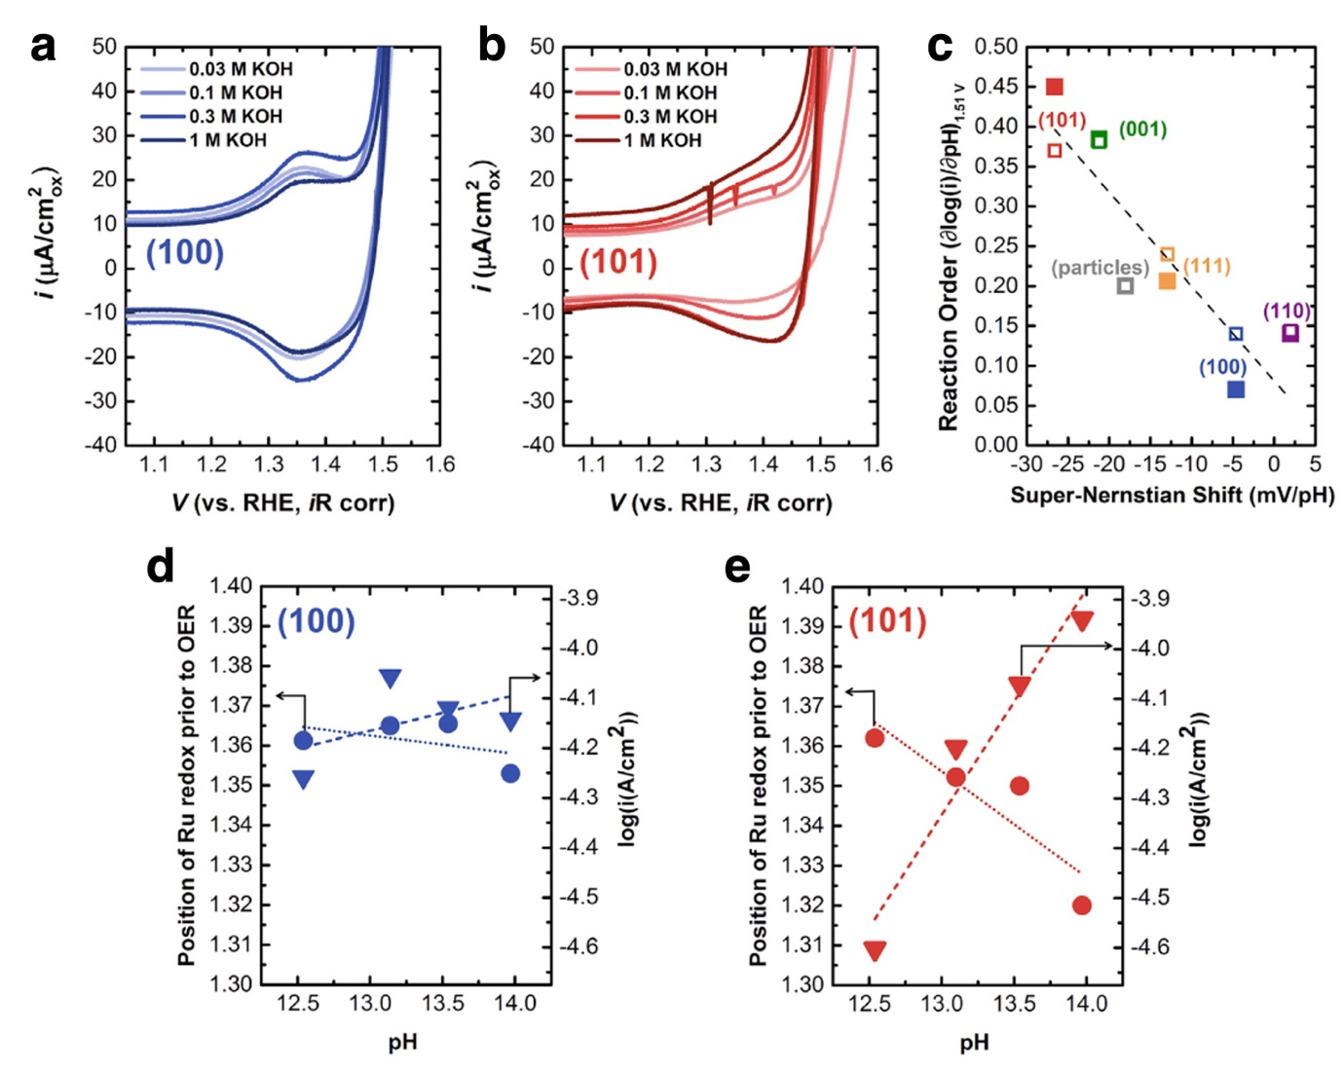
Figure 37 pH Dependence of the Ru Redox at ~1.35 V and OER Current. (A and B) CV measurements at 50 mV/s in Ar-saturated KOH for the (100) surface (A) and the (101) surface (B). (C) The pH dependence (reaction order) for OER activity on the RHE scale was measured by CV (solid) and potentiostatic (open) measurements. The super-Nernstian shift of the redox peak at ~1.35 V on the RHE scale is shown for comparison. (D and E) Position of Ru redox (left, circle) and OER current at 1.51 V on the RHE scale (right, triangle) and the pH used for determining the reaction order and super-Nernstian shift, which are negligible for the (100) surface (D) and notable for the (101) surface (E). Reproduced with permission from Ref³⁰⁸ Copyright 2017 Elsevier.

Stoerzinger et al.³⁰⁸ performed a similar study over differently oriented RuO₂ surfaces under alkaline conditions (in 0.03-1 M KOH; pH: 12.5-14.0), Figure 37. They find a Nernstian shift of the redox transition before the OER onset (at approx. 1.35 V) on the (110) and (100) surfaces but gradually increasing non-Nernstian (termed super-Nernstian) shift in ascending order from the (111) to (001) to (101) surfaces, on the latter of which it was 27 mV/pH. The super-Nernstian shift of this redox peak scaled with the pH dependence of OER activity (Figure 37c), such that the larger negative redox shift was accompanied by a greater pH dependence of OER activity. Although the actual magnitude of these quantities is somewhat ambiguous at close to zero dependence (e.g. the (100) orientation in Figure 37d) trends were clearer for example for the (101) surface (Figure 37e). Interestingly, at an arbitrarily selected pH 13, the (001) surface was the most active, closely followed by the (100); the least active surface orientations were the (110) and (111). The super-Nernstian shift of the pre-OER redox transition, and hence the “earliness” of this surface oxidation process before OER did not track the activity order. On the other hand, the OER activity was found to scale with the integrated charge of the cathodic redox transition at approximately 1.35 V, suggesting that this pre-OER redox transition provides the active sites/species for the reaction. The merge of the oxidation wave under acidic condition with the OER catalytic wave, as seen also in Figure 35a, has an implication to the actual surface state (change) under OER conditions. Interestingly, Lyons and Burke⁴⁴² has found an [OH⁻] reaction order of 0.83 (that is, close to 1) on the OER activity of thermally prepared RuO₂/Ti in 1-9 M NaOH at 80 °C, hence significantly stronger than the largest reaction order of 0.45 obtained by Stoerzinger on the (101) surface orientation. This suggests that either the reaction conditions or the macroscopic nature of the catalyst’s surface has an influence on the pH dependence.

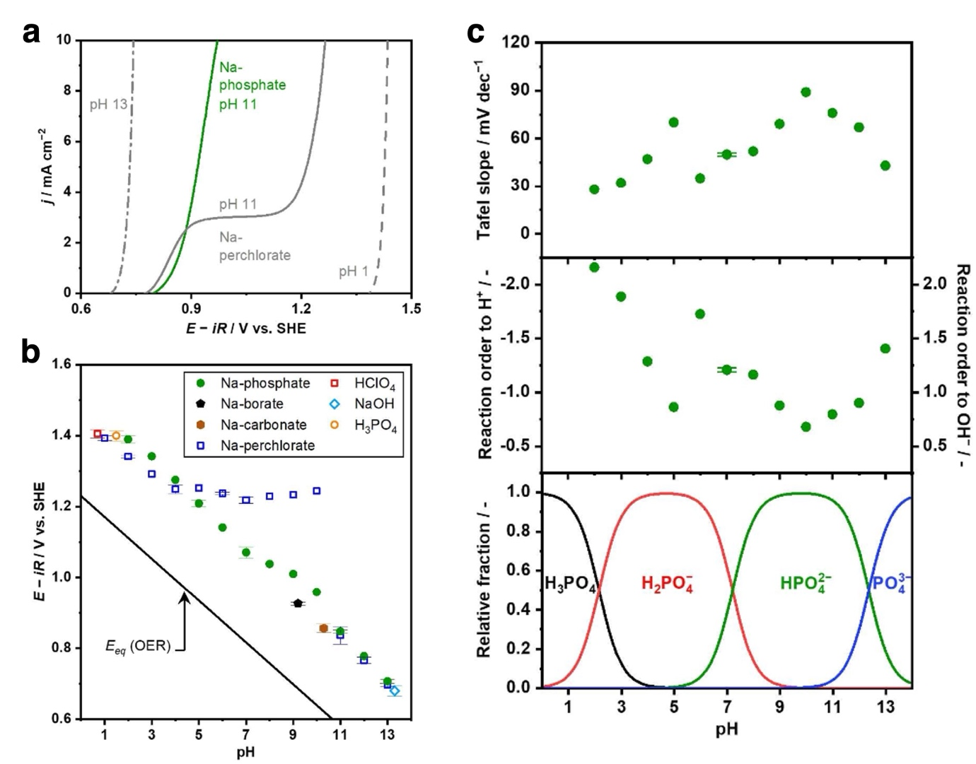
Figure 38 OER over IrO_{x} in various electrolytes. (a) LSVs over the IrO_{x} disk electrode in a RDE configuration are shown (0.1 mol/kg Na-perchlorate at pH 1, 11, and 13, or 0.1 mol/kg Na-phosphate at pH 11, 4900 rpm, -1 mV/sec, 298 K). The numbers in the figure indicate the electrolyte pH in the bulk. (b) Onset potential, defined as potential reaching 1 mA/cm, plotted as a function of electrolyte pH in the bulk. The solid line labeled as E_{eq} indicates the equilibrium potential for the OER. (c) Tafel slopes and kinetic order of the OER at various pH levels over IrO_{x}. (top) Tafel slope values (0.1 mol/kg Na-phosphate at pH 2–6 and 8–13, or 1.0 mol/kg Na-phosphate at pH 7, -1 mV/sec, 298 K). (middle) Calculated reaction order of H⁺ and OH⁻ of the OER over IrO_{x}. (bottom) Composition of phosphate displayed as a function of electrolyte pH. Reproduced from Ref.⁴⁴³ under the Creative Commons Attribution 4.0 License.
Nishimoto et al.^{422, 443} studied the OER kinetics on electrochemically prepared IrO_{x} in the pH range of 1-13 (in both buffered and unbuffered solutions) including Tafel analysis, H/D isotope experiments and temperature dependence. Under the unbuffered conditions, while the anodic current densities monotonically increased with the applied potential at the pH levels of 1 and 13, a two-step anodic event was observed at the weakly alkaline pH of 11 (Figure 38a). This latter the authors assigned to the reactant switching from OH⁻ at the diffusion limiting current to the water molecule once the potential was increased enough to sustain H₂O oxidation after the plateau. The two-step OER current was absent in the phosphate buffered electrolyte. The effect of electrolytes, unbuffered (Na-phosphate) or buffered (the rest), on the potential reaching 1 mA cm⁻² current density is plotted in Figure 38b. Notice, the potential is expressed at the standard hydrogen electrode scale, and hence the OER equilibrium potential shifts 59 mV/pH at RT, the diagonal solid line in the figure. In the unbuffered electrolyte, the OER potential followed roughly the Nernstian expectation at pH levels below 5 and above 10, while it remained constant at pH values in between, due to the shift in the local pH to approximately 4. Upon introduction of a buffering species, the close-to-Nernstian behavior was restored, though the overpotential varied ±0.1 V depending on the actual buffer solution and the pH. Under acidic conditions, noticeable isotope effects were observed, which the authors assigned to the O-O bond formation step being rate limiting. Under unbuffered near-neutral pH condition, the isotope effect was diminished and a sole electron-transfer step was proposed to be rate limiting. Temperature dependent OER experiments expressed in Tafel plots were used to back-extrapolate to the exchange current density and use its temperature dependence to calculate apparent activation energies at pH 7 and pH 1.0. The thus derived values were 36 and 6 kJ/mol, respectively. The value at pH = 1 seems quite unrealistic, which might be the result of the continuously bending Tafel lines at pH = 1, making the back-extrapolation to the exchange current density ambiguous. The Tafel slopes and the kinetic reaction orders were estimated for the phosphate buffered experiments, shown in Figure 38b. The Tafel slope varied substantially with the pH, starting at approximately 30 mV/dec at pH = 2, increasing to 70 mV/dec at pH = 5, followed by a decrease to 35 mV/dec. Increasing the pH then gave rise to a Tafel slope up to 90 and decreased back to 43 mV/dec at pH = 13. These changes were accompanied by changes in the [OH⁻] (or [H⁺]) reaction order. The reaction orders were, however, not measured directly but calculated from the partial derivatives of ($∂$E/$∂$log j)_{pH} (Tafel slop) and ($∂$E/$∂$pH)_{j} for which the average Nernstian pH dependence (60 mV/dec) was used. Based on this calculation, the [OH⁻] dependence ranges between approximately 0.7-2.1, inversely correlating with the variation in the Tafel slope. The authors relate these changes to the modulation of the prevailing buffer species as a function of pH. At this point we note that using the average Nernstian pH dependence might not be justified and instead the true (actual) derivative of ($∂$E/$∂$pH)_{j} would be required for a proper estimation of the reaction orders.

Minguzzi et al.⁴⁴⁴ proposed the construction of “dynamic potential–pH diagrams” by combining thermodynamic Pourbaix diagrams with kinetic data on the example of OER. Among other catalysts, they used a thermally prepared IrO₂ anode to demonstrate their approach. Somewhat similar to Nishimoto’s results, they found the activity higher at acidic (pH 0.1) or alkaline (pH 14.0) pHs, whereas at neutral pH the behavior depended on the nature of the electrolyte. Tafel slopes for the OER were higher at neutral pH (80.6 mV/dec in 1 M phosphate buffer before it bends and 116 mV/dec in 1 M NaClO₄ without buffer) than at the extreme pH values (48.8 mV/dec in 1 M NaOH, 58.9 mV/dec in 1 M HClO₄). At neutral pH the effect of the nature of the buffer solution was strong; currents recorded in 1 M phosphate buffer solution were one-to-two orders of magnitude higher at a given potential than those obtained in 1 M NaClO₄, without any buffer solution. However, at 2.0 V vs RHE, at the most positive potential investigated, currents recorded in the two cases were similar. This behavior was caused by the limited buffer capacity of the 1 M phosphate buffer, which could not compensate for the decrease of the surface pH at the highest current densities, and hence the pH gradient at the electrode surface became similar in the two solutions.

Independent of the electrolyte pH, the nature of the cation can have a strong effect on the OER activity; but not always. Rao et al.⁴⁴⁵ investigated the cation (M = Li, Na and K) and pH dependence on the OER activity of RuO₂(110). They find an alkali cation influence in alkaline (in 0.1 M MOH) conditions but not in acid (in 0.1 M HClO₄ + 0.1 M MClO₄). The position of the CV redox peaks was affected in alkaline and RuO₂(110) was the most active in KOH with LiOH and NaOH lagging approximately 20 mV behind. Hence, the difference in activity was still minimal. Interestingly, the temperature dependence estimated at 320 mV overpotential revealed an apparent activation energy of 0.53 eV in LiOH followed by 0.42 eV in KOH and 0.41 eV in NaOH. A stronger influence of the alkali cation was observed with amorphous IrO_{x}.⁴⁴⁶ The best electrolyte was again KOH and LiOH the worst with approximately 80 mV difference at 10 mA cm²⁻ current density. The sample in LiOH had a larger Tafel slope, and therefore the difference between the two electrolytes further increased at higher potentials. The reduced activity in LiOH was accompanied by a roughly 3-fold reduction of the electrochemically accessible surface area, evaluated in the potential range of 0.8-1.0 V, suggesting a blockage of the surface deprotonation processes.

Even stronger cationic effects were found with perovskites and metal-oxyhydroxides. Duan et al.⁴⁴⁰ studying the OER kinetics of La_{1−x}Sr_{x}CoO_{3−δ} perovskites and amorphous CoOOH and Fe_{0.5}Co_{0.5}OOH investigated the influence of alkali cation in MOH (M: Li, K, Na, Cs), the concentration of the electrolyte (0.1, 0.3 and 1 M) and the temperature. Apart from the electrolyte concentration we discussed above, the nature of alkali cation had a strong impact on the OER kinetics (Figure 34b and d), with Cs⁺ > Na⁺ > K⁺ >> Li⁺ for CoOOH and Cs⁺ > K⁺ > Na⁺ > Li⁺ for Fe_{0.5}Co_{0.5}OOH. This is similar to the report by Garcia et al.⁴⁴⁷ over NiOOH with/without Fe purified electrolytes. In studying the temperature dependence of OER (at constant 400 mV overpotential), the authors could extract the apparent activation energies and the pre-exponential factors. The concentration-independent OER kinetics of Fe_{0.5}Co_{0.5}OOH (Figure 34c) was found to be accompanied by an almost perfect compensation of the increase of the activation energy by an increase of the pre-exponential factor (Figure 34e). The dependence on the alkali cation (Figure 34d) was primarily driven by the decrease of the activation energy (Figure 34f) from ≈ 60 kJ mol⁻¹ in 1 M LiOH to 20 kJ mol⁻¹ in 1 M CsOH, though the effect of concomitantly decreasing pre-exponential attenuated the influence of E(a). For the Fe-free CoOOH the concentration dependence of KOH appeared to arise from the increase of the apparent pre-exponential factor. This increase may be explained by the greater number of active sites/species at larger pH or by the change in the entropy of activation due to modification of the electrolyte structure surrounding the active sites. For the La_{1−x}Sr_{x}CoO_{3−δ} perovskite samples the authors find a decrease of the experimentally determined apparent activation energies with increasing OER activity at fix (0.1 M) KOH concentration, similar to Bockis and Otagawa,⁸⁴ but including all data at various KOH concentrations revealed a loose linear correlation between apparent activation energy and the pre-exponential factor, suggesting again a compensation effect.

The influence of anions on the OER is less studied and often overlooked, but there are a few interesting examples. Vos et al.⁴³⁷ investigated the parallel evolution of Br₂ , Cl₂ and O₂ over IrO_{x}, their competition, with a special focus on the selectivity towards oxygen. Bromide and chloride are competitively absorbed on IrO_{x}, and their adsorption significantly slows down the OER. This effect was found to be additive. Bromide had a particularly strong influence, even a relatively small amount of bromide highly affected the oxygen evolution selectivity. Another anion that is reported to poison the surface of IrO_{x} is sulfate. Arminio-Ravelo et al.⁴⁴⁸ compared the influence of sulphuric acid and perchloric acid on the OER activity of electrochemically prepared IrO_{x}, at three concentration levels (0.05 M, 0.1 M and 0.5M). While the concentration of H₂SO₄ interfered with the oxidation of IrO_{x} and decreased its catalytic performance, HClO₄ did not show strong interferences with the electrochemistry of IrO_{x}. With increasing concentration of H₂SO₄, (i) the characteristic features corresponding to hydrogen adsorption and desorption disappeared as the number of cyclic voltammetry cycles increased, (ii) the oxidation wave at approximately 0.9-1.0 V has shifted to higher potentials and decreased in intensity, (iii) the OER activity and (iv) catalyst stability decreased. These observations suggest a stronger adsorption of HSO₄⁻ and SO₄²⁻ on the catalysts surface compared to ClO₄⁻. Somewhat similar sulfate poisoning was observed by Seow et al.⁴⁴⁹ They investigated SrCo_{0.9}Ir_{0.1}O_{3-δ} perovskite, which under acidic condition undergoes Sr and Co leaching and forms an amorphous IrO_{x} at the surface. They find that besides a sulfate adsorption-induced performance decrease, SrSO₄ has formed on the surface of the sample, which enhances the OER degradation.

The above collection of experiments illustrates that the influence of the actual electrolyte, more often than not, cannot be a priori neglected. Both the pH and the dissolved ions can have a profound effect on the OER performance, which were neglected in the CHE approach. It is therefore crucial to increase the complexity of theory and account for non-Nernstian processes in the chemistry of OER catalysts. In the next segment we uncover how theory can incorporate electrolyte in its calculations and later how these results may be used in microkinetic modeling.

Modeling the electrified solid/liquid interface

The interface between an electron conductor, the electrode, and an ion conductor, the electrolyte, is defined as the electric double layer (EDL). When the potential of the electrode is altered by the application of an external bias, electrons flow into or out of the electrode and, correspondingly, the distribution of ions in the electrolyte will be altered to screen the electrode charge. Driven by electrostatics, the electronic and ionic charges in the EDL are therefore rearranged, ensuring its global charge neutrality. This leads to structural changes as well as to a polarization of the interface. Clearly these effects can have an impact on the thermodynamics and the kinetics of the elementary steps of an electrochemical process like the OER. This is because some of the intermediates, reactants or products involved in the OER elementary steps can be charged or have a strong dipole that can couple to changes in the interfacial electric filed; the intermediates can form hydrogen bonds with the water molecules at the interface, and structural changes in the EDL can therefore influence the stability of the intermediates. One of the assumptions of the CHE approach, however, is that the adsorption energy of the reaction intermediates is independent of the interfacial electric filed.⁴⁵⁰ Moreover, some of the earliest applications of the CHE approach ignored even solvation effects, modeling the interface in vacuum. In this section we will discuss several attempts that have been made to model the effects of the EDL on the energetics of electrochemical reactions.

Modeling computationally the elementary electrochemical steps taking place in EDL is a formidable challenge.⁴⁵¹ The EDL typically extends for several nanometers, which requires exceedingly large computational cells. The liquid nature of the electrolyte requires accurate sampling of the configurational degrees of freedom to obtain statistically meaningful thermodynamic properties, which translates in long MD simulations. The reorganization of water molecules at the interface with a metallic electrode, in particular, has a characteristic relaxation time of the order of 1 ns,⁴⁵² a timescale not suitable for first principles MD. Since the electrode in experiments is held at fixed potential, in an electrochemical elementary step the electronic charge of the electrode is not constant. The system being simulated is therefore an open system, requiring in principle a grand canonical simulation at fixed electron chemical potential rather than a traditional simulation at fixed charge. Accounting, at the same time, for all these aspects is a daunting task, but significant progress has been made in the last few years to address each of these challenges.

The CHE approach⁵⁹ simplifies the problem modeling the system at constant charge rather than at constant potential. The only effect of the applied bias in this method is through the chemical potential of the electrons in the electrode. This implies that during an elementary step the electrode potential changes as the reaction proceeds from the initial to final state, at variance with the experimental case, where the electrode potential is constant. Moreover, the electrolyte in the earliest applications of this approach was either ignored altogether, i.e. the simulations were performed in vacuum,⁸⁸ or modeled explicitly via static water monolayers or bilayers.^{59, 87} Here we will describe some of the most significant attempts at overcoming two of the main limitations of the earliest applications of the CHE approach, namely the fact that the charge rather than the potential was kept constant, and the crude approximation of the structure of the EDL. As we will see, the various approaches that have been proposed in the last two decades often address both aspects simultaneously. This is connected to the fact that the EDL is globally neutral, so that introducing an approach to treat a charged electrode entails treating the response of the electrolyte, therefore requiring a suitable model for the counterions in the electrolyte.

Effects of the liquid environment on the relative stability of the OER reaction intermediates

We first address how researchers modeled the interactions of the electrolyte with the reaction intermediates in the special case of a neutral surface in a globally neutral electrode/electrolyte system, which is representative of the potential of zero charge. We focus in particular on the case in which the electrolyte is pure water. The intermediates of the OER (*OH, *O, *OOH) interact with water electrolytes mostly through hydrogen bonds. The earliest works aiming at capturing these effects did so treating water explicitly and considering 1 to 3 water bilayers in contact with the catalyst surfaces.^{87, 204, 453} The structure of water layers was locally optimized and the interaction was found to be significant for *OH and *OOH (around 0.3 eV) and negligibly small for *O.

Using a similar approach, Gauthier et al.⁴⁵⁴ considered the OER on IrO₂(110), modeling water explicitly. They included from 1 to 3 water layers and obtained their structure via a global optimization method based on minima hopping. Their main finding is that the solvent stabilization is quite pronounced, up to 0.4 eV, for adsorbed *OH and *OOH, which are capable of donating hydrogen bonds, while the number of water layers included in the model does not play a very significant role, with 2 water layers being sufficient to obtain converged results. This seems to be in contradiction with the results of Liu et al.,⁴⁵⁵ who found the number of layers can play a significant role, especially for the *OOH intermediate: the solvation energy changes from -0.54 eV using 1 water bilayer to -0.79 eV when using 3 bilayers.

Rather than optimizing the structure of the electrolyte, Heenen et al.⁶¹ used first-principles molecular dynamics (FPMD) to explicitly model the electrolyte in an effort to compute the stabilization effect on several adsorbates relevant for the OER, and also CO₂ reduction. We will include both classes of intermediate as doing so highlights the generality of the findings. In particular, they considered *CO, *CHO, *COH, *OCCHO, *OH, and *OOH adsorbates on Cu, Au, and Pt facets solvated by water. *OH and *OOH interact strongly with the solvent, with solvation energies up to 0.7 eV. The authors showed that the two main contributions of the solvent to the adsorption properties of these intermediates are hydrogen bonds and the fact that water competes with the adsorbates for adsorption on the surface. They were also able to derive quantitative correlations between these two contributions and solvation energies. In particular, they established that adsorbates like *OH and *COH are stabilized via H-bonds, while *CO and *COH are destabilized by competitive water adsorption.

Wang et al.⁴⁵⁶ modeled the OER on rutile TiO₂(110) using FPMD with an explicit description of the water solvent. They evaluated the solvation effects on the stability of the OER intermediates by extracting snapshots from the MD and optimizing them. The solvation effects $E_{int}^{i,j}$ for intermediate i and snapshot j were estimated writing the total energy between the full system $E_{tot}^{i,j}$ as a sum of the total energies of the catalyst surface $E_{catal}^{i,j}$, the water $E_{water}^{i,j}$subsystems and their interaction, at fixed ionic positions:
$$E_{tot}^{i,j}= E_{water}^{i,j}+E_{catal}^{i,j}+E_{int}^{i,j}$$ | Equation 71
These interaction energies were then averaged over the snapshots to yield the solvation energies on various surface structures and adsorbates. The very same approach was used also by Nong et al.⁶³ to model the OER on IrO₂(110).

Similarly to the work of Wang et al.⁴⁵⁶, the strategy adopted by Chun et al. in their very recent work⁴⁵⁷ is also based on the structural optimization of several snapshots extracted from FPMD simulations of various reaction intermediates with an explicit description of the water solvent. Focusing on the ORR on Pt(111), the authors estimated the solvation energy for the *OH and *OOH intermediates to be -0.56 eV and -0.27 eV, respectively. A 0.3 eV difference in the solvation energy between these two intermediates is clearly non-negligible. Furthermore, the authors showed that static water bilayers (1 to 3 bilayers were considered) often adopted^{87, 453, 458} to model solvation effects in electrocatalysis capture reasonably well the solvation energy of *OH (with errors below 0.1 eV) while the errors on the *OOH intermediate can be as large as 0.5 eV.

Another approach to quantify the effects of the water solvent on the stability of the OER intermediates was proposed by Gono et al.⁶⁰, who modeled the interface between the rutile TiO₂(110) surface and explicit water. The authors used the thermodynamic integration approach of Sprik and coworkers⁴⁵⁹ to compute the free energy cost of a dehydrogenation step:
$$G(P)-G(R) = ∆G_{dh} = ∆A_{dh} + ∆_{zp}E = \int_{0}^{1}{{〈∆_{dh}E〉}_{λ}dλ} + ∆_{zp}E$$ | Equation 72
where $∆A_{dh}$is the dehydrogenation free energy integral and $∆_{zp}E$ is the zero-point energy difference between reactants (R) and products (P). The term $∆A_{dh}$ is evaluated by time-averaging the vertical dehydrogenation energies ${〈∆_{dh}E〉}_{λ}$ , computed along a FPMD simulation performed at fixed values of the Kirkwood coupling parameter λ. In practice, the forces acting on atoms are obtained by linearly interpolating the forces computed on the potential energy surface of the reactant and products at various values of λ, and the integral is performed on a very limited number of points usually 3-5. These simulations are far from trivial and are computationally very demanding, and Gono et al.⁶⁰ compared the values of $∆G_{dh}$obtained with and without explicit water to infer the effects of solvation. They found that water can have a significant impact on the reaction energy of some of the OER elementary steps, in particular the cost of dehydrogenating the *OH intermediate to *O is lowered by 0.54 eV compared to vacuum (from 2.36 eV to 1.82 eV), while the effect on the other elementary steps is below 0.1 eV.

Describing water-based electrolytes explicitly, as done in the approaches described above, has distinct advantages and drawbacks. On the one hand, it allows an accurate description of the structure of water at the solid/liquid interface, of the H-bond network around reaction intermediates, of the partial solvation of counterions close to the surface; on the other hand, sampling the thermal fluctuations of liquids requires long MD simulations, and varying semi-continuously the charge of the counterions require large simulation cells. In fact, referring to full ab initio MD simulations of electrochemical systems, Letchworth-Weaver and Arias wrote in 2012 that "such calculations are necessarily of the heroic type", given their tremendous computational cost.⁴⁶⁰ Nowadays, with the increased computational resources at our disposal, these calculations are becoming more accessible but remain nonetheless very time consuming.

Implicit solvent models, where the solvent is described via a polarizable continuum, represent an alternative approach, allowing one to accurately capture the dielectric properties of the electrolytes and the electrostatic effects of the counterions, but typically failing in describing directional H-bonds and the modified properties of water close to an interface, where the partial quenching of translational and rotational degrees of freedom of water molecules results in reduced screening and a stiffer H-bond network, which significantly impacts the transport of reactants and products in proximity of the reaction sites.^{461, 462} The use of implicit solvents in electrocatalysis is the subject of an excellent recent review by Ringe et al⁶², while for a general overview of implicit solvent models we refer the readers to the review by Tomasi et al.⁴⁶³.

Heenen et al.⁶¹ used two popular continuum solvation models to compute the interactions of water with the OER—and CO₂ reduction intermediates, which we will include for generality. They compared their findings to FPMD simulations. The solvation models tested were the VaspSol continuum solvation in VASP and the self-consistent continuum solvation (SCCS) model of the Environ module⁴⁶⁴ in Quantum ESPRESSO⁴⁶⁵. The authors found the two models yield almost identical results, both of which however deviate substantially from the reference ab initio MD simulations, especially for adsorbates like ∗OH and ∗OOH where the interaction with the solvent is strong. Implicit solvation in fact overestimates the binding strength of all adsorbates on Cu(211) by 0.2–0.3 eV, while for (111) surfaces it underestimates the *OH binding strength by 0.3–0.6 eV and the *OOH binding strength on Au(111) by 0.2 eV. Figure 39 shows the adsorption energy and the solvation energy of various adsorbates in four different surfaces. The mean average error (MAE) in the adsorption energy relative to FPMD computed with implicit solvents is 0.24 eV, which originates almost entirely from the MAE in the solvation energy, 0.22 eV. The MAE in the adsorption energy computed in vacuum is 0.24 eV. The authors therefore concluded that they “find no apparent advantage in applying continuum solvation in comparison to a basic solid/vacuum calculation to determine adsorption energies at the metal/water interface”. The failure of the two implicit solvation models considered in this work is attributed to their inability to describe directional hydrogen bonds, implying that more sophisticated solvation models like the charge-asymmetric nonlocally-determined local-electric model (CANDLE)⁴⁶⁶ or the reference interaction site model (RISM)⁴⁶⁷ might not suffer from this problem.

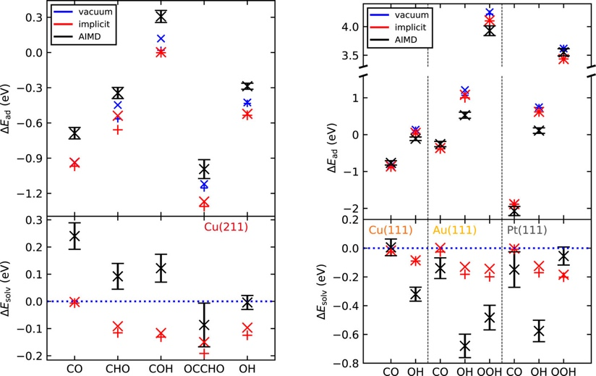
Figure 39 Adsorption ΔE_{ad} (top) and solvation energies ΔE_{solv} (bottom) for the adsorbates sampled on Cu(211) (left) and Cu(111), Au(111), and Pt(111) (right). Black symbols with error bars present the AIMD data; red and blue symbols present data obtained through geometry optimizations with and without implicit solvent. × symbols represent the time or site averaged data, and + symbols represent the most stable configuration obtained from geometry optimizations. Reproduced with permission from Ref.⁶¹ Copyright 2020 AIP Publishing.

Rajan et al.²³² modeled the OER on β-NiOOH, considering two facets and various active sites using hybrid functional calculations. They found that different facets and active sites can promote the OER via different mechanisms, but that the lowest overpotential on the two facets are remarkably similar, around 0.4 eV. They performed the calculations in vacuum using the CHE approach and they also evaluated the effects of solvation via an implicit PCM solvent model. They found that the effects of solvation on the energetics of the elementary steps are at most 0.09 eV. This is fully consistent with the results of Heenen et al.'s work⁶¹ discussed above, but warrants some caution since the effects of explicit treatment of water can be as large as the overpotential determined for this system.

Modeling electrochemical systems at fixed potential

One key assumption of the CHE approach is that the adsorption energy of the reaction intermediates is independent of the electrostatic field present at the electrode/electrolyte interface.⁴⁵⁰ Using a Pt(111) surface model, Karlberg et al.¹²⁸ computed how the adsorption energy of the intermediates of the ORR/OER (*O, *OH, *OOH) depends on the strength of an external electric field. To model the water solvent, the authors included a water bilayer in the case of *O, while for *OH and *OOH the authors included one water molecule per *OH and *OOH molecule. Assuming a voltage of 1.23 V and a double layer thickness of 3 Å, the authors argue that the interesting interval of electric field strength is the -0.5 and +0.5 V Å⁻¹ range. They show that the changes in adsorption energies are at most 0.1 eV, a value sufficiently small not to invalidate the predictions based on the CHE, where this effect is ignored, but sufficiently large to warrant caution when seeking for accurate predictions close to the top of the activity volcano. In general, one can expect adsorbates with large dipole moments to be more strongly affected by the interface electric field⁴⁵⁰, so in these cases including explicitly this effect can be necessary.

The interface electric field discussed above is intimately related to the electrode surface charge and to the response of the electrolyte that screens that excess charge with an equal and opposite charge provided by the counterions in the EDL. If we wish to model electrochemical reactions at an electrified solid/liquid interface, we need an approach that is able to treat charged interfaces. In this task, we are faced with the problem that simulations are normally performed at constant charge conditions, while experiments are performed at constant potential. To circumvent this problem, one strategy is to devise ways to obtain constant potential conditions from constant charge simulations. To this end, in 2008 Rossmeisl et al.⁴⁶⁸ considered a periodic system made of a Pt(111) electrode surface, modeled via a slab geometry, in contact with up to three water layers, optimized and static, and separated from periodic replicas via a vacuum region. They computed the work function of the system, therefore obtaining an internal definition of the absolute potential scale. Inserting hydrogen atoms in the water layers leads to charging of EDL, namely the electrons of the hydrogen atoms are spontaneously transferred to the electrode, while protons are added to the ice-like water layers (see Figure 40). Performing simulations varying both the unit cell and the number of hydrogen atoms inserted in the double layer, Rossmeisl et al. essentially modeled the EDL as a capacitor. Monitoring the change in electrode potential via the work function, the authors obtained the vacuum potential relative to SHE, i.e. absolute level of SHE, 5.17 V, in reasonable agreement with Trasatti's experimental estimate, 4.44 V.⁴⁶⁹ Next, the authors showed how to use this information to obtain reaction energies and activation energies at constant potential rather than at constant charge. They considered the elementary steps of an electrochemical process, the hydrogen evolution reaction, and computed how the electrode potential changes during an elementary step. The fact that the change in the electrode potential ΔU is non-zero is obviously an artifact due to the simulation being performed at constant charge rather than at constant potential. Keeping the EDL charge density constant and increasing the simulation size, however, the variation of the potential reduces linearly, so that it can be extrapolated to the infinite cell limit, where ΔU is zero. In this manner, the authors obtained an estimate of the reaction energies at constant potential (ΔU=0) as a function of the charge of the EDL, which is a function of the electrode potential U (see Figure 40).
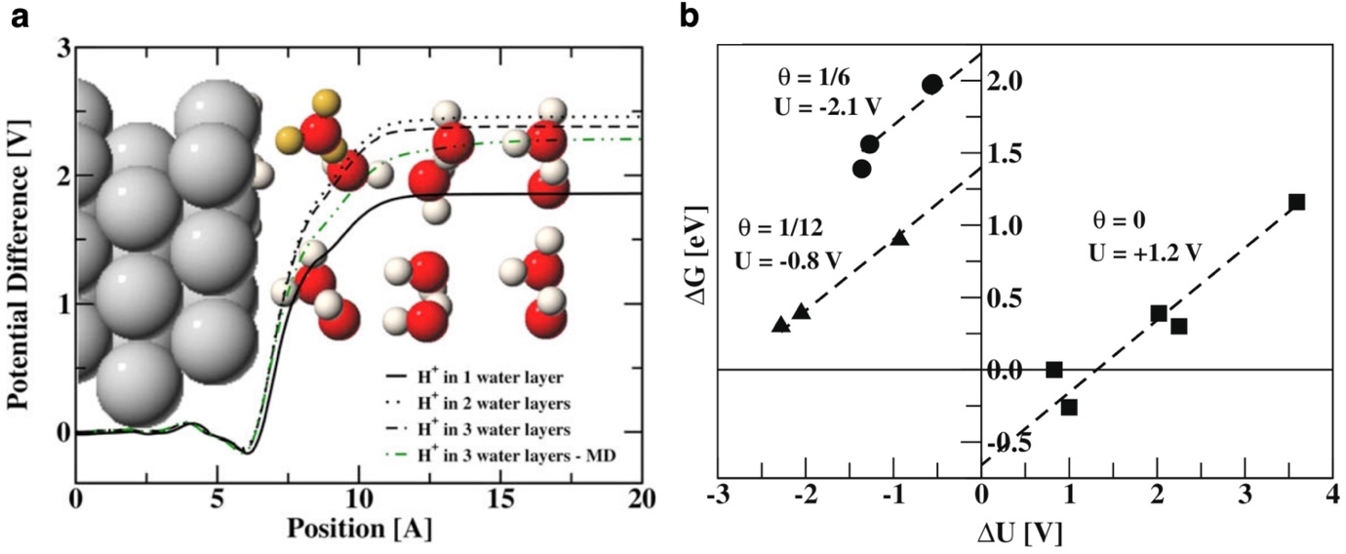
Figure 40 (a) A charged Pt(1 1 1) slab with 3 water layers outside and one solvated hydronium ion (yellow) per unit cell. The electrode potential, due to the charged interface, averaged parallel to the surface is shown for systems with 1, 2 and 3 relaxed water layers along with results from a DFT MD simulation of a proton solvated in 3 water layers. The latter potential profile is an average over 30 frames, picked randomly along a 3 ps trajectory, obtained after equilibration of the system at room temperature. (b) The reaction free energy of the Heyrovsky reaction: H₂ → H⁺ + e⁻ + H∗ as a function of the electrode potential change during the reaction, shown for different potentials. The extrapolation to ΔU = 0 gives the free energy values at given potential (or proton coverage) in the limit when the potential does not change during the electron-transfer reaction. The slope of the extrapolation is fixed to the theoretical value of 1/2. Reproduced with permission from Ref.⁴⁶⁸ Copyright 2008 Elsevier.
Another early attempt at modeling the electrified electrode/electrolyte interface is the work by Filhol and Neurock,^{470, 471} who, in 2006, introduced the "double reference" method. The authors modeled a metallic slab in contact with explicit water and performed calculations varying the number of electrons in the system. Charge neutrality was ensured by the uniform background charge applied in periodic calculations to avoid the divergence of the total energy in non-neutral systems. While in real systems the charging of the electrode would be compensated by a change in the concentration of the counterions in the EDL, here the role of the counterions is played by the uniform background charge. Inserting a vacuum layer inside the liquid region, the authors obtained a reference level to measure the potential in various region of the systems. By assuming that the potential inside the electrode is not influenced by the presence or absence of the vacuum region, the authors obtained a second reference potential, used to monitor the changes induced by the variation of the electronic charge of the system. With this approach, Filhol and Neurock modeled the activation of water at the Pd(111) surface, obtaining the phase diagram of the system as a function of the applied bias,⁴⁷⁰ monitoring the following two equilibria:
$$Pd-H_{2}O + e^{-} ⇄Pd-H + OH^{-}$$ | Equation 73
$$Pd-OH + H^{+}+e^{-} ⇄Pd-H_{2}O$$ |  | Equation 74
The authors considered a static model of the EDL, i.e. no attempt was made at sampling the structure of the liquid phase. In spite of these limitations, this is one of the first periodic DFT calculations aimed at modeling the effects of an applied potential, obtained by varying the charge of the system, on the energetics of an electrochemical process.

An alternative approach to model the electrified solid/liquid interface was proposed in 2006 by Otani and Sugino, who introduced the effective screening medium (ESM) approach⁴⁷² to model charged surfaces in contact with a dielectric. The authors solved the Poisson equation to determine the electrostatic potential retaining the periodicity only in the plane parallel to the surface, while imposing different boundary conditions in the normal direction, via the use of the Green's function technique. The electrolyte was modeled via the modified Poisson-Boltzmann model. This approach allows to impose a bias by fixing the electron chemical potential μ_{e-}, obtaining the number of the electrons self-consistently, similarly to Lozovoi et al.'s scheme to treat charged slabs.⁴⁷³ This approach gives the grand potential as a function of μ_{e-} and allows one to discuss the stability of different surface structures as a function of the applied bias. Nong et al. used these schemes to model the kinetics of the OER on the IrO₂(110) surface at constant potential.⁶³

The original ESM scheme was then coupled to FPMD to perform simulations at constant electrode potential⁴⁷⁴, via the use of a second order dynamics for the number of electrons, where the force acting on the electronic degree of freedom is the deviation of the instantaneous electrode potential from the target value. The working electrode, modeled with a periodic slab geometry, was in contact with a counter electrode, modeled with the ESM scheme, providing the countercharge and the reference potential. This kind of grand canonical simulation therefore realizes a numerical potentiostat.

A significant extension of the ESM method was achieved when Nishihara and Otani coupled it with the 3D version of RISM,^{475, 476} an implicit solvent model that allows one to describe specific interactions between the solute and solvent, using a classical force field modeled via a Lennard-Jones potential and point charges. This solvent model computes the equilibrium radial correlation functions of each pair of species present in the electrolyte, yielding the solvent structure around the solute, i.e. the solid/liquid interface. The authors developed a self-consistent method where the point charges of the system described explicitly are replaced by the DFT charge density, using the mixed boundary conditions (2D-periodic parallel to the surface and open in the normal direction) of the ESM approach. The authors modeled an Al(111) slab in contact with a NaCl (aq) solvent, varying the applied bias, and obtaining the solvent distribution under grand canonical conditions, therefore describing the variations of the structure of the EDL as the charge of the electrode changes with a varying bias (see Figure 41). This approach has been applied to model a variety of electrocatalytic reactions, including the HER⁴⁷⁷, CO₂ reduction⁴⁷⁸ and very recently the OER⁴⁷⁹ as well.
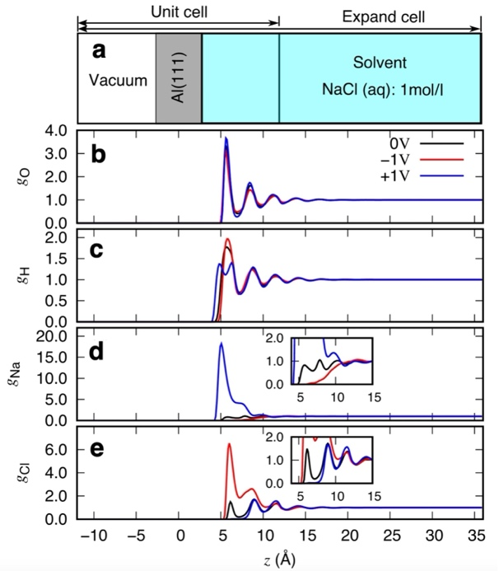
Figure 41 (a) Geometric configuration of the solid/liquid interface (vacuum/slab/solvent model). Normalized distribution function for (b) O, (c) H, (d) Na, and (e) Cl with different bias potentials. The Fermi energies of the systems are –5.3, –4.3, and –3.3 eV for –1.0, 0.0, and +1.0 V vs pzc, respectively. Adapted from Ref.⁴⁷⁶ under the Creative Commons Attribution 4.0 License.
Letchworth-Weaver and Arias⁴⁶⁰ in 2012 introduced an approach to model electrode/electrolyte interfaces at constant potential on the basis of joint density functional theory. While formally based on an exact theory for an explicit quantum-mechanical system in thermodynamic equilibrium with an environment characterized by nuclear densities of the electrolyte⁴⁸⁰, the first practical implementations of this scheme reduce to modeling the electrolyte via the linearized Poisson-Boltzmann equation:
$$-∇∙(ϵ_{b}s(r)∇ϕ(r))+κ^{2}s(r)ϕ(r)=4πρ_{el}(r)$$ | Equation 75
where $ϵ_{b}$ is the bulk dielectric constant of the solvent, $s(r)$ is the cavity shape function, $ϕ(r)$ is the electrostatic potential, $κ$ is the inverse Debye screening length due to the presence of ions in the electrolyte, $ρ_{el}(r)$ is the electron density. This approach therefore bears significant similarities with the work of Jinnouchi and Anderson⁴⁸¹, who first introduced a scheme to couple DFT calculations of charged slabs with a modified Poisson-Boltzmann description of the electrolyte. Different implicit solvation models differ in how the cavity shape function is determined on the basis of the electron density.⁴⁸² This approach therefore allows one to model the electrostatic screening provided by the electrolyte without performing long MD simulations and allows one to obtain an absolute reference to measure potentials against, since the boundary conditions imposed in the model yield a potential in the electrolyte equal to zero at infinity. Moreover, simulations can be performed in the grand canonical ensemble, i.e. at fixed electron chemical potential rather than at fixed number of electrons, via the use of suitable algorithms to ensure numerical convergence.⁴⁸²

Ping et al.²⁶⁵ modeled the OER on IrO₂, the only known catalyst that is both highly active and stable in acidic conditions, using the constant potential approach of Arias and co-workers^{460, 482}, combining DFT calculations of the IrO₂(110) surface with the CANDLE⁴⁶⁶ implicit solvent model and a linearized Poisson-Boltzmann equation to treat counterions. The authors first computed the surface phase diagram as a function of the applied bias (Figure 42b, see also Figure 57), thus obtaining the degree of surface oxidation at increasingly anodic conditions. Starting with both μ₁-O top sites and μ₂-O bridge sites protonated, they found that the first dehydrogenation of a μ₂-O bridge takes place slightly below 1.2 V (NHE), above 1.21 V (NHE) both the μ₂-O sites are dehydrogenated, and above 1.50 V the surface is completely oxidized. The voltage window over which the complete dehydrogenation of the surface takes place if therefore approximately 0.3 V. This approach has been uses also in other works on the OER: Zhou et al.⁴⁸³ focused on IrO₂(110), obtaining results very similar results to those obtained by Ping et al. discussed above, while Goddard and co-workers focused on NiFe-oxyhydroxide^{65, 484} electrocatalysts. The method has also been applied to investigate other electrocatalytic processes: Goodpaster et al.⁴⁸⁵ for example, modeled CO₂ reduction on Cu(100).

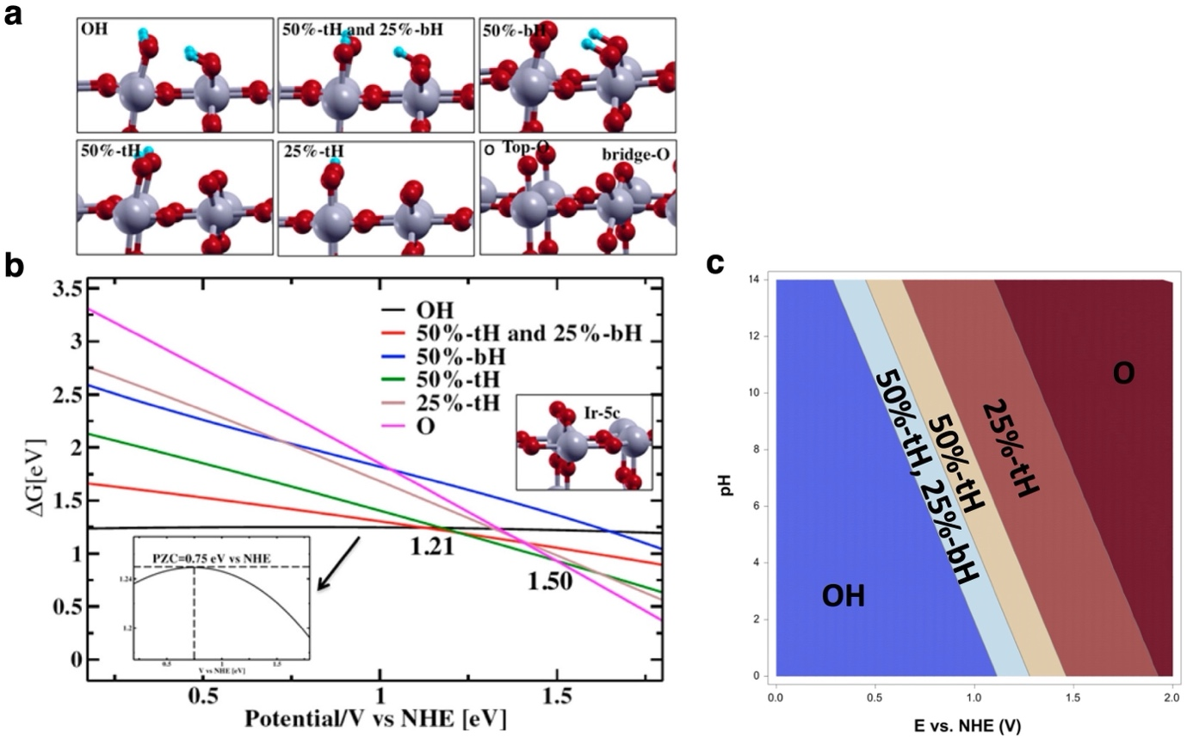
Figure 42 (a) The six panels show the surface structures with different OH terminations. Black curve, OH terminated surface; red curve, 75% OH terminated surface with 50% top O and 25% bridging O; blue curve, 50% OH terminated surface with bridging O; dark green curve, 50% OH terminated surface with top O; gray curve, 25% OH terminated surface with top O; purple curve, O terminated surface. (b) Surface phase diagram of IrO₂ (110) with one monolayer of H₂O as a function of applied potentials. The inset figure in panel (b) shows the zoom-in of the black curve (OH terminated surface) where the crossing of horizontal tangential line and the vertical line shows the potential of zero charge of IrO₂ (110) surface in solution at pH = 0. The purple and dark green lines cross at 1.50 eV and the red and dark green lines cross at 1.21 eV. The surface structure inside the surface diagram is the stoichiometric (110) IrO₂. (c) The Pourbaix diagram computed for the IrO₂(110) surface computed by Nong et al.⁶³, using the same labels as Ping et al.²⁶⁵ in panel (b). Panels (a) and (b) are adapted with permission from Ref.²⁶⁵ Copyright 2017 American Chemical Society. Panel (c) is adapted with permission from Ref.⁶³ Copyright 2020 Springer Nature.

It is interesting to compare the findings of Ping et al. on IrO₂(110) with those reported by Nong et al.⁶³ (see Figure 42c) on the same system, where the solvent was treated explicitly. In this case the first dehydrogenation takes place at 1.25 V (NHE), in good agreement with the results of Ping et al, but at 1.50 V (NHE) the hydrogen coverage is still 50% and the voltage necessary to completely oxidize the surface is 2.20 V (NHE). The voltage window for complete dehydrogenation is therefore around 1.0 V, suggesting a significant interaction among adsorbates (Frumkin behavior). Nong et al.⁶³ compared these findings to simulations in vacuum, where they found no such effect and the dehydrogenation window is therefore essentially zero, suggesting a key role of the solvent in stabilizing the protonated ligands. The experiments reported by Nong et al.⁶³, based on in situ XAS, show that the dehydrogenation of surface OH groups extends well above 1.5 V, in agreement with their theoretical model.

Gauthier el al. in their recent perspective⁴⁸⁶ discussed the challenges in modeling electrochemical processes using implicit solvent models and treating counterions via the linearized Poisson-Boltzmann equation. While this approach enables modeling the solid/liquid interface at constant potential, the description of the electrolyte can, in some cases, be problematic, resulting in unphysical buildup of charge close to the surface and the adsorbates. These problems can be mitigated by giving ions a finite size, as done in the modified Poisson-Boltzmann equation, an approach which has been discussed at length in Ringe et al.'s recent review on this topic.⁶² An implementation of the modified Poisson-Boltzmann equation in combination with implicit solvent model for constant potential calculations in the ONETEP linear-scaling DFT code⁴⁸⁷ has been recently presented by Bhandari et al.⁴⁸⁸.

An alternative to modeling counterions as a diffuse layer via the linearized or the modified Poisson-Boltzmann equation is represented by fixed planar models. Hörmann, Andreussi and Marzari discussed such an approach, which enables grand canonical simulations of electrodes in contact with an implicit solvent model.⁴⁸⁹ In this case, the solvent model adopted is the self-consistent continuum solvation (SCCS) model of Andreussi et al.⁴⁶⁴ and the counter charges present in the electrolyte to compensate for the charge on the electrode are modeled via a Gaussian-shaped counter-charge layer fixed a few Ångstroms from the surface.

The implicit and explicit models of the electrolyte described above can also be combined. Gauthier et al.⁴⁹⁰ investigated different manners of charging the interface: explicitly, by introducing co-adsorbates and/or varying the surface unit cell; implicitly, using a polarizable continuum and treating the counterions via the Poisson-Boltzmann equation (linearized or modified) or via a planar countercharge. The authors proved that different manners of charging the interface result in different capacitances, which in turn leads to not uniquely defined energetics of electrochemical steps when the potential is determined via the work function (see Figure 43a). Interestingly, the authors show that the effective surface charge, rather than the work function, is a considerably better descriptor of the driving force for an electrochemical step (see Figure 43b). The effective surface charge is defined as the surface charge transferred between initial and final state of an elementary electrochemical step plus the surface charge added implicitly. The authors argued that this behavior is due the fact that constant potential approaches, as determined by the work function, can achieve constant bulk potential rather than constant local potential, hence they display cell size dependence. The effective surface charge, depending on the local potential driving the electrochemical step, achieves the desired independence on the cell size.

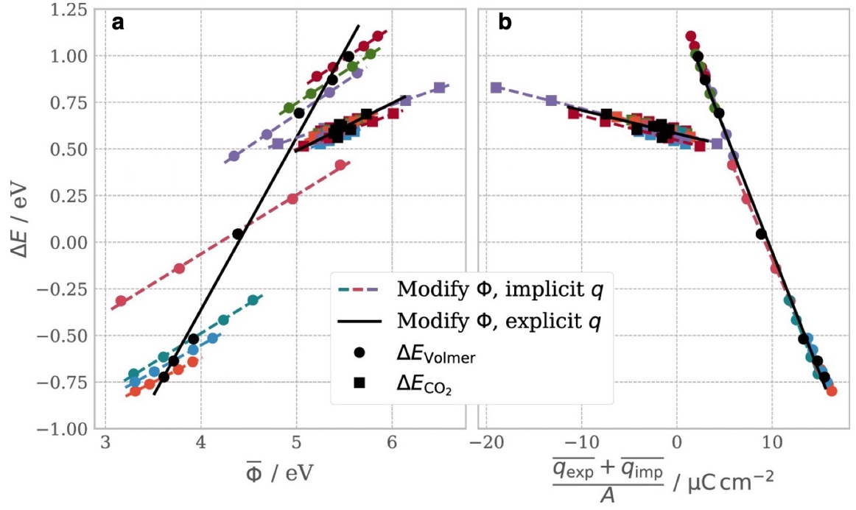
Figure 43 Reaction energetics of CO₂ adsorption and the Volmer reaction as a function of (a) the average work function (i.e., the grand canonical constant potential reaction energy), corresponding to the potential as the descriptor for the driving force. Panel (b) shows the same data set with the driving force given instead by the effective surface charge. Adapted with permission from Ref.⁴⁹⁰ Copyright 2019 American Chemical Society.

Modeling electrochemical systems at fixed pH

As discussed above, most simulations are performed at fixed charge while experiments are performed at fixed potential. This discrepancy drove researchers in the field either towards the developments of grand-canonical methods to impose a constant electrochemical potential for the electrons or towards methods to extract or extrapolate constant potential conditions from regular constant charge simulations. A similar problem arises with pH, i.e. the chemical potential of protons: experiments are performed at constant pH, hence the system can exchange protons with a proton reservoir, the electrolyte.

Nielsen et al.⁴⁹¹ in 2015 argued that, while no grand canonical approach existed at the time to impose constant pH in a simulation, one can rely on canonical simulations performed at varying number of protons and electrons and obtain a posteriori information on the free energy dependence on pH. To this end, Rossmeisl et al.⁴⁹² introduced the generalized computational hydrogen electrode (GCHE).

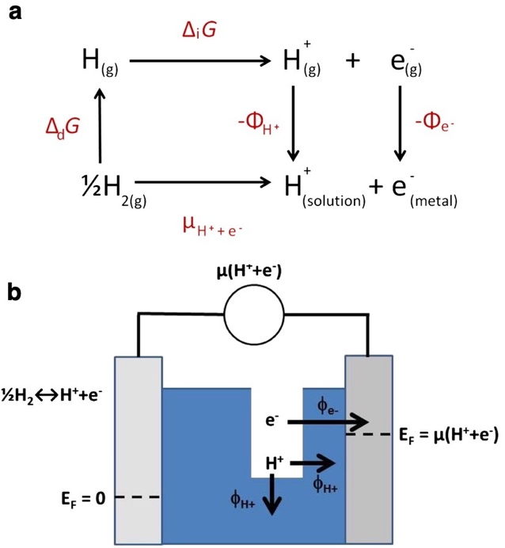
Figure 44 (a) The Born–Haber cycle for hydrogen insertion into an electrochemical interface. (b) Schematic figure of an electrochemical cell, showing the different energy variables. The left-hand side electrode is a reference electrode, and the right-hand side is the working electrode. Adapted with permission from Ref.⁴⁹¹ Copyright 2015 Elsevier.
They considered the Born-Haber cycle for hydrogen oxidation (Figure 44a). The change in energy for the reaction $\frac{1}{2}H_{2} →H_{(sol)}^{+}+e_{(m)}^{-}$, which is written in Figure 44a as $μ_{H^{+}+e^{-}},$is equal to the chemical potential referenced to the reversible hydrogen electrode, $-eU_{RHE}.$ $U_{RHE}$ is defined at arbitrary pH, so the effect of the electrode potential cannot be separated from the effect of pH in the CHE approach.⁴⁹³ From Figure 44a, however, we can see that this quantity can also be written as:
$$μ_{H^{+}+e^{-}}=∆_{d}G + ∆_{i}G - ϕ_{H^{+}}-ϕ_{e^{-}}$$ | Equation 76
where $∆_{d}G$ is half the dissociation energy of H₂, $∆_{i}G$ is H ionization energy, $ϕ_{H^{+}}$ and $ϕ_{e^{-}}$ are the work functions for a proton in solution and an electron in metal, measured with respect to vacuum just outside the solution phase (see Figure 44b). If pH=0 and $U_{RHE}=0$, we have
$$0=∆_{d}G + ∆_{i}G - ϕ_{H^{+}}^{0}-ϕ_{SHE}$$ | Equation 77
where $ϕ_{H^{+}}^{0}$is the work function for a proton at pH=0 and $ϕ_{SHE}$ is the work function of the standard hydrogen electrode, shown by Trasatti to be 4.44 eV.⁴⁶⁹ Since the variation of the proton's free energy in solution is lowered by 2.3k_{B}T per pH unit, we have
$$ϕ_{H^{+}}-ϕ_{H^{+}}^{0}=2.3k_{B}TpH$$ | Equation 78
and rearranging these equations we arrive at
$$-eU_{RHE}=μ_{H^{+}+e^{-}}=ϕ_{SHE}-ϕ_{e^{-}}-2.3k_{B}TpH$$ | Equation 79
This equation shows that specifying constant pH and $U_{RHE}$ imposes a constraint on the electron work function, or equivalently that a variation of the pH at constant $U_{RHE}$ implies a variation of the work function, e.g. through a change of the orientation of the dipoles of water molecules at the interface. Rossmeisl et al.⁴⁹² exploited this relation to determine, for a given metal/solution structure, the pH given $U_{RHE}$and the work function, which can be easily computed in DFT slab calculations. Constructing ($U_{RHE}$, pH) phase diagrams requires sampling many structures of the interface, for example via MD⁴⁹⁴, varying the number of H atoms inserted at the interface. The authors of this approach, defined this methodology as "a simple brute force approach, which is impractical. Currently this can be carried out only on the proof of concept level due to the high computational cost required to sample enough structures".⁴⁵⁰

Pasquarello and co-workers presented an alternative approach to study the effects of pH on the structure of the electrochemical interface.⁴⁹⁵ They focused on semiconductor/water interfaces, considering in particular the BiVO₄(010) surface, modeling explicitly liquid water via ab initio MD. They considered H⁺ adsorption on surface O atoms, OH⁻ adsorption on surface Be atoms, H₂O adsorption on Bi sites and its dissociation. The authors proposed a grand canonical method, based on thermodynamic integration and on the theory of charge defects, to compute the free energy cost to deprotonate individual adsorption sites on the surface. From this quantity, they were able to compute the pH at the point of zero charge, a quantity that can be compared with experimental measurements. Moreover, they obtained pH-dependent interfacial coverage of the various adsorbates at the semiconductor−water interfaces. This approach allows one to model charged intermediates, even though no corresponding counterions are present in the electrolyte. The role of counterions is therefore played by the homogeneous background charge (jellium) imposed in periodic calculations to ensure charge neutrality. The external bias is not explicitly included, so these simulations are representative of the flat band potential of the undoped semiconductor. Given the complexity of the methodology, here we only display the main findings of the work of Ambrosio et al.⁴⁹⁵ and we refer the reader to the original publication for the technical details. We stress that Chen and Sprik⁴⁹⁶ already accomplished the calculation of acidity constants of adsorption sites at the TiO₂(110)/water interface via ab initio MD, using an explicit description of the solvent and thermodynamic integration to compute free energy integrals, with an approach that has strong similarities with the one of Ambrosio et al.⁴⁹⁵

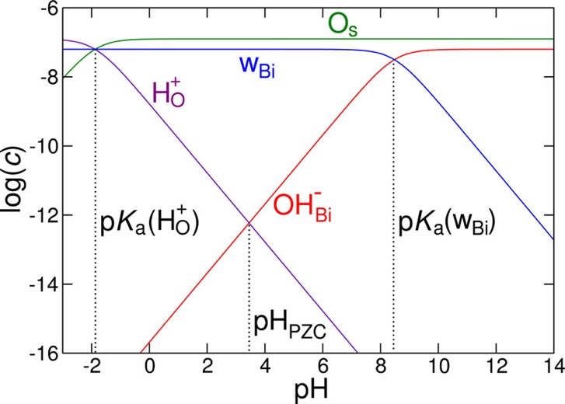
Figure 45: Acid–base logarithmic diagram for the coverage of the pristine BiVO₄(010) surface in an aqueous environment, as calculated at the h-rVV10 level of theory. Concentrations are given in mol/dm². Reproduced with permission from Ref.⁴⁹⁵ Copyright 2018 American Chemical Society.
Figure 45 shows the pH-dependence of the coverage of neutral and charged adsorbates present at the solid/liquid interface. Water prefers to adsorb molecularly on Bi sites. O sites are extremely acidic, with a pK_{a} of the adsorbed proton around -2, close to that of the hydronium ion in bulk water (-1.74). The adsorbed water molecules, on the other hand have a much lower pK_{a} compared to bulk water (8.2 vs 15.4), a consequence of the Bi-O charge transfer. The effects of the exchange and correlation functional was found to be modest, with a change of around 0.3 pH units when comparing the semi-local rVV10 functional with the hybrid h-rVV10.

Kinetics of the elementary steps

Modeling the kinetics of elementary steps of electrochemical reactions is quite challenging and considerably more complicated than the equivalent task for thermal catalysis. Since electrochemical reactions involve charge transfer between the electrolyte and the electrode, in addition to bond making and breaking, the role of the solvent and of the applied bias need to be accounted for. A complication that arises when trying to adopt the techniques normally used in thermal catalysis is the fact that calculations are normally performed at constant charge rather than at constant potential, the same issue already encountered in the previous section, when discussing how to compute reaction energies of elementary electrochemical steps. For example, during the Heyrovsky reaction on Pt(111) modeled in a (3×4) unit cell with constant charge calculations, the electrode potential changes by over 2 V,⁴⁹⁷ an enormous effect whose influence on the computed barriers needs to be examined. In this section we will examine both canonical and grand canonical approaches to model the barriers of electrochemical steps.

Barriers obtained from constant charge calculations

In the earliest works in the field, barriers of elementary steps were in fact simply assumed to be equal to reaction energies, as in the 2004 paper where the computational hydrogen electrode was introduced,⁵⁹ neglecting any additional barrier originating, for example, from proton transfer. Later works improved on this, adopting methods normally applied to thermal catalysis at solid/gas interfaces, like the nudged elastic band algorithm, to locate the transition state. To address the problem of constant potential vs. constant charge, Rossmeisl et al.^{458, 468} applied their extrapolation method, already discussed in detail Section 5.2, not only to reaction energies but also to activation energies. In the limit of large surface unit cells, the variation of the potential along the reaction linearly converges to zero. Varying both the coverage of the added H atoms and the simulation cells, and monitoring the variation of the work function to extract the electrode potential, the extrapolation method allows the calculation of activation energies as a function of the applied bias, where the bias is varied indirectly through the change in the coverage of the H atoms (see Figure 46). This approach has been adopted do compute the activation energy of the Heyrovsky and Volmer reactions in HER on Pt(111).^{458, 468} A drawback of this approach is the fact that extending it to more complex reactions and systems would be computationally very demanding, given the fact that numerous calculations of increasingly large systems are necessary to extrapolate the results at constant potential.
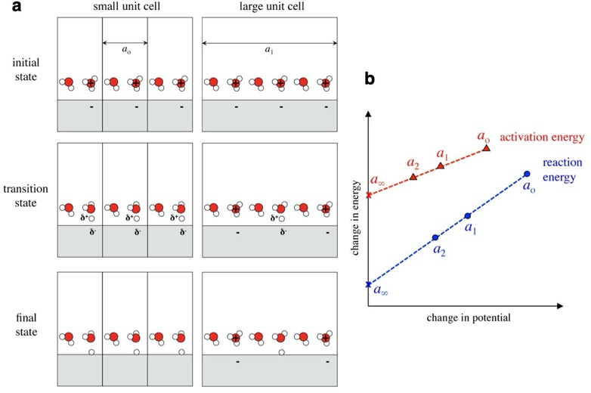
Figure 46 Schematic showing proton transfer to a surface calculated in hypothetical unit cells of different size, a_{o} and a₁. As the unit cell increases in size, the changes in interface charge density and the corresponding potential becomes smaller. Schematic showing proton transfer to a surface calculated in hypothetical unit cells of different size, a_{o} and a₁. As the unit cell increases in size, the changes in interface charge density and the corresponding potential becomes smaller. (b) Extrapolation of reaction and activation energies calculated at different cell sizes a_{i} and extrapolated to that at infinite cell size a∞, the constant potential limit. Adapted with permission from Ref.⁴⁹⁷ Copyright 2015 American Chemical Society.
To mitigate this problem, Chan and Nørskov⁴⁹⁷ introduced an approach to obtain the barrier at constant potential from a calculation performed at constant charge, within the same calculation. The authors assumed that the change in energy along the reaction coordinate of an electrochemical step can be separated into a chemical and an electrostatic contribution, and that the latter can be estimated from a capacitor model. This assumption is applicable to simple reactions like a proton transfer, where there are no dipoles that undergo large reorientations and the solvent does not undergo a large reorganization. In that case, using the work function $ϕ$ to monitor the change in the electrode potential, the energy difference between two states 1 and 2 (e.g. initial and transition states) is given by:
$$E_{2}(ϕ_{1})- E_{1}(ϕ_{1}) = E_{2}(ϕ_{2}) - E_{1}(ϕ_{1}) + \frac{{(q}_{2}-q_{1}){(ϕ}_{2}-ϕ_{1})}{2}$$ | Equation 80
where $q_{2}-q_{1}$ is the change in charge, evaluated with some partitioning scheme of the DFT electron density, for example Bader analysis. The geometry of the transition state is evaluated through a regular nudged elastic band (NEB) calculation. Figure 47 shows a parity plot comparing barriers obtained with this "charge extrapolation" approach and those obtained with the cell extrapolation scheme.

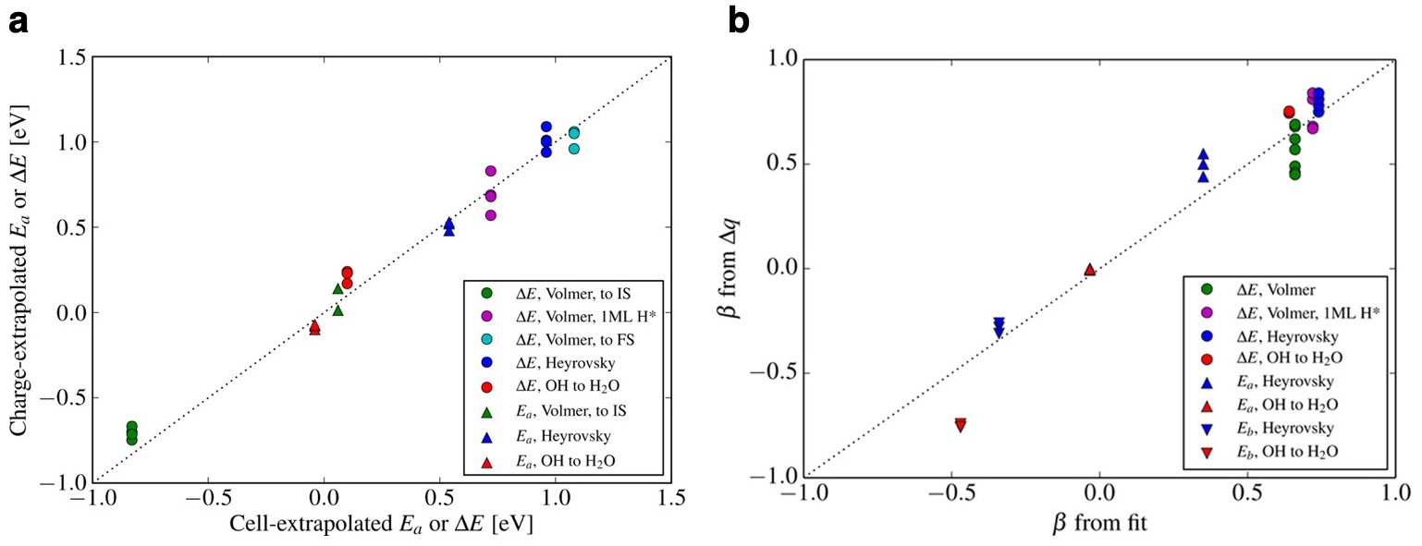
Figure 47 (a) Parity plot of reaction energies and barriers obtained using the cell-extrapolation scheme from refs^{60, 480}and the charge-extrapolated values. Reproduced with permission from Ref. ⁴⁹⁷ Copyright 2015 American Chemical Society. (b) Parity plot between the fitted β from a series of extrapolated energies and that from β = −Δq using the constant charge calculation. Reproduced with permission from Ref. ⁴⁹⁸ Copyright 2016 American Chemical Society.
While the approach described above allows one to estimate a constant potential barrier from a constant charge calculation, obtaining barriers at different potentials requires an extra step. Chan and Nørskov⁴⁹⁸ realized that simply applying Equation 80 to two different potentials leads to
$∆E(ϕ) = ∆E(ϕ_{ref}) - ∆q(ϕ-ϕ_{ref})$ | Equation 81
where $∆E$ is the energy difference $E_{2}- E_{1}$, $∆q$ is the corresponding change in charge, and $ϕ_{ref}$ is a reference work function. The applied bias therefore affects the activation energy via the change in electronic charge $∆q$, i.e. the transfer coefficient $β$ of Butler-Volmer theory (symmetry factor, in terms of Section 2.1, as it relates to individual elementary steps) is given by $-∆q$. The parity plot in Figure 47 (right) shows that this approximation works reasonably well when compared against the much more demanding approach based on the extrapolation scheme described above. The Bader scheme adopted by Chan and Nørskov is just one of many possible ways to partition the electronic charge. The effects of adopting different schemes has been discussed in Ref.⁴⁹⁹.

Nie et al.⁵⁰⁰ introduced an alternative approach, based on techniques normally adopted in thermal catalysis. Even though the authors did not focus on the OER, this approach is worth mentioning in this context because of its relevance and its relation to competing schemes. Using CO₂ reduction on Cu(111) as their electrocatalytic system of interest, the authors essentially treated proton-coupled electron transfer as hydrogenation reactions, i.e. they inserted an H atom in the system (e.g. on the catalyst surface or in a solvent water molecule) and use the NEB method to compute the minimum energy path for hydrogenating CO₂ reduction intermediates and to locate the transition state. The assumption here is that the transition state of this reaction is the same as the transition state for the electrochemical reaction, the proton-coupled electron transfer. Interestingly, Patel et al. have recently shown that the transition state determined with constant charge simulations can differ significantly from the one determined with constant potential simulations.⁴⁹⁹ The effect of the solvent is accounted for by performing the simulation in the presence of one or two water molecules. The effect of the bias, $U$, is treated assuming a Butler-Volmer dependence of the activation energy $E_{a}$ on U:
$$E_{a}(U) = E_{a}(U^{0})+β^{'}(U-U^{0})$$ | Equation 82
where $U^{0}$ is the equilibrium potential for the reductive adsorption of a proton and $β^{'}$, the symmetry factor or transfer coefficient⁸¹ (i.e. the fraction of the applied potential by which the barrier is lowered), is approximated via $β^{'}= 0.5+(μ_{TS}-μ_{reactant})/d$. Here $μ$ is the dipole moment and $d$ is the double layer thickness, assumed to be 3 Å. The authors found that the effect of the 1-2 water molecules added to model the solvent is minor; moreover, the symmetry factor $β^{'}$ is determined to be in the range 0.4-0.6, i.e. it does not deviate substantially from 0.5. This, however, is not always the case: Kastlunger et al.⁵⁰¹, for example, have shown that the Volmer step (* + H⁺ + e⁻ → *H) in the HER on Au(111) has a symmetry factor close to unity.

A system where several groups adopted an explicit and dynamical model of the solvent is the photoelectrochemical OER on TiO₂. Chen et al.⁵⁰² focused on the kinetics of the first PCET step, H₂O* + h⁺ → *OH + H⁺(aq), which is generally expected to be rate determining.^{201, 503} They considered the anatase (101) surface, first modeling the system via FPMD, then they selected three snapshots, removed one electron from the systems and optimized the geometry using hybrid functionals, which leads to hole localization on a surface oxygen atom. From these geometries they calculated the energy profile for proton transfer in two electronic configurations, one where the hole remains localized on the surface, and one where the hole is transferred to the water ligand (see Figure 48). These two electronic configurations mimic the diabatic states corresponding to hole transfer. The reaction coordinate adopted for the proton transfer is the difference in the distance between the proton and two O atoms (one of the surface water ligands and one of the solvent water molecules the proton transfers to), and the energy profile is obtained via a structural optimization with a constraint on the reaction coordinate.

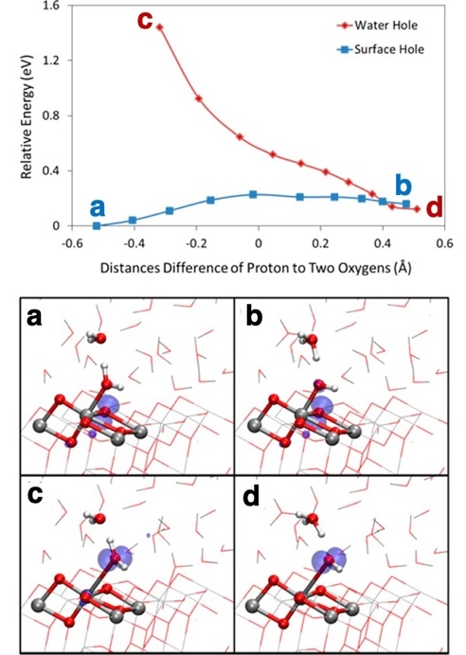
Figure 48 (Top) PT energy profiles in the surface-hole (a,b) and water-hole (c,d) states for a selected configuration along the FPMD trajectory of an anatase TiO₂(101) slab in contact with liquid water. (Bottom) Spin density (0.01 au contour) of the water-hole and surface-hole states before and after the proton transfer. Adapted with permission from Ref.⁵⁰² Copyright 2013 American Chemical Society.
Given the fact that the two potential energy curves intersect only once the proton transfer is completed, the authors conclude that the PCET is in fact not concerted but sequential, with hole transfer to form the hydroxyl radical following the proton transfer, which has a barrier of around 0.2-0.5 eV, depending on which of the three snapshots is considered. This combination of FPMD, employed to generate equilibrated structures, and transition state searches starting from snapshots of the MD and adopting a static description of the solvent, has been used also by Righi et al.⁶⁶ for the OER on Fe₂O₃(0001) and by Lyu et al. for the OER on BiVO₄.⁵⁰⁴ The significant effect of the solvent configuration on the kinetics of proton transfer found by Chen et al.⁵⁰², however, warrants some caution on the error bar associated to barriers extracted from a static description of the solvent and calls for a fully dynamical approach that accurately samples the degrees of freedom of the solvent molecules.

Wang et al.⁴⁵⁶ addressed this problem using the averaging techniques already discussed earlier in the context of solvation effects. They focused on the OER on rutile TiO₂(110) and considered the full catalytic process, not just the first PCET. To compute the activation energy and reaction energy of the elementary steps they first identified the initial, transition and final states (even though the way in which transition states were located in not described in their work) for all steps and then computed solvation effects running FPMD, selecting and optimizing around 15 snapshots and computing the average interaction between solvent and reactants. This approach was validated against the computationally much more demanding constrained MD technique, yielding errors on barriers in the range of 0.05 eV or less.

Stecher, Reuter and Oberhofer⁵⁰⁵ proposed a different approach, rooted in Marcus theory of electron transfer and derived from techniques normally adopted to model the free energy surface of electrochemical steps taking place in solvated molecular systems. Similar to the work of Chen et al., the authors focused on the proton transfer reaction between a water ligand bound to rutile TiO₂(110) and the water solvent: H₂O*⁺ → *OH + H⁺(aq), where an electron has been removed from the system. The authors considered two diabatic states corresponding to the proton being bound to the surface water ligand (initial state) or to a solvent water molecule in the second solvation shell of the resulting surface *OH (final state). For these two states, they derived two different empirical force fields based on a mixture of core-shell models for TiO₂, SPC/Fw⁵⁰⁶ for water and a Buckingham potential for the Ti-O(water) interactions. The reaction coordinate employed was the energy gap, i.e. the energy difference obtained with the two force fields for initial and final states on the same geometry along trajectories generated with quantum mechanics/molecular mechanics (QM/MM) simulations, where the QM calculations was performed with hybrid functional DFT calculations. The authors performed umbrella sampling simulations to sample windows of the reaction coordinate and obtained an energy barrier for proton transfer of around 0.2 eV, within the range derived by Chen et al. on anatase.⁵⁰² This kinetic barrier adds to the thermodynamic barrier computed via approaches like the computational hydrogen electrode, or other techniques to compute reaction energies. Among these, a related approach is the one developed by Sprik and co-workers⁵⁰⁷ using the energy gap as the central quantity in a free energy perturbation approach. This method has been used to compute the free energy cost to dehydrogenate a water ligand bound to rutile TiO₂(110), computing separately the reaction free energy for the electron removal, the proton removal and the combined proton and electron transfer.

Barriers obtained from constant potential calculations

Some of the grand canonical approaches described in Section 5.2 have been used not only to predict reaction energies but also activation energies at constant potential. The constant potential approach of Arias and co-workers^{460, 482}, coupled with the CANDLE⁴⁶⁶ implicit solvent model and a linearized Poisson-Boltzmann equation. In particular, this approach has been used by Goddard and co-workers first to model CO reduction on Cu(111)⁵⁰⁸ and then the OER of IrO₂(110)²⁶⁵. In the first work—which while on CO reduction rather than the OER, is worth discussing to highlight the generality of the method—the authors used the NEB algorithm to locate the transition states of the elementary steps, treating the PCET hydrogenation steps via the inclusion of a surface H adsorbate and then using the CHE approach to correct the energy of the initial state. In the second work, the authors computed the barriers for two non-electrochemical steps, the dissociation of water, leading to a *OOH intermediate at a CUS site and *OH intermediate at a bridge site, and the release of molecular oxygen from the CUS site, applying their grand canonical scheme to evaluate the influence of the applied bias on the activation energies. The very same approach has also been used by Zhou et al.⁴⁸³, also in this case to model the OER on IrO₂(110) via the mechanism proposed by Ping et al.²⁶⁵, obtaining very similar results. Figure 49 shows a comparison of the free energy profile for the OER on IrO₂(110) obtained by Zhou et al.⁴⁸³, including the transition states for water dissociation (TS1) and oxygen release (TS2). While differences between constant charge and constant potential simulations are as large as 0.2 eV at low applied potentials (1.3 V_{SHE}), the differences are negligibly small at higher potentials (1.8 V_{SHE}), for reasons that have not been clarified.

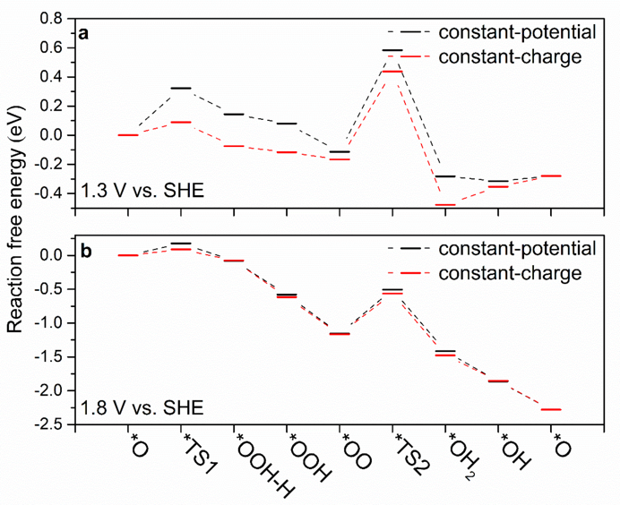
Figure 49 Comparison of reaction free energy profile (Path A) from constant-potential and constant-charge at (a) 1.3 V vs. SHE and (b) 1.8 V vs. SHE. Reproduced with permission from Ref.⁴⁸³ Copyright 2023 American Chemical Society.
Duan and Xiao⁵⁰⁹ introduced a grand canonical scheme for transition state searches in simulations at constant bias. They defined a generalized force F=(f, -μ_{e-}), where f=(-$∂H/∂r$) is the atomic force vector and μ_{e-}=(-$∂H/∂n$) is the electron chemical potential, H(r, n) is the enthalpy and n is the total charge. The transition state search is performed via the NEB algorithm, where the path is now defined via projections of the generalized force F, hence the number of electrons varies along the path to keep the electron chemical potential constant. The authors modeled the OER on RuO₂(110), coupling DFT calculations with a continuum solvent model (VASPsol⁵¹⁰). Also, in this case the first step evaluated was the dissociation of water leading to a *OOH intermediate at a CUS site, and the dependence of the energy profile as a function of the applied bias is displayed in Figure 50a-c.

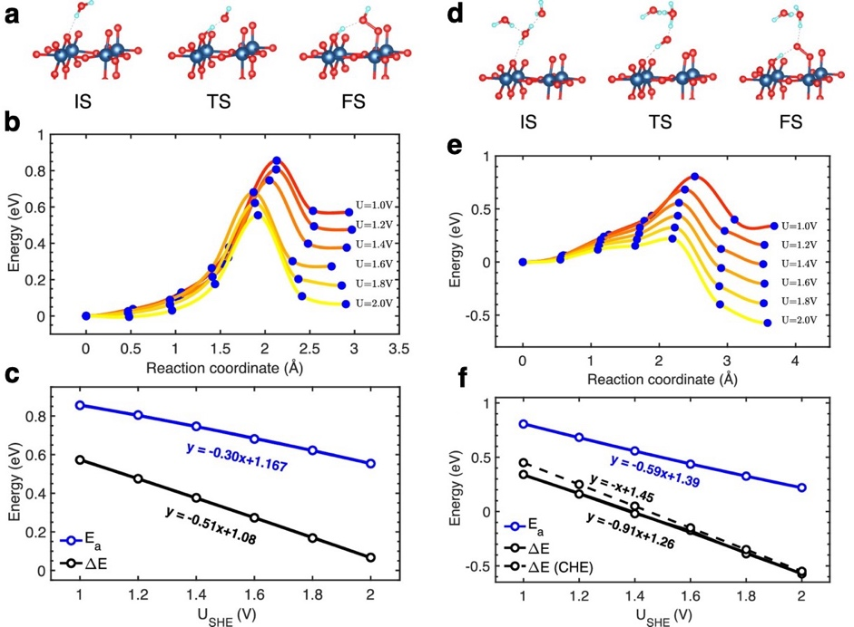
Figure 50 (a-c): Water dissociation pathway at different voltages. The IS, TS, and final state (FS) optimized at U = 1.6 V are shown in (a). In (b), the energy profiles along reaction coordinates at different potentials are shown. In (c), the potential dependences of activation barriers (E_{a}) and reaction energies (ΔE) are shown. (d-f): PCET pathway at different voltages. The IS, TS, and FS optimized at U = 1.6 V are shown in (d). In (e), the energy profiles along reaction coordinates at different potentials are shown. In (f), the potential dependences of activation barriers (E_{a}) and reaction energies (ΔE) are shown. Adapted with permission from Ref.⁵⁰⁹ Copyright 2021 American Chemical Society.
Similarly to what was found by Ping et al.²⁶⁵, there is a strong dependence of both the reaction and activation energies on the applied bias, even though this is a non-electrochemical step. This finding has been rationalized on the basis of a sizeable charge transfer between the reactants and the catalyst surface. The authors then considered the formation of the O-O via a PCET step, as displayed in Figure 50d-f. In this case the *OOH is not a stable intermediate and the proton is transferred spontaneously to a neighboring μ₂-O site. The dependence of the barrier on the applied bias is in this case considerably more pronounced. At a fixed applied voltage (1.6 V_{SHE}) the barrier for the O-O bond formation via the PCET step (0.44 eV) is lower than the non-electrochemical water dissociation step (0.68 eV), suggesting the PCET mechanism is the preferred route for this key step of the OER.
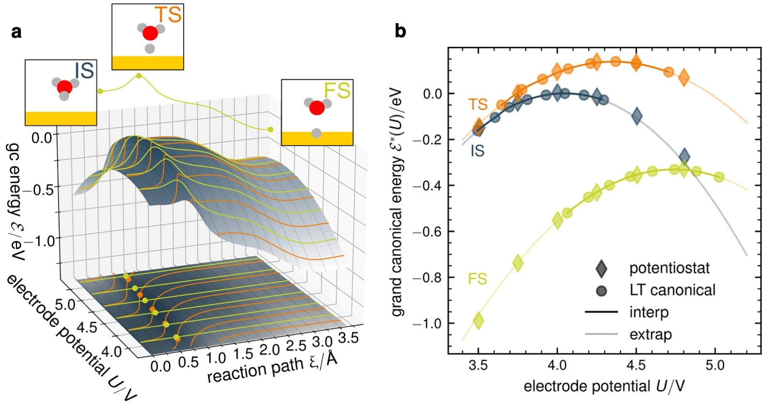
Figure 51 (a) Illustration of the absolute grand canonical PES along the reaction path in dependence of absolute electrode potential U. Constant potential paths are shown as bright green lines, and constant charge paths are shown as orange lines. Note the slight shift of the transition state position r⃗∥^{TS} indicated by points along each path. (b) Inter-/extrapolated grand canonical energies of initial, transition, and final state as a function of absolute electrode potential derived from eight constant charge climbing image NEBs for q = −0.555, −0,444, ..., 0.222 e⁻ (from left to right) in comparison with potentiostat results (diamonds). Cubic Hermite spline interpolation as solid lines, quadratic extrapolation as light solid lines. Adapted from Ref.⁵¹¹ under the Creative Commons Attribution 4.0 License.
While not on the OER, a recent work by Beinlich et al.⁵¹¹ is worth mentioning. These authors modeled the kinetics of the Volmer step of the HER (* + H⁺ + e⁻ → *H) on Au(111) comparing results obtained from constant potential and constant charge NEB calculations. The solvent was modeled implicitly, with the Solvated Jellium Model⁵⁰¹ and the proton is attached to a single interface water molecule. Building on previous works by Hörmann and co-workers^{489, 512}, the authors argued that while constant potential calculations map the grand canonical potential energy surface (gcPES) along straight constant potential lines (see green lines in Figure 51a, the same surface can be explored via grand canonical energies derived from constant charge calculations (orange lines in Figure 51a. To this end, the authors introduce a Legendre transform to map the constant charge energy, $E(q, \vec{r})$, at a given excess charge q, to the grand canonical energy, $ℇ(q, \vec{r})$ at the respective electrode potential $U(q,\vec{r})=\frac{∂E}{∂q}(q,\vec{r})$,
$$ℇ(U,\vec{r})=E(q(U),\vec{r})-q(U)U$$ | Equation 83
The authors show that since the canonical forces $\vec{F}$ computed at constant charge q are identical to the grand canonical forces $\vec{F}$ at the respective potential U(q), a stationary point (initial, final or transition state) computed on the canonical PES (cPES) is also a stationary point on the gcPES. This allows the authors to evaluate stationary points on the cPES at a certain excess charge q using traditional codes and algorithms like NEB to obtain their geometries ${\vec{r}}_{i}^{*}$ and potentials $U_{i}^{*}$, and Legendre transform their energies $E_{i}^{*}=E(q,{\vec{r}}_{i}^{*})$ to $ℇ_{i}^{*}=ℇ(U,{\vec{r}}_{i}^{*})$. This is shown in Figure 51b. The authors therefore show how it is possible to use multiple NEB calculations at various values of excess charge q to obtain the same information extracted from multiple NEB calculations at various values of the applied bias U. Furthermore, the authors of Ref.⁵¹¹ discuss how a single constant charge NEB calculation can suffice, if both the electronic and geometric dependence of the stationary points on the applied bias can be approximated, resulting in a sizeable reduction of the number of calculations necessary to compute the bias dependency of the barriers. We refer the reader to the original publication⁵¹¹ for further details and we note that a similar analysis had already been made in work by Duan and Xiao⁵⁰⁹ discussed earlier.

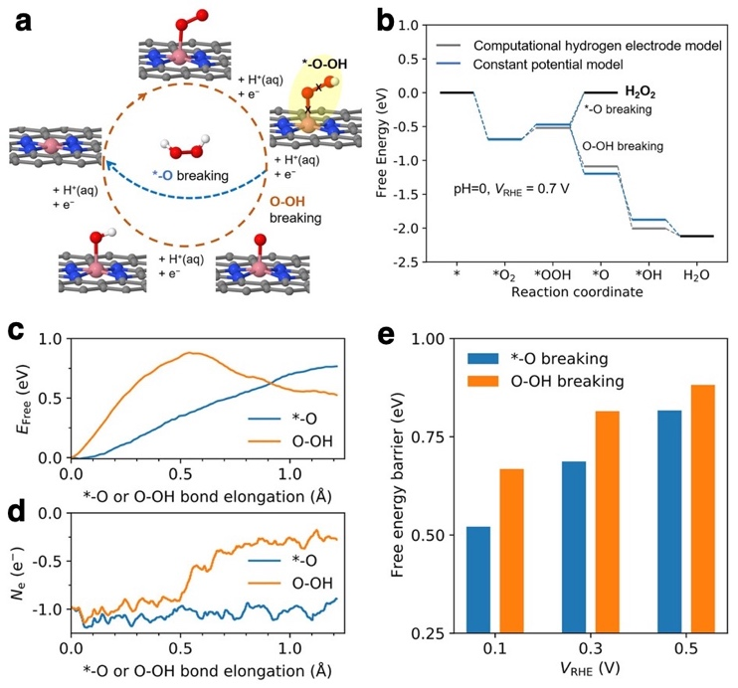
Figure 52 Left: (a) Pathways of ORR illustrated on a single cobalt atom embedded in nitrogen doped graphene (Co–N–C). They split after *–O–OH (highlighted) through *–O breaking or O–OH breaking: Co, pink; C, gray; O, red; H, white. (b) Free energy diagrams of the ORR on Co–N–C, calculated using different models, both indicating a strong thermodynamic preference for the O–OH breaking. Free energy profile (c) and net electron evolution (d) during the bond breakings under V_{RHE} = 0.5 V. (e) Activation energies for *–O and O–OH breakings under different potentials. These kinetics are calculated using CP-HS-DM. Adapted with permission from Ref.⁵¹³ Copyright 2021 American Chemical Society.
One of the most sophisticated approaches to simulate the kinetics of elementary electrochemical steps is the one adopted by Zhao and Liu⁵¹³ to model the oxygen reduction reaction on N-doped graphene containing a single Co atom. The method, named “constant-potential hybrid-solvation dynamic model” (CP-HS-DM), combines an approach inspired by the potentiostat of Bonnet et al.⁴⁷⁴ to perform MD at constant potential, an explicit description of a few water layers of the solvent in contact with the electrode and an implicit description of the bulk electrolyte containing the countercharge. To obtain the barriers, the authors adopted a free energy approach based on thermodynamic integration, the slow growth approach, where a constraint on a single reaction coordinate is linearly varied with time, and the resulting mean force is integrated to obtain the free energy profile along the reaction coordinate. With this approach the authors explained why some catalysts, while having a strong thermodynamic preference for breaking the O-OH bond of the hydroperoxide intermediate (see Figure 52), exhibit high selectivity for hydrogen peroxide. The reason, the authors argue, has to do with the kinetics of the *-O vs. the O-OH bond breaking step: As shown in Figure 52, the calculations reveal that that activation energy for breaking the O-OH bond can be larger than the energy required to break the *-O bond. Moreover, this study stresses that the selectivity depends on both applied potential and pH.

Finally, it is worth stressing that the algorithms that impose a constant electron chemical potential can suffer from numerical instabilities. These issues have been discussed in detail in recent works.^{482, 514}

Microkinetic models

A powerful approach to model electrochemical processes consists of combining the methodologies described in the previous sections to compute the thermodynamics and the kinetics of elementary steps with microkinetic models that describe the interplay of multiple steps. As for the case of thermal catalysis⁵¹⁵, a microkinetic model consists of a series of elementary steps, whose rate constants for the forward and backward reactions are usually estimated using transition state theory (Equation 4). The equations are typically solved for the steady state, in the mean-field approximation, where the unknowns are the surface coverages of the intermediates. This allows one to predict the rate of the overall process as a function of applied bias (and pH, in some cases) and to establish a direct link with experimental measurements, which typically report polarization curves (i.e. currents vs. applied bias, often assuming 100% Faradaic efficiency), Tafel slopes and exchange currents. In case of competing mechanisms, by comparing the rates of the elementary steps microkinetic models allow to determine which path dominates, not simply on the basis of the activation energies but accounting also for the steady state coverages of the intermediates.

A distinct advantage of predictions based on a microkinetic model compared to those based on the CHE is that both chemical steps and electrochemical steps can be treated on the same footing, provided one can compute accurately the kinetics of both kinds of elementary steps. Furthermore, the potential determining step identified via CHE calculations and the RDS identified via microkinetic modeling, might not coincide. For these particular cases, ranking the performance of various catalysts on the basis of the PDS rather than the RDS might lead to differences.⁵¹⁶

Microkinetic modeling in electrochemistry has been recently reviewed by Marshall⁵¹⁷ and by Linic and co-workers⁵¹⁸, and here we will discuss some relevant applications to the OER. A point worth stressing is the use of the quasi-equilibrium approximation. At the steady state, the net rate (i.e. the difference between the forward and backward rates) of each elementary step comprising the reaction mechanism is the same, and the step with the smallest forward rate is identified as the RDS⁵¹⁹. When the forward rate is orders of magnitudes larger than the net rate, one can safely assume that the forward and backward rates for that step are equal, i.e. the step is quasi-equilibrated. In this case, the concentrations (or coverages) of reactants and products can be determined from the equilibrium constant of that step. If one assumes that one particular step is the RDS while the other steps are quasi-equilibrated, the calculations are considerably simplified, since the barriers need to be computed only for the RDS. While this approximation is often adopted in microkinetic modeling, Marshall and Vaisson-Béthune showed that the quasi-equilibrium assumption is not always justified for the OER of IrO₂ and RuO₂.⁵¹⁹ Similar conclusions were drawn by Mefford and co-workers for the OER on Co-based (oxy)hydroxides⁵¹⁶. See also some discussion in Section 2.

Rutile oxides

Fang and Liu^{23, 64} modeled the OER on RuO₂(110) using DFT-PBE calculations coupled with a modified Poisson-Boltzmann description of the electrolyte. The authors first constructed the surface Pourbaix diagram, showing that at low overpotentials the surface O bridge atoms are partially protonated while the O atoms at the Ru CUS sites are deprotonated, and above 1.58 V(SHE) the surface is fully deprotonated. The authors considered two possible mechanisms for the O-O bond formation, namely the nucleophilic attack of a water molecule forming a *OOH intermediate at the CUS site and a *OH at bridge site, and the direct coupling of two *O atoms at neighboring CUS sites. While the second step has a large and essentially bias-independent activation energy, the first mechanism has a barrier that depends linearly on the applied bias, with a coefficient of -0.57 eV/V when the overpotential exceeds 0.3 V (see Figure 53 inset) and is fairly constant at lower overpotentials. Notice that the authors here neglected the fact that barriers were computed at constant charge rather than at constant potential, and assumed that the relevant potential for the estimate of the barrier is the one of the initial state. On the basis of these findings, the authors proposed a microkinetic model with a single RDS, obtaining a change in the Tafel slope around 1.58 V(SHE) due to the change of the surface structure: below this threshold potential, the surface needs first to be deprotonated and then the O-O bond takes place with a barrier that is nearly independent of the applied bias; above this potential the surface is fully oxidized and the barrier for the RDS has a strong bias dependence. The resulting Tafel slopes (55 mV/dec and 105 mV/dec) are in good agreement with experiments (59 mV/dec and 120 mV/dec) (see Figure 53).

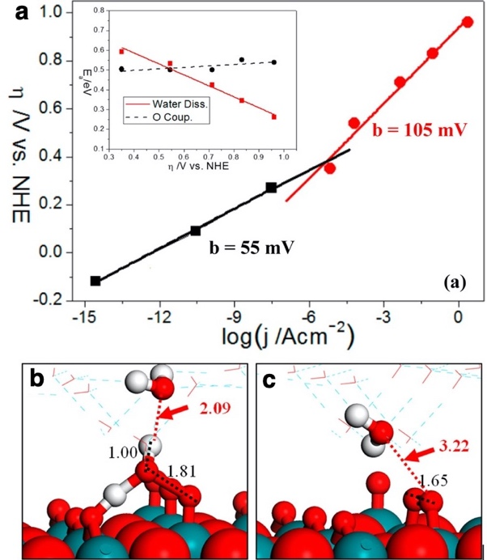
Figure 53 OER kinetics on RuO₂(110) from DFT/CM-MPB method. (a) Plot of reaction barrier E_{a} against the overpotential η for the water dissociation and the surface oxygen coupling on the O-terminated phase of RuO₂(110). Inset in (a) shows the calculated Tafel lines (log(j) ∼ η plot) for OER on RuO₂(110). The slopes, b = ∂η/∂log(j), of the fitted lines are indicated. (b) and (c) are TS structures of the water dissociation and surface oxygen coupling on the O-terminated phase of RuO₂(110) respectively. All the distances labeled are in Angstrom. O: red ball; H: white ball; Ru: green ball. Figures adapted with permission⁶⁴ Copyright 2010 American Chemical Society.
The work of Exner and co-workers focused on RuO₂(110) too, and presents an analysis on the basis of the Butler-Volmer theory for electron transfer and microkinetic modeling, assuming a single RDS while all other steps are treated as quasi-equilibrated.⁵²⁰ The authors derived analytical expressions to determine the parameters of the model (for example transfer coefficients and the energy of the transition state of the RDS) using as input theoretical information on the surface Pourbaix diagram and the experimental Tafel slopes and exchange currents. On this basis the authors propose, in agreement with Fang and Liu⁶⁴, that the reaction proceeds through the formation of the *OOH intermediate; however, while at overpotentials below 0.35 V(SHE) the reaction proceeds via a chemical step (the dissociation of water, leading to a H atom being transferred to a bridge O), above this value it proceeds with a PCET electrochemical step, where the proton is therefore released to the electrolyte and an electron to external circuit. It is not clear what drives this change of mechanism.

Dickens and co-workers³⁹⁹ constructed a microkinetic model for the OER on IrO₂ and other rutile-type metal oxides like RuO₂, RhO₂ and PtO₂. The authors considered a mechanism comprised of the following six elementary steps:

H₂O(l) + * → H₂O* Equation 84
H₂O* → *OH + H⁺ + e⁻ Equation 85
*OH → *O + H⁺ + e⁻ Equation 86
*O + H₂O(l) → *OOH + H⁺ + e⁻ Equation 87
*OOH → *O₂ + H⁺ + e⁻ Equation 88
*O₂→ * + O₂(g) Equation 89
Four of these steps are electrochemical (PCET) steps while the first and the last, water adsorption and oxygen desorption, are thermochemical steps. The authors computed the activation energy for deprotonating H₂O* on IrO₂(110) to be just 0.05 eV, assumed all deprotonation steps to be equally facile and thus assumed all PCET steps to be quasi-equilibrated, except for the one where the O-O bond takes place via the formation of the *OOH intermediate. They solved the model assuming a single RDS, either the formation of the *OOH intermediate or the release of oxygen, while all other steps are assumed to be quasi-equilibrated. They computed the activation energy for the formation of *OOH and extracted its dependence on the applied potential through an extrapolation method similar to one described earlier in Section 6.1, introduced by Chan and Nørskov^{497, 498}, involving a series of calculations adopting different IrO₂(110) unit cells. In order to extrapolate the model to other catalysts, the authors used the conventional thermochemical descriptor of the OER, ΔG_{*O}-ΔG_{*OH}, i.e. the difference between the adsorption energies of *O and *OH. They computed the activation energy for the formation of *OOH as a function of this descriptor, using data obtained on different materials (IrO₂, RuO₂, RhO₂ and PtO₂) and fitted linearly the dependence of this barrier on both the applied potential and the descriptor. For the desorption of O₂, on the other hand, they resorted to two limiting values obtained from experiments (0.28 eV and 0.98 eV) since O₂ is poorly described with the GGA functional¹¹⁴ adopted in this work and since entropic effects are likely non-negligible and demanding to compute. The results obtained assuming O₂ release is the RDS are vastly different depending on the barrier for O₂ desorption. Comparing the predictions to experimental evidence, the authors elected the smaller value to be more likely, and concluded that the RDS for the OER is the formation of *OOH.

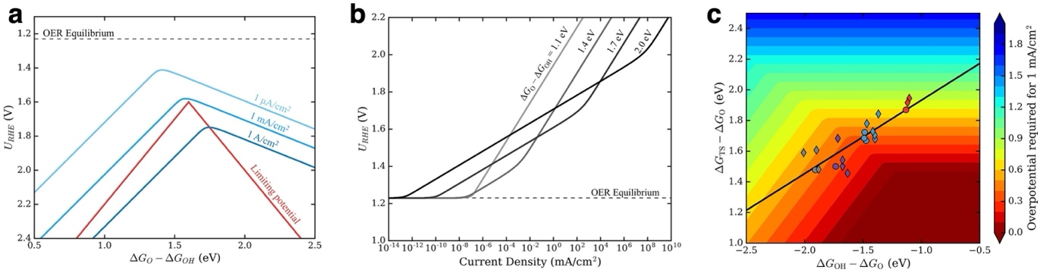
Figure 54 (a) Kinetic volcano plot for three different current densities when assuming OOH* formation as the sole RDS. Also shown is the limiting potential volcano from a purely thermodynamic analysis assuming ΔG_{*OOH} – ΔG_{*OH} = 3.2 eV. (b) Tafel lines for various descriptor values when assuming *OOH formation as the sole rate-determining step. (c) Contour plot illustrating the overpotential required to reach 1 mA/cm² as a function of the barrier for OOH* bond formation at 0 V vs SHE (assuming β = 0.58) and ΔG_{*OH} – ΔG_{*O}. Adapted with permission from Ref.³⁹⁹ Copyright 2019 American Chemical Society.
Figure 54 displays the results of the model, in terms of what the authors call as kinetic volcano curves relating the applied potential to the descriptor ΔG_{*O}-ΔG_{*OH} for three values of current densities. The limiting potential reported in the figure is the thermodynamic quantity normally extracted via the CHE approach, namely the applied potential at which all electrochemical steps are thermodynamically downhill, which is the traditional volcano curve explored using the CHE.

Both the microkinetic and the limiting potential models predict volcano shape relationship, with the left branches (small values of the descriptor) corresponding to *O coverages near unity and increasing the value of the descriptor lowers the barrier for the formation of *OOH. The right branches (large values of the descriptor) correspond to surface poisoning by *OH, resulting in a negative slope. The slopes in the two models differ due to the fact that kinetics is accounted for only in the microkinetic model, or kinetic volcano. An interesting outcome of the microkinetic model is that the maximum of the volcano occurs along the line U_{RHE} = ΔG_{*O} – ΔG_{*OH,} and that at this potential there is a change in the Tafel slope, as shown in Figure 54b. This change of Tafel slope has been measured experimentally in a variety of electrocatalysts, and is usually attributed to a change of mechanism, while here the model attributes the change in slope to a change of the surface coverages of the *O and *OH intermediates. This is essentially in line with the analysis proposed by Exner and co-workers⁵²⁰, who argued, on the basis of microkinetic models with a single RDS and all other steps in quasi-equilibrium, that the change of Tafel slopes can be ascribed to either a change in the RDS or to a change of the active surface under reaction conditions, the latter being the case here. Notice, however, that the quantitative agreement between this model and the measured values of the slope is only modest and highly dependent on the particular values of the parameters defining the kinetics of the formation of the *OOH intermediate. In terms of catalyst design, this work suggests that optimal catalysts should have a value of the descriptor ΔG_{*O} – ΔG_{*OH} around 1.6 eV, in agreement with previous works.^{88, 101} To break the scaling relationships between the formation energy of the intermediates, previous works suggested stabilizing the *OOH intermediate relative to *OH as an effective strategy.²⁴⁰ This work, on the other hand, shows the focus should be on reducing the barrier to form the *OOH intermediate (see Figure 54c).

Using the CANDLE implicit solvent model and the grand canonical scheme of Arias and co-workers^{460, 482} to model the system at constant potential, Ping et al.²⁶⁵ modeled the OER on IrO₂(110) considering the effects of the applied bias on the barriers of the electrochemical steps.
The authors considered two possible mechanisms for the key O-O bond formation step: (1) direct coupling of two neighboring O atoms; (2) nucleophilic attack of a solvent water molecule on a surface O. They excluded the first mechanism on thermodynamic grounds and focused on the second. Comparing the free energy of all possible positions of dissociated H₂O, they found that both *OOH and *OH intermediates prefer to form on μ₁-O atoms. The barrier for water dissociation, computed with NEB calculations at constant potential, is around 0.6 eV, as shown in Figure 55, and is the rate determining step of the process. The activation energy for the desorption of molecular O₂ is also fairly large, 0.56 eV, even though the authors argue that this value might be overestimated by the tendency of semi-local GGA functionals to overbind O₂.

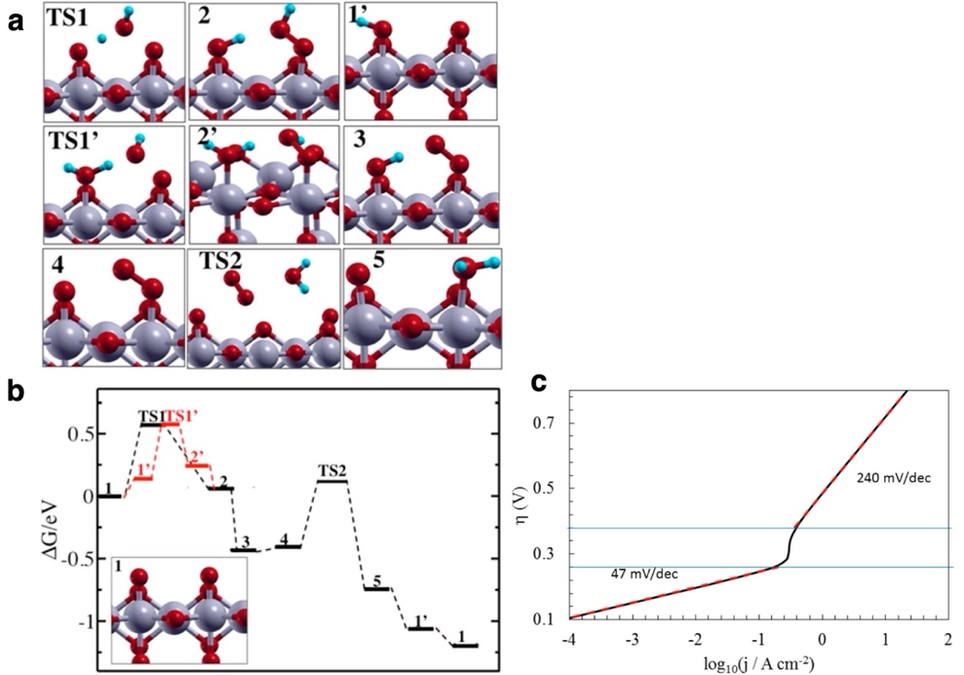
Figure 55 (a) Optimized structure and (b) free energy profile of intermediates and transition states of water dissociation reaction at U = 1.53 eV vs NHE. Red balls are O; blue balls are H; silver balls are Ir. (c) Tafel plot. The black line is the log(j) vs overpotential for OER on IrO₂ (110) calculated at the level of PBE-D2 DFT. The red dotted lines show the linear regions in the Tafel plot, which essentially superimpose on the black lines for each region. Below 0.26 V overpotential, the Tafel slope is 47 mV/dec, which can be compared with experimental values of 38−45 mV/dec. In this region our Tafel may be too high because we use a very crystalline surface. Above 0.38 V overpotential, the Tafel slope is 240 mV/dec, indicating the change in the reaction mechanism arising from to the dominant surface termination evolving from hydroxy to oxo. Adapted with permission from Ref.²⁶⁵ Copyright 2017 American Chemical Society.
The authors found that the transition states have an energy that depends linearly on the bias. Interestingly, even purely chemical steps have a non-zero symmetry factor, according to this scheme. Water dissociation, for example, has a symmetry factor of around 0.25 for the barrier and 0.5 for the reaction energy, due to charge transfer from the surface to the water molecule (capacitive charging). A constant charge approach would therefore completely miss the effect of an increasingly anodic bias in lowering the barrier of this chemical step. The authors then build a microkinetic model considering water dissociative adsorption as the RDS and computed the rate of the OER at two different coverages of surface hydrogen (0% and 25%), as predicted by their (pH, U) surface phase diagram (see Figure 42b), resulting in the following expression for the rate R:
$$R=K_{25}[C_{25}] + K_{0}[C_{0}]$$ | Equation 90
$$k_{25}=\frac{k_{B}T}{h}exp\left(\frac{-G_{25}\left(η\right)}{k_{B}T}\right)$$ | Equation 91
$$k_{0}=\frac{k_{B}T}{h}exp\left(\frac{-G_{0}\left(η\right)}{k_{B}T}\right)$$ | Equation 92
where $[C_{25}]$ and $[C_{0}]$ are the concentration of active sites at 25% and 0% coverage of surface H, respectively, $k_{25}$ and $k_{0}$ are the corresponding rate constants, $G_{25}\left(η\right)$ and $G_{0}\left(η\right)$ are the corresponding (bias dependent) activation energies. The resulting current density, as a function of the applied bias, are displayed in Figure 55c. The current is exponential on the bias because the barrier for the RDS is reduced by the capacitive charging of the interface, and the complete oxidation of the surface at 1.50 V results in an abrupt increase of the Tafel slope, likely because of a reduced dependence of the barrier on the bias. Notice that the Tafel slope at high bias is strongly overestimated compared to experiments.

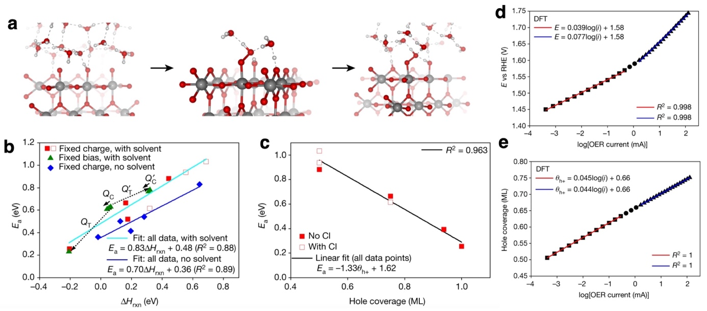
Figure 56 (a) Water-oxyl coupling on the (110) surface of rutile-type IrO₂ with μ₂-O and 1:1 μ₁-OH:μ₁-O. In the initial state, a water molecule near the oxyl (left panel) forms an O-O bond with the μ₁-O at the transition state (middle panel)—for clarity only the solvent directly involved are shown—with the simultaneous transfer of hydrogen to a surface μ₂-O through the formation of Zundel-like species. In the final state (right panel) the μ₁-O has been transformed into a μ1-OOH. (b) Computed activation energies for O-O coupling plotted as a function of ΔH_{rxn}, where ΔH_{rxn} becomes more negative as θ_{h+} increases. Green triangles show E_{a} computed at the potential of zero charge for surfaces with θ_{h+}=1/2, 3/4, and 1 ML (in order of increasing exothermicity) under a constant potential condition. For θ_{h+}=1/2 and 3/4 ML green triangles include results with purely capacitive charging from 0.1 to 0.5 V, e. g. charging the interface while artificially constraining the average surface oxidation state. Red squares show E_{a} as a function of ΔH_{rxn} under a constant charge condition. The unfilled red squares show surfaces with adsorbed Cl. Chlorine was used to investigate charge storage using a non-reducible ligand, and a full discussion including the corresponding experiments can be found in the SI. Blue diamonds show the corresponding energies in the absence of solvent. (c) Activation energies for O-O coupling as a function of oxidative hole coverage. (d) Tafel plot computed with DFT data from the IrO₂(110) surface using Equation 93. (e) Computed θ_{h+} versus log(current) corresponding to (d). Adapted with permission from Ref.⁶³ Copyright 2020 Springer Nature.
Nong et al.⁶³ modeled the same process, the OER on IrO₂(110), describing the solvent explicitly. They considered the same key elementary step modeled by Ping et al, namely the dissociative adsorption of a water molecule on surface *O ligand and forming the hydroperoxo intermediate, locating the transition state with the NEB algorithm. They treated the effects of the bias in two ways. First, by performing constant potential calculations with the ESM scheme, they accounted for the effects of capacitive charging. Second, considering that an increasingly anodic bias oxidizes the surface via a PCET step (*OH →*O + e⁻ + H⁺), they modeled the reaction at various coverages of surface holes (stored in μ₁-O surface oxyl species). At variance with Ping et al, the authors found that while capacitive charging has a negligibly small effect, the oxidative charging of the surface strongly reduces the activation energy for the O-O bond formation via water dissociation (see Figure 56c). In fact, there is a Brønsted-Evans-Polanyi type of relationship between the activation energy and the reaction energy for the O-O coupling step, as shown in Figure 56b. The authors argued that the effect of the bias on the key O-O step is therefore indirect: oxidizing the surface makes the O-O coupling more exothermic, which in turn reduces the barrier of the rate determining step of the OER. Crucially, the exponential dependence of the current density on the bias is the result of a linearly decreasing barrier of the O-O coupling step induced by the accumulation of oxidative charge at the surface, Figure 56e. A simple microkinetic model built assuming water dissociation to the sole RDS and assuming the preceding step, the dehydrogenation of *OH, to be quasi-equilibrated, results in the following expression for the current:
$$i={k_{0}θ}_{O^{*}}exp\left(-\frac{βθ_{O^{*}}+γ}{k_{B}T}\right)$$ | Equation 93
Using DFT values for activation energy and the coverages, the authors found a good match between the predictions of the model and the experimental data, with Tafel slopes below and above 1.58 V(RHE) of 39 mV/dec and 77 mV/dec, compared to the experimental 43-47 mV/dec and 71-76 mV/dec.

Zhou et al.⁴⁸³ modeled the OER on IrO₂(110) using the same theoretical approach and the same reaction mechanism of Ping et al.²⁶⁵, where the O-O bond takes place via water dissociation, resulting in a *OOH adsorbate at a CUS site and a *OH adsorbate at a bridge site. The free energy profile obtained via constant potential calculations of intermediates and barriers is shown in Figure 57, where the transition states refer to two non-electrochemical steps, the dissociation of water (TS1) and the release of oxygen via H₂O* replacement of *OO (TS2). The second barrier is considerably larger than the first one.
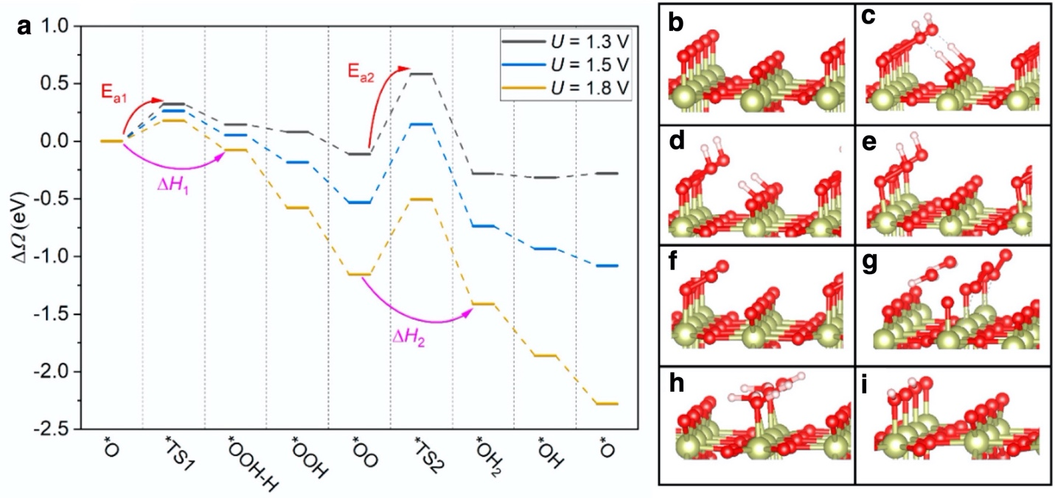
Figure 57 (a) Reaction free energy at constant potential from GCDFT for the oxygen-terminated surface; The inputs show the corresponding optimized structures of reaction intermediates and transition states: (b) *O, (c) *TS1, (d) *OOH-H, (e) *OOH, (f) *OO, (g) *TS2, (h) *OH₂, and (i) *OH. Adapted with permission from Ref.⁴⁸³ Copyright 2023 American Chemical Society.

The authors then built a microkinetic model considering the effects of the surface hydrogen coverage. They considered separately three different MK models corresponding to three different surface coverages of hydrogen, representative of different applied biases, and then summed the contributions, weighted with a Boltzmann factor, as shown in Figure 58. Path A corresponds to a hydrogen coverage of 50%, path B 25% and path A 0%. The agreement with experiments is only modest, predicting Tafel slopes lower than experiment by a factor 2 at low overpotential and extremely large Tafel slopes at high overpotential. The authors then used continuous functions to describe both the dependence of the barriers on coverages and potential, and to describe the dependence of the coverage of active sites on the applied potential. The results of a continuum description (as opposed to the original model where the hydrogen coverage changes abruptly between 50%, 25% and 0%) are in better agreement with experiment in the low overpotential region (see in Figure 58d).

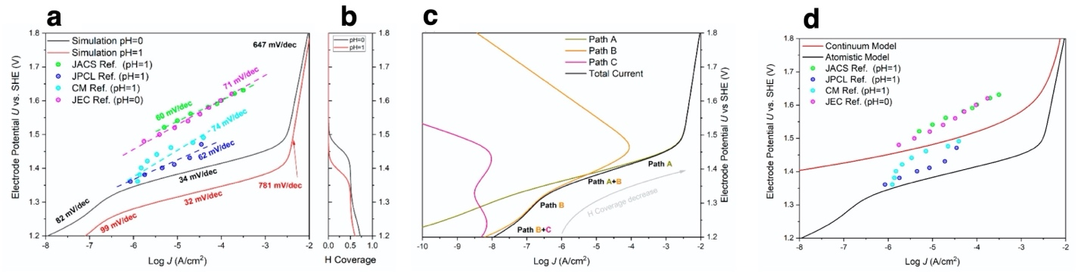
Figure 58 (a) Simulated Tafel plot from GCDFT-based reaction barrier and surface structure evolution for pH 0 and pH 1 paths with some early experimental data as comparison. (b) H coverage change vs the electrode potential. (c) Decomposed contribution of current from path A/B/C. (d) Tafel plot simulation by continuum models with and without the θ^{eff} effect. Adapted with permission from Ref.⁴⁸³ Copyright 2023 American Chemical Society.
At variance with the approaches described above, the parameters of microkinetic models for the OER can also be derived entirely from experimental data. This is the case for the work by Geppert and co-workers⁵²¹ who modeled the OER on nanoparticulated rutile IrO₂. The authors postulated a single site model consisting of the usual adsorbate evolution mechanism via 4 PCET steps where the O-O bond takes place through the formation of the *OOH intermediate, but also explicitly included three chemical steps, namely the adsorption of water at a vacant site and at an oxygen adsorbate, as well as the desorption of molecular oxygen (see Figure 59a). The authors assumed for each electrochemical step a Butler-Volmer expression for the rate constant and, at variance with the models discussed so far, did not assume either the quasi-equilibrium approximation nor did they limit themselves to the steady-state conditions; they considered the full-time evolution of the current density as a function of a linearly varying applied potential as obtained from cyclic voltammograms at various scan rates. The symmetry factors in all electrochemical steps were fixed to 0.5 and the pre-exponential frequency factor for all steps were set to a fixed value. The fitted parameters include the activation energies and reaction energy, the double layer capacitance and the density of active sites.

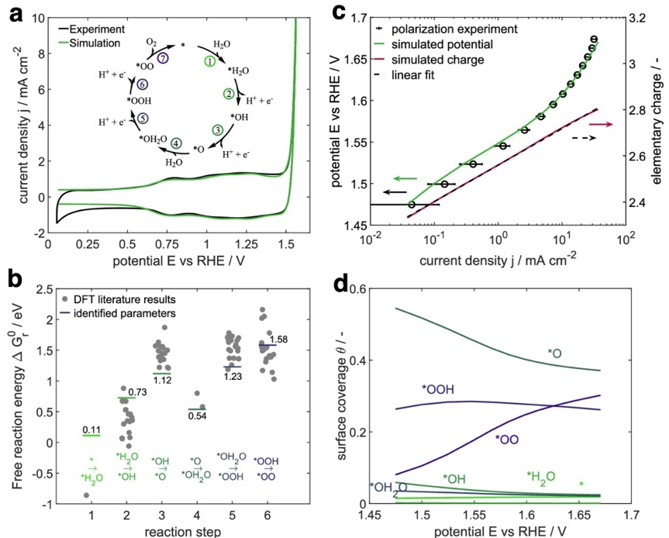
Figure 59 (a) Comparison of the experimental and simulated CV curves for a scan rate of 200 mV s^{–1} at the pristine state with the best set of parameters. (b) Identified reaction free-energy parameters for steps 1–6 at electrochemical standard conditions in comparison to DFT-calculated values reported in the literature. (c) Experimental and simulated polarization curves for technically relevant potentials and the simulated change in elementary charge per active site. Experiments were repeated three times. (d) Corresponding surface coverages of the steady-state simulation. Adapted from Ref.⁵²¹ under the Creative Commons Attribution 4.0 License.
Figure 59b shows that the reaction free energies for the elementary steps considered in the model fall within the range of values computed with DFT calculations reported in the literature, with the exception of water adsorption on a vacant site, which is predicted to be endoergonic (+0.11 eV) while theory predicts it to be strongly exoergonic (-0.8 eV)³⁹⁹. The resulting Tafel lines (see Figure 59c) closely match the experimental data. Analyzing the evolution of both the adsorbate coverages and the free energy diagram as a function of the applied bias, the authors stress that the continuous change in the Tafel slope is due to the fact that not only the deprotonation of *OOH is rate limiting but also the two chemical steps of water adsorption and oxygen desorption. Interestingly, the model predicts that above 1.6 V (RHE) half the surface is covered with either *OO or *OOH adsorbates. A previous work on hydrous IrO₂ by the same group⁵²², based on the same approach, predicted water adsorption to be strongly exoergonic (-1.37 eV) and the coverages of *OO and *OOH at OER evolution potentials are negligibly small. Operando measurements able to detect spectroscopic features associated with the O-O bond (e.g. vibrational spectroscopy) could be used to validate this prediction.

Oxyhydroxides

Using a grand canonical scheme coupled with the CANDLE implicit model for the solvent, Xiao et al.⁶⁵ investigated the OER on (Ni,Fe)OOH electrocatalysts, considering the (100) surface of the γ-phase. They identified the formation of a μ₁-O oxyl radical species and the subsequent O–O coupling as the two key steps in the OER. The role of Fe surface atoms, in d⁴ Fe(IV) oxidation state, favors the formation of the radical, while the O-O coupling takes place at a surface closed shell d⁶ Ni(IV) site. On pure γ-NiOOH, creating the O radical is the most demanding step (ΔG=2.44 V) and the dissociative adsorption of water, leading to the O-O bond formation via the hydroperoxo *OOH ligand, has an activation energy of 0.48 eV (see Figure 60). The final release of O₂ has a barrier of 0.4 eV in PBE calculations while it is not activated with the B3PW91 functional, a large discrepancy suggesting that, at least for this step, the role of exact exchange plays a crucial role. To compute the current density (j) as function of the applied bias, the authors built a microkinetic model assuming a single RDS, while all other steps are treated as quasi-equilibrated. The OER rate is then given by $r_{OER}(U)= c[*O^{∙}](k_{B}T/h)e^{-∆G^{a}(U)/k_{B}T}$, where $c[*O^{∙}]$is the surface concentration of the $O^{∙}$ radical species, $∆G^{a}(U)$ is the barrier for the O-O coupling step. The current j is computed from $r_{OER}$ via the charge of the electron transferred and the overpotential η is evaluated at j=10 mA/cm². In the case of pure γ-NiOOH the reported overpotential η=1.22 V does not differ dramatically from the thermodynamic overpotential 2.44-1.06=1.38 V (here 1.06 is the equilibrium potential for the OER obtained with the B3PW91 functional, to be compared with the experimental 1.23 V), but it is significantly higher than the experimental estimate, 0.7 V. This led the authors to suggest that the experimental samples might contain impurities, e.g. Fe, that facilitate the kinetics of the OER.

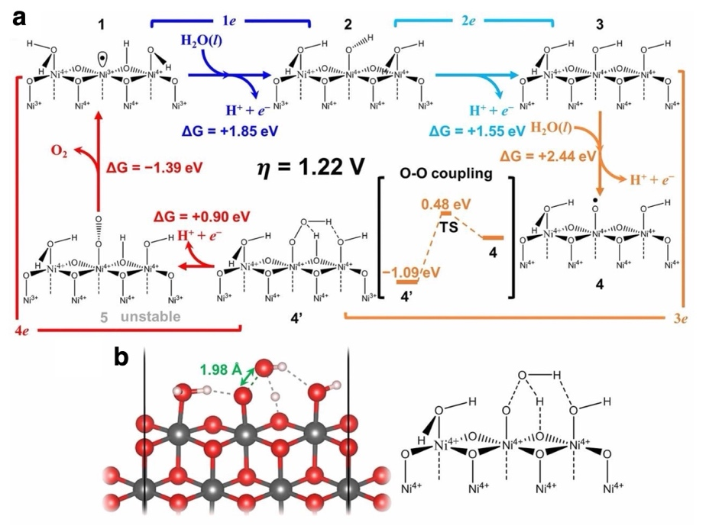
Figure 60 Mechanism for OER on pure γ-NiOOH catalyst. (A) The mechanistic cycle of OER catalyzed by pure γ-NiOOH surface [B3PW91 predicted free energy differences ∆G and barrier at U = 2.28 V (η = 1.22 V) corresponding to j = 10 mA/cm²]. (B) The structure of TS for O–O coupling. Adapted with permission from Ref.⁶⁵ Copyright 2018. Published under PNAS license.
Indeed, the addition of surface Fe ions leads to a much easier formation of the $O^{∙}$ radical at the Fe(IV) site, with a free energy cost of 1.99 eV, and the subsequent O-O bond formation via water dissociation has a barrier of 0.37 eV (see Figure 61a). Thermodynamically, the most demanding step is now the first dehydrogenation of a surface *OH group, ΔG=2.06 eV, and the overpotential predicted by the microkinetic model, η=0.84 V, is again only slightly lower than the thermodynamic overpotential 2.06-1.06=1.00 V. Adding subsurface Fe lowers the cost to for the $O^{∙}$ radical even further to 1.20 eV, while the most demanding step remains the first dehydrogenation, ΔG=2.04 eV. Surprisingly, the overpotential determined from the microkinetic model, η=0.42 V, is now much lower than the thermodynamic overpotential 2.04-1.06=0.98 V. Notice that the authors here assumed quasi-equilibrium for the step, which is also the PDS, an assumption that needs to be validated. Interestingly, the effect of Fe is found only when using energies computed with hybrid B3PW91 functional, while PBE calculations indicate that the surface and subsurface Fe ions have only a small influence on the kinetics of the process.

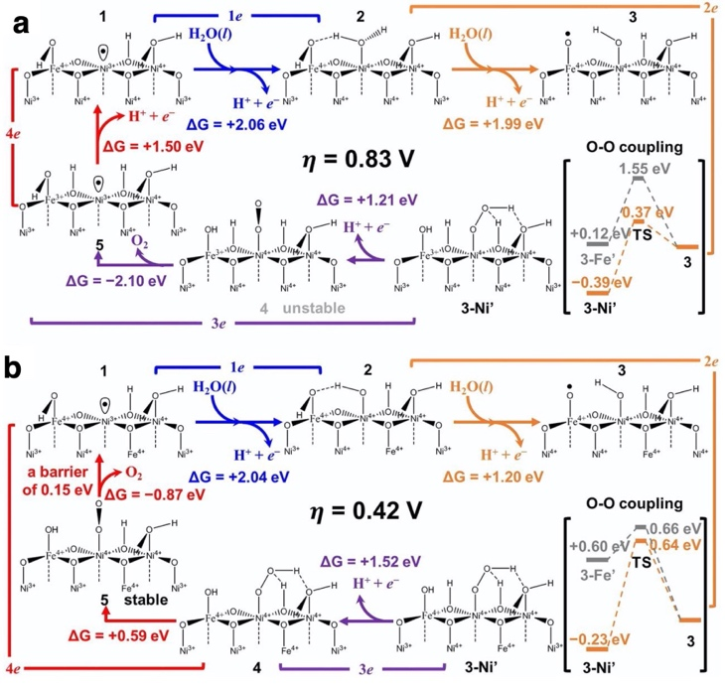
Figure 61: The mechanistic cycles for OER on γ-(Ni,Fe)OOH catalysts (based on B3PW91 predicted free energies and barriers). (A) One-third surface Fe doping case, leading to U = 1.89 V (η = 0.83 V) for j = 10 mA/cm². (B) One-third surface Fe doping plus 1/3 subsurface Fe doping, leading to U = 1.48 V (η = 0.42 V) for j = 10 mA/cm². Adapted with permission from Ref.⁶⁵ Copyright 2018. Published under PNAS license.
In a follow-up work, Xiao and co-workers⁴⁸⁴ considered the very same system, γ-(Ni,Fe)OOH(100), using the same grand-canonical approach but with a different solvation model and employing the PBE+U functional rather than the hybrid B3PW91; note the U here is a Hubbard U term accounting for onsite d-d repulsion and should not be confused with not an electrochemical potential. Moreover, in this second work the authors considered no surface water ligand, only hydroxide groups. On pure NiOOH, when considering the nucleophilic attack of a water molecule on a surface O radical, also known as the AEM, the thermodynamic overpotential is found to be 0.73 V compared to the much larger 1.38 V of the previous study, even though the very same step (the formation of the oxygen radical) is involved. In this work, however, the authors considered also the LOM, involving the coupling of an oxygen adsorbate and an oxygen atom of the lattice, as well as the intramolecular oxygen coupling (IMOC) involving two oxygen adsorbates. For pure NiOOH, the LOM is the favored mechanism at low applied overpotential, with a thermodynamic overpotential of 0.49 V due to O₂ release, while the AEM dominates at higher applied bias. The change of mechanism is due to the fact that the barrier of different O-O coupling mechanisms depends on the bias in different ways, a crucial finding that can only be captured with methods like the one adopted here that are able to describe this dependence. Adding Fe significantly lowers the energy cost to form the oxygen radical, but the preferred mechanism at low applied bias is the LOM which in fact proceeds without the formation of the radical.

A related approach has been proposed by Mefford and co-workers⁵¹⁶ to model the OER on the ($11\overline{2}0$) surface Co-based oxides, hydroxides and oxyhydroxides (CoO₂, β-Co(OH)₂ and β-CoOOH). The authors combined thermodynamic data computed via DFT calculations with microkinetic modeling, where kinetic parameters were derived from fitting of experiments. The authors used the PBE+U functional and the CHE approach, modeling the electrochemical interfaces in vacuum, to obtain bulk and surface (pH, U) diagrams. The authors postulated a 4-step mechanism consisting of the following elementary steps taking place at a single Co surface site:
* + OH⁻ $⇌$ *OH + e⁻ Equation 94
*OH + OH⁻ $⇌$ *O + H₂O + e⁻ Equation 95
*O + OH⁻ $⇌$ *OOH + e⁻ Equation 96
*OOH + OH⁻ $⇌$ O₂ + H₂O + e⁻ Equation 97
They computed the standard redox potential for each of these steps, $U_{i,DFT}^{0^{'}},$considering various coverages of adsorbates at the other Co surface sites (H₂O*, *OH, *O). They assumed for the forward and backward rate constants of each step a Butler-Volmer expression:
$$k_{i,f}=k_{i}^{0}exp\left(\left(1-β_{i}\right)f\left(U-U_{i,DFT}^{0^{'}}\right)\right)$$ | Equation 98
$$k_{i,b}=k_{i}^{0}exp\left(-β_{i}f\left(U-U_{i,DFT}^{0^{'}}\right)\right)$$ | Equation 99
$$υ_{i}=k_{i,f}θ_{i,R}-k_{i,b}θ_{i,P}$$ | Equation 100
where $k_{i}^{0}$ is the pre-exponential frequency factor (the intrinsic standard rate constant) of the i-th step, $β_{i}$ is the symmetry (or transfer) coefficient, $f$ =F/RT (F is the Faraday constant, R is the ideal gas constant and T is temperature), U is the applied bias on the RHE scale, $υ_{i}$ is the net rate, $θ_{i,R}$ and $θ_{i,P}$are the coverages of the reactant and product adsorbates, respectively. The equations are solved at the steady state ($\frac{dθ_{i}}{dt}=0$) assuming the symmetry factors are equal to 0.5 and fitting the intrinsic standard rate constants $k_{i}^{0}$. Furthermore, the authors used a self-consistency loop to ensure that the coverages utilized to compute the thermodynamics of the elementary steps are consistent with the coverages predicted by the microkinetic model (see Figure 62).

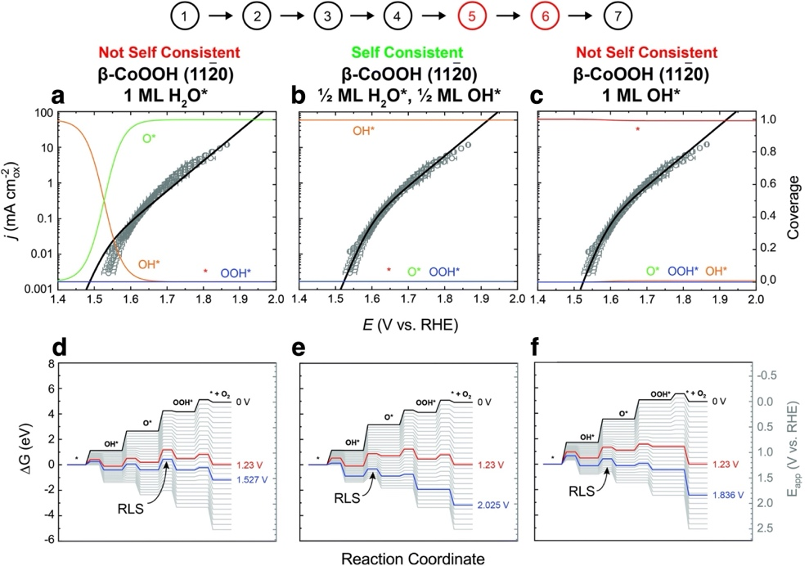
Figure 62 Steady state microkinetic fits and self-consistency criterion evaluation for the β-CoOOH (1120) surface with different DFT coverages. The fits are shown in black and the coverage predicted by the steady state microkinetic model shown in red for the clean surface, orange for OH*, green for O*, and blue for OOH* for the (a) surface with 1 ML H₂O* DFT coverage, (b) surface with ½ ML H₂O*, ½ ML OH* DFT coverage, and (c) the surface with 1 ML OH* DFT coverage. The full reaction coordinates at applied voltages from 0 to 2.5 V vs. RHE in 0.1 V increments are shown for the (d) surface with 1 ML H₂O* DFT coverage, (e) surface with ½ ML H₂O*, ½ ML OH* DFT coverage, and (f) the surface with 1 ML OH* DFT coverage. The reaction coordinates at the standard OER potential (E⁰ = 1.23 V vs. RHE) and the PLS for the given bulk phase and surface are shown in red and blue, respectively. The RLS is highlighted and compared to the DFT coverage to calculate the thermodynamic adsorbate energetics. Only the β-CoOOH (1120) surface with ½ ML H₂O*, ½ ML OH* DFT coverage fits the self-consistency criterion where the kinetics traps the surface in a dominant OH* coverage due to a RLS of OH* → O*. Adapted from Ref.⁵¹⁶ with permission from the Royal Society of Chemistry.
Interestingly, the potential limiting step (PLS) identified on the basis of the thermodynamics of the 4 steps via the CHE approach and the rate determining step (RDS) identified solving the kinetics equations do not always coincide. While the Tafel curves displayed in Figure 62 provide a good fit of the experimental data, further improvement can be achieved by adding to the set of elementary steps a bulk redox process between CoO₂, β-Co(OH)₂ and β-CoOOH, thus considering the possibility that the surface undergoes a transformation as the bias drives the phase change. It is worth stressing that the redox potentials for these transformations obtained through fitting, 1.593 V (RHE) for both transitions, and those obtained from DFT calculations, 1.150 V and 1.758 V, differ quite considerably, possibly due to the limited accuracy of the employed PBE+U functional. Moreover, the authors compared results obtained by solving the full model with those where all steps but the RDS were treated as quasi-equilibrated, and concluded that the quasi-equilibrium approximation results in poor agreement with experiments.

These studies on oxyhydroxides clearly indicate that modeling the OER requires considering multiple competing mechanisms, accounting for the fact that the barriers are potential-dependent. Moreover, when dealing with transition metal atoms with partially filled d-shells and with oxygen radicals, there is fairly large uncertainty due to the use of approximate exchange and correlation functionals. Finally, notice that most studies focus on highly idealized surface terminations, not accounting for the structural complexity of real electrochemical interfaces.

pH and electrolyte effects in MK models

Bonnefont reviewed very recently how microkinetic simulations can been employed to understand of the effect of pH on the electrocatalytic reactions in fuel cells and electrolyzers.⁵²³ A number of recent investigations addressed the open question of why the rate of the HER/HOR on Pt is around 2 orders of magnitude slower in alkaline compared to acidic media.⁵²⁴ Lamoureux et al.⁵²⁵ used microkinetic modeling based on DFT calculations performed in explicit solvent, testing two models for the proton source in the HER/HOR: The first contains a H₃O⁺ ion in a water monolayer, representative of acidic media, the second contains a Na⁺ cation in a water bilayer, representative of alkaline media. The microkinetic model includes Volmer and Heyrovsky elementary steps both in acidic media (where H₃O⁺ is the proton source) and in alkaline media (where H₂O is the proton source), as well as the Tafel step, water dissociative adsorption and OH adsorption. The pH was introduced in the microkinetic model via the energy of H₃O⁺ and OH⁻, since the entropic term results in decrease of the energy of 2.3k_{B}T*pH for H₃O⁺ and an equal and opposite increase for OH⁻. Correspondingly, the barriers where H₃O⁺ is a reactant increase with increasing pH. The resulting model gave results in qualitative agreement with the experiments. It predicts the reaction proceeds via the Volmer-Heyrovsky mechanism with a switch in the proton donor at a pH around 4, and therefore attributes to this change the observed lowering of the rate with increasing pH.

Using first principles MD with an explicit description of the electrolyte, Li et al.⁴⁶¹ disputed these findings. They showed that the water distribution and the structure of the H-bond network in the EDL has an effect on the kinetics of the Volver step in the HER, but it is the opposite of what would be expected: The barrier for the Volmer step in their calculation is higher in acidic media compared to the alkaline case, at variance with the results of Lamoureux et al.⁵²⁵ Notice that the structural model adopted in the work Li et al.⁴⁶¹ is far more complex, and like more representative of the experimental interface, compared to the highly simplified one adopted by Lamoureux et al.⁵²⁵ They suggest, however, that a gap in the H-bond network gap in the alkaline EDL is responsible for the observed dependence of the rate of the HER on pH. The role of pH in the HER/HOR is therefore still an open issue.

In the case of the OER, Rajan and Carter⁵²⁶ proposed a microkinetic model for the reaction on Fe-doped β-NiOOH on the basis of their previous study²³³, where they used the CHE approach in combination with hybrid functional calculations to identify possible reaction paths on the ($\overline{1}2\overline{1}1$) surface. They considered a path consisting of four intermediates: a dihydroxo species (HO*OH), a hydroxo-oxo species (HO*O + ^{γ}OH), a hydroxo species (HO* + ^{γ}OH₂), and a hydroxo-aqua species (HO*OH₂), where * and γ denote surface Fe and Ni atoms. Each of the four elementary steps of the model involves a PCET reaction, with reaction free energies computed with the CHE approach assuming bulk concentration of the reactants. The authors used experimental data to fit some of the parameters in their model, in particular the free energy term Δω corresponding to the work done to bring reactants and products from the bulk of the electrolyte to the catalyst surface, and the parameters to describe the kinetics of the elementary steps. The kinetics was formulated on the basis of Marcus theory of outer sphere electron transfer, resulting in the following expression for the forward rate of the i-th elementary step:
$$k_{fi} = \frac{k_{B}T}{h}exp\left(-\frac{λ_{i}}{4k_{B}T}{\left(1+\frac{ΔG_{bulk,i}^{0}(U)+Δω_{i}}{λ_{i}}\right)}^{2}\right)$$ | Equation 101
where $λ_{i}$ is the reorganization energy, which is fitted against the experiments of Louie and Bell.⁵²⁷

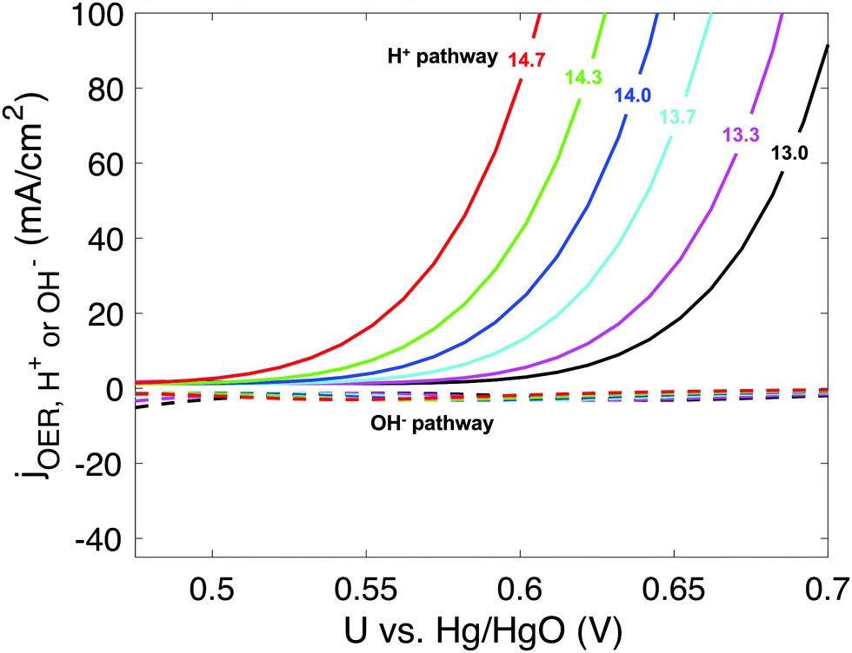
Figure 63 OER current densities attributed to H⁺ (solid lines) and OH⁻ (dashed lines) pathways at various applied potential and pH values. The rightmost (black) curve represents pH = 13.0 and the leftmost (red) curve represents pH = 14.7. Reproduced with permission from Ref.⁵²⁶ with permission from the Royal Society of Chemistry.
The authors considered the possibility that each of the four PCET steps can involve either protons or hydroxide ions as reactants, and fitting produced vastly different reorganization energies for these two species, $λ_{H^{+}}$ = 0.744 eV and $λ_{{OH}^{-}}$ = 2.474 eV. The outcome is that the kinetics of steps involving protons are considerably faster than those involving hydroxide, to the point that, according to this model, even at pH=14 the OER proceeds mainly via acidic steps (see Figure 63). This is a very counterintuitive finding, since in highly alkaline electrolytes the OER is normally expected to involve hydroxide ions, and Louie and Bell's experiments show that the reaction order in OH⁻ is one.⁵²⁷ Rajan and Carter also find that the surface is positively charged with their model, while one would expect an opposite finding in an alkaline electrolyte where hydroxide anions can bind to the surface. Furthermore, the authors predict that the exchange current for this system is around 3.5 μA cm⁻², a value in line with that of RuO₂, one of the most active catalysts for the OER. Clearly, to support the validity of these findings, it would be interesting to validate the estimates of the reorganization energies with first principles calculations. In fact, Lamoureux et al.⁵²⁵, argued against such a hypothesis, which was formulated to explain the fastest rate of the HER on Pt in acidic media compared to alkaline media.

Fornaciari et al.⁶⁷ performed a combined experimental and theoretical study to understand the pH effects on the OER in IrO₂(110). In their MK model, the authors considered the adsorbate evolution mechanism, comprising eight PCET steps, including both acidic and alkaline conditions:
R1: *OH $⇌$ *O + H⁺ + e⁻ Equation 102
R2: H₂O + *O $⇌$ *OOH + H⁺ + e⁻ Equation 103
R3: *OOH $⇌$ * + O₂ + H⁺ + e⁻ Equation 104
R4: * + H₂O $⇌$ *OH + H⁺ + e⁻ Equation 105
R5: *OH + OH⁻ $⇌$ *O + H₂O + e⁻ Equation 106
R6: *O + OH⁻ $⇌$ *OOH + e⁻ Equation 107
R7: *OOH + OH⁻ $⇌$ * + O₂ + H₂O + e⁻ Equation 108
R8: * + OH⁻ $⇌$ *OH + e⁻ Equation 109
The pH enters into the model via the concentration of the reactant and products H⁺ and OH⁻. The forward rate constant of the i-th step $k_{fi}$ is assumed to have a Butler-Volmer form,
$$k_{fi}= Aexp\left(\frac{∆E_{0V}-βn_{i}eη}{k_{B}T}\right)$$ | Equation 110
where A is a prefactor, $∆E_{0V}$ is the activation energy at equilibrium potential, β is the transfer coefficient, n_{i} the number of electrons involved in the reaction, $η$ is the overpotential. The kinetic parameters in the model are extracted from the work of Exner et al.⁵²⁸, while the reaction free energies are computed with the CHE approach in vacuum. In their experiments, they controlled the pH via titration of the electrolyte rather than with buffers.
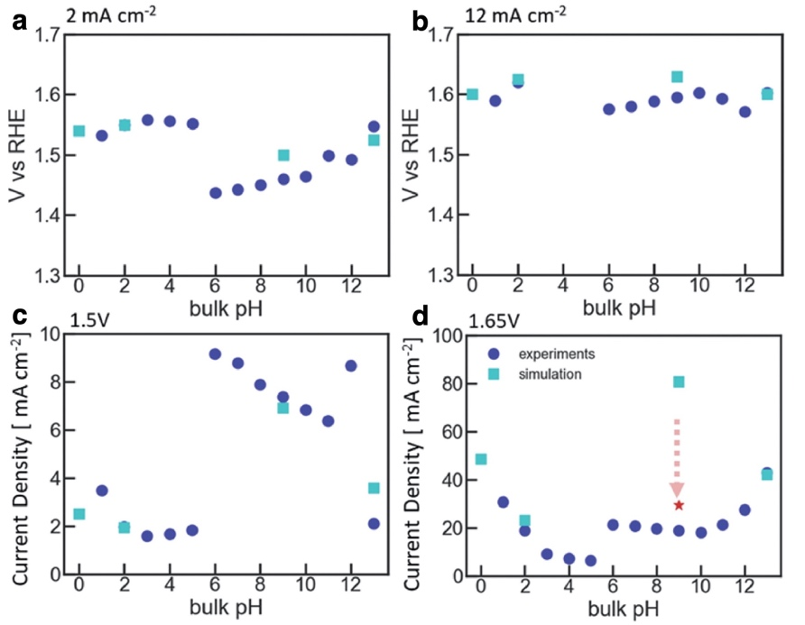
Figure 64: Oxygen evolution overpotential as a function of bulk pH, for IrO₂ nanoparticles from experiments (circles) and simulations (squares). The potentials were reported at current densities of (a) 2 mA cm⁻² and (b) 12 mA cm⁻². The current densities were reported at corresponding voltages of (c) 1.5 V and (d) 1.65 V. The pH's ran in the simulation are pH 0, 2, 9, and 13. The red star indicates the pH at the surface of the electrode, 2.34, determined by the transport model, when the bulk pH is 9. Adapted from Ref.⁶⁷ under the Creative Commons Attribution 4.0 License.
As shown in Figure 64, low current density (2 mA cm⁻²), they measured lower overpotentials in the near neutral pH range, while at high current density (12 mA cm⁻² or higher potential the trend is reversed, with highly acidic or alkaline conditions outperforming neutral conditions. The microkinetic model provides good agreement with experiments, even though to reconcile theory and measurements the predicted activation energies for the alkaline steps had to be readjusted. A noticeable exception is pH 9, where the agreement is rather poor. The authors used a transport model to simulate the rotating-disk-electrode experimental setup and concluded that at these pH conditions mass-transfer effects are crucial, since the local pH is considerably more alkaline than the bulk electrolyte. Correcting for these effects results in a considerable improvement (see Figure 64d). Interestingly, a sensitivity analysis shows that at pH 0 at low overpotential there are two RDS's, the formation of *OOH and the release of O₂, while at pH 9 and 13 and at high overpotentials the formation of *OOH is the sole RDS. These results suggest that both the acidic and alkaline pathways may occur at neutral pH and low bias, which explains the improved performance at these conditions. The authors suggest that at high current densities transport effects dominate, resulting in a drop of the interface pH, a scenario not captured by the microkinetic model.

Microkinetic modeling has been used not only to capture the effects of pH but also to describe the influence of electrolyte ions on the OER catalytic activity. Huang et al.⁵²⁹, in particular built a model for the β-NiOOH(0001) surface targeting the effects of non-specifically adsorbed alkali metal cations. They combined a DFT description of the elementary steps of the OER and continuum model for the EDL structure. The authors assumed the 4-PCET step AEM model in alkaline conditions. The reaction energies of the elementary steps were evaluated with the CHE approach, while the rate constant $k_{i}^{f,b}$ for the i-th step has a Butler-Volmer dependence on the applied bias:
$$k_{i}^{f,b}=\frac{k_{B}T}{h}exp\left(-\frac{G_{a,i}^{f,b}}{k_{B}T}\right)$$ | Equation 111
$$G_{a,i}^{f}=G_{a,i}^{0}+β_{i}ΔΔG_{i}, G_{a,i}^{b}=G_{a,i}^{0}+(1-β_{i})ΔΔG_{i},$$ | Equation 112
where f and b indicate the forward and backward reaction, $G_{a,i}^{0}$is the activation energy at equilibrium conditions, $β_{i}$ is the symmetry factor and $ΔΔG_{i}$ is the variation of the reaction energy with respect to equilibrium, which include the effects of the bias (a la Butler-Volmer), of the coverages (a la Brønsted−Evans−Polanyi) and of the electric field in the double layer. The effects of the double layer are modeled via a Poisson-Boltzmann type of equation that include an electric field dependence of local dielectric constant. The properties of the electrolyte considered in the model enter via the relative size of the solvated cations. The reaction energies of the elementary steps are computed with the CHE approach, the symmetry factors are fixed to 0.5, activation energies at equilibrium potential are fitted, and the charges and dipoles of the adsorbates are also fitted.
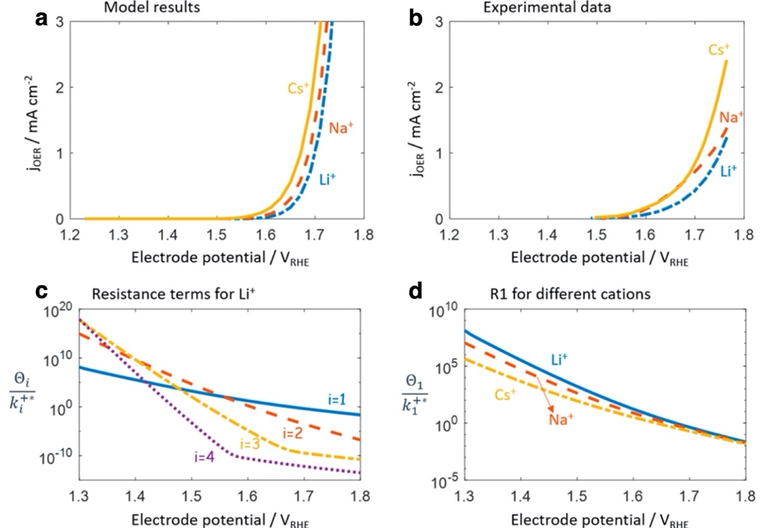
Figure 65 Model-experiment comparison. (a) Model-calculated polarization curves for OER in 0.1 MOH (M = Li⁺, Na⁺, Cs⁺) with model parameters listed in Table 1. (b) Experimental polarization curves under the same condition measured by Michael et al. (24) (c) Four resistance terms as a function of the electrode potential for the case of M = Li⁺. (d) Rate-determining resistance above 1.6 VRHE, for different cations. Adapted from Ref.⁵²⁹ under the Creative Commons Attribution 4.0 License.

The model correctly reproduces the trends observed experimentally (see Figure 65). As the size of the cations increases, fewer cations accumulate near the surface, which results in an increase of the current density measured at fixed potential. The authors refer to this phenomenon as cation overcrowding. Interestingly, the RDS changes as a function of the applied bias (see Figure 65c).
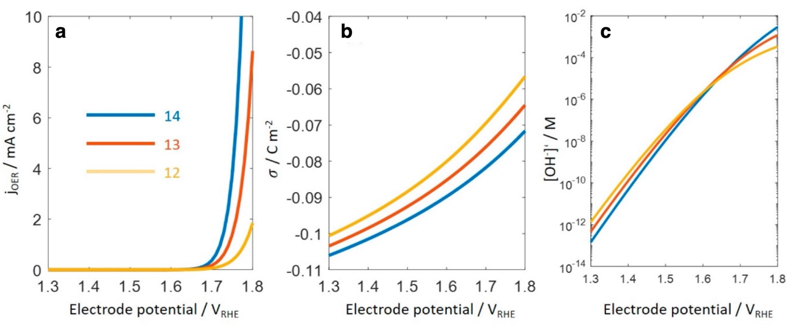
Figure 66 (a) pH effect of the OER in x (x = 1, 0.1, 0.01) M LiOH with the total ionic strength kept at 1 M. (b) Surface charging relation for the three pHs. (c) OH– concentration at the reaction plane as a function of the electrode potential for the three pHs. Adapted from Ref.⁵²⁹ under the Creative Commons Attribution 4.0 License.

Since the model consists of 4 PCET steps, the reaction free energy of each step is pH independent in the RHE scale. The microkinetic model, however, shows that the polarization curves depend on pH, with an increased OER activity under more alkaline conditions (see Figure 66a), in agreement with experiments. The origin of this behavior is again related to the cation overcrowding phenomenon. At more alkaline conditions the surface is more negatively charged (see Figure 66b), at variance with the predictions of Rajan and Carter⁵²⁶ discussed earlier, and the cation overcrowding is therefore more pronounced at higher pH, reducing the concentration of OH⁻ in the EDL, even though this concentration is higher in the bulk under more alkaline conditions. At higher electrode potentials, however, the electrode is less negatively charged, reducing the overcrowding effect, and above 1.6 V_{RHE} the concentration of OH⁻ in the EDL is larger at larger pH values. Since the reaction is limited by the concentration of OH⁻, the OER activity increases with pH above 1.6 V_{RHE}.

Photoelectrochemical OER

Microkinetic modeling has been used also to model the photoelectrochemical OER in semiconducting oxides like TiO₂ and α-Fe₂O₃. A fundamental difference between metallic electrocatalysts like IrO₂ and RuO₂ and semiconducting photocatalysts like TiO₂ and α-Fe₂O₃ is the effect of the applied bias on the electrochemical potential of the electrons/holes. In the absence of Fermi level pinning, the band edges of a semiconductor at the solid/liquid interface are pinned, i.e. the energies of the band edges do not vary as a function of the applied bias. An increasingly anodic bias in an n-type semiconductor, for example, will increase bend bending, the size of the space charge layer and (exponentially) the population of holes at the interface, not their energy. Accordingly, the rate constants of elementary steps introduced in microkinetic models, even in the case of electrochemical steps, do not have a direct Butler-Volmer type of dependence on the applied bias. In some formulations, the rate constants are derived from transition state theory⁴⁵⁶, while other authors⁵³⁰ employed Gerisher's formulation of electron transfer⁵³¹, where rates depend on the alignment between the band edges and the redox potential of the elementary step. Activation energies and reaction energies, as in the case of metallic electrocatalysts, can depend on the coverage of the reaction intermediates.

Wang and co-workers⁴⁵⁶ used DFT calculations to compute the reaction free energy and the activation energy of the elementary steps of the OER on rutile TiO₂(110). The authors built a microkinetic model entirely from first-principles, with no adjustable parameters, with a total of 14 elementary steps. They included two paths for the O-O bond formation, both involving surface adsorbates, resulting either in a *OO²⁻ peroxo or a *OOH⁻ hydroperoxo intermediate, triggered in both case by the presence of a *O⁻ radical. Reaction energies and barriers are assumed to be coverage independent. The authors computed the rate of the OER as a function of the concentration of "surface reaching holes" $C_{h^{+} }$, and made contact with experiments via an estimate of this quantity ($C_{h^{+} }$= ~ 10⁻⁹ ML). Figure 67 displays the prediction of the model, reporting the OER rate as a function of the concentration of the surface reaching holes and of the activation energy of some key steps. The authors concluded that the factor limiting the performance of TiO₂ is the low concentration of surface reaching holes.
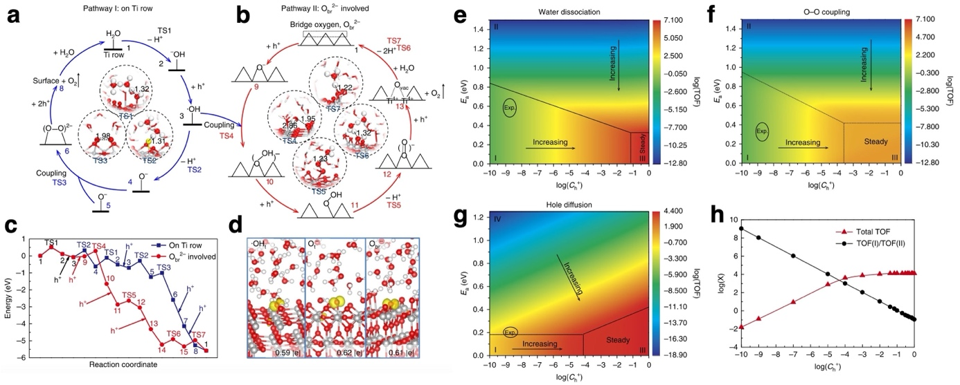
Figure 67 (a) One of the dual pathways (pathway I) occurring on the Ti row. (b) The other pathway (pathway II) involving bridge oxygen. Insets show the TS structures. (c) The energy profiles of pathways I and II, in which states 1, 2, … 15 correspond to the states in a and b. The elementary steps involving holes are labeled by h⁺. (d) The existence of three key surface radicals in the process. They are illustrated by the spin-density plots (dumbbell-shaped O 2p orbital; isovalue of 0.005) and the Bader charge difference (~0.6 |e| means that those oxygens after trapping h⁺ are positively charged with + 0.6 |e| with respect to the lattice O in bulk TiO₂). Influence of different kinetic barriers (water dissociation (e), O–O coupling (f) and hole diffusion (g)) and C_{h+} on the total TOF. The trends in different regions (I, II, III and IV) are indicated by black arrows. The experimental concentrations of holes with calculated barriers are labeled as black circles. (h) The contribution ratio between pathways I and II to the total TOF. ‘X’ represents the total TOF for the red curve and the contribution ratio for the black curve, respectively. Adapted with permission from Ref.⁴⁵⁶ Copyright 2018 Springer Nature.
Righi et al. used a similar approach to model the photoelectrochemical OER in α-Fe₂O₃.⁶⁶ At variance with Wang et al.⁴⁵⁶, however, here the authors distinguished two kinds of holes: those trapped in μ₂-O oxyl intermediates (also named surface holes or *O^{I-}) and those present in the space charge layer ($C_{h^{+} }$in the nomenclature of Wang et al.). Using transient photocurrent measurements under chopped illumination, and integrating the cathodic current transients, the authors obtained an estimate of the coverage of both surface holes and of space charge layers holes, which were distinguished by their decay with time. The authors used DFT calculations to obtain the coverage dependence of both the reaction energies and activation energies of the elementary steps. Here the O-O bond is assumed to take place via the nucleophilic attack of either a water molecule or a hydroxide ion on a *O^{I-} surface intermediate, with the second being kinetically favored, while the direct coupling of surface adsorbates was predicted to be strongly activated. The microkinetic model, solved at the steady state, correctly predicts a third-order dependence of the photocurrent on the surface hole coverage, as seen in multiple experiments^{532, 533}, and a small apparent activation energy (see Figure 68). This is rationalized on the basis of an O-O step involving a chemical step, the dissociative adsorption of a hydroxide ion on three surface holes leading to a *OO⁻ superoxo intermediate, with an activation energy that is weakly dependent on the surface hole coverage.
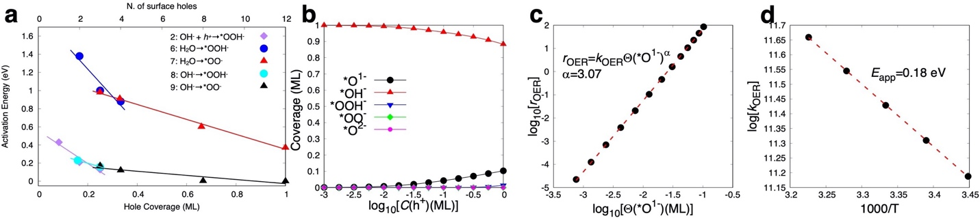
Figure 68 (a) Activation energy of the O–O bond formation step versus the coverage of surface holes, reported in monolayers in the bottom x-axis and as number of surface holes per simulation cell in the top x-axis. The numbers in the colour code represent the reaction number. (b) Coverage of various reaction intermediates as a function of the concentration of holes in the SCL. (c) log–log plot of the OER rate versus the coverage of *O¹⁻ intermediates. (d) log of the OER rate constant plotted against inverse temperature for C(h+) = 1 ML. The red dashed lines in (c) and (d) are linear fits of the data points. Adapted from Ref.⁶⁶ under the Creative Commons Attribution 4.0 License.

George et al.⁵³⁰ also focused on α-Fe₂O₃, considering the (110) surface and the following single-site mechanism via μ₁ adsorbates in alkaline electrolytes:
* + OH⁻ $⇌$ *OH + e⁻ Equation 113
*OH + OH⁻ $⇌$ *O + H₂O + e⁻ Equation 114
*O + OH⁻ $⇌$ *OOH + e⁻ Equation 115
*OOH + OH⁻ $⇌$ *O₂ + H₂O + e⁻ Equation 116
* O₂ $⇌$ O₂ (aq) Equation 117
For the desorption of molecular oxygen, the authors assumed a constant rate of desorption. To compute the rate of the elementary electrochemical steps, the authors employed Gerischer's model for electron transfer⁵³¹, where the forward and backward rates for the i-th step are computed as
$$γk_{fi}=k_{v,max}exp\left[-\frac{{\left(E_{v}-E_{F,redox,i}^{0}-λ\right)}^{2}}{4k_{B}Tλ}\right]$$ | Equation 118
$$k_{bi}=k_{v,max}exp\left[-\frac{{\left(E_{v}-E_{F,redox,i}^{0}+λ\right)}^{2}}{4k_{B}Tλ}\right]$$ | Equation 119
Here $E_{v}$ is the energy of the valence band maximum, $E_{F,redox,i}^{0}$ is the redox potential of the i-th step, computed via the CHE approach in vacuum⁵³⁴, $k_{v,max}$is a pre-exponential factor, $λ$is the solvent reorganization energy, assumed to be equal to 1 eV (notice that the same quantity was estimated to be 2.474 eV in Rajan and Carter's work⁵²⁶, and that rates depend exponentially on this quantity). The forward and backward current densities for the i-th step are then calculated as
$$j_{fi} = ek_{fi}p_{s}c_{red,i}$$ | Equation 120
$$j_{bi} = ek_{bi}N_{v}c_{ox,i}$$ | Equation 121
where e is the electron charge, $N_{v}$is the effective density of states of the valence band, $p_{s}$ is the hole density at the surface of hematite, $c_{red,i}$ and $c_{ox,i}$ are the concentration of the reduced and oxidized intermediate species. The effect of the applied bias U enters in the expression of the hole density:
$$p_{s}=p_{s}^{0}exp\left(\frac{U}{k_{B}T}\right)$$ | Equation 122
where $p_{s}^{0}$is the equilibrium hole density in the dark. The authors solved the model in the dark as a function of the applied bias, obtaining the j-U characteristic, the coverage of the intermediates as a function of the applied bias as well as the impedance spectrum.

In a follow-up work, the model was then extended by George et al.⁵³⁵ to consider explicitly also the dynamics of the charge carriers in the space charge layer of the semiconductor. Given the complexity of the model, here we briefly sketch only its main features and refer the readers to the original paper for further details.

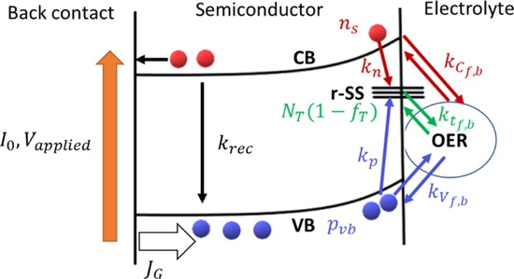
Figure 69: Schematic of charge carrier dynamics under illumination within the space charge region showing recombination, trapping, and oxygen evolution reaction via VB (blue), CB (red), and r-SS (green). The red circles represent electrons, and the blue circles represent holes. Reproduced with permission from Ref.⁵³⁵ Copyright 2020 American Chemical Society.
The OER was assumed to proceed via the same mechanism adopted in the earlier work⁵³⁰, but this time the free energy cost of the elementary steps were computed including solvation effects rather than in vacuum, resulting in differences as large as 0.4 eV. Crucially, the authors included in the model the presence of mid-band gap states (r-SS) at the semiconductor-electrolyte interface, characterized by a single level at energy E_{T} and with a surface density N_{T} (T stands for trap). Charge transfer to/from the OER intermediates can occur via the valence band, the conduction band or the r-SS states, as illustrated schematically in Figure 69. Using Gärtner's equation⁵³¹, the hole flux to the surface (J_{G}) for a given illumination intensity I₀ can be computed as
$$J_{G}=I_{0}\left(1-\frac{exp\left(-αW_{SC}\right)}{1+αL_{p}}\right)$$ | Equation 123
where α is the absorption coefficient, W_{SC} is the width of the space charge layer and L_{p} is the hole diffusion length. The width of the space charge layer is related to the potential drop across the space charge layer (u_{SC}) via
$$W_{SC}=\sqrt{\frac{2ϵ_{r}ε_{0}}{eN_{D}}\left(u_{SC}-k_{B}T/e\right)}$$ | Equation 124
where ε_{r} and ε₀ are the permittivity of the semiconductor and of free space, N_{D} is the doping density. The authors obtained an equation for the rate of change of the hole density (p_{s}), accounting for hole generation and transport, recombination, hole trapping at trap states, charge transfer to/from the OER intermediates via both the valence and the conduction band. Similarly, they obtained an equation for the rate of change of the occupation of the trap states (f_{T}) accounting for electron and hole trapping at trap states, and charge transfer to/from the OER intermediates via the trap states. Based on the standard definition of capacitance (C=dq/dV), the authors also obtained expressions for the capacitances due to both r-SS trap states (C_{r-SS}) and to the OER intermediates (C_{i-SS}). Besides the free energy cost of the OER elementary steps computed with the CHE approach, the model requires over 20 parameters, mostly obtained from experimental estimates.

The model was solved at the steady state varying the density of the trap states N_{T}, as shown in Figure 70. Interestingly, the authors argue that while a sufficiently high density of trap states can cause Fermi-level pinning, as revealed a plateau in the Mott–Schottky plot (Figure 70c), the capacitance related to OER intermediates do not cause such effects, at variance with the interpretation of the experimental Mott–Schottky analysis.^{536, 537}

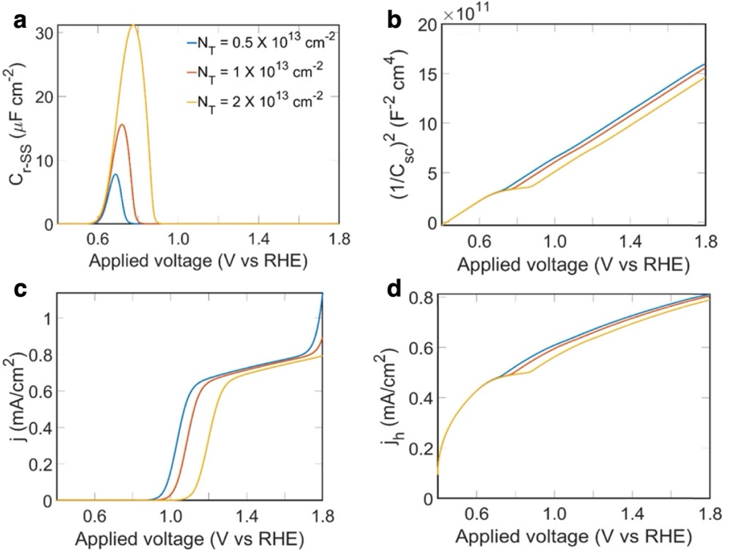
Figure 70 (a) Effect of surface state density of r-SS (N_{T} ) on the surface state capacitance, C_{r-SS}, as a function of applied potential; both the maximum and the full width at half-maximum of C_{r-SS} increase with an increase in N_{T}. (b) Mott–Schottky plots; the pinning coincides with C_{r-SS} and the FLP is extended when N_{T} is increased. (c) j–V plots; higher onset potential and lower saturation current density are found with higher N_{T} (d) Hole current density (j_{h}); a plateau is observed before potentials corresponding to the onset potential from j–V plots and the plateau increases with an increase in N_{T}. Adapted with permission from Ref.⁵³⁵ Copyright 2020 American Chemical Society.

Further improvements in the description of photoelectrochemical OER could be obtained coupling a detailed description of elementary steps of OER, as done by George et al.⁵³⁵, with approaches that model photoelectrochemical devices including the electrostatic interactions both in the semiconductor and in the electrolyte, as well as carriers generation, recombination and transport⁵³⁸, as done in the SLJCompact tool by Bevan and co-workers⁵³⁹. Note that the approach of Bevan et al. does not include trap states and the whole catalytic process is enters in the model via an expression of the rate for hole transfer.

Conclusion

We have reviewed modeling of the OER mechanism spanning efforts from before the widespread use of DFT to the most sophisticated ab initio studies. Several key points and themes emerged and will now be summarized. The introduction of the CHE approach⁵⁹ has had an enormous impact in computational electrochemistry, enabling the use of DFT simulations in this field. As ab initio thermodynamics offered a way to introduce temperature and pressure effects into total energy calculations to predict (T, p) phase diagrams, the CHE allows total energy calculations of reaction intermediates to be linked to experimental electrochemical potential scales, thus enabling the prediction of (pH, U) phase diagrams. Moreover, assuming a reaction mechanism consisting of a sequence of PCET steps and using the maximum free energy cost of these steps as a descriptor of catalytic activity, this approach affords a quick way to predict the ability of any material to promote a specific reaction. The OER was one of the first electrocatalytic processes investigated using the CHE approach.⁸⁷ Crucially, through the use of linear relationships between the adsorption energy of the reaction intermediates, the CHE offered a way to explain why a certain material excels or fails in promoting the OER, ultimately linking the catalytic activity to the strength of the interaction between the catalyst surface and a few adsorbates. When compared to experimental measurements, however, the predictive power of the CHE offers mixed results. For perovskites, the predicted activity trends are in excellent agreement with experiments, but the predicted overpotentials are more than twice the experimental values; for oxides, the predicted overpotentials are only weakly correlated with the measured ones.¹⁰¹ A possible reason to explain, at least in part, this discrepancy is the structure sensitivity of the OER^{175, 308} and the amorphization of a catalyst’s surface under OER conditions^{309, 310}, suggesting that a single well-defined low-energy surface structure could be a poor structural model for an electrode under operating conditions. Clearly, these are not limitations of the CHE approach but of the structural models adopted in the calculations.

The notion of scaling relationships among the adsorption energies of the reaction intermediates rests on the assumption of a well-defined reaction mechanism involving a single active site. Breaking the scaling relationships and the resulting volcano plot of activity versus descriptor entails involving neighboring sites, which interact differently with different intermediates, or which might promote a different mechanism. Engaging bridging oxygen sites next to the active CUS sites in rutile-type oxides, for example via doping, was shown to induce strong effects in RuO₂(110).²⁴⁰ This departure from the originally proposed⁸⁷ single-site nucleophilic attack mechanism (also known as AEM, adsorbate evolution mechanism) was extended even further in perovskite catalysts, where lattice oxygen atoms were found to be involved (LOM, lattice oxygen mechanism), in agreement with isotope labeling experiments.³²⁹ Various types of LOMs have been proposed^{324, 329, 408}, showing there is a large mechanistic diversity and flexibility, that was all but ignored in the first applications of the CHE to the OER. The involvement of lattice oxygen is strongly linked to the electronic structure of the catalyst^{324, 327, 329} and in particular to the appearance of electron holes on lattice oxygen atoms, occurring in the presence of high M-O covalency resulting either from orbital overlap or from a negative charge transfer regime. It is not clear, however, whether the involvement of lattice oxygen is linked to the catalyst instability^{381, 382}, or whether the high covalency of the M-O bond could result in reduced dissolution and increases stability.^{359, 384}

One of the most appealing, but also somewhat questionable, aspects of the CHE approach is that completely removing the effects of the electric field in the double layer at the electrode/electrolyte interface enormously simplifies the calculations of the free energy cost of the elementary steps, since this quantity can be now computed as a difference of total energies, as done in thermal catalysis. While the effects of the electric field have been shown, at least in some cases, to be small, solvation effects cannot be ignored, since different reaction intermediates interact differently with water-based electrolytes. These interactions can be as large as 0.5-0.6 eV for intermediates like *OOH and *OH that form multiple hydrogen bonds with water, while they can be as low as 0.1 eV for *O, which can interact weakly with water.^{455, 457} Implicit PCM-type solvent models are unable to describe directional interactions like H-bonds and are therefore of limited value in this regard.⁶¹ An explicit description of water, with solvation effects obtained from statistical averages of structures extracted from molecular dynamic simulations, offers a viable, albeit time consuming, way to estimate solvation effects.^{456, 457}

A key finding that emerges in applications of the CHE to the OER is that the coverage of the OER intermediates plays a crucial role. This was shown clearly already in the very first application of the CHE approach to the OER on Pt(111), where the potential determining step changes as function of the oxygen coverage.⁸⁷ The assumption of thermodynamic equilibrium, which underpins the CHE approach, for an open system like an electrocatalyst under operation can, however, lead to incorrect predictions. Consider for example the case of IrO₂(110): when not only *OH and *O but also *OO or *OOH intermediates are considered as possible adsorbates present at the surface, the thermodynamic equilibrium assumption leads to *OO covered surfaces at biases around 1.3 V vs RHE in some works¹²⁷, or *OOH covered surfaces at biases around 1.5 V vs RHE in other works⁵²⁸, at odds with experimental evidence.^{63, 404}

A step beyond the equilibrium approximation for an out of equilibrium system is offered by microkinetic modeling, where the coverages of the reaction intermediates are an output of the calculations, and the relative importance of competing mechanisms can be compared. Often the equations are strongly simplified via the assumption that non rate determining steps are quasi-equilibrated, a dangerous assumption⁵¹⁹ that can and should be tested. The inputs of microkinetic models consist of reaction energies and barriers for the elementary steps included in the model. Notice that when these quantities are coverage dependent, the models need to be solved self-consistently, i.e. the predicted coverages must be consistent with those used to compute the parameters of the models. An appealing aspect of these simulations is that predictions like the current density-voltage (j-V) curves can be directly compared against experiments, thus offering a suitable platform to test the validity of the underlying assumptions and input parameters.⁵⁴⁰ The coverages of intermediates are notoriously difficult to measure in operando, but significant progress in that direction has been made and, at least in some cases, predicted coverages can be tested against experimental evidence.^{63, 404}

Barriers and reaction energies of the elementary steps can, in general, depend on the variation of the electric field in the double layer, an effect ignored in the CHE approach. In fact, while in experiments the potential is held constant, in ab initio simulations typically the charge is constant, hence the potential can vary, up to several volts⁴⁹⁷, along the reaction coordinate. To mitigate this effect, researchers have adopted two strategies. The first consists of obtaining constant potential information from constant charge calculations. This can be done either via extrapolation from a series of calculations with different surface cells^{458, 468} or via models that capture the capacitive contribution to the barrier originating from charge transfer along the reaction coordinate.^{497, 498} The second strategy consists of adopting a grand canonical approach, where the electronic charge in the electrode can vary as a function of the external bias and correspondingly the electrolyte screens the excess charge. Several implementations of this scheme have been proposed, mostly in combination with a continuum description of the electrolyte.^{460, 472, 482, 501, 509} When applied to the OER on IrO₂(110), the extrapolation technique predicts a large effect (transfer coefficient of 0.6) of the applied bias on the barrier for the O-O bond formation via the AEM.³⁹⁹ Grand canonical schemes have been applied assuming the O-O bond formation takes place via a purely chemical step, the dissociation of water. A large effect of the bias on the barrier has been predicted even in this case, since it is argued that charge is transferred from the reactant to the surface.^{265, 509} Other works, based on different implementations and electrolyte models, predict instead negligibly small effects.⁶³

Microkinetic models based on DFT data have been applied to the OER on IrO₂(110), in some cases with bias-dependent barriers^{265, 399, 483}, in other cases with coverage dependent barriers⁶³, in all cases adopting the quasi-equilibrium assumption. The predictions are very sensitive to the DFT-related uncertainties, for example the adsorption energy of molecular oxygen.³⁹⁹ The comparison with experiment is some cases poor, with Tafel slopes deviating significantly from experiments, especially at high anodic bias^{265, 483}, in other cases more favorable.⁶³ The parameters entering the microkinetic models can also be fitted to match experimental polarization curves.⁵²² The fitted parameters can then be tested against theory and the emergence of large discrepancies can raise some doubts regarding either the accuracy of the theoretical simulations or the assumptions of the fitted model.

Microkinetic models have also been applied to model the OER on Ni, Co and Ni-Fe oxyhydroxides, in some cases using DFT input parameters, in other cases fitting against experiments.^{516, 526} Comparison of the predicted j-V polarization curves against experiments appears in most cases excellent, even though the adopted mechanisms are different^{65, 484}, which suggests further mechanistic validation beyond j-V curves is necessary. And while coverages of the intermediates are difficult to measure in operando, the impact of the changes of the electrolyte composition (i.e. pH and counterions) can be tested. The pH can have a large effect on the activity of OER catalysts: at fixed potential on the RHE scale, perovskites can exhibit a close to order 1 dependence on the concentration of hydroxide anions^{315, 363}, a finding incompatible with a sequence of PCET steps, as often assumed in CHE calculations, and symptomatic of the involvement of lattice oxygen in the reaction mechanism (LOM). Redox peaks in rutile-type IrO₂(110) thin films display non-Nernstian behavior^{126, 441}, also in this case casting doubts on mechanisms consisting solely of PCET steps. Experiments on IrO₂ as well as other catalysts have proved that the nature of the electrolyte (e.g. buffered or unbuffered or different counterion species) plays a role too.^{422, 443, 444} The effects or electrolyte composition are particularly large in perovskites and oxyhydroxides.^{440, 447} In spite of their relevance, save for few notable exceptions^{526, 529}, the effects of pH and electrolyte composition in the OER have received very little attention by the theoretical community. This is partly due to the difficulty in controlling pH in first principles simulations, where the number of atoms is conserved^{450, 491}, and also because modeling ionic species and their solvation shells require large cells and painfully long MD simulations. In fact, when these effects have been included in the models, it has been done via implicit descriptions of the electrolyte, in the case of the OER⁵²⁹, and also in the case of CO₂ reduction.⁵⁴¹

Our review highlighted the tremendous amount of work that has been accomplished in 20 years of research in the field of theoretical modeling of the OER, starting with very powerful but highly simplified models^{59, 87}, which enabled invaluable insights and formed the basis of our understanding of the OER. State-of-the-art approaches now include sophisticated first-principles based models that integrate multiple competing mechanisms and multiple environment effects, like the solvation, bias and coverage dependence of barriers and energies.

In our view, the lessons emerging from the large body of research that we reviewed suggest that theoretical modeling of the OER should address the following critical points: (i) The OER is a structure sensitive process and real catalysts are structurally complex, so any understanding emerging from theoretical modeling should be tested against variations of the structure adopted for the catalyst; (ii) There exist multiple competing mechanisms, including the AEM, as well as a series of LOMs, comprising of both electrochemical and chemical steps, and involving multiple sites: limiting our analysis to a single mechanism on a single site is an unwarranted simplification; (iii) The coverage of the reaction intermediates plays a crucial role in the energetics of the elementary steps, hence kinetic models should be solved self-consistently; (iv) The validity of the quasi-equilibrium approximation in microkinetic models should be tested; (v) Electrolyte effects, in general, cannot be ignored and to model solvation in aqueous media water needs to be described explicitly, at least for the first few layers directly in contact with the intermediates, to capture changes in the H-bond network; (vi) The energetics of some of the steps can exhibit strong dependence on the external bias, which can be accounted for; (vii) When the parameters of microkinetic models are derived from fitting against experimental j-V curves and differ substantially from theoretical or experimental estimates, we should reconsider the assumptions of the models.

Disentangling the relative contributions of all these factors is a field where theory can make a significant contribution. We stressed that progress is strongly dependent on combined theoretical and experimental efforts⁵⁴⁰, with theory striving to predict not one but multiple quantities that can be measured and experiments need to address characterizing the electrode/electrolyte interface in operando at the atomic scale. In our view, to enable further insights and improve the predictive power of modeling, two critical areas deserve even more attention compared to the current state-of-the-art: (i) The interfaces of electrocatalysts are structurally complex^{542, 543} and modeling this complexity is a largely unexplored field. New developments in the field of machine learning, including novel interatomic potentials,^{544, 545} represent an area with enormous potential to bridge this gap and to guide the search for new catalysts;⁵⁴⁶ (ii) We identified electrolyte effects in the OER as an important but fairly unexplored area, and so is the multiscale nature of the problem due to transport across multiple interfaces, including mass transport in the electrolyte⁵⁴⁷, but also charge transport (and recombination) in photoelectrochemical devices.⁵³⁸ If the rapid advances made over the past twenty years are any guide, extending theory to tackle these issues will radically change our understanding of electrochemistry and the OER.

References

(1) Shao, Y.; Markovic, N. M. Prelude: The Renaissance of Electrocatalysis. Nano Energy 2016, 29, 1-3.
(2) Bockris, J. O. M. The Hydrogen Economy: Its History. Int. J. Hydrogen Energy 2013, 38, 2579-2588.
(3) Bockris, J. O. M. Electrochemistry for a Future Society. In Trends in Electrochemistry, Springer US, 1977; pp 1-23.
(4) Marcus, R. A. Electron Transfer Reactions in Chemistry. Theory and Experiment. Rev. Mod. Phys. 1993, 65, 599-610.
(5) Marcus, R. A. Theoretical Relations among Rate Constants, Barriers, and Broensted Slopes of Chemical Reactions. J. Phys. Chem. 1968, 72, 891-899.
(6) Dickinson, E. J. F.; Wain, A. J. The Butler-Volmer Equation in Electrochemical Theory: Origins, Value, and Practical Application. J. Electroanal. Chem. 2020, 872, 114145.
(7) Fraggedakis, D.; McEldrew, M.; Smith, R. B.; Krishnan, Y.; Zhang, Y.; Bai, P.; Chueh, W. C.; Shao-Horn, Y.; Bazant, M. Z. Theory of Coupled Ion-Electron Transfer Kinetics. Electrochim. Acta 2021, 367, 137432.
(8) Domínguez-Flores, F.; Melander, M. M. Electrocatalytic Rate Constants from Dft Simulations and Theoretical Models: Learning from Each Other. Curr. Opin. Electrochem. 2022, 36, 101110.
(9) Hartnig, C.; Koper, M. T. M. Solvent Reorganization in Electron and Ion Transfer Reactions near a Smooth Electrified Surface: A Molecular Dynamics Study. J. Am. Chem. Soc. 2003, 125, 9840-9845.
(10) Koper, M. T. M.; Schmickler, W. A Kramers Reaction Rate Theory for Electrochemical Ion Transfer Reactions. Chem. Phys. 1996, 211, 123-133.
(11) Koper, M. T. M.; Mohr, J. H.; Schmickler, W. Quantum Effects in Adiabatic Electrochemical Electron-Transfer Reactions. Chem. Phys. 1997, 220, 95-114.
(12) He, Z.-D.; Chen, Y.-X.; Santos, E.; Schmickler, W. The Pre-Exponential Factor in Electrochemistry. Angew. Chem. Int. Ed. 2018, 57, 7948-7956.
(13) Schmickler, W.; Koper, M. T. M. Adiabatic Electrochemical Electron-Transfer Reactions Involving Frequency Changes of Inner-Sphere Modes. Electrochem. Commun. 1999, 1, 402-405.
(14) Schmickler, W. A Unified Model for Electrochemical Electron and Ion Transfer Reactions. Chem. Phys. Lett. 1995, 237, 152-160.
(15) Santos, E.; Aradi, B.; van der Heide, T.; Schmickler, W. Free Energy Curves for the Volmer Reaction Obtained from Molecular Dynamics Simulation Based on Quantum Chemistry. J. Electroanal. Chem. 2024, 954, 118044.
(16) Björketun, M. E.; Tripkovic, V.; Skúlason, E.; Rossmeisl, J. Modeling of the Symmetry Factor of Electrochemical Proton Discharge Via the Volmer Reaction. Catal. Today 2013, 202, 168-174.
(17) Ikeshoji, T.; Otani, M. Toward Full Simulation of the Electrochemical Oxygen Reduction Reaction on Pt Using First-Principles and Kinetic Calculations. Phys. Chem. Chem. Phys. 2017, 19, 4447-4453.
(18) Maheshwari, S.; Li, Y.; Agrawal, N.; Janik, M. J. Chapter Three - Density Functional Theory Models for Electrocatalytic Reactions. In Adv. Catal., Vol. 63; Academic Press, 2018; pp 117-167.
(19) Antipin, D.; Risch, M. Calculation of the Tafel Slope and Reaction Order of the Oxygen Evolution Reaction between Ph 12 and Ph 14 for the Adsorbate Mechanism. Electrochem. Sci. Adv. 2023, 3, e2100213.
(20) Kronberg, R.; Laasonen, K. Reconciling the Experimental and Computational Hydrogen Evolution Activities of Pt(111) through Dft-Based Constrained Md Simulations. ACS Catal. 2021, 11, 8062-8078.
(21) Sundararaman, R.; Vigil-Fowler, D.; Schwarz, K. Improving the Accuracy of Atomistic Simulations of the Electrochemical Interface. Chem. Rev. 2022, 122, 10651-10674.
(22) Bagger, A.; Castelli, I. E.; Hansen, M. H.; Rossmeisl, J. Fundamental Atomic Insight in Electrocatalysis. In Handbook of Materials Modeling: Applications: Current and Emerging Materials, Springer International Publishing, 2018; pp 1-31.
(23) Fang, Y.-H.; Liu, Z.-P. Tafel Kinetics of Electrocatalytic Reactions: From Experiment to First-Principles. ACS Catal. 2014, 4, 4364-4376.
(24) M, V.; Singh, S.; Bononi, F.; Andreussi, O.; Karmodak, N. Thermodynamic and Kinetic Modeling of Electrocatalytic Reactions Using a First-Principles Approach. J. Chem. Phys. 2023, 159, 111001.
(25) Zhao, Y.; Adiyeri Saseendran, D. P.; Huang, C.; Triana, C. A.; Marks, W. R.; Chen, H.; Zhao, H.; Patzke, G. R. Oxygen Evolution/Reduction Reaction Catalysts: From in Situ Monitoring and Reaction Mechanisms to Rational Design. Chem. Rev. 2023, 123, 6257-6358.
(26) Song, J.; Wei, C.; Huang, Z.-F.; Liu, C.; Zeng, L.; Wang, X.; Xu, Z. J. A Review on Fundamentals for Designing Oxygen Evolution Electrocatalysts. Chem. Soc. Rev. 2020, 49, 2196-2214.
(27) Wang, X.; Zhong, H.; Xi, S.; Lee, W. S. V.; Xue, J. Understanding of Oxygen Redox in the Oxygen Evolution Reaction. Adv. Mater. 2022, 34, 2107956.
(28) Gao, L.; Cui, X.; Sewell, C. D.; Li, J.; Lin, Z. Recent Advances in Activating Surface Reconstruction for the High-Efficiency Oxygen Evolution Reaction. Chem. Soc. Rev. 2021, 50, 8428-8469.
(29) Plevová, M.; Hnát, J.; Bouzek, K. Electrocatalysts for the Oxygen Evolution Reaction in Alkaline and Neutral Media. A Comparative Review. J. Power Sources 2021, 507, 230072.
(30) Tahir, M.; Pan, L.; Idrees, F.; Zhang, X.; Wang, L.; Zou, J.-J.; Wang, Z. L. Electrocatalytic Oxygen Evolution Reaction for Energy Conversion and Storage: A Comprehensive Review. Nano Energy 2017, 37, 136-157.
(31) Suen, N.-T.; Hung, S.-F.; Quan, Q.; Zhang, N.; Xu, Y.-J.; Chen, H. M. Electrocatalysis for the Oxygen Evolution Reaction: Recent Development and Future Perspectives. Chem. Soc. Rev. 2017, 46, 337-365.
(32) Fabbri, E.; Schmidt, T. J. Oxygen Evolution Reaction—the Enigma in Water Electrolysis. ACS Catal. 2018, 8, 9765-9774.
(33) Vazhayil, A.; Vazhayal, L.; Thomas, J.; Ashok C, S.; Thomas, N. A Comprehensive Review on the Recent Developments in Transition Metal-Based Electrocatalysts for Oxygen Evolution Reaction. Appli. Surf. Sci. Adv. 2021, 6, 100184.
(34) Brouzgou, A. Oxygen Evolution Reaction. In Methods for Electrocatalysis: Advanced Materials and Allied Applications, Springer International Publishing, 2020; pp 149-169.
(35) Son, Y. J.; Kawashima, K.; Márquez, R. A.; Smith, L. A.; Chukwuneke, C. E.; Mullins, C. B. Key Concepts for Understanding Alkaline Oxygen Evolution Reaction at the Atomic/Molecular Scale. Curr. Opin. Electrochem. 2023, 39, 101298.
(36) Sharshir, S. W.; Joseph, A.; Elsayad, M. M.; Tareemi, A. A.; Kandeal, A. W.; Elkadeem, M. R. A Review of Recent Advances in Alkaline Electrolyzer for Green Hydrogen Production: Performance Improvement and Applications. Int. J. Hydrogen Energy 2024, 49, 458-488.
(37) Hassan, N. S.; Jalil, A. A.; Rajendran, S.; Khusnun, N. F.; Bahari, M. B.; Johari, A.; Kamaruddin, M. J.; Ismail, M. Recent Review and Evaluation of Green Hydrogen Production Via Water Electrolysis for a Sustainable and Clean Energy Society. Int. J. Hydrogen Energy 2024, 52, 420-441.
(38) Oliveira, A. M.; Beswick, R. R.; Yan, Y. A Green Hydrogen Economy for a Renewable Energy Society. Curr. Opin. Chem. Eng. 2021, 33, 100701.
(39) Hassan, Q.; Abdulateef, A. M.; Hafedh, S. A.; Al-samari, A.; Abdulateef, J.; Sameen, A. Z.; Salman, H. M.; Al-Jiboory, A. K.; Wieteska, S.; Jaszczur, M. Renewable Energy-to-Green Hydrogen: A Review of Main Resources Routes, Processes and Evaluation. Int. J. Hydrogen Energy 2023, 48, 17383-17408.
(40) Shen, H.; Choi, C.; Masa, J.; Li, X.; Qiu, J.; Jung, Y.; Sun, Z. Electrochemical Ammonia Synthesis: Mechanistic Understanding and Catalyst Design. Chem 2021, 7, 1708-1754.
(41) Wu, T.; Fan, W.; Zhang, Y.; Zhang, F. Electrochemical Synthesis of Ammonia: Progress and Challenges. Mater. Today Phys. 2021, 16, 100310.
(42) Xu, H.; Ithisuphalap, K.; Li, Y.; Mukherjee, S.; Lattimer, J.; Soloveichik, G.; Wu, G. Electrochemical Ammonia Synthesis through N2 and H2o under Ambient Conditions: Theory, Practices, and Challenges for Catalysts and Electrolytes. Nano Energy 2020, 69, 104469.
(43) Yang, B.; Ding, W.; Zhang, H.; Zhang, S. Recent Progress in Electrochemical Synthesis of Ammonia from Nitrogen: Strategies to Improve the Catalytic Activity and Selectivity. Energy Environ. Sci. 2021, 14, 672-687.
(44) Overa, S.; Ko, B. H.; Zhao, Y.; Jiao, F. Electrochemical Approaches for Co2 Conversion to Chemicals: A Journey toward Practical Applications. Acc. Chem. Res. 2022, 55, 638-648.
(45) Zhu, P.; Wang, H. High-Purity and High-Concentration Liquid Fuels through Co2 Electroreduction. Nat. Catal. 2021, 4, 943-951.
(46) Tan, X.; Yu, C.; Ren, Y.; Cui, S.; Li, W.; Qiu, J. Recent Advances in Innovative Strategies for the Co2 Electroreduction Reaction. Energy Environ. Sci. 2021, 14, 765-780.
(47) Koper, M. T. M. Thermodynamic Theory of Multi-Electron Transfer Reactions: Implications for Electrocatalysis. J. Electroanal. Chem. 2011, 660, 254-260.
(48) Klemenc, A. Die Elektrolytischen Vorgänge an Der Anode Als Wirkungen Des Hydroxyls. Z. Phys. Chem. 1939, 185A, 1-36.
(49) Foerster, F.; Yamasaki, J. Über Die Elektrolyse Der Alkalibromide Und Die Verzögerungserscheinungen Der Anodischen Abscheidung Der Halogene. Zeitschrift für Elektrochemie und angewandte physikalische Chemie 1910, 16, 321-355.
(50) Gurney, R. W.; Rutherford, E. The Quantum Mechanics of Electrolysis. Proc. R. soc. Lond. Ser. A-Contain. Pap. Math. Phys. Character 1931, 134, 137-154.
(51) Gurney, R. W.; Fowler, R. H. The Quantum Mechanics of Electrochemistry.―Ii. Proc. R. soc. Lond. Ser. A-Contain. Pap. Math. Phys. Character 1932, 136, 378-396.
(52) Eyring, H.; Glasstone, S.; Laidler, K. J. Application of the Theory of Absolute Reaction Rates to Overvoltage. J. Chem. Phys. 1939, 7, 1053-1065.
(53) Bockris, J. O. M. Electrolytic Polarisation: Iii. The Effect of the Solvent on the Oxygen Overpotential. Discuss. Faraday Soc. 1947, 1, 229-235.
(54) Bockris, J. O. M. Effect of the Solvent on Oxygen Overpotential. Nature 1947, 159, 401-402.
(55) Malcolm W. Chase, Jr. Nist-Janaf Thermochemical Tables; Fourth edition. Washington, DC : American Chemical Society ; New York : American Institute of Physics for the National Institute of Standards and Technology, 1998., 1998.
(56) LeRoy, R. L.; Bowen, C. T.; LeRoy, D. J. The Thermodynamics of Aqueous Water Electrolysis. J. Electrochem. Soc. 1980, 127, 1954.
(57) Lee, Y.; Suntivich, J.; May, K. J.; Perry, E. E.; Shao-Horn, Y. Synthesis and Activities of Rutile Iro2 and Ruo2 Nanoparticles for Oxygen Evolution in Acid and Alkaline Solutions. J. Phys. Chem. Lett. 2012, 3, 399-404.
(58) Mattos-Costa, F. I.; de Lima-Neto, P.; Machado, S. A. S.; Avaca, L. A. Characterisation of Surfaces Modified by Sol-Gel Derived Ruxir1-Xo2 Coatings for Oxygen Evolution in Acid Medium. Electrochim. Acta 1998, 44, 1515-1523.
(59) Nørskov, J. K.; Rossmeisl, J.; Logadottir, A.; Lindqvist, L.; Kitchin, J. R.; Bligaard, T.; Jónsson, H. Origin of the Overpotential for Oxygen Reduction at a Fuel-Cell Cathode. J. Phys. Chem. B 2004, 108, 17886-17892.
(60) Gono, P.; Ambrosio, F.; Pasquarello, A. Effect of the Solvent on the Oxygen Evolution Reaction at the Tio2–Water Interface. J. Phys. Chem. C 2019, 123, 18467-18474.
(61) Heenen, H. H.; Gauthier, J. A.; Kristoffersen, H. H.; Ludwig, T.; Chan, K. Solvation at Metal/Water Interfaces: An Ab Initio Molecular Dynamics Benchmark of Common Computational Approaches. J. Chem. Phys. 2020, 152,
(62) Ringe, S.; Hörmann, N. G.; Oberhofer, H.; Reuter, K. Implicit Solvation Methods for Catalysis at Electrified Interfaces. Chem. Rev. 2022, 122, 10777-10820.
(63) Nong, H. N.; Falling, L. J.; Bergmann, A.; Klingenhof, M.; Tran, H. P.; Spöri, C.; Mom, R.; Timoshenko, J.; Zichittella, G.; Knop-Gericke, A.; et al. Key Role of Chemistry Versus Bias in Electrocatalytic Oxygen Evolution. Nature 2020, 587, 408-413.
(64) Fang, Y.-H.; Liu, Z.-P. Mechanism and Tafel Lines of Electro-Oxidation of Water to Oxygen on Ruo2(110). J. Am. Chem. Soc. 2010, 132, 18214-18222.
(65) Xiao, H.; Shin, H.; Goddard, W. A. Synergy between Fe and Ni in the Optimal Performance of (Ni,Fe)Ooh Catalysts for the Oxygen Evolution Reaction. Proc. Natl. Acad. Sci. U.S.A. 2018, 115, 5872-5877.
(66) Righi, G.; Plescher, J.; Schmidt, F.-P.; Campen, R. K.; Fabris, S.; Knop-Gericke, A.; Schlögl, R.; Jones, T. E.; Teschner, D.; Piccinin, S. On the Origin of Multihole Oxygen Evolution in Haematite Photoanodes. Nat. Catal. 2022, 5, 888-899.
(67) Fornaciari, J. C.; Weng, L.-C.; Alia, S. M.; Zhan, C.; Pham, T. A.; Bell, A. T.; Ogitsu, T.; Danilovic, N.; Weber, A. Z. Mechanistic Understanding of Ph Effects on the Oxygen Evolution Reaction. Electrochim. Acta 2022, 405, 139810.
(68) Tafel, J. Über Die Polarisation Bei Kathodischer Wasserstoffentwicklung. Z. Phys. Chem. 1905, 50U, 641-712.
(69) Erdey-Grúz, T.; Volmer, M. Zur Theorie Der Wasserstoff Überspannung. Z. Phys. Chem. 1930, 150A, 203-213.
(70) Butler, J. A. V. Studies in Heterogeneous Equilibria. Part Ii.—the Kinetic Interpretation of the Nernst Theory of Electromotive Force. Trans. Faraday Society 1924, 19, 729-733.
(71) Horiuti, J.; Polanyi, M. Acta Physicochim. Urss. Acta Physicochim. URSS 1935, 2,
(72) Eyring, H. The Activated Complex in Chemical Reactions. J. Chem. Phys. 1935, 3, 107-115.
(73) Marcus, R. A. On the Theory of Oxidation‐Reduction Reactions Involving Electron Transfer. I. J. Chem. Phys. 1956, 24, 966-978.
(74) Hush, N. S. Adiabatic Rate Processes at Electrodes. I. Energy‐Charge Relationships. J. Chem. Phys. 1958, 28, 962-972.
(75) Gerischer, H. Über Den Ablauf Von Redoxreaktionen an Metallen Und an Halbleitern. Z. Phys. Chem. 1960, 26, 223-247.
(76) Dogonadze, R. R.; Kuznetsov, A. M. Theory of Charge Transfer Kinetics at Solid-Polar Liquid Interfaces. Prog. Surf. Sci. 1975, 6, 1-41.
(77) Bard, A. J.; Faulkner, L. R.; White, H. S. Interfacial Electrochemistry Electrochemical Methods: Fundamentals and Applications, 3rd Edition; Wiley, 2022.
(78) Schmickler, W.; Santos, E. Interfacial Electrochemistry; Springer Berlin, Heidelberg, 2010. DOI: https://doi.org/10.1007/978-3-642-04937-8.
(79) Vetter, K. J. Elektrochemische Kinetik; Springer Berlin, Heidelberg, 1961. DOI: https://doi.org/10.1007/978-3-642-86547-3.
(80) Gileadi, E. Simultaneous Two-Electron Transfer in Electrode Kinetics. J. Electroanal. Chem. 2002, 532, 181-189.
(81) Guidelli, R.; Compton, R. G.; Feliu, J. M.; Gileadi, E.; Lipkowski, J.; Schmickler, W.; Trasatti, S. Defining the Transfer Coefficient in Electrochemistry: An Assessment (Iupac Technical Report). Pure Appl. Chem. 2014, 86, 245-258.
(82) Fletcher, S. Tafel Slopes from First Principles. J. Solid State Electrochem. 2009, 13, 537-549.
(83) Exner, K. S. Why the Microkinetic Modeling of Experimental Tafel Plots Requires Knowledge of the Reaction Intermediate's Binding Energy. Electrochem. Sci. Adv. 2022, 2, e2100037.
(84) Bockris, J. O. M.; Otagawa, T. Mechanism of Oxygen Evolution on Perovskites. J. Phys. Chem. 1983, 87, 2960-2971.
(85) Doyle, R. L.; Godwin, I. J.; Brandon, M. P.; Lyons, M. E. G. Redox and Electrochemical Water Splitting Catalytic Properties of Hydrated Metal Oxide Modified Electrodes. Phys. Chem. Chem. Phys. 2013, 15, 13737-13783.
(86) Kobussen, A. G. C.; Broers, G. H. J. The Oxygen Evolution on La0.5ba0.5coo3: Theoretical Impedance Behaviour for a Multi-Step Mechanism Involving Two Adsorbates. J. Electroanal. Chem. Interfacial Electrochem. 1981, 126, 221-240.
(87) Rossmeisl, J.; Logadottir, A.; Nørskov, J. K. Electrolysis of Water on (Oxidized) Metal Surfaces. Chem. Phys. 2005, 319, 178-184.
(88) Rossmeisl, J.; Qu, Z. W.; Zhu, H.; Kroes, G. J.; Nørskov, J. K. Electrolysis of Water on Oxide Surfaces. J. Electroanal. Chem. 2007, 607, 83-89.
(89) Busch, M.; Ahlberg, E.; Panas, I. Electrocatalytic Oxygen Evolution from Water on a Mn(Iii–V) Dimer Model Catalyst—a Dft Perspective. Phys. Chem. Chem. Phys. 2011, 13, 15069-15076.
(90) Wang, L.-P.; Wu, Q.; Van Voorhis, T. Acid−Base Mechanism for Ruthenium Water Oxidation Catalysts. Inorg. Chem. 2010, 49, 4543-4553.
(91) Shinagawa, T.; Garcia-Esparza, A. T.; Takanabe, K. Insight on Tafel Slopes from a Microkinetic Analysis of Aqueous Electrocatalysis for Energy Conversion. Sci Rep 2015, 5, 13801.
(92) Alsaç, E. P.; Bodappa, N.; Whittingham, A. W. H.; Liu, Y.; de Lazzari, A.; Smith, R. D. L. Structure–Property Correlations for Analysis of Heterogeneous Electrocatalysts. Chem. Phys. Rev. 2021, 2, 031306.
(93) Clancy, J. P.; Chen, N.; Kim, C. Y.; Chen, W. F.; Plumb, K. W.; Jeon, B. C.; Noh, T. W.; Kim, Y. J. Spin-Orbit Coupling in Iridium-Based 5d Compounds Probed by X-Ray Absorption Spectroscopy. Phys. Rev. B 2012, 86, 195131-195131.
(94) Pfeifer, V.; Jones, T. E.; Velasco Vélez, J. J.; Arrigo, R.; Piccinin, S.; Hävecker, M.; Knop-Gericke, A.; Schlögl, R. In Situ Observation of Reactive Oxygen Species Forming on Oxygen-Evolving Iridium Surfaces. Chem. Sci. 2017, 8, 2143-2149.
(95) Conway, B. E.; Gileadi, E. Kinetic Theory of Pseudo-Capacitance and Electrode Reactions at Appreciable Surface Coverage. Trans. Faraday Society 1962, 58, 2493-2509.
(96) Bai, L.; Gao, L.; Conway, B. E. Problem of in Situ Real-Area Determination in Evaluation of Performance of Rough or Porous, Gas-Evolving Electrocatalysts. Part 2.—Unfolding of the Electrochemically Accessible Surface of Rough or Porous Electrodes: A Case-Study with an Electrodeposited Porous Pt Electrode. J. Chem. Soc., Faraday Trans. 1993, 89, 243-249.
(97) Anantharaj, S.; Kundu, S. Do the Evaluation Parameters Reflect Intrinsic Activity of Electrocatalysts in Electrochemical Water Splitting? ACS Energy Lett. 2019, 4, 1260-1264.
(98) van der Heijden, O.; Park, S.; Eggebeen, J. J. J.; Koper, M. T. M. Non-Kinetic Effects Convolute Activity and Tafel Analysis for the Alkaline Oxygen Evolution Reaction on Nifeooh Electrocatalysts. Angew. Chem. Int. Ed. 2023, 62, e202216477.
(99) van der Heijden, O.; Eggebeen, J. J. J.; Trzesniowski, H.; Deka, N.; Golnak, R.; Xiao, J.; van Rijn, M.; Mom, R. V.; Koper, M. T. M. Li+ Cations Activate Nifeooh for Oxygen Evolution in Sodium and Potassium Hydroxide. Angew. Chem. Int. Ed. 2024, 63, e202318692.
(100) Park, H. K.; Ahn, H.; Lee, T. H.; Lee, J. Y.; Lee, M. G.; Lee, S. A.; Yang, J. W.; Kim, S. J.; Ahn, S. H.; Kim, S. Y.; et al. Grain Boundaries Boost Oxygen Evolution Reaction in Nife Electrocatalysts. Small Methods 2021, 5, 2000755.
(101) Man, I. C.; Su, H.-Y.; Calle-Vallejo, F.; Hansen, H. A.; Martínez, J. I.; Inoglu, N. G.; Kitchin, J.; Jaramillo, T. F.; Nørskov, J. K.; Rossmeisl, J. Universality in Oxygen Evolution Electrocatalysis on Oxide Surfaces. ChemCatChem 2011, 3, 1159-1165.
(102) Peterson, A. A.; Abild-Pedersen, F.; Studt, F.; Rossmeisl, J.; Nørskov, J. K. How Copper Catalyzes the Electroreduction of Carbon Dioxide into Hydrocarbon Fuels. Energy Environ. Sci. 2010, 3, 1311-1315.
(103) Kaxiras, E.; Bar-Yam, Y.; Joannopoulos, J. D.; Pandey, K. C. Ab Initio Theory of Polar Semiconductor Surfaces. I. Methodology and the (22) Reconstructions of Gaas(111). Phys. Rev. B 1987, 35, 9625-9635.
(104) Qian, G.-X.; Martin, R. M.; Chadi, D. J. First-Principles Study of the Atomic Reconstructions and Energies of Ga- and as-Stabilized Gaas(100) Surfaces. Phys. Rev. B 1988, 38, 7649-7663.
(105) Reuter, K.; Scheffler, M. Composition, Structure, and Stability of Ruo2(110) as a Function of Oxygen Pressure. Phys. Rev. B 2001, 65, 035406.
(106) Reuter, K.; Scheffler, M. Composition and Structure of the Ruo2(110) Surface in an O2 and Co Environment: Implications for the Catalytic Formation of Co2. Phys. Rev. B 2003, 68, 045407.
(107) Stampfl, C. Surface Processes and Phase Transitions from Ab Initio Atomistic Thermodynamics and Statistical Mechanics. Catal. Today 2005, 105, 17-35.
(108) Reuter, K.; Stampf, C.; Scheffler, M. Ab Initio Atomistic Thermodynamics and Statistical Mechanics of Surface Properties and Functions. In Handbook of Materials Modeling: Methods, Springer Netherlands, 2005; pp 149-194.
(109) Reuter, K. Ab Initio Thermodynamics and First-Principles Microkinetics for Surface Catalysis. Catal. Lett. 2016, 146, 541-563.
(110) Persson, K. A.; Waldwick, B.; Lazic, P.; Ceder, G. Prediction of Solid-Aqueous Equilibria: Scheme to Combine First-Principles Calculations of Solids with Experimental Aqueous States. Phys. Rev. B 2012, 85, 235438.
(111) Li, W.-X.; Stampfl, C.; Scheffler, M. Insights into the Function of Silver as an Oxidation Catalyst by Ab Initio Atomistic Thermodynamics. Phys. Rev. B 2003, 68, 165412.
(112) Sargeant, E.; Illas, F.; Rodríguez, P.; Calle-Vallejo, F. Importance of the Gas-Phase Error Correction for O2 When Using Dft to Model the Oxygen Reduction and Evolution Reactions. J. Electroanal. Chem. 2021, 896, 115178.
(113) Martínez, J. I.; Hansen, H. A.; Rossmeisl, J.; Nørskov, J. K. Formation Energies of Rutile Metal Dioxides Using Density Functional Theory. Phys. Rev. B 2009, 79, 045120.
(114) Kurth, S.; Perdew, J. P.; Blaha, P. Molecular and Solid-State Tests of Density Functional Approximations: Lsd, Ggas, and Meta-Ggas. Int. J. Quantum Chem. 1999, 75, 889-909.
(115) Almeida, M. O.; Kolb, M. J.; Lanza, M. R. V.; Illas, F.; Calle-Vallejo, F. Gas-Phase Errors Affect Dft-Based Electrocatalysis Models of Oxygen Reduction to Hydrogen Peroxide. ChemElectroChem 2022, 9, e202200210.
(116) Sun, Q.; Reuter, K.; Scheffler, M. Effect of a Humid Environment on the Surface Structure of Ruo2(110). Phys. Rev. B 2003, 67, 205424.
(117) Wang, J.; Fan, C. Y.; Sun, Q.; Reuter, K.; Jacobi, K.; Scheffler, M.; Ertl, G. Surface Coordination Chemistry: Dihydrogen Versus Hydride Complexes on Ruo2(110). Angew. Chem. Int. Ed. 2003, 42, 2151-2154.
(118) Reuter, K.; Scheffler, M. First-Principles Atomistic Thermodynamics for Oxidation Catalysis: Surface Phase Diagrams and Catalytically Interesting Regions. Phys. Rev. Lett. 2003, 90, 046103.
(119) Huynh, M. H. V.; Meyer, T. J. Proton-Coupled Electron Transfer. Chem. Rev. 2007, 107, 5004-5064.
(120) Warburton, R. E.; Soudackov, A. V.; Hammes-Schiffer, S. Theoretical Modeling of Electrochemical Proton-Coupled Electron Transfer. Chem. Rev. 2022, 122, 10599-10650.
(121) Weinberg, D. R.; Gagliardi, C. J.; Hull, J. F.; Murphy, C. F.; Kent, C. A.; Westlake, B. C.; Paul, A.; Ess, D. H.; McCafferty, D. G.; Meyer, T. J. Proton-Coupled Electron Transfer. Chem. Rev. 2012, 112, 4016-4093.
(122) Koper, M. T. M. Theory of Multiple Proton–Electron Transfer Reactions and Its Implications for Electrocatalysis. Chem. Sci. 2013, 4, 2710-2723.
(123) Koper, M. T. M. Theory of the Transition from Sequential to Concerted Electrochemical Proton–Electron Transfer. Phys. Chem. Chem. Phys. 2013, 15, 1399-1407.
(124) Göttle, A. J.; Koper, M. T. M. Proton-Coupled Electron Transfer in the Electrocatalysis of Co2 Reduction: Prediction of Sequential Vs. Concerted Pathways Using Dft. Chem. Sci. 2017, 8, 458-465.
(125) Groß, A. Reversible Vs Standard Hydrogen Electrode Scale in Interfacial Electrochemistry from a Theoretician’s Atomistic Point of View. J. Phys. Chem. C 2022, 126, 11439-11446.
(126) Kuo, D.-Y.; Kawasaki, J. K.; Nelson, J. N.; Kloppenburg, J.; Hautier, G.; Shen, K. M.; Schlom, D. G.; Suntivich, J. Influence of Surface Adsorption on the Oxygen Evolution Reaction on Iro2(110). J. Am. Chem. Soc. 2017, 139, 3473-3479.
(127) Opalka, D.; Scheurer, C.; Reuter, K. Ab Initio Thermodynamics Insight into the Structural Evolution of Working Iro2 Catalysts in Proton-Exchange Membrane Electrolyzers. ACS Catal. 2019, 9, 4944-4950.
(128) Karlberg, G. S.; Rossmeisl, J.; Nørskov, J. K. Estimations of Electric Field Effects on the Oxygen Reduction Reaction Based on the Density Functional Theory. Phys. Chem. Chem. Phys. 2007, 9, 5158-5161.
(129) Yeh, K.-Y.; Janik, M. J. Density Functional Theory-Based Electrochemical Models for the Oxygen Reduction Reaction: Comparison of Modeling Approaches for Electric Field and Solvent Effects. J. Comput. Chem. 2011, 32, 3399-3408.
(130) Kelly, S. R.; Kirk, C.; Chan, K.; Nørskov, J. K. Electric Field Effects in Oxygen Reduction Kinetics: Rationalizing Ph Dependence at the Pt(111), Au(111), and Au(100) Electrodes. J. Phys. Chem. C 2020, 124, 14581-14591.
(131) Nørskov, J. K.; Bligaard, T.; Logadottir, A.; Bahn, S.; Hansen, L. B.; Bollinger, M.; Bengaard, H.; Hammer, B.; Sljivancanin, Z.; Mavrikakis, M.; et al. Universality in Heterogeneous Catalysis. J. Catal. 2002, 209, 275-278.
(132) Fierro, S.; Nagel, T.; Baltruschat, H.; Comninellis, C. Investigation of the Oxygen Evolution Reaction on Ti/Iro2 Electrodes Using Isotope Labelling and on-Line Mass Spectrometry. Electrochem. Commun. 2007, 9, 1969-1974.
(133) Wohlfahrt-Mehrens, M.; Heitbaum, J. Oxygen Evolution on Ru and Ruo2 Electrodes Studied Using Isotope Labelling and on-Line Mass Spectrometry. J. Electroanal. Chem. Interfacial Electrochem. 1987, 237, 251-260.
(134) Krishtalik, L. I. Kinetics and Mechanism of Anodic Chlorine and Oxygen Evolution Reactions on Transition Metal Oxide Electrodes. Electrochim. Acta 1981, 26, 329-337.
(135) Bockris, J. O.; Shamshul Huq, A. K. M. The Mechanism of the Electrolytic Evolution of Oxygen on Platinum. Proc. R. Soc. Lond. A 1956, 237, 277-296.
(136) Damjanovic, A.; Dey, A.; Bockris, J. O. M. Electrode Kinetics of Oxygen Evolution and Dissolution on Rh, Ir, and Pt‐Rh Alloy Electrodes. J. Electrochem. Soc. 1966, 113, 739.
(137) Bockris, J. O. M. Kinetics of Activation Controlled Consecutive Electrochemical Reactions: Anodic Evolution of Oxygen. J. Chem. Phys. 1956, 24, 817-827.
(138) Bronoel, G.; Reby, J. Mechanism of Oxygen Evolution in Basic Medium at a Nickel Electrode. Electrochim. Acta 1980, 25, 973-976.
(139) Matsumoto, Y.; Sato, E. Electrocatalytic Properties of Transition Metal Oxides for Oxygen Evolution Reaction. Mater. Chem. Phys. 1986, 14, 397-426.
(140) Wade, W. H.; Hackerman, N. Anodic Phenomena at an Iron Electrode. Trans. Faraday Society 1957, 53, 1636-1647.
(141) Kobussen, A. G. C. Oxygen Evolution on La0.5ba0.5coo3: Impedance Measurements. J. Electroanal. Chem. Interfacial Electrochem. 1981, 126, 199-220.
(142) Liang, Q.; Brocks, G.; Bieberle-Hütter, A. Oxygen Evolution Reaction (Oer) Mechanism under Alkaline and Acidic Conditions. JPhys Energy 2021, 3, 026001.
(143) Ogasawara, H.; Brena, B.; Nordlund, D.; Nyberg, M.; Pelmenschikov, A.; Pettersson, L. G. M.; Nilsson, A. Structure and Bonding of Water on Pt(111). Phys. Rev. Lett. 2002, 89, 276102.
(144) Sumaria, V.; Krishnamurthy, D.; Viswanathan, V. Quantifying Confidence in Dft Predicted Surface Pourbaix Diagrams and Associated Reaction Pathways for Chlorine Evolution. ACS Catal. 2018, 8, 9034-9042.
(145) Hansen, H. A.; Rossmeisl, J.; Nørskov, J. K. Surface Pourbaix Diagrams and Oxygen Reduction Activity of Pt, Ag and Ni(111) Surfaces Studied by Dft. Phys. Chem. Chem. Phys. 2008, 10, 3722-3730.
(146) van Santen, R. A.; Neurock, M.; Shetty, S. G. Reactivity Theory of Transition-Metal Surfaces: A Brønsted−Evans−Polanyi Linear Activation Energy−Free-Energy Analysis. Chem. Rev. 2010, 110, 2005-2048.
(147) Cheng, J.; Hu, P.; Ellis, P.; French, S.; Kelly, G.; Lok, C. M. Brønsted−Evans−Polanyi Relation of Multistep Reactions and Volcano Curve in Heterogeneous Catalysis. J. Phys. Chem. B 2008, 112, 1308-1311.
(148) Bligaard, T.; Nørskov, J. K.; Dahl, S.; Matthiesen, J.; Christensen, C. H.; Sehested, J. The Brønsted–Evans–Polanyi Relation and the Volcano Curve in Heterogeneous Catalysis. J. Catal. 2004, 224, 206-217.
(149) Hammer, B.; Nørskov, J. K. Theoretical Surface Science and Catalysis—Calculations and Concepts. In Adv. Catal., Vol. 45; Academic Press, 2000; pp 71-129.
(150) Michaelides, A.; Liu, Z. P.; Zhang, C. J.; Alavi, A.; King, D. A.; Hu, P. Identification of General Linear Relationships between Activation Energies and Enthalpy Changes for Dissociation Reactions at Surfaces. J. Am. Chem. Soc. 2003, 125, 3704-3705.
(151) Wang, S.; Temel, B.; Shen, J.; Jones, G.; Grabow, L. C.; Studt, F.; Bligaard, T.; Abild-Pedersen, F.; Christensen, C. H.; Nørskov, J. K. Universal Brønsted-Evans-Polanyi Relations for C–C, C–O, C–N, N–O, N–N, and O–O Dissociation Reactions. Catal. Lett. 2011, 141, 370-373.
(152) Wang, S.; Petzold, V.; Tripkovic, V.; Kleis, J.; Howalt, J. G.; Skúlason, E.; Fernández, E. M.; Hvolbæk, B.; Jones, G.; Toftelund, A.; et al. Universal Transition State Scaling Relations for (De)Hydrogenation over Transition Metals. Phys. Chem. Chem. Phys. 2011, 13, 20760-20765.
(153) Logadottir, A.; Rod, T. H.; Nørskov, J. K.; Hammer, B.; Dahl, S.; Jacobsen, C. J. H. The Brønsted–Evans–Polanyi Relation and the Volcano Plot for Ammonia Synthesis over Transition Metal Catalysts. J. Catal. 2001, 197, 229-231.
(154) Akhade, S. A.; Nidzyn, R. M.; Rostamikia, G.; Janik, M. J. Using Brønsted-Evans-Polanyi Relations to Predict Electrode Potential-Dependent Activation Energies. Catal. Today 2018, 312, 82-91.
(155) Panov, G. I.; Parfenov, M. V.; Parmon, V. N. The Brønsted−Evans−Polanyi Correlations in Oxidation Catalysis. Catal. Rev. 2015, 57, 436-477.
(156) Plessow, P. N.; Abild-Pedersen, F. Examining the Linearity of Transition State Scaling Relations. J. Phys. Chem. C 2015, 119, 10448-10453.
(157) Kwon, N. H.; Kim, M.; Jin, X.; Lim, J.; Kim, I. Y.; Lee, N.-S.; Kim, H.; Hwang, S.-J. A Rational Method to Kinetically Control the Rate-Determining Step to Explore Efficient Electrocatalysts for the Oxygen Evolution Reaction. NPG Asia Mater. 2018, 10, 659-669.
(158) Feng, X.; Jiao, Q.; Dai, Z.; Dang, Y.; Suib, S. L.; Zhang, J.; Zhao, Y.; Li, H.; Feng, C.; Li, A. Revealing the Effect of Interfacial Electron Transfer in Heterostructured Co9s8@Nife Ldh for Enhanced Electrocatalytic Oxygen Evolution. J. Mater. Chem. A 2021, 9, 12244-12254.
(159) Ouyang, T.; Ye, Y.-Q.; Wu, C.-Y.; Xiao, K.; Liu, Z.-Q. Heterostructures Composed of N-Doped Carbon Nanotubes Encapsulating Cobalt and Β-Mo2c Nanoparticles as Bifunctional Electrodes for Water Splitting. Angew. Chem. Int. Ed. 2019, 58, 4923-4928.
(160) Zhang, P.; Wang, Z.; Hou, X.; Lu, J.; Xu, X.; Stampfl, C.; Hu, C. Mechanistic Studies of Oxygen Reduction and Evolution Reactions on Ni3s2 Surfaces. Appl. Catal., A 2021, 624, 118324.
(161) Lee, J.; Kumar, A.; Yang, T.; Liu, X.; Jadhav, A. R.; Park, G. H.; Hwang, Y.; Yu, J.; Nguyen, C. T. K.; Liu, Y.; et al. Stabilizing the Ooh* Intermediate Via Pre-Adsorbed Surface Oxygen of a Single Ru Atom-Bimetallic Alloy for Ultralow Overpotential Oxygen Generation. Energy Environ. Sci. 2020, 13, 5152-5164.
(162) Shi, Z.; Yu, Z.; Guo, J.; Jiang, R.; Hou, Y.; Chen, Y.; Chen, H.; Wang, M.; Pang, H.; Tang, W. Lattice Distortion of Crystalline-Amorphous Nickel Molybdenum Sulfide Nanosheets for High-Efficiency Overall Water Splitting: Libraries of Lone Pairs of Electrons and in Situ Surface Reconstitution. Nanoscale 2022, 14, 1370-1379.
(163) Li, Y.; Hu, R.; Wan, X.; Shang, J.-X.; Wang, F.-H.; Shui, J. Density Functional Theory Calculation of Zn and N Codoped Graphene for Oxygen Reduction and Evolution Reactions. Adv. Theory Simul. 2020, 3, 2000054.
(164) Jung, S. Y.; Kim, K. M.; Mhin, S.; Kim, Y.-K.; Ryu, J. H.; Enkhtuvshin, E.; Kim, S. J.; Thao, N. T. T.; Choi, S.; Song, T.; Han, H. Computational Atomic-Scale Design and Experimental Verification for Layered Double Hydroxide as an Efficient Alkaline Oxygen Evolution Reaction Catalyst. Int. J. Energy Res. 2022, 46, 11972-11988.
(165) Yang, Y.; Yang, Q.-N.; Yang, Y.-B.; Guo, P.-F.; Feng, W.-X.; Jia, Y.; Wang, K.; Wang, W.-T.; He, Z.-H.; Liu, Z.-T. Enhancing Water Oxidation of Ru Single Atoms Via Oxygen-Coordination Bonding with Nife Layered Double Hydroxide. ACS Catal. 2023, 13, 2771-2779.
(166) Gu, J.; Magagula, S.; Zhao, J.; Chen, Z. Boosting Orr/Oer Activity of Graphdiyne by Simple Heteroatom Doping. Small Methods 2019, 3, 1800550.
(167) Wang, Y.; Tao, S.; Lin, H.; Wang, G.; Zhao, K.; Cai, R.; Tao, K.; Zhang, C.; Sun, M.; Hu, J.; et al. Atomically Targeting Nife Ldh to Create Multivacancies for Oer Catalysis with a Small Organic Anchor. Nano Energy 2021, 81, 105606.
(168) He, F.; Liu, Y.; Cai, Q.; Zhao, J. Size-Dependent Electrocatalytic Activity of Orr/Oer on Palladium Nanoclusters Anchored on Defective Mos2 Monolayers. New J. Chem. 2020, 44, 16135-16143.
(169) Liu, Y.; Ran, N.; Ge, R.; Liu, J.; Li, W.; Chen, Y.; Feng, L.; Che, R. Porous Mn-Doped Cobalt Phosphide Nanosheets as Highly Active Electrocatalysts for Oxygen Evolution Reaction. Chem. Eng. J. 2021, 425, 131642.
(170) Guan, C.; Xiao, W.; Wu, H.; Liu, X.; Zang, W.; Zhang, H.; Ding, J.; Feng, Y. P.; Pennycook, S. J.; Wang, J. Hollow Mo-Doped Cop Nanoarrays for Efficient Overall Water Splitting. Nano Energy 2018, 48, 73-80.
(171) Sun, Y.; Ren, X.; Sun, S.; Liu, Z.; Xi, S.; Xu, Z. J. Engineering High-Spin State Cobalt Cations in Spinel Zinc Cobalt Oxide for Spin Channel Propagation and Active Site Enhancement in Water Oxidation. Angew. Chem. Int. Ed. 2021, 60, 14536-14544.
(172) Yan, P.; Liu, Q.; Zhang, H.; Qiu, L.; Wu, H. B.; Yu, X.-Y. Deeply Reconstructed Hierarchical and Defective Niooh/Feooh Nanoboxes with Accelerated Kinetics for the Oxygen Evolution Reaction. J. Mater. Chem. A 2021, 9, 15586-15594.
(173) Xu, D.; Long, X.; Xiao, J.; Zhang, Z.; Liu, G.; Tong, H.; Liu, Z.; Li, N.; Qian, D.; Li, J.; Liu, J. Rationally Constructing Coo and Cose2 Hybrid with Cnts-Graphene for Impressively Enhanced Oxygen Evolution and Dft Calculations. Chem. Eng. J. 2021, 422, 129982.
(174) Li, R.; Hu, B.; Yu, T.; Chen, H.; Wang, Y.; Song, S. Insights into Correlation among Surface-Structure-Activity of Cobalt-Derived Pre-Catalyst for Oxygen Evolution Reaction. Adv. Sci. 2020, 7, 1902830.
(175) Rao, R. R.; Kolb, M. J.; Giordano, L.; Pedersen, A. F.; Katayama, Y.; Hwang, J.; Mehta, A.; You, H.; Lunger, J. R.; Zhou, H.; et al. Operando Identification of Site-Dependent Water Oxidation Activity on Ruthenium Dioxide Single-Crystal Surfaces. Nat. Catal. 2020, 3, 516-525.
(176) Rao, R. R.; Kolb, M. J.; Halck, N. B.; Pedersen, A. F.; Mehta, A.; You, H.; Stoerzinger, K. A.; Feng, Z.; Hansen, H. A.; Zhou, H.; et al. Towards Identifying the Active Sites on Ruo2(110) in Catalyzing Oxygen Evolution. Energy Environ. Sci. 2017, 10, 2626-2637.
(177) Hu, Y.; Luo, X.; Wu, G.; Chao, T.; Li, Z.; Qu, Y.; Li, H.; Wu, Y.; Jiang, B.; Hong, X. Engineering the Atomic Layer of Ruo2 on Pdo Nanosheets Boosts Oxygen Evolution Catalysis. ACS Appl. Mater. Interfaces 2019, 11, 42298-42304.
(178) Zhang, R.; Wei, Z.; Ye, G.; Chen, G.; Miao, J.; Zhou, X.; Zhu, X.; Cao, X.; Sun, X. “D-Electron Complementation” Induced V-Co Phosphide for Efficient Overall Water Splitting. Adv. Energy Mater. 2021, 11, 2101758.
(179) Exner, K. S.; Over, H. Kinetics of Electrocatalytic Reactions from First-Principles: A Critical Comparison with the Ab Initio Thermodynamics Approach. Acc. Chem. Res. 2017, 50, 1240-1247.
(180) Koper, M. T. M. Analysis of Electrocatalytic Reaction Schemes: Distinction between Rate-Determining and Potential-Determining Steps. J. Solid State Electrochem. 2013, 17, 339-344.
(181) Abild-Pedersen, F.; Greeley, J.; Studt, F.; Rossmeisl, J.; Munter, T. R.; Moses, P. G.; Skúlason, E.; Bligaard, T.; Nørskov, J. K. Scaling Properties of Adsorption Energies for Hydrogen-Containing Molecules on Transition-Metal Surfaces. Phys. Rev. Lett. 2007, 99, 016105.
(182) Calle-Vallejo, F.; Martínez, J. I.; García-Lastra, J. M.; Rossmeisl, J.; Koper, M. T. M. Physical and Chemical Nature of the Scaling Relations between Adsorption Energies of Atoms on Metal Surfaces. Phys. Rev. Lett. 2012, 108, 116103.
(183) Greeley, J. Theoretical Heterogeneous Catalysis: Scaling Relationships and Computational Catalyst Design. Annu. Rev. Chem. Biomol. Eng. 2016, 7, 605-635.
(184) Montemore, M. M.; Medlin, J. W. Scaling Relations between Adsorption Energies for Computational Screening and Design of Catalysts. Catal. Sci. Technol. 2014, 4, 3748-3761.
(185) Calle-Vallejo, F.; Loffreda, D.; Koper, M. T. M.; Sautet, P. Introducing Structural Sensitivity into Adsorption–Energy Scaling Relations by Means of Coordination Numbers. Nat. Chem. 2015, 7, 403-410.
(186) Stoerzinger, K. A.; Qiao, L.; Biegalski, M. D.; Shao-Horn, Y. Orientation-Dependent Oxygen Evolution Activities of Rutile Iro2 and Ruo2. J. Phys. Chem. Lett. 2014, 5, 1636-1641.
(187) Gland, J. L.; Sexton, B. A.; Fisher, G. B. Oxygen Interactions with the Pt(111) Surface. Surf. Sci. 1980, 95, 587-602.
(188) Gileadi, E. Problems in Interfacial Electrochemistry That Have Been Swept under the Carpet. J. Solid State Electrochem. 2011, 15, 1359-1371.
(189) Laitinen, H. A.; Enke, C. G. The Electrolytic Formation and Dissolution of Oxide Films on Platinum. J. Electrochem. Soc. 1960, 107, 773.
(190) Conway, B. E.; Liu, T. C. Characterization of Electrocatalysis in the Oxygen Evolution Reaction at Platinum by Evaluation of Behavior of Surface Intermediate States at the Oxide Film. Langmuir 1990, 6, 268-276.
(191) Arrigo, R.; Hävecker, M.; Schuster, M. E.; Ranjan, C.; Stotz, E.; Knop-Gericke, A.; Schlögl, R. In Situ Study of the Gas-Phase Electrolysis of Water on Platinum by Nap-Xps. Angew. Chem. Int. Ed. 2013, 52, 11660-11664.
(192) Diaz-Morales, O.; Calle-Vallejo, F.; de Munck, C.; Koper, M. T. M. Electrochemical Water Splitting by Gold: Evidence for an Oxide Decomposition Mechanism. Chem. Sci. 2013, 4, 2334-2343.
(193) Yang, S.; Hetterscheid, D. G. H. Redefinition of the Active Species and the Mechanism of the Oxygen Evolution Reaction on Gold Oxide. ACS Catal. 2020, 10, 12582-12589.
(194) Calle-Vallejo, F.; Inoglu, N. G.; Su, H.-Y.; Martínez, J. I.; Man, I. C.; Koper, M. T. M.; Kitchin, J. R.; Rossmeisl, J. Number of Outer Electrons as Descriptor for Adsorption Processes on Transition Metals and Their Oxides. Chem. Sci. 2013, 4, 1245-1249.
(195) Koper, M. T. M. Structure Sensitivity and Nanoscale Effects in Electrocatalysis. Nanoscale 2011, 3, 2054-2073.
(196) Galizzioli, D.; Tantardini, F.; Trasatti, S. Ruthenium Dioxide: A New Electrode Material. I. Behaviour in Acid Solutions of Inert Electrolytes. J. Appl. Electrochem. 1974, 4, 57-67.
(197) Horkans, J.; Shafer, M. W. An Investigation of the Electrochemistry of a Series of Metal Dioxides with Rutile‐Type Structure: Moo2, Wo 2, Reo2, Ruo2, Oso2, and Iro2. J. Electrochem. Soc. 1977, 124, 1202.
(198) Divanis, S.; Frandsen, A. M.; Kutlusoy, T.; Rossmeisl, J. Lifting the Discrepancy between Experimental Results and the Theoretical Predictions for the Catalytic Activity of Ruo2(110) Towards Oxygen Evolution Reaction. Phys. Chem. Chem. Phys. 2021, 23, 19141-19145.
(199) Briquet, L. G. V.; Sarwar, M.; Mugo, J.; Jones, G.; Calle-Vallejo, F. A New Type of Scaling Relations to Assess the Accuracy of Computational Predictions of Catalytic Activities Applied to the Oxygen Evolution Reaction. ChemCatChem 2017, 9, 1261-1268.
(200) Exner, K. S. Why Approximating Electrocatalytic Activity by a Single Free‐Energy Change Is Insufficient. Electrochim. Acta 2021, 375, 137975.
(201) Valdés, Á.; Qu, Z. W.; Kroes, G. J.; Rossmeisl, J.; Nørskov, J. K. Oxidation and Photo-Oxidation of Water on Tio2 Surface. J. Phys. Chem. C 2008, 112, 9872-9879.
(202) Valdés, Á.; Kroes, G. J. Cluster Study of the Photo-Oxidation of Water on Rutile Titanium Dioxide (Tio2). J. Phys. Chem. C 2010, 114, 1701-1708.
(203) Valdés, Á.; Kroes, G.-J. First Principles Study of the Photo-Oxidation of Water on Tungsten Trioxide (Wo3). J. Chem. Phys. 2009, 130,
(204) Rossmeisl, J.; Dimitrievski, K.; Siegbahn, P.; Nørskov, J. K. Comparing Electrochemical and Biological Water Splitting. J. Phys. Chem. C 2007, 111, 18821-18823.
(205) Dau, H.; Limberg, C.; Reier, T.; Risch, M.; Roggan, S.; Strasser, P. The Mechanism of Water Oxidation: From Electrolysis Via Homogeneous to Biological Catalysis. ChemCatChem 2010, 2, 724-761.
(206) Koper, M. T. M.; Heering, H. A. Comparison of Electrocatalysis and Bioelectrocatalysis of Hydrogen and Oxygen Redox Reactions. In Fuel Cell Science, 2010; pp 71-110.
(207) Lyons, M. E. G.; Brandon, M. P. A Comparative Study of the Oxygen Evolution Reaction on Oxidised Nickel, Cobalt and Iron Electrodes in Base. J. Electroanal. Chem. 2010, 641, 119-130.
(208) Yeo, B. S.; Klaus, S. L.; Ross, P. N.; Mathies, R. A.; Bell, A. T. Identification of Hydroperoxy Species as Reaction Intermediates in the Electrochemical Evolution of Oxygen on Gold. ChemPhysChem 2010, 11, 1854-1857.
(209) Forgie, R.; Bugosh, G.; Neyerlin, K. C.; Liu, Z.; Strasser, P. Bimetallic Ru Electrocatalysts for the Oer and Electrolytic Water Splitting in Acidic Media. Electrochem. Solid-State Lett. 2010, 13, B36.
(210) Macounova, K.; Makarova, M.; Krtil, P. Oxygen Evolution on Nanocrystalline Ruo2 and Ru0.9ni0.1o2-Δ Electrodes – Dems Approach to Reaction Mechanism Determination. Electrochem. Commun. 2009, 11, 1865-1868.
(211) Fernández, E. M.; Moses, P. G.; Toftelund, A.; Hansen, H. A.; Martínez, J. I.; Abild-Pedersen, F.; Kleis, J.; Hinnemann, B.; Rossmeisl, J.; Bligaard, T.; Nørskov, J. K. Scaling Relationships for Adsorption Energies on Transition Metal Oxide, Sulfide, and Nitride Surfaces. Angew. Chem. Int. Ed. 2008, 47, 4683-4686.
(212) Hansen, H. A.; Man, I. C.; Studt, F.; Abild-Pedersen, F.; Bligaard, T.; Rossmeisl, J. Electrochemical Chlorine Evolution at Rutile Oxide (110) Surfaces. Phys. Chem. Chem. Phys. 2010, 12, 283-290.
(213) Ruberto, C.; Lundqvist, B. I. Nature of Adsorption on Tic(111) Investigated with Density-Functional Calculations. Phys. Rev. B 2007, 75, 235438.
(214) Vojvodic, A.; Hellman, A.; Ruberto, C.; Lundqvist, B. I. From Electronic Structure to Catalytic Activity: A Single Descriptor for Adsorption and Reactivity on Transition-Metal Carbides. Phys. Rev. Lett. 2009, 103, 146103.
(215) Araujo, R. B.; Rodrigues, G. L. S.; dos Santos, E. C.; Pettersson, L. G. M. Adsorption Energies on Transition Metal Surfaces: Towards an Accurate and Balanced Description. Nat. Commun. 2022, 13, 6853.
(216) Wellendorff, J.; Silbaugh, T. L.; Garcia-Pintos, D.; Nørskov, J. K.; Bligaard, T.; Studt, F.; Campbell, C. T. A Benchmark Database for Adsorption Bond Energies to Transition Metal Surfaces and Comparison to Selected Dft Functionals. Surf. Sci. 2015, 640, 36-44.
(217) Bockris, J. O. M.; Otagawa, T. The Electrocatalysis of Oxygen Evolution on Perovskites. J. Electrochem. Soc. 1984, 131, 290.
(218) Vojvodic, A.; Calle-Vallejo, F.; Guo, W.; Wang, S.; Toftelund, A.; Studt, F.; Martínez, J. I.; Shen, J.; Man, I. C.; Rossmeisl, J.; et al. On the Behavior of Brønsted-Evans-Polanyi Relations for Transition Metal Oxides. J. Chem. Phys. 2011, 134,
(219) Frevel, L. J.; Mom, R.; Velasco-Vélez, J.-J.; Plodinec, M.; Knop-Gericke, A.; Schlögl, R.; Jones, T. E. In Situ X-Ray Spectroscopy of the Electrochemical Development of Iridium Nanoparticles in Confined Electrolyte. J. Phys. Chem. C 2019, 123, 9146-9152.
(220) Torun, E.; Fang, C. M.; de Wijs, G. A.; de Groot, R. A. Role of Magnetism in Catalysis: Ruo2 (110) Surface. J. Phys. Chem. C 2013, 117, 6353-6357.
(221) Mom, R. V.; Cheng, J.; Koper, M. T. M.; Sprik, M. Modeling the Oxygen Evolution Reaction on Metal Oxides: The Infuence of Unrestricted Dft Calculations. J. Phys. Chem. C 2014, 118, 4095-4102.
(222) González, D.; Heras-Domingo, J.; Sodupe, M.; Rodríguez-Santiago, L.; Solans-Monfort, X. Importance of the Oxyl Character on the Iro2 Surface Dependent Catalytic Activity for the Oxygen Evolution Reaction. J. Catal. 2021, 396, 192-201.
(223) Haase, F. T.; Bergmann, A.; Jones, T. E.; Timoshenko, J.; Herzog, A.; Jeon, H. S.; Rettenmaier, C.; Cuenya, B. R. Size Effects and Active State Formation of Cobalt Oxide Nanoparticles During the Oxygen Evolution Reaction. Nat. Energy 2022, 7, 765-773.
(224) Velasco-Vélez, J.-J.; Carbonio, E. A.; Chuang, C.-H.; Hsu, C.-J.; Lee, J.-F.; Arrigo, R.; Hävecker, M.; Wang, R.; Plodinec, M.; Wang, F. R.; et al. Surface Electron-Hole Rich Species Active in the Electrocatalytic Water Oxidation. J. Am. Chem. Soc. 2021, 143, 12524-12534.
(225) Carbonio, E. A.; Sulzmann, F.; Teschner, D.; Velasco-Vélez, J. J.; Hävecker, M.; Gericke, A. K.; Schlögl, R.; Jones, T. Thermal Synthesis of Electron Deficient Oxygen Species on Crystalline Iro2. Catal. Sci. Technol. 2024, 14, 572-580.
(226) Andris, E.; Navrátil, R.; Jašík, J.; Srnec, M.; Rodríguez, M.; Costas, M.; Roithová, J. M−O Bonding Beyond the Oxo Wall: Spectroscopy and Reactivity of Cobalt(Iii)-Oxyl and Cobalt(Iii)-Oxo Complexes. Angew. Chem. Int. Ed. 2019, 58, 9619-9624.
(227) Shimoyama, Y.; Kojima, T. Metal–Oxyl Species and Their Possible Roles in Chemical Oxidations. Inorg. Chem. 2019, 58, 9517-9542.
(228) García-Mota, M.; Bajdich, M.; Viswanathan, V.; Vojvodic, A.; Bell, A. T.; Nørskov, J. K. Importance of Correlation in Determining Electrocatalytic Oxygen Evolution Activity on Cobalt Oxides. J. Phys. Chem. C 2012, 116, 21077-21082.
(229) Xu, Z.; Rossmeisl, J.; Kitchin, J. R. A Linear Response Dft+U Study of Trends in the Oxygen Evolution Activity of Transition Metal Rutile Dioxides. J. Phys. Chem. C 2015, 119, 4827-4833.
(230) Bajdich, M.; García-Mota, M.; Vojvodic, A.; Nørskov, J. K.; Bell, A. T. Theoretical Investigation of the Activity of Cobalt Oxides for the Electrochemical Oxidation of Water. J. Am. Chem. Soc. 2013, 135, 13521-13530.
(231) Tkalych, A. J.; Martirez, J. M. P.; Carter, E. A. Effect of Transition-Metal-Ion Dopants on the Oxygen Evolution Reaction on Niooh(0001). Phys. Chem. Chem. Phys. 2018, 20, 19525-19531.
(232) Govind Rajan, A.; Martirez, J. M. P.; Carter, E. A. Facet-Independent Oxygen Evolution Activity of Pure Β-Niooh: Different Chemistries Leading to Similar Overpotentials. J. Am. Chem. Soc. 2020, 142, 3600-3612.
(233) Martirez, J. M. P.; Carter, E. A. Unraveling Oxygen Evolution on Iron-Doped Β-Nickel Oxyhydroxide: The Key Role of Highly Active Molecular-Like Sites. J. Am. Chem. Soc. 2019, 141, 693-705.
(234) Martirez, J. M. P.; Carter, E. A. Noninnocent Influence of Host Β-Niooh Redox Activity on Transition-Metal Dopants’ Efficacy as Active Sites in Electrocatalytic Water Oxidation. ACS Catal. 2020, 10, 2720-2734.
(235) Christensen, R.; Hansen, H. A.; Dickens, C. F.; Nørskov, J. K.; Vegge, T. Functional Independent Scaling Relation for Orr/Oer Catalysts. J. Phys. Chem. C 2016, 120, 24910-24916.
(236) García-Mota, M.; Vojvodic, A.; Metiu, H.; Man, I. C.; Su, H.-Y.; Rossmeisl, J.; Nørskov, J. K. Tailoring the Activity for Oxygen Evolution Electrocatalysis on Rutile Tio2(110) by Transition-Metal Substitution. ChemCatChem 2011, 3, 1607-1611.
(237) Craig, M. J.; Coulter, G.; Dolan, E.; Soriano-López, J.; Mates-Torres, E.; Schmitt, W.; García-Melchor, M. Universal Scaling Relations for the Rational Design of Molecular Water Oxidation Catalysts with near-Zero Overpotential. Nat. Commun. 2019, 10, 4993.
(238) Zhang, W.; Banerjee-Ghosh, K.; Tassinari, F.; Naaman, R. Enhanced Electrochemical Water Splitting with Chiral Molecule-Coated Fe3o4 Nanoparticles. ACS Energy Lett. 2018, 3, 2308-2313.
(239) Garcés-Pineda, F. A.; Blasco-Ahicart, M.; Nieto-Castro, D.; López, N.; Galán-Mascarós, J. R. Direct Magnetic Enhancement of Electrocatalytic Water Oxidation in Alkaline Media. Nat. Energy 2019, 4, 519-525.
(240) Halck, N. B.; Petrykin, V.; Krtil, P.; Rossmeisl, J. Beyond the Volcano Limitations in Electrocatalysis – Oxygen Evolution Reaction. Phys. Chem. Chem. Phys. 2014, 16, 13682-13688.
(241) Kuo, D.-Y.; Eom, C. J.; Kawasaki, J. K.; Petretto, G.; Nelson, J. N.; Hautier, G.; Crumlin, E. J.; Shen, K. M.; Schlom, D. G.; Suntivich, J. Influence of Strain on the Surface–Oxygen Interaction and the Oxygen Evolution Reaction of Sriro3. J. Phys. Chem. C 2018, 122, 4359-4364.
(242) Hwang, J.; Feng, Z.; Charles, N.; Wang, X. R.; Lee, D.; Stoerzinger, K. A.; Muy, S.; Rao, R. R.; Lee, D.; Jacobs, R.; et al. Tuning Perovskite Oxides by Strain: Electronic Structure, Properties, and Functions in (Electro)Catalysis and Ferroelectricity. Mater. Today 2019, 31, 100-118.
(243) Zang, Y.; Niu, S.; Wu, Y.; Zheng, X.; Cai, J.; Ye, J.; Xie, Y.; Liu, Y.; Zhou, J.; Zhu, J.; et al. Tuning Orbital Orientation Endows Molybdenum Disulfide with Exceptional Alkaline Hydrogen Evolution Capability. Nat. Commun. 2019, 10, 1217.
(244) Wang, L.; Zeng, Z.; Gao, W.; Maxson, T.; Raciti, D.; Giroux, M.; Pan, X.; Wang, C.; Greeley, J. Tunable Intrinsic Strain in Two-Dimensional Transition Metal Electrocatalysts. Science 2019, 363, 870-874.
(245) Petrie, J. R.; Cooper, V. R.; Freeland, J. W.; Meyer, T. L.; Zhang, Z.; Lutterman, D. A.; Lee, H. N. Enhanced Bifunctional Oxygen Catalysis in Strained Lanio3 Perovskites. J. Am. Chem. Soc. 2016, 138, 2488-2491.
(246) Rondinelli, J. M.; Spaldin, N. A. Structural Effects on the Spin-State Transition in Epitaxially Strained Lacoo3 Films. Phys. Rev. B 2009, 79, 054409.
(247) Stoerzinger, K. A.; Choi, W. S.; Jeen, H.; Lee, H. N.; Shao-Horn, Y. Role of Strain and Conductivity in Oxygen Electrocatalysis on Lacoo3 Thin Films. J. Phys. Chem. Lett. 2015, 6, 487-492.
(248) Hamal, E. K.; Toroker, M. C. Strain Controlling Catalytic Efficiency of Water Oxidation for Ni1−Xfexooh Alloy. In Foundations of Molecular Modeling and Simulation, Springer, Singapore, 2021.
(249) Obodo, K. O.; Ouma, C. N. M.; Bessarabov, D. First Principles Evaluation of the Oer Properties of Tm−X (Tm = Cr, Mn, Fe, Mo, Ru, W and Os, and X = F and S) Doped Iro2(110) Surface. Electrochim. Acta 2022, 403, 139562.
(250) Huang, Z.-F.; Song, J.; Dou, S.; Li, X.; Wang, J.; Wang, X. Strategies to Break the Scaling Relation toward Enhanced Oxygen Electrocatalysis. Matter 2019, 1, 1494-1518.
(251) Pérez-Ramírez, J.; López, N. Strategies to Break Linear Scaling Relationships. Nat. Catal. 2019, 2, 971-976.
(252) Govindarajan, N.; Koper, M. T. M.; Meijer, E. J.; Calle-Vallejo, F. Outlining the Scaling-Based and Scaling-Free Optimization of Electrocatalysts. ACS Catal. 2019, 9, 4218-4225.
(253) Exner, K. S.; Anton, J.; Jacob, T.; Over, H. Ligand Effects and Their Impact on Electrocatalytic Processes Exemplified with the Oxygen Evolution Reaction (Oer) on Ruo2(110). ChemElectroChem 2015, 2, 707-713.
(254) Feng, J.; Lv, F.; Zhang, W.; Li, P.; Wang, K.; Yang, C.; Wang, B.; Yang, Y.; Zhou, J.; Lin, F.; et al. Iridium-Based Multimetallic Porous Hollow Nanocrystals for Efficient Overall-Water-Splitting Catalysis. Adv. Mater. 2017, 29, 1703798.
(255) Liu, J.; Xiao, J.; Luo, B.; Tian, E.; Waterhouse, G. I. N. Central Metal and Ligand Effects on Oxygen Electrocatalysis over 3d Transition Metal Single-Atom Catalysts: A Theoretical Investigation. Chem. Eng. J. 2022, 427, 132038.
(256) Huang, W.; Li, J.; Liao, X.; Lu, R.; Ling, C.; Liu, X.; Meng, J.; Qu, L.; Lin, M.; Hong, X.; et al. Ligand Modulation of Active Sites to Promote Electrocatalytic Oxygen Evolution. Adv. Mater. 2022, 34, 2200270.
(257) Zhang, B.; Zheng, X.; Voznyy, O.; Comin, R.; Bajdich, M.; García-Melchor, M.; Han, L.; Xu, J.; Liu, M.; Zheng, L.; et al. Homogeneously Dispersed Multimetal Oxygen-Evolving Catalysts. Science 2016, 352, 333-337.
(258) Petrykin, V.; Macounová, K.; Okube, M.; Mukerjee, S.; Krtil, P. Local Structure of Co Doped Ruo2 Nanocrystalline Electrocatalytic Materials for Chlorine and Oxygen Evolution. Catal. Today 2013, 202, 63-69.
(259) Petrykin, V.; Bastl, Z.; Franc, J.; Macounova, K.; Makarova, M.; Mukerjee, S.; Ramaswamy, N.; Spirovova, I.; Krtil, P. Local Structure of Nanocrystalline Ru1−Xnixo2−Δ Dioxide and Its Implications for Electrocatalytic Behavior—an Xps and Xas Study. J. Phys. Chem. C 2009, 113, 21657-21666.
(260) Makarova, M. V.; Jirkovský, J.; Klementová, M.; Jirka, I.; Macounová, K.; Krtil, P. The Electrocatalytic Behavior of Ru0.8co0.2o2-X — the Effect of Particle Shape and Surface Composition. Electrochim. Acta 2008, 53, 2656-2664.
(261) Jirkovský, J.; Makarova, M.; Krtil, P. Particle Size Dependence of Oxygen Evolution Reaction on Nanocrystalline Ruo2 and Ru0.8co0.2o2-X. Electrochem. Commun. 2006, 8, 1417-1422.
(262) Macounová, K.; Jirkovský, J.; Makarova, M. V.; Franc, J.; Krtil, P. Oxygen Evolution on Ru1 - Xnixo2 -Y Nanocrystalline Electrodes. J. Solid State Electrochem. 2009, 13, 959-965.
(263) Macounová, K.; Makarova, M.; Jirkovský, J.; Franc, J.; Krtil, P. Parallel Oxygen and Chlorine Evolution on Ru1-Xnixo2-Y Nanostructured Electrodes. Electrochim. Acta 2008, 53, 6126-6134.
(264) Da Silva, L. M.; Boodts, J. F. C.; De Faria, L. A. Oxygen Evolution at Ruo2(X)+Co3o4(1−X) Electrodes from Acid Solution. Electrochim. Acta 2001, 46, 1369-1375.
(265) Ping, Y.; Nielsen, R. J.; Goddard, W. A., III. The Reaction Mechanism with Free Energy Barriers at Constant Potentials for the Oxygen Evolution Reaction at the Iro2 (110) Surface. J. Am. Chem. Soc. 2017, 139, 149-155.
(266) Busch, M. Water Oxidation: From Mechanisms to Limitations. Curr. Opin. Electrochem. 2018, 9, 278-284.
(267) Reier, T.; Pawolek, Z.; Cherevko, S.; Bruns, M.; Jones, T.; Teschner, D.; Selve, S.; Bergmann, A.; Nong, H. N.; Schlögl, R.; et al. Molecular Insight in Structure and Activity of Highly Efficient, Low-Ir Ir–Ni Oxide Catalysts for Electrochemical Water Splitting (Oer). J. Am. Chem. Soc. 2015, 137, 13031-13040.
(268) Nong, H. N.; Reier, T.; Oh, H.-S.; Gliech, M.; Paciok, P.; Vu, T. H. T.; Teschner, D.; Heggen, M.; Petkov, V.; Schlögl, R.; et al. A Unique Oxygen Ligand Environment Facilitates Water Oxidation in Hole-Doped Irniox Core–Shell Electrocatalysts. Nat. Catal. 2018, 1, 841-851.
(269) Seitz, L. C.; Dickens, C. F.; Nishio, K.; Hikita, Y.; Montoya, J.; Doyle, A.; Kirk, C.; Vojvodic, A.; Hwang, H. Y.; Norskov, J. K.; Jaramillo, T. F. A Highly Active and Stable Irox/Sriro3 Catalyst for the Oxygen Evolution Reaction. Science 2016, 353, 1011-1014.
(270) Lee, K.; Osada, M.; Hwang, H. Y.; Hikita, Y. Oxygen Evolution Reaction Activity in Irox/Sriro3 Catalysts: Correlations between Structural Parameters and the Catalytic Activity. J. Phys. Chem. Lett. 2019, 10, 1516-1522.
(271) Akbashev, A. R.; Roddatis, V.; Baeumer, C.; Liu, T.; Mefford, J. T.; Chueh, W. C. Probing the Stability of Sriro3 During Active Water Electrolysis Via Operando Atomic Force Microscopy. Energy Environ. Sci. 2023, 16, 513-522.
(272) Kuznetsova, E.; Petrykin, V.; Sunde, S.; Krtil, P. Selectivity of Nanocrystalline Iro2-Based Catalysts in Parallel Chlorine and Oxygen Evolution. Electrocatalysis 2015, 6, 198-210.
(273) Jirkovský, J. S.; Busch, M.; Ahlberg, E.; Panas, I.; Krtil, P. Switching on the Electrocatalytic Ethene Epoxidation on Nanocrystalline Ruo2. J. Am. Chem. Soc. 2011, 133, 5882-5892.
(274) Liao, P.; Keith, J. A.; Carter, E. A. Water Oxidation on Pure and Doped Hematite (0001) Surfaces: Prediction of Co and Ni as Effective Dopants for Electrocatalysis. J. Am. Chem. Soc. 2012, 134, 13296-13309.
(275) Fan, K.; Chen, H.; Ji, Y.; Huang, H.; Claesson, P. M.; Daniel, Q.; Philippe, B.; Rensmo, H.; Li, F.; Luo, Y.; Sun, L. Nickel–Vanadium Monolayer Double Hydroxide for Efficient Electrochemical Water Oxidation. Nat. Commun. 2016, 7, 11981.
(276) Ye, S.-H.; Shi, Z.-X.; Feng, J.-X.; Tong, Y.-X.; Li, G.-R. Activating Coooh Porous Nanosheet Arrays by Partial Iron Substitution for Efficient Oxygen Evolution Reaction. Angew. Chem. Int. Ed. 2018, 57, 2672-2676.
(277) Jiang, J.; Sun, F.; Zhou, S.; Hu, W.; Zhang, H.; Dong, J.; Jiang, Z.; Zhao, J.; Li, J.; Yan, W.; Wang, M. Atomic-Level Insight into Super-Efficient Electrocatalytic Oxygen Evolution on Iron and Vanadium Co-Doped Nickel (Oxy)Hydroxide. Nat. Commun. 2018, 9, 2885.
(278) Liu, J.; Ji, Y.; Nai, J.; Niu, X.; Luo, Y.; Guo, L.; Yang, S. Ultrathin Amorphous Cobalt–Vanadium Hydr(Oxy)Oxide Catalysts for the Oxygen Evolution Reaction. Energy Environ. Sci. 2018, 11, 1736-1741.
(279) Zhai, Y.; Ren, X.; Sun, Y.; Li, D.; Wang, B.; Liu, S. Synergistic Effect of Multiple Vacancies to Induce Lattice Oxygen Redox in Nife-Layered Double Hydroxide Oer Catalysts. Appl. Catal., B 2023, 323, 122091.
(280) Xiang, R.; Peng, L.; Wei, Z. Tuning Interfacial Structures for Better Catalysis of Water Electrolysis. Chem. - Eur. J. 2019, 25, 9799-9815.
(281) Bao, J.; Zhang, X.; Fan, B.; Zhang, J.; Zhou, M.; Yang, W.; Hu, X.; Wang, H.; Pan, B.; Xie, Y. Ultrathin Spinel-Structured Nanosheets Rich in Oxygen Deficiencies for Enhanced Electrocatalytic Water Oxidation. Angew. Chem. Int. Ed. 2015, 54, 7399-7404.
(282) Chen, D.; Qiao, M.; Lu, Y.-R.; Hao, L.; Liu, D.; Dong, C.-L.; Li, Y.; Wang, S. Preferential Cation Vacancies in Perovskite Hydroxide for the Oxygen Evolution Reaction. Angew. Chem. Int. Ed. 2018, 57, 8691-8696.
(283) Ling, T.; Yan, D.-Y.; Jiao, Y.; Wang, H.; Zheng, Y.; Zheng, X.; Mao, J.; Du, X.-W.; Hu, Z.; Jaroniec, M.; Qiao, S.-Z. Engineering Surface Atomic Structure of Single-Crystal Cobalt (Ii) Oxide Nanorods for Superior Electrocatalysis. Nat. Commun. 2016, 7, 12876.
(284) Nguyen, M.-T.; Piccinin, S.; Seriani, N.; Gebauer, R. Photo-Oxidation of Water on Defective Hematite(0001). ACS Catal. 2015, 5, 715-721.
(285) Kang, W.; Wei, R.; Yin, H.; Li, D.; Chen, Z.; Huang, Q.; Zhang, P.; Jing, H.; Wang, X.; Li, C. Unraveling Sequential Oxidation Kinetics and Determining Roles of Multi-Cobalt Active Sites on Co3o4 Catalyst for Water Oxidation. J. Am. Chem. Soc. 2023, 145, 3470-3477.
(286) Sun, W.; Song, Y.; Gong, X.-Q.; Cao, L.-m.; Yang, J. An Efficiently Tuned D-Orbital Occupation of Iro2 by Doping with Cu for Enhancing the Oxygen Evolution Reaction Activity. Chem. Sci. 2015, 6, 4993-4999.
(287) Suryanto, B. H. R.; Wang, Y.; Hocking, R. K.; Adamson, W.; Zhao, C. Overall Electrochemical Splitting of Water at the Heterogeneous Interface of Nickel and Iron Oxide. Nat. Commun. 2019, 10, 5599.
(288) Ng, J. W. D.; García-Melchor, M.; Bajdich, M.; Chakthranont, P.; Kirk, C.; Vojvodic, A.; Jaramillo, T. F. Gold-Supported Cerium-Doped Niox Catalysts for Water Oxidation. Nat. Energy 2016, 1, 16053.
(289) Sun, W.; Song, Y.; Gong, X.-Q.; Cao, L.-m.; Yang, J. Hollandite Structure Kx≈0.25iro2 Catalyst with Highly Efficient Oxygen Evolution Reaction. ACS Appl. Mater. Interfaces 2016, 8, 820-826.
(290) Meng, G.; Sun, W.; Mon, A. A.; Wu, X.; Xia, L.; Han, A.; Wang, Y.; Zhuang, Z.; Liu, J.; Wang, D.; Li, Y. Strain Regulation to Optimize the Acidic Water Oxidation Performance of Atomic-Layer Irox. Adv. Mater. 2019, 31, 1903616.
(291) Chaudhary, P.; Zagalskaya, A.; Over, H.; Alexandrov, V. Strain-Dependent Activity-Stability Relations in Ruo2 and Iro2 Oxygen Evolution Catalysts. ChemElectroChem 2024, 11, e202300659.
(292) Suntivich, J.; May, K. J.; Gasteiger, H. A.; Goodenough, J. B.; Shao-Horn, Y. A Perovskite Oxide Optimized for Oxygen Evolution Catalysis from Molecular Orbital Principles. Science 2011, 334, 1383-1385.
(293) Hong, W. T.; Risch, M.; Stoerzinger, K. A.; Grimaud, A.; Suntivich, J.; Shao-Horn, Y. Toward the Rational Design of Non-Precious Transition Metal Oxides for Oxygen Electrocatalysis. Energy Environ. Sci. 2015, 8, 1404-1427.
(294) Zaffran, J.; Toroker, M. C. Metal–Oxygen Bond Ionicity as an Efficient Descriptor for Doped Niooh Photocatalytic Activity. ChemPhysChem 2016, 17, 1630-1636.
(295) Hong, W. T.; Stoerzinger, K. A.; Lee, Y.-L.; Giordano, L.; Grimaud, A.; Johnson, A. M.; Hwang, J.; Crumlin, E. J.; Yang, W.; Shao-Horn, Y. Charge-Transfer-Energy-Dependent Oxygen Evolution Reaction Mechanisms for Perovskite Oxides. Energy Environ. Sci. 2017, 10, 2190-2200.
(296) Simböck, J.; Ghiasi, M.; Schönebaum, S.; Simon, U.; de Groot, F. M. F.; Palkovits, R. Electronic Parameters in Cobalt-Based Perovskite-Type Oxides as Descriptors for Chemocatalytic Reactions. Nat. Commun. 2020, 11, 652.
(297) Calle-Vallejo, F.; Díaz-Morales, O. A.; Kolb, M. J.; Koper, M. T. M. Why Is Bulk Thermochemistry a Good Descriptor for the Electrocatalytic Activity of Transition Metal Oxides? ACS Catal. 2015, 5, 869-873.
(298) Trasatti, S. Electrocatalysis by Oxides — Attempt at a Unifying Approach. J. Electroanal. Chem. Interfacial Electrochem. 1980, 111, 125-131.
(299) Wu, Q.; Wang, Y.; Zhang, K.; Xie, Z.; Sun, K.; An, W.; Liang, X.; Zou, X. Advances and Status of Anode Catalysts for Proton Exchange Membrane Water Electrolysis Technology. Mater. Chem. Front. 2023, 7, 1025-1045.
(300) Liang, Q.; Bieberle-Hütter, A.; Brocks, G. Anti-Ferromagnetic Ruo2: A Stable and Robust Oer Catalyst over a Large Range of Surface Terminations. J. Phys. Chem. C 2022, 126, 1337-1345.
(301) Dickens, C. F.; Nørskov, J. K. A Theoretical Investigation into the Role of Surface Defects for Oxygen Evolution on Ruo2. J. Phys. Chem. C 2017, 121, 18516-18524.
(302) Stoerzinger, K. A.; Diaz-Morales, O.; Kolb, M.; Rao, R. R.; Frydendal, R.; Qiao, L.; Wang, X. R.; Halck, N. B.; Rossmeisl, J.; Hansen, H. A.; et al. Orientation-Dependent Oxygen Evolution on Ruo2 without Lattice Exchange. ACS Energy Lett. 2017, 2, 876-881.
(303) Klyukin, K.; Zagalskaya, A.; Alexandrov, V. Role of Dissolution Intermediates in Promoting Oxygen Evolution Reaction at Ruo2(110) Surface. J. Phys. Chem. C 2019, 123, 22151-22157.
(304) Yamada, I.; Takamatsu, A.; Asai, K.; Shirakawa, T.; Ohzuku, H.; Seno, A.; Uchimura, T.; Fujii, H.; Kawaguchi, S.; Wada, K.; et al. Systematic Study of Descriptors for Oxygen Evolution Reaction Catalysis in Perovskite Oxides. J. Phys. Chem. C 2018, 122, 27885-27892.
(305) Matienzo, D. D.; Kutlusoy, T.; Divanis, S.; Bari, C.; Instuli, E. Benchmarking Perovskite Electrocatalysts’ Oer Activity as Candidate Materials for Industrial Alkaline Water Electrolysis. Catalysts 2020, 10(12), 1387.
(306) Gao, X.; Sun, Z.; Ran, J.; Li, J.; Zhang, J.; Gao, D. High Efficiency Electrocatalyst of Lacr0.5fe0.5o3 Nanoparticles on Oxygen-Evolution Reaction. Sci. Rep. 2020, 10, 13395.
(307) Rao, R. R.; Kolb, M. J.; Hwang, J.; Pedersen, A. F.; Mehta, A.; You, H.; Stoerzinger, K. A.; Feng, Z.; Zhou, H.; Bluhm, H.; et al. Surface Orientation Dependent Water Dissociation on Rutile Ruthenium Dioxide. J. Phys. Chem. C 2018, 122, 17802-17811.
(308) Stoerzinger, K. A.; Rao, R. R.; Wang, X. R.; Hong, W. T.; Rouleau, C. M.; Shao-Horn, Y. The Role of Ru Redox in Ph-Dependent Oxygen Evolution on Rutile Ruthenium Dioxide Surfaces. Chem 2017, 2, 668-675.
(309) Bergmann, A.; Martinez-Moreno, E.; Teschner, D.; Chernev, P.; Gliech, M.; De Araújo, J. F.; Reier, T.; Dau, H.; Strasser, P. Reversible Amorphization and the Catalytically Active State of Crystalline Co3o4 During Oxygen Evolution. Nat. Commun. 2015, 6, 8625.
(310) Chung, D. Y.; Lopes, P. P.; Farinazzo Bergamo Dias Martins, P.; He, H.; Kawaguchi, T.; Zapol, P.; You, H.; Tripkovic, D.; Strmcnik, D.; Zhu, Y.; et al. Dynamic Stability of Active Sites in Hydr(Oxy)Oxides for the Oxygen Evolution Reaction. Nat. Energy 2020, 5, 222-230.
(311) May, K. J.; Carlton, C. E.; Stoerzinger, K. A.; Risch, M.; Suntivich, J.; Lee, Y.-L.; Grimaud, A.; Shao-Horn, Y. Influence of Oxygen Evolution During Water Oxidation on the Surface of Perovskite Oxide Catalysts. J. Phys. Chem. Lett. 2012, 3, 3264-3270.
(312) Risch, M.; Grimaud, A.; May, K. J.; Stoerzinger, K. A.; Chen, T. J.; Mansour, A. N.; Shao-Horn, Y. Structural Changes of Cobalt-Based Perovskites Upon Water Oxidation Investigated by Exafs. J. Phys. Chem. C 2013, 117, 8628-8635.
(313) Fabbri, E.; Nachtegaal, M.; Binninger, T.; Cheng, X.; Kim, B.-J.; Durst, J.; Bozza, F.; Graule, T.; Schäublin, R.; Wiles, L.; et al. Dynamic Surface Self-Reconstruction Is the Key of Highly Active Perovskite Nano-Electrocatalysts for Water Splitting. Nat. Mater. 2017, 16, 925-931.
(314) Lopes, P. P.; Chung, D. Y.; Rui, X.; Zheng, H.; He, H.; Farinazzo Bergamo Dias Martins, P.; Strmcnik, D.; Stamenkovic, V. R.; Zapol, P.; Mitchell, J. F.; et al. Dynamically Stable Active Sites from Surface Evolution of Perovskite Materials During the Oxygen Evolution Reaction. J. Am. Chem. Soc. 2021, 143, 2741-2750.
(315) Liu, J.; Jia, E.; Stoerzinger, K. A.; Wang, L.; Wang, Y.; Yang, Z.; Shen, D.; Engelhard, M. H.; Bowden, M. E.; Zhu, Z.; et al. Dynamic Lattice Oxygen Participation on Perovskite Lanio3 During Oxygen Evolution Reaction. J. Phys. Chem. C 2020, 124, 15386-15390.
(316) Sun, Y.; Wu, C.-R.; Ding, T.-Y.; Gu, J.; Yan, J.-W.; Cheng, J.; Zhang, K. H. L. Direct Observation of the Dynamic Reconstructed Active Phase of Perovskite Lanio3 for the Oxygen-Evolution Reaction. Chem. Sci. 2023, 14, 5906-5911.
(317) Li, Z.; Xie, Y.; Huang, Z.; Su, Y.; Sun, C.; Fu, J.; Wei, H.; Wu, F.; Ou, G. Amorphization of Lacoo3 Perovskite Nanostructures for Efficient Oxygen Evolution. ACS Appl. Nano Mater. 2022, 5, 14209-14215.
(318) Kim, B.-J.; Abbott, D. F.; Cheng, X.; Fabbri, E.; Nachtegaal, M.; Bozza, F.; Castelli, I. E.; Lebedev, D.; Schäublin, R.; Copéret, C.; et al. Unraveling Thermodynamics, Stability, and Oxygen Evolution Activity of Strontium Ruthenium Perovskite Oxide. ACS Catal. 2017, 7, 3245-3256.
(319) Wan, G.; Freeland, J. W.; Kloppenburg, J.; Petretto, G.; Nelson, J. N.; Kuo, D.-Y.; Sun, C.-J.; Wen, J.; Diulus, J. T.; Herman, G. S.; et al. Amorphization Mechanism of Sriro3 Electrocatalyst: How Oxygen Redox Initiates Ionic Diffusion and Structural Reorganization. Sci. Adv. 2021, 7, eabc7323.
(320) Diaz-Morales, O.; Raaijman, S.; Kortlever, R.; Kooyman, P. J.; Wezendonk, T.; Gascon, J.; Fu, W. T.; Koper, M. T. M. Iridium-Based Double Perovskites for Efficient Water Oxidation in Acid Media. Nat. Commun. 2016, 7, 12363.
(321) Geiger, S.; Kasian, O.; Ledendecker, M.; Pizzutilo, E.; Mingers, A. M.; Fu, W. T.; Diaz-Morales, O.; Li, Z.; Oellers, T.; Fruchter, L.; et al. The Stability Number as a Metric for Electrocatalyst Stability Benchmarking. Nat. Catal. 2018, 1, 508-515.
(322) Schlögl, R. Heterogeneous Catalysis. Angew. Chem. Int. Ed. 2015, 54, 3465-3520.
(323) Damjanovic, A.; Jovanovic, B. Anodic Oxide Films as Barriers to Charge Transfer in O 2 Evolution at Pt in Acid Solutions. J. Electrochem. Soc. 1976, 123, 374.
(324) Rong, X.; Parolin, J.; Kolpak, A. M. A Fundamental Relationship between Reaction Mechanism and Stability in Metal Oxide Catalysts for Oxygen Evolution. ACS Catal. 2016, 6, 1153-1158.
(325) Hardin, W. G.; Mefford, J. T.; Slanac, D. A.; Patel, B. B.; Wang, X.; Dai, S.; Zhao, X.; Ruoff, R. S.; Johnston, K. P.; Stevenson, K. J. Tuning the Electrocatalytic Activity of Perovskites through Active Site Variation and Support Interactions. Chem. Mater. 2014, 26, 3368-3376.
(326) Hardin, W. G.; Slanac, D. A.; Wang, X.; Dai, S.; Johnston, K. P.; Stevenson, K. J. Highly Active, Nonprecious Metal Perovskite Electrocatalysts for Bifunctional Metal–Air Battery Electrodes. J. Phys. Chem. Lett. 2013, 4, 1254-1259.
(327) Mefford, J. T.; Rong, X.; Abakumov, A. M.; Hardin, W. G.; Dai, S.; Kolpak, A. M.; Johnston, K. P.; Stevenson, K. J. Water Electrolysis on La1−Xsrxcoo3−Δ Perovskite Electrocatalysts. Nat. Commun. 2016, 7, 11053.
(328) Willsau, J.; Wolter, O.; Heitbaum, J. Does the Oxide Layer Take Part in the Oxygen Evolution Reaction on Platinum?: A Dems Study. J. Electroanal. Chem. Interfacial Electrochem. 1985, 195, 299-306.
(329) Grimaud, A.; Diaz-Morales, O.; Han, B.; Hong, W. T.; Lee, Y.-L.; Giordano, L.; Stoerzinger, K. A.; Koper, M. T. M.; Shao-Horn, Y. Activating Lattice Oxygen Redox Reactions in Metal Oxides to Catalyse Oxygen Evolution. Nat. Chem. 2017, 9, 457-465.
(330) Kasian, O.; Geiger, S.; Li, T.; Grote, J.-P.; Schweinar, K.; Zhang, S.; Scheu, C.; Raabe, D.; Cherevko, S.; Gault, B.; Mayrhofer, K. J. J. Degradation of Iridium Oxides Via Oxygen Evolution from the Lattice: Correlating Atomic Scale Structure with Reaction Mechanisms. Energy Environ. Sci. 2019, 12, 3548-3555.
(331) Schweinar, K.; Gault, B.; Mouton, I.; Kasian, O. Lattice Oxygen Exchange in Rutile Iro2 During the Oxygen Evolution Reaction. J. Phys. Chem. Lett. 2020, 11, 5008-5014.
(332) Lin, C.; Li, J.-L.; Li, X.; Yang, S.; Luo, W.; Zhang, Y.; Kim, S.-H.; Kim, D.-H.; Shinde, S. S.; Li, Y.-F.; et al. In-Situ Reconstructed Ru Atom Array on Α-Mno2 with Enhanced Performance for Acidic Water Oxidation. Nat. Catal. 2021, 4, 1012-1023.
(333) Zhang, L.; Wang, L.; Wen, Y.; Ni, F.; Zhang, B.; Peng, H. Boosting Neutral Water Oxidation through Surface Oxygen Modulation. Adv. Mater. 2020, 32, 2002297.
(334) Lee, S.; Banjac, K.; Lingenfelder, M.; Hu, X. Oxygen Isotope Labeling Experiments Reveal Different Reaction Sites for the Oxygen Evolution Reaction on Nickel and Nickel Iron Oxides. Angew. Chem. Int. Ed. 2019, 58, 10295-10299.
(335) Grimaud, A.; Hong, W. T.; Shao-Horn, Y.; Tarascon, J. M. Anionic Redox Processes for Electrochemical Devices. Nat. Mater. 2016, 15, 121-126.
(336) Grimaud, A.; May, K. J.; Carlton, C. E.; Lee, Y.-L.; Risch, M.; Hong, W. T.; Zhou, J.; Shao-Horn, Y. Double Perovskites as a Family of Highly Active Catalysts for Oxygen Evolution in Alkaline Solution. Nat. Commun. 2013, 4, 2439.
(337) Zhu, Y.; Zhou, W.; Chen, Z.-G.; Chen, Y.; Su, C.; Tadé, M. O.; Shao, Z. Srnb0.1co0.7fe0.2o3−Δ Perovskite as a Next-Generation Electrocatalyst for Oxygen Evolution in Alkaline Solution. Angew. Chem. Int. Ed. 2015, 54, 3897-3901.
(338) Zhang, N.; Chai, Y. Lattice Oxygen Redox Chemistry in Solid-State Electrocatalysts for Water Oxidation. Energy Environ. Sci. 2021, 14, 4647-4671.
(339) González, D.; Sodupe, M.; Rodríguez-Santiago, L.; Solans-Monfort, X. Metal Coordination Determines the Catalytic Activity of Iro2 Nanoparticles for the Oxygen Evolution Reaction. J. Catal. 2022, 412, 78-86.
(340) Zaanen, J.; Sawatzky, G. A.; Allen, J. W. Band Gaps and Electronic Structure of Transition-Metal Compounds. Phys. Rev. Lett. 1985, 55, 418-421.
(341) Sathiya, M.; Rousse, G.; Ramesha, K.; Laisa, C. P.; Vezin, H.; Sougrati, M. T.; Doublet, M. L.; Foix, D.; Gonbeau, D.; Walker, W.; et al. Reversible Anionic Redox Chemistry in High-Capacity Layered-Oxide Electrodes. Nat. Mater. 2013, 12, 827-835.
(342) McCalla, E.; Abakumov, A. M.; Saubanère, M.; Foix, D.; Berg, E. J.; Rousse, G.; Doublet, M.-L.; Gonbeau, D.; Novák, P.; Van Tendeloo, G.; et al. Visualization of O-O Peroxo-Like Dimers in High-Capacity Layered Oxides for Li-Ion Batteries. Science 2015, 350, 1516-1521.
(343) Surendranath, Y.; Kanan, M. W.; Nocera, D. G. Mechanistic Studies of the Oxygen Evolution Reaction by a Cobalt-Phosphate Catalyst at Neutral Ph. J. Am. Chem. Soc. 2010, 132, 16501-16509.
(344) Wang, H.; Lee, H.-W.; Deng, Y.; Lu, Z.; Hsu, P.-C.; Liu, Y.; Lin, D.; Cui, Y. Bifunctional Non-Noble Metal Oxide Nanoparticle Electrocatalysts through Lithium-Induced Conversion for Overall Water Splitting. Nat. Commun. 2015, 6, 7261.
(345) Søgaard, M.; Hendriksen, P. V.; Mogensen, M.; Poulsen, F. W.; Skou, E. Oxygen Nonstoichiometry and Transport Properties of Strontium Substituted Lanthanum Cobaltite. Solid State Ionics 2006, 177, 3285-3296.
(346) Petrov, A. N.; Cherepanov, V. A.; Zuev, A. Y. Thermodynamics, Defect Structure, and Charge Transfer in Doped Lanthanum Cobaltites: An Overview. J. Solid State Electrochem. 2006, 10, 517-537.
(347) Abbate, M.; Zampieri, G.; Okamoto, J.; Fujimori, A.; Kawasaki, S.; Takano, M. X-Ray Absorption of the Negative Charge-Transfer Material Srfe1−Xcoxo3. Phys. Rev. B 2002, 65, 165120.
(348) Potze, R. H.; Sawatzky, G. A.; Abbate, M. Possibility for an Intermediate-Spin Ground State in the Charge-Transfer Material Srcoo3. Phys. Rev. B 1995, 51, 11501-11506.
(349) Chowdhury, S.; Jana, A.; Kuila, M.; Reddy, V. R.; Choudhary, R. J.; Phase, D. M. Negative Charge-Transfer Energy in Srcoo2.5 Thin Films: An Interplay between O-2p Hole Density, Charge-Transfer Energy, Charge Disproportionation, and Ferromagnetic Ordering. ACS Appl. Electron. Mater. 2020, 2, 3859-3870.
(350) Fantin, R.; van Roekeghem, A.; Benayad, A. Self-Regulated Ligand-Metal Charge Transfer Upon Lithium-Ion Deintercalation Process from Licoo2 to Coo2. PRX Energy 2023, 2, 043010.
(351) Maiyalagan, T.; Jarvis, K. A.; Therese, S.; Ferreira, P. J.; Manthiram, A. Spinel-Type Lithium Cobalt Oxide as a Bifunctional Electrocatalyst for the Oxygen Evolution and Oxygen Reduction Reactions. Nat. Commun. 2014, 5, 3949.
(352) Imamura, M.; Matsubayashi, N.; Shimada, H. Catalytically Active Oxygen Species in La1-Xsrxcoo3-Δ Studied by Xps and Xafs Spectroscopy. J. Phys. Chem. B 2000, 104, 7348-7353.
(353) Sunstrom, J. E.; Ramanujachary, K. V.; Greenblatt, M.; Croft, M. The Synthesis and Properties of the Chemically Oxidized Perovskite, La1–Xsrxcoo3−Δ(0.5≤X≤0.9). J. Solid State Chem. 1998, 139, 388-397.
(354) Le Toquin, R.; Paulus, W.; Cousson, A.; Prestipino, C.; Lamberti, C. Time-Resolved in Situ Studies of Oxygen Intercalation into Srcoo2.5, Performed by Neutron Diffraction and X-Ray Absorption Spectroscopy. J. Am. Chem. Soc. 2006, 128, 13161-13174.
(355) Mueller, D. N.; Machala, M. L.; Bluhm, H.; Chueh, W. C. Redox Activity of Surface Oxygen Anions in Oxygen-Deficient Perovskite Oxides During Electrochemical Reactions. Nat. Commun. 2015, 6, 6097.
(356) Khomskii, D. I. Transition Metal Compounds; Cambridge University Press, 2014. DOI: DOI: 10.1017/CBO9781139096782.
(357) Bisogni, V.; Catalano, S.; Green, R. J.; Gibert, M.; Scherwitzl, R.; Huang, Y.; Strocov, V. N.; Zubko, P.; Balandeh, S.; Triscone, J.-M.; et al. Ground-State Oxygen Holes and the Metal–Insulator Transition in the Negative Charge-Transfer Rare-Earth Nickelates. Nat. Commun. 2016, 7, 13017.
(358) Mizokawa, T.; Namatame, H.; Fujimori, A.; Akeyama, K.; Kondoh, H.; Kuroda, H.; Kosugi, N. Origin of the Band Gap in the Negative Charge-Transfer-Energy Compound Nacuo2. Phys. Rev. Lett. 1991, 67, 1638-1641.
(359) Yagi, S.; Yamada, I.; Tsukasaki, H.; Seno, A.; Murakami, M.; Fujii, H.; Chen, H.; Umezawa, N.; Abe, H.; Nishiyama, N.; Mori, S. Covalency-Reinforced Oxygen Evolution Reaction Catalyst. Nat. Commun. 2015, 6, 8249.
(360) Gao, H.; Xiao, Z.; Du, S.; Liu, T.; Huang, Y.-C.; Shi, J.; Zhu, Y.; Huang, G.; Zhou, B.; He, Y.; et al. Reducing the Ir−O Coordination Number in Anodic Catalysts Based on Irox Nanoparticles Towards Enhanced Proton-Exchange-Membrane Water Electrolysis. Angew. Chem. Int. Ed. 2023, 62, e202313954.
(361) Liu, Z.; Sun, Y.; Wu, X.; Hou, C.; Geng, Z.; Wu, J.; Huang, K.; Gao, L.; Feng, S. Charge Transfer-Induced O P-Band Center Shift for an Enhanced Oer Performance in Lacoo3 Film. CrystEngComm 2019, 21, 1534-1538.
(362) Guan, D.; Zhang, K.; Zhou, W.; Shao, Z. Utilizing the Charge-Transfer Model to Design Promising Electrocatalysts. Curr. Opin. Electrochem. 2021, 30, 100805.
(363) Li, X.; Wang, H.; Cui, Z.; Li, Y.; Xin, S.; Zhou, J.; Long, Y.; Jin, C.; Goodenough, J. B. Exceptional Oxygen Evolution Reactivities on Cacoo3 and Srcoo3. Sci. Adv. 2019, 5, eaav6262.
(364) Cheng, X.; Fabbri, E.; Nachtegaal, M.; Castelli, I. E.; El Kazzi, M.; Haumont, R.; Marzari, N.; Schmidt, T. J. Oxygen Evolution Reaction on La1–Xsrxcoo3 Perovskites: A Combined Experimental and Theoretical Study of Their Structural, Electronic, and Electrochemical Properties. Chem. Mater. 2015, 27, 7662-7672.
(365) Forslund, R. P.; Hardin, W. G.; Rong, X.; Abakumov, A. M.; Filimonov, D.; Alexander, C. T.; Mefford, J. T.; Iyer, H.; Kolpak, A. M.; Johnston, K. P.; Stevenson, K. J. Exceptional Electrocatalytic Oxygen Evolution Via Tunable Charge Transfer Interactions in La0.5sr1.5ni1−Xfexo4±Δ Ruddlesden-Popper Oxides. Nat. Commun. 2018, 9, 3150.
(366) Yoo, J. S.; Rong, X.; Liu, Y.; Kolpak, A. M. Role of Lattice Oxygen Participation in Understanding Trends in the Oxygen Evolution Reaction on Perovskites. ACS Catal. 2018, 8, 4628-4636.
(367) Xu, X.; Pan, Y.; Zhong, Y.; Shi, C.; Guan, D.; Ge, L.; Hu, Z.; Chin, Y.-Y.; Lin, H.-J.; Chen, C.-T.; et al. New Undisputed Evidence and Strategy for Enhanced Lattice-Oxygen Participation of Perovskite Electrocatalyst through Cation Deficiency Manipulation. Adv. Sci. 2022, 9, 2200530.
(368) Yu, N.; Zhang, Z.-J.; Chai, Y.-M.; Dong, B. Regulation Engineering of the Surface and Structure of Perovskite-Based Electrocatalysts for the Oxygen Evolution Reaction. Mater. Chem. Front. 2023, 7, 4236-4258.
(369) Lu, M.; Zheng, Y.; Hu, Y.; Huang, B.; Ji, D.; Sun, M.; Li, J.; Peng, Y.; Si, R.; Xi, P.; Yan, C.-H. Artificially Steering Electrocatalytic Oxygen Evolution Reaction Mechanism by Regulating Oxygen Defect Contents in Perovskites. Sci. Adv. 2022, 8, eabq3563.
(370) Zhao, J.-W.; Zhang, H.; Li, C.-F.; Zhou, X.; Wu, J.-Q.; Zeng, F.; Zhang, J.; Li, G.-R. Key Roles of Surface Fe Sites and Sr Vacancies in the Perovskite for an Efficient Oxygen Evolution Reaction Via Lattice Oxygen Oxidation. Energy Environ. Sci. 2022, 15, 3912-3922.
(371) Huang, Z.-F.; Song, J.; Du, Y.; Xi, S.; Dou, S.; Nsanzimana, J. M. V.; Wang, C.; Xu, Z. J.; Wang, X. Chemical and Structural Origin of Lattice Oxygen Oxidation in Co–Zn Oxyhydroxide Oxygen Evolution Electrocatalysts. Nat. Energy 2019, 4, 329-338.
(372) He, Z.; Zhang, J.; Gong, Z.; Lei, H.; Zhou, D.; Zhang, N.; Mai, W.; Zhao, S.; Chen, Y. Activating Lattice Oxygen in Nife-Based (Oxy)Hydroxide for Water Electrolysis. Nat. Commun. 2022, 13, 2191.
(373) Huang, Z.-F.; Xi, S.; Song, J.; Dou, S.; Li, X.; Du, Y.; Diao, C.; Xu, Z. J.; Wang, X. Tuning of Lattice Oxygen Reactivity and Scaling Relation to Construct Better Oxygen Evolution Electrocatalyst. Nat. Commun. 2021, 12, 3992.
(374) Wu, T.; Sun, S.; Song, J.; Xi, S.; Du, Y.; Chen, B.; Sasangka, W. A.; Liao, H.; Gan, C. L.; Scherer, G. G.; et al. Iron-Facilitated Dynamic Active-Site Generation on Spinel Coal2o4 with Self-Termination of Surface Reconstruction for Water Oxidation. Nat. Catal. 2019, 2, 763-772.
(375) Zhang, N.; Feng, X.; Rao, D.; Deng, X.; Cai, L.; Qiu, B.; Long, R.; Xiong, Y.; Lu, Y.; Chai, Y. Lattice Oxygen Activation Enabled by High-Valence Metal Sites for Enhanced Water Oxidation. Nat. Commun. 2020, 11, 4066.
(376) Liu, S.; Chang, Y.; He, N.; Zhu, S.; Wang, L.; Liu, X. Competition between Lattice Oxygen and Adsorbate Evolving Mechanisms in Rutile Ru-Based Oxide for the Oxygen Evolution Reaction. ACS Appl. Mater. Interfaces 2023, 15, 20563-20570.
(377) Zagalskaya, A.; Alexandrov, V. Role of Defects in the Interplay between Adsorbate Evolving and Lattice Oxygen Mechanisms of the Oxygen Evolution Reaction in Ruo2 and Iro2. ACS Catal. 2020, 10, 3650-3657.
(378) Tripkovic, V.; Hansen, H. A.; Vegge, T. From 3d to 2d Co and Ni Oxyhydroxide Catalysts: Elucidation of the Active Site and Influence of Doping on the Oxygen Evolution Activity. ACS Catal. 2017, 7, 8558-8571.
(379) Shi, Z.; Wang, Y.; Li, J.; Wang, X.; Wang, Y.; Li, Y.; Xu, W.; Jiang, Z.; Liu, C.; Xing, W.; Ge, J. Confined Ir Single Sites with Triggered Lattice Oxygen Redox: Toward Boosted and Sustained Water Oxidation Catalysis. Joule 2021, 5, 2164-2176.
(380) Chen, R.; Wang, Z.; Chen, S.; Wu, W.; Zhu, Y.; Zhong, J.; Cheng, N. Activating Lattice Oxygen in Spinel Oxides Via Engineering Octahedral Sites for Oxygen Evolution. ACS Energy Lett. 2023, 8, 3504-3511.
(381) Binninger, T.; Mohamed, R.; Waltar, K.; Fabbri, E.; Levecque, P.; Kötz, R.; Schmidt, T. J. Thermodynamic Explanation of the Universal Correlation between Oxygen Evolution Activity and Corrosion of Oxide Catalysts. Sci. Rep. 2015, 5, 12167.
(382) Zagalskaya, A.; Evazzade, I.; Alexandrov, V. Ab Initio Thermodynamics and Kinetics of the Lattice Oxygen Evolution Reaction in Iridium Oxides. ACS Energy Lett. 2021, 6, 1124-1133.
(383) Wen, Y.; Chen, P.; Wang, L.; Li, S.; Wang, Z.; Abed, J.; Mao, X.; Min, Y.; Dinh, C. T.; Luna, P. D.; et al. Stabilizing Highly Active Ru Sites by Suppressing Lattice Oxygen Participation in Acidic Water Oxidation. J. Am. Chem. Soc. 2021, 143, 6482-6490.
(384) Ronge, E.; Ohms, J.; Roddatis, V.; Jones, T.; Sulzmann, F.; Knop-Gericke, A.; Schlögl, R.; Kurz, P.; Jooss, C.; Skorupska, K. Operation of Calcium-Birnessite Water-Oxidation Anodes: Interactions of the Catalyst with Phosphate Buffer Anions. Sustainable Energy Fuels 2021, 5, 5535-5547.
(385) Back, S.; Tran, K.; Ulissi, Z. W. Toward a Design of Active Oxygen Evolution Catalysts: Insights from Automated Density Functional Theory Calculations and Machine Learning. ACS Catal. 2019, 9, 7651-7659.
(386) Zeng, Y.; Yan, L.; Tian, S.; Sun, X. Loading Irox Clusters on Mno2 Boosts Acidic Water Oxidation Via Metal–Support Interaction. ACS Appl. Mater. Interfaces 2023, 15, 47103-47110.
(387) Wang, Z.; Zheng, Z.; Xue, Y.; He, F.; Li, Y. Acidic Water Oxidation on Quantum Dots of Irox/Graphdiyne. Adv. Energy Mater. 2021, 11, 2101138.
(388) Wang, C.; Zhai, P.; Xia, M.; Wu, Y.; Zhang, B.; Li, Z.; Ran, L.; Gao, J.; Zhang, X.; Fan, Z.; et al. Engineering Lattice Oxygen Activation of Iridium Clusters Stabilized on Amorphous Bimetal Borides Array for Oxygen Evolution Reaction. Angew. Chem. Int. Ed. 2021, 60, 27126-27134.
(389) Li, Y.-F.; Selloni, A. Mechanism and Activity of Water Oxidation on Selected Surfaces of Pure and Fe-Doped Niox. ACS Catal. 2014, 4, 1148-1153.
(390) Costanzo, F. Effect of Doping Β-Niooh with Co on the Catalytic Oxidation of Water: Dft+U Calculations. Phys. Chem. Chem. Phys. 2016, 18, 7490-7501.
(391) Friebel, D.; Louie, M. W.; Bajdich, M.; Sanwald, K. E.; Cai, Y.; Wise, A. M.; Cheng, M.-J.; Sokaras, D.; Weng, T.-C.; Alonso-Mori, R.; et al. Identification of Highly Active Fe Sites in (Ni,Fe)Ooh for Electrocatalytic Water Splitting. J. Am. Chem. Soc. 2015, 137, 1305-1313.
(392) Tkalych, A. J.; Zhuang, H. L.; Carter, E. A. A Density Functional + U Assessment of Oxygen Evolution Reaction Mechanisms on Β-Niooh. ACS Catal. 2017, 7, 5329-5339.
(393) Flores, R. A.; Paolucci, C.; Winther, K. T.; Jain, A.; Torres, J. A. G.; Aykol, M.; Montoya, J.; Nørskov, J. K.; Bajdich, M.; Bligaard, T. Active Learning Accelerated Discovery of Stable Iridium Oxide Polymorphs for the Oxygen Evolution Reaction. Chem. Mater. 2020, 32, 5854-5863.
(394) Patel, A. M.; Nørskov, J. K.; Persson, K. A.; Montoya, J. H. Efficient Pourbaix Diagrams of Many-Element Compounds. Phys. Chem. Chem. Phys. 2019, 21, 25323-25327.
(395) Singh, A. K.; Zhou, L.; Shinde, A.; Suram, S. K.; Montoya, J. H.; Winston, D.; Gregoire, J. M.; Persson, K. A. Electrochemical Stability of Metastable Materials. Chem. Mater. 2017, 29, 10159-10167.
(396) Huang, L.-F.; Rondinelli, J. M. Electrochemical Phase Diagrams of Ni from Ab Initio Simulations: Role of Exchange Interactions on Accuracy. J. Phys.: Condens.Matter 2017, 29, 475501.
(397) Huang, L.-F.; Scully, J. R.; Rondinelli, J. M. Modeling Corrosion with First-Principles Electrochemical Phase Diagrams. Annu. Rev. Mater. Res. 2019, 49, 53-77.
(398) Pourbaix, M. J. N.; Van Muylde, J.; de Zoubov, N. Electrochemical Properties of the Platinum Metals. Platinum Met. Rev. 1959, 3, 100-106.
(399) Dickens, C. F.; Kirk, C.; Nørskov, J. K. Insights into the Electrochemical Oxygen Evolution Reaction with Ab Initio Calculations and Microkinetic Modeling: Beyond the Limiting Potential Volcano. J. Phys. Chem. C 2019, 123, 18960-18977.
(400) Barmparis, G. D.; Lodziana, Z.; Lopez, N.; Remediakis, I. N. Nanoparticle Shapes by Using Wulff Constructions and First-Principles Calculations. Beilstein J. Nanotechnol. 2015, 6, 361-368.
(401) Deka, N.; Jones, T. E.; Falling, L. J.; Sandoval-Diaz, L.-E.; Lunkenbein, T.; Velasco-Velez, J.-J.; Chan, T.-S.; Chuang, C.-H.; Knop-Gericke, A.; Mom, R. V. On the Operando Structure of Ruthenium Oxides During the Oxygen Evolution Reaction in Acidic Media. ACS Catal. 2023, 13, 7488-7498.
(402) Velasco Vélez, J. J.; Bernsmeier, D.; Mom, R. V.; Zeller, P.; Shao-Horn, Y.; Roldan Cuenya, B.; Knop-Gericke, A.; Schlögl, R.; Jones, T. E. Iridium Oxide Coordinatively Unsaturated Active Sites Govern the Electrocatalytic Oxidation of Water. Adv. Energy Mater. 2024, 2303407.
(403) Weber, T.; Vonk, V.; Escalera-López, D.; Abbondanza, G.; Larsson, A.; Koller, V.; Abb, M. J. S.; Hegedüs, Z.; Bäcker, T.; Lienert, U.; et al. Operando Stability Studies of Ultrathin Single-Crystalline Iro2(110) Films under Acidic Oxygen Evolution Reaction Conditions. ACS Catal. 2021, 11, 12651-12660.
(404) Mom, R. V.; Falling, L. J.; Kasian, O.; Algara-Siller, G.; Teschner, D.; Crabtree, R. H.; Knop-Gericke, A.; Mayrhofer, K. J. J.; Velasco-Vélez, J.-J.; Jones, T. E. Operando Structure–Activity–Stability Relationship of Iridium Oxides During the Oxygen Evolution Reaction. ACS Catal. 2022, 12, 5174-5184.
(405) Binninger, T.; Doublet, M.-L. The Ir–Oooo–Ir Transition State and the Mechanism of the Oxygen Evolution Reaction on Iro2(110). Energy Environ. Sci. 2022, 15, 2519-2528.
(406) Binninger, T.; Kowalski, P. M.; Eikerling, M. H. Oxygen Desorption – Critical Step for the Oxygen Evolution Reaction. Curr. Opin. Electrochem. 2023, 42, 101382.
(407) Pearce, P. E.; Yang, C.; Iadecola, A.; Rodriguez-Carvajal, J.; Rousse, G.; Dedryvère, R.; Abakumov, A. M.; Giaume, D.; Deschamps, M.; Tarascon, J.-M.; Grimaud, A. Revealing the Reactivity of the Iridium Trioxide Intermediate for the Oxygen Evolution Reaction in Acidic Media. Chem. Mater. 2019, 31, 5845-5855.
(408) Grimaud, A.; Demortière, A.; Saubanère, M.; Dachraoui, W.; Duchamp, M.; Doublet, M.-L.; Tarascon, J.-M. Activation of Surface Oxygen Sites on an Iridium-Based Model Catalyst for the Oxygen Evolution Reaction. Nat. Energy 2016, 2, 16189-16189.
(409) Liang, C. Unravelling the Effects of Active Site Densities and Energetics on the Water Oxidation Activity of Iridium Oxides. submitted, personal communication 2024,
(410) Thanawala, S. S.; Baird, R. J.; Georgiev, D. G.; Auner, G. W. Amorphous and Crystalline Iro2 Thin Films as Potential Stimulation Electrode Coatings. Appl. Surf. Sci. 2008, 254, 5164-5169.
(411) Reier, T.; Teschner, D.; Lunkenbein, T.; Bergmann, A.; Selve, S.; Kraehnert, R.; Schlögl, R.; Strasser, P. Electrocatalytic Oxygen Evolution on Iridium Oxide: Uncovering Catalyst-Substrate Interactions and Active Iridium Oxide Species. J. Electrochem. Soc. 2014, 161, 876-882.
(412) Abbott, D. F.; Lebedev, D.; Waltar, K.; Povia, M.; Nachtegaal, M.; Fabbri, E.; Copéret, C.; Schmidt, T. J. Iridium Oxide for the Oxygen Evolution Reaction: Correlation between Particle Size, Morphology, and the Surface Hydroxo Layer from Operando Xas. Chem. Mater. 2016, 28, 6591-6604.
(413) Ruiz Esquius, J.; Morgan, D. J.; Algara Siller, G.; Gianolio, D.; Aramini, M.; Lahn, L.; Kasian, O.; Kondrat, S. A.; Schlögl, R.; Hutchings, G. J.; et al. Lithium-Directed Transformation of Amorphous Iridium (Oxy)Hydroxides to Produce Active Water Oxidation Catalysts. J. Am. Chem. Soc. 2023, 145, 6398-6409.
(414) Diklić, N.; Clark, A. H.; Herranz, J.; Aegerter, D.; Diercks, J. S.; Beard, A.; Saveleva, V. A.; Chauhan, P.; Nachtegaal, M.; Huthwelker, T.; et al. Surface Ir+5 Formation as a Universal Prerequisite for O2 Evolution on Ir Oxides. ACS Catal. 2023, 13, 11069-11079.
(415) Ooka, H.; Yamaguchi, A.; Takashima, T.; Hashimoto, K.; Nakamura, R. Efficiency of Oxygen Evolution on Iridium Oxide Determined from the Ph Dependence of Charge Accumulation. J. Phys. Chem. C 2017, 121, 17873-17881.
(416) Pedersen, A. F.; Escudero-Escribano, M.; Sebok, B.; Bodin, A.; Paoli, E. A.; Frydendal, R.; Friebel, D.; Stephens, I. E. L.; Rossmeisl, J.; Chorkendorff, I.; Nilsson, A. Operando Xas Study of the Surface Oxidation State on a Monolayer Irox on Ruox and Ru Oxide Based Nanoparticles for Oxygen Evolution in Acidic Media. J. Phys. Chem. B 2017, 878-887.
(417) Czioska, S.; Boubnov, A.; Escalera-López, D.; Geppert, J.; Zagalskaya, A.; Röse, P.; Saraçi, E.; Alexandrov, V.; Krewer, U.; Cherevko, S.; Grunwaldt, J.-D. Increased Ir–Ir Interaction in Iridium Oxide During the Oxygen Evolution Reaction at High Potentials Probed by Operando Spectroscopy. ACS Catal. 2021, 11, 10043-10057.
(418) Czioska, S.; Ehelebe, K.; Geppert, J.; Escalera-López, D.; Boubnov, A.; Saraçi, E.; Mayerhöfer, B.; Krewer, U.; Cherevko, S.; Grunwaldt, J.-D. Heating up the Oer: Investigation of Iro2 Oer Catalysts as Function of Potential and Temperature. ChemElectroChem 2022, 9, e202200514.
(419) Shi, Z.; Li, J.; Jiang, J.; Wang, Y.; Wang, X.; Li, Y.; Yang, L.; Chu, Y.; Bai, J.; Yang, J.; et al. Enhanced Acidic Water Oxidation by Dynamic Migration of Oxygen Species at the Ir/Nb2o5−X Catalyst/Support Interfaces. Angew. Chem. Int. Ed. 2022, 61, e202212341.
(420) Diklić, N.; Clark, A. H.; Herranz, J.; Diercks, J. S.; Aegerter, D.; Nachtegaal, M.; Beard, A.; Schmidt, T. J. Potential Pitfalls in the Operando Xas Study of Oxygen Evolution Electrocatalysts. ACS Energy Lett. 2022, 7, 1735-1740.
(421) Saveleva, V. A.; Wang, L.; Teschner, D.; Jones, T.; Gago, A. S.; Friedrich, K. A.; Zafeiratos, S.; Schlögl, R.; Savinova, E. R. Operando Evidence for a Universal Oxygen Evolution Mechanism on Thermal and Electrochemical Iridium Oxides. J. Phys. Chem. Lett. 2018, 9,
(422) Nishimoto, T.; Shinagawa, T.; Naito, T.; Takanabe, K. Microkinetic Assessment of Electrocatalytic Oxygen Evolution Reaction over Iridium Oxide in Unbuffered Conditions. J. Catal. 2020, 391, 435-445.
(423) Liang, C.; Katayama, Y.; Tao, Y.; Morinaga, A.; Moss, B.; Celorrio, V.; Ryan, M.; IStephens, f. E. L.; Durrant, J. R.; Rao, R. R. Role of Electrolyte Ph on Water Oxidation for Iridium Oxides. J. Am. Chem. Soc. 2024, 146, 8928–8938.
(424) Bozal-Ginesta, C.; Rao, R. R.; Mesa, C. A.; Liu, X.; Hillman, S. A. J.; Stephens, I. E. L.; Durrant, J. R. Redox-State Kinetics in Water-Oxidation Irox Electrocatalysts Measured by Operando Spectroelectrochemistry. ACS Catal. 2021, 11, 15013-15025.
(425) Gileadi, E.; Conway, B. E. Kinetic Theory of Adsorption of Intermediates in Electrochemical Catalysis. J. Chem. Phys. 1963, 39, 3420-3430.
(426) Saraby-Reintjes, A. Electrocatalysis under Temkin Adsorption Conditions. J. Chem. Soc., Faraday Trans. 1 1987, 83, 271-279.
(427) Nattino, F.; Marzari, N. Operando Xanes from First-Principles and Its Application to Iridium Oxide. Phys. Chem. Chem. Phys. 2020, 22, 10807-10818.
(428) Cherevko, S.; Reier, T.; Zeradjanin, A. R.; Pawolek, Z.; Strasser, P.; Mayrhofer, K. J. J. Stability of Nanostructured Iridium Oxide Electrocatalysts During Oxygen Evolution Reaction in Acidic Environment. Electrochem. Commun. 2014, 48, 81-85.
(429) Macdonald, D. D. On the Existence of Our Metals-Based Civilization: I. Phase-Space Analysis. J. Electrochem. Soc. 2006, 153, B213.
(430) Zagalskaya, A.; Alexandrov, V. Mechanistic Study of Iro2 Dissolution During the Electrocatalytic Oxygen Evolution Reaction. J. Phys. Chem. Lett. 2020, 11, 2695-2700.
(431) Ha, M.-A.; Larsen, R. E. Multiple Reaction Pathways for the Oxygen Evolution Reaction May Contribute to Iro2 (110)’S High Activity. J. Electrochem. Soc. 2021, 168, 024506.
(432) Gebremariam, G. K.; Jovanović, A. Z.; Pašti, I. A. The Effect of Electrolytes on the Kinetics of the Hydrogen Evolution Reaction. Hydrogen 2023, 4, 776-806.
(433) Monteiro, M. C. O.; Goyal, A.; Moerland, P.; Koper, M. T. M. Understanding Cation Trends for Hydrogen Evolution on Platinum and Gold Electrodes in Alkaline Media. ACS Catal. 2021, 11, 14328-14335.
(434) Ringe, S. Cation Effects on Electrocatalytic Reduction Processes at the Example of the Hydrogen Evolution Reaction. Curr. Opin. Electrochem. 2023, 39, 101268.
(435) Moura de Salles Pupo, M.; Kortlever, R. Electrolyte Effects on the Electrochemical Reduction of Co2. ChemPhysChem 2019, 20, 2926-2935.
(436) Wang, Y.; Liu, Y.; Wiley, D.; Zhao, S.; Tang, Z. Recent Advances in Electrocatalytic Chloride Oxidation for Chlorine Gas Production. J. Mater. Chem. A 2021, 9, 18974-18993.
(437) Vos, J. G.; Venugopal, A.; Smith, W. A.; Koper, M. T. M. Competition and Selectivity During Parallel Evolution of Bromine, Chlorine and Oxygen on Irox Electrodes. J. Catal. 2020, 389, 99-110.
(438) Mohammed-Ibrahim, J.; Moussab, H. Recent Advances on Hydrogen Production through Seawater Electrolysis. Mater. Sci. Energy Technol. 2020, 3, 780-807.
(439) Guo, J.; Zheng, Y.; Hu, Z.; Zheng, C.; Mao, J.; Du, K.; Jaroniec, M.; Qiao, S.-Z.; Ling, T. Direct Seawater Electrolysis by Adjusting the Local Reaction Environment of a Catalyst. Nat. Energy 2023, 8, 264-272.
(440) Duan, Y.; Dubouis, N.; Huang, J.; Dalla Corte, D. A.; Pimenta, V.; Xu, Z. J.; Grimaud, A. Revealing the Impact of Electrolyte Composition for Co-Based Water Oxidation Catalysts by the Study of Reaction Kinetics Parameters. ACS Catal. 2020, 10, 4160-4170.
(441) Kuo, D.-Y.; Paik, H.; Kloppenburg, J.; Faeth, B.; Shen, K. M.; Schlom, D. G.; Hautier, G.; Suntivich, J. Measurements of Oxygen Electroadsorption Energies and Oxygen Evolution Reaction on Ruo2(110): A Discussion of the Sabatier Principle and Its Role in Electrocatalysis. J. Am. Chem. Soc. 2018, 2, 17597–17605.
(442) Lyons, M. E. G.; Burke, L. D. Mechanism of Oxygen Reactions at Porous Oxide Electrodes. Part 1.—Oxygen Evolution at Ruo2 and Rusn1–O2 Electrodes in Alkaline Solution under Vigorous Electrolysis Conditions. J. Chem. Soc., Faraday Trans. 1 1987, 83, 299-321.
(443) Nishimoto, T.; Shinagawa, T.; Naito, T.; Takanabe, K. Delivering the Full Potential of Oxygen Evolving Electrocatalyst by Conditioning Electrolytes at near-Neutral Ph. ChemSusChem 2021, 14, 1554-1564.
(444) Minguzzi, A.; Fan, F.-R. F.; Vertova, A.; Rondinini, S.; Bard, A. J. Dynamic Potential–Ph Diagrams Application to Electrocatalysts for Water Oxidation. Chem. Sci. 2012, 3, 217-229.
(445) Rao, R. R.; Huang, B.; Katayama, Y.; Hwang, J.; Kawaguchi, T.; Lunger, J. R.; Peng, J.; Zhang, Y.; Morinaga, A.; Zhou, H.; et al. Ph- and Cation-Dependent Water Oxidation on Rutile Ruo2(110). J. Phys. Chem. C 2021, 125, 8195-8207.
(446) del Rosario, J. A. D.; Li, G.; Labata, M. F. M.; Ocon, J. D.; Chuang, P.-Y. A. Unravelling the Roles of Alkali-Metal Cations for the Enhanced Oxygen Evolution Reaction in Alkaline Media. Appl. Catal., B 2021, 288, 119981.
(447) Garcia, A. C.; Touzalin, T.; Nieuwland, C.; Perini, N.; Koper, M. T. M. Enhancement of Oxygen Evolution Activity of Nickel Oxyhydroxide by Electrolyte Alkali Cations. Angew. Chem. Int. Ed. 2019, 58, 12999-13003.
(448) Arminio-Ravelo, J. A.; Jensen, A. W.; Jensen, K. D.; Quinson, J.; Escudero-Escribano, M. Electrolyte Effects on the Electrocatalytic Performance of Iridium-Based Nanoparticles for Oxygen Evolution in Rotating Disc Electrodes. ChemPhysChem 2019, 20, 2956-2963.
(449) Seow, J. Z. Y.; Chen, Y.; Ge, J.; Fisher, A. C.; Xu, Z. J. Deciphering the Poisoning Effect of Sulfate on a Perovskite-Derived Iroxhy Catalyst for Water Oxidation in Acid. J. Electrochem. Soc. 2023, 170, 044507.
(450) Bagger, A.; Castelli, I. E.; Hansen, M. H.; Rossmeisl, J. Fundamental Atomic Insight in Electrocatalysis. In Handbook of Materials Modeling, Springer, Cham., 2020; pp 1473-1503.
(451) Groß, A. Structure of Electrode-Electrolyte Interfaces, Modeling of Double Layer and Electrode Potential. In Handbook of Materials Modeling: Applications: Current and Emerging Materials, Springer International Publishing, 2018; pp 1-34.
(452) Limmer, D. T.; Willard, A. P.; Madden, P.; Chandler, D. Hydration of Metal Surfaces Can Be Dynamically Heterogeneous and Hydrophobic. Proc. Natl. Acad. Sci. U.S.A. 2013, 110, 4200-4205.
(453) Skúlason, E.; Karlberg, G. S.; Rossmeisl, J.; Bligaard, T.; Greeley, J.; Jónsson, H.; Nørskov, J. K. Density Functional Theory Calculations for the Hydrogen Evolution Reaction in an Electrochemical Double Layer on the Pt(111) Electrode. Phys. Chem. Chem. Phys. 2007, 9, 3241-3250.
(454) Gauthier, J. A.; Dickens, C. F.; Chen, L. D.; Doyle, A. D.; Nørskov, J. K. Solvation Effects for Oxygen Evolution Reaction Catalysis on Iro2(110). J. Phys. Chem. C 2017, 121, 11455-11463.
(455) Liu, S.; White, M. G.; Liu, P. Mechanism of Oxygen Reduction Reaction on Pt(111) in Alkaline Solution: Importance of Chemisorbed Water on Surface. J. Phys. Chem. C 2016, 120, 15288-15298.
(456) Wang, D.; Sheng, T.; Chen, J.; Wang, H. F.; Hu, P. Identifying the Key Obstacle in Photocatalytic Oxygen Evolution on Rutile Tio2. Nat. Catal. 2018, 1, 291-299.
(457) Chun, H. J.; Morankar, A.; Zeng, Z.; Greeley, J. Solvation Enthalpy Determination for Aqueous-Phase Reaction Adsorbates Using Ab Initio Molecular Dynamics-Based Structure Sampling. J. Phys. Chem. C 2024, 128, 1621-1632.
(458) Skúlason, E.; Tripkovic, V.; Björketun, M. E.; Gudmundsdóttir, S.; Karlberg, G.; Rossmeisl, J.; Bligaard, T.; Jónsson, H.; Nørskov, J. K. Modeling the Electrochemical Hydrogen Oxidation and Evolution Reactions on the Basis of Density Functional Theory Calculations. J. Phys. Chem. C 2010, 114, 18182-18197.
(459) Costanzo, F.; Sulpizi, M.; Valle, R. G. D.; Sprik, M. The Oxidation of Tyrosine and Tryptophan Studied by a Molecular Dynamics Normal Hydrogen Electrode. J. Chem. Phys. 2011, 134, 244508-244508.
(460) Letchworth-Weaver, K.; Arias, T. A. Joint Density Functional Theory of the Electrode-Electrolyte Interface: Application to Fixed Electrode Potentials, Interfacial Capacitances, and Potentials of Zero Charge. Phys. Rev. B 2012, 86, 075140.
(461) Li, P.; Jiang, Y.; Hu, Y.; Men, Y.; Liu, Y.; Cai, W.; Chen, S. Hydrogen Bond Network Connectivity in the Electric Double Layer Dominates the Kinetic Ph Effect in Hydrogen Electrocatalysis on Pt. Nat. Catal. 2022, 5, 900-911.
(462) Shah, A. H.; Zhang, Z.; Huang, Z.; Wang, S.; Zhong, G.; Wan, C.; Alexandrova, A. N.; Huang, Y.; Duan, X. The Role of Alkali Metal Cations and Platinum-Surface Hydroxyl in the Alkaline Hydrogen Evolution Reaction. Nat. Catal. 2022, 5, 923-933.
(463) Tomasi, J.; Mennucci, B.; Cammi, R. Quantum Mechanical Continuum Solvation Models. Chem. Rev. 2005, 105, 2999-3094.
(464) Andreussi, O.; Dabo, I.; Marzari, N. Revised Self-Consistent Continuum Solvation in Electronic-Structure Calculations. J. Chem. Phys. 2012, 136, 064102.
(465) Giannozzi, P.; Baroni, S.; Bonini, N.; Calandra, M.; Car, R.; Cavazzoni, C.; Ceresoli, D.; Chiarotti, G. L.; Cococcioni, M.; Dabo, I.; et al. Quantum Espresso: A Modular and Open-Source Software Project for Quantum Simulations of Materials. J. Phys.: Condens.Matter 2009, 21, 395502-395502.
(466) Sundararaman, R.; Goddard, W. A., III. The Charge-Asymmetric Nonlocally Determined Local-Electric (Candle) Solvation Model. J. Chem. Phys. 2015, 142, 064107.
(467) Beglov, D.; Roux, B. An Integral Equation to Describe the Solvation of Polar Molecules in Liquid Water. J. Phys. Chem. B 1997, 101, 7821-7826.
(468) Rossmeisl, J.; Skúlason, E.; Björketun, M. E.; Tripkovic, V.; Nørskov, J. K. Modeling the Electrified Solid-Liquid Interface. Chem. Phys. Lett. 2008, 466, 68-71.
(469) Trasatti, S. The Absolute Electrode Potential: An Explanatory Note. J. Electroanal. Chem. 1986, 209, 417-428.
(470) Filhol, J.-S.; Neurock, M. Elucidation of the Electrochemical Activation of Water over Pd by First Principles. Angew. Chem. Int. Ed. 2006, 403-406.
(471) Taylor, C. D.; Wasileski, S. A.; Filhol, J.-s.; Neurock, M. First Principles Reaction Modeling of the Electrochemical Interface : Consideration and Calculation of a Tunable Surface Potential from Atomic and Electronic Structure. Phys. Rev. B 2006, 73, 165402.
(472) Otani, M.; Sugino, O. First-Principles Calculations of Charged Surfaces and Interfaces: A Plane-Wave Nonrepeated Slab Approach. Phys. Rev. B 2006, 73, 115407.
(473) Lozovoi, A. Y.; Alavi, A.; Kohanoff, J.; Lynden-Bell, R. M. Ab Initio Simulation of Charged Slabs at Constant Chemical Potential. J. Chem. Phys. 2001, 115, 1661-1669.
(474) Bonnet, N.; Morishita, T.; Sugino, O.; Otani, M. First-Principles Molecular Dynamics at a Constant Electrode Potential. Phys. Rev. Lett. 2012, 109, 1-5.
(475) Hagiwara, S.; Nishihara, S.; Kuroda, F.; Otani, M. Development of a Dielectrically Consistent Reference Interaction Site Model Combined with the Density Functional Theory for Electrochemical Interface Simulations. Phys. Rev. Mater. 2022, 6, 1-14.
(476) Nishihara, S.; Otani, M. Hybrid Solvation Models for Bulk, Interface, and Membrane: Reference Interaction Site Methods Coupled with Density Functional Theory. Phys. Rev. B 2017, 96, 115429.
(477) Haruyama, J.; Ikeshoji, T.; Otani, M. Electrode Potential from Density Functional Theory Calculations Combined with Implicit Solvation Theory. Phys. Rev. Mater. 2018, 2, 095801.
(478) Weitzner, S. E.; Akhade, S. A.; Varley, J. B.; Wood, B. C.; Otani, M.; Baker, S. E.; Duoss, E. B. Toward Engineering of Solution Microenvironments for the Co2 Reduction Reaction: Unraveling Ph and Voltage Effects from a Combined Density-Functional-Continuum Theory. J. Phys. Chem. Lett. 2020, 11, 4113-4118.
(479) Hagiwara, S.; Kuroda, F.; Kondo, T.; Otani, M. Electrocatalytic Mechanisms for an Oxygen Evolution Reaction at a Rhombohedral Boron Monosulfide Electrode/Alkaline Medium Interface. ACS Appl. Mater. Interfaces 2023, 15, 50174-50184.
(480) Petrosyan, S. A.; Briere, J.-F.; Roundy, D.; Arias, T. A. Joint Density-Functional Theory for Electronic Structure of Solvated Systems. Phys. Rev. B 2007, 75, 205105.
(481) Jinnouchi, R.; Anderson, A. B. Aqueous and Surface Redox Potentials from Self-Consistently Determined Gibbs Energies. J. Phys. Chem. C 2008, 112, 8747-8750.
(482) Sundararaman, R.; Goddard, W. A., III; Arias, T. A. Grand Canonical Electronic Density-Functional Theory: Algorithms and Applications to Electrochemistry. J. Chem. Phys. 2017, 146, 114104.
(483) Zhou, Z.; Kan, E.; Deng, K.; Ogitsu, T.; Pham, T. A.; Zhan, C. Synergic Effects of Surface Chemistry and Applied Potentials on the Kinetics of the Electrocatalytic Oxygen Evolution Reaction in Iro2. ACS Appl. Energy Mater. 2023, 6, 11963-11972.
(484) Wang, Z.; Goddard, W. A.; Xiao, H. Potential-Dependent Transition of Reaction Mechanisms for Oxygen Evolution on Layered Double Hydroxides. Nat. Commun. 2023, 14, 4228.
(485) Goodpaster, J. D.; Bell, A. T.; Head-Gordon, M. Identification of Possible Pathways for C-C Bond Formation During Electrochemical Reduction of Co2: New Theoretical Insights from an Improved Electrochemical Model. J. Phys. Chem. Lett. 2016, 7, 1471-1477.
(486) Gauthier, J. A.; Ringe, S.; Dickens, C. F.; Garza, A. J.; Bell, A. T.; Head-Gordon, M.; Nørskov, J. K.; Chan, K. Challenges in Modeling Electrochemical Reaction Energetics with Polarizable Continuum Models. ACS Catal. 2019, 9, 920-931.
(487) Prentice, J. C. A.; Aarons, J.; Womack, J. C.; Allen, A. E. A.; Andrinopoulos, L.; Anton, L.; Bell, R. A.; Bhandari, A.; Bramley, G. A.; Charlton, R. J.; et al. The Onetep Linear-Scaling Density Functional Theory Program. J. Chem. Phys. 2020, 152, 174111-174111.
(488) Bhandari, A.; Peng, C.; Dziedzic, J.; Anton, L.; Owen, J. R.; Kramer, D.; Skylaris, C. K. Electrochemistry from First-Principles in the Grand Canonical Ensemble. J. Chem. Phys. 2021, 155, 024114.
(489) Hörmann, N. G.; Andreussi, O.; Marzari, N. Grand Canonical Simulations of Electrochemical Interfaces in Implicit Solvation Models. J. Chem. Phys. 2019, 150,
(490) Gauthier, J. A.; Dickens, C. F.; Heenen, H. H.; Vijay, S.; Ringe, S.; Chan, K. Unified Approach to Implicit and Explicit Solvent Simulations of Electrochemical Reaction Energetics. J. Chem. Theory Comput. 2019, 15, 6895-6906.
(491) Nielsen, M.; Björketun, M. E.; Hansen, M. H.; Rossmeisl, J. Towards First Principles Modeling of Electrochemical Electrode–Electrolyte Interfaces. Surf. Sci. 2015, 631, 2-7.
(492) Rossmeisl, J.; Chan, K.; Ahmed, R.; Tripković, V.; Björketun, M. E. Ph in Atomic Scale Simulations of Electrochemical Interfaces. Phys. Chem. Chem. Phys. 2013, 15, 10321-10325.
(493) Hansen, M. H.; Jin, C.; Thygesen, K. S.; Rossmeisl, J. Finite Bias Calculations to Model Interface Dipoles in Electrochemical Cells at the Atomic Scale. J. Phys. Chem. C 2016, 120, 13485-13491.
(494) Hansen, M. H.; Rossmeisl, J. Ph in Grand Canonical Statistics of an Electrochemical Interface. J. Phys. Chem. C 2016, 120, 29135-29143.
(495) Ambrosio, F.; Wiktor, J.; Pasquarello, A. Ph-Dependent Surface Chemistry from First Principles: Application to the Bivo4(010)–Water Interface. ACS Appl. Mater. Interfaces 2018, 4, 10011-10021.
(496) Cheng, J.; Sprik, M. Acidity of the Aqueous Rutile Tio2(110) Surface from Density Functional Theory Based Molecular Dynamics. J. Chem. Theory Comput. 2010, 6, 880-889.
(497) Chan, K.; Nørskov, J. K. Electrochemical Barriers Made Simple. J. Phys. Chem. Lett. 2015, 6, 2663-2668.
(498) Chan, K.; Nørskov, J. K. Potential Dependence of Electrochemical Barriers from Ab Initio Calculations. J. Phys. Chem. Lett. 2016, 7, 1686-1690.
(499) Patel, A. M.; Vijay, S.; Kastlunger, G.; Nørskov, J. K.; Chan, K. Generalizable Trends in Electrochemical Protonation Barriers. J. Phys. Chem. Lett. 2021, 12, 5193-5200.
(500) Nie, X.; Esopi, M. R.; Janik, M. J.; Asthagiri, A. Selectivity of Co2 Reduction on Copper Electrodes: The Role of the Kinetics of Elementary Steps. Angew. Chem. Int. Ed. 2013, 52, 2459-2462.
(501) Kastlunger, G.; Lindgren, P.; Peterson, A. A. Controlled-Potential Simulation of Elementary Electrochemical Reactions: Proton Discharge on Metal Surfaces. J. Phys. Chem. C 2018, 122, 12771-12781.
(502) Chen, J.; Li, Y.-F.; Sit, P.; Selloni, A. Chemical Dynamics of the First Proton-Coupled Electron Transfer of Water Oxidation on Tio2 Anatase. J. Am. Chem. Soc. 2013, 135, 18774-18777.
(503) Oberhofer, H.; Reuter, K. First-Principles Thermodynamic Screening Approach to Photo-Catalytic Water Splitting with Co-Catalysts. J. Chem. Phys. 2013, 139, 044710.
(504) Lyu, S.; Wiktor, J.; Pasquarello, A. Oxygen Evolution at the Bivo4-Water Interface: Mechanism of the Water Dehydrogenation Reaction. ACS Catal. 2022, 12, 11734-11742.
(505) Stecher, T.; Reuter, K.; Oberhofer, H. First-Principles Free-Energy Barriers for Photoelectrochemical Surface Reactions: Proton Abstraction at Tio2(110). Phys. Rev. Lett. 2016, 117, 276001.
(506) Wu, Y.; Tepper, H. L.; Voth, G. A. Flexible Simple Point-Charge Water Model with Improved Liquid-State Properties. J. Chem. Phys. 2006, 124, 024503.
(507) Cheng, J.; Sulpizi, M.; Vandevondele, J.; Sprik, M. Hole Localization and Thermochemistry of Oxidative Dehydrogenation of Aqueous Rutile Tio2(110). ChemCatChem 2012, 4, 636-640.
(508) Xiao, H.; Cheng, T.; Goddard, W. A.; Sundararaman, R. Mechanistic Explanation of the Ph Dependence and Onset Potentials for Hydrocarbon Products from Electrochemical Reduction of Co on Cu (111). J. Am. Chem. Soc. 2016, 138, 483-486.
(509) Duan, Z.; Xiao, P. Simulation of Potential-Dependent Activation Energies in Electrocatalysis: Mechanism of O-O Bond Formation on Ruo2. J. Phys. Chem. C 2021, 125, 15243-15250.
(510) Mathew, K.; Sundararaman, R.; Letchworth-Weaver, K.; Arias, T. A.; Hennig, R. G. Implicit Solvation Model for Density-Functional Study of Nanocrystal Surfaces and Reaction Pathways. J. Chem. Phys. 2014, 140, 084106.
(511) Beinlich, S. D.; Kastlunger, G.; Reuter, K.; Hörmann, N. G. Controlled Electrochemical Barrier Calculations without Potential Control. J. Chem. Theory Comput. 2023, 19, 8323-8331.
(512) Hörmann, N. G.; Marzari, N.; Reuter, K. Electrosorption at Metal Surfaces from First Principles. npj. Comput. Mater. 2020, 6, 136.
(513) Zhao, X.; Liu, Y. Origin of Selective Production of Hydrogen Peroxide by Electrochemical Oxygen Reduction. J. Am. Chem. Soc. 2021, 143, 9423-9428.
(514) Xia, Z.; Xiao, H. Grand Canonical Ensemble Modeling of Electrochemical Interfaces Made Simple. J. Chem. Theory Comput. 2023, 19, 5168-5175.
(515) Motagamwala, A. H.; Dumesic, J. A. Microkinetic Modeling: A Tool for Rational Catalyst Design. Chem. Rev. 2021, 121, 1049-1076.
(516) Mefford, J. T.; Zhao, Z.; Bajdich, M.; Chueh, W. C. Interpreting Tafel Behavior of Consecutive Electrochemical Reactions through Combined Thermodynamic and Steady State Microkinetic Approaches. Energy Environ. Sci. 2020, 13, 622-634.
(517) Marshall, A. T. Using Microkinetic Models to Understand Electrocatalytic Reactions. Curr. Opin. Electrochem. 2018, 7, 75-80.
(518) Baz, A.; Dix, S. T.; Holewinski, A.; Linic, S. Microkinetic Modeling in Electrocatalysis: Applications, Limitations, and Recommendations for Reliable Mechanistic Insights. J. Catal. 2021, 404, 864-872.
(519) Marshall, A. T.; Vaisson-Béthune, L. Avoid the Quasi-Equilibrium Assumption When Evaluating the Electrocatalytic Oxygen Evolution Reaction Mechanism by Tafel Slope Analysis. Electrochem. Commun. 2015, 61, 23-26.
(520) Exner, K. S.; Sohrabnejad-Eskan, I.; Over, H. A Universal Approach to Determine the Free Energy Diagram of an Electrocatalytic Reaction. ACS Catal. 2018, 8, 1864-1879.
(521) Geppert, J.; Röse, P.; Czioska, S.; Escalera-López, D.; Boubnov, A.; Saraçi, E.; Cherevko, S.; Grunwaldt, J.-D.; Krewer, U. Microkinetic Analysis of the Oxygen Evolution Performance at Different Stages of Iridium Oxide Degradation. J. Am. Chem. Soc. 2022, 144, 13205-13217.
(522) Geppert, J.; Kubannek, F.; Röse, P.; Krewer, U. Identifying the Oxygen Evolution Mechanism by Microkinetic Modelling of Cyclic Voltammograms. Electrochim. Acta 2021, 380, 137902.
(523) Bonnefont, A. Deciphering the Effect of Ph on Electrocatalytic Reactions with Kinetic Modeling. Curr. Opin. Electrochem. 2023, 39, 101294-101294.
(524) Jia, Q.; Liu, E.; Jiao, L.; Li, J.; Mukerjee, S. Current Understandings of the Sluggish Kinetics of the Hydrogen Evolution and Oxidation Reactions in Base. Curr. Opin. Electrochem. 2018, 12, 209-217.
(525) Lamoureux, P. S.; Singh, A. R.; Chan, K. Ph Effects on Hydrogen Evolution and Oxidation over Pt(111): Insights from First-Principles. ACS Catal. 2019, 9, 6194-6201.
(526) Govind Rajan, A.; Carter, E. A. Microkinetic Model for Ph- and Potential-Dependent Oxygen Evolution During Water Splitting on Fe-Doped Β-Niooh. Energy Environ. Sci. 2020, 13, 4962-4976.
(527) Louie, M. W.; Bell, A. T. An Investigation of Thin-Film Ni–Fe Oxide Catalysts for the Electrochemical Evolution of Oxygen. J. Am. Chem. Soc. 2013, 135, 12329-12337.
(528) Exner, K. S.; Over, H. Beyond the Rate-Determining Step in the Oxygen Evolution Reaction over a Single-Crystalline Iro2(110) Model Electrode: Kinetic Scaling Relations. ACS Catal. 2019, 9, 6755-6765.
(529) Huang, J.; Li, M.; Eslamibidgoli, M. J.; Eikerling, M.; Groß, A. Cation Overcrowding Effect on the Oxygen Evolution Reaction. JACS Au 2021, 1, 1752-1765.
(530) George, K.; Van Berkel, M.; Zhang, X.; Sinha, R.; Bieberle-Hütter, A. Impedance Spectra and Surface Coverages Simulated Directly from the Electrochemical Reaction Mechanism: A Nonlinear State-Space Approach. J. Phys. Chem. C 2019, 123, 9981-9992.
(531) Memming, R. Charge Transfer Processes at the Semiconductor–Liquid Interface. In Semiconductor Electrochemistry, John Wiley & Sons, Ltd, 2015; pp 169-266.
(532) Le Formal, F.; Pastor, E.; Tilley, S. D.; Mesa, C. A.; Pendlebury, S. R.; Grätzel, M.; Durrant, J. R. Rate Law Analysis of Water Oxidation on a Hematite Surface. J. Am. Chem. Soc. 2015, 137, 6629-6637.
(533) Mesa, C. A.; Francàs, L.; Yang, K. R.; Garrido-Barros, P.; Pastor, E.; Ma, Y.; Kafizas, A.; Rosser, T. E.; Mayer, M. T.; Reisner, E.; et al. Multihole Water Oxidation Catalysis on Haematite Photoanodes Revealed by Operando Spectroelectrochemistry and Dft. Nat. Chem. 2020, 12, 82-89.
(534) Zhang, X.; Klaver, P.; Van Santen, R.; Van De Sanden, M. C. M.; Bieberle-Hütter, A. Oxygen Evolution at Hematite Surfaces: The Impact of Structure and Oxygen Vacancies on Lowering the Overpotential. J. Phys. Chem. C 2016, 120, 18201-18208.
(535) George, K.; Khachatrjan, T.; van Berkel, M.; Sinha, V.; Bieberle-Hütter, A. Understanding the Impact of Different Types of Surface States on Photoelectrochemical Water Oxidation: A Microkinetic Modeling Approach. ACS Catal. 2020, 10, 14649-14660.
(536) Klahr, B.; Fabregat-santiago, F.; Hamann, T. W. Water Oxidation at Hematite Photoelectrodes : The Role of Surface States. J. Am. Chem. Soc. 2012, 134, 4294-4302.
(537) Klahr, B.; Gimenez, S.; Fabregat-Santiago, F.; Bisquert, J.; Hamann, T. W. Electrochemical and Photoelectrochemical Investigation of Water Oxidation with Hematite Electrodes. Energy Environ. Sci. 2012, 5, 7626-7636.
(538) Iqbal, A.; Bevan, K. H. Simultaneously Solving the Photovoltage and Photocurrent at Semiconductor-Liquid Interfaces. J. Phys. Chem. C 2018, 122, 30-43.
(539) Bevan, K. H.; Miao, B.; Iqbal, A. Sljcompact: A Semiconductor-Liquid Junction Solver for Rapid Band Diagram Insights into Photoelectrochemical Devices. Comput. Phys. Commun. 2023, 286, 108638-108638.
(540) Resasco, J.; Abild-Pedersen, F.; Hahn, C.; Bao, Z.; Koper, M. T. M.; Jaramillo, T. F. Enhancing the Connection between Computation and Experiments in Electrocatalysis. Nat. Catal. 2022, 5, 374-381.
(541) Ringe, S.; Clark, E. L.; Resasco, J.; Walton, A.; Seger, B.; Bell, A. T.; Chan, K. Understanding Cation Effects in Electrochemical Co2 Reduction. Energy Environ. Sci. 2019, 12, 3001-3014.
(542) Raman, A. S.; Selloni, A. Acid–Base Chemistry of a Model Iro2 Catalytic Interface. J. Phys. Chem. Lett. 2023, 14, 7787-7794.
(543) Schienbein, P.; Blumberger, J. Nanosecond Solvation Dynamics of the Hematite/Liquid Water Interface at Hybrid Dft Accuracy Using Committee Neural Network Potentials. Phys. Chem. Chem. Phys. 2022, 24, 15365-15375.
(544) Ding, H.; Liu, H.; Chu, W.; Wu, C.; Xie, Y. Structural Transformation of Heterogeneous Materials for Electrocatalytic Oxygen Evolution Reaction. Chem. Rev. 2021, 121, 13174-13212.
(545) Zhong, H.; Zhang, Q.; Yu, J.; Zhang, X.; Wu, C.; Ma, Y.; An, H.; Wang, H.; Zhang, J.; Wang, X.; Xue, J. Fundamental Understanding of Structural Reconstruction Behaviors in Oxygen Evolution Reaction Electrocatalysts. Adv. Energy Mater. 2023, 13, 2301391.
(546) Esterhuizen, J. A.; Mathur, A.; Goldsmith, B. R.; Linic, S. High-Performance Iridium–Molybdenum Oxide Electrocatalysts for Water Oxidation in Acid: Bayesian Optimization Discovery and Experimental Testing. J. Am. Chem. Soc. 2024, 146, 5511-5522.
(547) Zhang, L.; Cai, J.; Chen, Y.; Huang, J. Modelling Electrocatalytic Reactions with a Concerted Treatment of Multistep Electron Transfer Kinetics and Local Reaction Conditions. J. Phys.: Condens.Matter 2021, 33, 504002.

Bios

Travis Jones is a Staff Scientist at Los Alamos National Laboratory in Los Alamos (LANL), NM, USA. He obtained his Ph.D. in Chemistry from the Colorado School of Mines, Golden, CO in 2011 under Mark Eberhart and carried out postdoctoral work with Catherine Stampfl in the School of Physics at the University of Sydney, Sydney, Australia and at the National Research Council - Istituto Officina dei Materiali in Trieste, Italy with Simone Piccinin. He went to the Inorganic Chemistry department at the Fritz-Haber-Institute in Berlin as a Humboldt Fellow, where he stayed as scientist until moving to LANL in 2022. His research focuses on combining experimental operando characterization of heterogeneous catalysis with computational methods to understand reaction mechanisms.

Detre Teschner is a Senior Staff Scientist at the Max-Planck-Institute for Chemical Energy Conversion in Mülheim and a Guest Scientist at the Fritz-Haber-Institute (FHI) in Berlin. He is a chemical engineer by training from the University of Veszprém, Hungary and went on to obtain a Ph.D. in Catalysis in 2001 from the same university after doing catalysis research at the Institute of Isotopes in Budapest. In 2003, he moved to the FHI with a Roman-Herzog Fellowship, where he worked as a Postdoc and later as a Senior Scientist in the group of Prof. Robert Schlögl. His research focuses on experimental operando characterization of materials and processes in heterogeneous, electro- and photo-catalysis, often at the Berliner Synchrotron, BESSY II.

Simone Piccinin is a Senior Staff Scientist at the National Research Council (CNR) - Istituto Officina dei Materiali (IOM) in Trieste, Italy. He received a Ph.D. in Chemistry from Princeton University in 2006 under the supervision of Prof. Roberto Car, and then carried out postdoctoral work at the University of Sydney in the group of Prof. Catherine Stampfl at the School of Physics. He joined CNR-IOM in 2009 as a Marie-Curie fellow. His research focuses on computational modeling of materials and processes for applications in heterogeneous, electro- and photo-catalysis, targeting fundamental challenges in the field of energy conversion and storage.

Acknowledgements
TEJ acknowledges the Laboratory Directed Research and Development program of Los Alamos National Laboratory under project number 20240061DR for support.

For Table of Contents Only
